Applying an Efficient Approach for Modeling and Optimization of Membrane Gas Separation Processes Using Maxwell-Stefan Theory
Héctor Octavio Rubiera Landa,^{a,*} Joeri F. M. Denayerª
ªDepartment of Chemical Engineering, Vrije Universiteit Brussel, Pleinlaan 2, B-1050 Elsene, Brussels, Belgium
hector.octavio.rubiera.landa@vub.be
Abstract
The Maxwell-Stefan theory (M-S) provides a comprehensive framework for mass transfer that can be applied for describing multicomponent diffusion in microporous materials, e.g., zeolites and metal-organic frameworks (MOFs), see e.g., Krishna (1990). M-S theory has been applied successfully to model membrane separation processes, cf. Krishna (2014), relying on principles that can accurately estimate competitive adsorption equilibria, such as the Ideal Adsorbed Solution Theory (IAST) by Myers & Prausnitz (1965). In this work, we incorporate IAST to solve transient mass balances of membrane processes with an efficient strategy developed by Fechtner & Kienle (2018) for chromatographic separations modeling. To render accurate & efficient computations of the required M-S mass transfer fluxes, we apply analytical expressions for partial derivatives of adsorbed concentrations w.r.t. fluid concentrations developed by Rubiera Landa et al. (2013). We implement this efficient approach in three types of membrane process models of increasing detail to analyze propane/propylene separations on thin-layered membranes made of zeolitic imidazolate frameworks (ZIFs). In the first model, we consider only the thin-layered membrane. The second model considers a “batch” process, which includes mass balances around membrane, permeate & retentate compartments. The last more-detailed model considers a spatially-distributed asymmetric hollow-fiber membrane system, with flux estimations obtained from the less-detailed models. Robustness & efficiency of the proposed M-S/IAST calculation approach are tested with an optimization study using the more-detailed model, where we apply a genetic algorithm to identify process operation variables (i.e., decision variables) that yield optimal performance for this hydrocarbon separation example.
Keywords: Maxwell-Stefan approach, Ideal Adsorbed Solution Theory (IAST), membrane separation processes, Multi-Objective Optimization (MOO)
  - Introduction
Adsorption-based separation processes have gained considerable attention in the last decades due to their potential for providing suitable alternatives to energy-intensive, well-established technologies, such as distillation processes. Owing to their operational flexibility, they constitute an attractive option for electrification of the chemical industry.
This is particularly important in the production of light hydrocarbon olefins, viz. ethylene & propylene, and their associated separation & purification steps. Designing & developing these kinds of processes is a challenging task, which requires fundamental understanding of mass transfer and adsorption principles. The Maxwell-Stefan approach (M-S) provides a comprehensive theoretical framework based on Irreversible Thermodynamics that has been developed by Krishna (1990, 2014) to describe mass transfer in microporous materials, including e.g., adsorbent particles and thin-layered membranes. Adsorption equilibrium thermodynamics is included in this approach to consider the effect that local adsorbed concentrations produce in the effective transport of species inside the microporous medium. IAST is a well-established alternative to describe competitive equilibria in microporous materials using single-component adsorption isotherms. In combination with M-S theory, permeation behavior of many gas mixtures & materials can be predicted & analyzed in detail.

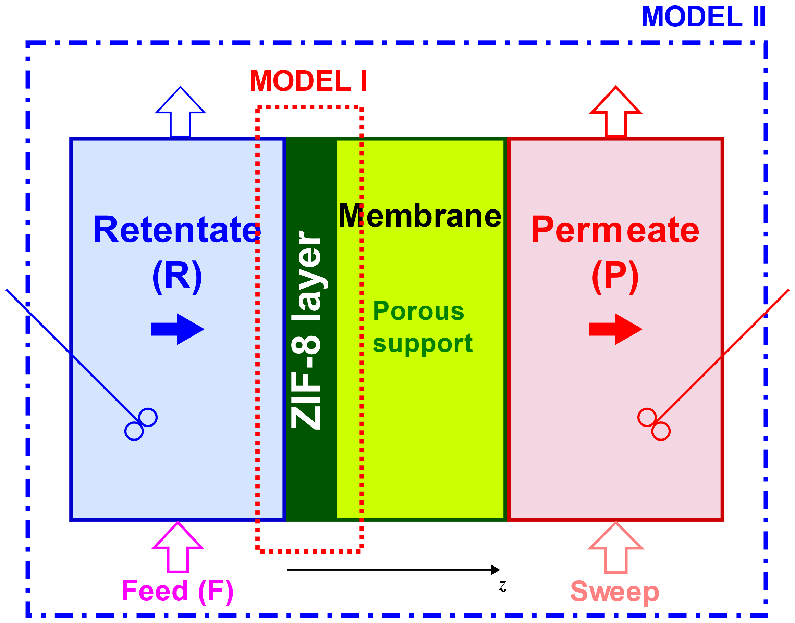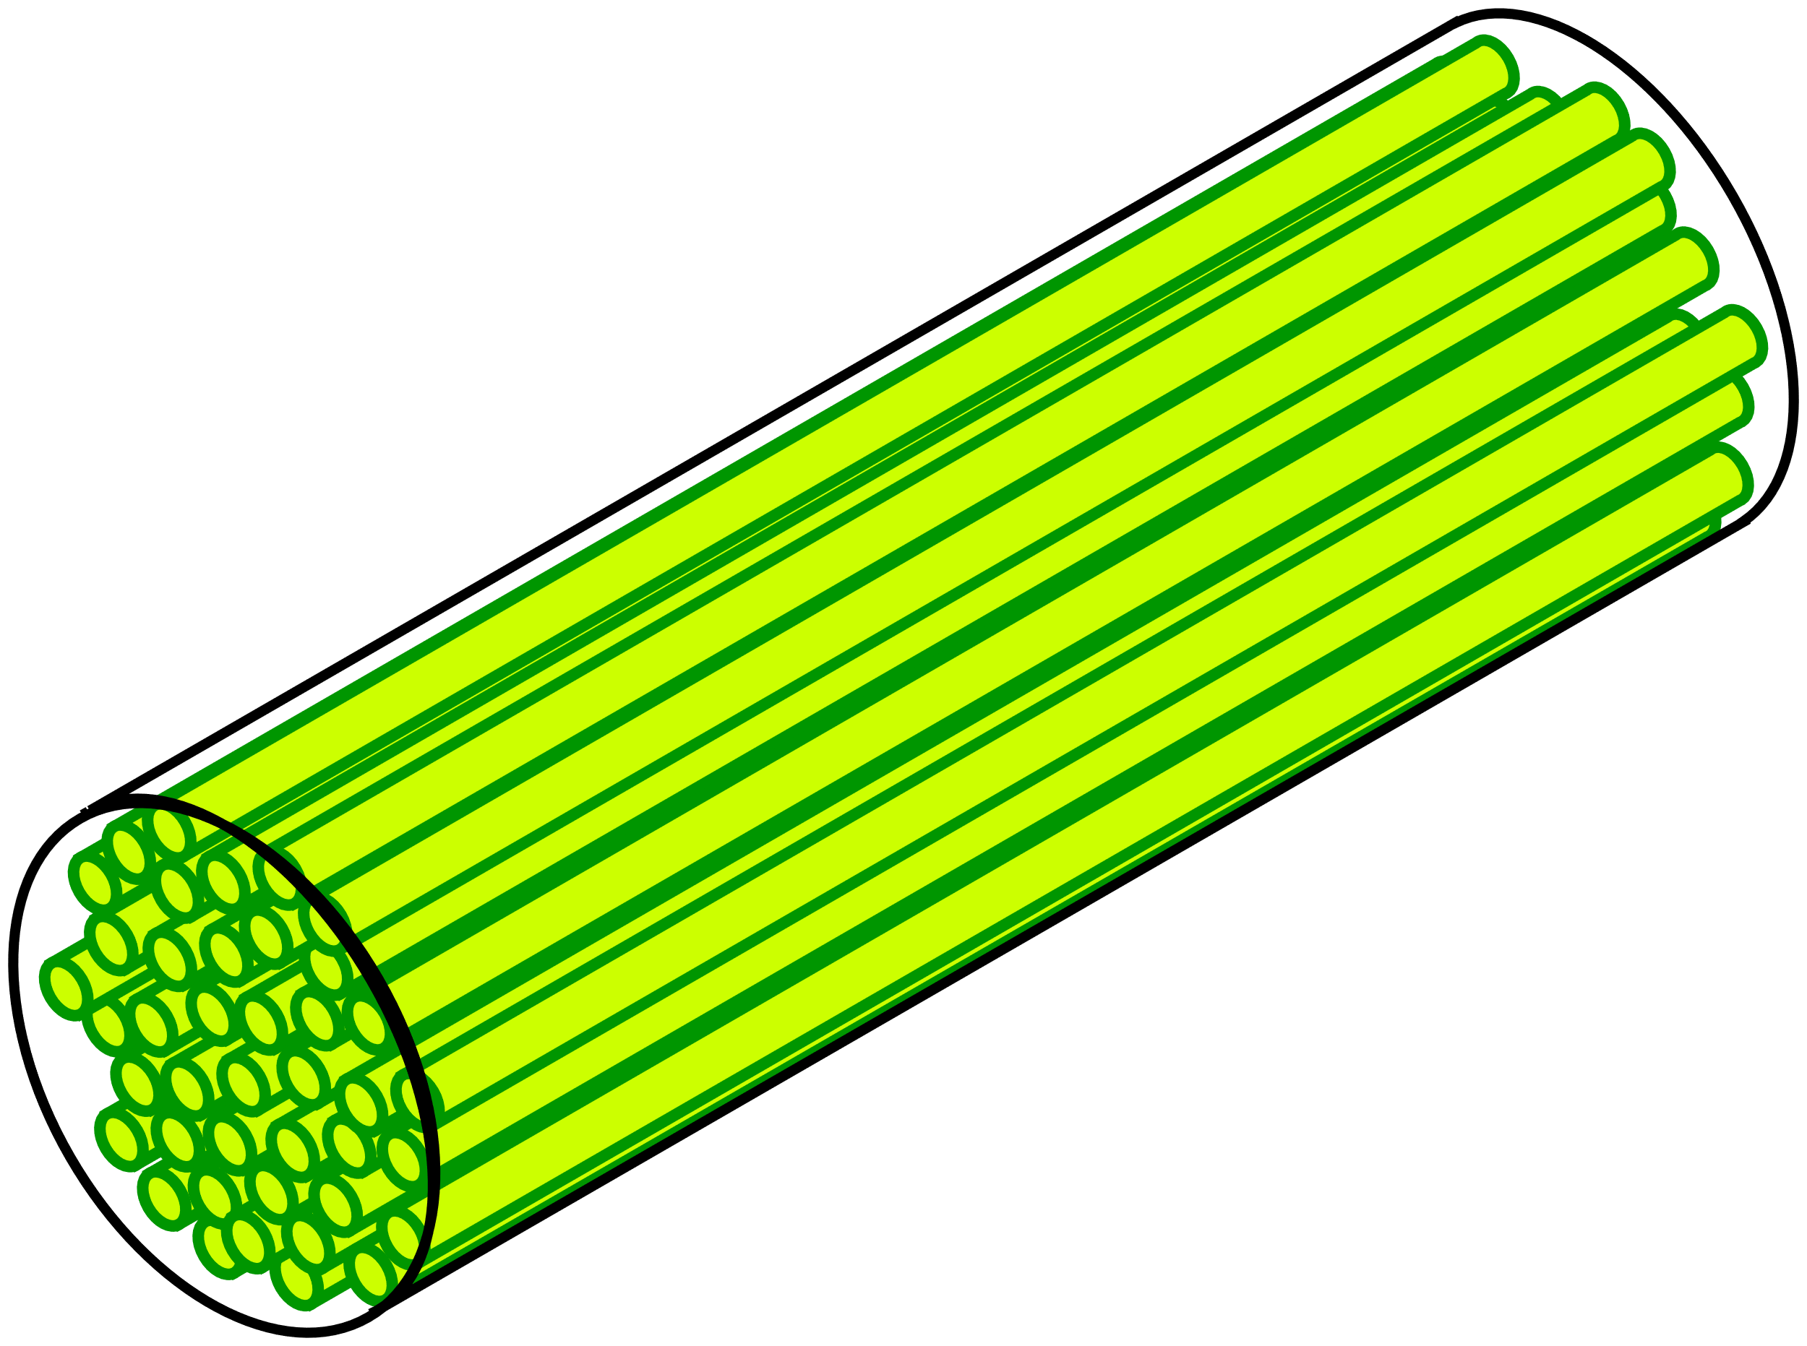

Figure 1: Graphical illustration of membrane processes that apply ZIF-8 thin-layered membrane for propylene/propane mixture separation. Left: Thin-layered membrane (Model I) & “Batch” process (Model II). Right: Spatially-distributed hollow-fiber membrane module (Model III).

Investigated membrane separation processes: Graphical illustrations of thin-layered membrane separation processes considered in this work are displayed in Fig. 1. A high-pressure feed gas (F) mixture of propylene (component 1) & propane (component 2) is continuously supplied to the process on the retentate side (R), whereas the permeate side (P) remains under low pressure. As a result, a pressure differential is established across a ZIF-8 membrane, generating concentration gradients and inducing a preferential permeation of the faster-diffusing propylene through the microporous material, which is exploited to achieve separation. A defect-free ZIF-8 thin layer is assumed; mass transfer resistance of the porous support is ignored, as well as any mechanism of membrane degradation.
  - Methods & Algorithms
Efficient implementation to solve M-S flux equations: The explicit, compact matrix form of the flux equations derived from M-S approach, used to describe multicomponent mass transfer (Krishna (1990, 2014)), is:
$$N=-σ Δ Γ ∇_{ξ} q ; Γ≔diag\left(\frac{q_{i}}{c_{i}}\right)J_{c}, i=1,…,N_{c},$$ | (1)
with Jacobian, $J_{c}$, of fluid-phase concentrations, $c$, w.r.t. loadings, $q$, at equilibrium. Ideal gas behavior & isothermal conditions are assumed. Diffusional frictional effects of the confined species are quantified by $σΔ$, which take M-S diffusivities, $D_{i}^{MS}$, & adsorbed-phase molar fractions, $x_{i}$, into account. Thermodynamic factors, $Γ$, require knowledge of adsorption equilibria, $c=f^{-1}\left(q\right)$, which are only available analytically for a few simple adsorption equilibrium equations. Therefore, from a calculation point of view, an inversion of equilibria, $q=f\left(c\right)$, and corresponding evaluation of Jacobian elements, $∂c_{i}/∂q_{j}, i,j=1,…,N_{c}$, are required to implement Eq. (1) in mass balance equations of the membrane processes studied herein. To overcome this difficulty, the Inverse Function Theorem is invoked, so Jacobian, $J_{c}$, in Eq. (1) can be written as
$$J_{c}≡J_{q}^{-1}; N=-σ Δ diag\left(\frac{q_{i}}{c_{i}}\right)J_{q}^{-1} ∇_{ξ} q, N={\left[N_{1},…,N_{N_{c}}\right]}^{T},$$ | (2)
whereby, analytical formulae by Rubiera Landa et al. (2013), applicable to IAST, are used to calculate $J_{q}^{-1}$—see details in Rubiera Landa and Denayer (2023). This renders efficient & robust M-S flux calculations where $Γ$ are obtained in closed form with minimal computational cost.
Applied membrane models: Model I: Transient model for thin-layered membrane. The applicable 1-D mass balances around the thin-layered membrane—see Fig. 1—are:
$$\frac{∂q_{i}}{∂t}=\frac{1}{ρ}\frac{∂N_{i}}{∂z} i=1,…,N_{c},$$ | (3)
with $N_{i}$ given by Eq. (2), and implicitly-defined IAST equilibria, $φ\left(c,c^{0},q,T\right)=0$. This yields a partial differential-algebraic equation (PDAE) system, with applicable IC & BCs. After sufficiently long time, the process reaches steady-state, i.e., flux values become constant & separation performance is evaluated then. Model II: “Batch” membrane process. An additional level of complexity is introduced by considering steady-state mass balances around well-mixed retentate (R) & permeate (P) sides, including the membrane and inlet & outlet molar flow rates (see Fig. 1). This yields the following nonlinear equation in the unknown, $y_{1}^{R}$, for the binary mixture case, $N_{c}=2$, considered here—cf. van de Graaf et al. (1999):
$f\left(y_{1}^{R}\right)=\frac{\dot{n_{1}^{F}}-N_{1}^{ss} A}{\left[\dot{n_{1}^{F}}+\dot{n_{2}^{F}}\right]-\left[N_{1}^{ss}A+N_{2}^{ss}A\right]}-y_{1}^{R}=0$ ; $y_{1}^{R}+y_{2}^{R}=1$ ; $N_{i}^{ss}=f\left(y_{1}^{R}\right).$ | (4)
Eqs. (4) are solved iteratively by applying Algorithm 1. The computations of steady-state M-S fluxes, $N_{i}^{ss}$, with Model I, Eqs. (3), are embedded in the solution of Eq. (4). Afterward, performance metrics are evaluated.
Algorithm 1: Batch membrane mass balance (Model II)
1: Specify feed parameters, $\dot{n^{F}}$, $y_{1}^{F}$, operating pressures, $p^{R}$, $p^{R}$; & membrane area, $A$.
2: Assign a guess value for $y_{1}^{P}←y_{1}^{P\left(*\right)}$
3: Compute $y_{1}^{R}$ from $f\left(y_{1}^{R}\right)=0$ with Eqs. (4), applying Eqs. (3) for steady-state flux values, $N_{1}^{ss}$, $N_{2}^{ss}.$
4: Close the steady-state mass balances with $\dot{n^{r}}=\dot{n^{F}}-\sum_{i=1}^{N_{c}}{N_{i}^{ss}A}=\dot{n^{F}}-\dot{n^{P}}$
5: Verify if $y_{1}^{P}-\frac{\dot{n_{1}^{P}}}{\sum_{i=1}^{N_{c}}{\dot{n_{i}^{P}}}} ,$else, iterate until fulfilled.
6: Calculate performance metrics: perm-selectivity, $Φ_{Sel.,i}$; permeability, $Φ_{Perm.,i}$.

Model III: Asymmetric hollow fiber membrane. We take the following 1-D spatially-distributed, steady-state model by Gabrielli et al. (2017), to calculate retentate side (R) molar flow rate & compositions:
$\frac{d}{dz}\dot{n^{R}}=\dot{n^{F}}m\frac{y_{1}^{R}-\frac{p^{P}}{p^{R}}y^{*}}{y^{*}}$ ; $\frac{d}{dz}y_{1}^{R}=\frac{1}{\dot{n^{F}}}m\frac{\left(y_{1}^{R}-y^{*}\right)\left(y_{1}^{R}-\frac{p^{P}}{p^{R}}y^{*}\right)}{y^{*}\dot{n^{R}}}$ , | (5a)
with dimensionless parameter, $m≔\frac{Π_{1}Ap^{R}}{\dot{n^{F}}}$. The total membrane area for $N_{f}$ hollow fibers of length, $L_{f}$, with outer radius, $r_{o}$, is: $A=A_{f}N_{f}=2πr_{o}L_{f}N_{f}$. Local molar fraction at position, $z=z^{*}$, is,
$y^{*}=\frac{1+\left(α-1\right)\left(\frac{p^{P}}{p^{R}}+y_{1}^{R}\right)-{\left[{\left[1+\left(α-1\right)\left(\frac{p^{P}}{p^{R}}+y_{1}^{R}\right)\right]}^{2}-4\frac{p^{P}}{p^{R}}α\left(α-1\right)y_{1}^{R}\right]}^{1/2}}{2\frac{p^{P}}{p^{R}}\left(α-1\right)}$. | (5b)
The IC is: $\dot{n^{R}}\left(z=0\right)=\dot{n^{F}} y_{1}^{R}\left(z=0\right)=y_{1}^{F}$. Perm-selectivity, defined as the ratio of steady-state permeances, $α≔Π_{1}/Π_{2}$, is supplied as a parameter to the model and computed with Models I or II. Mass balances around the fiber module are closed with:
$$\dot{n^{F}}=\dot{n^{R}}\left(z=L_{f}\right)+\dot{n^{P}}\left(z=L_{f}\right);$$  $\dot{n^{F}}y_{1}^{F}=\dot{n^{R}}\left(z=L_{f}\right)y_{1}^{R}\left(z=L_{f}\right)+\dot{n^{P}}\left(z=L_{f}\right)y_{1}^{P}\left(z=L_{f}\right)$. | (5c)
Solution of membrane models: In Model I, the PDAE system, Eqs. (3), is solved by applying the Method-of-lines approach (Schiesser (1991)). A cell-centered finite volume method (FVM)—see e.g., Hundsdorfer and Verwer (2003)—is applied to discretize along spatial coordinate, $z$, yielding an index-1 DAE system to integrate numerically, until steady-state is attained. In Model II, Eq. (4) in the unknown, $y_{1}^{R}$, is solved with MATLAB™ function ‘fsolve’. In Model III, Eqs. (5), the set of ODEs are integrated from $z=0$ to $z=L_{f}$. All models use MATLAB™ function ‘ode15s’ for integration.
Propylene/propane separation using ZIF-8: In this study, we apply parameters at $T=308 K$ reported by Zhang et al. (2012) for the propylene/propane/ZIF-8 system, including single-component adsorption equilibria & zero-coverage diffusivity values used in M-S flux calculations. Competitive equilibria are calculated with IAST & Jacobian formulation, Eq. (2).
Estimation of perm-selectivity & permeabilities from Models I & II using sampling technique: Models I & II provide permeability values and performance metrics, perm-selectivity, $α$, & permeability, $Φ_{Perm.,i}$, based exclusively on M-S flux calculations. These metrics are then supplied to the more-detailed Model III. Latin Hypercube Sampling design (McKay et al. (1979))—function ‘lhsdesign’ in MATLAB™—is used to explore these metrics. A design with $M=100$ samples is applied for variables, $p^{R}∈\left[1.5×{10}^{5},4.5×{10}^{5}\right] Pa$ & ${y_{1}}^{R}∈\left[0.4,0.85\right]$, keeping constant $p^{P}={10}^{3} Pa$.
Application of multi-objective optimization (MOO) to analyze process performance of Model III: We formulate the following bound-constrained MOO task:
$maximize \{Φ_{Pu,i}\left(u\right),Φ_{Re,i}\}$, s. t. $u^{lb}≤u≤u^{ub}$, | (6)
with purity, $Φ_{Pu,i}$, recovery, $Φ_{Re,i}$ & decision variables, $u$. Other relevant objectives include specific membrane area, $Φ_{A,i}$, & specific energy consumption, $Φ_{En,i}$. Due to the robustness and fast calculation of Model III, a black-box function approach can be employed to solve task (6). Therefore, the optimal separation performance of the hollow-fiber membrane module can be explored by applying genetic algorithms (GA).
Table 1. Design variables & bounds for MOO task.
Variable | $$A,\left[m^{2}\right]$$ | $$p^{R},\left[Pa\right]$$ | $$p^{P},\left[Pa\right]$$
Lower bound | $$0.47\left(50 fibers\right)$$ | $$1.5×{10}^{5}$$ | $$1×{10}^{4}$$
Upper bound | $$3.77\left(400 fibers\right)$$ | $$4.5×{10}^{5}$$ | $$8×{10}^{4}$$
We use the NSGA-II (Deb et al. (2002)) variant ‘gamultiobj’ available in MATLAB™. Applied decision variables are listed in Table 1 with corresponding bounds. A population size of 75 function evaluations with a maximum budget of 150 generations is specified. Additional simulation parameters are: molar feed flow rate, $\dot{n^{F}}=0.05 mol/s$; hollow-fiber outer diameter, $r_{o}=1.5×{10}^{-3} m$ ($1.5 mm$); fiber length, $L_{f}=1 m$; membrane layer thickness, $δ=2.5×{10}^{-6} m$ ($2.5 microns$); and permeances, $Π_{1}=4.2×{10}^{-8} mol/\left(m^{2}⋅s⋅Pa\right)$ & $Π_{1}=3.9×{10}^{-10} mol/\left(m^{2}⋅s⋅Pa\right)$. Propylene feed compositions, $y_{1}^{F}=\{0.4,0.6,0.85\}$, are considered for comparison.
  - Results & Discussion
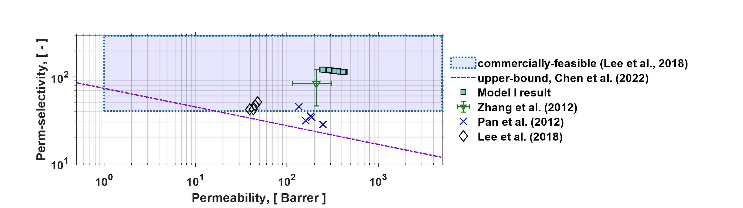
Figure 2. Robeson plot for propylene/propane pair, displaying: Model I sampling result; experimental measurements by Lee et al. (2018) & Pan et al. (2012); & estimation by Zhang et al. (2012) for comparison.

Estimation of perm-selectivity & permeability values with Model I: Fig. 2 illustrates a Robeson plot for the propylene/propane pair with the performance result obtained by applying Model I. Propylene to propane perm-selectivity has relatively close values between $115$ and $125$, with propylene permeabilities in the range $[250,400] Barrer$—
($1 Barrer=3.35×{10}^{-16} mol/\left(m⋅s⋅Pa\right)$). Similar results are obtained with Model II. Accordingly, ZIF-8 thin-layered membranes perform beyond the known upper bound for polymeric membranes reported by Chen et al. (2022) & fall inside the projected commercially-viable region discussed in Lee et al. (2018). Experimental data of some authors is also displayed in Fig. 2, showing deviations from model predictions. Factors such as membrane fabrication and processing methods, porous support & MOF synthesis contribute to the observed performance discrepancies, as discussed by Lee et al. (2018). The models herein discussed assume ideal membranes, ignoring porous support effects; these should be considered in more-detailed process models.
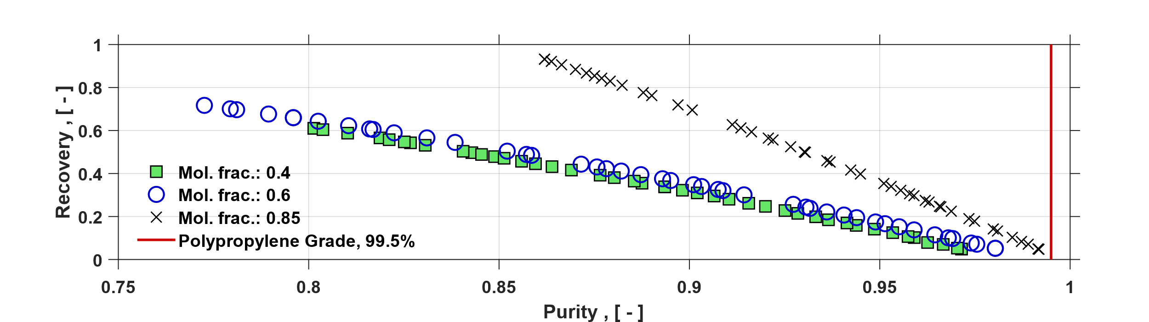
Figure 3. Computed propylene recovery vs. propylene purity Pareto frontiers for different feed compositions, $y_{1}^{F}=\{0.4,0.6,0.85\}$. Design variables & bounds applied are listed in Table 1.

MOO results for Model III: Fig. 3 illustrates MOO results for the asymmetric hollow-fiber membrane module (cf. Fig. 1). The optimizer identifies the trade-off between recovery & purity for each feed composition, $y_{1}^{F}$, considered. The best result in terms of these conflicting metrics is obtained when a stream enriched with propylene is processed by the membrane module. Pareto frontiers also show that this is a challenging separation, where purity values close to the desired propylene-grade purity ($99.5\%$) are difficult to attain with a single hollow-fiber module, as specified. This aspect of membrane performance for propylene/propane separations has also been discussed in detail by Yamaki et al. (2022), where membrane cascades have been proposed as an alternative to meet stringent downstream propylene purity requirements at feasible product recoveries.
  - Conclusion
We have presented a detailed strategy to analyze the separation performance of membrane processes based on thin-layers of microporous adsorbents. We considered models of increasing complexity, incorporating information of less-detailed models (I & II) into a spatially-distributed model (III) that provides a more-detailed representation of a membrane separation operation. M-S flux calculations in a propylene/propane/ZIF-8 example were incorporated efficiently by applying analytical thermodynamic factor expressions. Separation performance was analyzed with a GA, confirming the robustness of our modeling approach, identifying optimal recovery vs. purity trade-offs for the example considered. The presented strategy provides an attractive alternative for materials screening studies from first principles and can assist in conceptual process design of challenging gas separation tasks.
Acknowledgement: We thank the support of Agentschap Innoveren & Ondernemen, Belgium, in the frame of Moonrise-MOONSHOT Project HBC.2020.2612 (3E210291): “Hybrid membrane/sorption technology for more efficient C2 and C3 separations”.
References
X. Y. Chen, A. Xiao, D. Rodrigue, 2022. Polymer-based Membranes for Propylene/Propane Separation. Separation & Purification Reviews 51 (1), 130-142.
K. Deb, A. Pratap, S. Agarwal, T. Meyarivan, 2002. A Fast and Elitist Multiobjective Genetic Algorithm: NSGA-II. IEEE Transactions on Evolutionary Computation 6 (2), 182-197.
M. Fechtner, A. Kienle, 2018. Efficient simulation and equilibrium theory for adsorption processes with implicit adsorption isotherms - Ideal adsorbed solution theory. Chemical Engineering Science 177, 284-292.
P. Gabrielli, M. Gazzani, M. Mazzotti, 2017. On the optimal design of membrane-based separation processes. Journal of Membrane Science 526, 118-130.
W. Hundsdorfer, J. G. Verwer, 2003. Numerical solution of time-dependent advection-diffusion-reaction equations. Springer, ISBN 3-540-03440-4.
R. Krishna, 1990. Multicomponent surface diffusion of adsorbed species: A description based on the Generalized Maxwell-Stefan equations. Chemical Engineering Science 45 (7), 1779-1791.
R. Krishna, 2014. The Maxwell-Stefan description of mixture diffusion in nanoporous crystalline materials. Microporous and Mesoporous Materials 185, 30-50.
M. J. Lee, M. R. A. Hamid, J. Lee, J. S. Kim, Y. M. Lee, H.-K. Jeong, 2018. Ultrathin zeolitic-imidazolate framework ZIF-8 membranes on polymeric hollow fibers for propylene/propane separation. Journal of Membrane Science 559, 28-34.
M. D. McKay, R. J. Beckman, W. J. Conover, 1979. A Comparison of Three Methods for Selecting Values of Input Variables in the Analysis of Output from a Computer Code. Technometrics 21 (2), 239-245.
A. L. Myers, J. M. Prausnitz, 1965. Thermodynamics of Mixed-Gas Adsorption. AIChE Journal 11 (1), 121-127.
Y. Pan, T. Li, G. Lestari. Z. Lai, 2012. Effective separation of propylene/propane binary mixtures by ZIF-8 membranes. Journal of Membrane Science 390-391,93-98.
H. O. Rubiera Landa, J. F. M. Denayer, 2023. Efficient modeling and simulation of gas separations applying Maxwell-Stefan approach and Ideal Adsorbed Solution Theory. Chemical Engineering Science (submitted).
H. O. Rubiera Landa, D. Flockerzi, A. Seidel-Morgenstern, 2013. A Method for Efficiently Solving the IAST Equations with an Application to Adsorber Dynamics. AIChE Journal 59 (4), 1263-1277.
W. E. Schiesser, 1991. The numerical method of lines: integration of partial differential equations. Academic Press, ISBN 9780128015513.
J. M. van de Graaf, F. Kapteijn, J. A. Moulijn, 1999. Modeling Permeation of Binary Mixtures Through Zeolite Membranes. AIChE Journal 45 (3), 497-511.
T. Yamaki, N. Thuy, N. Hara, S. Taniguchi, S. Kataoka, 2022. Design and Evaluation of Two-Stage Membrane-Separation Processes for Propylene-Propane Mixtures. Membranes 12 (2), 163.
C. Zhang, R. P. Lively, K. Zhang, J. R. Johnson, O. Karvan, W. J. Koros, 2012. Unexpected Molecular Sieving Properties of Zeolitic Imidazolate Framework-8. The Journal of Physical Chemistry Letters 3, 2130-2134.

