Modelling of the Co-gasification of Waste Plastic and Biomass using Oxygen-CO₂ Mixtures
Nomadlozi L. Khumaloª, Bilal Patelª

ªDepartment of Chemical Engineering,University of South Africa, Corner of Christiaan de Wet Road and Pioneer Avenue, Florida 1709, South Africa
*patelb@unisa.ac.za
Abstract

Gasification provides a promising solution for valorizing plastic waste by using high temperatures and gasifying agents to convert the waste into versatile syngas. However, the gasification of plastic waste comes with various operational challenges. Co-gasifying plastic waste with biomass offers several advantages, including the reduction of operational challenges, decreased tar formation, and the production of syngas with improved quality and higher energy content.
The study investigates the impact of various factors on the syngas produced from the co-gasification of sawdust (SD) and plastic waste (low-density polyethylene, PE) using different blend ratios (BRs) of PE (25 %, 50 %, and 75 %) and different operating conditions, including equivalence ratio (ER) and CO₂/C ratios (0.6 and 1.4). The study utilized a non-stoichiometric equilibrium model within Aspen Plus to analyze the co-gasification process. The key findings include the production of syngas with high hydrogen (H₂) content, high Lower Heating Value (LHV) of 9.2 MJ/Nm³, and high H₂/CO ratios. These favorable outcomes were achieved at low ER values below 0.4 and a CO₂/C ratio equal to 0.6.

Keywords: co-gasification, blend ratio, equivalence ratio; synergistic effect, plastic waste.
  - Introduction

The extensive use of plastics has resulted in significant plastic waste (PW) generation, causing environmental pollution (Midilli et al. 2022). Currently, over 79% of plastic waste is disposed in landfills or ends up in the environment (Tejaswini et al. 2022). Landfilling and incineration are both not feasible environmental solutions to waste plastics. Chemical valorization of PW through gasification has shown to be an effective conversion technology, addressing environmental concerns, and reducing reliance on fossil fuels. Gasification involves the high-temperature conversion of carbonaceous components with limited oxygen, resulting in the production of syngas, which is a valuable energy product (Rafey et al. 2023). Despite its high conversion efficiency, mono-gasification of plastic waste faces challenges such as polymer agglomeration and high tar yield. To overcome these limitations, biomass (BM) is a suitable complement to plastic waste due to it being carbon-neutral, environmentally friendly, and abundantly available (Mariyam et al. 2022). Co-gasification process, combining biomass and plastic waste, mitigates operational challenges associated with mono-gasification, reduces tar formation, and improves the quality and energy content of the syngas produced (Shahbaz et al. 2020). However, a gap in the existing literature on the impact of using a mixture of oxygen and carbon dioxide as a gasifying agent during the co-gasification of biomass (pine sawdust) and plastic waste (low-density Polyethylene) has been identified. Carbon dioxide promotes the dry reforming reaction, which increases combustible gases and, when mixed with oxygen, facilitates auto-thermal operation (Pinto et al. 2016).

Previous research, such as studies conducted by Kaydouh et al. (2022), De et al. (2021) Ruoppolo et al. (2012), and Wang et al. (2021), primarily focused on co-gasification of biomass and plastic waste, but typically utilized single gasifying agents like air, steam, oxygen, or carbon dioxide, instead of mixtures of gasifying agents. The study aims to investigate the impact of feedstock composition, which includes biomass, plastic waste, and their blended feedstocks (e.g., (25 % PE + 75 % biomass, (50 % PE + 75 % biomass) and (75 % PE + 25 % biomass), using an oxygen-carbon dioxide mixture as the gasifying agent. The focus will be on assessing how these variables affect the composition of the syngas (including the concentration H₂), the H₂/CO ratio of the syngas, and the Lower Heating Value (LHV) of the syngas. The research will also explore the potential synergistic interaction between biomass and plastic waste during the co-gasification process.

  - Modelling framework

A non- stoichiometric process model was developed in Aspen Plus for the co-gasification of biomass and plastic (Khumalo et al. 2023). The Peng-Robinson-Boston-Mathias (PR-BM) thermodynamic model was selected (Ramzan et al. 2011). The enthalpy and density functions for biomass (sawdust) and plastic waste (PE) were defined using HCOALGEN and DCOALIGT algorithms. The feedstocks considered was polyethylene (PE), biomass (sawdust) and various blend ratios; (25% PE + 75 % biomass), (50 % PE + 50% biomass) and (75% PE + 25% biomass). Biomass properties were specified based on ultimate analyses (Carbon (C): 45.5 %, Hydrogen (H): 5 %, Oxygen (O): 47.1 %, Nitrogen (N): 0.05 % and ash: 2.35 %) and proximate analyses (Fixed Carbon (FC): 18.45 %, Volatile Matter (VM): 79.2 %, ash: 2.35 % and Moisture Content (MC): 5.76 %). Similarly, the ultimate analyses of plastic waste (C: 85.81 %, H:13.86 %, O: 0 %, N: 0.12 %, S:0.06 % and ash: 0.15 %), proximate analysis of plastic waste (FC: 0 %, VM: 99.85 %, ash content: 0.15 % and MC: 0.02 %) (Al Amoodi et al. 2013) was also specified. Gasifying agents such as oxygen and carbon dioxide were specified with variations in equivalence ratio (ER) between 0.1 -1 and CO₂/C ratios equal to 0.6 and 1.4.
The gasifier was modelled utilising a RYield reactor, which was used for the decomposition of non- conventional components into elements. These elements, together with the gasifying agents, enter a RGibbs reactor, which uses Gibbs energy minimization to predict product distribution The products pass through a cyclone unit, which separates solids (ash) from the gaseous product. The effect of feedstock composition and gasifying agent flowrate, on the product gas composition, H₂/CO ratio and Lower Heating Value (LHV) was determined. The LHV was calculated using equation (1)

LHV_{syngas} = 10.79 X_{H2} + X_{CO}+ 35.83 X_{CH4} (1)
where, X is the molar fraction of the gaseous component (Tavares et al. 2018).
  - Results and Discussion

3.1 Effect of the equivalence ratio on H₂ composition in the product gas for various blend ratios when carbon dioxide – oxygen mixture is used as gasifying agent.

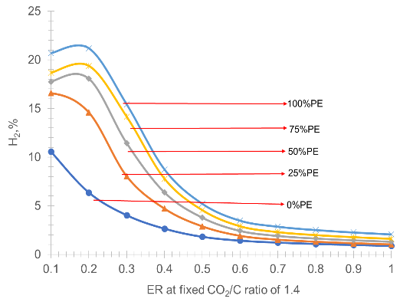
The data in Figure 3.1 (a) and (b), illustrates that at low equivalence ratio (ER) values below 0.4 the hydrogen (H₂) content is high for all feedstocks, however as ER increases further the H₂ content decreases. Figure 3.1 (a) show that the addition of plastic waste, (PW), (polyethylene), (PE) to the feedstock in the presence of oxygen – carbon dioxide mixture as a gasifying agent increases the H₂ composition in the product gas, with the highest H₂ composition of 30% achieved at an ER equal to 0.14 and a fixed CO₂/C ratio equal to 0.6 from the blend ratio of (75 % PE + 25 % biomass). The increase in H₂ composition can be attributed to PE, which acts as a H₂ donor to the radicals generated from biomass (BM) pyrolysis thus stabilizing those radicals (Ahmed et al. 2011). In Figure 3.1 (b), the results show that the H₂ composition produced at higher carbon dioxide flowrates i.e., CO₂/C ratio equal to 1.4, is lower than that obtained at lower carbon dioxide flowrates i.e.CO₂/C ratio equal to 0.6. This phenomenon occurs because the addition of carbon dioxide at a high flowrate promotes certain chemical reactions, such as the reverse dry reforming reaction and reverse water gas shift reaction which is responsible for a decrease in the H₂ content of the product gas (Islam 2020). The synergy between BM and PW, when an oxygen-carbon dioxide mixture is used as gasifying agent, is evident at low CO₂/C ratio of 0.6 instead of 1.4. This is observed in Figure 3.1 (a) as the highest hydrogen content was obtained from the blended feedstocks such as a blend ratio of (25 % PE + 75 % biomass) instead of a single feedstock, whereas, in Figure 3.1 (b) there was no synergistic interaction between BM and PW since the highest H₂ content was obtained from PE feedstock.
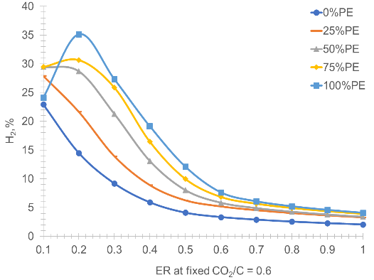

- (b)
Figure 3.1 Effect of the equivalence ratio (ER) on the (a) H₂, when carbon dioxide is added (a) at low flowrate through CO₂/C ratio equals to 0.6 and (b) CO₂/C equals to 1.4.

3.2. Effect of oxygen – carbon dioxide mixtures as a gasifying agent on the H₂/CO ratio of the syngas.

Figure 3.2 (a) and (b) show that as the (ER) increases from 0.1 to 1, using an oxygen-carbon dioxide mixture as a gasifying agent, the H₂/CO ratios of the syngas decrease for various blends of feedstocks. The highest H₂/CO ratios in the syngas are achieved at low ER values below 0.4. When ER is below 0.4, certain chemical reactions like the Boudouard reaction, partial oxidation reaction, water-gas shift reaction, reverse methanation CO₂ reforming reaction, and methanation reaction are favourable, leading to an enhancement in the H₂/CO ratios of the syngas. Moreover, Figure 3.2 (a) and (b) indicate that when polyethylene is added to the feedstock mixtures, the H₂/CO ratio of the syngas increases when an oxygen-carbon dioxide mixture is used as the gasifying agent. This increase can be attributed to the high H₂ content in PE material. However, the use of an oxygen-carbon dioxide mixture as the gasifying agent does not lead to a synergistic interaction between biomass and polyethylene since the recommended H₂/CO ratio of 2 was not obtained from the blended feedstocks, but from 100 % PE. In addition, Figure 3.2 (a) reveals that the H₂/CO ratio of 2 was obtained from the PE feedstock and not from the blended feedstocks. This suggests that for the co-gasification of biomass and PW, the use of an oxygen-carbon dioxide mixture as a gasifying agent is not suitable for achieving the desired syngas quality.
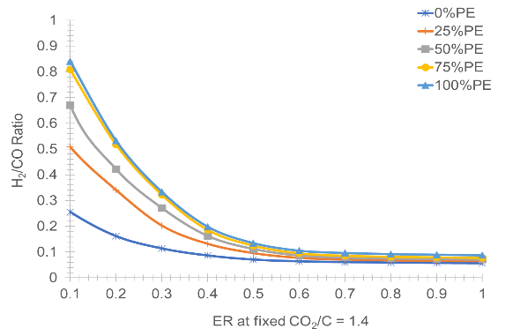
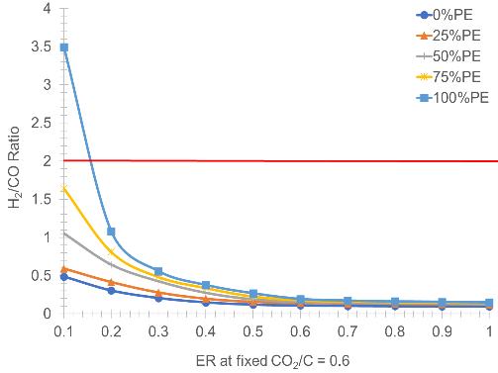

(a) (b)

Figure 3.2 Effect of the equivalence ratio on the H₂/CO ratio of syngas when carbon dioxide is added (a) CO₂/C ratio equal to 0.2 and (b) CO₂/C ratio is increased to 1.4.

3.3. Effect of oxygen – carbon dioxide mixtures as a gasifying agent on the Lower Heating Value (LHV) of the syngas

In Figure 3.3 (a) and (b), it is observed that an increase in the equivalence ratio (ER) from 0.1 to 1, with fixed CO₂/C ratios at 0.6 and 1.4, initially causes feedstocks with higher polyethylene percentages to increase in Lower Heating Value (LHV). However, as ER continues to increase, the LHV subsequently decreases. This trend is consistent for all feedstock types, except for the LHV of biomass, which decreases as ER increases. At ER below 0.4, there is an increase in LHV due to chemical reactions, such as the Boudouard reaction, partial oxidation, reverse water gas reaction, dry reforming reaction, and methanation reaction, which favour combustible gases such as H₂, CO and CH₄. Figure 3.3 (a) and (b) also show that an increase in the PE percentage in the feedstocks, when an oxygen-carbon dioxide mixture is used as the gasifying agent, leads to an increase in the LHV of the syngas, this is attributed to light and stable hydrocarbons formed by thermal cracking of polymer chains, which contributes to the increase in combustible gases ,which consequently increases the LHV of the syngas (Parrillo et al. 2023). Furthermore, Figure 3.3 (a) and (b) demonstrate that when the CO₂/C ratio increases from 0.6 to 1.4, the LHV of the syngas decreases. In Figure 3.3 (a), the highest LHV of 9.2 MJ/Nm³ is produced from when ER is 0.1 and CO₂/C ratio equal to 0.6 at a blend ratio of (25 % PE + 75 % biomass). Whereas, in Figure 3.3 (b), the highest LHV is obtained from a single feedstock of polyethylene. This suggests that the use of an oxygen-carbon dioxide mixture as a gasifying agent enhances the LHV of the syngas at low carbon dioxide flow rates with a CO₂/C ratio of 0.6. Consequently, this indicates that during the co-gasification of biomass and polyethylene in the presence of an oxygen-carbon dioxide mixture as a gasifying agent, a synergistic interaction between biomass and polyethylene occurs, leading to higher LHV values when low ER values below 0.4 and at fixed CO₂/C ratio equal to 0.6 are utilised.
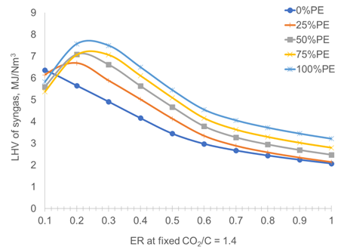
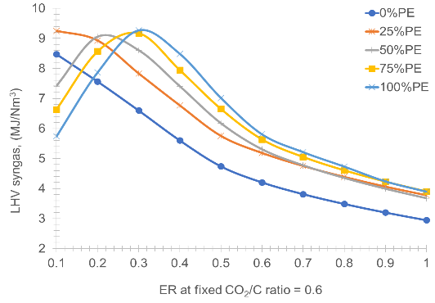

- (b)

Figure 3.3 (a) and (b) Effect of the equivalence ratio (ER) on the Lower Heating Value (LHV) of syngas when carbon dioxide flowrate is varied (a) CO₂/C ratio equal to 0.6 and (b) CO₂ /C ratio equals to 1.4.

4. Conclusion

The co-gasification of biomass and plastic waste using an oxygen-carbon dioxide mixture as the gasifying agent has revealed some interesting findings. Specifically, increasing the polyethylene percentage in the blended feedstocks leads to higher levels of H₂ in the syngas, as well as an increase in the LHV of the syngas, which reaches a maximum of 9.2 MJ/Nm³ at low ER values below 0.4 and low carbon dioxide flowrate through CO₂/C ratio of 0.4. This improvement can be attributed to the fact that PE has a high volatile matter and low oxygen content. The most significant improvements are observed in feedstock blend ratio containing (25 % PE + 75 % biomass) compared to other blended feedstock ratios. A high-quality product composition and energy content of syngas are most favourable when the equivalence ratio (ER) is kept low, below 0.4, and with a fixed CO₂/C ratio equal to 0.6. These conditions lead to a more efficient syngas production process when co-gasifying biomass and polyethylene.
References

I.I. Ahmed, N. Nipatummakul, A.K. Gupta, (2011), Characteristics of Syngas From Co-gasification of Polyethylene and Woodchips, Applied Energy, 88,165 – 174.
N. Al Amoodi, P. Kannan, A. Al Shoaibi, C. Shrinivasakannan, (2013), Aspen Plus Simulation of Polyethylene Gasification under Equilibrium Conditions, Chemical Engineering Communication, 200, 7 – 9.
S. De, S. Pati, (2021), Model Development and Thermodynamic Analysis of Biomass Co-gasification using Aspen Plus, Indian Chemical Engineer, 63,172 – 183.
M. D.W Islam, (2020), Effect of Different Gasifying Agents (Steam. H₂O₂, Oxygen, CO₂ and Air) on Gasification Parameters, International Journal of Hydrogen Energy, 45,31760 – 31774.
M. Kaydouh, N. Hassan, (2022), Thermodynamic Simulation of the Co-gasification of Biomass and Plastic Waste for Hydrogen-Rich Syngas Production, Results in Engineering, 100771.
N. L Khumalo, B. Patel, (2023), A Parametric Analysis of the Co-gasification of Biomass and Plastic Waste using Aspen Plus, Computer Aided Chemical Engineering,52,1421 – 1426.
S. Mariyam, M. Shahbaz, T. Al-Ansari, H.R, Mackey, G. McKay, (2022), A Critical Review on Co-gasification and Co-pyrolysis for Gas Production, Renewable and Sustainable, Energy Reviews, 161, 112349.
A. Midilli, H. Kucuk, M. Haciosmanoglu, U. Akbulut, I. Dincer, (2022), A Review on Converting Plastic Wastes into Clean Hydrogen via Gasification for better Sustainability, International Journal Energy Research, 46,4001 – 32.
F. Parrillo, F. Ardolino, C. Boccia, G. Cali, D. Marotto, A. Pettinau, U. Arena, (2023), Co-gasification of Plastics Waste and Biomass in a Pilot Scale Fluidied Bed Reactor, Energy, 273,127220.
F. Pinto, R. Andre, M. Miranda, D. Neves, F. Varela, J. Santos, (2016), Effect of Gasification Agent on Co-gasification of Rice Production Wastes Mixtures, Fuel,180,407 – 416.
A. Rafey, K. Pal. A. Bohre, A. Modak, K.K, Pant, (2023), A state-of-the-art review on the on the Technological Advancements for the Sustainable Management of Plant Waste in Consort with the Generation of Energy and Value – Added Chemicals, 13,420.
N. Ramzan, A. Ashraf, S. Naveed, A. Malik, (2011), Simulation of Hybrid Biomass Gasification Using Aspen Plus: A Comparative Performance Analysis for Food, Municipal Solid and Poultry Waste, Biomass and Bioenergy ,35, 3962 – 3969.
G. Ruoppolo, P. Ammendola, R. Chirone, F. Miccio, (2012), H₂-rich Syngas Production by Fluidized Bed Gasification of Biomass and Plastic Fuel, Waste Management, 32,724 – 732.
M. Shahbaz, T. Al-Ansan, M. Inayat, S. A, Sulaiman, P. Parthasarathy, G. McKay, (2020), A Critical Review on the Influence of Process Parameters in Catalytic Co-gasification: Current Performance and Challenges for a Future Prospectus, Renewable and Sustainable Energy Reviews,134,110382.
R. Tavares, E. Monteiro, F. Tabet, A. Rouboa, (2020), Numerical Investigation of Optimum Operation Conditions of Syngas and Hydrogen Production from Biomass Gasification using Aspen Plus, Renewable Energy,146,1309 – 1314.
M.S.S.R Tejaswini, P. Pathak, S. Ramkrishna, P.S. Ganesh, (2022), A Comprehensive Review on Integrative Approach for Sustainable Management of Plastic Waste and its Associated Externalities, Science of the Total Environment, 825,153973.
Z. Wang, J, Li, K. G, Burra, X, Liu, X. Li, M. Zang, T. Lei, (2021), Synergetic Effect on CO₂-Assisted Co-gasification of Biomass and Plastics, Journal of Energy Resource Technology,143,031901-8

