Multi-Objective Optimization Approach for Enhancing Flexibility of a Pharmaceutical Tableting Process

Ilias Bouchkira^{a,b}, Brahim Benyahia^{c,*}
ª E2S UPPA, LaTEP, Universite de Pau et des Pays de l’Adour, Pau, France.
^{b} Laboratoire Réactions et Génie des Procédés, Université de Lorraine, Nancy, France.
^{c} Department of Chemical Engineering, Loughborough University, Epinal Way, Loughborough, LE11 3TU, United Kingdom.

b.benyahia@lboro.ac.uk
Abstract
In the field of process engineering, the flexibility index has emerged as a cornerstone for ensuring production adaptability and resilience in the face of volatile and unpredictable market demand. This paper introduces a novel approach, leveraging multi-objective optimization techniques, to enhance flexibility, with a focus on meeting the rigorous quality requirements of the pharmaceutical industry. A pharmaceutical tableting process, renowned for its tight regulatory and quality requirements, precision, and adaptability, serves as a model to validate the proposed methodology. Two crucial operating parameters, lubrication rate and solid fraction, are identified as Critical Process Parameters (CPP), with the tablet tensile strength and hardness being the Critical Quality Attributes (CQA). Through multi-objective optimization, the approach transcends traditional univariate methods, offering a holistic perspective to simultaneously optimize quality and flexibility alongside conventional key performance indicators. Preliminary findings reveal the identification of a robust Design Space, characterized by specific combinations of lubrication rate and solid fraction, ensuring exceptional tableting performance even in the presence of uncertainties. This research pioneers a more resilient and adaptive manufacturing landscape, offering pharmaceutical and related industries a groundbreaking opportunity to optimize processes and mitigate risks in an ever-changing and uncertain operating environment.
Keywords: Flexibility Analysis, Multi-Objective Optimization, Design Space, Critical Quality Attributes, Tableting Process.
  - Introduction
In the ever-evolving landscape of process engineering, the pursuit of flexibility has become a cornerstone principle, vital for ensuring the adaptability and resilience of industrial processes in the face of volatile and often unpredictable market demand of modern production (Floudas et al. 2001). This concept of flexibility analysis and the exploration of design space have gained significant importance within the realm of chemical engineering (Campbell et al. 2022). They provide a means to enhance not only the quality and precision of manufacturing processes but also their adaptability to evolving conditions and requirements.
This paper presents a groundbreaking approach to augmenting flexibility in industrial processes, leveraging the power of multi-objective optimization techniques. Through a compelling case study within the pharmaceutical sector, this research introduces an innovative methodology that has the potential to improve process design and operation, with a specific focus on meeting the stringent quality requirements in pharmaceutical production.
The pharmaceutical tableting, a domain where quality, precision, and adaptability are of paramount importance, serves as a demonstrator for this proposed methodology. In this context, the research narrows its focus to two pivotal operating parameters: the lubrication rate and solid fraction, both selected as Critical Process Parameters. Complementing these inputs is tablet tensile strength, identified as model Critical Quality Attribute (Bouchkira and Benyahia, 2023).
The main novelty of the proposed approach is the utilization of multi-objective optimization, which transcends the limitations of traditional, single objective optimization methods (Benyahia et al. 2010). This methodology offers a more comprehensive perspective, considering both quality and flexibility alongside the conventional key performance indicators. Preliminary findings from this research are promising, as they systematically identify the primary operating region, often referred to as the "Design Space" in a polygonal shape, which differs from the classic approach that results in a Box-shape. This region is characterized by specific combinations of the lubrication rate and solid fraction, and it remarkably sustains exceptional tableting performance even in the presence of significant uncertainties. This underscores the robustness and adaptability of the pharmaceutical tableting process, setting a precedent for other industrial applications.

  - Model and method
    - Lubrication model

In tablet press, tensile strength is a very important Critical Quality Attributes (CQA) which requires tight monitoring and effective control. This CQA can be related to the solid fraction in the tablets ($sf)$ and the powder lubrication extent ($k)$. Several mathematical models can be used to capture tablets’ tensile strength amongst which are those developed by Kushner and Moore (2010) and Pitt et al. (1988) given by

$$\frac{ts}{{ts}_{sf=0.85,0}}=\left(1-β\right)+βexp⁡(-γk)$$ | (1)
Where ${ts}_{sf=0.85,0}$is the initial tensile strength at 0.85 solid fraction, $γ$ is the lubrication rate constant of the blend, and $β$ is the total fraction of tensile strength that can be lost due to lubrication. To avoid dependence on the initial solid fraction, the following empirical equations were introduced:

$${ts}_{sf=0.85,0}=a_{1}exp⁡(b_{1}\left(1-sf\right))$$ | (2)
$$β= a_{2}\left(1-sf\right)+ b_{2}$$ | (3)

The resulting model captures the impact of two main factors or inputs namely the solid
fraction $sf$ and lubricant extent$k$, and involves a vector of five unknown parameters to
($θ=\left[a_{1}\left(MPa\right); b_{1}\left(-\right); a_{2}\left(-\right);b_{2}\left(-\right), γ \left({dm}^{-1}\right)\right])$, whose values were taken from Cenci et al., 2022.

    - Multi-objective optimization-based Design Space
The approach utilizes a multi-objective optimization technique aiming to enhance the quality and performance of tablet production. The objective is to find an optimal set of parameters (Design Space) that balance the tensile strength of the tablets with other criteria. In this work, solid fraction and lubrication extent are considered. As shown in the figure below, the main purpose is to find the maximized variation ranges [$Sf^{N}-δ.ΔSf; Sf^{N}+δ.ΔSf]$ and [$k^{N}-δ.Δk$ ${;k}^{N}+δ.Δk$], respectively for solid fraction and lubrication extent, that can be allowed during the tableting process, and that would deliver the targeted tablet tensile strength with minimum uncertainty, i.e., min [$T_{s}-T_{s}^{obj-};$ $T_{s}+T_{s}^{obj+}]$.
In the scheme below, $Sf^{N}$ and $k^{N}$ are nominal values of solid fraction and lubrication extent. $ΔSf$ and $Δk$ are operating errors or uncertainties, $δ$ (in the classic design space approaches i.e., box-based); $δ_{i,j}$ (in this work) are flexibility factors to be optimized to determine the optimal design space as stated by Floudas et al. 2010. The novelty in the proposed approach is that unlike the box-based approaches which are characterized by the same $δ$ resulting in a single-optimization problem, in this work, each corner is characterized by a specific $δ_{i,j}$ which gives more flexibility but results in a muti-objective optimization problem. We consequently aim to determine the coordinates of the optimal design space given by A, B, D and D. The targeted optimal design space is shown in figure 1. The corresponding multi-optimization problem is formulated by equation 4.
The constraints on the solid fraction and lubrication extent can be transformed to the matrix notation below (equation 5).

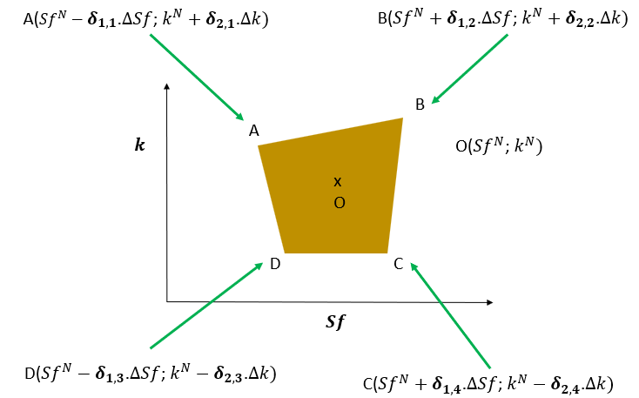
Figure 1. General representation of the optimal Design Space.

)$\min_{X} F={\left[f_{1},f_{2},-f_{3}\right]}^{T}$
$$f_{1}=-T_{s}+T_{s}^{obj-}, f_{2}=T_{s}-T_{s}^{obj+}, f_{3}=-\sum_{i,j}{δ_{i,j}}$$
Subject to: (4)
$$\begin{matrix} & Sf≤\min_{i}⁡(Sf^{N}+δ_{1,i}.ΔSf) \\ & Sf≥\max_{i}⁡(Sf^{N}+δ_{1,i}.ΔSf) \\ & k≤{\min_{i}(k}^{N}+δ_{2,i}.Δk) \\ & k≥{\max_{i}(k}^{N}-δ_{2,i}.Δk)\end{matrix}$$
$$X=[Sf,k, \vec{δ}]$$
In this work, the proposed multi-objective optimization problem is solved using a genetic algorithm within MATLAB which is a gradient-free global optimization solver. Here, a Pareto front of 200 solutions was identified, and the selection criterion described in the following section was considered to identify the best optimal solutions.
$\left[\begin{matrix}-1 & 0 & -ΔSf & 0 & 0 & 0 & 0 & 0 & 0 & 0 \\ 0 & -1 & 0 & -Δk & 0 & 0 & 0 & 0 & 0 & 0 \\ 1 & 0 & 0 & 0 & -ΔSf & 0 & 0 & 0 & 0 & 0 \\ 0 & 1 & 0 & 0 & 0 & -Δk & 0 & 0 & 0 & 0 \\ 1 & 0 & 0 & 0 & 0 & 0 & -ΔSf & 0 & 0 & 0 \\ 0 & 1 & 0 & 0 & 0 & 0 & 0 & -Δk & 0 & 0 \\ -1 & 0 & 0 & 0 & 0 & 0 & 0 & 0 & -ΔSf & 0 \\ 0 & -1 & 0 & 0 & 0 & 0 & 0 & 0 & 0 & -Δk\end{matrix}\right]$ $. \left[\begin{matrix}Sf \\ k \\ δ_{1,1} \\ δ_{2,1} \\ δ_{1,2} \\ δ_{2,2} \\ δ_{1,3} \\ δ_{2,3} \\ δ_{1,4} \\ δ_{2,4}\end{matrix}\right]$ $≤ \left[\begin{matrix}-Sf^{N} \\ {-k}^{N} \\ Sf^{N} \\ k^{N} \\ Sf^{N} \\ k^{N} \\ -Sf^{N} \\ -k^{N}\end{matrix}\right]$ (5)
    - Selection criterion
As the resolution of the multi-objective optimization problem results in a Pareto front with several optimal solutions, it is essential to select the best optimal solution. Several decision aiding approaches exist in the literature among which, the Multi-attribute Utility Theory (MAUT). However, as we are interested in maximizing the area of the flexibility region, the selection criterion in this work is based on comparing the resulting area values with each optimal solution, and to choose the one that provides more flexibility as the best solution. The Shoelace formula is used to find the area of the polygons given the coordinates of its vertices. For a quadrilateral with coordinates (x₁, y₁), (x₂, y₂), (x₃, y₃), and (x₄, y₄). The Shoelace formula is given by
(6)
$$A={\sum{.}}_{i=1}^{n} A_{i}=\frac{1}{2}{\sum{.}}_{i=1}^{n} \left(y_{i}+y_{i+1}\right)\left(x_{i}-x_{i+1}\right)$$
  - Results and discussion
Six different scenarios are simulated and discussed in this section. Indeed, The investigation into tablet formulation scenarios sheds light on the intricate relationship between the formulation parameters and tablet tensile strength. The scenarios conducted offer insights into the sensitivity and impact of variations in solid fraction $Sf^{N}$, lubrication extent $k^{N}$, uncertainties in these parameters ($ΔSf$ and $Δk$), and the objective range for tensile strength ($T_{s}^{obj-}$ and $T_{s}^{obj+}$) on the tablet's flexibility and overall quality.
The initial scenario (Scenario 1) served as a reference point for subsequent variations. Scenario 2, altering the nominal values of solid fraction and lubrication extent (from 1.2;0.8 to 1.0;1.0), showcased the system's sensitivity to these parameters. This sensitivity underscores the crucial role of solid fraction and lubrication extent in determining tablet tensile strength. Furthermore, it highlights the necessity for precise and robust control and consideration of these parameters in formulation design to achieve desired tensile strength characteristics.
Scenarios 3 and 4 introduced uncertainties $ΔSf$ and $Δk$ in solid fraction and lubrication extent, respectively. The contrast between these scenarios revealed that uncertainty in lubrication extent $Δk$ contributed more significantly to the tablet's quality than uncertainty in solid fraction $ΔSf$. This finding emphasizes the need for a more in-depth understanding and control of lubrication extent to ensure consistent tablet quality.
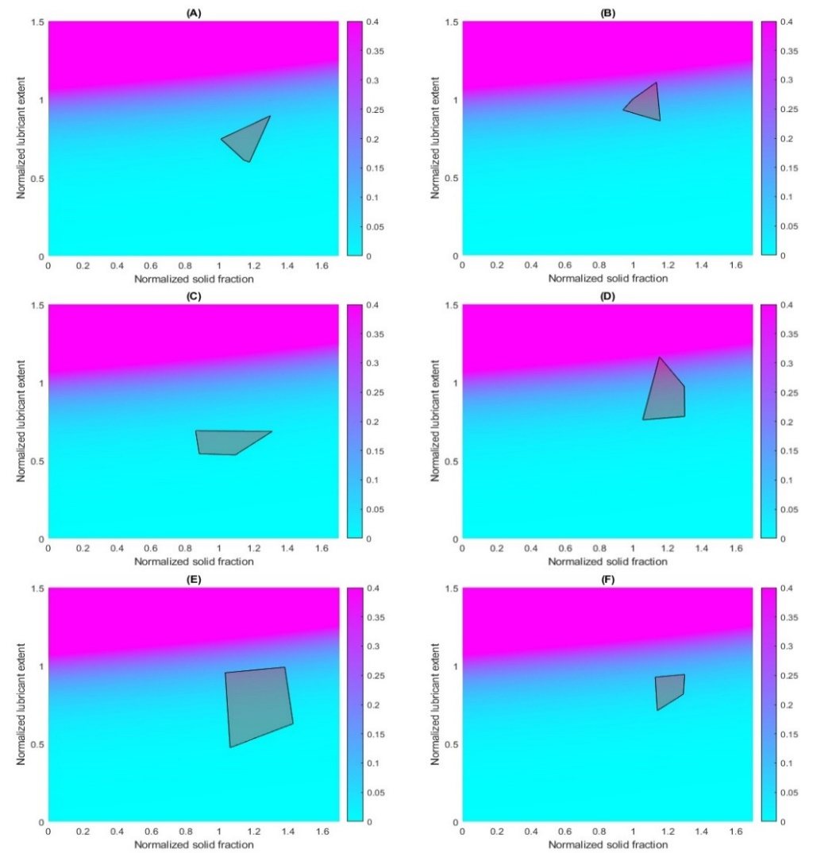
The subsequent scenarios, altering the objective range for tensile strength, provided intriguing results. Scenario 5, with a broader objective range, exhibited a higher flexibility region compared to Scenario 6. This outcome suggests that a wider range for acceptable tensile strength leads to a more flexible formulation space. A broader acceptable range enables a wider set of formulation parameters while still meeting the critical quality attributes of the tablets, offering more leeway in the design of pharmaceutical formulations.
Figure 2. Deign Space for six scenarios. (A-F) correspond to Scenarios (1-6) respectively.
Table 1: Summary of the proposed six different scenarios.
 | $$Sf^{N}$$ | $$k^{N}$$ | $$ΔSf$$ | $$Δk$$ | $$T_{s}^{obj-}$$ | $$T_{s}^{obj+}$$
Scenario 1 | 1.2 | 0.8 | 0.1 | 0.1 | 0.1 | 0.32
Scenario 2 | 1.0 | 1.0 | 0.1 | 0.1 | 0.1 | 0.32
Scenario 3 | 1.2 | 0.8 | 0.15 | 0.1 | 0.1 | 0.32
Scenario 4 | 1.2 | 0.8 | 0.1 | 0.15 | 0.1 | 0.32
Scenario 5 | 1.2 | 0.8 | 0.1 | 0.1 | 0.05 | 0.45
Scenario 6 | 1.2 | 0.8 | 0.1 | 0.1 | 0.15 | 0.2
  - Conclusion
This research advances process engineering methodologies by employing multi-objective optimization to reconcile quality and flexibility in pharmaceutical manufacturing. The study analyses six scenarios to comprehensively explores the pharmaceutical tableting process, assessing the impact of different formulation parameters on tablet tensile strength and manufacturing flexibility. Scenario 5 stands out for its superior flexibility, introducing a broader objective range ($T_{s}^{obj-}$ = 0.05, $T_{s}^{obj+}$ = 0.45) that allows for a more extensive set of formulation parameters, while achieving desired tensile strength objectives. This broader flexibility region demonstrates the importance of defining a wide acceptable range for tensile strength in manufacturing design. While the current Design Space is based on a four-vertices polygon, future works will explore extending the approach to higher orders for increased robustness and reliability.
Acknowledgements
The authors acknowledge funding from the UK Engineering and Physical Sciences Research Council (EPSRC), for Made Smarter Innovation – Digital Medicines Manufacturing Research Centre (DM2), EP/V062077/1.
References
Benyahia, B., Latifi, M.A., Fonteix, C., Pla, F. (2010). Multicriteria dynamic optimization of an emulsion copolymerization reactor. Computer Aided Chemical Engineering 28, 457-462.
Bouchkira, Ilias, and Brahim Benyahia. "Multi-Objective Model-based Design of Experiments of Pharmaceutical Tableting Process." Computer Aided Chemical Engineering. Vol. 52. Elsevier, 2023. 349-354.
Kushner IV J., and Moore, F. (2010). Scale-up model describing the impact of lubrication on tablet tensile strength. International Journal of Pharmaceutics 399(1-2), 19-30.
Cenci, F., Bano, G., Christodoulou, C., Vueva, Y., Zomer, S., Barolo, M., ... & Facco, P. (2022). Streamlining tablet lubrication design via model-based design of experiments. International Journal of Pharmaceutics, 614, 121435.
Campbell, T., Rielly, C. & Benyahia, B. (2022). Digital design and optimization of an integrated reaction-extraction-crystallization-filtration continuous pharmaceutical process. Computer Aided Chemical Engineering, 51, 775-780.
Floudas, C. A., Gümüş, Z.H., and Ierapetritou, M.G. (2001). Global optimization in design under uncertainty: feasibility test and flexibility index problems. Industrial & Engineering Chemistry Research, 40(20), 4267-4282.

