Design of carbon neutral methanol production via integration of renewable hydrogen and dry reforming process
Mahmoud Abdalla,ª Mohammed G. Mohammed,^{a,b} Umer Zahid^{a,c *}
ªDepartment of Chemical Engineering, King Fahd University of Petrolume & Monerals, Dhahran 31261, Saudi Arabia
^{b}Interdisciplinar Research Center for Hydrogen & Energy Storage, King Fahd University of Petrolume & Monerals, Dhahran 31261, Saudi Arabia
^{c}Interdisciplinar Research Center for Membranes & Water Security, King Fahd University of Petrolume & Monerals, Dhahran 31261, Saudi Arabia
uzahid@kfupm.edu.sa
Abstract
Carbon emission poses a huge threat to the environment. Despite recent advancements in carbon capture technology, the economic viability of utilizing captured CO₂ is considered a challenge to further progress. This work aims to study the technical feasibility of an environmentally friendly process for producing methanol as a liquid hydrogen carrier while utilizing captured CO₂. In this study, methane and CO₂ are used as a feedstock to produce synthesis gas (syngas), while green hydrogen produced via water electrolysis adjust the composition of the syngas to enhance the methanol synthesis reaction. The process is simulated using Aspen Plus assuming annual production capacity of 100,000 t of methanol with a purity of 99.5 mol.%. The study also includes an evaluation of energy requirements in each section of the process.
Keywords: Methanol, Green Hydrogen, Sustainable Process, Dry Methane Reforming.
  - Introduction
One of the major growing global concerns is CO₂ emissions and its impact on global warming. CO₂ emissions have increased over recent years causing a rise in global temperature leading to an unprecedented series of climatic events, underscoring the urgency and gravity of addressing this environmental challenge. Among the proposed solutions, carbon capture and utilization (CCU) hold great promise. CCU involves capturing CO₂ emissions from industrial processes and power plants and preventing them from entering the atmosphere. In addition, CCU approach includes developing methods for utilizing the captured CO₂ in various ways, such as production of fuels, chemicals, and building materials, contributing to a circular carbon economy.

Methanol is a clean fuel that is produced employing carbon dioxide as feedstock with diverse industrial applications such as the production of acetic acid, formaldehyde, and plastics. The design of a carbon-neutral methanol production process is a complex and multifaceted challenge, requiring the integration of various technologies. (Ugwu et al., 2022) proposed a gas switching dry reforming (GSDR) process, which efficiently converts CO₂ and CH₄ into syngas suitable for methanol production. This is complemented by (Roh et al., 2015), who explored sustainable CO₂ conversion processes, including combined reforming and CO₂ hydrogenation, to reduce CO₂ emissions and production costs. (Kar et al., 2018) further enhanced the sustainability of the process by developing a system for CO₂ capture and hydrogenation to methanol, with a focus on catalyst and amine reuse. Finally, (Yang et al., 2018) introduced a parallel-series system combining steam and dry methane reforming to achieve high-efficiency CO₂ utilization in methanol production. Although, some of the previous studies discussed the production of methanol by dry reforming, none of these studies proposed the integration of green hydrogen as a way of adjusting the composition of the syngas. This study investigates the feasibility of methanol production through the integration of green hydrogen with dry reforming, demonstrating a case wherein methanol serves as a carrier for hydrogen while concurrently mitigating CO₂ emissions.
  - Process Details
In this study, Aspen Plus and Aspen Custom Modeler were employed as simulation tools. The whole process simulation, excluding the electrolyzer, was conducted utilizing Aspen Plus. Peng-Robinson (PR) thermodynamic property package was selected due to its widespread applicability and reasonably high accuracy across a broad spectrum of pressures and temperatures.

    - Dry Reforming Unit
The feedstock composition, consisting of pure CO₂ and CH₄, is introduced into a Dry Reformer (DR), the simulation of which is performed using RPlug kinetic reactor model. The kinetic model of Eq.(1)&(2), with power law kinetics, developed by (Luyben, 2014) is used.

$CH_{4}+CO_{2}↔2H_{2}+2CO$  $H_{2}+CO_{2}→CO+H2O$ | (1)  (2)

The DR consists of 800 tubes, each with a diameter of 0.1 m and 4 m in length. The tubes are filled with a catalyst whose density is 2000 kg/m³ and a voidage of 0.6. To prevent coke formation, the operating temperature of the DR is 1000 ˚C. Subsequently, the effluent undergoes a heat exchange process to harness the thermal energy from the very high temperature effluent stream for elevating the temperature of the feedstock.

    - Reactor Feed Preparation and Conditioning Unit
The product of the dry reforming process, syngas, then goes through a series of compressions and cooling stages to attain the required temperature and pressure conditions (200 ˚C and 80 bar) required for the methanol synthesis reaction. The stoichiometric number which represents the ratio of hydrogen to carbon in the syngas mixture should be above 2 for an optimal methanol synthesis reactor performance Eq. (3). The syngas produced from the dry reformer is deficient in hydrogen, therefore a solar-assisted electrolyzer for green hydrogen production by a proton exchange membrane (PEM) is integrated with the dry reformer as shown in Figure 1.

$SN=\frac{y_{H2}-y_{CO_{2}}}{y_{CO}+y_{CO_{2}}}$ | (3)

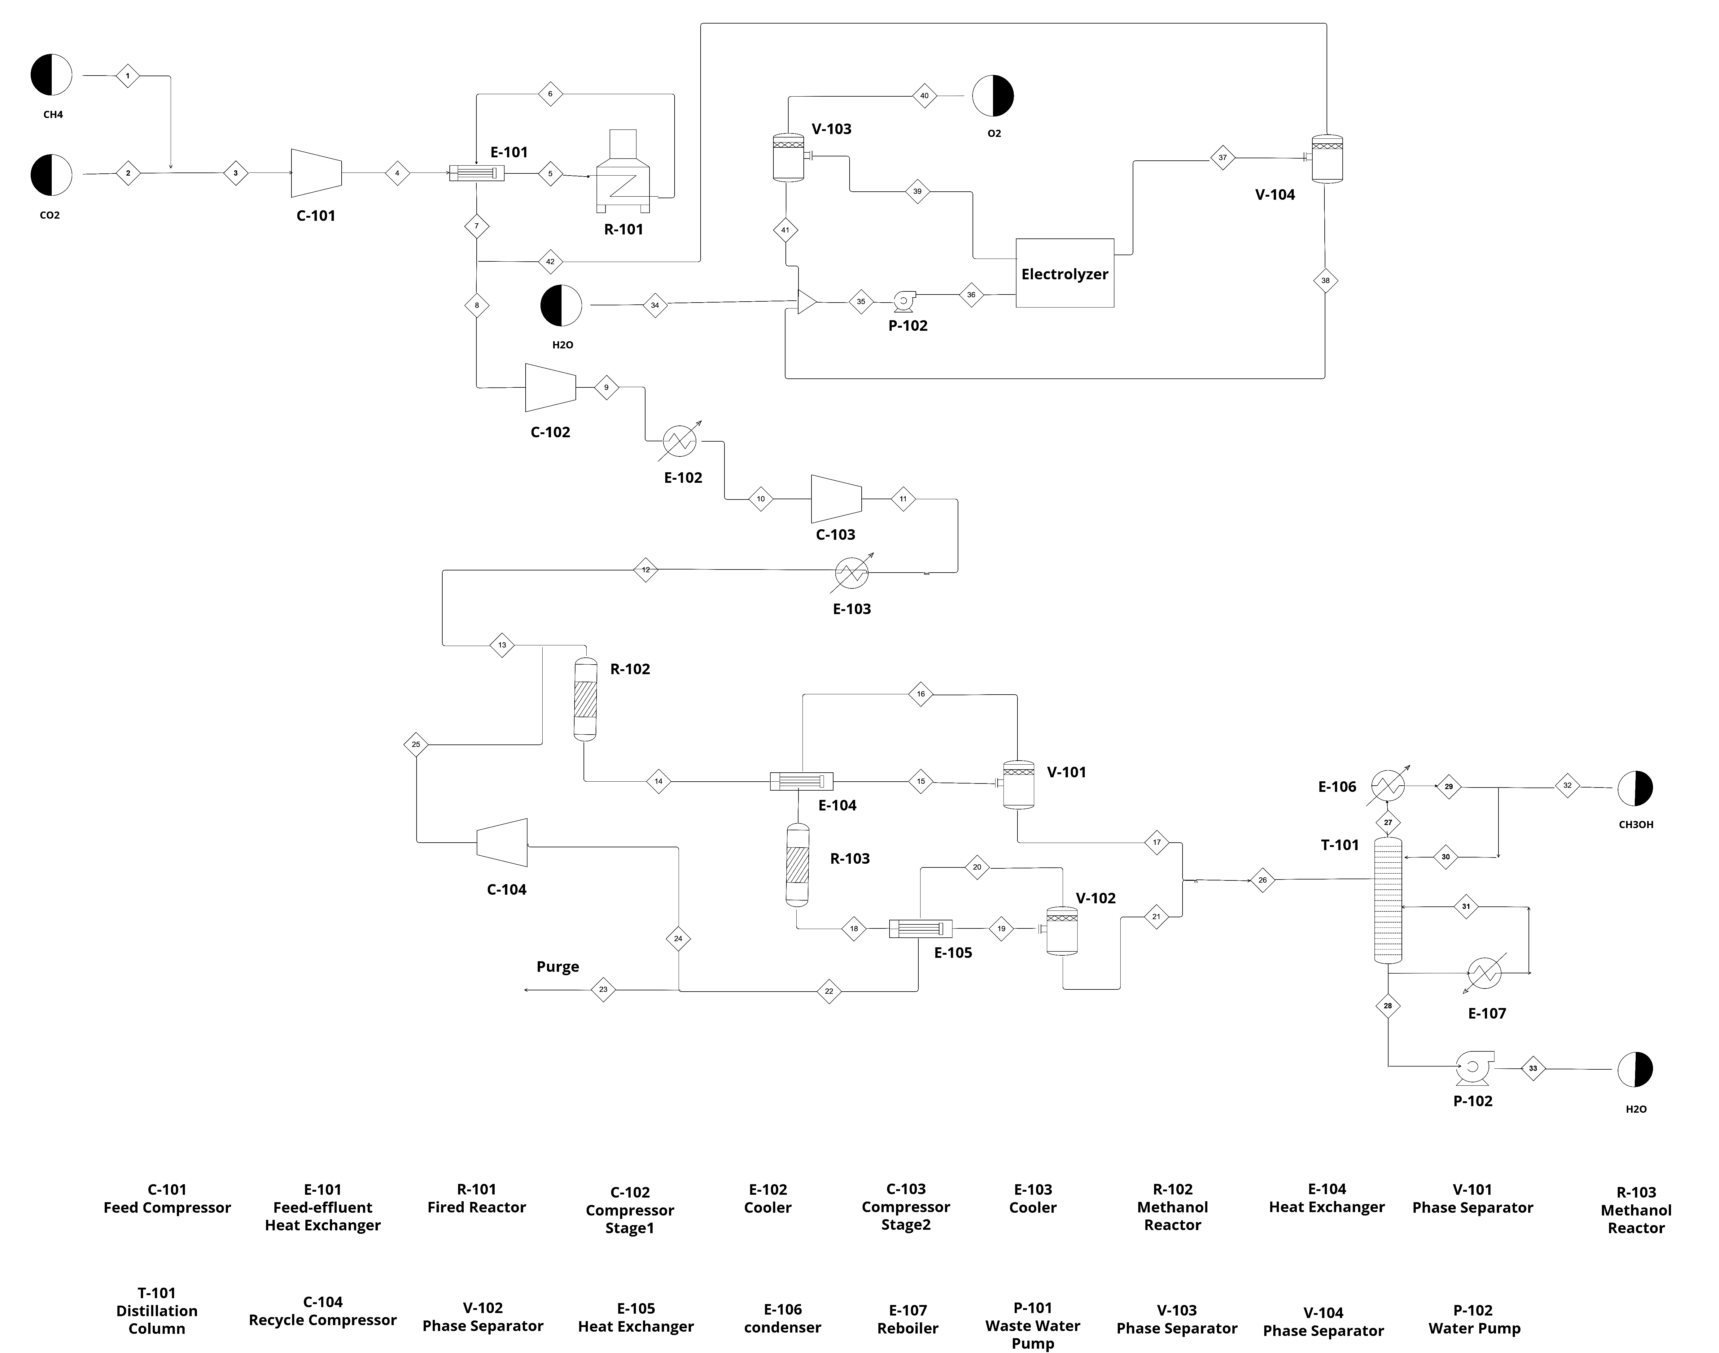

Figure 1: Process Flow Diagram of Methanol Production via Dry Reforming and Water Electrolysis as a Source of Green Hydrogen

1.1. Methanol Reactor unit
The syngas with adjusted stoichiometric number then enters the first methanol reactor modeled using an adiabatic kinetic RPlug model. The reaction kinetics used are (Langmuir-Hinshelwood -Hougen-Watson) (LHHW) with three reactions of Eq. (4) - (6) taking place simultaneously (Al-Qadri et al., 2023).

$CO+2H_{2}↔CH_{3}OH$  $CO_{2}+3H_{2}↔CH_{3}OH+H_{2}O$  $CO_{2}+H_{2}↔CO+H_{2}O$ | (4)  (5)  (6)

The methanol reactor consists of 2000 tubes with a tube diameter of 0.0375 m and length of 4 m, filled with a catalyst with a density of 2000 kg/m³ and a voidage of 0.5. According to Le Chatelier’s principle, any removal of products will shift the reaction towards the forward direction. Therefore, methanol and water are separated from the unreacted non-condensable syngas using a flash drum. The syngas is then sent to the second methanol synthesis reactor with an identical configuration to the first one. To prevent the accumulation of inert substances, 10% of the recycled stream is purged while the remaining unreacted syngas from the second reactor is recycled back to be mixed with the feed to the first reactor.

    - Electrolyzer Unit
Electrolysis is a chemical process where a chemical reaction takes places induced by an electric current. The chemical reaction in this case is considered a redox reaction where one molecule gains an electron and the other loses it. The reaction of water splitting takes place in a special electrolytic cell called “electrolyzer”. In this work, Aspen Custom Modeler is used to model a Proton Exchange Membrane electrolyzer (PEM) in order to calculate the size and electrical power required to supply enough hydrogen for methanol production.

      - Voltage
Electrolyzer is an assembly of electrochemical cells connected in series, therefore the same current passes through all the cells while the voltage depends on the number of cells. The operating voltage Eq. (7) is the sum of the ideal voltage $V_{id}$ and the losses that are commonly named “overvoltage”.

$V=V_{id}+V_{act}+V_{ohm}+V_{diff}$ | (7)

The ideal voltage $V_{id}$ is the thermodynamic energy required for the water splitting and can be calculated by Gibbs free energy. The activation overvoltage $V_{act}$ represents the energy required to initiate the chemical reaction. This voltage depends on the catalyst, current density, and the reaction. The ohmic overvoltage $V_{ohm}$, delineates the energy dissipation attributable to membrane and electrode resistivity. The diffusion overvoltage $V_{diff}$ characterizes the energy losses resulting from mass transport limitations. However, based on many experimental evidences, the diffusion overvoltage can be neglected since the contribution of this term is very small as stated in the work of (Carmo et al., 2013).

      - Mass Balance and Hydrogen Production rate
The rate of hydrogen production and water consumption inside the electrolyzer cell is directly dependent on the rate of the current flow as Eq. (8) implies.

${\dot{N}}_{H_{2}}=\frac{i A}{n F }$ | (8)

Where ${\dot{N}}_{H_{2}}$ is the mole flow rate of hydrogen, $i$ is the exchange current density, $A$ is the cross-sectional area for electrolyzer cell, $n$ is the number of electrons involved in the reaction and $F$ is the Faraday constant with a value of 96485 C/mol.
The mass balance inside a cell, mainly the flow of hydrogen proton and water due to the effect of electro-osmotic drag, diffusivity and pressure difference are calculated as shown in a study conducted by (Colbertaldo et al., 2017).
Table 1 summarizes the input specifications for the major units of the process, the reactors and electrolyzer.

Table 1: Input specifications for simulation models
Unit/ system | Aspen Model | Parameters
Dry Reformer | Reactor model: RPlug | Temperature = 1000 °C  Pressure = 4 bar  CO₂/ CH₄ (mol./mol.) = 1
Methanol Synthesis | Reactor model: RPlug | Temperature = 200 ˚C  Pressure = 80 bar  Syngas SN = 2  Cu-based catalyst
Electolyzer | Custom Modeler | Temperature = 55 ˚C  Pressure:  Anode = 2.5 bar  Cathode = 30 bar  Cell Area = 1 m²  Current density = 0.6 A/cm²  Number of Cells = 4362
  - Result and Discussion
    - Electrolyzer performance
The polarization curve as shown in Figure 2(a) intercepts with the y-axis at the ideal voltage, which is about 1.23 V. The curve then steadily increases until it reaches a plateau where the voltage remains relatively constant. This plateau represents a required voltage to overcome all the three overpotentials activation, diffusion, and ohmic. Also, it corresponds to the region where the electrolysis reaction is efficiently taking place.

    - Energy consumption
The energy consumption analysis for the process is shown in Figure 2(b) illustrates the energy consumption in different process sections. Electricity usage dominates energy consumption with ~ 50 % of the total required energy. The largest portion of energy is consumed by the electrolyzer in comparison with other process sections. The required electricity for green hydrogen production will be supplied from renewable sources such as solar, wind, or hydropower which is out of focus in this study and would be worthy of investigation in a future study.

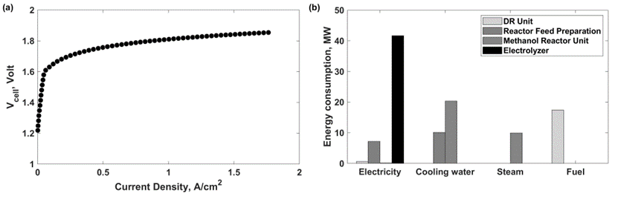
Figure 2 (a): Electorlyzer polarization curve, (b): Energy consumption of each process unit
Cooling water represents the only cooling utility for this process since the lowest temperature in this process is ~ 20 ˚C. DR required heating utility out of usual hot steam in form of a fuel, in this case natural gas to be able to reach the operating temperature of 1000 ˚C.

  - Conclusions
A complete simulation of a methanol production process via green hydrogen and dry methane reforming has been developed. A PEM electrolyzer is utilized to provide pure hydrogen in order to raise the stoichiometric number of syngas to meet the required composition for methanol synthesis. The results show a significant consumption of electricity, mainly in electrolyzer to drive the water splitting reaction. They also show that approximately 90,000 t/y of CO₂ is utilized to produce 100,000 t/y of methanol, which demonstrates a significant positive environmental impact. Further work is needed to address the economic viability of the process, highlighting the CO₂ subsidy amount or renewable electricity price required to reach a breakeven point.

Acknowledgement
The author(s) would like to acknowledge the support provided by the Deanship of
Scientific Research at King Fahd University of Petroleum & Minerals (KFUPM).
References
Abdin, Z., Webb, C.J., Gray, E.MacA., 2015. Modelling and simulation of a proton exchange membrane (PEM) electrolyser cell. Int. J. Hydrog. Energy 40, 13243–13257.
Al-Qadri, A.A., Ahmed, U., Jameel, A.G.A., Ahmad, N., Zahid, U., Zein, S.H., Naqvi, S.R., 2023. Process design and techno-economic analysis of dual hydrogen and methanol production from plastics using energy integrated system. Int. J. Hydrog. Energy 48, 10797–10811.
Carmo, M., Fritz, D.L., Mergel, J., Stolten, D., 2013. A comprehensive review on PEM water electrolysis. Int. J. Hydrog. Energy 38, 4901–4934.
Colbertaldo, P., Gómez Aláez, S.L., Campanari, S., 2017. Zero-dimensional dynamic modeling of PEM electrolyzers. Energy Procedia, Proceedings of the 9th International Conference on Applied Energy 142, 1468–1473.
Kar, S., Sen, R., Goeppert, A., Prakash, G.K.S., 2018. Integrative CO2 Capture and Hydrogenation to Methanol with Reusable Catalyst and Amine: Toward a Carbon Neutral Methanol Economy. J. Am. Chem. Soc. 140, 1580–1583.
Luyben, W.L., 2014. Design and Control of the Dry Methane Reforming Process. Ind. Eng. Chem. Res. 53, 14423–14439.
Roh, K., Nguyen, T.B.H., Suriyapraphadilok, U., Lee, J.H., Gani, R., 2015. Development of sustainable CO2 conversion processes for the methanol production 37, 1145–1150.
Ugwu, A., Osman, M., Zaabout, A., Amini, S., 2022. Carbon Capture Utilization and Storage in Methanol Production Using a Dry Reforming-Based Chemical Looping Technology. Energy Fuels 36, 9719–9735.
Yang, Y., Liu, J., Shen, W., Li, J., Chien, I.-L., 2018. High-efficiency utilization of CO2 in the methanol production by a novel parallel-series system combining steam and dry methane reforming. Energy 158, 820–829.

