Conceptual Design of a Large Ship Propulsion System Fueled by an Ammonia-Hydrogen Blend: Toward a Decarbonized Shipping Transport
Antonio Sánchez^{a*}, M.A. Martín Rengel^{b}, Mariano Martínª
ªDepartment of Chemical Engineering. University of Salamanca. Plz. Caídos 1-5, Salamanca, 37008, Spain
^{b}Departament of Materials Science, Universidad Politecnica de Madrid. Avd. de la Memoria 4, Madrid, 28040, Spain
antoniosg@usal.es
Abstract
In the pursuit of decarbonizing maritime transport and achieving net-zero greenhouse gas emissions, ammonia is gaining prominence as a green fuel. In this work, an integrated ship propulsion system based on ammonia is proposed consisting of ammonia decomposition, internal combustion engine, and NO_{x} removal which collectively address the inherent challenges associated with ammonia combustion. The optimal system configuration demonstrates an energy and exergy efficiency of 42.4% and 48.1% respectively, with NO_{x} emissions (one of the critical issues in ammonia combustion) below 0.5 g/kWh. The economic evaluation shows that the initial investment is reasonable at 784 €/kW, but operating costs are high at 210 €/MWh. The success of green ammonia as a marine fuel relies on achieving competitive production costs, namely below 0.4 €/kg.
Keywords: Ammonia, Decarbonization, Hydrogen, Maritime transport, Ship.
  - Introduction
A considerable portion of current greenhouse gas emissions is attributed to passenger and cargo transportation, primarily through shipping, which plays a pivotal role in global trade. Maritime transport accounts for approximately 3% of global greenhouse gas emissions. To address this issue, the International Maritime Organization (IMO) has set ambitious targets to achieve net-zero greenhouse gas emissions from international shipping by 2050. This is a great challenge, considering that over 95% of existing ships rely on internal combustion engines powered by fossil fuels. To decarbonize the shipping sector, various alternatives have been proposed. Direct electrification is an efficient method to introduce renewables into ships. However, it may be limited to shorter distances due to the challenges associated with the size of the batteries.
Hydrogen and its derivatives, such as methanol and ammonia, are also promising energy vectors for maritime transport (Korberg et al., 2021). The main limitation in the use of hydrogen onboard is related to its storage. Hydrogen is a gas at ambient conditions with a low volumetric energy density. In addition, due to its small molecular size, hydrogen is prompt to leak. Compressed or liquefied hydrogen can enhance energy density but at a remarkable cost, making it suitable for specific applications with limited operating hours.
To face these challenges, there is a growing focus on producing green fuels from renewable hydrogen (McKinlay et al., 2021). These options offer substantial improvements in energy density, thereby enhancing storage conditions and reducing associated costs. Notably, two green fuels have emerged as particularly promising alternatives: methanol and ammonia. Methanol is liquid at ambient conditions, resulting in a reduced storage cost of approximately 0.13 €/kWh. However, a significant concern is addressing the entire CO₂ cycle. When methanol is burned, it releases CO₂ and water. While the idea of reusing this CO₂ to synthesize more methanol for maritime purposes is promising, implementing an onboard capture system is fraught with technical and economic limitations. An alternative involves direct air capture onshore, but with substantially higher removal costs. In contrast, ammonia presents a more straightforward solution, as it is a carbon-free fuel synthetized through the combination of hydrogen and nitrogen. The maritime industry is increasingly drawn to ammonia as a sustainable option (Wang et al., 2023). Ammonia can be stored as a liquid at 240 K and atmospheric pressure or at 10 bar and ambient temperature, with a storage cost of approximately 0.25 €/kWh. Due to its carbon-free nature and the extensive experience in ammonia production and storage, this alternative is the selected choice in this study.
Nonetheless, there are two primary challenges that must be addressed when using ammonia as a fuel in maritime internal combustion engines. Firstly, ammonia is considered a relatively unreactive fuel due to its low flame speed and high autoignition temperature. To overcome this limitation, a common approach is to use a co-fuel in conjunction with ammonia. Hydrogen is the alternative of choice, primarily because it is a carbon-free chemical, ensuring that the blend has no associated CO₂ emissions. Moreover, hydrogen can be produced from ammonia through its decomposition. Secondly, during the combustion of ammonia, a non-negligible amount of nitrogen oxides can be produced, which is a significant pollutant. As a result, it becomes imperative to implement emission control measures when using ammonia in combustion engines to mitigate the environmental impact and ensure compliance with emission standards.
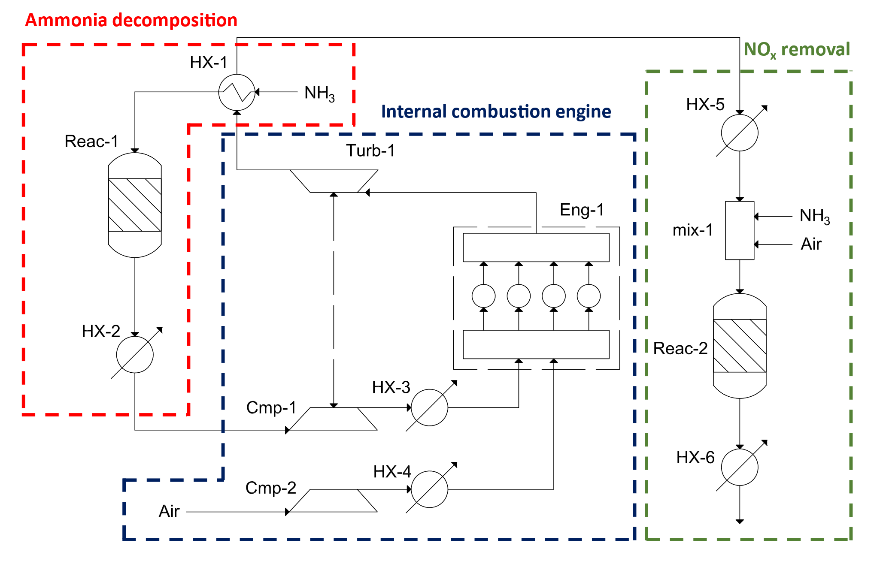
Figure 1: Process diagram of the proposed propulsion system

Currently, most research efforts are primarily concentrated on the isolated analysis of ammonia engines, analyzing them from both experimental and theoretical perspectives. However, achieving a comprehensive understanding of the entire propulsion system is essential. This necessitates considering not just the engine but also the processes associated with raw material preparation and exhaust gas cleanup. In this study, a more holistic approach is taken by conducting an integrated analysis of an ammonia-based propulsion system using a process perspective. This assessment includes all the stages required to convert ammonia into usable energy, including the production of hydrogen as a co-fuel and the treatment of exhaust gases from the engine. This comprehensive analysis represents a significant step to introduce ammonia as a viable and environmentally friendly fuel in the maritime transport sector, allowing for the decarbonization of this critical activity.
  - Propulsion system description and modelling
The proposed propulsion system is based on three main sections: ammonia decomposition, internal combustion engine (ICE), and NO_{x} removal. The complete design of this propulsion system is illustrated in Figure 1. In the initial stage of the proposed system, ammonia decomposition takes place. The objective of this step is to generate a blend of ammonia/hydrogen for utilization as fuel in the internal combustion engine. Specifically, a mixture comprising 70% ammonia and 30% hydrogen is chosen, as this ratio is commonly recommended in the literature to enhance the flammability properties of ammonia. The reaction carried out in this reactor is as follows:
$2NH_{3}⇋N_{2}+3H_{2}$ (1)
The ammonia decomposition reaction occurs within an adiabatic fixed-bed reactor and is highly endothermic. To address the energy requirements of this process, a heat exchanger is introduced prior to the reactor unit. For heat integration within the system, the exhaust gases from the internal combustion engine serve as the heating agent in this unit. The design of this reactor involves the formulation of a set of differential equations that combine mass, heat, and momentum transfer. In this configuration, Ni/Al₂O₃ catalyst is selected with the following kinetic expression for the ammonia decomposition:
$r=3k_{reac}\left[K_{p}^{2}a_{N_{2}}{\left(\frac{a_{H_{2}}^{3}}{a_{NH_{3}}^{2}}\right)}^{α}-{\left(\frac{a_{NH_{3}}^{2}}{a_{H_{2}}^{3}}\right)}^{1-α}\right]ΦΩ$ (2)
The second stage of the proposed propulsion system is the internal combustion engine (ICE). Specifically, a two-stroke compression ignition (CI) internal combustion engine equipped with a turbocharger is selected for this study. The selection of the CI alternative is motivated by the considerable ignition energy required for marine systems. A thermodynamic modeling technique is used that employs an ideal Miller-Sabathe cycle, comprising the following steps: adiabatic compression, constant volume heat addition, constant pressure heat addition, adiabatic expansion, and heat removal. Several parameters are required to model this unit collected from real maritime ICEs and for experimental ammonia-based engines. These are presented for the four different engine loads analyzed in this work in Table 1.
Table 1: Parameters fixed in the modeling of the engine performance
 | 100% | 75% | 50% | 25%
Inlet pressure into the cylinder (bar) | 4.0 | 3.2 | 2.2 | 1.3
Maximum pressure (bar) | 180 | 165 | 145 | 110
Compression ratio (CR) | 14 | 14 | 14 | 14

Moreover, to control the maximum temperature within the engine, an equivalence ratio (ER) of 0.85 has been established. The combustion of the ammonia/hydrogen blend primarily results in the generation of nitrogen and water. However, it is essential to note that a non-negligible quantity of nitrogen oxides (NO_{x}) is produced within the combustion chamber. Determining the exact concentration of NO_{x} is challenging due to limited research in real maritime engine conditions. In this study, the NO_{x} concentration in the exhaust gases is set at 2000 ppm based on the findings presented by Liu et al. (2022). These results are derived from a combustion engine utilizing a mixture of ammonia and hydrogen with the 70/30 ratio.
The final stage in the propulsion system involves the selected catalytic reduction (SCR). Its primary purpose is to reduce the concentrations of NO_{x} to levels below the stringent limits set forth by the International Maritime Organization (IMO). This reduction process is based on the following chemical reaction:
$4NO+4{NH}_{3}+O_{2}→4N_{2}+6H_{2}O$ (3)
For this reduction reaction, a fixed-bed monolithic reactor is employed, featuring a commercial Cu-zeolite catalyst. The operational temperature range of this unit falls between 550 K and 750 K. In this setup, both ammonia (the fuel of the proposed system) and oxygen (from the air) are introduced as reagents. The entire system is subject to optimization to determine the most favorable operating conditions, assess the energy performance, and evaluate the economic aspects associated with this novel propulsion system centered around ammonia.
  - Results and discussion
The baseline of the propulsion system proposed corresponds to a production capacity of 11MW. Furthermore, it has undergone an assessment under four engine load conditions: 100%, 75%, 50%, and 25%. These changes in engine load have a significant impact on the operating conditions of the decomposition reactor. To address the most challenging scenario, which is the maximum load, the decomposition reactor has been designed with a maximum inlet temperature set at 750K. This limitation is imposed due to the limited temperature gradient between the incoming ammonia and the exhaust gases from the engine. This aspect is crucial, primarily because of the substantial endothermicy of the decomposition reaction. As the engine load decreases, it becomes necessary to reduce the inlet temperature of the decomposition reactor to maintain the same ammonia/hydrogen ratio while processing a smaller ammonia flow rate. For instance, at a 25% load, the inlet temperature of the decomposition reactor is reduced to approximately 730 K. There exists a close relationship between the operation of the decomposition reactor and the SCR unit. Both units are arranged in series, and the exhaust gases came from the ammonia decomposition (as heating agent) to the SCR section. Consequently, if the conditions in the decomposition are more restrictive in terms of temperature, the inlet temperature of the SCR reactor is reduced because a higher fraction of the energy of the gases is released in the decomposition section. As a result, at 100% engine load, the inlet temperature in the SCR reactor is around 670 K. This value can be increased to 750 K when the engine load is decreased. These differences in inlet temperature have a direct impact on the NO_{x} removal yield. Specifically, higher operating temperatures and lower loads result in higher removal efficiency, with the removal rate ranging from approximately 90% at full load to nearly 100% for an engine load of 25%.
The performance of the internal combustion engine is predominantly regulated by the combustion temperature, which is controlled by varying the excess of air (equivalence ratio). This temperature is usually around 2500 K. Thermodynamic calculations indicate that the thermal efficiency of the proposed cycle falls within the range of 60-70%. However, taking a conservative approach and accounting for irreversibilities and energy losses, this value is reduced up to 50%. In the combustion chamber, the concentration of nitrogen oxides in the exhaust gases measures around 3.5-4 g/kWh. This exceeds the current target set by the International Maritime Organization (IMO) in TIER III, 2 g/kWh. Consequently, the introduction of the SCR section is required to meet the strictest emissions legislation. Following the SCR treatment, which reported removal efficiencies ranging from 90-100%, the NO_{x} concentration is effectively reduced to below 0.5 g/kWh. As a result, the proposed ammonia-based propulsion system enables maritime transportation with zero direct CO₂ emissions and significantly reduced NO_{x} emissions, aligning with stringent environmental standards.
To analyze the energy performance, Figure 2 shows the main energy flows of the entire propulsion system (for the 100% of the engine load).
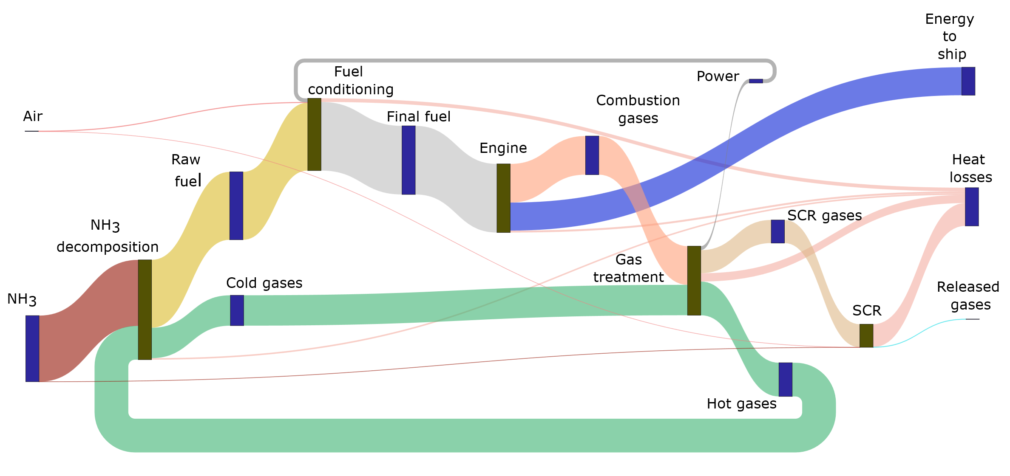
Figure 2: Sankey diagram with the main energy flows of the propulsion system

In the system proposed, ammonia serves as the primary energy input, introduced into the decomposition section. While exhaust gases from the engine are recycled, only approximately 10% of the energy can be transferred to the inlet ammonia due to limitations imposed by temperature gradients. The resulting blend of ammonia/hydrogen is then sent to the engine. Notably, the power generated by the combustion gases is looped back to the fuel conditioning section as part of the turbocharger scheme. The engine's thermal efficiency stands at 50%, as previously mentioned. A considerable amount of energy from the combustion gases is dissipated as heat in various sections of the system. Further integration, for instance, with some of the ship's utilities, has the potential to enhance the overall system's energy efficiency. In its current configuration, the global energy efficiency is 42.4%. Additionally, an exergy analysis is conducted for this configuration. The global exergy efficiency is determined to be 48.1% with the internal combustion engine (35.5%) and the SCR unit (53.2%) as the stages with lowest exergy performance This is primarily attributed to the chemical reactions involved.
An economic analysis of the system is also performed. For the baseline capacity of 11MW, the capital cost (CAPEX) of the system adds up to 8.7 M€ (784 €/kW). The internal combustion engine based on ammonia accounts for the largest share of this investment, representing around 65% of the total CAPEX. This investment cost is slightly higher than current alternatives based on fossil fuels. For instance, marine gas oil is reported to have a capital cost of 530 €/kW. However, it is comparable to other alternative fuels like hydrogen (700-800 €/kW) or methanol (550-600 €/kW). When analyzing the operating cost (OPEX) of the propulsion system, three primary components should be considered: the cost of the fuel (NH₃), the amortization cost, and the maintenance cost. The results for different engine loads assessed in this study are presented in Figure 3.
The current operating cost varies from 210 €/MWh for full load to 243 €/MWh for 25% of the engine load. This propulsion cost is notably higher compared to existing technologies, which typically range from 120 to 160 €/MWh, similar to other alternative green fuels, falling within the 200-300 €/MWh range. As depicted in the figure, the primary contributor to these costs is the fuel cost, accounting for over 90% of the total when operating at full capacity. Therefore, a critical factor for the adoption of ammonia as a fuel in shipping transport is the reduction of the cost of green ammonia.
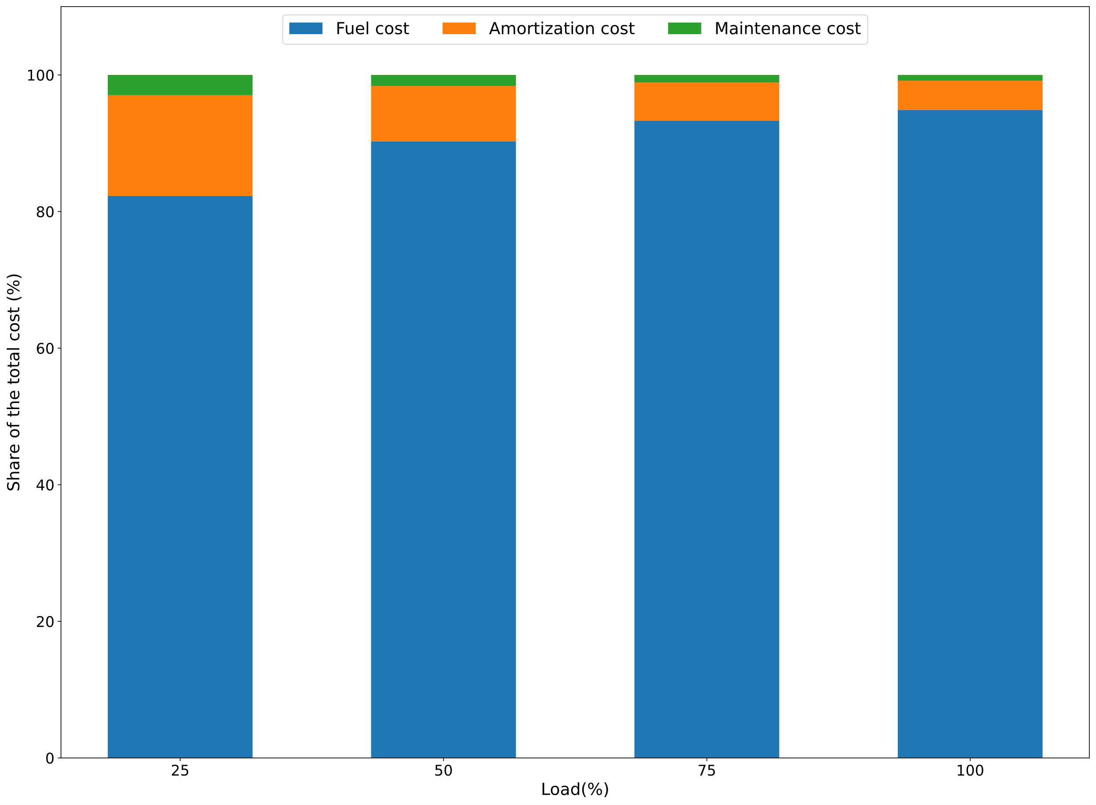
Figure 3: Breakdown of the operating cost for the different engine loads
  - Conclusions
A conceptual design for a ship propulsion system using ammonia is presented, aiming the full decarbonization of the shipping sector. The system proposed involves three core sections (ammonia decomposition, engine, and NO_{x} removal) to tackle the challenges associated with ammonia combustion. The integrated system shows an energy efficiency of 42.4% and maintains NO_{x} emissions below 5 g/kWh, aligning with the IMO targets. From an economic standpoint, the capital and operating costs remain relatively high, standing at 784 €/kW and 210 €/MWh, respectively. However, there is potential for cost reduction, mainly if green ammonia can be priced more competitively in the market.
Acknowledgments
The authors acknowledge H2MetAmo project by the financial support.
References
A.D. Korberg, S. Brynolf, M. Grahn, I.R. Skov, 2021, Techno-economic assessment of advanced fuels and propulsion systems in future fossil-free ships. Renew. Sust. Energ. Rev., 142, 110861.
H.Wang, P. Daoutidis, Q. Zhang, 2023, Ammonia-based green corridors for sustainable maritime transportation. Digital Chemical Engineering, 6, 100082.
L. Liu, F. Tan, Z. Wu, Y. Wang, H. Liu, 2022, Comparison of the combustion and emission characteristics of NH₃/NH₄NO₂ and NH₃/H₂ in a two-stroke low speed marine engine, Int. J. Hydrog. Energy, 47, 40, 17778-17787.
C.J. McKinlay, S.R. Turnock, D.A. Hudson, 2021, Route to zero emission shipping: Hydrogen, ammonia or methanol? Int. J. Hydrog. Energy, 46, 55, 28282-28297.

