Computer-Aided Assessment of a Droplet Absorber for CO₂ Direct Air Capture
Maria F. Gutierrez^{a*}, Kasimhussen Vhora^{a,b}, Andreas Seidel-Morgensternª , Gábor Janiga^{b}, Peter Schulzeª
ªMax Planck Institute for Dynamics of Complex Technical Systems Magdeburg, Sandtorstr. 1, 39106 Magdeburg, Germany
^{b}Otto von Guericke University Magdeburg, Universitätsplatz 2, 39106 Magdeburg, Germany
*gutirrezsnchez@mpi-magdeburg.mpg.de
Abstract
In this study, a droplet absorber capable of capturing CO₂ from air was assessed by means of CFD simulations and differential mass balances. The absorber uses a NaOH solution dispersed in micro droplets that drives the flow of air in a co-current arrangement. Three different absorber geometries were evaluated to study the influence of the height and the absorber diameter on the absorption performance. According to the results, the specific surface area is reduced along the absorber due to droplet collision and coalescence; however, after two meters the specific surface area is increased again. Analysis of simulation results showed that changes in the rate of collision, coalescence and droplet breakup generate this behaviour. The longest absorber showed the best performance in terms of capture rate (1.1 kg CO²/(h-m³ abs)) and energy consumption (1 kWh/kg CO₂), while changes in absorber diameter did not influence the absorber performance.
Keywords: CO₂ absorption, CFD simulation, capture rate, energy consumption.
  - Introduction
Carbon Dioxide Removal (CDR) technologies are crucial to achieve net negative CO₂ emissions to the atmosphere and climate neutrality (IPCC, 2023). The CODA (Carbon-negative sODA ash) project has been studying a CDR technology for the absorption of CO₂ from air using a sodium hydroxide (NaOH) aqueous solution to produce sodium carbonate (Na₂CO₃) in a more sustainable way (BMBF & FONA, 2023). While in the traditional Solvay process nearly 0.5 kg CO₂/kg soda are emitted, in the CODA process around 0.4 kg CO₂/ton soda are removed from the air (besides the emission avoidance).
When CO₂ is captured directly from the atmosphere (Direct Air Capture, DAC), large amounts of air should be processed due to its low concentration (currently ~417 ppm). The economic feasibility of DAC systems relies on the design of suitable equipment able to provide a high volumetric capture rate (smaller capital cost) with the lowest energy demand (less operational costs), minimizing total costs for CO₂ DAC. Previous efforts to achieve this resulted in investigation of spray absorbers (Stolaroff et al., 2008), counter-current packed absorbers (Mazzotti et al., 2013) and cross flow packed absorbers (Holmes & Keith, 2012). With the aim to reduce the air pressure drop (energy demand) and to avoid the use of packing and fans (capital cost), a droplet absorber in which the liquid flow drives the gas flow in a co-current mode and could tolerate crystal formation has been studied in the CODA project. The performance of such an absorber was previously evaluated using a simple model that neglected the droplet coalescence (Gutierrez et al., 2023). However, evaluation of the technology under more realistic conditions is still required.
In the present study, the CO₂ capture rate of the droplet absorber is predicted through a combination of differential mass balances and Computational Fluid Dynamics (CFD) simulations. Three different absorber geometries were evaluated to observe the influence of the absorber diameter and length on the surface area, the capture rate and the energy consumption due to pumping. The use of CFD for the design of a droplet absorber for DAC applications is the novelty of this study.
  - Droplet absorber
Table 1. Absorber geometry and liquid flow rate
Absorber variable | Units | Base case | Dx2 | Hx3
Absorber diameter | mm | 28.4 | 56.8 | 28.4
Absorber height | m | 1.54 | 1.54 | 5
Number of nozzles | - | 841 | 3341 | 841
Liquid flow | L/h | 157.72 | 626.56 | 157.72
A nozzle plate with holes of 180 µm diameter arranged in a triangular pattern and 0.9 mm distance (middle-middle) produced the droplets in the studied absorber. In all geometries studied the holes in the nozzle represented 3.3% of the total nozzle plate area. The liquid volumetric flow rate was set to ensure the operation in the Rayleigh breakup regime of round liquid jets in quiescent air, where the surface tension force is the predominant breakup mechanism (Huimin Liu, 1999). This ensured the vertical fall of the droplets and avoiding the loss of surface area due to collision with the absorber wall. The fall of the droplets drives the movement of the air inside the absorber by friction so that the liquid and the gas flow are arranged in a co-current mode. Three different geometries were studied: a base case, an absorber with the same diameter but with a longer height (Hx3) and an absorber with the same length but with a wider diameter (Dx2). Details on the base case was provided in a previous publication (Gutierrez et al., 2023) and specific details on the geometries used and liquid flow rate is provided in Table 1.
    - Material balance
The absorption of CO₂ from the air by droplets of a NaOH solution was described using the differential mass balance shown in Eq. (1). In this equation $y_{CO_{2}}$represents the mole fraction of CO₂ in the gas phase, $z$ is the absorber height, $K_{G,CO_{2}}^{c}$ is the overall mass transfer coefficient of CO₂ in the gas phase, $a$ is the specific surface area, ${\dot{G}}^{'}$ is the molar flow per cross sectional area, $y_{co_{2}}^{*}$ is the CO₂ gas mole fraction in equilibrium with the CO₂ liquid bulk concentration, $P$ is the pressure of the system, $R$ is the universal gas constant and $T$ is the temperature of the system.
$$\frac{dy_{CO_{2}}}{dz}=-\frac{K_{G,CO_{2}}^{c}a}{{\dot{G}}^{'}}\left(y_{co_{2}}-y_{co_{2}}^{*}\right)\frac{P}{RT}$$ | (1)
The overall mass transfer coefficient was calculated using the two-resistance theory as described in a previous publication (Gutierrez et al., 2023). This coefficient is a function of kinetic and solubility parameters as well as hydrodynamic variables, namely the droplet diameter, the gas and the liquid velocities. In contrast with our previous publication, the hydrodynamic variables here were not kept constant along the absorber. In addition, in this case, the water loss by evaporation was neglected, the temperature was considered constant along the absorber (10°C) and the liquid entering the absorber was saturated in sodium carbonate. Other assumptions and considerations that remain the same are here shortly summarized and reported in detail in our previous publication:
- The change of ${\dot{G}}^{'}$ was neglected because CO₂ concentrations are very small and water evaporation is not considered.
- Phase equilibrium concentration ($y_{co_{2}}^{*}$) was calculated by using Henry’s law and assuming ideal gas. The required CO₂ concentration in the liquid phase was calculated with differential mass balances in the liquid phase.
- The reaction is irreversible due to the high concentration of hydroxide ions ($OH^{-}$) in comparison with that of CO₂ in the liquid phase.
- The effect of the reaction in the mass transfer was considered by using the Enhancement factor ($E$), which is a function of the Hatta number ($Ha$). Due to the considered operational conditions, the droplet absorber remains in the “very fast” reaction regime, where $Ha>3$ and $E=Ha$ (Danckwerts, 1970). Consequently, the liquid mass transfer coefficient depends on the kinetic rate constant, the concentration of CO₂ and $OH^{-}$ in the liquid phase and the liquid diffusivity of CO₂.
    - CFD Simulation
The hydrodynamic variables, the pressure of the system and specific surface area were calculated by means of a detailed CFD simulation performed in the Simcenter STAR CCM+ software (version 2020.1, Siemens Product Lifecycle Management Software Inc., Plano, TX, USA). For that, a digital twin of the absorber was built and used as base to construct a volumetric domain, which was partitioned into discrete cells to generate a polyhedral mesh. The Reynolds Averaged Navier-Stokes (RANS) equations were discretized using the finite volume method. The turbulence model k-ω Menter SST two-layer was used for the closure of the RANS equations. The Eulerian-Lagrangian framework was used to model the flow of liquid water droplets and air inside the cylindrical absorber (the Lagrangian model for tracking droplets and the Eulerian model for the air). In the CFD simulation, the liquid droplets were represented by a reduced number of parcels. Each parcel consisted of particles assumed to be spherical, sharing identical properties such as diameter, velocity and density. Each parcel was treated as a source term integrated into the governing equations of mass and momentum at its specific location. The no-time counter (NTC) collision model was used to simulate the interaction between droplets that occurs during collisions and coalescence. For the Hx3 geometry, the KHRT droplet breakup model (based on the Kelvin-Helmholtz and the Rayleigh-Taylor theories) was also used. Two boundary conditions were set: the wall boundary condition and the bottom pressure outlet.
The results of droplet velocity and gas velocity from the CFD simulations were used to calculate mean values in segments of 10 mm height, so that their radial variation was neglected. In each segment, the total surface area was calculated and divided into the segment volume to obtain the specific surface area along the absorber. The total model (CFD simulation + differential balances) was validated with experimental data on the base case geometry. Both the induced gas velocity and the CO₂ concentration in the outlet of the absorber could be well described by the model within a 2.2% of relative error. Mesh validation and evaluation of the parcel size was done for the base case. Details on such validations will be provided in a future publication.
    - Capture rate and energy consumption
The droplet absorber was evaluated in terms of the capture rate ($r$, directly related with the capital costs) and the energy consumption ($E$, directly related with the operational costs). The performance variables were evaluated according with Eq. (2) and Eq. (3). In the last equation, $ρ_{L}$ is the liquid density, $g$ is the gravity, $∆P_{nozz}$ is the nozzle plate pressure drop, ${\dot{F}}_{L}$ is the volumetric flow rate, $η_{p}$ is the pump efficiency (85%) and $A$ is the cross sectional area. The nozzle plate pressure drop was calculated with a correlation proposed in the literature for pressure drop across micro-orifices (Ushida et al., 2014).
$$r(z)=K_{G,CO_{2}}^{c}a\left(y_{co_{2}}-y_{co_{2}}^{*}\right)\frac{P}{RT}$$ | (2)
$$E=\frac{\left(ρ_{L}gH+∆P_{nozz}\right){\dot{F}}_{L}/η_{p}}{\int_{0}^{H}{\left[K_{G,CO_{2}}^{c}a\left(y_{co_{2}}-y_{co_{2}}^{*}\right)\frac{P}{RT}\right]Adz}}$$ | (3)
  - Results and Discussion
The specific surface area along the absorber for the studied geometries is presented in Figure 1 (a) to (c). Due to droplet coalescence, the specific surface area is reduced within the first two meters of absorber. As presented in Figure 1 (d), 76% of the reduction of the number of droplets occurs in the same region. Despite the loss in surface area, the specific surface area is in the range of other type of absorbers (random and structured packing).
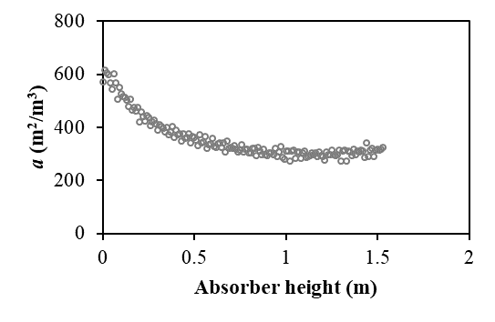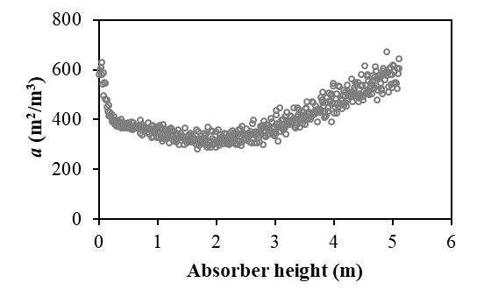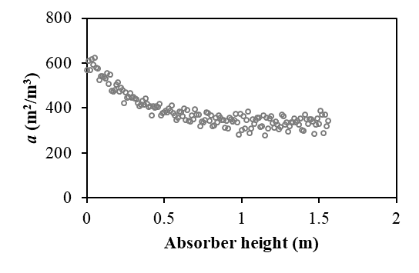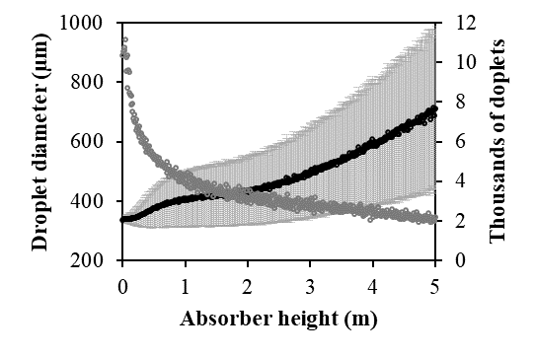
(a)
(b)
(c)
(d)<<<<<<<<<<<<<<<<<<<<<<<<<
Figure 1: Specific surface area for the (a) Base case, (b) Hx3 and (c) Dx2 geometries and (d) mean droplet diameter and droplet count for the Hx3 geometry.
Interestingly, the specific surface area starts to increase after the first two meters of absorber height (Figure 1 (b)). The specific surface area in a segment of absorber can be calculated as $a_{s}=Nπd^{2}/V_{s}$, where $N$ is the number of droplets in the segment, $d$ is the mean droplet diameter in the segment and $V_{s}$ is the segment volume. In the first two meters of absorber (see Figure 1 (d)), the diameter of the droplets is increased and the droplet count is heavily reduced due to coalescence ($↓N≫↑d$), therefore the specific surface area is reduced. After this height, the breakup of droplets becomes significant, which slows down the reduction of droplet number ($N$). Considering the standard deviation of the droplet diameter (shown as error bar in Figure 1 (d)), big droplets prone to breakage can be found in the absorber after 2.5 m height. In this way, the loss of droplets due to collision is compensated with the generation of droplets due to breakup (although the rate of collision is still higher than the rate of breakup). At the same time, the droplet diameter ($d$) keeps increasing along the absorber due to coalescence. After 2.5 m height, the number of droplets decrease linearly (not as heavily as before) and the droplet diameter keeps increasing linearly ($↓N<↑d$), and since $a_{s}∝d^{2}$, the specific surface area starts to linearly increase despite the reduction in the number of droplets. On the other hand, the increase of the absorber diameter does not affect significantly the behavior of specific surface area along the absorber, only a slight dispersion of this variable is observed (Figure 1 (c)).
CFD results on droplet and induced gas velocities for the Hx3 geometry is presented in Figure 2 (a). Results for the base case and the Dx2 geometry follow the same trend until the respective absorber length for those geometries. While the droplet velocity always increases along the absorber, the induced gas velocity reaches a constant value after 2.5 m. The gravity force is always acting on the droplets, which causes the constant increment on the liquid velocity along the absorber. For the air, the force of the droplets downwards and the friction force with the wall in the opposite direction of the movement reach an equilibrium at 2.5 m. Consequently, the relative velocity between the droplets and the air increases continuously after 2.5 m, which also increases the probability of breakup. In contrast to other absorbers, the gas and liquid flows are tightly related in the droplet absorber. Results here obtained are useful to determine the gas to liquid ratio in the droplet absorber for different geometries, which is required for further process design.
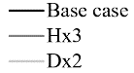
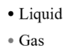
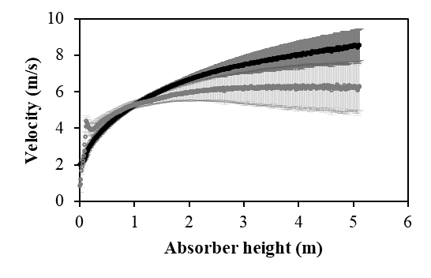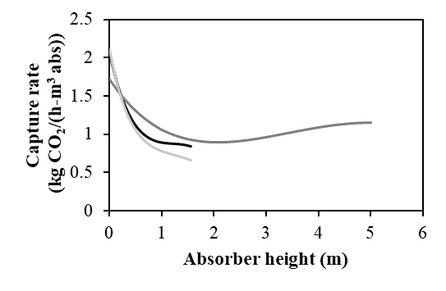
(a)
(b)
Figure 2: (a) Droplet and induced air velocity for the Hx3 geometry and (b) capture rate for the three geometries studied.
Results of capture rate along the absorber are presented in Figure 2 (b). Capture rate of the droplet absorber is also in the same range of packed absorbers (1.2-2.2 kg CO₂/(h-m³) in counter-current arrangement (Mazzotti et al., 2013) and 0.68 kg CO₂/(h-m³) in cross-flow arrangement (Holmes & Keith, 2012)). For all cases, capture rate decreases rapidly in the first meter of absorber height, mainly due to the loss in surface area. After one meter of absorber, the decrease in capture rate slows down, and for the longer absorber (Hx3) a slight increase in the capture rate is observed. In general, differences in capture rate between the three studied geometries is small and all geometries have a similar performance in terms of capture rate.
On the other hand, the energy consumed per mass of absorbed CO₂ is 1.38 kW-h/kg CO₂ for the base case, 1.03 kW-h/kg CO₂ for the Hx3 geometry and 1.15 kW-h/kg CO₂ for the Dx2 geometry. This parameter is in the same range of reported values for other droplet absorbers (1.2-2.5 kW-h/kg CO₂ (Stolaroff et al., 2008). In comparison with packed absorbers, the droplet absorber does not require a fan to generate the gas flow. However, the total energy consumption of the droplet absorber is still higher than that reported for packed absorbers (0.555 kW-h/kg CO₂ in counter-current arrangement (Zeman, 2008) and 0.082 kW-h/kg CO₂ in cross-flow arrangement (Keith et al., 2018)). The lowest energy consumption reported for packed absorbers was obtained using a special low pressure drop packing in a cross-flow arrangement and a discontinuous pumping of the liquid (Keith et al., 2018). For the droplet absorber, results on the energy consumption showed that the longest absorber has the lowest energy consumption. Moreover, the results allowed identifying that the absorber height should be at least one meter to make the energy consumption reaching a reasonable value. Below this height, the capture of CO₂ is not enough to compensate the use of energy in the absorber. Despite of the higher operational costs, the droplet absorber could still represent a feasible technology for DAC in terms of capital costs and the energetic optimization is still to be done. Besides obtaining a higher capture rate (smaller absorber) than the cross-flow absorber, packing and fan costs could be avoided by using the droplet absorber.
  - Conclusions
The combination of detailed CFD simulations and differential mass balances allowed assessing three different geometries of a droplet absorber for DAC. The CFD simulations showed that the flow of gas is driven by friction with the falling droplets in the absorber. The performance of the droplet absorber in terms of specific surface area and capture rate is comparable to that reported for packed absorbers. The specific surface area and the capture rate decrease in the first 2 meters of absorber but starts to increase due to changes in droplet diameter and number of droplets. The amount of energy consumed per mass of captured CO₂ of the longest absorber is the smallest among the studied geometries. The droplet absorber height should be at least one meter to reach a feasible energy consumption. Further studies should focus on cost analysis that includes both operational and capital costs and on optimization of the droplet absorber design.
References
BMBF (Bundesministerium für Bildung und Forschung), & FONA (Forschung für Nachhaltigkeit). (2023, September 13). CODA – Development of an environmentally friendly process for the production of soda ash. Funding Measures. https://www.fona.de/en/measures/funding-measures/KlimPro/coda.php
Danckwerts, P. V. (1970). Gas-Liquid Reactions. McGraw-Hill.
Gutierrez, M. F., Schulze, P., Seidel-Morgenstern, A., & Lorenz, H. (2023). Parametric study of the reactive absorption of CO2 for soda ash production. In A. C. Kokossis, M. C. Georgiadis, & E. Pistikopoulos (Eds.), 33rd European Symposium on Computer Aided Process Engineering (Vol. 52, pp. 2935–2940). Elsevier.
Holmes, G., & Keith, D. W. (2012). An air-liquid contactor for large-scale capture of CO2 from air. Philosophical Transactions of the Royal Society A: Mathematical, Physical and Engineering Sciences, 370(1974), 4380–4403.
Huimin Liu. (1999). Fundamental Phenomena and Principles in Droplet Processes. In Science and Engineering of Droplets (pp. 121–237). William Andrew.
IPCC. (2023). Climate change 2023: synthesis report. https://www.ipcc.ch/report/ar6/syr/
Keith, D. W., Holmes, G., Angelo, D. St., & Heidel, K. (2018). A Process for Capturing CO2 from the Atmosphere. Joule, 2(8), 1573–1594
Mazzotti, M., Baciocchi, R., Desmond, M. J., & Socolow, R. H. (2013). Direct air capture of CO2 with chemicals: Optimization of a two-loop hydroxide carbonate system using a countercurrent air-liquid contactor. Climatic Change, 118(1), 119–135.
Stolaroff, J. K., Keith, D. W., & Lowry, G. V. (2008). Carbon dioxide capture from atmospheric air using sodium hydroxide spray. Environmental Science and Technology, 42(8), 2728–2735.
Ushida, A., Hasegawa, T., & Narumi, T. (2014). Anomalous phenomena in pressure drops of water flows through micro-orifices. Microfluidics and Nanofluidics, 17(5), 863–870.
Zeman, F. (2008). Experimental results for capturing CO2 from the atmosphere. AIChE Journal, 54(5), 1396–1399.

