Design and simulation of hydrate-based desalination using R-152a refrigerant.
Sief Addeen Aldroubi ª , Umer Zahid ^{a,b} , Hassan Baaqeel ^{a,c} *
ª Department of Chemical Engineering, King Fahd University of Petroleum and Minerals, Dhahran 31261, Saudi Arabia
^{b} Interdisciplinary Research Center for Membranes & Water Security, King Fahd University of Petroleum & Minerals, Dhahran 31261, Saudi Arabia
^{c} Interdisciplinary Research Center for Renewable Energy & Power Systems, King Fahd University of Petroleum & Minerals, Dhahran 31261, Saudi Arabia
baaqeel@kfupm.edu.sa
Abstract
Innovative desalination technologies are coming into greater focus to meet the mounting problem of securing freshwater resources. Among them, Gas Hydrate-Based Desalination is one of the intriguing possibilities, distinguished by its exceptional water recovery capabilities despite the water’s salinity. In this study, R-152a is selected as a hydrate former due to its hydrate formation properties at a high temperature and lower pressures compared to conventional refrigerants. The results show that R-152a is an efficient hydrate formation refrigerant when compared to using propane and methane, resulting in a specific energy consumption of 3.72 kWh/m³. Moreover, it possesses a low global warming potential (GWP), promoting both energy efficiency and environmental sustainability. Finally, a sensitivity analysis was performed to study the effect of brine concentration on the overall performance of the hydrate-based desalination process.
Keywords: R-152a, hydrate-based desalination, hydrates, energy
  - Introduction
Accessing fresh and clean water is becoming increasingly challenging. To address these difficulties, highlighting desalination becomes crucial. Desalination is a process that eliminates salts and impurities from seawater, offering a consistent supply of pure water and potential solutions to freshwater scarcity. Given that approximately 97% of Earth's water is saline, studying and exploring diverse desalination techniques is imperative. These techniques are broadly categorized into three groups: Thermal-based desalination, Membrane-based desalination, and emerging methods such as Gas-hydrate based desalination and Capacitive Deionization (CDI). Multistage flash (MSF) and multiple effect distillation (MED), the most widely spread thermal based technologies. Even though they are efficient in producing fresh water, their high energy requirements associated with the water phase change limit their application. On the other hand, the most common membrane technology used, accounting for around 60% of the pure water produced is RO desalination (World Bank, 2019). However, RO technology is limited to water with low total dissolved solids (TDS) and its feasibility is weakened by the fact that RO systems require a pre-treatment plant where chemical additives are added to the sea water and high operating pressure reaching 80 bar (Subramani and Jacangelo, 2015). Hence, it is crucial to develop and investigate new desalination technologies like hydrate-based desalination. Hydrate-based desalination is a process where pure water is forced to form a crystal-like structure known as hydrate around a certain guest molecule at temperatures above the water’s freezing point. Melting the hydrate produces salt-free water and the hydrate former guest molecule which can be used again in the process. Both formation and dissociation temperature of hydrate are dependent on the hydrate former chosen (Babu et al., 2018). Gas hydrates formed aren't considered chemical compounds; instead, the enclosed guest interacts with water molecules through relatively weak van der Waals forces. A range of studies have explored gas hydrate-based desalination. (Sahu et al., 2018) identified propane and ethane as suitable candidates for this purpose, while (Cha and Seol, 2013) proposed the use of cyclopentane and cyclohexane as secondary hydrate guests to increase gas hydrate formation temperature. (He et al., 2018) focused on improving the efficiency of gas hydrate-based desalination processes by developing a process that utilizes LNG cold energy, significantly reducing energy consumption. It was reported that the resulting specific energy consumption of the process was reduced from 65.14 kWh/m³ when using an external refrigeration cycle to 0.84 kWh/m³ when using LNG cold energy to cool the process. (He et al., 2020) proposed a process where cyclopentane was used as a hydrate former to increase the hydrate formation temperature to 280.25 K. However, during the hydrate dissociation cyclopentane tends to form an emulsion requiring a secondary complicated process to separate cyclopentane and water. (McCormack and Andersen, 1995) pioneered the use of R-141b refrigerant as a hydrate former in two Hydrate-based desalination pilot plants in the US. The outcomes showed promise, enabling further exploration into utilizing refrigerants as hydrate formers. Refrigerants, when employed in this role, tend to decrease energy consumption because they typically form at higher temperatures and lower pressures. Recent studies by (Mok et al., 2022) and (Dongre et al., 2022) compared the effectiveness of various refrigerants as hydrate formers, highlighting R-152a as the top choice due to its superior kinetics, lowest Global Warming Potential (GWP) and conversion rates. According to their studies, R-152a forms hydrates at higher temperatures and lower pressures compared to propane and other refrigerants like R-22. Moreover, the kinetics of R-152a remains unaffected by seawater salt concentration, making it a strong candidate for optimizing hydrate-based desalination processes, particularly in countries without LNG imports. This study aims to simulate the hydrate-based desalination process using R-152a as a hydrate former.
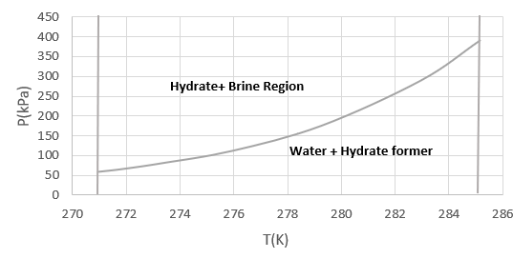
Figure 1: Phase equilibria data for R-152a at 5 wt% NaCl
  - Process design
    - Refrigeration cycle
In the phase diagram of R-152a hydrates shown above, it is evident that at a particular pressure, the feed needs to be cooled below the equilibrium temperature for hydrate formation. At our operating pressure of 300 kPa, the equilibrium temperature is approximately 284 K. To ensure hydrate formation, the reaction runs at 283 K. Because the hydrate formation reaction is exothermic, the temperature of the reactor should be controlled at 283 K to prevent hydrate crystal dissociation. An ethylene-glycol cycle which is constantly cooled in heat exchanger-5 is responsible for controlling the temperature; hence preventing the dissociation of hydrate crystals. For fair comparison of the process performance with previous works, the same working fluid and heat exchanger network in the refrigeration cycle is simulated in this work. (He et al., 2018)
    - Hydrate based desalination process
      - Process Description
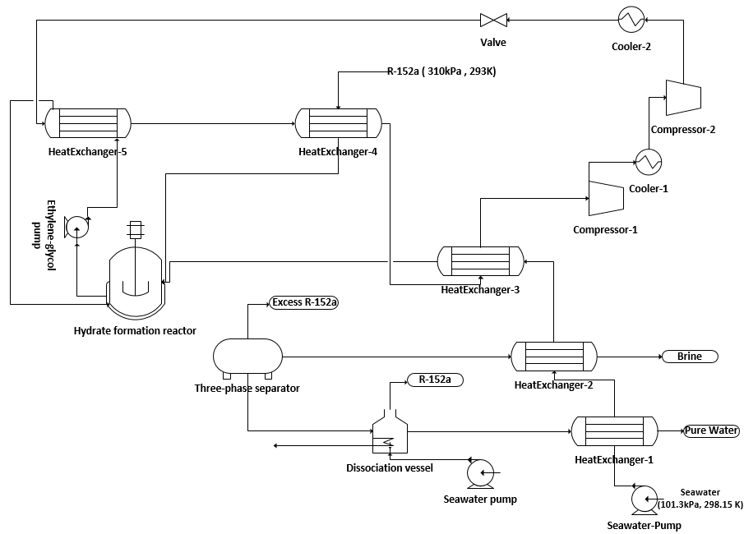
Figure 2 below shows the process flow diagram of hydrate-based desalination along with the external refrigeration cycle. The simulation details of this work are shown in Table 1. R-152a is usually stored in containers up to 500 kPa at temperature ranges of 293-298 K to remain in gaseous state, this storage condition is beneficial as it reduces the energy required to compress the feed. R-152a (293 K and 310 kPa) is cooled by propane in heat exchanger 4 to reach the hydrate formation conditions. The feed sea water at ambient conditions (298.15 K and 101.3KPa) is pumped to 315 kPa to account for any pressure losses in the pipes and heat exchangers. Then, it undergoes cooling in two successive heat exchangers (1 and 2) by pure water and brine respectively, before being further cooled by propane. The cooled feed (R-152a and seawater) enters the hydrate formation reactor forming hydrate crystals. The reactor effluent containing a mixture of crystals, brine, and excess hydrate former, undergoes separation in a three-phase separator where hydrate crystals are separated from the mixture entering a dissociation vessel. Seawater is used to increase the temperature of the vessel disturbing the equilibrium conditions, producing pure water and R-152a which might be used again in the process.
Figure 2: Process flow diagram of hydrate-based desalination

      - Hydrate formation and dissociation
The hydrate formation reactor was modelled using Aspen Custom modeler. The following reactions are hydrate formation and dissociation reactions respectively.

$C_{2}H_{4}F_{2}+7.7H_{2}O ->C_{2}H_{4}F_{2}∙\left(7.7H_{2}O\right)$ | (1)
$$C_{2}H_{4}F_{2}∙\left(7.7H_{2}O\right)->C_{2}H_{4}F_{2}+7.7H_{2}O$$ | (2)
A published hydrate model (Chen and Guo, 1998) was employed to characterize the composition of the refrigerant R-152a within the hydrate structure. The resulting composition of R-152a in the hydrate phase exhibited a value of 0.996, indicating its limited solubility in water. Consequently, no flash calculation was deemed necessary for assessing gas/liquid interactions. This result aligns with existing literature and serves as validation for the model. Furthermore, both mass and energy balances were conducted to ensure the accuracy of the process simulation. Validation of the model was also achieved by comparing the calculated enthalpy of hydrate formation, which measured at -84 kJ/mol, closely resembling the value reported by (Mok et al., 2021) of -82.2 kJ/mol.
$${Mass balance: V}_{in}y_{i}+L_{in}x_{i}=L_{out}x_{i}+Hx_{i}^{H}+V_{out}y_{i}$$ | (3)
$$Water transfer rate: \frac{L_{in}x_{i}}{L_{out}x_{i}}$$ | (4)
Table1. Process simulation details
Unit/ system | Aspen Model | Parameters
Refrigeration cycle | Aspen Plus | HEX ΔTmin =2  Isentropic Compressors efficiency: 75%  Working Fluid: Propane  Intercooling stage compressors (T= 293K)
Hydrate formation Reactor | Aspen Custom Modeler | Temperature = 283 K  Pressure = 300 KPa  H2O/ R-152a (mol./mol.) =7.7  Water transfer rate = 60% (Mok et al,2022)
Dissociation vessel | Aspen Plus | Temperature = 298.15 K
  - Results and discussion
    - Specific energy consumption
$SEC=\frac{Total Work}{Volume of Pure water produced per hour}$ | (5)
It is usually an indicator of the energy requirement of the process. In the case where the hydrate former recycling is not considered, it was reported that when using methane as a hydrate former to purify produced water, the specific energy consumption was 99.6 kWh/m³, given that it was assumed that methane enters the process at 4000 kPa and further compressed to 8000 kPa (Babu et al., 2021). In addition, when using propane as a hydrate former the SEC was reported to be 65.14 kWh/m³ (He et al., 2018). At a water transfer rate of 60% (Mok et al., 2022), 8.32 m³/h of pure water is produced from this proposed process, the specific energy tends to be 3.72 kWh/m³. This proves that using R-152a tends to increase the possibility of commercializing this desalination technology. Figure 3 shows the energy analysis of the process. It can be clearly shown that, the highest energy consuming equipment are the ones in the refrigeration cycle, which imply that if any renewable energy source or sustainable refrigeration system to be integrated with the process instead of the traditional refrigeration cycle, it would decrease the SEC even more.
    - Water salinity and specific energy consumption
It is important to analyze the effect of sea water salinity in terms of NaCl concentration on specific energy consumption (SEC). The concentrations of NaCl from 10% to 70% are studied. Referring to figure 4, as the concentration of NaCl increases, SEC increases. This is because as water becomes more saline, less water is produced per hour; hence more energy is consumed per m3 of water. This study ensures that investigating new hydrate formers with high water transfer rate can promote the commercialization of this desalination technique even at high saline solutions.
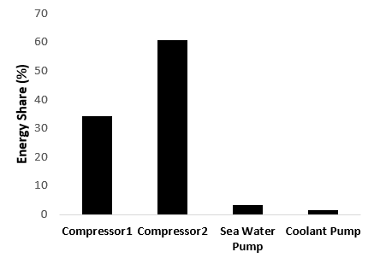 | 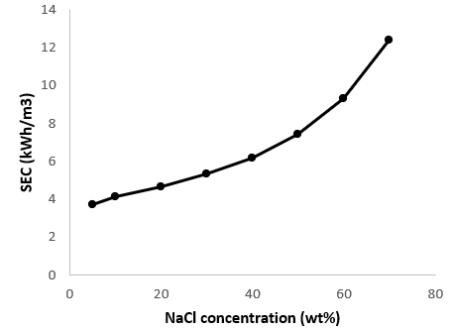
Figure 3: Energy share per equipment | Figure 4: SEC vs Water Salinity

  - Conclusions
Utilizing R-152a as a hydrate former significantly enhances the efficiency of the hydrate-based desalination process by making the hydrate crystal forms at higher temperature and lower pressure. This results in a water transfer rate of 60% and a SEC of 3.72 kWh/m³. Such enhancement in the performance will make this desalination technique attractive for commercialization. Even though the specific energy consumption decreased drastically when using R-152a, the compressors of the refrigeration cycle are the major contributors to energy consumption, which make exploring the possibility of renewable energy integration crucial to achieve lower energy consumption.

Acknowledgement
The author(s) would like to acknowledge the support provided by the Deanship of Scientific Research at King Fahd University of Petroleum & Minerals (KFUPM).

References
Babu, P., Bollineni, C., Daraboina, N., 2021. Energy Analysis of Methane-Hydrate-Based Produced Water Desalination. Energy Fuels 35, 2514–2519.
Babu, P., Nambiar, A., He, T., Karimi, I.A., Lee, J.D., Englezos, P., Linga, P., 2018. A Review of Clathrate Hydrate Based Desalination To Strengthen Energy–Water Nexus. ACS Sustain. Chem. Eng. 6, 8093–8107.
Cha, J.-H., Seol, Y., 2013. Increasing Gas Hydrate Formation Temperature for Desalination of High Salinity Produced Water with Secondary Guests. ACS Sustain. Chem. Eng. 1, 1218–1224.
Chen, G.-J., Guo, T.-M., 1998. A new approach to gas hydrate modelling. Chem. Eng. J. 71, 145–151.
Dongre, H.J., Deshmukh, A., Jana, A.K., 2022. A thermodynamic framework to identify apposite refrigerant former for hydrate-based applications. Sci. Rep. 12, 16688.
He, T., Chong, Z.R., Babu, P., Linga, P., 2020. Techno-Economic Evaluation of Cyclopentane Hydrate-Based Desalination with Liquefied Natural Gas Cold Energy Utilization. Energy Technol. 8, 1900212.
He, T., Nair, S.K., Babu, P., Linga, P., Karimi, I.A., 2018. A novel conceptual design of hydrate based desalination (HyDesal) process by utilizing LNG cold energy. Appl. Energy 222, 13–24.
McCormack, R.A., Andersen, R.K., 1995. Clathrate desalination plant preliminary research study. Water treatment technology program report No. 5 (Final) (No. PB-96-118286/XAB). Thermal Energy Storage, Inc., San Diego, CA (United States).
Mok, J., Choi, W., Seo, Y., 2022. Theoretically achievable efficiency of hydrate-based desalination and its significance for evaluating kinetic desalination performance of gaseous hydrate formers. Desalination 524, 115487.
Mok, J., Choi, W., Seo, Y., 2021. Evaluation of kinetic salt-enrichment behavior and separation performance of HFC-152a hydrate-based desalination using an experimental measurement and a thermodynamic correlation. Water Res. 193, 116882.
Sahu, P., Krishnaswamy, S., Ponnani, K., Pande, N.K., 2018. A thermodynamic approach to selection of suitable hydrate formers for seawater desalination. Desalination 436, 144–151.
Subramani, A., Jacangelo, J.G., 2015. Emerging desalination technologies for water treatment: A critical review. Water Res. 75, 164–187.
World Bank, 2019. The Role of Desalination in an Increasingly Water-Scarce World. World Bank, Washington, DC.

