Benders Decomposition to Integrate MILP and Discrete-Event Simulation for Flow Shop Scheduling
Roderich Wallrath* ^{a,b}, Edwin Zondervan ^{b}, Meik Franke ^{b}
ª University of Twente, Faculty of Science and Technology, Sustainable Process
Technology, Drienerlolaan 5, 7522 NB Enschede, The Netherlands
^{b} Bayer AG, Kaiser-Wilhelm Allee 1, 51368 Leverkusen, Germany
*r.wallrath@utwente.nl
Abstract
Optimization-based decision-making in the chemical industry is highly beneficial but also very difficult, because many decision variables must be considered, and their interrelation is complicated. Different modeling techniques exist each with individual strengths. We propose Benders decomposition to integrate mixed-integer linear programming (MILP) and discrete-event simulation (DES) to solve flow shop scheduling problems. The basic idea is to generate valid Benders cuts based on sensitivity information of DES models which can be found in the critical path of a DES solution. We apply our Benders-DES approach to a scaled literature flow shop with secondary resource constraints and find that near optimal solutions can be found quickly. From the optimality gap information during the solution process we can conclude that Benders-DES is a promising approach to combine rigorous optimization capabilities with high-fidelity modeling capabilities.

Keywords: Benders decomposition, Mixed-integer programming, Discrete-event simulation, Simulation-optimization, Flow shop scheduling
  - Introduction
For companies in the process and chemical industry optimization-based decision-making is a critical advantage in today's fast-paced and interconnected world. However, the complexity when optimizing chemical processes is very high: A chemical process which is operated by personnel on process units, consumes raw materials and utilities, and produces goods into a manufacturing supply chain, which is naturally subjected to many constraints and objectives. While simulation models can describe complex real-world processes to a great level of detail for which solutions can be obtained in reasonable computation time, their results might still be far from optimal. Mathematical optimization models, on the other hand, quickly grow to intractable size, when trying to include all relevant constraints. Simulation optimization (SO) has emerged as a powerful tool to solve complex problems without compromising solution quality and computation time (Amaran et. al., 2016, Chen et. al. 2012). For example, Paulo et. al. (2023) successfully use rigorous optimization and discrete-event simulation for the optimal design of biomass supply chains including the uncertainty of conversion factors in the fermentation for bioethanol and transesterification for biodiesel. However, there are two drawbacks of SO methods. First, due to the evaluation-intensive search process massive computational resources may be required when solving complex problems. Second, these methods do not provide optimality gap information and the user must decide when to terminate the search process. The potential upside of finding a better solution remains unknown. Wan et. al. (2005) suggest a simulation-based optimization framework in which a surrogate model is derived from the simulations to decrease the computational burden. Combining simulation with rigorous optimization techniques is still relatively unexplored field. Forbes et. al (2023) propose a logic-based Benders approach that evaluates a discrete-event simulation sub-problem to derive cuts for the master problem. Zhang et. al. (2017) derive Benders cuts from a discrete-event simulation model to find the optimal design parameters of a joint workstation, workload and buffer allocation system. The objective of this work is to integrate MILP and DES for flow shops by inferring dual information from critical paths to build valid Benders cuts.
  - Model Integration
We argue that the Benders decomposition framework as shown in Eq. (1) can be used to integrate mathematical optimization and discrete-event simulation directly. The basic idea is to generate valid optimality cuts $μ≥$ $u^{T}\left(g-Bx\right)$ and feasibility cuts $0≥u^{T}\left(g-Bx\right)$ based on sensitivity information of DES models.
$$\min{c^{T}x+ µ}$$  $$s.t.{\begin{aligned}Ax≥b \\ μ≥u^{T}\left(g-Bx\right) ∀ u∈O' \\ 0≥u^{T}\left(g-Bx\right) ∀ u∈F' \\ x≥0\end{aligned}}$$ | (1)
We consider the original flow shop problem shown in Eq. (2) where $c_{max}$ is the makespan, $c_{im}$ the completion time of the job taking position$i$ on machine $m$ , $y_{ji}∈\{0,1\}$ the indicator variable of job $j$ being in position$i$ , and $t_{jm}$ the processing time of job $j$ on machine $m$. Any solution of this flow shop problem contains dual variables $u_{im}$ corresponding to the constraints (2e) and (2f) which are equal to 1 if a job in position$i$ on machine $m$ lies on the critical path. By solving a DES model of this flow shop problem, we also obtain a critical path that consists of a jobs in positions$i$ on machines $m$. Therefore, we can map the critical path of a DES solution to the dual variables $u_{im}$ and build valid Benders cuts of the form $u^{T}\left(g-Bx\right)$. In Figure 1 a flow shop featuring 3 machines and 4 jobs is shown with the critical path and the active constraints.

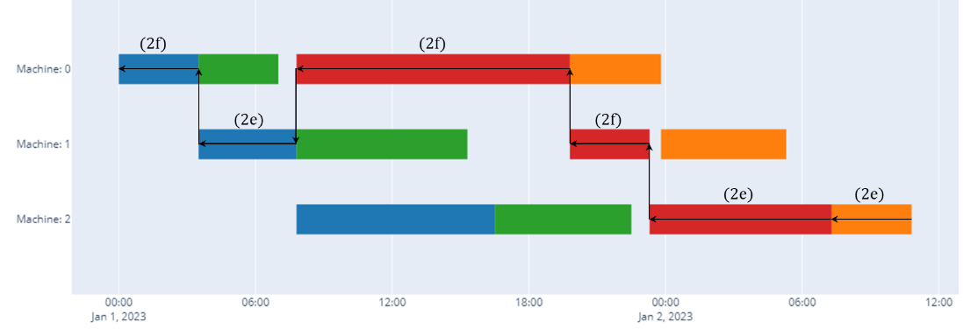 Figure 1: Example Gantt chart and critical path of flow shop with 3 machines and 4 jobs.
$$\min{c_{max}}$$ | (2a)
s.t. $c_{max}≥c_{im} ∀ i∈N, m∈M$ | (2b)
$$\sum_{i ∈ N}{y_{ji}=1 ∀ j∈N}$$ | (2c)
$$\sum_{j ∈ N}{y_{ji}=1 ∀ i∈N}$$ | (2d)
$$c_{im}+ \sum_{j ∈ N}{y_{ji}t_{jm}=c_{i+1m} ∀ i∈N_{0}, m∈M]}$$ | (2e)
$$c_{im}+ \sum_{j ∈ N}{y_{ji}t_{jm+1}=c_{im+1} ∀ i∈N, m∈M_{0}}$$ | (2f)
$$y_{ji}∈\{0,1\}$$ | (2g)

Our Benders master problem shown in (3) obtains an optimality cut$μ≥$ $\sum{u_{im}y_{ji}t_{im}}$ from the DES solution in each iteration $k$, where $u_{im}$ contains the dual information of the critical path and $y_{ji}$ encodes the job order. If the DES solution is does not improve the upper bound a feasibility cut $N>$ $\sum{y_{ji}}$ is added as well. In iteration $k+1$ the master problem is solved and its solution $y_{ji}$ represents a new job order which is then simulated by the DES sub-problem to give new dual information and the next Benders cuts.

$$\min{µ}$$ | (3a)
$$s.t.{μ≥\sum_{\begin{aligned}\left(i,j,m\right) \\ ∈\left(N,N,M\right)\end{aligned}}{u_{im}y_{ji}t_{im}} }∀ u∈O^{'}$$ | (3b)
$${N>\sum_{(i,j)}{y_{ji}} }∀ i,j∈F^{'}$$ | (3c)
$$\sum_{i ∈ N}{y_{ji}=1 ∀ j∈N}$$ | (3d)
$$\sum_{j ∈ N}{y_{ji}=1 ∀ i∈N}$$ | (3e)
$$y_{ji}∈\{0,1\}$$ | (3f)

  - Computational Studies
To test the performance of our Benders approach we apply it to the literature flow shop problem from Edgar et. al. (2001). Thereafter, we scale this problem, solve random instances, and introduce additional resource constraints.
    - Literature flow shop

Figure 2: 3-stage flow shop

We consider the flow shop problem from Edgar et. al. (2001) as shown in Figure 2, in which 4 jobs visit 3 units with machine-specific processing times. The objective is to minimize the makespan of all jobs. As shown in Figure 3, the Benders cuts give good lower bounds on the optimum, while the DES solutions approach the optimum quickly. As a result, we find the optimal job order with a makespan of 34.8 hours after 5 iterations. Since there are only 24 different job orders in this example, our investigations in the following focus on larger instances.

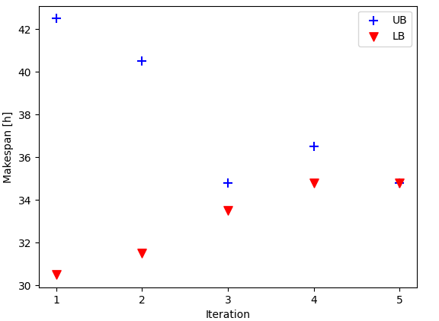
Figure 3: Bound convergence of Benders-DES approach for literature flow shop
    - Scaled Literature flow shop
We scale the literature flow shop of Chapter 3.1 with respect to the number of units and jobs and introduce the consumption of steam by each job as an example of secondary resource constraints. Note that we do not include the secondary resource constraints into the Benders cuts or the master problem but only into the DES model. In Figure 4 the remaining gaps and number of iterations of random instances of different problem sizes are shown after 2, 10, 60, 600, 1800 and 3600 seconds of solution time. For example, the problem size “10x5, 50Steam” corresponds to a setup with 10 jobs, 5 units, and 50 consumable units of steam. For each problem size we solve 30 instances with randomized processing times and steam consumption per job. From Figure 4 we observe that near optimal solutions with less than 10% remaining gap can be found for most of the problem sizes after less than 10 minutes. While we see that all problems with 10 jobs and 5 units converged to 0% gap after 200 iterations, we also recognize that for most of the larger problems achieving 0% gap is very difficult. Although, this might be due to the exponentially growing search space we also know that the Benders cuts omit the secondary resource constraints. Therefore, if secondary resource constraints are active in the optimum, the master problem is not able to proof optimality. This means dual variables of the secondary resource constraints could extend the cuts.

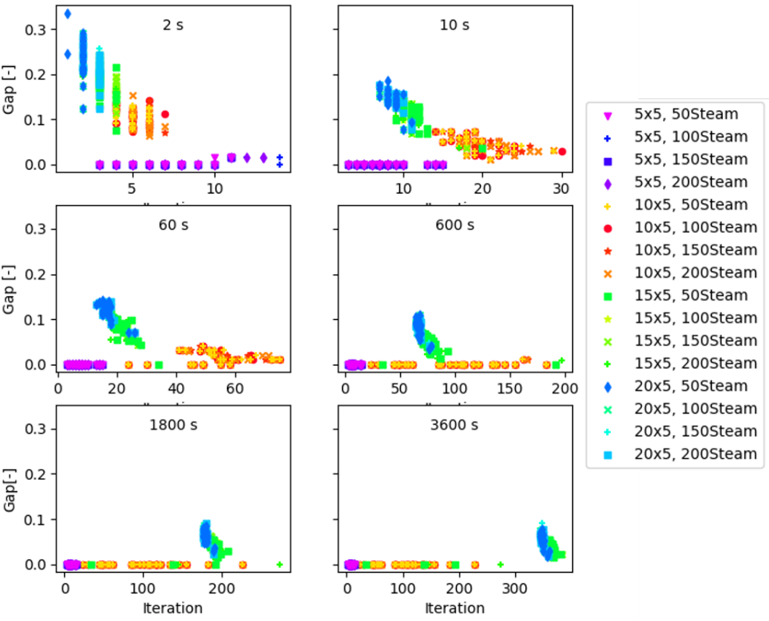
Figure 4: Remaining gap and number of iterations of different-sized, randomized problems with secondary resource constraints after 2, 10, 60, 600, 1800 and 3600 seconds of solution time.
  - Conclusions
We showed that it is possible to integrate MILP and DES for flow shops by inferring dual information from critical paths to build valid Benders cuts. With this integration, rigorous optimization capabilities can be combined with high-fidelity modeling and simulation capabilities. Our computational studies showed that the Benders-DES approach solves small to realistic-size flow shop scheduling problems in less than 30 minutes with an optimality gap of 10%. We were able to generate guaranteed near-optimal solutions of DES models after 200 iterations. Furthermore, when adding secondary resource constraints to the DES model, the master problem still guides the search process to near-optimal solutions in short time while reporting optimality gap information. Since DES models can include these constraints more efficiently than a MILP model, we argue that the Benders-DES approach extends the scope optimization models in general. Future research should focus on the applicability to a realistic case study, other types of optimization problems as well as speeding up the solution times.
References
Helena Paulo, Miguel Vieira, Bruno S. Gonçalves, Susana Relvas, Tânia Pinto-Varela, Ana P. Barbosa-Povoa, 2023, A Discrete-Event Simulation Approach to the Design and Planning of Biomass Supply Chains considering Technological Learning, Computer Aided Chemical Engineering, Elsevier, Volume 52, 2023, Pages 1285-1291, ISSN 1570-7946, https://doi.org/10.1016/B978-0-443-15274-0.50205-5
Ye Chen, Linas Mockus, Seza Orcun, Gintaras V. Reklaitis, 2012, Simulation-optimization approach to clinical trial supply chain management with demand scenario forecast, Computers & Chemical Engineering, Volume 40, Pages 82-96, ISSN 0098-1354, https://doi.org/10.1016/j.compchemeng.2012.01.007
Xiaotao Wan, Joseph F. Pekny, Gintaras V. Reklaitis, 2005, Simulation-based optimization with surrogate models—Application to supply chain management, Computers & Chemical Engineering, Volume 29, Issue 6, Pages 1317-1328, ISSN 0098-1354, https://doi.org/10.1016/j.compchemeng.2005.02.018
M.A. Forbes, M.G. Harris, H.M. Jansen, F.A. van der Schoot, T. Taimre, 2023, Combining optimisation and simulation using logic-based Benders decomposition, European Journal of Operational Research,Volume 312, Issue 3,2024,Pages 840-854, ISSN 0377-2217, https://doi.org/10.1016/j.ejor.2023.07.032.
M. Zhang, A. Matta, A. Alfieri and G. Pedrielli, 2017, A simulation-based benders' cuts generation for the joint workstation, workload and buffer allocation problem, 13th IEEE Conference on Automation Science and Engineering (CASE) , Xi'an, China, 2017, pp. 1067-1072, doi: 0.1109/COASE.2017.8256247
Amaran, S., Sahinidis, N.V., Sharda, B. et al., 2014, Simulation optimization: a review of algorithms and applications. 4OR-Q J Oper Res 12, 301–333. https://doi.org/10.1007/s10288-014-0275-2
Thomas F. Edgar and David M. Himmelblau, 2001, Optimization of Chemical Processes, McGraw-Hill, Pages 560 – 564, New York, NY, USA

