Modeling and Economic Optimization of an Industrial Site for Natural Gas Processing: an MINLP Approach
Tayná E. G. Souza^{a,b*}, Argimiro R. Secchiª, Letícia C. Santos^{b}
ªChemical Engineering Program, COPPE, Universidade Federal do Rio de Janeiro (UFRJ), Rio de Janeiro – RJ, Brazil
^{b}Petróleo Brasileiro S.A. (PETROBRAS), Rio de Janeiro - RJ, Brazil
taynaegs@gmail.com
Abstract
In this work, a multi-step MINLP (mixed-integer nonlinear programming) strategy was proposed for high-level enterprise-wide economic optimization of a multi-unit and -feedstock natural gas processing site. The framework was studied in a Petrobras facility using Aspen HYSYS for process simulation, Python for optimization and Microsoft Excel as data transfer interface. MINLP was broken down into a hybrid nonlinear programming (NLP - particle swarm plus flexible polyhedron) added to a mixed-integer programming (MIP - branch-and-bound plus linear programming as initial estimate generator for NLP subproblems). A potential profit increase of 9.1 % (118.78 R$ / 1000 m³) was found by optimizing raw gas distribution to process units and selecting their operating status, thus showing how successful the proposed strategy is.
Keywords: Multi-unit NGPUs, Process Simulation, Enterprise-wide Optimization
  - Introduction
Natural gas is a mixture of mostly paraffin hydrocarbons from underground reservoirs (MONDAL et al., 2013). Its primary use is as fuel (MONDAL et al., 2013), specially as a transition source from oil to renewable energy. Although field conditioning usually takes place near the wellhead, further onshore processing is needed to guarantee market specification – this is carried out by natural gas processing plants. Those facilities are subject to variations in the inlet streams from upstream.
Although several papers have been published on modeling and optimization of gas plants, there is a lack of focus on high-level integrated business perspective, embracing the enterprise-wide optimization concept. Souza et al. (2022) tried to fulfill this gap by introducing an NLP approach via global optimization and rigorous simulation. However promising, this approach is still limited, since multi-unit natural gas processing facilities also have the flexibility of putting one or more plants on standby when inlet feed flowrate is low – reduction of operating costs (OpEx). Besides, gas processing units (NGPUs) have lower feed boundaries – below which continuous operation is not feasible and plant is shut down – those conditions generate binary decision variables. Thus, a robust mixed integer nonlinear programming (MINLP) approach is required for daily basis application. This work intends to fill this gap by proposing an MINLP optimization strategy for economic optimization of an industrial multi-unit natural gas processing site and comparing results with the NLP approach from Souza et al. (2022).
  - Background
    - Process description
The system in study is the same Petrobras facility presented by Souza et al. (2022) – the largest natural gas processing facility in Brazil. This site receives non-processed raw gas from three different offshore sources and processes it into four products: sales gas, NGL (C₂⁺), LPG, and C₅⁺, plus two intermediate streams: NGL (C₃⁺) and residual gas. The site is composed of five NGPUs that may differ by refrigeration technology, performance and capacity. There are also three liquid fractionating units (LFUs) that receive: 1) unstabilized condensate from slug catchers (SG), 2) intermediate NGL (C₃⁺) from NGPU-A, 3) lighter liquid formed in knockout drums. A general schematic of the industrial site is presented in Fig. 1(a) (further details in Souza et al., 2022).
There are several possible configurations to send the multi-feedstock raw gas to the five process units. Those possible routes are the continuous decision variables ($u$) of the optimization problem proposed by Souza et al. (2022). In this work, binary decision variables ($y$) are also added, representing the NGPUs operating status, plus two degrees of freedom: u₁₁, fraction of the residual gas from NGPU-E that is reprocessed, and u₁₂, fraction of the residual gas from NGPU-A that is reprocessed (Fig. 1(a)). Product profile and overall OpEx will vary according to feed route configuration and NGPU operating status. It is important to mention that currently this is a manual decision of the Operations team, which may lead to suboptimal operating conditions.
    - Process modeling and simulation
HYSYS commercial simulator was the tool chosen to build a static first-principles model of the facility. The model has already been presented, discussed and validated in the previous work of Souza et al. (2022), where further details can be found. Validation showed good agreement with plant data, thus presenting itself as a good starting point to the simulation-optimization framework proposed here and detailed in the next section.
  - Methodology
The high-level methodology of this work is similar to the one from Souza et al. (2022). Difference here lies in the MINLP approach: at each iteration, process simulation receives continuous and integer decision variables, carries out mass/energy balances and passes back model variables to the MINLP optimizer, which computes the objective function. Upon convergence, an optimum operating point is found, associated with maximum business profit and optimum values of the decision variables (Fig. 1(b)).
    - Optimization framework
Each individual gas plant is represented by several non-linear processes (ZHANG et al., 2016). and has the flexibility of changing operating status, which leads to integer binary decision variables. Thus, this work proposed an MINLP optimization strategy. This agrees with the literature, which states that MINLP techniques are well-suited to such problems: nonlinear process plus desired selection of process alternatives, possibly with discrete variables (MENCARELLI et al., 2020).
Figure 1(b) summarizes the proposed methodology: particle swarm (PSO) global method is used as pre-screening with relaxed integers to generate initial estimates for MINLP; branch-and-bound and flexible polyhedrons (FPO) are used in a loop to find an MINLP solution via tree-search – this step defines the integer values that are translated into plant operating status in HYSYS simulation; PSO and FPO are used in series with tighter tolerances to refine the MINLP result and reach a final optimal solution. Based on the experience provided by Souza et al. (2022), it was studied the possibility of using PSO + FPO in each NLP subproblem from tree-search. Unfortunately, time consumption would make it unfeasible for industrial application, so an LP was used instead to generate feasible estimates to each NLP subproblem.
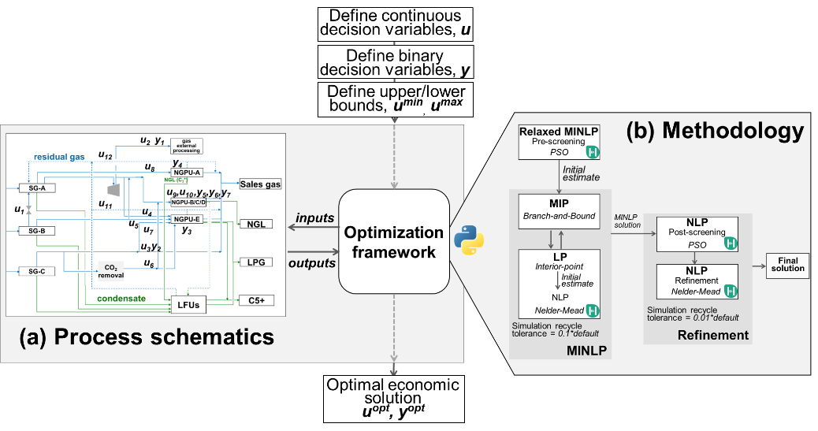
Figure 1: Simulation-optimization framework proposed in this work (created by the authors): (a) model schematic including the decision variables. (b) MINLP optimization methodology proposed. PSO, branch-and-bound and FPO methods are employed in three main steps: pre-screening, MINLP solution and post-refinement.
    - Optimization problem formulation
The proposed optimization problem has the goal of achieving the optimal feed allocation ($u$) and NGPUs operating status ($y$) to maximize business profit. For the sake of result comparison, the objective function ($S$ in Eq. (1)) is the profit, calculated as revenue minus OpEx. The costs used in this work are from Souza et al. (2022).
$S\left[x\left(u, y\right),u,y\right]=\sum_{i=1}^{n_{p}}{m_{i}Q_{pi}}-\left[c_{EE}Power_{EE}+c_{FG}Q_{FG}\right]+Pen\left[x\left(u, y\right),u,y,r\right] (1)$
where $x$ are model variables, $n_{p}=5$ is the number of products, $m_{i}$ is market product price, $Q_{p}$are product flowrates, $c$ are average costs of electricity and fuel gas. $Power_{EE}$ is electricity demand and $Q_{FG}$ is fuel gas consumption, which uses lower heating value to match units. $r$ is the scale factor for magnitude equalization. Inequality constraints were accounted for by adding a penalty term (Pen) to the objective function, with adjusted magnitude, thus avoiding numerical issues in the optimization search. Equality constrains are guaranteed from feasible path approach. Constraint values and penalty function mathematics can be found in Souza et al. (2022).
    - Computational Aspects
Figure 1 summarizes the complete strategy. The optimization problem was implemented in Python. For PSO algorithm, pyswarm package was customized to create continuous intervals based on the choice of binary variables. For local NLP, spicy package (spicy.optimize.minimize) was adapted to include an LP (interior point) for initial estimate generation. Size of the initial simplex was modified to ensure proper exploration. A Matlab implementation of branch-and-bound (SOARES, 2001) was adapted to Python and tailored for this work. Excel was used as user interface with VBA procedures and a bidirectional communication with Aspen HYSYS and Python.
  - Results and Discussion
    - Optimization results
Optimization framework was implemented in three main steps: 1) PSO relaxed pre-screening with 190 particles and 20 iterations generated a feasible initial estimate to the 2) MINLP step, which was solved by branch-and-bound (MIP tree-search with tolerance of 0.1 for integer variables, 0.00001 for the continuous ones and 0.01 for constraints) coupled with FPO (NLP with 0.1 overall tolerance). In this step, convergence of recycle streams was 10% of HYSYS default; an LP was solved with interior-point to generate a feasible initial estimate for NLP problem. 3) Lastly, NLP variables of the MINLP solution were refined by PSO post-screening (120 particles and 20 iterations) followed by NLP – FPO local refinement (0.001 overall tolerance) with recycle convergence tightened to 1% of default.
      - Computational effort
Process modeling and optimization were executed in an Intel CoreTM i5 10210U processor, 1.60GHz. Model execution time was dependent on how close input conditions were from previous execution, varying from 40s to nearly 3min. This dependence is a consequence of HYSYS convergence strategy, which utilizes the current converged solution as initial guess for the next run (SOUZA et al., 2022).
For each optimization step, total execution time was: 1) PSO pre-screening: 8h 2min; 2) MINLP: 15h 20min; 3) post-refinement: 10h 39min. Thus, total execution time was 34h, which is consistent with the dimension and complexity of the system: i) rigorous phenomenological simulation approach, ii) global non-deterministic optimization method (PSO), iii) utilization of several solution steps and optimization algorithms.
    - Analysis of the Variables Search Space
PSO was used to explore and better understand the MINLP space of variables. A total of 6592 feasible points were gathered from individual PSO executions and the results for u₈ (NGPU-A feed gas flowrate) are shown in Fig. 2. This is a very representative plot to understand the space of variables, since it shows a wall-shaped region at u₈=0.5 where some of the best objective function values are and which corresponds to the lowest value of u₈ when NGPU-A is under operation (y₄=1). This is the region where an NLP approach would find its optimum. However, the region with u₈=0 is not only feasible in this MINLP approach (y₄=0), but concentrates a region of economically interesting points, where the MINLP optimum might lie.
      - MINLP results
The MINLP problem was successfully solved and the tree-search step-by-step results are presented in Table 1. Results show that the MINLP optimizer found an optimum at y₄=0. This means that NGPU-A was put in standby, in agreement with the search space analysis in Section 4.2 and shows the advantage of formulating an MINLP approach in comparison to NLP – the optimizer used the plant flexibility of putting NGPUs in standby to find an optimum economic operating point better than the one found in Souza et al. (2022) from NLP approach (objective function of 0.985 versus 0.979).
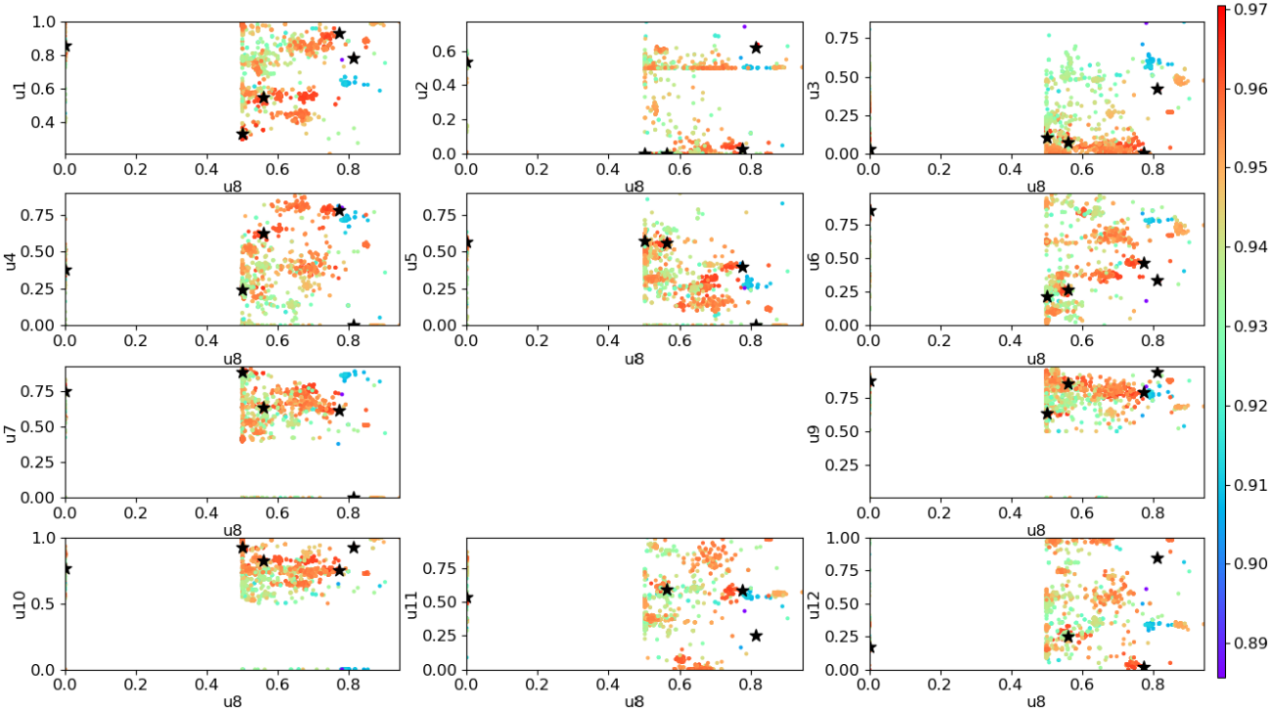
Figure 2: Plots of u₈ (NGPU-A feed flowrate) u₁ to u₁₂. Colors refer to objective function ($S$) value (color-bar in the right). Star symbols: five highest $S$ values.
Table 1: Tree-search results from MINLP solution. Table shows number of executions, tree node, binary variables (y₁ to y₇), iterations, function evaluation of each NLP run.
# | Node | y₁ | y₂ | y₃ | y₄ | y₅ | y₆ | y₇ | S | Iterations | Feval.
1 | 1 | 1 | 0.509 | 0.970 | 0.628 | 0.955 | 0.902 | 0.965 | 0.955 | 202 | 342
2 | 1 | 0 | 0.395 | 0.997 | 0.997 | 0.891 | 0.996 | 0.969 | 0.969 | 209 | 337
3 | 2 | 0 | 1 | 0.929 | 0.589 | 0.968 | 0.930 | 0.973 | 0.973 | 217 | 361
4 | 2 | 0 | 0 | 0.900 | 0.526 | 0.909 | 0.969 | 0.972 | 0.972 | 100 | 198
5 | 3 | 0 | 1 | 0.821 | 0 | 0.998 | 0.986 | 0.967 | 0.967 | 158 | 257
6 | 3 | 0 | 1 | 0.968 | 1 | 0.934 | 0.974 | 0.973 | 0.972 | 130 | 251
7 | 4 | 0 | 1 | 0.972 | 1 | 0.993 | 0.993 | 0.934 | 0.934 | 187 | 301
8 | 4 | 0 | 1 | 0.692 | 1 | 0.886 | 0.945 | 0.973 | 0.973 | 119 | 212
9 | 4 | 0 | 1 | 0 | 0 | 0.980 | 0.980 | 0 | 0 | 4 | 67
10 | 4 | 0 | 1 | 1 | 0 | 0.829 | 0.995 | 0.985 | 0.985 | 108 | 186
11 | 5 | 0 | 1 | 1 | 0 | 0 | 0.850 | 0 | 0 | 4 | 63
12 | 5 | 0 | 1 | 1 | 0 | 1 | 0.973 | 0.983 | 0.983 | 175 | 308
13 | Final | 0 | 1 | 1 | 0 | 1 | 1 | 0.985 | 0.985 | 19 | 62
    - Profit Gain
Economic results from optimization solution are shown in Table 2.
Table 2: Potential profit gain resulting from the solution of NLP and MINLP problem formulations in comparison to a base case, defined as initial estimate.
Problem formulation | Objective function | Potential profit gain (%) | Potential profit gain (R$/1000m³)
NLP – FPO (Souza et al., 2022) | 0.9704 | 6.4 % | 83.73
NLP – PSO + FPO (Souza et al., 2022) | 0.9790 | 7.3 % | 96.11
MINLP | 0.9852 | 8.0 % | 104.94
MINLP + post refinement | 0.9948 | 9.1 % | 118.78
Base case (Souza et al., 2022) | 0.9120
By adding the operating status of the NGPUs as integer decision variables, better economic results were found. Additionally, coupling the MINLP solution with a post-refinement step showed the best overall results, bringing a potential gain of over 9 % in plant variable profit. Results show that it is overall advantageous to work with an MINLP strategy in comparison to NLP, even considering the higher computation demand for MINLP, and this is a consequence of the gas plant dynamic scenarios that might lead to the possibility of putting one or more NGPUs in standby, reducing OpEx.
  - Conclusions
This work had the objective to formulate a high-level economic optimization framework for a multi-unit industrial natural gas processing facility, considering the flexibility of having NGPUs in standby. This resulted in an MINLP optimization problem, aiming at the optimum operating point for maximum business profit. MINLP model was broken down into an NLP combined with MIP, both solved as a simulation-optimization integrated framework, using HYSYS for simulation, Python for optimization and Excel as data transfer interface. An augmented objective function was used to incorporate inequality constraints. The problem was successfully solved using branch-and-bound coupled with flexible polyhedron, preceded by a PSO pre-screening, in 23h 22min (Intel ® CoreTM i5 10210U processor with 1.60 GHz). An LP problem was formulated with interior-point to generate feasible initial estimates for Nelder-Mead. Results were then refined in a with PSO in series with Nelder-Mead, considering tighter tolerances for both the NLP problem and process simulation. Results were in agreement with the graphical analysis from PSO. Both resulted in disfavouring the three process units that have the lowest liquid recovery fractions, a consequence of the products sales prices, defining higher values for liquid streams. An objective function of 0.9948 was obtained, in comparison to 0.9120 of base-case, indicating a potential increase of 9.1 % or 118.78 R$/1000 m³ in industrial plant variable profit. This work thus provided a contribution to the literature by successfully proposing an MINLP optimization framework and methodology for the business economic optimization of a natural gas processing site. Although the methodology was implemented and tested in a specific industrial case, it is applicable to other midstream sites. It also makes way for new works and developments regarding digital transformation in the natural gas processing research field.
References
L. Mencarelli, Q. Chen, A. Pagot, 2020, A review on superstructure optimization approaches in process system engineering, Computers and Chemical Engineering, v. 136.
S. Mokhtab, W. A. Poe, J. Y. Mak, 2012, Handbook of natural gas transmission and processing, Elsevier Inc.
S. Mondal, M. R. Uddin, A. K. Azan, 2013, Simulation and Optimization of natural gas processing plant, International conference on mechanical, industrial and materials engineering.
R. Soares, 2001, Modificação e implementação de algoritmos para problemas MINLP.
T. Souza, A. R. Secchi, L. C. Santos. Modeling and economic optimization of an industrial site for natural gas processing: A nonlinear optimization approach, 2023, Digital Chemical Engineering, 6, 100070.
B. Zhang, Q. L. Chen, J. Li, C. A. Floudas, 2016. Operational strategy and planning for raw natural gas refining complexes: process modeling and global optimization. AlChE J., 652–668.
Q. Zheng, S. Rebennack, N. A. Iliadis, P. M. Pardalos, 2010. Optimization models in the natural gas industry. Handbook of power systems I, energy systems. Springer, Berlin, pp. 121–148.

