Ribbon Splitting in Roller Compaction and Monitoring of a Dry Granulation Process
David Sixon,ª Josie Kirsch,ª Adam Georgopoulos,ª Rexonni Lagare,ª Marcial Gonzalez,^{b,c} Zoltan Nagy,ª Gintaras Reklaitisª*
ªDavidson School of Chemical Engineering, Purdue University, West Lafayette, IN 47907, USA ^{b}School of Mechanical Engineering, Purdue University, West Lafayette, IN 47907, USA ^{c}Ray W. Herrick Laboratories, Purdue University, West Lafayette, IN 47907, USA *Corresponding Author: reklaiti@purdue.edu
Abstract
While ribbon splitting is an observable and measurable occurrence, the design of production-scale roller compactors obscures the operator’s view of ribbon splitting and may have contributed to the lack of literature on the phenomenon. However, as the principles of continuous manufacturing are applied to processes that use roller compaction (such as continuous dry granulation), ribbon splitting may be able to serve as a novel way to monitor the system. This study demonstrates how roller compactor parameters are connected to ribbon splitting and how this relationship can be used to potentially detect issues upstream. First, using pure excipient powder, the behavior of ribbon splitting was mapped out as a function of roller compactor variables: roll gap and hydraulic pressure. As the roller compactor’s hydraulic pressure and roll gap decreases, the ribbon splitting behavior goes from splitting to not-splitting. With a general idea of ribbon splitting conditions laid out, the composition of the powder fed into the roller compactor was varied to show that changes in composition can lead to changes in ribbon splitting. A shift in the behavior of ribbon splitting (from not-splitting to splitting) demonstrated the potential that ribbon splitting has to offer as a signal suitable for monitoring roller compaction in a continuous process, giving a roller compactor operator a real time tool to identify possible deviations from normal behavior upstream. However, changing the feed composition did not always cause a change in the ribbon splitting behavior, suggesting that there is a complex relationship between parameters of the roller compactor, the composition, and ribbon splitting. Ongoing work is focused on generating a larger set of data points of split and not-split conditions under a wider range of values of operating variables with the goal of developing a machine learning for predicting ribbon splitting.
Keywords: Ribbon Splitting, Roller Compactor, Dry Granulation, Continuous Manufacturing
  - Introduction
As the implementation of continuous manufacturing occurs across many industries, new methods and measures need to be developed to monitor the unit operations without disturbing the continuous flow of materials. The pharmaceutical industry has several processes that are being converted from batch to continuous operation: one of these is dry granulation-based tablet manufacture. In this process, a powder blend of active pharmaceutical ingredient (API) and excipient is converted into a solid tablet without the introduction of solvents or moisture. The process consists of feeding the powder components continuously, blending them together, increasing particle size using a roller compactor, and forming the tablets in a tablet press. The roller compactor serves multiple functions: to mitigate the tendency of powders in the blend to segregate, to produce granules of increased particle size, to improve the flow of the resulting granular material, and to reduce the fraction of fine particles which must be processed in the tablet press (Sun et al, 2016). In the roller compactor, the powder blend is first compressed into a thin ribbon, and then the ribbon is milled into granules of a desired size.
The roller compactor is thus an essential part of the dry granulation process. Several studies have attempted to model the roller compactor with the goal of controlling and optimizing the process, most recently Y.-S. Huang et al (2023). These studies have also employed various sensors to monitor critical roller compactor variables and the properties of the ribbon/granules produced. However, most of the properties are measured off-line, making the measurements difficult to use for monitoring and controlling continuous operation.
Ribbon splitting offers a real-time solution to this at-line/off-line measurement problem. Ribbon splitting occurs when ribbon leaves the rollers of the roller compactor as two ribbons instead of the expected one, as shown in Figure 1. This phenomenon is rather easy to observe, since the ribbons leaving the roller compactor can be classified as split or not-split if the observer’s view of the roller compactor’s rollers is not obstructed.
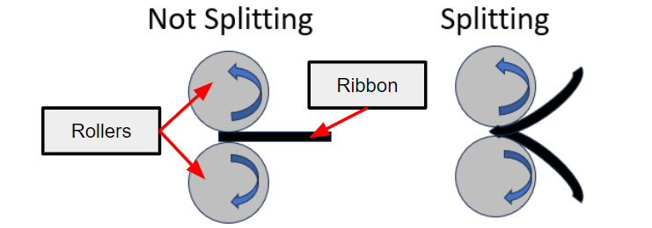
Figure 1. The not-split ribbon case is shown on the left, while the split ribbon case is shown on the right.

Several attempts have been made to model/explain ribbon splitting, including Mahmah et al (2019). As more data is collected on ribbon splitting behavior at different sets of conditions, predictions of splitting or not-splitting can be made. These predictions can be further enhanced and automated with a machine learning model, which could characterize an inputted set of conditions as split or not-split. Furthermore, with a camera sensor and some redesigning of the roller compactors, the ribbon splitting behavior could be monitored and compared to a machine learning model’s prediction automatically. Then, if the ribbon splitting behavior deviates from the predictions, the roller compactor would alert the operator, who could diagnose possible issues upstream or with the roller compactor and possibly initiate corrective action. With the end goal of building a machine learning model for ribbon splitting, this study aims to explore how roller compactor parameters and the composition of the powder mixture fed into the roller compactor impact ribbon splitting, and how ribbon splitting could be used as a monitoring strategy in a continuous dry granulation process.
  - Methodology
    - Mapping of Roller Compactor Parameters
For purposes of the first part of this study, the roller compactor receives a powder flow originating from a feeder located on the top floor of the pilot plant and proceeding through a blender at a constant flow rate, as shown on the left-hand side of Figure 2. A feed screw pushes powder from the roller compactor hopper to between the rollers which compact the powder into a ribbon which may or may not undergo splitting. The key roller compactor parameters are shown in the right-hand side of Figure 2.

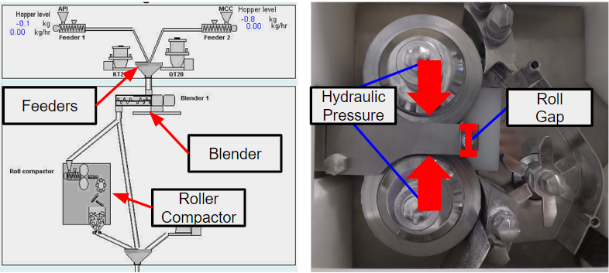
Figure 2. Pilot Plant and Roller Compactor Setup

For the following experiments, the controlled variables and their ranges are as follows: Roll Gap (1.6-2.8 mm), Roll Speed (4 RPM), Hydraulic Pressure (30-90 bar), and Feed-Screw Speed (20-50 RPM). Roll gap and hydraulic pressure are the two main variables of focus. It is important to note that all experiments mapping the roller compactor parameters were conducted using pure Microcrystalline Cellulose (MCC) 102 to simplify both the procedure and results. The incorporation of the effects of variation in composition on ribbon splitting is part of the second phase of the study. The roller compactor, feeder, and hopper were cleaned between runs as any stray powder can risk contamination of the ribbon and lead to inaccurate results. Runs were conducted for five minutes, to ensure steady-state was reached, and the steady-state process data was collected. This process data would be crucial to building a machine learning model for ribbon splitting in future works. Most sets of conditions were replicated.

2.1.2 Change of Composition Experiments
The second feeder in the pilot plant was added into the experimental design to vary the composition of the powder blend produced in the blender. The same procedure was followed, but this time, a focus was put on roller compactor conditions that resulted in not-split ribbons. After observing that the ribbon was not-splitting, and that the roller compactor was in steady-state, the second feeder was manually activated (introducing another material), and further observations were made to see if the ribbon splitting behavior changed. The first feeder (supplying MCC) flow rate was set at 9.00 kg/h, while the second feeder (supplying the API) flow rate was set at 1.00 kg/h. In these experiments, the API was Acetaminophen.
  - Results and Discussion
    - Mapping of Roller Compactor Parameters
Once all the process data for each run at a set of Roller Compactor parameters was collected, the relationships between splitting parameters and ribbon splitting could be illustrated. Figure 3 demonstrates one of these relationships. In ongoing work, a machine learning model is being developed to capture these relationships.
As shown in Figure 3, there are clear regions where ribbon splitting occurs. At higher pressures and larger roll gaps, the ribbon splitting occurs, and vice versa. This trend can be explained as follows: at larger roll gaps or higher pressures, the stress on the edges of the ribbon during compaction is much greater than the stress in the middle. When the ribbon is allowed to recover elasticity directly after compaction, the difference in stress is too much and the ribbon splits in two (Mahmah et al, 2019). At smaller roll gaps and lower pressures, the difference in stress along the height of the ribbon is less during compaction, allowing for the ribbon to remain intact.
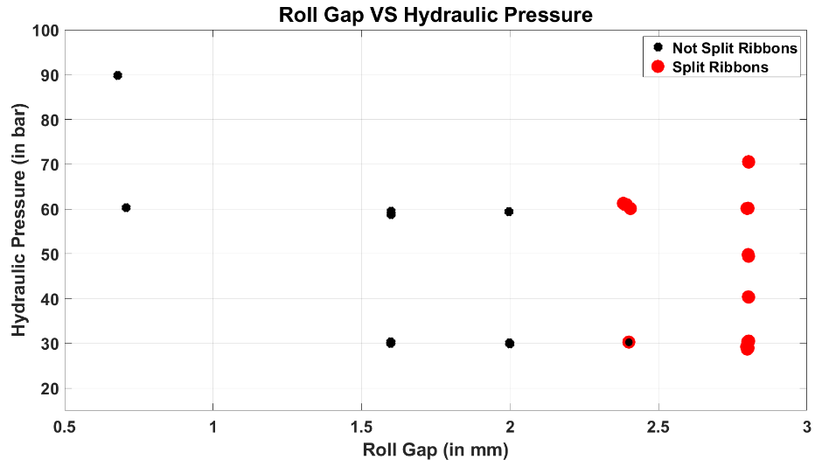
Figure 3. Average Roll Gap at Steady State vs Average Hydraulic Pressure at Steady State, with each point denoted as Split or Not-Split Ribbon. The red points signify split ribbons, while the black points show not-split ribbons.

    - Change of Composition Experiments
With a map of roll gap and hydraulic pressure defined in Figure 3, the ribbon splitting phenomena can be explored as a possible monitoring tooling for the continuous dry granulation process. The map gives a prediction of ribbon splitting behavior for 100% excipient composition. The composition was changed under two different roller compactor sets of variables. The first set of roller compactor parameters was closer to the boundary between splitting and not-splitting regions, while the second condition was farther away from this boundary. The goal was to see how much composition impacts ribbon splitting, since the conditions closer to the possible ribbon splitting boundary should be more sensitive to changes in feed composition when compared to conditions farther from the boundary.

      - Changing Composition Impacts Ribbon Splitting Behavior Example
Figure 4 (A) shows the timeline of a trial in which the Roller Compactor is set at 60 bar and a roll gap of 2.0 mm. As predicted by the ribbon splitting map in Figure 3, the ribbon does not split initially. However, at t = 90 seconds, the API feeder is turned on, continuously adding the second component (API) to the feed. At t = 265 seconds, the ribbon splitting behaviour changes from not-splitting to splitting.
The delay between contaminant being added to the system and ribbon splitting behaviour changing is due to the residence time of the contaminant in the blender and Roller Compactor Hopper. The ribbon splitting behaviour could not change until the contaminated mixture reached the Roller Compactor, and there was change in the composition of the material being compressed.
      - Changing Composition Does Not Impact Ribbon Splitting Behavior Example
While there was a change in ribbon splitting behaviour in the previous example, this is not always the case. Figure 4 (B) shows the timeline of a run in which the Roller Compactor is set at 60 bar and a roll gap of 1.6 mm. As predicted by the ribbon splitting map in Figure 3, this ribbon does not split initially. When looking at Figure 3 and the previous example, one might expect this experiment to have a switch in ribbon splitting behaviour once the second component is added. However, that is not the case.

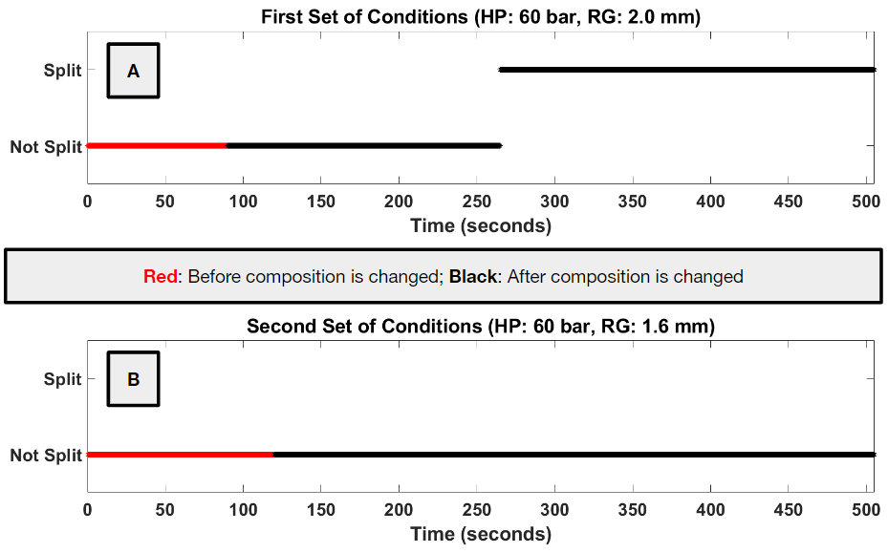

Figure 4. (A) First Set of Roller Compactor Conditions: Hydraulic Pressure: 60 bar; Roll Gap: 2.0 mm. Ribbon splitting occurs at 265 seconds. (B) Second Set of Roller Compactor Conditions: Hydraulic Pressure: 60 bar; Roll Gap: 1.6 mm. In both cases, API Feeder turned on at 90 seconds.

Despite a change in composition, the ribbon splitting behavior did not change. This demonstrates that while ribbon splitting is a function of composition, the operating variables of the roller compactor are also important. This supports the idea that there exists a more complex boundary in the ribbon splitting map, separating the not-split and split ribbon conditions. The closer a condition is to that boundary; the more sensitive ribbon splitting is to changes in composition.
    - Monitoring Roller Compactor Operating Errors
While generating Figure 3 to find regions of splitting and not-splitting amongst the roller compactor parameters, the roller compactor would malfunction from time to time. Table 1 shows one of these cases, where the relative standard deviations for the second run are much higher than the first, and ribbon splitting behavior changes. Instead of having to check the process data for unusual variations around the set point, the ribbon splitting could be monitored. If the ribbon splitting had unexpected behaviour, that could notify the operator that something is wrong and stop the process for inspection.
Table 1. Ribbon Splitting Experiments where the Roller Compactor Malfunctioned
Roll Gap Set Point | Average Roll Gap | Roll Gap Relative  St Dev | Hydraulic Pressure Set Point | Average  Hydraulic Pressure | Hydraulic Pressure Relative St Dev | Expected Splitting Behavior | Splitting Behavior
2.0 | 1.996 | 0.0116 | 60 | 59.425 | 0.0018 | Not-Split | Not-Split
2.0 | 1.992 | 0.1885 | 60 | 59.716 | 0.0109 | Not-Split | Split

  - Conclusions
Ribbon Splitting can be controlled, in part, by hydraulic pressure and roll gap. At higher pressures and larger roll gaps, the ribbon is more likely to split when it leaves the rollers. Composition can also impact ribbon splitting. In ongoing work, additional data is being generated to fill out the ribbon splitting map to better define the split and not-split regions.
Using the additional data points generated at different compositions, a machine learning model will be implemented to more precisely quantify the boundary between the split and not-split regions. Using this model, for the given feed composition and set of roller compactor conditions, prediction of the behavior of ribbon splitting will be enabled. A camera sensor could be integrated into the roller compactor to monitor the ribbon state. If ribbon behavior is found to deviate from model prediction, an alert would be issued to the operator. As further development, a control schema could be implemented which if splitting occurred would adjust compactor variables to achieve a feasible no-split condition.
Acknowledgements
This work was supported by the NSF under grant #2140452. The authors would like to thank Abigail Delaney, Dr. Yan-Shu Huang, and the Purdue CP3 lab, as well as Prof. Jim Lister and Dr. Chalak Omar from Sheffield University.
References
Y-. S. Huang, D. Sixon, P. Bailey, R. Lagare, M. Gonzalez, Z. Nagy, G. Reklaitis, 2023, A Machine Learning-assisted Hybrid Model to Predict Ribbon Solid Fraction, Granule Size Distribution and Throughput in a Dry Granulation Process, Computer Aided Chemical Engineering, 52, 813-818.
O. Mahmah, M. J. Adams, C. Omar, B. Gururajan, A. Salman, 2019, Roller compaction: Ribbon splitting and sticking, International Journal of Pharmaceutics, 559, 156-172.
C. Sun, P. Kleinebudde, 2016, Mini review: Mechanisms to the loss of tabletability by dry granulation, European Journal of Pharmaceutics and Biopharmaceutics, 106, 9-14.

