Distillation Electrification Through Optimal Use of Heat Pumps
Akash Nogajaª, Mohit Tawarmalani^{a,b}, Rakesh Agrawalª*
ªDavidson School of Chemical Engineering, Purdue University, West Lafayette, IN, USA
^{b}Daniels School of Business, Purdue University, West Lafayette, IN, USA
*agrawalr@purdue.edu
Abstract
Decarbonization of the chemical industry necessitates a careful evaluation of the ways in which unit operations are employed. Decarbonizing distillation, which accounts for 90-95% of liquid separations, presents a unique challenge and an opportunity to significantly mitigate chemical sector’s carbon emissions on a global scale. Electrification of distillation via the use of vapor compression heat pumps has shown promising results for a variety of binary mixtures. This research explores diverse electrification methods, focusing on Mechanical Vapor Recompression - Heat Pumps (MVR-HP) and delving into the integration of intermediate reboilers/condensers and multi-effect systems. We demonstrate various strategies that reduce energy consumption beyond the simple binary MVR-HP while adhering to CAPEX constraints.
Keywords: Distillation, Heat Pump, Decarbonization
  - Introduction
At the core of chemical and petrochemical sectors, downstream thermal separations play a pivotal role, accounting for a substantial percentage of their energy consumption and operational costs. The most prevalent thermal separation technique, distillation, alone consumes approximately 2.4 Quads per year (energy equivalent to 431 million bbl. of oil) in the United States (Chapas & Colwell, 2007). While distillation systems bolster the global economy, they concurrently contribute substantially to carbon emissions. A 10% reduction in distillation energy consumption has the potential to mitigate CO₂ emissions by approximately 5.3 million tons per year (Environmental Protection Agency, 2008). The aforementioned discussion underscores the imperative need to transition such energy-intensive processes toward more sustainable technologies (Mallapragada et al., 2023).
Traditionally, thermal separations have been reliant on heat generated from the condensation of steam, which, in turn, is primarily produced using fossil fuels. This dependence on fossil fuels as the heat source has been the primary driver of the carbon intensity associated with thermal separations. In our study, we advocate for the transition to electricity as the energy source, with the underlying assumption that the proportion of renewable electricity will witness a substantial increase in the near future (Agrawal & Siirola, 2023). However, our findings reveal that, despite the current economy's reliance on burning fossil fuels for a substantial share of electricity, employing optimally electrified distillation systems remains advantageous compared to traditional steam-driven distillation. In most cases, optimally electrified systems exhibit lower effective fuel consumption, considering both the fuel required for steam generation and electricity production.
Identifying an 'optimally electrified distillation system' using commercial process simulators can prove to be prohibitively complex even for a binary distillation system (Tumbalam Gooty et al., 2021). Heat pumps (HP) are widely acknowledged as one of the most energy-efficient electrification methods, effectively harnessing the heat released at the condenser to power the reboilers (Null, 1976). Various heat pumping technologies, such as mechanical vapor recompression (MVR), bottom flashing, external loop vapor compression, absorption heat pumps, etc., can be the optimal choice depending on the specific application (Kiss & Infante Ferreira, 2016). Moreover, the energy efficiency of such systems can potentially be enhanced by incorporating strategies such as feed pre-heating, intermediate reboilers, multi-effect distillation, and similar process intensification approaches.

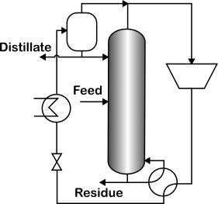
Figure 1: Mechanical Vapor Recompression assisted binary distillation system
The fundamental MVR system for binary distillation is illustrated in Figure 1. In this configuration, the overhead vapour is compressed to a higher pressure and subsequently condensed against the boiling liquid in the reboiler. The technology's high coefficient of performance (COP) and extensive applicability render it an attractive choice for electrification. For instance, Chavez Velasco et al. (2021) achieved an impressive COP of approximately 35 for the separation of p/o-Xylene. Assuming a typical power plant efficiency of 50%, the effective fuel consumption is reduced by 20 times compared to steam-driven process. The literature consistently demonstrates the success of MVR for close boiling systems, as exemplified above. In Section 3, titled 'Binary Distillation’, we present additional case studies involving mixtures with disparate component boiling points.
To maintain a focused scope, this research specifically delves into MVR-HP, chosen for its widespread applicability. We investigate pathways that reduce effective fuel consumption for binary distillation using simplified models. We rigorously validate our findings across various binary mixtures. Additionally, to further reduce fuel consumption, we consider the use of intermediate reboilers/condensers with HP Assisted Distillation (HPAD). We obtain valuable insights that can help practitioners design optimal heat pump arrangements for binary distillation systems.
Our paper is organized as follows. We first describe our shortcut model and show that it compares well with the detailed ASPEN simulations for binary distillations. Then, we use intermediate heat exchangers to improve the efficiency of HPAD. Finally, to reduce capital expenditure, we use multi-effect distillation that recovers a portion of the energy savings without operating multiple processors.
  - Model Development
Assessment of various binary arrangements for HP systems can prove to be difficult using commercial process simulators. In this section, we develop high fidelity models that can be globally optimized to find the minimum energy consumption. The Underwood equations are employed to calculate the minimum vapor requirement for any ideal split in a distillation column. However, to calculate the heat duties rather than the vapor requirement, we employ simple latent heat transformations discussed by Mathew et al. (2023) -
$$F_{i}^{LH}=F_{i}λ_{i}$$ | (1)
$F_{i}^{LH}$ is the latent heat variable defining heat flow, $F_{i}$ is the molar flow and $λ_{i}$ is the molar enthalpy of vaporization of component ‘i’ in the feed.
To ensure a positive driving force in the heat exchanger involving condensation of compressed vapor and boiling liquid, we introduce a simple surrogate model (Nogaja et al., 2022)
$$T=\frac{B_{mix}}{A_{mix}+ln\left(ρ\right)}-C_{mix}; ρ=\frac{P^{ref}}{P}\sum_{i}{α_{i}x_{i}}$$ | (2)
The parameters $A_{mix},B_{mix}$ and $C_{mix}$ are specific to a mixture and are trained using data from experiments or detailed thermodynamic models. The variable $ρ$ captures the thermodynamic state (liquid fraction) of the stream.
To calculate the HP work, we employ a simple Carnot approximation of the isentropic compressor. These equations are combined together in a systematic framework and optimized using Gurobi 9.1 to yield the global minimum energy.
  - Binary Distillation Systems
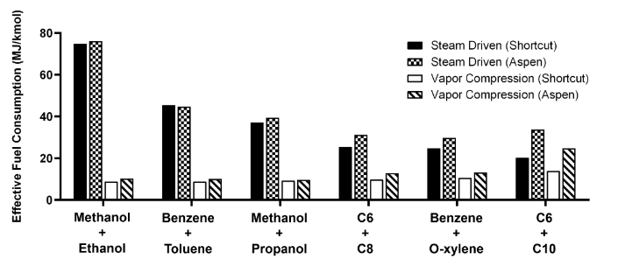
To validate the constructed simplified model, we apply it to multiple equimolar binary steam-driven and HPAD systems featuring varying component boiling point differences. These flowsheets are also simulated using ASPEN Plus V11, and a comparative study of the shortcut model and the process simulator is illustrated in Figure 2. The model demonstrates robust performance for mixtures with close boiling points but exhibits diminishing accuracy as the boiling point differences increase.
Figure 2: Comparison of shortcut model for binary distillation systems with ASPEN Plus V11. The temperature difference between the components of the mixture increase along the X axis.
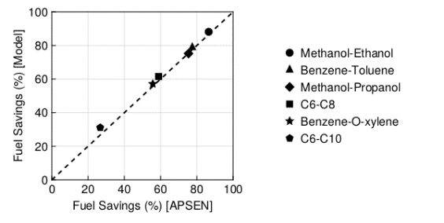
Nevertheless, the shortcut model displays a strong agreement with the percentage reduction in fuel consumption achieved by switching to vapor compression (refer to Figure 3). Given that the research's objective is a comparative analysis and identification of lucrative HPAD configurations, the shortcut model offers a reasonable substitute that allows global optimization techniques.
Figure 3: Percent decrease in effective fuel consumption by switching to vapor compression HP
  - Benefits of Intermediate Reboiler / Condensers
Intermediate Reboilers (IR) and Condensers (IC) are recognized for enhancing the exergy efficiency of distillation columns (Agrawal & Herron, 1998). IRs can supply a portion of the energy required by the distillation column at a lower temperature than the reboiler, while ICs can remove heat at a temperature higher than the condenser. However, despite their second law benefits, they do not reduce energy consumption in traditional steam driven distillation systems.
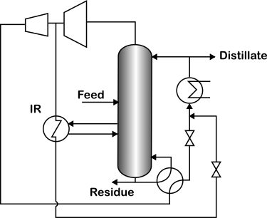
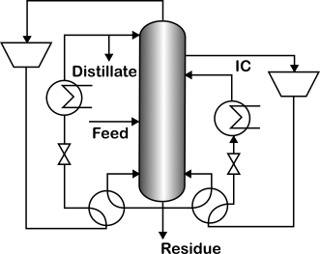
In the context of Heat Pumps, where energy consumption depends on both heat (first law) and temperatures (second law), IRs and ICs present an opportunity for further reducing energy consumption. Figure 4 depicts the strategies incorporating a heat pump link between (a) the top condenser and IR and (b) IC and bottom reboiler. Note that the heat pump between the top condenser and the bottom reboiler remains active, albeit with a reduced heat load.
(a)
(b)
Figure 4: Operational enhancement of Binary Distillation using Heat Pump, featuring Heat Pump integration between (a) Condenser and IR and (b) IC and Reboiler
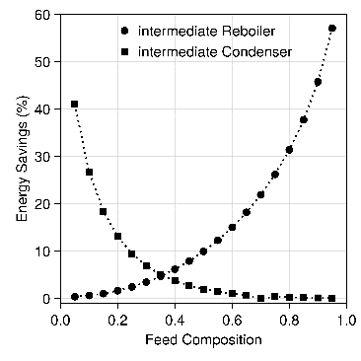
Taking the example of the Benzene – Toluene equimolar mixture presented in Section 3, the IR assisted HPAD reduces energy demand further by approximately 10% compared to simple HPAD. On the other hand, IC-assisted HPAD decreases energy consumption by approximately 2%. Therefore, while the savings with IR-HPAD are significant, the energy savings with IC-HPAD do not justify the added operational complexity. However, when the feed sis richer in the heavier component, IC-HPAD begins to demonstrate noteworthy energy savings (refer to Figure 5). In contrast, IR-HPAD saves more when the feed is richer in the lighter component.
Figure 5: Variation of percent reduction in energy consumption by IR and IC - HPAD as compared to Binary VR-HPAD with feed composition
Although IR/C lead to significant energy savings, they require additional capital expenditure owing to the presence of either a multi-stage compressor (IR-HPAD) or the use of two distinct compressor units (IC-HPAD). To mitigate this concern, we introduce a strategy that utilizes a single compressor but improves the efficiency of MVR-HP.
  - Multi-effect Heat Pump Assisted Distillation (ME-HPAD):
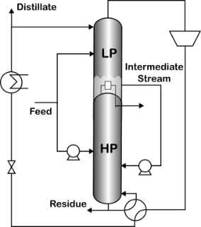
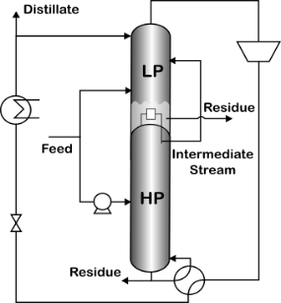
Multi-effect distillation systems are extensively employed to significantly reduce the required heat duty. Introducing heat pumps in multi-effect systems creates two competing effects – the overall heat requirement of the separation system decreases, but at the expense of elevating the pressure and consequently, the temperature of the high-pressure column. The interplay between these two factors determines the energy savings of these systems beyond simple MVR-HP. Figure 6 shows the proposed ME-HPAD systems. The columns of configuration (a), operating without heat pump and at the same pressure, is theoretically equivalent to IR system. Similarly, configuration (b) is the equivalent of IC. However, increasing the pressure of the HP column limits the energy savings that can be derived from the system.
(a)
(b)
Figure 6: ME - HPAD systems for binary systems. Strategy (a) excels with mixtures having feeds rich in the lighter component, while (b) is preferable for feeds rich in the heavier one.
In the case of the Benzene-Toluene system, with a feed stream comprising of 75% benzene, configuration (a) exhibits an 18% lower energy consumption compared to simple single column MVR-HP. Similarly, for a feed stream with 25% benzene composition, configuration (b) saves 6% energy. For reference, IR (resp. IC) presents 26% (resp. 9.4%) energy reduction for 75% (resp. 25%) benzene composition feeds. Hence, even with a single compressor, ME-HPAD can reduce energy consumption further when compared to a simple single column VRC.
  - Conclusions
Mechanical Vapor Recompression (MVR) offers an energy-efficient strategy for mitigating carbon emissions in binary distillation systems. Our examples demonstrate that, even in the current economy where a significant share of electricity is generated by burning natural gas and other fossil fuels, MVR effectively reduces fuel consumption.
When designing such systems, it is essential not to limit considerations to heat pump links operating solely between the top condenser and the bottom reboiler. Exploring HP links involving intermediate reboilers and condensers can further decrease energy consumption, particularly for feeds with an imbalance in component concentrations.
Nevertheless, IR/IC systems necessitate the operation of at least two compressors. We show that by employing equivalent Multi-Effect Distillation (MED) systems for IR and IC, energy consumption can be reduced. Although the reduction is not as much as with IR/IC - HPAD systems, it remains significant when compared to a simple VRC-HP.
  - Acknowledgements
The authors thank the National Science Foundation under Cooperative Agreement No. EEC-1647722 for funding.
References
Agrawal, R., & Herron, D. M. (1998). Efficient use of an intermediate reboiler or condenser in a binary distillation. AIChE Journal, 44(6), 1303–1315.
Agrawal, R., & Siirola, J. J. (2023). Decarbonization of Chemical Process Industries via Electrification. The Bridge, 32–40.
Chapas, R. B., & Colwell, J. A. (2007). Industrial Technologies Program Research Plan for Energy-Intensive Process Industries.
Chavez Velasco, J. A., Tawarmalani, M., & Agrawal, R. (2021). Systematic Analysis Reveals Thermal Separations Are Not Necessarily Most Energy Intensive. Joule, 5(2), 330–343.
Environmental Protection Agency. (2008). Greenhouse Gas Equivalencies Calculator | US EPA. https://www.epa.gov/energy/greenhouse-gas-equivalencies-calculator
Kiss, A. A., & Infante Ferreira, C. A. (2016). Heat Pumps in Chemical Process Industry. CRC Press.
Mallapragada, D. S., Dvorkin, Y., Modestino, M. A., Esposito, D. V., Smith, W. A., Hodge, B.-M., Harold, M. P., Donnelly, V. M., Nuz, A., Bloomquist, C., Baker, K., Grabow, L. C., Yan, Y., Rajput, N. N., Hartman, R. L., Biddinger, E. J., Aydil, E. S., & Taylor, A. D. (2023). Decarbonization of the chemical industry through electrification: Barriers and opportunities. Joule, 7(1), 23–41.
Mathew, T. J., Tawarmalani, M., & Agrawal, R. (2023). Relaxing the constant molar overflow assumption in distillation optimization. AIChE Journal, 69(9).
Nogaja, A. S., Mathew, T. J., Tawarmalani, M., & Agrawal, R. (2022). Identifying Heat-Integrated Energy-Efficient Multicomponent Distillation Configurations. Industrial and Engineering Chemistry Research, 61(37). https://doi.org/10.1021/acs.iecr.2c00870
Null, H. R. (1976). Heat Pumps in Distillation. Chem. Eng. Prog., 58, 58–64.
Tumbalam Gooty, R., Chavez Velasco, J. A., & Agrawal, R. (2021). Methods to assess numerous distillation schemes for binary mixtures. Chemical Engineering Research and Design, 172, 1–20.

