Computer-aided Molecular and Process Design (CAMPD) for Ionic Liquid Assisted Extractive Distillation of Refrigerant Mixtures
Ashfaq Iftakher,ª Rafiqul Gani,^{b,c,d} M. M. Faruque Hasan^{a,e,*}
ªArtie McFerrin Department of Chemical Engineering, Texas A&M University, College Station, TX, USA
^{b}PSE for SPEED Company, Ordrup Jagtvej42D, DK-2920 Charlottenlund, Denmark
^{c}Sustainable Energy and Environment Thrust, The Hong Kong University of Science and Technology (Guangzhou), Guangzhou, China
^{d} Department of Applied Sustainability, Széchenyi István University, Győr, Hungary
^{e}Texas A&M Energy Institute, Texas A&M University, College Station, TX 77843-3122, USA
hasan@tamu.edu
Abstract
Computer-aided Molecular and Process Design, CAMPD, is a technique that simultaneously optimizes the choice of materials, such as solvents, and the corresponding process configurations for many chemical separation processes. The technique involves formulating an equation-oriented optimization model representing the overall design problem, which then can be solved in many ways depending on the chemicals involved, the property and process models, and the complexity and size of the problem, among others. Due to the complexity and large-size of the problem, and a lack of predictive property models, we have applied a decomposition-based CAMPD strategy that involves solving a series of subproblems sequentially to reduce the overall search space, thereby reducing the computational burden. We illustrate our strategy through a case study involving the design of ionic liquids (ILs) as solvents for the extractive-distillation based separation of an azeotropic refrigerant mixture, R-410A. Separation of such mixtures is gaining increased interest due to the need to remove, substitute or reuse constituent refrigerant chemicals that have undesirable properties (such as high global warming potential, flammability, etc.). ILs are considered because of their designable properties as functions of their molecular structures. Based on available measured data, group-contribution based predictive property models have been developed and interfaced with the workflow of the proposed strategy. A set of promising ILs have been identified and their performance verified through process simulation.
Keywords: CAMPD, Group contribution, Solvent Design, Process and Product Design, Mathematical Modeling, Optimization
  - Introduction

The systematic identification of optimal materials and processes is often realized through Computer-aided Molecular and Process Design (CAMPD). The influence and importance of the selection of materials on the overall performance of chemical separation processes have been highlighted in the past (e.g., Liu et al., 2018; Iftakher et al. 2023). A typical CAMPD problem can be formulated as a mixed-integer non-linear programming (MINLP) problem, as shown in Eq. (1).

$$\min_{m,η}{ C(η,p)}$$  $\text{s.t. }$ $p=f(m,η)$  $s\left(m\right)≤0$  $g\left(η\right)≤0$  $h\left(η,p\right)=0$  $m∈Z_{+}^{d}, η∈R^{n}×Z_{+}^{w}$ |  | (1)

where, the decision variables include both discrete and continuous variables. Molecular design involves finding the optimal values for a set of integer variables ($m$) that represent the building blocks or groups representing the material (solvent). Process design and configuration involves finding the optimal values for a set of process variables ($η$) that represents the process design specifications that typically involve a subset of integer variables (e.g., feed location, number of column stages, etc.) and a subset of continuous variables (e.g., solvent flow rate to the extractive distillation (ED) process, reflux ratio, operating pressure, and temperature, etc.). The objective function $C$ minimizes the process operating cost in this example and is subject to a set of constraints. The constraint $p$ involves bounds on thermodynamic and transport properties that are predicted through the molecular structure-property relationships. The constraint $s$ involves a set of molecular structural constraints that ensure that the constructed molecule satisfies atom balance. The constraint $g$ involves process constraints, while the constraint $h$ involves the governing mass and energy conservation of the process.

While the design of organic solvents integrated with separation process design is well-developed (Hostrup et al. 1999, Bardow et al. 2010, Burger et al. 2015, Liu et al. 2018 - to cite a few), the design of ionic liquids (ILs) together with the design of the separation process is relatively new (Song et al. 2018, Chen et al. 2019, Zhou et al. 2021 – to cite a few). Solving CAMPD problems with accurate but computationally expensive property and process models has been a challenge due to the nonlinearity and nonconvexity of these models when ionic liquids are considered as solvents. Also, CAMPD is a multi-scale optimization problem, as it integrates molecular to process level decisions, making it difficult to solve even using the state-of-the-art solvers (Misener and Floudas, 2014).

In this work, we propose a multi-level decomposition framework that decomposes the overall CAMPD into a set of sub-problems, thereby facilitating the optimal/near-optimal design of sustainable, energy-efficient, and cost-effective chemical processes. In particular, we employ the well-known and simple group-contribution (GC) based models together with complex but accurate machine-learning (ML) based models for IL-related property estimations. As both these types of models need measured data, which are not available in sufficient amounts, truly predictive property models, such as the COSMO-based models (Jaschik et al., 2017) are used for generation of gas solubility data needed for design as well as for developing models. The overall optimization model is then decomposed based on the target solvent-process constraints. We illustrate our framework through the solution of an industrially relevant problem, namely the selection of optimal/promising ionic liquid (IL) and the configuration of an ED process for separating
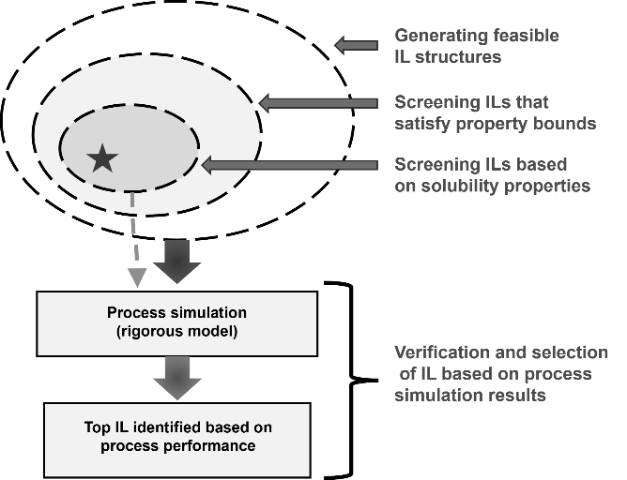
Figure 1: Decomposition of CAMPD for refrigerant separation using ionic liquid
R-410A ($50 wt\% - 50 wt\%$ mixture of R-32 and R-125) refrigerant mixture. ILs are promising solvent candidates due to their high thermal and chemical stability as well as selective gas solubility. However, their design space can potentially be very large due to the likely assignments (combinations) of their anion and cation parts. Also, designing an ED process is highly non-trivial due to the existence of many degrees of freedom. To overcome these challenges, we decompose the CAMPD problem into a series of subproblems to sequentially reduce the overall search space. We first generate a set of structurally feasible ILs (depicted by the outer circle in Figure 1). We then use the developed GC- and ML-based property models (density, viscosity, surface tension and melting point) for ILs and use them to screen the promising IL-candidates based on a set of desired property ranges (depicted by the darker inner circle of Figure 1). Next, we use the developed GC-based gas solubility models and use them to qualitatively identify a reduced number of ILs for selective separation of the R-410A chemicals (depicted by the smallest inner circle of Figure 1). Finally, for the most promising IL, we verify the process performance through rigorous process simulation.

  - Decomposition of CAMPD for Ionic Liquid Design

The solution to the CAMPD is achieved through three sequential steps as illustrated in Figure 1.
    - Step 1: Generating structurally feasible IL structures
We first generate a set of feasible IL structures by considering the structural feasibility constraints. Each IL is assumed to be constructed by a cation core, an anion, and an alkyl side chain that is attached to the cation core. For example, 1-butyl-3-methylimidazolium chloride contains an imidazolium cation core, a chloride anion, and a butyl side chain. IL-structural constraints are described in Eq. (2).

$\sum_{j∈Ca}{c_{j}=1}$ ; $\sum_{j∈An}{c_{j}=1}$ ; $\sum_{j∈Ca∪Sub}{\left(2-v_{j}\right)⋅c_{j}-2=0}$  $$LB≤\sum_{j∈Sub}{c_{j}≤UB}$$ | (2)
where, the first and second constraints ensure that a feasible IL contains only one cation and anion. The third constraint ensures that a feasible IL must satisfy the octet rule, i.e., there must not be any free bonds (Karunanithi et al., 2005). The final constraint provides a bound on the number of groups that can be present in the side chain to ensure generation of a finite number of ILs.
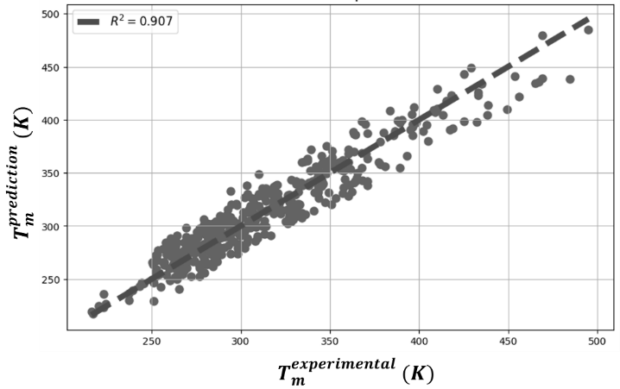
Figure 2: GC-based model for IL melting point
    - Step 2: Screening ILs based on pure component and solubility property bounds
In this step, we screen the ILs (that are generated in Step 1) based on the bounds on viscosity, density, and melting point. Viscosity influences the ED column sizing. Density determines the degree of gas diffusivity in ILs, whereas melting point ensures that the selected IL remains liquid at the operating conditions. To predict these properties, we have developed a GC-based model for melting point ($T_{m}$) and trained an Artificial Neural Network with Rectified Linear Unit as activation function (ReLU-ANN) for density ($ρ$) and viscosity ($μ$). The limited availability of data along with the high variability (uncertainty) in the dataset makes it difficult to model $T_{m}$ for ILs. To address this issue, we have carefully collected melting point data for 471 ILs (Paduszynski et al., 2021) and have developed a GC-based model whose performance is shown in Figure 2. For density (31167 temperature and pressure dependent data points) and viscosity (14337 temperature dependent data points), we have achieved good fit for the trained ReLU-ANN model. Regarding mixture properties, we select solubility (and selectivity) as it dictates the degree of selective absorption of refrigerants in IL which are defined in Eq. (3).

$solubility, S=\frac{1}{γ^{∞}}$ ; $selectivity, S_{H}^{R32/R125}={\left(\frac{K_{H_{R125}}}{K_{H_{R32}}}\right)}_{T}$ | (3)
where, $γ^{∞}$ is the activity coefficient at infinite dilution, and $K_{H}$ is the Henry’s constant measured at a specified temperature and is defined as $=\lim_{x→0}\left(\frac{P}{x}\right)$. To capture the selective solubility of ILs towards R-32 or R-125, we predict Henry’s constant of R-32 and R-125 in ILs through a GC model.
    - Step 3: Process simulation for the set of promising IL-candidates
For the set of screened ILs after Step 2, we perform simulation for the ED process to quantify process performance. We use the Non-Random Two Liquid (NRTL) model. Using the available measured vapor liquid equilibrium (VLE) data, we first regress the NRTL model parameters to compute the activity coefficient ($γ$). In the absence of sufficient measured data, the predicted Henry’s constants through the GC-based model could directly be used to compute the infinite dilution activity coefficient as follows: $γ^{∞}=\frac{K_{H}}{P^{sat}}$ , where $P^{sat}$ is the saturation vapor pressure of the refrigerant.
  - Results for R-410A separation
In Step 1, we generate 710 feasible IL structures that contain 47 cation cores, 48 anion cores and 43 side groups. In Step 2, we then screen the ILs based on the following property bounds: $40 \text{K}≤T_{m}≤303 \text{K}$,$900\frac{kg}{m^{3}}≤ρ≤1600\frac{kg}{m^{3}}$, $3 mPa.s≤μ≤1000 mPa.s.$ From an initial pool of 710 ILs, 315 ILs satisfied the specified property bounds. After that, we further screen the ILs based on mixture properties. Finally in Step 3, among the feasible ILs that satisfy both the pure component properties and the solubility properties, we select a small set of 12 promising ILs as listed in Table 1. The GC model for these ILs also show qualitatively correct trend of solubility and selectivity for R-32 compared to R-125. Also, for these ILs, measured VLE data are available. From the set of promising ILs, we select [EMIM][DCA] to evaluate the process performance. The process configuration is preconceived from our previous work (Monjur et al., 2022). We then simulate the process in Aspen Plus v12 with the objective to achieve high recovery of both R-32 and R-125 ($>99.5 wt\%$). The simulated process flowsheet is shown in Figure 3. The IL is introduced to the column at 3rd stage while the R-410A mixture is introduced to the column at 15th stage. There are 30 stages in total. $99.5 wt\%$ R-125 is separated from the top of the ED column. The IL+R-32 stream comes out from the bottom of the column and then is fed to the flash separator. From the top of the flash separator, $99.6 wt\%$ R-32 is separated, and the IL is recycled back to the ED column. Therefore, highly selective separation of the azeotropic R-410A refrigerant mixture is achieved.

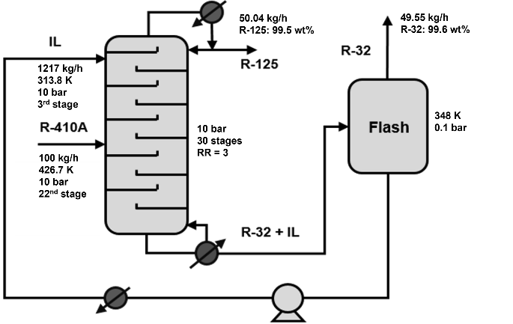

Figure 3: ED process for R-410A separation

Table 1: List of promising ILs with experimental and predicted Henry’s constants
ILs | Measured |  | GC Model
 | $$K_{H_{R32}}$$ | $$K_{H_{R125}}$$ | $$K_{H_{R32}}$$ | $$K_{H_{R32}}$$
[EMIM][SCN] | 4.45 | 26.96 | 3.56 | 37.96
[EMIM][Ac] | 2.51 | 2.89 | 2.51 | 2.89
[EMIM][DCA] | 2.91 | 15.79 | 2.79 | 11.93
[EMIM][OTF] | 1.76 | 3.60 | 1.98 | 1.99
[EMIM][TF2N] | 1.24 | 1.32 | 1.43 | 0.38
[BMIM][SCN] | 2.38 | 50 | 3.26 | 39
[BMIM][DCA] | 2.37 | 9.11 | 2.49 | 12.97
[BMIM][BF4] | 1.39 | 6.25 | 1.57 | 4.22
[HMIM][BF4] | 1.45 | 3.23 | 1.27 | 5.26
[HMIM][OTF] | 1.60 | 2.45 | 1.38 | 4.06
[HMIM][TF2N] | 1.03 | 1.52 | 0.83 | 2.46
[HMIM][FAP] | 0.75 | 1.32 | 0.75 | 1.32
  - Conclusions
We developed a decomposition-based strategy to efficiently solve CAMPD problems focusing on the design of ionic liquid-based solvents for the extractive distillation-based separation of R-410A mixtures. We have developed GC and ML-based models for key IL properties. After generating an initial pool of ILs and subsequently applying property-based constraints, we have identified a set of ILs that show promise for highly selective separation for R-410A with favourable process performance. The simulated process for [EMIM][DCA] shows highly selective separation of both R-32 and R-125, thereby verifying the decomposition-based solution strategy. As a current and future work, we are generating IL-based gas solubility data through the predictive COSMO-sac model to use them as pseudo-measured data to develop GC-based models for a wider application range so that better IL-solvents can be found and to make the applied CAMPD more versatile. Preliminary results have shown sufficient promise to pursue this option.
References
A. Bardow, K. Steur, J. Gross, 2010, Continuous-Molecular Targeting for Integrated Solvent and Process Design, Industrial & Engineering Chemistry Research, 49, 6, 2834-2840
J. Burger, V. Papaioannou, S. Gopinath, G. Jackson, A. Galindo, C. S. Adjiman, 2015, A hierarchical method to integrated solvent and process design of physical CO₂ absorption using the SAFT‐γ Mie approach, AIChE Journal, 61,10, 3249-3269
Y. Chen, E. Koumaditi, R. Gani, G. M. Kontogeorgis, J. M. Woodley, 2019, Computer-aided design of ionic liquids for hybrid process schemes, Computers & Chemical Engineering, 130, 106556
M. Hostrup, P. M. Harper, R. Gani, 1999, Design of environmentally benign processes: integration of solvent design and separation process synthesis, Computers & Chemical Engineering, 23, 10, 1395-1414
A. Iftakher, M. S. Monjur, M. M. F. Hasan, 2023, An Overview of Computer-aided Molecular and Process design, Chemie Ingenieur Technik, 95, 3, 315-333
M. Jaschik, D. Piech, K. Warmuzinski, J. Jaschik, 2017, Prediction of gas solubility in ionic liquids using the COSMO-SAC model, Chemical and Process Engineering, 38, 1, 19-30
A. Karunanithi, L.E.K. Achenie, R. Gani, 2005, A new decomposition based CAMD methodology for the design of optimal solvents and solvent mixtures, Industrial & Engineering Chemistry Research, 44, 13, 4785-4797
Q. Liu, L. Zhang, L. Liu, J. Du, A. K. Tula, M. Eden, R. Gani, 2018, OptCAMD: An optimization-based framework and tool for molecular and mixture product design, Computers & Chemical Engineering, 124, 285-301
R. Misener, C. A. Floudas, 2014, ANTIGONE: Algorithms for coNTinuous / Integer Global Optimization of Nonlinear Equations, Journal of Global Optimization, 59, 2-3, 503–526
M. S. Monjur, A. Iftakher, M. M. F. Hasan, 2022, Separation process synthesis for high-gwp refrigerant mixtures: Extractive distillation using ionic liquids. Industrial & Engineering Chemistry Research, 61(12), 4390-4406
K. Paduszynski, K. Klebowski, M. Krolikowski, 2021, Predicting melting point of ionic liquids using QSPR approach: Literature review and new models, Journal of Molecular Liquids, 344, 117631
Z. Song, T. Zhou, Z. Qi, K. Sundmacher, 2018, Systematic method for screening ionic liquids as extraction solvents exemplified by an extractive desulfurization process, ACS Sustainable Chemistry & Engineering, 5 (4), 3382-3389
T. Zhou, R. Gani, K. Sundmacher, 2021, Hybrid data-driven and mechanistic modeling approaches for multiscale material and process design, Engineering, 7 (9), 1231-1238

