Dynamic Modelling of a Milk Triple Effect Falling Film Evaporator with Mechanical Vapor Recompression

Hattachai Aeowjaroenlapa, Jakob Strohmb, Isuru Udugamaa, Wei Yua, Brent Younga*

aThe University of Auckland, Auckland 1010, New Zealand

bTechnical University of Munich, Munich 80333, Germany

b.young@auckland.ac.nz

Abstract

The dairy industry plays a crucial role in the global food supply chain, with milk powder processing plants being integral components of this industry. The efficient operation of the plant is essential to ensure high-quality milk powder production while minimizing resource consumption and operational costs. Conventional steady-state modelling is not enough to handle the complex dynamic scenarios in the plant, as well as the demonstration of process control. In this work, we developed a novel dynamic model with integrated control loops for a Triple Effect Falling Film Evaporator with Mechanical Vapor Recompression (MVR) using the industrial process simulator, Aspen HYSYS. To represent the complexity of real compounds, we simulated milk by employing hypothetical components based on literature data and regressions. We then investigated the effects of changes in milk composition, production throughput, and product quality versus energy consumption on the industrial standard control-based control scheme with both feed-forward and feedback elements. Finally, model limitations and future possibilities were also examined.

**Keywords**: Milk Evaporator, Dynamic Modelling, Process Control

* 1. Introduction

The significance of food processing in modern society is continually growing, and in New Zealand, dairy products play a vital role in contributing to the economy (Ballingall and Pambudi, 2017). One of the most important parts of the dairy industry is the large-scale production of milk powder, a process characterized by the removal of water under strictly hygienic conditions, all executed with a focus on minimizing costs (Packer *et al*., 1998). Evaporation is the second most energy-intensive stage in milk powder production, behind the drying process (Ruan *et al*., 2015). Some researchers have suggested energy-saving opportunities, including evaporating milk at temperatures exceeding 70°C using multi-effect evaporators and employing mechanical vapor recompression (MVR) in conjunction with falling-film evaporators (Bylund, 2003; Pisecky *et al*., 2012).

For modelling and simulation studies, there is a limited amount of literature addressing the modeling of falling-film evaporators for milk powder application using industrial process simulators (Zhang *et al*., 2018). Previously, researchers have done extensive studies on developing artificial milk components in commercial process simulation software (Zhang *et al*., 2014; Munir *et al*., 2016). Subsequently, a steady-state model of a commercial multiple effects Falling Film Evaporator (FFE) was proposed (Zhang *et al*., 2018). In this study, we extend these prior efforts by developing a dynamic model of a triple-effect falling film evaporator tailored for the milk powder production process and then integrating it with a conventional process control scheme currently used in the actual plant.

* 1. Process Description

Generally, the water content in raw milk varies, typically ranging from 87 wt% to 91 wt%. To transform milk into milk powder, the removal of this water is essential, achieved through the evaporation of water in milk. While cost-effectiveness is a priority, hygiene standards must be maintained throughout the process. Moreover, it is also important to preserve desirable natural properties such as nutritional value, flavour, colour, and solubility. To meet these requirements, the process is commonly conducted under reduced pressure, lowering the boiling point of water, and therefore avoiding excessively high temperatures (Packer *et al*., 1998).

* + 1. Multi-effect Evaporator

For the evaporator, the water content in pasteurised and standardised feed milk is decreased from an initial 87 % to a final concentration of around 50 % by boiling water from the milk. Heat is a critical factor in this operation, but due to the sensitivity of certain milk components to heat, evaporation is also normally carried out under reduced pressure.

In the process, milk circulates within vertical tubes, while steam provides direct heating from the shell for evaporation. A lower pressure is maintained inside of the tubes compared to the shell side. Gravity facilitates the downward flow of liquid, creating a film on the inner tube wall. On the shell side of the FFE, the heat source, often in the form of saturated steam, provides the necessary heat for evaporation. This steam flows between the tubes, condenses, and forms a falling film on the exterior of the tubes. The heat transferred during this exchange raises the temperature of the liquid inside the tubes. The reduced pressure on the tube side results in a lower boiling point for the water within the liquid compared to the shell side steam, leading to water evaporation inside the tubes. The simplicity of this design is a key reason why falling film evaporation is favored in dairy processes. The process offers advantages such as a short residence time and a substantial heat transfer area, making it well-suited for milk powder production (Zhang *et al*., 2018). Due to the significant energy intensity of the evaporation process, Falling Film Evaporators (FFEs) are often configured as multi-effect evaporators to minimize steam consumption (Bylund, 2003).

* + 1. Mechanical Vapor Recompression (MVR)

The concept of vapor recompression involves the recycling of steam generated from the product to enhance heat recovery. Through the compression of vapor, its temperature is elevated, allowing the recompressed steam to be used in heating a subsequent effect of the Falling Film Evaporator. Mechanical Vapor Recompression (MVR) is particularly suitable for compressing larger quantities of steam, enabling a higher degree of heat recovery. In the case of MVR, electric power is employed instead of thermal energy. This introduces the opportunity to significantly decrease the reliance on thermal energy.

* + 1. Process Flow Diagram and Process Control

To study the dynamic behaviors of a triple-effect FFE with MVR in a milk powder processing plant, the process flow diagram, along with the control scheme and a simulation baseline, is shown in Figure 1.

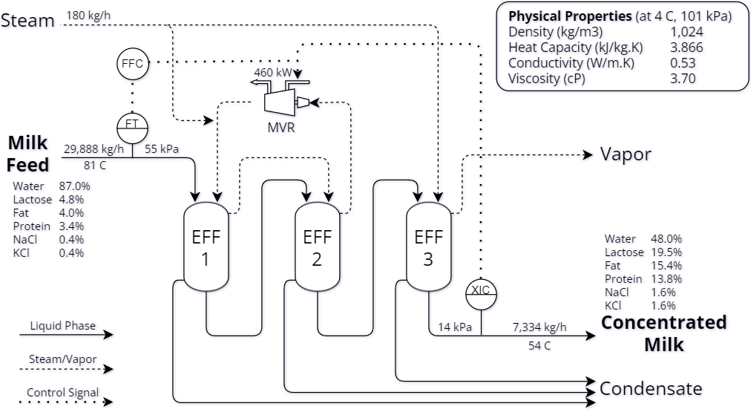

Figure 1 Process Flow Diagram (PFD)

Two conventional control loops were employed in this model. Firstly, the feed-forward control adjusted the electric power of the MVR according to the inlet flow rate of the evaporator. This scheme was designed to handle the fluctuation or the disturbance in the inlet flow. The second scheme considered the final water content in the milk product stream, which was controlled by a feedback control loop with the electric power supplied to MVR in order to ensure product quality.

* 1. Model Development in Aspen HYSYS
     1. Pseudo-milk Component

In previous research (Zhang *et al*., 2014; Munir *et al*., 2016), a simulated milk stream incorporating pseudo-milk components was developed for industrial process simulators. This involved “hypothetically” generating key components of milk, including fat, proteins, lactose, and minerals, by populating key properties in the simulator. Thermodynamic and physical properties such as heat capacity, thermal conductivity, density, and viscosity of these pseudo-milk components were developed and validated before use in the model.

* + 1. Flowsheet Model

Although Aspen HYSYS is one of the most rigorous commercial process simulation software with up-to-date databases, there is no model of an evaporator included in the model library. Therefore, a combination of shell and tube heat exchanger and separator models was utilized to represent the behaviors of the triple-effect FFE. The entire simulation flowsheet is shown in Figure 2.

Figure 2 Simulation Flowsheet in Aspen HYSYS

* 1. Results and Discussion

To investigate process stability, two operating scenarios i.e., changes in flowrate and water content of the Milk Feed stream were introduced to the process. The effect of the changes on Q-MVR and the water content in the Milk Product stream was monitored and described below.

* + 1. Changes in Feed Flowrate

In Figure 3, the results showed variations in feed flowrate at -5% and +5%, respectively. In terms of process stability, the control loops effectively returned the system to its steady state, maintaining the water content in the product at 48% despite the introduced changes. Notably, the -5% case demonstrated a significantly quicker return to a steady state compared to the other scenarios. In the standard scenario for Q-MVR, the process required 460 kW. Interestingly, when the feed was increased by +5%, the Q-MVR surged up to 1220 kW, while at -5% feed flowrate, it required only 145 kW.

Figure 3 Variations of Feed Flowrate on Process Stability

* + 1. Changes of Water Content in Feed

In Figure 4, the outcomes of variations in the water content of the Milk Feed stream, specifically +2% and -2% were presented. The control loops still maintained both the setpoint of water content in the product and process stability across the variations. Similarly, the -2% case exhibited a quicker return to a new steady state compared to the other scenarios. Moreover, the +2% case demanded a substantial Q-MVR of 1170 kW, whereas a low 140 kW was required for the -2% case.

The surges in Q-MVR observed in the higher range cases, namely +5% and +2%, could be attributed to the characteristics and efficiency of the compressor model utilized in this simulation, which required relatively higher power at higher throughput.

However, it should be noted that the Autotuning feature in HYSYS applied in this model resulted in the tuning parameters for the controllers. The result of this tuning, which is not necessarily optimal, could be seen from the observed non-linear behaviour and non-stable regions of Q-MVR and setpoints, particularly in the lower range cases, such as -5% and -2%. This research gap could be filled by the implementation of the advanced controller model and tuning strategy, which is included in our future research plans.

Figure 4 Variations of Water Content in Feed on Process Stability

* 1. Conclusions

This study described a novel dynamic model with integrated control loops for a triple-effect FFE with MVR tailored for a milk processing plant. The two control loops, aligned with the control scheme of the actual plant, allowed us to investigate the impact of variations in feed flowrate and water content on the process stability. The dynamic model could be used as a foundation for future work in controller tuning optimisation, process optimisation, and improvement in process control. The knowledge obtained from this study could also provide a stepping stone for refining operational strategies and enhancing the efficiency of milk processing plants.

References

J. Ballingall and D. Pambudi, 2017, Dairy trade’s economic contribution to New Zealand, New Zealand Institute of Economic Research

G. Bylund, 2003, Dairy Processing Handbook, Tetra Pak Processing Systems AB

M.T. Munir, Y. Zhang, W. Yu, D.I. Wilson, B.R. Young, Virtual milk for modelling and simulation of dairy processes, Journal of Dairy Science, Volume 99, Issue 5, Pages 3380-3395

J. E. Packer, J. Robertson, H. Wansbrough, 1998, Chemical Processes in New Zealand. 2nd ed. 1. New Zealand Institute of Chemistry

I.J. Pisecky, 2012, Handbook of Milk Powder Manufacture, GEA Process Engineering A.

Q. Ruan, H. Jiang, M. Nian, Z. Yan, 2015, Mathematical modeling and simulation of countercurrent multiple effect evaporation for fruit juice concentration, Journal of Food Engineering, Volume 146, Pages 243-251

Y. Zhang, M.T. Munir, W. Yu, B.R. Young, 2014, Development of hypothetical components for milk process simulation using a commercial process simulator, Journal of Food Engineering, Volume 121, Pages 87-93

Y. Zhang, M.T. Munir, I. Udugama, W. Yu, B.R. Young, 2018, Modelling of a milk powder falling film evaporator for predicting process trends and comparison of energy consumption, Journal of Food Engineering, Volume 225, Pages 26-33