Digital Twins in Operation: The Role of Robust Surrogate Modelling
Isaac Severinsenª*, Wei Yuª, Timothy Gordon Walmsley^{b}, Brent Youngª
ªDepartment of Chemical and Materials Engineering, University of Auckland, 5 Grafton Road, Auckland, 1010, New Zealand
^{b}Ahuora — Centre for Smart Energy Systems, School of Engineering, The University of Waikato, Gate 8, Hillcrest Road, Hamilton, 3240, New Zealand *isev820@aucklanduni.ac.nz
Abstract
Digital twins are becoming commonplace in many aspects of the process industry. Despite this, digital twins deployed to assist plant operations in real-time are relatively rare. This work details the unique requirements of an operational digital twin, and what separates them from existing digital twins is explored. Ultimately, this work contributes to the goal of an autonomous plant by analyzing the reliability of models trained. Operational digital twins can have more significant consequences as, in many cases, the output is not interpreted by a human. This is in contrast to other forms of digital twins used for process optimization, fault analysis, or design. This use case means that any underlying model must be extremely robust. This requirement is typically ignored in non-operational applications as modellers strive for accuracy, simplicity, or smooth convex functions. In many cases, dimensionality is reduced, which is antithetical here as the model must reflect the reality of the process and not a specified subset of the feature space. A novel method for surrogate model training is developed to improve the robustness of data driven models. This technique involves splitting the dataset based on the rarity of the datapoint with respect to observed operational conditions. The benefit of a model trained in this way is that accurate results will be given for all operational conditions, helping train a non-human operator. When used to train surrogate models, this can quantify improvements in robustness. This work is developed using a case study of a geothermal power plant. The outcome is to create an operator training simulator. It will be a long time before humans are removed from the loop, and a fully autonomous plant is realized. This work highlights the challenges is reaching this and demonstrates a clear pathway for this progression.
Keywords: Surrogate Modelling, Digital Twin, Operator Training Simulator
  - Introduction
Digital twins are at the forefront of digital chemical engineering. In recent years significant research and development has been devoted to this goal. One definition of a digital twin is presented by Yu et al., (2022) who define a digital twin as a digital representation of system that looks, behaves and connects to the physical system. This work is focusing on the ‘behaves-like’ aspect where effectively a process model is required.
Surrogate modelling is a technique used to encode information from an existing model. In practice it typically involves training a machine learning model on the outputs of a first-principles model (Forrester et al., 2008). Surrogate models have been presented as a suitable solution for forming part of a digital twin (Bárkányi et al., 2021). While the definitions and use-cases for the digital twin may differ, the consensus is that surrogate modelling provides the best way to encode information from other models into a digital twin. For a digital twin to be used in operation it must be fast to compute, at least as fast as the plant itself. This means that existing accurate but complex models (e.g., CFD) must be encapsulated by faster surrogate models to remain useful within operations.
  - Methodology
    - Surrogate modelling
Implementing surrogate modelling typically requires a machine learning approach although many different varieties are used (McBride & Sundmacher, 2019). The approach used depends upon the goal of the work. Most surrogate modelling with process engineering has been with the goal of optimization thus the algorithms used have been focused upon those with smooth convex functions and derivatives. In this work the focus is on accuracy over the feature space of the model. The second objective is to produce a robust model. These requirements mean that methods like kriging and Gaussian process modelling are less appropriate in this context, due to their focus on interpolation.
    - Train test split
A significant factor in developing data driven models is the training data supplied. Many focus on the quality of the data supplied, often using data augmentation techniques to improve it. In the case of surrogate modelling the data utilized is typically rich and well distributed over the input feature space. This is in comparison to using standard plant data where the distribution of data is often extremely limited resulting in poor outcomes for modelling.

Typically, the entire data set is split into training and testing sets randomly. This means that when the testing set is evaluated, the ability for the model to interpolate is tested. This is desirable as it helps address the bias-variance tradeoff by ensuring that the fitting function’s surface is smooth and not overtrained towards the training data points. There are many other techniques for addressing this overfitting problem, but utilizing the training-testing split is a reliable method of analyzing this.

Here we propose a novel alternative to this training testing split. Instead of splitting the data set randomly we propose splitting the dataset geographically. Specifically, we propose restricting training data to a subset of the feature space and testing on the remainder. This means the model's ability to interpolate is specifically not tested, instead testing extrapolation. We hypothesize that this training testing regime also addresses the bias variance tradeoff, as the response of the model to any unknown data should identify this issue.

This technique is intended to be used in the model discrimination or hyperparameter tuning portion of developing a machine learning model. We will analyze a variety of machine learning techniques for their robustness in extrapolation. Following this we will identify the impacts of changes in hyperparameters or model design that are typically used to address bias-variance tradeoff.

    - Case Study
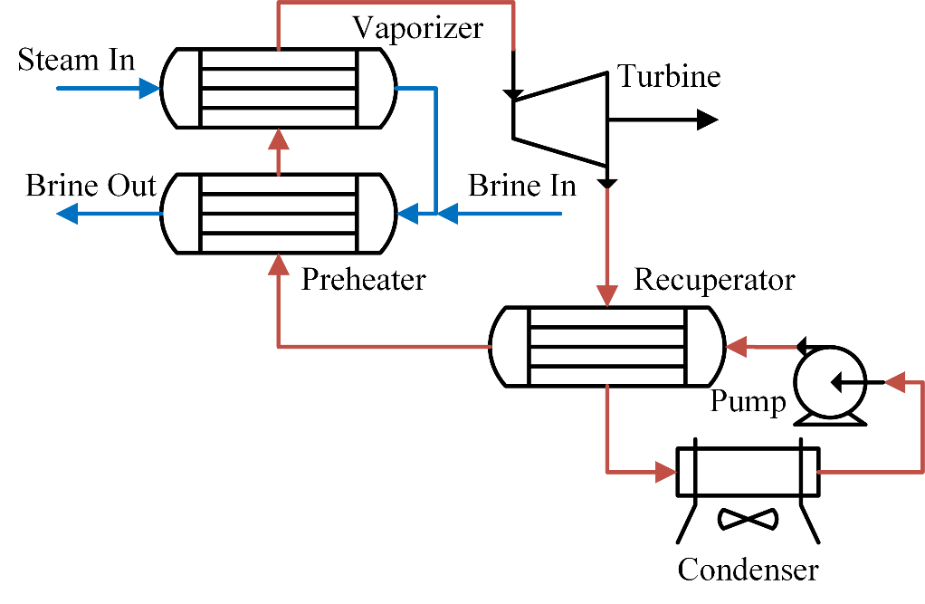
The case study in this work is an industrial binary cycle geothermal power plant in New Zealand. A diagram of the system is given in Figure 1.
Figure 1. Schematic diagram of the geothermal power plant under study. Blue represents geothermal fluid, red organic fluid.
As seen in Figure 1 the Organic Rankine Cycle (ORC) system largely consists of heat exchangers, which will be the focus of this work. Two years of data was extracted from the data historian in its raw form. This data was preprocessed to form a 1,000,000 point steady state dataset as discussed in Severinsen et al., (2023). This preprocessed data was then used to regress a one-dimensional model built in python for the heat exchanger.

Here we will examine the preheater seen in Figure 1. This unit is typically operated with only single-phase fluids on both sides but in extreme cases the working fluid can be vaporized if conditions allow. The unit can experience temperature cross but there is no chance of the brine being vaporised as at this pressure water boils at ~220°C. This is beyond the scope of brine temperatures in Table 1 where the feature space for input variables is described. Notably the limits on pressure are very tight as loss of pressure during operation is not within scope. Flow rate is varied from 0 to ~150% of nominal operation. This is the main variable of study and truly represents out-of-specification (abnormal) operation.

Table 1. Table describing the input feature space of model.
Variable | Maximum | Minimum | units
brine_T_in | 215 | 100 | °C
brine_p_in | 25 | 24 | bar
brine_flow | 150 | 0 | kg/s
WF_T_in | 150 | 50 | °C
WF_P_in | 25 | 15 | bar
WF_flow | 100 | 0 | kg/s
This feature space was sampled using a Latin hypercube with 10,000 points to ensure uniform exploration of the feature space. This data set was fed to the python-based model of the system with output variables of outlet temperature, pressure drop and change in enthalpy for both streams. This data set was used to train a variety of models using the random and geographic train-test split. Eight techniques from scikit-learn, surrogate modelling toolbox and keras were used, with the results shown in Table 2.
  - Results
The first investigation determined suitable surrogate modelling methods that can be used as a baseline. Here we simply investigate the performance of the model using the normal, interpolation focussed, train-test split. This serves as a good example of how model discrimination is typically done.
Table 2. Correlation statistics for the surrogate python model
 | R2 | MAE | MSE
Neural Network (NN) | 0.9939 | 2836 | 1.019E8
Kriging | 0.9977 | 1199 | 3.487E7
Radial Basis Function (RBF) | 0.9774 | 6785 | 3.987E8
Kriging Partial Least Squares (KPLS) | 0.9882 | 2943 | 1.995E8
Support Vector Regression (SVR) | 0.9685 | 9563 | 4.584E8
Adaboost | 0.9954 | 2081 | 5.566E7
Decision Tree | 0.9852 | 3470 | 1.792E8
Random Forest (RF) | 0.9958 | 1910 | 5.818E7

As seen in Table 2, many of the techniques studied are suitable for surrogate modelling with accurate models produced. These metrics provide a poor measure of model performance and as mentioned only measure interpolation performance. Even when using graphical analysis like QQ plots, model discrimination is difficult. Here we introduce extrapolation as a model discriminator using the aforementioned-technique. The original data is split into training and testing datasets based on Euclidean distance. The threshold Euclidean distance is chosen iteratively so that the training and testing datasets preserve the 80/20 ratio. The two models developed have identical parameters and training times only differing in the geographical feature spaces of the training and testing datasets. To compare this training testing regime, we will compare the predictions of datapoints within both testing datasets directly as seen in Figure 2.

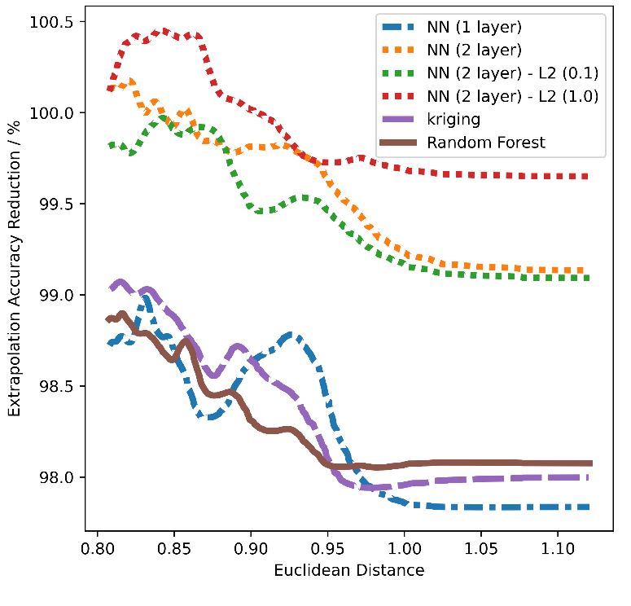
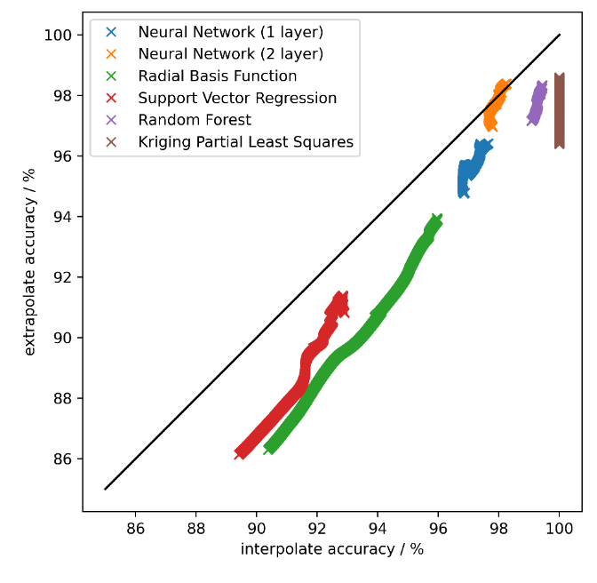
Figure 2 shows the interpolation and extrapolation accuracy for points within the ‘fringe’ testing region. Clearly each model has a variety of accuracies which can be analyzed subsequently. Generally, we can see interpolation accuracy is higher than extrapolation which is an expected result. Some techniques have more variation in accuracy both in an absolute sense and relative to extrapolation results. Overall, the robustness of a model can be identified by the proximity of results to the identity line. To examine this further the distance from the identity line has been isolated in Figure 3, where it is plotted against Euclidean distance. Here we examine various hyperparameters and alternatives for the neural network.
Figure 3. Graph comparing extrapolation ability of different models.
Figure 2. Graph comparing interpolation and extrapolation accuracy for a variety of machine learning techniques.
Figure 3 shows that extrapolation accuracy relative to interpolation decreases as proximity to training data increases. This is again expected as the model is extrapolating the response into an unknown region. The interesting result from this plot is the performance of each model. Increasing the number of layers in the neural network had a big impact extrapolation accuracy. This is likely because this level of detail was required to fit the shape of the underlying data, indeed it can be seen the interpolation accuracy improved in Figure 2 as well. Most notably we can see that regularisation of the neural network has a significant effect if the regularisation parameters are tuned.
  - Discussion
These results do not indicate that the model can be used to extrapolate with this level of accuracy but that in this case extrapolation is only slightly worse outside the training feature space. This result is useful as it provides another tool to analyze the robustness of a model and assess the impact of regularisation.

The challenge with applying this work is that any results are unique to the system. For example, in this system it is known where the phase boundaries are for the fluids in question. If the model were used to extrapolate to a condition where steam could be generated from the working fluid (a condition on which the model is not trained) then it could present accuracy issues. To generalise the issue is that the feature space be known a-priori which is certainly a challenge for many newer processes, especially more complex ones. A benefit of the technique is that it is relatively easy to implement but must be manually analyzed.

Future work in this field is likely to focus on understanding multi-dimensional data in a more coherent way. There are also opportunities to use dimensional reduction or non-rectangular feature spaces to enhance this work.
  - Conclusions
This work has proposed a method of analyzing the robustness of models developed. Using a novel training-testing split we can isolate the extrapolation of a model from interpolation. Using this technique, a simple system has been analyzed and the improvement in robustness from using L2 regularisation has been quantified.
References
Bárkányi, Á., Chován, T., Németh, S., & Abonyi, J. (2021). Modelling for Digital Twins—Potential Role of Surrogate Models. Processes, 9(3), Art. 3. https://doi.org/10.3390/pr9030476
Forrester, A., Sobester, A., & Keane, A. (2008). Engineering Design via Surrogate Modelling. John Wiley & Sons Ltd.
McBride, K., & Sundmacher, K. (2019). Overview of Surrogate Modeling in Chemical Process Engineering. Chemie Ingenieur Technik, 91(3), 228–239. https://doi.org/10.1002/cite.201800091
Severinsen, I., Yu, W., Walmsley, T., & Young, B. (2023). COVERT: A classless approach to generating balanced datasets for process modelling. ISA Transactions. https://doi.org/10.1016/j.isatra.2023.10.031
Yu, W., Patros, P., Young, B., Klinac, E., & Walmsley, T. G. (2022). Energy digital twin technology for industrial energy management: Classification, challenges and future. Renewable and Sustainable Energy Reviews, 161, 112407. https://doi.org/10.1016/j.rser.2022.112407

