Evaluating Performance of Hierarchical Scheduling Frameworks for Varying Matte Grades in Copper Smelting Process

hussain.ahmed@tuni.fi
Abstract
In the copper smelting process, a significant amount of copper is lost during copper production. The increasing demand for copper in various industries and the depletion of high-quality copper ores have accentuated the need to design innovative scheduling frameworks that minimize copper losses in the copper smelting process and ensure long-term benefits. One crucial factor influencing copper losses is the selection of matte grade. While previous studies have predominantly concentrated on enhancing throughput and batch time in the copper smelting process, they often overlooked the critical aspect of matte grade selection. This study conducts a sensitivity analysis of two hierarchical scheduling frameworks specifically designed for the copper smelting process. The objective is to compare their impact on copper losses and identify the framework that optimizes processes better through diverse matte-grade selections.
Keywords: copper smelting, process modelling, discrete-time optimization, coordination, hierarchical scheduling.
  - Introduction
The widespread demand for copper in various industries is increasing, but the availability of high-quality copper ores is declining, leading to lower-grade ores utilization. This shift raises production costs and reduces throughput, exacerbating the gap between demand and supply (Ahmed, et al., 2021; Schipper, et al., 2018). Copper smelters, a fundamental process for copper production, lead to copper loss, a challenge that becomes more evident with lower-grade ores utilization (Ahmed, et al., 2022). One possible solution to minimize copper losses is to design innovative scheduling solutions for the copper smelting process that can provide optimal operation and address long-term challenges.

The copper smelting process involves Flash Smelting Furnace (FSF), which produces matte with a predefined grade (Engell, 2008; Korpi, et al., 2019; Suominen, et al., 2016). This matte is loaded to the Peirce Smith Converters (PSCs) that remove the remaining unwanted elements from the matte by passing it through multiple blowing stages (Ahmed, et al., 2021). The final product of the PSC, known as white metal, is loaded into the Anode Furnace (AF) and then electrolysis for further processing.

For the copper smelting process, various scheduling solutions are presented. Suominen et al. (2016) introduced a centralized continuous-time Mixed Integer Linear Programming (MILP) framework that maximizes process throughput and respects operational constraints. Similarly, Harjunkoski et al. (2009) presented a MILP approach considering inter-dependencies among process units. In our previous work (Ahmed, et al., 2022), a discrete-time MILP hierarchical scheduling framework based on rigorous heuristics is proposed to optimize the operational point of the copper smelting process. In another work (Ahmed & Villko, 2023b), we introduced a price-based coordination approach for optimal scheduling of units. All the above studies overlook matte grade selection, thus curtailing their overall utility and effectiveness in smelting processes.

Motivated by finding the optimal matte grade that minimizes copper losses and increases the process throughput, this study provides the sensitivity analysis of two hierarchical scheduling frameworks with respect to the change in the matte grade. The objective is to compare both frameworks concerning copper losses and find the framework that provides better process operation with more matte grade selections.
  - Assumptions
This study considers a copper smelting process processing a specific concentrate type. The process involves an FSF that generates matte with a predetermined grade, transferred periodically to PSC units. The PSC units undergo slag-blowing and copper-blowing stages to produce blister copper batches. In this process, FSF inter-dependencies occur when matte levels exceed or fall below FSF storage capacity limits. In the PSC, logistic inter-dependencies arise due to timing issues in matte loading. Blow inter-dependencies among PSC units arise from gas pipeline handling capacities, highlighting critical aspects of the smelting operation.
  - Scheduling Frameworks
This study aims to optimize a copper smelting process involving one FSF, three PSC units, and one AF unit. The goal is to increase AF throughput by optimizing the FSF feed rate and minimizing copper losses during FSF and PSC operations, as shown in Eq. (1). Here, $h$ represents the scheduling horizon, ${AF}_{prod}$ stands for AF throughput, $feed_{FSF}^{h}$ is the FSF feed rate, $Cu_{FSF}$ refers to copper losses during FSF operation, and $Cu_{PSC}$ indicates copper losses during PSC operation.
$$\max_{{feed}_{FSF}, Cu_{FSF}, Cu_{PSC}}{AF_{prod}=\sum_{h=1}^{H}{{feed}_{FSF}^{h}-\sum_{h=1}^{H}{(Cu_{FSF}^{h}+Cu_{PSC}^{h})}}}$$ | (1)
This study considers two scheduling frameworks, each comprising an FSF model, a PSC model, and a coordinator to address process inter- dependencies. For further details, refer to (Ahmed, et al., 2022; Ahmed & Villko, 2023b).
    - FSF model
FSF matte production varies with feed rate and mate grade. The FSF aims to maximize concentrate utilization and minimize copper losses, as given in Eq. (2). The approach to address the FSF inter-dependencies depends on the framework type in use. Framework 1 (${pu}_{FSF}^{h}=0$) utilizes Eq. (3) to keep the matte in the FSF within storage capacity limits. Framework 2 uses Eq. (2) to resolve only the FSF upper storage capacity limit violations, while the lower storage capacity limit violations are addressed through the PSC model. Here, $lower_{FSF}^{h}$ and ${upper}_{FSF}^{h}$ are the FSF lower and upper storage limits, $ut_{FSF}^{h}$ are the violating times, $pu_{FSF}^{h}$ are the prices, and $md_{PSC}^{h}$ is the FSF demand on the PSC units. At the end of each iteration, the FSF model sends back the mass trajectory $mass_{FSF}^{h}$ to the coordinator.
$$\max_{feed_{FSF}}{f_{FSF}=\sum_{h=1}^{H}{({feed}_{FSF}^{h}-Cu_{FSF}^{h}})}+\sum_{h∈ut_{FSF}^{h}}^{H}{{pu}_{FSF}^{h}×(md_{PSC}^{h}+{upper}_{FSF}^{h}-mass_{FSF}^{h})}$$ | (2)
$${lower}_{FSF}^{h}≤mass_{FSF}^{h}≤{upper}_{FSF}^{h}$$ | (3)
    - PSC model
A PSC batch includes multiple matte loading ($ml_{i}$), slag blowing ($sb_{i}$), slag skimming ($sk_{i}$), and single copper-blowing ($cb$) operations. The order of PSC operations ($z_{i}$) is predefined and stored in the set $Z$, as given below.
$z_{i}∈Z=\left\{ml_{i}, sb_{i}, sr_{i}, cb\right\}$ $i$ represents repeated operations $i∈\{1, 2, 3,..., I\}$
The PSC batch has a shorter batch time than the scheduling horizon ($T≪H$) and allows the execution of one PSC batch operation ($b_{z_{i}}$) at a time. Like the FSF, the PSC model resolves process inter-dependencies differently based on the employed framework. In Framework 1, it receives conflicting loading times $ml_{PSC }^{t}$, FSF lower storage capacity violating times $ml_{FSF}^{t}$, and blowing times ${scb}_{PSC}^{t}$ and uses Eq. (4) to prevent the PSC unit from executing loading operations or blow operations at conflicting times. In Framework 2, the PSC model tackles loading and blow inter-dependencies between the PSC units similarly to Framework 1. However, it uses prices as a penalty in the objective function to address FSF lower storage capacity limit violations.
$$b_{z_{i}}=0 ∀ t=\{ml_{PSC}^{t}, ml_{FSF}^{t}, scb_{no}^{t}\}$$ | (4)
$$\min_{Cu_{PSC}, mass_{ele},idle}{f_{PSC}^{n,b}=\sum_{t=1}^{T}{({mass_{ele}^{t}+Cu}_{PSC}^{t}+idle^{t}})}+\sum_{t=1}^{lt_{FSF}}{{pl}_{FSF}^{t}×(m{do}_{PSC}^{t}+{md}_{PSC}^{t} -lo{wer}_{FSF}^{t})}$$ | (5)
The primary objective of the PSC model is to minimize unwanted elements in matte $mass_{ele}^{t}$, copper losses $Cu_{PSC}^{t}$, and unnecessary idle times $idle^{t}$, as given in Eq. (5). To address FSF lower storage capacity limit violations in Framework 2, this model incorporates prices $pl_{FSF}^{t}$, the earliest available time for the PSC batch to begin its loading operation without violating the FSF lower-capacity limit $lt_{FSF}$, FSF matte demanded by the conflicting batch ${md}_{PSC}^{t}$, and the FSF matte demanded by the batches on non-conflicting PSC units $mdo_{PSC}^{t}$ in Eq. (5). At the end of each iteration, the PSC model returns the loading times, blowing times, and matte demand to the coordinator.
    - Coordinator
After each iteration, the coordinator collects the necessary information from the FSF and PSC models. Based on the framework employed, it uses two alternating approaches to address the process inter-dependencies. They are briefly discussed below.
      - Framework 1
Framework 1 employs rigorous heuristics to resolve FSF and PSC inter-dependencies. The coordinator arranges PSC batch loading times, blowing times, and FSF mass trajectory to determine $ml_{PSC }^{t}$, ${scb}_{PSC }^{t}$, and $ml_{FSF }^{t}$, and send them to the PSC model. FSF inter-dependencies are handled directly by the FSF model.
      - Framework 2
Framework 2 combines rigorous and flexible heuristics to manage inter-dependencies between FSF and PSC units. For PSC dependencies, it addresses PSC loading and blowing violations using the approach similar to Framework 1. For handling FSF inter-dependencies, the coordinator employs price-based heuristics, calculating optimal prices through a market-inspired scheme. These prices are calculated using proportional-integral (PI) controllers. These prices guide the allocation of matte to PSC units, allowing the resolution of FSF inter-dependencies at the unit level.
  - Simulations
This study analyzes a copper smelting setup that produces 15 PSC batches. The research explores the impact of matte grade (55% to 75%) on FSF performance, copper losses, PSC batch time, and computational demands. Both frameworks are simulated using literature-derived copper loss rates (Bellemans, et al., 2017; Tan, 2007). Matte grade varies incrementally by 0.1%. Results, including copper losses, FSF feed rate, batch time, and CPU time for both frameworks, are shown in Figures 1 to 5.

For low matte grades (below 61%), FSF matte production is high, and the PSC units require longer to process the matte, making them the bottleneck. Longer PSC blowing times lead to higher copper losses in the PSC, as shown in Figure 1. For high matte grades (above 71%), FSF processing time increases, consequently decreasing its production and making it the bottleneck. For the medium matte grade values (61% - 71%), both the FSF and PSC units are partially the source of the bottleneck.

In Framework 2, copper losses in the PSC are consistently higher across all matte grade values compared to Framework. It addresses FSF lower-storage limit violations by penalizing the PSC model objective function, but this approach leads to sub-optimal PSC blowing times, elevating copper losses. Furthermore, a higher price value penalized more the objective function, adding unnecessary idle times to the schedule, further inflating PSC batch times, as shown in Figure 2. In the FSF, copper losses for higher matte grade values in Framework 2 are lower than in Framework 1 due to reduced FSF feed rate.

PSC units are the bottleneck for low matte values; therefore, the frameworks keep the FSF feed rate lower to respect the FSF upper storage capacity limit. As the matte grade increases, the demand for the matte also increases, leading to an increase in the FSF feed rate. However, operating the FSF at higher matte grades yields an optimal FSF operation but also elevates copper losses within the FSF. As minimization of the copper loss and maximization of the feed rate are the prime objectives of the FSF in the copper smelting process, operating the copper smelting process at lower and higher matte grade values produces a sub-optimal solution.

Framework 2 does not offer a matte grade value conducive to achieving a solution with a high FSF feed rate and minimal FSF and PSC copper losses. In contrast, Framework 1
demonstrates optimal performance with matte grade values ranging from 67.3% to 71%. Within this range, total copper losses are minimal, the copper content in the AF input is high, and the FSF operates at maximum capacity, as illustrated in Figures 3 and 4.
Framework 1 calculates optimal PSC operation durations than Framework 2; thus, the computational demand of Framework 1 is higher than that of Framework 2, as shown in Figure 5. Therefore, from the perspective of framework complexity, Framework 2 provided solutions with lower computational demand. Since the copper industry is keenly interested in minimizing losses and maximizing input concentrate utilization, process personnel tend to favor Framework 1 despite these disparities.

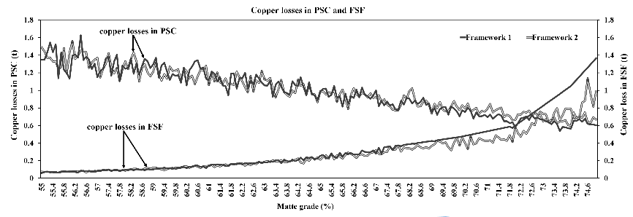

Figure 1: Copper losses in FSF and PSC units
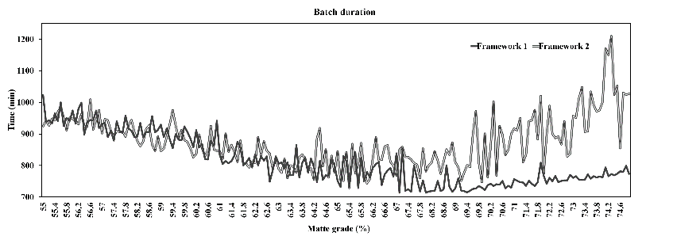

Figure 2: PSC batch time
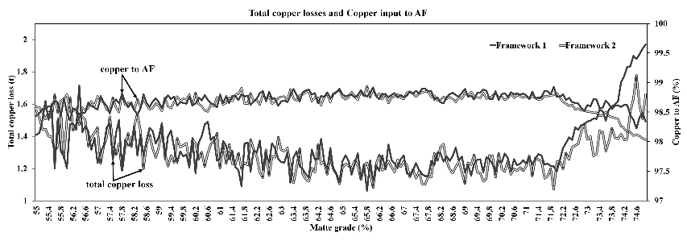

Figure 3: Total copper losses and copper to AF
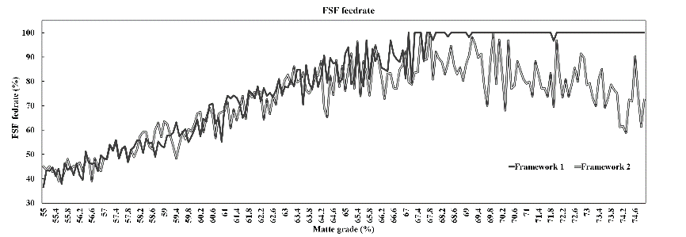

Figure 4: FSF feed rate
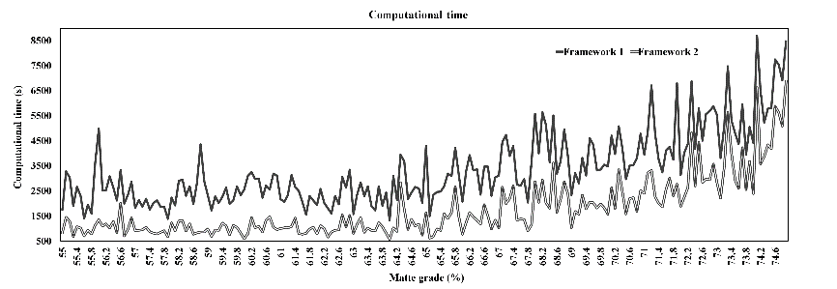

Figure 5: Computational demand

Framework 2 yields sub-optimal solutions but allows process units to handle FSF storage independently. It is ideal when rigorous scheduling is impractical in copper smelting. To enhance its quality, operators can choose lower PI controller gain values. However, this can raise computational demands.
  - Conclusion
This study examines how matte grade affects copper losses and smelting process throughput. Two scheduling frameworks with MILP-based FSF and PSC models are presented here. Simulation results favor Framework 1 due to optimal process operation for matte grade 67.3% to 71%. Future research will concentrate on sensitivity analysis and efficient price-updating mechanisms for enhanced solutions.

References

Ahmed, H., Ricardez-Sandoval, L. A. & Villko, M., 2022. Centralized and hierarchical scheduling frameworks for copper smelting process. Computers & Chemical Engineering, 164(0098-1354), p. 107864.
Ahmed, H., Ricardez-Sandoval, L. & Vilkko, M., 2021. Optimal Scheduling of the Peirce–Smith Converter in the Copper Smelting Process. Processes, 9(11).
Ahmed, H. & Vilkko, M., 2023a. Price-based coordination strategy for copper smelting process. Computers & Chemical Engineering, Volume 178, p. 108395.
Ahmed, H. & Villko, M., 2023b. Coordination strategy based on hard-heuristics and price-updating scheme for copper smelting process. Computers \& Chemical Engineering, 173(0098-1354), p. 108198.
Bellemans, I., De W., E., Moelans, N. & Verbeken, K., 2017. Metal losses in pyrometallurgical operations - A review. Advances in Colloid and Interface Science, Volume 255.
Engell, S., 2008. Logistic Optimization of Chemical Production Processes. s.l.:s.n.
Harjunkoski, I., Werner B., H. & Fahl, M., 2009. Simultaneous scheduling and optimization of a copper plant. s.l., Elsevier, pp. 1197 - 1202.
Korpi, M. et al., 2019. Plant-wide optimization of a copper smelter : how to do it in practice?. s.l., s.n.
Schipper, B. W. et al., 2018. Estimating global copper demand until 2100 with regression and stock dynamics. Resources, Conservation and Recycling, 132(0921-3449), pp. 28-36.
Suominen, O., Mörsky, V., Ritala, R. & Vilkko, M., 2016. Framework for optimization and scheduling of a copper production plant. s.l., Elsevier, pp. 1243-1248.
Tan, P., 2007. Applications of thermodynamic modeling in copper converting operations. International Journal of Materials Research - INT J MATER RES, Volume 98, pp. 995-1003.

