Global sensitivity Analysis on System Design Parameters of Silver Nanoparticles Production
Ziyi Han^{a,b}, Heng Yi Teah^{c,d}, Yasunori Kikuchi^{a,c,e}
ªDepartment of Chemical System Engineering, The University of Tokyo, 113-8656 7-3-1 Hongo, Bunkyo-ku, Tokyo, Japan
^{b}Department of Applied Chemistry, Waseda University, 169-8555 3-4-1 Okubo, Shinjuku-ku, Tokyo, Japan
^{c}Presidential Endowed Chair for “Platinum society”, The University of Tokyo, 113-8656 7-3-1 Hongo, Bunkyo-ku, Tokyo, Japan
^{d}Waseda Research Institute for Science and Engineering, Waseda University, 169-8555 3-4-1 Okubo, Shinjuku-ku, Tokyo, Japan
^{e}Institute for Future Initiatives, The University of Tokyo, 113-8656 7-3-1 Hongo, Bunkyo-ku, Tokyo, Japan
ykikuchi@ifi.u-tokyo.ac.jp
Abstract
This study investigates the environmental impact of silver nanoparticles (AgNPs) synthesis methods, focusing on key system design parameters. Global sensitivity analysis (GSA) is effective in monitoring influences of multiple parameters to a life cycle assessment (LCA) model. In this GSA, alternate silver and energy sources are implemented into the LCA model for AgNPs production by proposing integrated energy and silver scenarios that outline the current and future productions. Our result has highlighted that inherent factors determined by technological options of AgNPs will become increasingly important in the future, envisioning the direction of improvement on the design of AgNPs synthesis routes.
Keywords: silver nanoparticles, life cycle assessment, global sensitivity analysis, green nanomaterials
  - Introduction
Silver nanoparticles (AgNPs) have diverse applications in modern consumer products for antimicrobial, optical, and electrical properties. Developing cleaner syntheses of AgNPs without compromising the functions is desired, as the global AgNP production are increasing (Temizel-Sekeryan & Hicks, 2020). AgNP syntheses can be divided into two categories, wet and dry chemistry. Dry chemistry methods break down bulk silver with external force, usually supported by intensive energy. Wet chemistry methods reduce Ag ions in precursor solution to Ag atoms, often followed by controlled growth of Ag particles with stabilizing agents. There are also emerging biosynthesis methods that exploit biomolecules from plant extracts or microbes for redox reactions. Previous life cycle assessment (LCA) study on AgNP syntheses (Pourzahedi & Eckelman, 2015) revealed that (1) ≥ 60% of total greenhouse gas (GHG) emissions was attributed to silver source acquisition that depends on reaction yield and silver precursor type; (2) about 20 % was attributed to energy consumption that depends on the choice of the route and the presumed energy efficiency. The environmental impacts from respective reagents, water supply, and direct emissions that differed based on the choice of synthesis method were trivial. However, changes in external factors such as switching silver sources from primary to secondary, and energy sources from fossil fuels to renewable energy, cannot support the development of AgNP syntheses – the interest of AgNP experimentalists.
Sensitivity analysis is a method to track and simulate parameter changes in the LCA model. Conventional (local) sensitivity analysis is conducted by altering only one
parameter at a time on only foreground level. Limitations arise when multiple parameters that affecting background dataset occurred. Global sensitivity analysis (GSA) is proposed (Saltelli et al., 2007), to examine how the LCA output is affected by multiple input uncertainties.
In this study, we intend to clarify the effect of the system design parameters on environmental impact of AgNPs considering the uncertainties of silver and energy sources. We applied GSA to deal with the two parameters simultaneously using integrated silver and energy scenarios, so that the LCA result would be useful in showing the potential improvement in technological choices under some practical scenarios.
  - Method
The goal of this study is to investigate the influence of system design parameters driven by external factors like global energy policies and real-world resource scarcity. We first conduct a prospective LCA of selected AgNP synthesis methods as case studies. We then apply GSA to examine the uncertainty of external factors and demonstrate the value of GSA in the interpretation of LCA results.
    - Prospective Life Cycle Assessment
The LCA aimed to evaluate the prospective environmental performance of AgNP production via 11 reported synthesis routes, including five dry chemistry methods (flame spray pyrolysis, arc discharge, and arc plasma (Pourzahedi & Eckelman, 2015; Slotte & Zevenhoven, 2017)), four wet chemistry methods (based on: glucose (Bafana et al., 2018), sodium borohydride (Tolaymat et al., 2010), ethylene glycol, and trisodium citrate (Temizel-Sekeryan & Hicks, 2020) respectively), and two biological methods (using Annona Glabra leaf extract (Amarasinghe et al., 2020), and Rhodococcus (Otari et al., 2012)). Global warming potential (GWP) from IPCC 2013 method was the impact category. Fig. 1 shows the cradle-to-gate system boundary, starting from the acquisition of raw materials to produce necessary reagents, to the reagent production, and ending by the process of producing AgNPs.
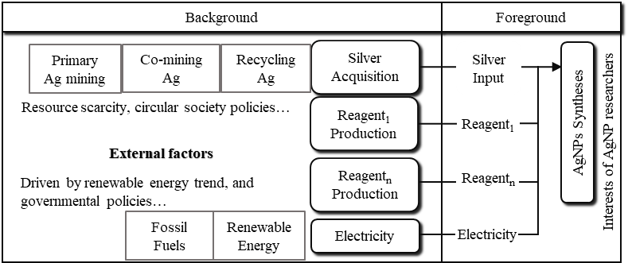
The functional unit is defined as 1kg of AgNPs with spherical shapes, and an industrial scale production is assumed.
Figure 1. Cradle-to-gate system boundary of prospective LCA for AgNPs synthesis methods
The foreground AgNP inventory, i.e., material and energy required for each AgNP synthesis, is collected from literature. The material input is calculated with stoichiometric relationships, and scaled up from lab to industrial scales, assuming a maximum yield (100 %). The energy input is estimated based on a scale-up framework (Piccinno et al., 2016). The background inventory, i.e., the production of required chemicals, water supply, electricity generation, are obtained from datasheet in ecoinvent Database, version 3.9.1. The region of the rest-of-the-world (RoW), or global (GLO) was selected.
    - Global Sensitivity Analysis
The goal of this GSA is to assess the sensitivity of the key system design parameters in LCA modeling. The scope involves energy mix with higher composition of renewable energy and secondary silver source to substitute primary silver mining. Fig.2 describes the framework of GSA and the general calculation procedure.
We first develop the scenarios based on foreseeable near future. The energy plots are inspired by global transition trend towards renewable energy. We set the upper boundary as full enactment of renewable energy equally allocated to wind and solar energy, and the lower boundary as current global energy mix in 2021. An intermediate is selected as the proposed energy mix in 2030 under Announced Pledges Scenario (International Energy
Agency, 2022) with 40 % fossil fuel. In both future energy scenarios, heat production by diesel is substituted by biodiesel (Karlsson et al., 2017) with respect to the proportion of renewable energy, but heat from natural gas is unchanged. Regarding resource availability of silver, there are three sources. Primary mining silver is the silver obtained as main product from silver mines, accompanied by other metals from the ore. But primary silver mines are depleting (Silver Institute, 2021), and global silver supply is shifting to co-mining silver, i.e., silver as by-products of mining and refineries of other metals, e.g., gold, copper, lead, and zinc. Recycling silver is a recently essential source of silver from waste x-ray film and waste PV panels. Combining the above scenario settings, four scenarios were set for GSA: (1) Primary silver mining with energy mix in 2021, (2) Co-mining silver with energy mix in 2030, (3) Co-mining silver with 100 % Renewable Energy, and (4) Recycling silver with 100 % Renewable Energy.
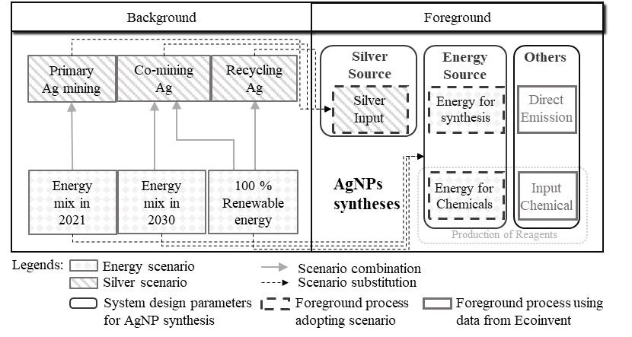
Secondly, we adopted the four scenarios to the LCA model by substituting the silver source and energy mix. The energy data in exchange activities of chemicals and water are traced by inventory dataset in ecoinvent at least once, and corresponding impact from different sources are plugged into the model.
Figure 2. Calculation procedure for global sensitivity analysis of AgNPs.
  - Results and Discussion
Fig. 3 shows the comparison between the average GWP of 3 categories, 11 methods of AgNP synthesis routes among 4 GSA scenarios. The average GWP of each category of methods is taken from the sum of GWP of all methods in the same category divided by the number of the methods. The error bar indicates the range of calculation results. The lower limit of the error bar is the minimum, while the upper limit is the maximum. The emission from silver acquisition in wet chemistry and biosynthesis methods are consistent, as all methods in these two categories use the same silver nitrate precursor, while, in the case of dry chemistry methods, either bulk silver or silver octanoate will be selected as the silver source for the desired method. The “other” factor is inherent among the four scenarios, for it represents the foreground data that are innate in the choices of techniques.
    - Scenario 1 (Primary Silver Mining with Global Energy Mix in 2021): Benchmark
Fig. 3 (a) shows scenario 1, representing the upper boundary in GSA. The average overall GWP for dry- and wet- chemistry, and biosynthesis methods are 1190, 859, and 678 kg CO₂-eq, respectively. Silver and energy consumption covered over 90 % of the total GWP for all AgNP methods, conform to the pattern reported by Pourzahedi and Eckelman (2015). But the “other” factor is trivial, suggesting that the selection of AgNP techniques among methods has limited relevance for improving environmental performance.
Specifically, the GWP of silver acquisition peaks at 2399 kg CO₂-eq in dry chemistry category, massively higher than all others. This results from flame spray pyrolysis method. It uses silver octanoate as a unique silver precursor, which is derived from silver nitrate with less than 50 % yield and emits 1014 kg CO₂-eq/kg GHG. Since the production of silver octanoate belongs to the background reagent production, the yield is unlikely to improve under current conditions.
    - Scenario 2 (Co-mining Silver with Global Energy Mix in 2030): Near Term
Comparing Fig. 3 (a) and (b), the average for GWP in scenario 2 reduced substantially from scenario 1, with the reduction of 83 % for dry chemistry methods, 74 % for wet chemistry methods, and 88 % for biosynthesis methods regarding 1 functional unit.
The cutback is ascribed to both the reduction in impact factor and the implementation of GSA. The impact of electricity reduced 50%, from 0.72 kg CO₂-eq/kWh in scenario 1 to 0.36 kg CO₂-eq/kWh in this scenario. In addition, 1 kg silver from co-mining emits 48.2 kg CO₂-eq GHG, 92 % reduction from primary mining silver. Without GSA, the impact of co-mining silver will become 382 kg CO₂-eq, only 38 % reduction from primary silver. The absence of GSA, with only foreground electricity data substituted, causes an inconsistency within the scenario, in which AgNP synthesis has adopted energy mix in 2030, but processes related to silver mining maintains to use energy mix in 2021.
    - Scenario 3 (Co-mining Silver with 100 % Renewable Energy): Progressive Approach
In scenario 3, as shown in Fig. 3 (c), the average GWP for all three categories continues to decrease. Silver and energy no longer dominate the GWP in this scenario. The emission from energy consumption reduces further, as the impact from electricity is minimized to 0.05 kg CO₂-eq/kWh, 14 % of that in scenario 2.
Moreover, within the wet chemistry category, “other” factor distinguishes the AgNP routes with lower emission and those with emissions among the highest, indicating the technological innovation will become a decisive factor for cleaner syntheses under progressive external resource environments. For instance, the ethylene glycol method has the highest GWP among the 11 methods in scenario 3, the direct reason for which is the reagent consumption like PVP, possessing high inherent environmental impact (328 kg CO₂-eq/kg AgNPs).
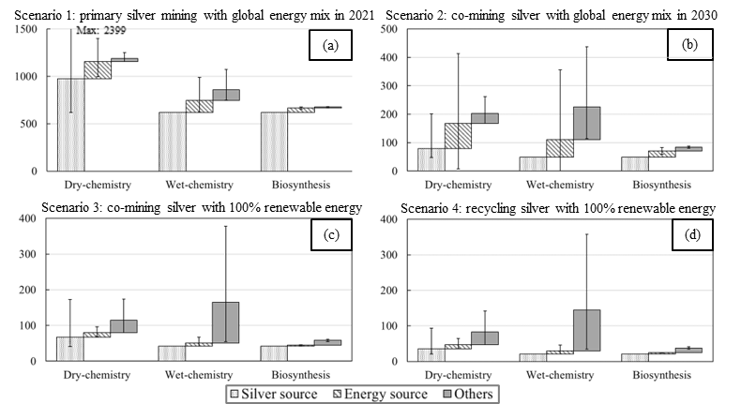
Figure 3. Average Global Warming Potential (unit: kg CO2-eq.) of three groups of eleven reported AgNPs synthesis methods in four proposed scenarios: (a) Primary mining silver with energy mix in 2021, (b) Co-mining silver with energy mix in 2030, (c) Co-mining silver with 100% renewable energy, and (d) Recycling silver with 100% renewable energy.
    - Scenario 4 (Recycling Silver with 100 % Renewable Energy): Ideal Sustainability
Scenario 4 represents the lower boundary of GSA. Fig. 3 (d) showed that this scenario has the lowest average GWP and smallest deviation of data among the four. In this scenario, the average portion of “other” factor is even higher, with 52 % in wet chemistry, 30 % in dry chemistry and 35 % in biosynthesis methods. This implies a more complex decision-making process for cleaner AgNP routes, in which the silver and energy source as well as innovations in technological factors are equally important and must be comprehensively considered.
    - Discussion
The significance of GSA is highlighted. GSA not only better represents impact factors of silver and energy in alternative scenarios, but also avoiding the inconsistency in the energy mix of foreground and background inventory.
The results also provide insights to evaluate AgNP environmental performance under current and future scenarios. At present, the sources of silver and energy are pivotal to the improvement of AgNP; while, in the future, these two factors become less influential and technical characteristics for a synthesis route, e.g., choices of reagents, are prominent. For dry chemistry methods, their disadvantages in intensive energy input could be relieved to some extent, but the improvement in impacts from silver source like silver octanoate requires further investigation. As for the wet chemistry methods, the factors determined by technology structures have caused distinct performance, making the choices in input reagents more essential, when developing cleaner AgNP syntheses.
  - Conclusions
The incumbent LCA modeling of AgNP syntheses using lab-scale data and current resource plot is insufficient to extend the model into the advancing manufacturing of AgNPs. This study used global sensitivity analysis based on the trajectory of silver source acquisition and energy generation mix, projecting both foreground and background data, showing the significance of technological innovations considering AgNP productions with better environmental performance in future scenarios, in comparison with current scenario in which silver and energy are the decisive factors. The insights can assist not only laboratory researchers to conceive and design experiment procedures for green synthesis, but also policy makers to better contemplate on this thriving industry.
Acknowledgements
The authors thank Professor Izumi Hirasawa for his special support on the study. This work was conducted in the Research Institute for Social Implementation of Chemical Wisdom, Waseda Research Institute for Science and Engineering. This work was supported by JST SPRING, Grant Number JPMJSP2108. The activities of the Presidential Endowed Chair for “Platinum Society” at the University of Tokyo are supported by Mitsui Fudosan Corporation, Sekisui House, Ltd., East Japan Railway Company, and Toyota Tsusho Corporation.
References
L. D. Amarasinghe, P. A. S. R. Wickramarachchi, A. A. A. U. Aberathna, W. S. Sithara, and C. R. De Silva, 2020, Comparative study on larvicidal activity of green synthesized silver nanoparticles and Annona glabra (Annonaceae) aqueous extract to control Aedes aegypti and Aedes albopictus (Diptera: Culicidae). Heliyon, 6(6), e04322.
A. Bafana, S. V. Kumar, S. Temizel-Sekeryan, S. A. Dahoumane, L.Haselbach, and C. S. Jeffryes, 2018, Evaluating microwave-synthesized silver nanoparticles from silver nitrate with life cycle assessment techniques. Sci. Total Environ., 636, 936–943.
International Energy Agency, 2022, World Energy Outlook 2022, https://www.iea.org/reports/world-energy-outlook-2022
H. Karlsson, S. Ahlgren, M. Sandgren, V. Passoth, O. Wallberg, and P.-A. Hansson, 2017, Greenhouse gas performance of biochemical biodiesel production from straw: soil organic carbon changes and time-dependent climate impact. Biotechnol. Biofuels, 10(1), 217.
S. V. Otari, R. M. Patil, N. H. Nadaf, S. J. Ghosh, and S. H. Pawar, 2012, Green biosynthesis of silver nanoparticles from an actinobacteria Rhodococcus sp. Mater. Lett., 72, 92–94.
F. Piccinno, R. Hischier, S. Seeger, and C. Som (2016). From laboratory to industrial scale: a scale-up framework for chemical processes in life cycle assessment studies. J. Clean. Prod., 135, 1085–1097.
L. Pourzahedi, and M. J. Eckelman, 2015, Comparative life cycle assessment of silver nanoparticle synthesis routes. Environ. Sci. Nano, 2(4), 361–369.
Silver Institute, 2021, World silver survey 2021, https://www.silverinstitute.org/wp-content/uploads/2021/04/World-Silver-Survey-2021.pdf
M. Slotte, and R. Zevenhoven, 2017, Energy requirements and life cycle assessment of production and product integration of silver, copper and zinc nanoparticles. J. Clean. Prod., 148, 948–957.
S. Temizel-Sekeryan, and A. L. Hicks, 2020, Global environmental impacts of silver nanoparticle production methods supported by life cycle assessment. Resour Conserv Recycl, 156.
T. M. Tolaymat, A. M. El Badawy, A. Genaidy, K. G. Scheckel, T. P. Luxton, and M. Suidan, 2010, An evidence-based environmental perspective of manufactured silver nanoparticle in syntheses and applications: A systematic review and critical appraisal of peer-reviewed scientific papers. Sci. Total Environ., 408(5), 999–1006.

