Process simulation of effects of ammonia co-firing on the thermal performances of the supercritical circulating fluidized bed boiler
Seong-ilª Kim and Won Yang^{a*}
ªCarbon Neutral Technology R&D Department; Research Institute of Clean Manufacturing System; Korea Institute of Industrial Technology, Cheon-an, 31056, Republic of Korea
Email_of_the_Corresponding_yangwon@kitech.re.kr
Abstract
The use of ammonia co-firing technology for carbon neutrality has emerged in the power generation industry. It is necessary to determine the optimal operating conditions by investigating boiler performance during ammonia co-firing. In this study, a process simulation was performed to determine the effect of ammonia co-firing on the thermal performances of the 550 MWe supercritical circulating fluidized bed (CFB) boiler. The process simulations were conducted using co-firing ratios of 5, 10, 15, 20, and 30%. Although the amount of CO₂ reduction during ammonia co-firing was confirmed, the radiation and convective heat transfer rates decreased due to changes in the adiabatic flame temperature, flue gas flow rate, and increased moisture heat loss. Accordingly, the main and reheat steam temperatures decrease. In conclusion, the boiler thermal efficiency decreases under the condition of ammonia co-firing. These findings can be used to establish optimal operating conditions for CO₂ reduction and improve plant efficiency, which are operational trade-offs during ammonia co-firing.
Keywords: ammonia co-firing, CFB boiler, process simulation, heat transfer
  - Introduction
With the global declaration of carbon neutrality, the reduction of greenhouse gases in the power generation sector must be accompanied. According to Korea's Nationally Determined Contribution, greenhouse gas emissions from the power generation sector were adjusted downward from 192.7 million tons to 145.9 million tons by 2030. According to Korea’s power mix, the power generations of a coal-fired power plant and a combined cycle power plant account for 32.8% and 68.7%, respectively. Therefore, for carbon neutrality in the power generation field, the transition from fossil fuel-based to carbon-free fuel is essential. Under this power supply situation, Korea announced the 10th basic plan for electricity supply and demand this year as shown in Table 1. In 2030, electricity production from coal-fired plants by utilizing ammonia will begin. Based on the power supply and demand plan, Korea started an ammonia co-firing demonstration project in 2030. The target co-firing rate is 20%, and it is planned to be demonstrated in pulverized coal (PC) boilers and circulating fluidized bed (CFB) boilers in 2027. In particular, the world's first ammonia co-firing project in a circulating fluidized bed boiler was started in Korea. The target power plants were two PC boilers and two CFB boilers in Korea.
Table 1 10th Basic plant for electricity supply and demand in KOREA, 2023
Year | Division | Nuclear | Coal | LNG | Renewable | H₂ & NH₃ | Etc. | Total
2030 | Generation  [TWh] | 201.7 | 122.5 | 142.4 | 134.1 | 13.0 | 8.1 | 621.8
 | Ratio | 32.4% | 19.7% | 22.9% | 21.6% | 2.1% | 1.3% | 100%
2036 | Generation  [TWh] | 230.7 | 95.9 | 62.3 | 204.4 | 47.4 | 26.6 | 667.3
 | Ratio | 34.6% | 14.4% | 9.3% | 30.6% | 7.1% | 4.0% | 100%

Table 2 shows the fuel characteristics of ammonia compared to other hydrocarbon fuels. Ammonia combustion only generates water and nitrogen. Therefore, ammonia can be considered as a carbon-free fuel. Ammonia is easily transportable and storable due to high
boiling temperature compared to other fuels. However, ammonia has lower combustibility than other fuels, and fuel-NOx may be emitted, when ammonia is combusted due to the N component in ammonia. Therefore, it is important to minimize NO_{x} emissions, while ensuring sufficient ammonia combustibility.
Previous studies have mainly been conducted to identify ammonia combustion and NO_{x} emission characteristics [Kobayashi et al.]. However, under the ammonia co-firing condition, the flue gas properties change due to the change in adiabatic flame temperature, required air flow rate, flue gas composition, and flue gas mass flow rate. These changes affect the radiation and convection heat transfer rate of each heat exchanger in a boiler. Accordingly, main and reheat steam temperatures change, which means a change in plant efficiency. Therefore, for ammonia co-firing, it is necessary to establish optimal operating conditions by analyzing the heat transfer characteristics in the boiler in terms of power operation.
The aim of this study is to predict main and reheat steam temperature by investigating the variation of heat transfer rate through process simulation techniques. The process simulation model was developed by In-house code to analyze the change in heat transfer mechanism. The target plant was selected as the 550 MW_{e} CFB boiler, which is the subject of the demonstration project. The simulation results were compared with the 870 MW_{e} PC boiler. Based on the simulation data, it is possible to understand the relationship between CO₂ reduction and boiler thermal efficiency according to the change in heat transfer rate due to ammonia co-firing.
  - Model descriptions
    - Target boiler system and CFB loop model
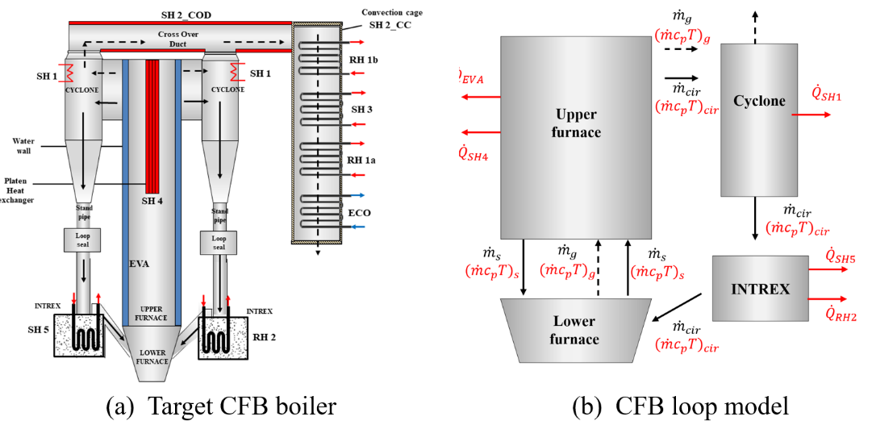
Fig. 1 shows a schematic diagram of the target CFB boiler and the model diagram of the CFB loop. Unlike pulverized coal boilers, the CFB boiler has a solid return part due to the bed material. The CFB loop includes a cyclone, a loop-seal, and external heat exchanger (EXHE) or internal heat exchanger (INTREX). EHEX and INTREX are a type of heat exchanger that utilizes the sensible heat of circulating solids. The bed material is circulated in this CFB loop. Due to these bed materials, the range of the furnace temperature of the CFB boiler is about 800~900 ºC, which is lower than that of the PC boiler. Due to these characteristics, thermal NOx emissions are lower than PC boilers and low-grade coal can be used. The solid return part of the target boiler has 8 cyclones, 8 loop seals, and 8 INTREXs. The INTREXs of the target boiler system are used as the final superheater (SH) and reheater (RH). The heat exchangers of the target boiler system include economizer (ECO), evaporator (EVA), SH1~5, and RH1~2. The CFB loop includes EVA and SH4 in the combustion chamber, SH1 in the cyclone, and SH5 and RH2 in ITNREX. Since the heat load of the heat exchangers of the CFB loop accounts for 68% of the total boiler heat load, it is important to evaluate the heat transfer characteristics within the CFB loop. Due to the bed material, the following model consideration has to be applied. Ascending and descending solids in the furnace and circulating solids must be considered. Therefore, the CFB furnace was divided into lower furnace (LF) and upper furnace (UF) by considering the up-down flows of solids between LF and UF. Additionally, because circulating solids affect the heat transfer rate and temperature of the CFB loop, the solid circulation rate must be derived. In this study, the temperature of the CFB loop was adjusted to match the design data by adjusting the solid circulation rate. Therefore, a fitting equation of a second order of the flue gas velocity was presented. In addition, to derive the heat transfer coefficient (HTC) of INTREX, a correlation equation is developed based on the solid circulation rate and inlet solid temperature of INTREX by using the design data of HTC of INTREX.
Figure 1 Schematic diagram of the target CFB boiler (a) and model diagram of the CFB loop (b) [Kim et. al.]

    - Process simulation model
The model approach is the heat exchanger block simulation model. Fig. 2 shows a schematic diagram of the process simulation model and each heat exchanger model. In this model approach, the entire boiler system is divided into finite heat exchangers. Each heat exchanger is composed of a gas-solid side model and a water-steam side model, in which a lumped parameter model was applied. The gas-solid side and water-steam side models are connected through heat transfer. Therefore, the mass and energy balances of the solid-gas and water-steam blocks are solved. In this model, the heat transfer rate is calculated by overall HTC, heat transfer area, and logarithmic mean temperature difference. Overall HTC is calculated using the external HTC of the gas-solid side and the internal HTC of the water-steam side.
The applied correlations for the calculation of HTC of the CFB boiler are as follows. The calculation of outer HTC is divided into the CFB furnace, solid return part, and back pass. In the CFB furnace, the cluster-renewal model is applied, which can calculate the radiation and convection heat transfer of bed material and flue gas [Basu, 2006]. In the
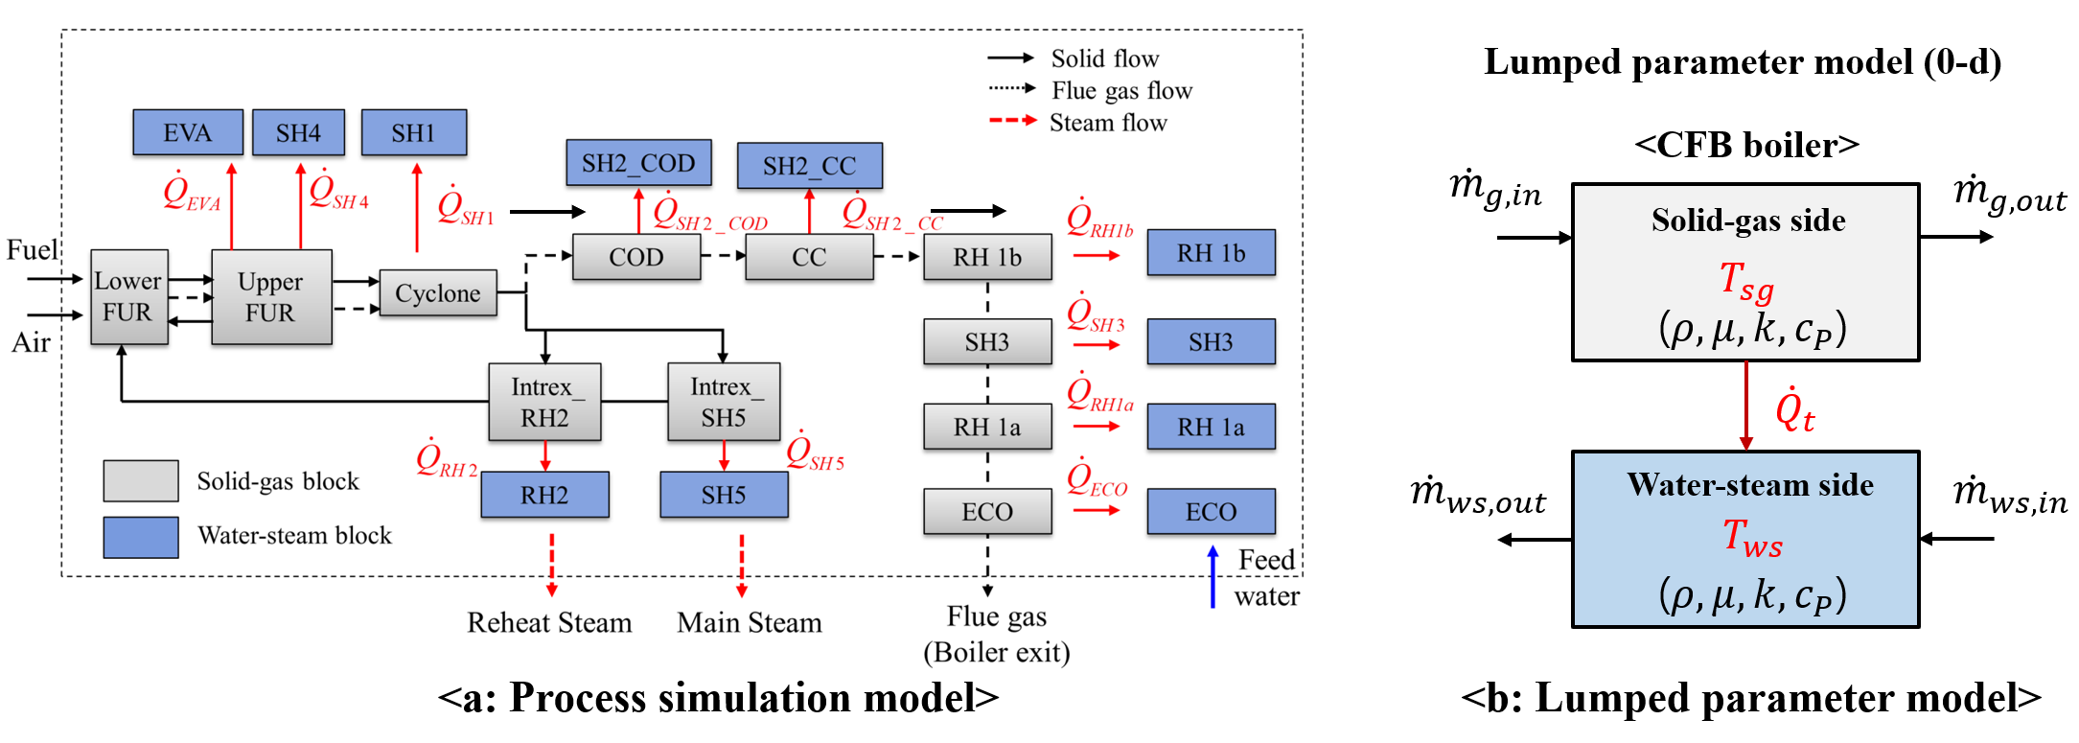Figure 2 Diagram of process simulation model (a) and lumped parameter model (b) [Kim. et. al.]

solid return part, the fitting equation was applied as mentioned in the previous page [Zhang et al.]. In the back pass, the correlation for calculating the radiation and convection of the flue gas was applied [Basu, 2000; Incropera et al.]. HTC of the water-steam side was applied according to subcritical and supercritical pressures [Incropera et al.; Sallevelt et al.]. This process simulation model was validated with the design data. The error rate of solid-gas temperature, the water-steam temperature, and the heat transfer rate are below 5%. Therefore, model reliability was confirmed.
  - Process simulation results
The simulation conditions are Boiler Maximum Continuous Rating with the design coal. The ammonia co-firing ratio is 0, 5, 10, 20, and 30% based on high heating value (HHV). As shown in Table 2, the CFB boiler utilizes low-grade coal compared to the PC boiler. Table 3 shows the mass balance results and adiabatic flame temperature (AFT) according to ammonia co-firing. The total flue gas flow rate and AFT decrease according to the increase in ammonia co-firing ratio. Solid circulation rate decreases due to the decrease in air flow rate. At 30% co-firing condition, the solid circulation rate decreases by approximately 150 kg/s. It is assessed that the reduction in solid circulation does not significantly affect heat transfer. Apparently, as the ammonia co-firing ratio increases, the mole fraction of CO₂ decreases, and the mole fraction of H₂O increases.
Table 2 Design coal of the CFB boiler and PC boiler
 | C (%) | H (%) | O (%) | N (%) | S (%) | Ash (%) | Mois. (%) | HHV (kcal/kg)
CFB | 47.80 | 3.67 | 22.5 | 0.75 | 0.22 | 4.5 | 20.5 | 4,350
PC | 57.42 | 3.32 | 11.7 | 1.15 | 0.31 | 6.0 | 20.0 | 5,300
Table 3 Mass balance results and adiabatic flame temperature according to ammonia co-firing ratio.
Design coal_BMCR load condition |  | Unit | Ammonia co-firing ratio
 |  |  | 0% | 5% | 10% | 20% | 30%
Coal flow rate |  | kg/s | 76.20 | 72.39 | 68.58 | 60.96 | 53.34
Ammonia flow rate |  | kg/s | 0 | 3.08 | 6.16 | 12.32 | 18.47
Total air flow rate |  | kg/s | 532.32 | 528.31 | 524.31 | 516.29 | 508.27
Total flue gas flow rate |  | kg/s | 604.83 | 600.28 | 595.73 | 586.63 | 577.53
Solid circulation rate |  | kg/s | 3,093 | 3,069 | 3,046 | 2,999 | 2,953
Flue gas composition  (Mass fraction) | O₂ | % | 3.38 | 3.37 | 3.36 | 3.35 | 3.33
 | N₂ | % | 66.75 | 67.17 | 67.60 | 68.47 | 69.36
 | CO₂ | % | 21.93 | 20.99 | 20.04 | 18.09 | 16.08
 | H₂O | % | 7.94 | 8.46 | 9.00 | 10.1 | 11.23
Adiabatic flame temperature |  | °C | 1,668 | 1,665 | 1,662 | 1,657 | 1,651

Fig. 3 shows the simulation results of the heat transfer rate of each heat exchanger according to the ammonia co-firing ratio (a) and the comparison with the PC boiler (b). The process simulation model and results of the PC boiler can be referred to the reference [Kim et. al.]. Although flame emissivity slightly increases due to the increase in H₂O mole fraction, the radiation heat transfer rate decreases due to the decrease in AFR, circulating solids, and mass fraction of coal particles. In addition, the convective heat transfer rate decreases due to the decrease in the flue gas mass flow rate. However, as shown in Fig. 3(b), the decrease in heat transfer rate of the CFB boiler is lower than in the PC boiler. This is because the CFB boiler uses low-grade coal (low HHV and large content of moisture). Therefore, the reduction in AFT and heat loss of moisture of the CFB boiler is lower than that of the PC boiler. In addition, due to the heat transfer mechanism of the circulating solids, the reduction in radiative heat transfer in CFB boilers is lower compared to PC boilers, where only a flue gas heat transfer mechanism exists. Accordingly, the main and reheat steam temperature decreases due to the decrease in the radiation and convection heat transfer rate under the ammonia co-firing condition as shown in Fig. 4. Because there is a difference in the heat transfer rate of both boilers, the reduction of main and reheat steam temperature of the CFB boiler is lower than that of the PC boiler. At ammonia co-firing of 30%, the main and reheat steam temperatures of the CFB boiler decrease by 18.5ºC and 6.5ºC, respectively.
Fig. 5 shows the reduction of CO₂ and boiler thermal efficiency. As shown in Fig. 5, As the ammonia co-firing rate increases, the reduction in CO₂ emissions increases, but the boiler thermal efficiency decreases. This shows the trade-off relationship between CO₂ reduction and boiler thermal efficiency. The boiler thermal efficiency of the CFB boiler decreases by 1.9%, which is lower than that of the PC boiler (2.3%). Therefore, it is important to establish optimal operation conditions with ammonia-co-firing conditions.

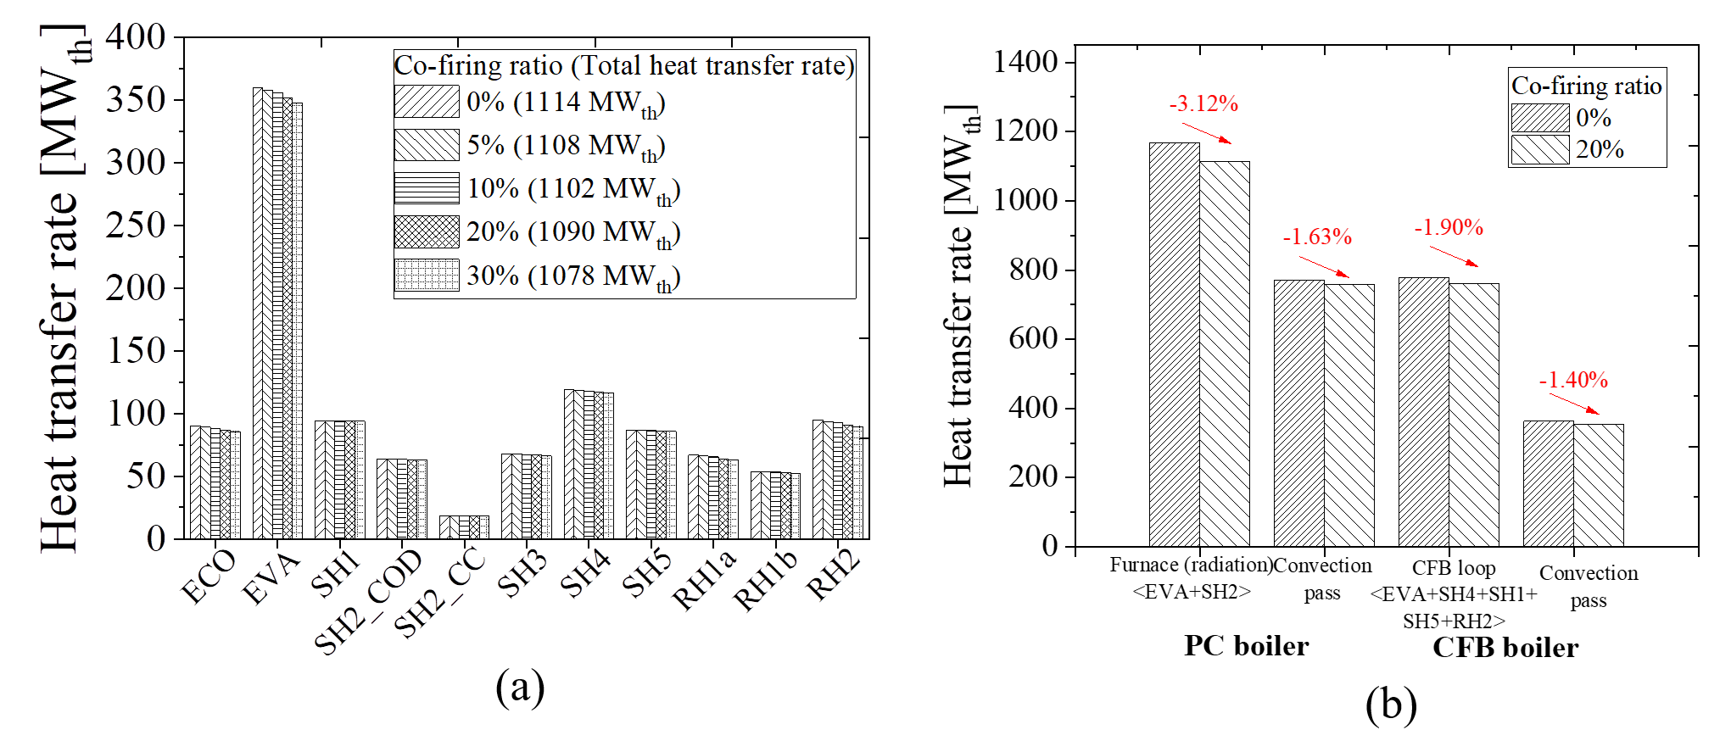
Figure 3 Simulation results of heat transfer rate of each heat exchanger according to ammonia co-firing ratio (a) and the comparison with PC boiler (b)
  - Conclusions
We performed a process simulation of a CFB boiler utilizing ammonia as a carbon-free fuel for the evaluation of thermal performance. We demonstrated the reduction of radiation and convective heat transfer rate with ammonia co-firing conditions. This means a reduction in plant efficiency. However, we also confirmed the reduction of the heat transfer rate of the CFB boiler is lower than that of the PC boiler due to the use of low-grade coal and the heat transfer mechanism of circulating solids. This study can be used to establish optimal operating conditions for CO₂ emissions and the improvement of plant efficiency during ammonia co-firing in terms of power plant operation.
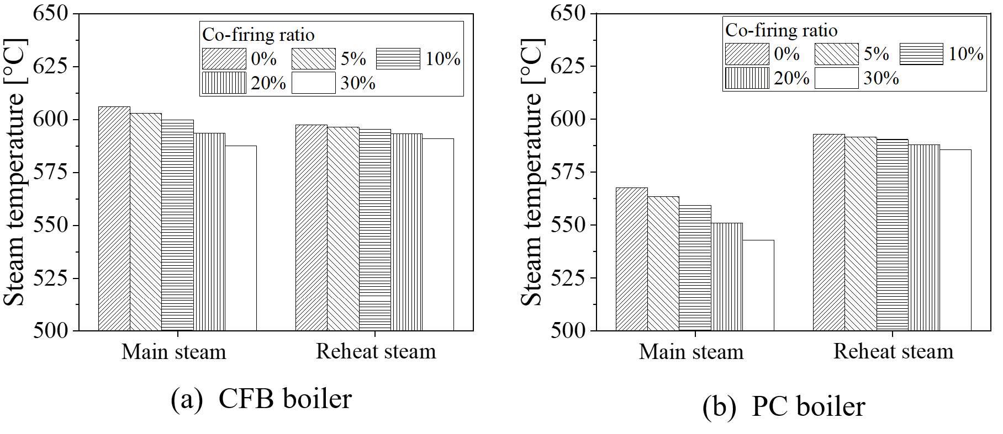
Figure 4 Simulation results of main and reheat steam temperatures of the CFB boiler and the PC boiler
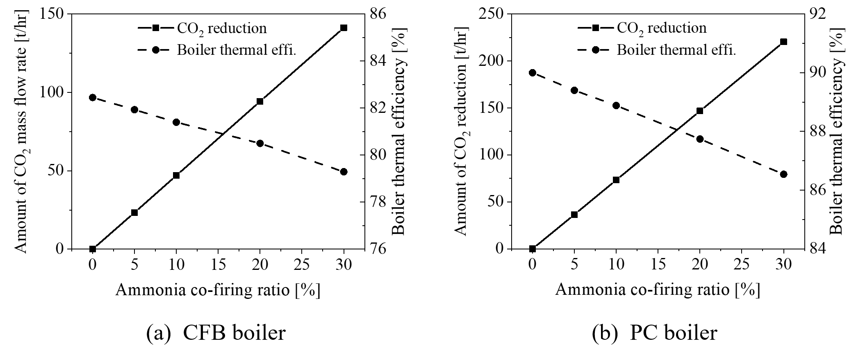
Figure 5 Relationship between the reduction of CO2 and boiler thermal efficiency of the CFB boiler and PC boiler.
References
P. Basu, 2006, Chap. Heat Transfer in Circulating Fluidized Beds, Combustion and gasification in fluidized beds. New York: Taylor & Francis, pp. 178.
P. Basu, C. Kefa, L. Jestin, 2000, Chap. Boiler Furnace Design Methods, Boiler and burners (Design and Theory). New York, Springer, pp. 128
FP. Incropera, DP. Dewitt, TL. Bergman, AS. Lavine, 2008, Fundamentals of Heat and Mass Transfer, New York, Wiley.
S. Kim, M. Lim, Y. Lee, J. Lee, and W Yang, 2023, Evaluation of effects of ammonia co-firing on the thermal performances of supercritical pulverized coal and circulating fluidized bed boilers, 276, 116528.
H. Kobayashi, A. Hayakawa, K. Somarathne, E. Okafor. Science and technology of ammonia combustion. 2019, Proc Combust Inst 37, 109–133. https://doi.org/10.1016/j.proci.2018.09.029.
J. Sallevelt, J. Withag, E. Bramer, D. Brilman, G. Brem, 2012, One-dimensional model for heat transfer to a supercritical water flow in a tube, J Supercrit Fluids, 68, 1–12. https://doi.org/10.1016/j.supflu.2012.04.003.
M. Zhang, H. Wu, Q. Lu, Y. Sun, and G. Song, 2012, Heat transfer characteristics of fluidized bed heat exchanger in a 300MW CFB boiler, Powder Technol, 222, 1–7.

