Intensified biodiesel production from waste palm oil in a plug flow reactor
Barcia-Quimi Andrea F.^{a*}, Beltran-Borbor Kelly.ª, Piza-Espinoza Angeloª, Tinoco-Caicedo Diana^{a,b}
ª Facultad de Ciencias Naturales y Matemáticas (FCNM), Escuela Superior Politécnica del Litoral Ecuador, 090903 Guayaquil, Ecuador.
^{b} Centro de Energías Renovables y Alternativas (CERA), Escuela Superior Politécnica del Litoral Ecuador, 090903 Guayaquil, Ecuador.
*abarcia@espol.edu.ec
Abstract

Biodiesel from waste oil is a promising sustainable alternative to energy supply. Traditionally, this process is carried out in batch reactors, whose reaction times require more than 60 minutes to achieve a maximum yield of 97.6%, according to Narváez et al. (2007). This implies high energy consumption and operating costs for product discharge, cleaning, and running. Therefore, a continuous flow microreactor was designed to intensify the process in a shorter production time under similar operating conditions. Said tubular reactor achieved significant time reduction up to 10 minutes with a yield of 83.33 % and 84.09 % for methanol to oil molar ratios 4:1 and 12:1, respectively. These results were satisfactory compared to the batch yields. The biodiesel quality obtained for both molar ratios was also evaluated under INEN regulations. Those results were within the permissible limits.

Keywords: Waste oil, Tubular reactor, Intensification, Biodiesel
  - Introduction
The increasing energy demand and environmental deterioration over the years have led to the search for sustainable alternatives for energy production. Biodiesel is a promising route to replace fossil fuels as it can be produced from waste oil. This biofuel is an excellent substitute for crude oil-derived diesel, given its similar characteristics in viscosity, energy density, and chain length (Naik et al., 2010). Moreover, its production does not generate toxic waste and does not release polluting gases during combustion (Rodionova et al., 2017). Conventionally, biodiesel synthesis is carried out in batch reactors, as it allows the optimization of operating parameters (Bashir et al., 2022).
These reactors are integrated by a stirred tank that receives a specific concentration of reagents and catalysts to react in a set time. The minimum volume required will depend on the desired production rate and the complete cycle time: reagent loading, heating, reaction, product discharge, and cleaning (Tabatabaei et al., 2019). Despite the simplicity of this reactor, the main drawbacks of the process include operating times over 1 hour, high operating costs, higher energy consumption, higher reagent consumption, non-uniform mixing, and large space requirements (Awogbemi & Kallon, 2022; Zahan & Kano, 2019). Such shortcomings lead to a rejection in the energy sector towards withdrawing conventional fuels.
Multiple studies have been conducted on different reactor technologies to intensify biodiesel production and solve operational parameter constraints. Researchers are interested in the transition from batch to continuous production. Technologies such as microchannel reactors, continuous stirred tanks, oscillatory flow reactors, and rotating tube reactors promise to improve mass transfer and accelerate reaction rate (Madhawan et al., 2018).
Channels with internal diameters in millimeter ranges characterize the microscale continuous flow reactor. Therefore, mass and heat transfer are inversely related to the dimensions of this cross-section. Thus, this type of technology guarantees a better dissipation of mass and heat since there is a larger contact surface, and the volume and hot spots are minimized (Carlucci, 2022).
As a result, residence times are much shorter than in batch reactors. Tanawannapong et al. (2013) reported 91.7 % conversion of methyl esters in 5 seconds using a 9:1 methanol-to-oil molar ratio and 1 wt % KOH at 65 °C. Baydir & Aras (2022) adapted a 0.8 mm diameter T-type cell mixer inside a 1 mm diameter tubular reactor to obtain 99.8 % Fatty Acid Methyl Esters (FAME) in 2 min residence time using a methanol-oil molar ratio 6:1 and 1 wt. % KOH at 60 °C. Other authors implemented a zigzag structure in microreactors of 240 um hydraulic diameter to achieve 99.5 % FAME conversion in 28 seconds under a 9:1 methanol-oil molar ratio at 56 °C and 1.2 wt. % NaOH (Wen et al., 2009).
Based on the above, using continuous flow technologies is now a challenge that promises to overcome the limitations of the batch reactor and intensify biodiesel production. This paper will present the design and implementation of a microscale plug flow reactor. The reaction yield was compared at different methanol - oil molar ratios (MR) in a batch reactor and the proposed tubular reactor, as well as the effects of virgin and waste cooking oil in the reaction results.
  - Methodology
    - Materials
The oil sample used for biodiesel production is refined palm oil from a local distributor, which was previously used to cook fried foods at high temperatures (above 200 °C). Said sample did not require previous treatments and was used as direct feed for the tubular reactor. The acid value of waste cooking oil was 1.16 mg KOH/g according to NTE INEN 38. Methanol (AR grade) was purchased from HaymanKimia. Potassium hydroxide from Merck Co. Ltd. was used to prepare the catalytic solution.
    - Reaction conditions
The biodiesel reaction was developed at the upper and lower molar ratios (MR 4:1; MR 12:1), as stated in the latest research by Barcia-Quimi et al. (2023), to reduce methanol consumption during the reaction. KOH concentration was set to 1 wt. % on the mass of palm oil, which was then stirred for 5 minutes with the corresponding methanol to oil molar ratio. The maximum operating temperature (60 °C) reported by the kinetic study of palm oil methanolysis by Narváez et al. (2007) in a batch reactor was adopted in this research. At these conditions, the conversion to methyl esters reaches its maximum after 80 minutes of reaction and 1 wt. % KOH. For the current study, the batch reactor worked for 1 hour under the same operating conditions.
Past research done by Barcia-Quimi et al. (2023) suggests a reaction time of 30 minutes in a batch operation to maximize biodiesel production yield and minimize production costs and carbon footprint. Therefore, the residence time for the proposed tubular reactor must consider this time range so that the solution responds to a viable and cost-effective technology. For this purpose, the molar concentration profile of palm oil ethanolysis by Narváez et al. (2015) was analyzed.
    - System description
The reaction was performed in a prototype laboratory-scale tubular reactor. The material availability and its thermal resistance to the reaction temperature of the system were the basis for the selection of the diameter of the channels. Thus, PVC plastic pipes with internal diameters of 4.55 mm and thickness of 0.60 mm were used to transport the reactant fluids and subsequent transesterification. The microchannel length (L) was calculated using Equation 7 after determining the residence time (τ) in min, where $v_{0}$ is the feed flow in mL/min and D is the pipe's internal diameter in cm.
$$L=\frac{4τv_{0}}{πD^{2}}$$ | (7)
The pipeline was arranged in a spiral configuration to promote mass transfer, given the low miscibility between the fatty acids in the oil and methanol, as shown in Figure 1.
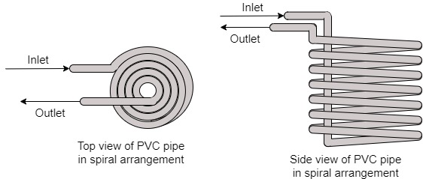
Figure 1. Tubular reactor design drawing.
An inlet-reactor-outlet system was used, in which the reagents must be pre-loaded and pushed by a pumping system to allow mixing of the reagents by turbulence. Figure 2 shows the process flow diagram, including the separation and drying of the biodiesel.
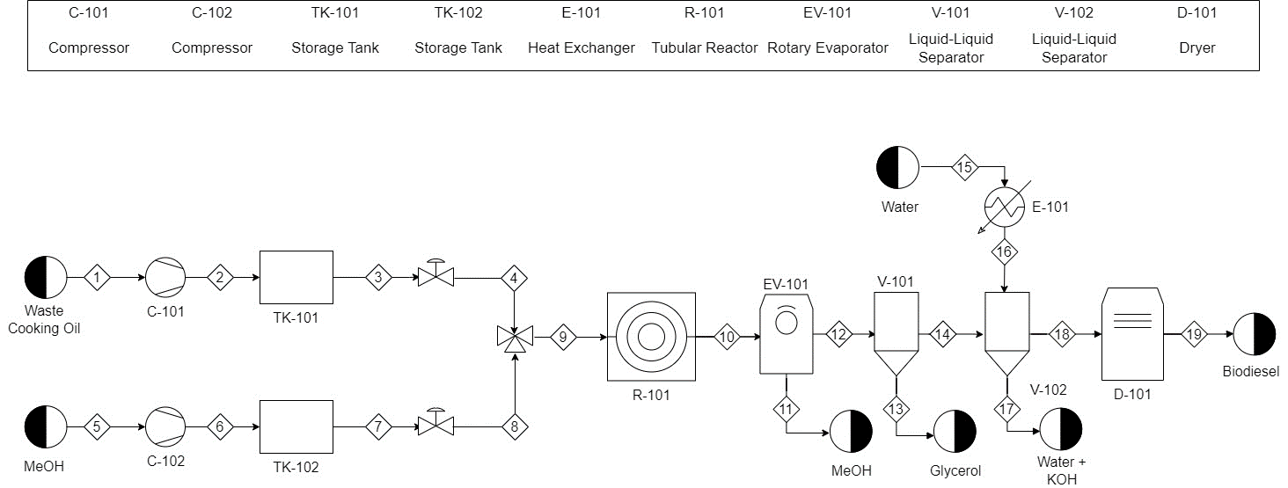
Figure 2. Process flow diagram to produce biodiesel in a tubular reactor.
Waste cooking oil was placed in tank TK-101. Tank TK-102 was filled with catalytic solutions. Compressors C-101 and C-102 were set up as pumping systems. A Welch WOB-L 2534 pressure pump was used for the oil, and a Power 500 aquarium air pump was used for the catalyst.
The pipes used to transport the reagents before entering the reactor were intravenous infusion hoses with their roller flow regulators. Those acted as control valves. A T-shaped micromixer was connected to the reactor piping (R-101). A distillation balloon collected the reaction products at the reactor outlet. The reactor was placed in a water bath at 60 °C.
After transesterification, excess methanol was removed by rotary evaporation (EV-101) at 40 °C and 200 mbar. The mixture was allowed to stand for one day so that glycerol could be separated by decantation (V-101). The biodiesel was washed with distilled water at 50 °C to remove the catalyst. Subsequently, the final product was taken to an oven (D-101) to remove moisture.
    - Reaction Yield
The methyl esters in the oil and biodiesel were determined by gas chromatography in different hexane solutions. The methodology reported by Fallon et al. (2007) was followed to prepare the oil samples. The yield (Y %) was calculated as the ratio between the total concentration of the FAMES detected in the chromatographic curve of the biodiesel and the total concentration of the FAMES extracted in the oil.
$$Y \%=\frac{{\left[EM\right]}_{Biodiesel}}{{\left[EM\right]}_{oil}} x 100\%$$ | (7)
    - Physicochemical characterization of biodiesel
The physicochemical characteristics of the biodiesel obtained in the tubular reactor were determined. The properties analyzed are cloud point, pour point, acidity, saponification index, density, iodine value, calorific value, kinematic viscosity, and ash content.
  - Results
Figure 3 exhibits the molar concentration profile of the kinetic model of Narváez et al. (2015) adapted to the proposed reactor for MR 4:1 and MR 12:1. As shown in the graph; it is possible to obtain a conversion higher than 80 % TG in the first 5 minutes of reaction under the proposed operating conditions. Considering the limitations of a natural system such as pressure drop, mass and heat transfer limitations, and flow irregularities, a residence time of 10 minutes was estimated. Therefore, a pipe length of 10 meters was calculated.

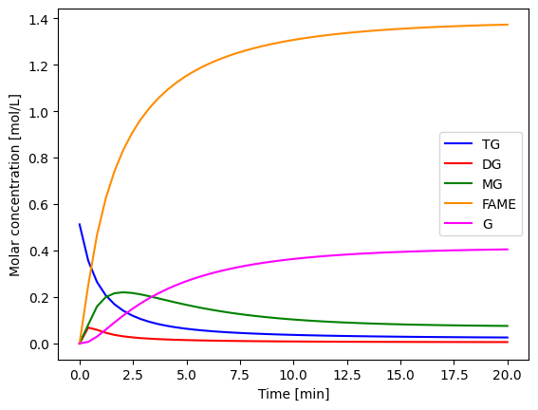 | 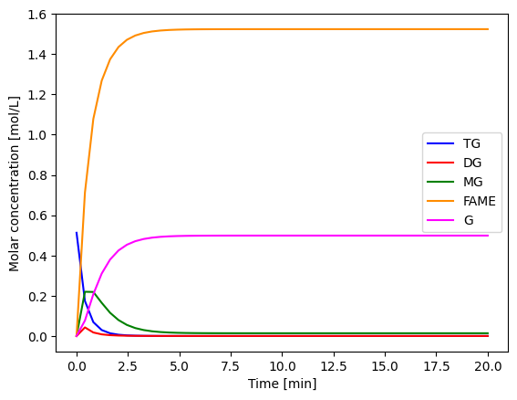
(a) | (b)
Figure 3. Molar concentration profile of palm oil methanolysis from Narváez et al. (2015) adapted to a tubular reactor at 60 °C and 1 wt. % KOH with (a) RM 4:1 and (b) RM 12:1.
The chromatographic tests reported a higher content of fatty acids in the refined oil than in the waste oil. This could be because the former did not undergo a degradative heating process. Thus, the operating time will be essential to promote the FAME production. On the other hand, the biodiesel from waste oil had satisfactory results due to a lower TG content. Table 1 presents the reaction yields in the batch and tubular reactor.
The batch reactor may be suitable when working with low MR at high TG concentrations since it prioritizes the reaction time. On the other hand, the tubular reactor favors greater contact between molecules due to its high area-volume ratio, which results in a higher yield for an optimal molar ratio. In either case, the tubular reactor continues to be a beneficial option given the significant time minimization of 83.33 %.
Table 1. Results of reaction yields in batch and tubular reactors.
Feedstock | Batch Reactor Yield (%) |  | Tubular Reactor Yield (%)
 | MR 4:1 | MR 12:1 | MR 4:1 | MR 12:1
Virgin oil | 60.37 | 52.46 | 55.16 | 70.26
Waste oil | 55.96 | 81.42 | 83.33 | 84.09
Table 2 summarizes the biodiesel characterization results obtained from the tubular reactor at 60 °C with constant volumetric flows and a residence time of 10 minutes for both molar ratios studied. The criteria of the Ecuadorian Technical Norm under which the quality of the product is defined are also indicated.

Table 2. Results of the biodiesel characterization produced in the tubular reactor.
Parameter | Unit | Result |  | Value range | Normative Reference
 |  | MR 4:1 | MR 12:1
Cloud Point | °C | 5 | 6 | - | -
Pour Point | °C | -2 | 3 | - | -
Acidity | wt. % | 0.1180 | 0.1484 | ≤ 0.5 | NTE INEN 2482
Saponification index | mg/g | 273.88 | 258.82 | - | -
Density | g/ml | 0.8622 | 0.8594 | 0.860 – 0.900 | NTE INEN 2482
Iodine Value | cg/g | 83.4215 | 83.8945 | ≤ 120 | NTE INEN 2482
Calorific Value | MJ/m3 | 36 247 | 37 619 | ≥ 33 192 | ASTM D6751
Kinematic Viscosity | mm2/s | 4.1225 | 3.4933 | 3.5 - 5 | NTE INEN 2482
Ash Content | wt. % | 0.022 | 0.023 | ≤ 0.025 | NTE INEN 2482
These results are all within the specifications of the referenced standards. Therefore, the proposed tubular reactor can produce quality biodiesel in a shorter production time.
  - Conclusions
The operation of a tubular reactor at laboratory scale for the biodiesel production through transesterification of palm oil was successfully tested. It was demonstrated that the millimetric dimensions of the pipe diameter provide a larger contact surface to improve mass transfer and intensify the process. This is because high yields of 83.33 % and 84.09 % corresponding to the MR 4:1 and 12:1 were obtained under the same conditions compared to a batch reactor in a shorter reaction time (10 minutes). Moreover, this biofuel was found to have an acceptable quality according to the characterizations performed under INEN regulations, since the values reported in the experimentation are within the specifications. For future studies, the use of non-toxic catalysts should be explored, so that the reaction runs in an eco-friendly way.
References
Awogbemi, O., & Kallon, D. V. Von. (2022). Application of Tubular Reactor Technologies for the Acceleration of Biodiesel Production. Bioengineering, 9(8), 347. https://doi.org/10.3390/bioengineering9080347
Barcia-Quimi, A. F., Risco-Bravo, A., Alcivar-Espinoza, K., & Tinoco-Caicedo, D. L. (2023). Design of a sustainable biodiesel production process by a multi-objective optimization. Computer Aided Chemical Engineering, 52, 519–524. https://doi.org/10.1016/B978-0-443-15274-0.50083-4
Bashir, M. A., Wu, S., Zhu, J., Krosuri, A., Khan, M. U., & Ndeddy Aka, R. J. (2022). Recent development of advanced processing technologies for biodiesel production: A critical review. Fuel Processing Technology, 227, 107120. https://doi.org/10.1016/j.fuproc.2021.107120
Baydir, E., & Aras, O. (2022). Increasing biodiesel production yield in narrow channel tubular reactors. Chemical Engineering and Processing - Process Intensification, 170(September 2021), 108719. https://doi.org/10.1016/j.cep.2021.108719
Carlucci, C. (2022). An Overview on the Production of Biodiesel Enabled by Continuous Flow Methodologies. Catalysts, 12(7), 717. https://doi.org/10.3390/catal12070717
Madhawan, A., Arora, A., Das, J., Kuila, A., & Sharma, V. (2018). Microreactor technology for biodiesel production: a review. Biomass Conversion and Biorefinery, 8(2), 485–496. https://doi.org/10.1007/s13399-017-0296-0
Naik, S. N., Goud, V. V., Rout, P. K., & Dalai, A. K. (2010). Production of first and second generation biofuels: A comprehensive review. Renewable and Sustainable Energy Reviews, 14(2), 578–597. https://doi.org/10.1016/j.rser.2009.10.003
Narváez, P. C., Noriega, M. A., & Cadavid, J. G. (2015). Kinetics of palm oil ethanolysis. Energy, 83, 337–342. https://doi.org/10.1016/j.energy.2015.02.029
Narváez, P. C., Rincón, S. M., & Sánchez, F. J. (2007). Kinetics of palm oil methanolysis. JAOCS, Journal of the American Oil Chemists’ Society, 84(10), 971–977. https://doi.org/10.1007/s11746-007-1120-y
O’Fallon, J. V., Busboom, J. R., Nelson, M. L., & Gaskins, C. T. (2007). A direct method for fatty acid methyl ester synthesis: Application to wet meat tissues, oils, and feedstuffs. Journal of Animal Science, 85(6), 1511–1521. https://doi.org/10.2527/jas.2006-491
Rodionova, M. V., Poudyal, R. S., Tiwari, I., Voloshin, R. A., Zharmukhamedov, S. K., Nam, H. G., Zayadan, B. K., Bruce, B. D., Hou, H. J. M., & Allakhverdiev, S. I. (2017). Biofuel production: Challenges and opportunities. International Journal of Hydrogen Energy, 42(12), 8450–8461. https://doi.org/10.1016/j.ijhydene.2016.11.125
Tabatabaei, M., Aghbashlo, M., Dehhaghi, M., Panahi, H. K. S., Mollahosseini, A., Hosseini, M., & Soufiyan, M. M. (2019). Reactor technologies for biodiesel production and processing: A review. Progress in Energy and Combustion Science, 74, 239–303. https://doi.org/10.1016/j.pecs.2019.06.001
Tanawannapong, Y., Kaewchada, A., & Jaree, A. (2013). Biodiesel production from waste cooking oil in a microtube reactor. Journal of Industrial and Engineering Chemistry, 19(1), 37–41. https://doi.org/10.1016/j.jiec.2012.07.007
Wen, Z., Yu, X., Tu, S.-T., Yan, J., & Dahlquist, E. (2009). Intensification of biodiesel synthesis using zigzag micro-channel reactors. Bioresource Technology, 100(12), 3054–3060. https://doi.org/10.1016/j.biortech.2009.01.022
Zahan, K. A., & Kano, M. (2019). Technological Progress in Biodiesel Production: An Overview on Different Types of Reactors. Energy Procedia, 156(September 2018), 452–457. https://doi.org/10.1016/j.egypro.2018.11.086

