Simulation and 3E assessment of pre-combustion CO₂ capture process using novel Ionic liquids for blue H₂ production
Sadah Mohammedª, Fadwa Eljackª, Saad Al-Sobhiª, Monzure-Khoda Kazi ^{b}
ªQatar University, Department of Chemical Engineering, College of Engineering, P.O. Box 2713, Doha, Qatar
^{b}Texas A&M Energy Institute, Texas A&M University, College Station, TX 77843-3372, United States
Fadwa.Eljack@qu.edu.qa
Abstract
Incorporating pre-combustion CO₂ capture with H₂ production is expected to be a crucial technology that significantly contributes to CO₂ emissions reduction from the current H₂ production methods that rely on natural gas. This work evaluates the exergy, energy, and economic aspects of a CO₂ capture process using new ionic liquid (IL) [NMIM][DCN] for H₂ production, and compares it with the established IL [HMIM][DCN]. The package “PySCF” in Python was used for geometry optimization, and a COSMO-based/Aspen approach was employed for component definition in Aspen Plus. The pre-combustion CO₂ capture was simulated using Aspen Plus V12®. Through the simulation, it was evident that IL [NMIM][DCN] exhibited promising results with a CO₂ capacity of 92.84% and 99.7% H₂ recovery, in contrast to [HMIM][DCN] (CO₂ capacity: 80% and H₂ recovery: 94.6%). Additionally, [NMIM][DCN] demonstrated lower energy consumption, utility cost and CAPEX compared to [HMIM][DCN] due to its low energy requirement for CO₂ separation. However, it is noteworthy that exergy and OPEX values were significantly high for [HMIM][DCN], and this suggests further analysis to optimize the [HMIM][DCN]-based process.

Keywords: CO₂ Capture, Ionic Liquids, Aspen Plus, COSMO-SAC, Exergy
  - Introduction
With the imperative shift toward a low-carbon economy and the objective of reaching net-zero emissions by 2025, the global demand for hydrogen production is expected to rise. Hydrogen, a non-carbonaceous fuel, offers a low-emission alternative to traditional fossil fuels and can be blended with natural gas to meet diverse energy system demands.
Around 95% of the global hydrogen demand is fulfilled via the reforming of fossil fuels, of which steam methane reforming (SMR) constitutes 50% of the overall production (Oh et al., 2022). However, the SMR process, being energy intensive, leads to high CO₂ emissions (89.1 gCO₂/MJ) (Birol, 2019). To address this, blue hydrogen production offers a viable solution, where CO₂ is removed from hydrogen effluent gases in fossil fuel processes using CO₂ capture technology, resulting in lower carbon intensity (22.4 gCO₂/MJ) (Regulator, 2020). Therefore, it is imperative to develop a highly efficient process for capturing CO₂, aimed at producing H₂ with a low-carbon footprint. Achieving this involves adopting the pre-combustion CO₂ capture approach, due to its high efficiency in removing high CO₂ concentration. Normally, in the pre-combustion process, CO₂ removal is accomplished by the absorption process. Physical absorption application has become a standard practice for developing versatile, energy-efficient, and economically viable pre-combustion CO₂ capture systems. The latter emphasizes the energy and solvent requirements as vital aspects during the design stage. In this regard, Ionic liquids (ILs) have gained popularity due to their desirable CO₂ capture properties in pre-combustion applications like low vapor pressure. This study focuses on improving efficiency while minimizing capital and operating costs in pre-combustion CO₂ capture for the production of blue H₂ using novel ILs. The study scrutinizes the system engineering aspects, including energy, exergy, and economics (3E), comparing them to established IL.
  - Methodology
- Geometry optimization and property method
The novel IL introduced in this work, namely 1-nonyl-3-methylimidazolium dicyanamide [NMIM][DCN] (see Figure 1), was designed using a predictive deep learning model (DL), which was developed in our previous work (Mohammed et al., 2023).

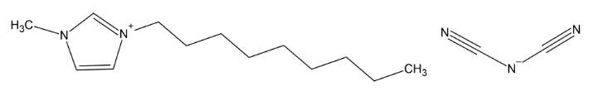
Figure 1: Molecular structure of the novel IL
Based on the DL results, the novel IL exhibited the highest CO₂ solubility (x_{CO2} = 0.425) and low viscosity ($γ_{IL}$= 0.061 Pa.s) at 1.5 MPa and 283.15 K, compared to other designed ILs. Following the acquisition of the IL’s molecular structure, molecular geometry optimization was conducted following a procedure outlined by (Wang & Song, 2016). This method explicitly incorporates collective translations and rotations, allowing for effective traversal of many-dimensional potential energy surfaces. The “PySCF” package available in the programming language “Python” was employed for all the density functional theory (DFT) calculations. The “B3LYP” functional coupled with the “STO-3G” basis set, was selected. Subsequently, a file “.XYZ” that contains the optimized geometry was generated via a Python code based on the above-mentioned information. Following that, the “.XYZ” file was integrated into COSMO-RS software to acquire the necessary parameters, including sigma profile (SGPRF1 to SGPRF5), activity coefficients, molecular volume “CSACVL”, and Henry’s constant to define [NMIM][DCN] in simulation software “Aspen Plus” following a COSMO-based/Aspen approach described in previous work (Ferro et al., 2018). A similar approach was implemented to an established IL “1-hexyl-3-methylimidazolium dicyanamide, [HMIM][DCN]”. Both results of the studied ILs were compared and analyzed.
- Process modeling of IL-based CO₂ capture
Figure 2 shows the IL-based pre-combustion CO₂ capture process, following a similar process configuration proposed by (Zhai & Rubin, 2018). The process was developed in simulation software “Aspen Plus V12®”. In this configuration, the process comprises a “RADFRAC” packed absorber column (C-101) where the CO₂ in the simplified inlet syngas stream (CO₂/H₂: 0.37/0.63) is absorbed by the IL. Pure hydrogen stream (S-03) exists the overhead of the absorber tower. Subsequently, the CO₂-rich stream (S-04) leaving the absorber is entered flash drums (F-101 & F-102) that are arranged in series for regeneration. The two CO₂ streams (S-05 & S-07) from the two flash drums are mixed using a mixer (M-101), and the stream (S-08), which mainly contains IL exits the second flash drum, then cooled (E-101) and circulated back to the absorber.
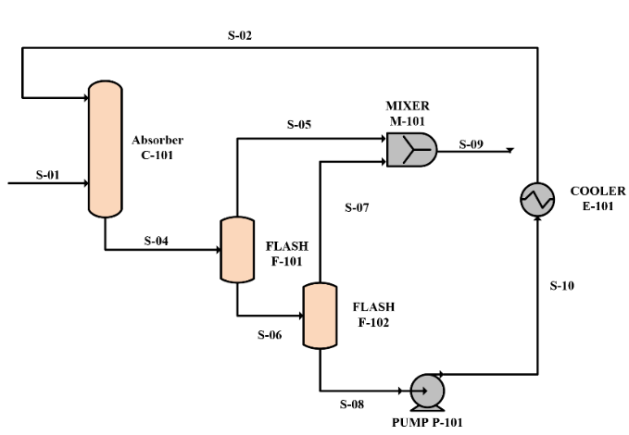
Figure 2: IL-based pre-combustion CO₂ physical absorption process scheme.
- Energy and exergy analyses
To assess the total energy consumption associated with equipment duty, an energy analysis was conducted. Consequently, the proposed process was optimized via sensitivity analysis to identify the optimal operating parameters that would result in lower energy requirements. Exergy analysis accounts for the maximum amount of efficient work accomplished from a process through the identification of the irreversibility within the process. Exergy assessment in any process involves the combination of two components: physical exergy and chemical exergy. In this study, only physical exergy is considered. Exergy destruction takes place within processing equipment, identifying the generation of entropy that causes deviation in the process and introduces inefficiencies. Exergy analysis for calculating exergy destruction (equations (1)-(4)) and exergy efficiency (equations (5)-(7)) of the processing equipment are listed below (Kazmi et al., 2021):
$I_{absorber,min}= \sum{{\left(\dot{m}.\dot{e}\right)}_{in}-}\sum{{\left(\dot{m}.\dot{e}\right)}_{out}}$ | (1)
$I_{pump}= \sum{{\left(\dot{m}.\dot{e}\right)}_{in}-}\sum{{\left(\dot{m}.\dot{e}\right)}_{out}}+W$ | (2)
$I_{heat exchanger}= \sum{{\left(\dot{m}.\dot{e}\right)}_{in}-}\sum{{\left(\dot{m}.\dot{e}\right)}_{out}}$ | (3)
$I_{separator}= \sum{{\left(\dot{m}.\dot{e}\right)}_{in}-}\sum{{\left(\dot{m}.\dot{e}\right)}_{out}}$ | (4)
$${eff}_{pump}= \frac{\sum{{\left(\dot{m}.\dot{e}\right)}_{out}-}\sum{{\left(\dot{m}.\dot{e}\right)}_{in}}}{W}$$ | (5)
$${eff}_{heat exchanger}= 1- \left[{\left\{\frac{\sum_{1}^{n}{m∆e}}{\sum_{1}^{n}{m∆h}}\right\}}_{hot}-{\left\{\frac{\sum_{1}^{n}{m∆e}}{\sum_{1}^{n}{m∆h}}\right\}}_{cold}\right]$$ | (6)
$${eff}_{separator}= \frac{\sum{{\left(\dot{m.\dot{e}}\right)}_{out}}}{\sum{{\left(\dot{m.\dot{e}}\right)}_{in}}}$$ | (7)
- Economic analysis
In this section, economic analysis was implemented based on the energy and exergy analysis. The overall cost of the proposed pre-combustion CO₂ capture process was assessed using a built-in feature called Aspen Process Economic Analysis (APEA). This feature uses the Aspen plus simulation run to evaluate the total process costs encompassing operational expenditure (OPEX) and capital expenditure (CAPEX). APEA employs a bottom-up methodology, breaking down the process to assess each component through the appropriate cost model.
  - Results and discussion

Sensitivity analysis
To examine the impact of crucial operating variables on CO₂ removal, a sensitivity analysis was carried out on the pre-combustion CO₂ capture process. To attain high CO₂ solubility and pure H₂ stream, the inlet flow rate of the IL to the absorber as well as the operating pressure were varied to explore the effect on the CO₂ capture. Figure 3 shows the optimal IL flow rate for [NMIM][DCN] and [HMIM][DCN]. It is conspicuous from the figure that [NMIM][DCN] requires less flow rate ($≈490 kmol/h)$ to achieve high CO₂ capture, unlike [HMIM][DCN] which requires a higher flow rate ($≈660 kmol/h)$.
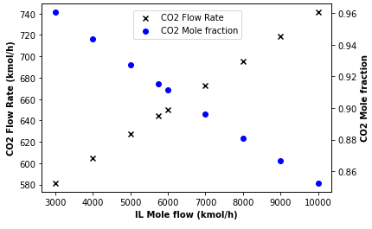
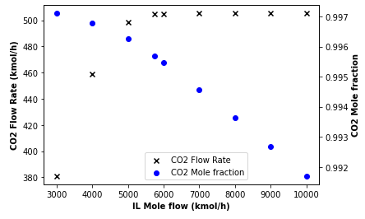

Optimal rate
(1)
Optimal rate
(2)

Figure 3: Impact of IL flow rate (1) [NMIM][DCN], and (2) [HMIM][DCN] on purity and yield of CO₂

Figure 4 depicts the CO₂ and H₂ flow rate (kmol/h) in the rich-solvent stream (stream S-04, see Figure 2). It can be seen from the results that [NMIM][DCN] absorbs less hydrogen even at a higher pressure compared to [HMIM][DCN].
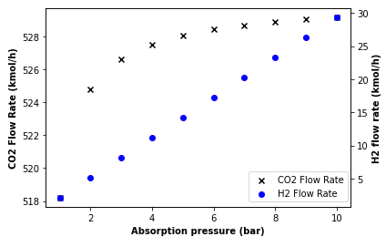
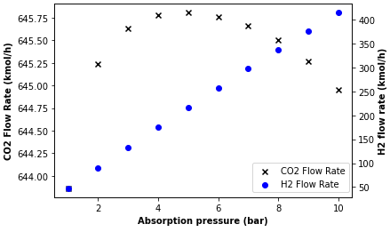
(1)
(2)

Figure 4: Impact of absorber operating pressure on CO₂ and H₂ solubility in (1) [NMIM][DCN], and (2) [HMIM][DCN].

The separation process is a crucial step in the CO₂ removal process. In this step, two flash columns were required to completely separate the CO₂ from the IL. In column F-101, a pressure and temperature-swing was implemented as seen in Figure 5-1 and Figure 5-2, and only temperature-swing is applied in column F-102 as shown in Figure 5-3. More CO₂ is separated when IL [NMIM][DCN] is used at low temperatures and pressure. The findings from this analysis prove that increasing the alkyl chain in ILs improves CO₂ solubility and enhances separation processes. Based on the above analysis and optimizing the operating parameters, remarkable H₂ and CO₂ recovery (%) results were obtained. Specifically, [NMIM][DCN] exhibited an excellent recovery value of 99.7% for H₂ and 92.84% for CO₂. In comparison, [HMIM][DCN] demonstrated slightly lower but still significant recovery rates, with 94.6% for H₂ and 80% for CO₂.
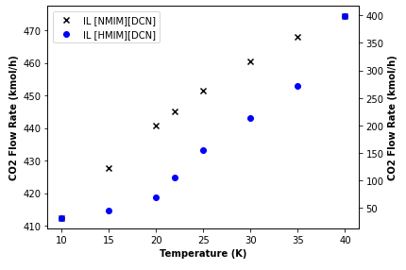
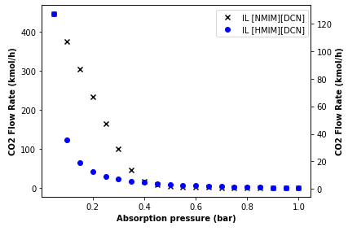
(1)
(2)
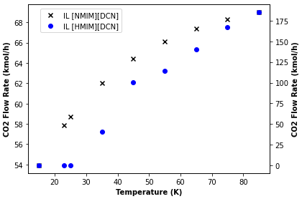
(3)
Figure 5: Effect of temperature (K) and pressure (bar) on CO₂ purity in (1) Column F-101, and (2) Column F-102

3E assessment
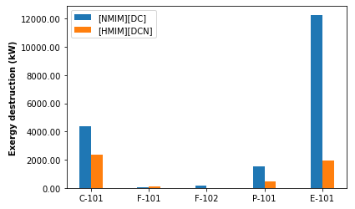
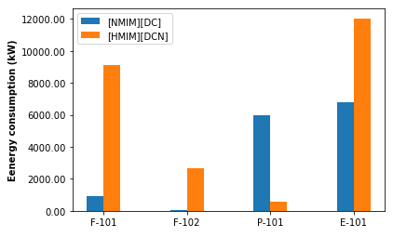

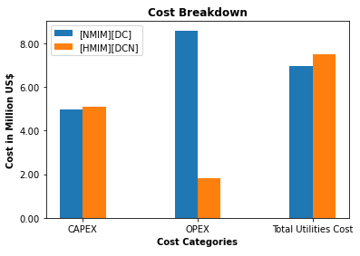
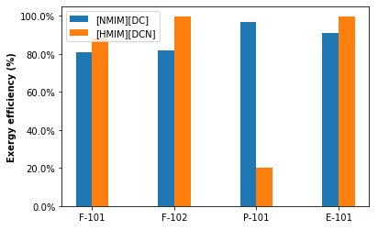

Figure 6: 3E assessment of [NMIM][DCN] and [HMIM][DCN] IL-based CO₂ capture process

Figure 6 illustrates the 3E analysis for the proposed process under the optimized operating parameters. Notably, when considering energy consumption, IL [NMIM][DCN] exhibited low energy consumption due to the CO₂ separation occurring at low temperatures and pressure as outlined in section ‎3.1. Specifically, in column F-101, [NMIM][DCN] shows significantly low energy consumption (900 kW) compared to [HMIM][DCN] (9137 kW). A similar trend is noticed in column F-102, where [NMIM][DCN] consumes lower energy than [HMIM][DCN]. Furthermore, in terms of exergy destruction, a notable difference is highlighted. In column C-101, [NMIM][DCN] experiences a higher exergy destruction of 4362.0 kW compared to [HMIM][DCN] (2347.5 kW), indicating that [HMIM][DCN] exhibits better exergy efficiency. Regarding the economic aspects, [NMIM][DCN] has slightly lower CAPEX ($4.98 million) and utility cost ($6.95 million) compared to [HMIM][DCN] ($5.08 million) and ($7.51 million), respectively. However, [NMIM][DCN] incurs significantly higher OPEX ($8.59 million) compared to the low OPEX value ($1.83 million) for [HMIM][DCN].
  - Conclusions
This paper presents a 3E assessment of a pre-combustion CO₂ capture process using novel IL [NMIM][DCN] and established IL [HMIM][DCN] for H₂ hydrogen production. Optimized molecular geometry was obtained via the “PySCF” package in Python, while COMSO-RS provided the sigma profile and other properties for component definition were obtained from COSMO-RS. Subsequently, the sensitivity analysis identified the optimum operating parameters and based on the results, the 3E analysis was conducted. The results highlight that [NMIM][DCN] has a notable advantage for H₂ production over [HMIM][DCN] due to its high CO₂ capacity (92.84%), low energy consumption, utility cost and CAPEX. However, the extremely high OPEX value ($8.59 million) suggests that [NMIM][DCN] necessitates further studies to reduce this value to an acceptable range.
  - Acknowledgment
The authors acknowledge the paper was made possible by grant QUHI-CENG-22-23-465 from Qatar University. The statements made herein are solely the responsibility of the author[s].
  - Reference
Birol, F. (2019). The Future of Hydrogen – Analysis - IEA. Technology Report. https://www.iea.org/reports/the-future-of-hydrogen
Ferro, V. R., Moya, C., Moreno, D., Santiago, R., De Riva, J., Pedrosa, G., Larriba, M., Diaz, I., & Palomar, J. (2018). Enterprise Ionic Liquids Database (ILUAM) for Use in Aspen ONE Programs Suite with COSMO-Based Property Methods. Industrial and Engineering Chemistry Research, 57(3), 980–989. https://doi.org/10.1021/acs.iecr.7b04031
Kazmi, B., Raza, F., Taqvi, S. A. A., Awan, Z. ul H., Ali, S. I., & Suleman, H. (2021). Energy, exergy and economic (3E) evaluation of CO2 capture from natural gas using pyridinium functionalized ionic liquids: A simulation study. Journal of Natural Gas Science and Engineering, 90(February), 103951. https://doi.org/10.1016/j.jngse.2021.103951
Mohammed, S., Eljack, F., Al-Sobhi, S., & Kazi, M.-K. (2023). Development of deep learning framework to predict physicochemical properties for Ionic liquids. In A. C. Kokossis, M. C. Georgiadis, & E. Pistikopoulos (Eds.), 33rd European Symposium on Computer Aided Process Engineering (Vol. 52, pp. 2119–2124). Elsevier. https://doi.org/https://doi.org/10.1016/B978-0-443-15274-0.50337-1
Oh, H. T., Kum, J., Park, J., Dat Vo, N., Kang, J. H., & Lee, C. H. (2022). Pre-combustion CO2 capture using amine-based absorption process for blue H2 production from steam methane reformer. Energy Conversion and Management, 262(February). https://doi.org/10.1016/j.enconman.2022.115632
Regulator, C. E. (2020). Market Snapshot: How hydrogen has the potential to reduce the CO2 emissions of natural gas. Canada Energy Regulator. https://www.cer-rec.gc.ca/en/data-analysis/energy-markets/market-snapshots/2020/market-snapshot-hydrogen-potential.html
Wang, L. P., & Song, C. (2016). Geometry optimization made simple with translation and rotation coordinates. Journal of Chemical Physics, 144(21). https://doi.org/10.1063/1.4952956
Yu, M., Wang, K., & Vredenburg, H. (2021). Insights into low-carbon hydrogen production methods: Green, blue and aqua hydrogen. International Journal of Hydrogen Energy, 46(41), 21261–21273. https://doi.org/10.1016/j.ijhydene.2021.04.016
Zhai, H., & Rubin, E. S. (2018). Systems Analysis of Physical Absorption of CO2 in Ionic Liquids for Pre-Combustion Carbon Capture. Environmental Science and Technology, 52(8), 4996–5004. https://doi.org/10.1021/acs.est.8b00411

