Quality Modelling in Batch Processes with High Dimensional Output Feedback
Aswin Chandrasekar, Hassan Abdulhussain, Michael R. Thompson, Prashant Mhaskar
Department of Chemical Engineering, McMaster University, Hamilton, Ontario, Canada
mhaskar@mcmaster.ca
Abstract
We present and compare two novel data-driven modelling approaches for batch processes utilizing information from thermal images. Data from a bench scale A rotational molding experimental set up is used to illustrate the approaches. Like most batch processes, the key challenge is to develop a model for quality attributes (such as impact strength and sinkhole area) that are only measurable after batch completion, using non-traditional sensors such as thermal images. We propose and compare multiple approaches 1) where the data from the images is reduced to a lower dimensional space using principal component analysis (PCA), and then a subspace modelling technique is used to derive a dynamic model and an associated quality model, 2) the image data is directly used in the subspace modelling technique to in turn determine the dynamic model and the associated quality model, and 3) the image data and quality model are derived through a Prediction Error Minimization approach.
Keywords: Image-based dynamic and quality modeling, Batch Processes, Thermal images, Non-traditional sensors, Subspace Identification, Prediction Error Minimization
  - Introduction
Most industrial processes, regardless of the domain, have a common target of achieving high quality products. Sometimes, batch operation is preferred, for example, in pharmaceutical, or biochemical applications when the focus is on the quality requirement rather than the quantity of the products. However, due to this reason, coming up with a suitable control routine for the process becomes an important task to maintain consistency in the product quality. Model predictive controllers (MPC) have been conventionally used for many industrial applications. An MPC has an underlying dynamic process model which allows the controller to predict the future of the process and enables it to take the most optimum control action. Arriving at a good model is one of the challenges, especially in processes where there is no first principles model available. An even more pressing challenge and opportunity is the availability of non-traditional sensors such as sounds or images. In such cases, the model development becomes crucial in the eventual effectiveness of the control strategy.
There has been some work in utilizing high dimensional data directly, but most of the image-based modelling has been done in the context of soft sensing applications like monitoring and fault detection (Gopaluni et al. (2020)). Narasingam and Kwon (2017) have applied Dynamic Mode Decomposition (DMDc) directly on spatial CFD data to construct a dynamic model between the inputs and the outputs, which are specific points in the spatial data. In this case, it is safe to assume that the states of the process are present in the high dimensional CFD (Computational Fluid Dynamics) data, and moreover the mapping between the states and the output is known to the authors (i.e., data at specific locations). In most cases, these two assumptions may not hold true. Likewise, Lu and Zavala (2021) have used DMDc on thermal images on a system with multiple heating inputs spread across the spatial field, with the controlled variable being the image itself. Often in processes, one might not have such a high dimensional reference signal, and moreover, the desired target might not be in the form of a setpoint in the first place, but rather for the processed product to meet a certain quality demand. There are other works (Masti and Bemporad (2021)) which combine the reduction of high dimensional data and constructing the dynamic model into one Neural Network model, but these approaches assume high volume of available data. In our case, and in most batch processes, we deal with a limited amount of experimental data and might not have the luxury to run too many experiments considering the material and the energy costs. Considering these issues, we present a general modelling approach to model the process, and present three novel approaches. Data from a Bi-axial Rotational Molding setup, which is a batch process used for manufacturing hollow plastics, is utilized. The system has only one heater as the input. The mold rotates biaxially inside the oven and a thermal imaging camera is placed outside the oven to capture the image of the mold, which is the only continuously measured output of the system. Although the rotation speed is given along with the equipment, the rotation is not perfect and hence the camera cannot be hard-coded to take images at particular instances to get the mold in the frame perfectly. Furthermore, there are two quality variables associated with the molded product; the sinkhole area percentage and the impact strength, which can be measured only through destructive means, only after the experiment is done. It is essential that a model is developed taking into consideration the aforementioned challenges. The proposed modelling approaches are as follows. First, a neural network-based classifier is trained on all the images of a batch, to detect whether the box is in the camera frame. For the images for which the box is detected, the modeling is done in 3 separate ways. In one approach, the high dimensional image data is reduced to a representative (lower dimensional) set of variables which reasonably represent the dynamics of the mold temperature- and/or even more importantly, captures the information necessary to estimate the final product quality. To achieve this, we fit a Principal Component Analysis (PCA) Model on only the images containing the box, to acquire a set of these latent variables. A Linear Time Invariant State Space (LTI SS) model is built between the input and the previously obtained latent variables and a Partial Least Squares (PLS) model is built between the latent variables and the quality measurements. In the second approach, a subsapce model is directly identified using the image data (without reduction), and an associated quality model is identified. Finally, in the third approach, a prediction error minimization approach is utilized to determine the dynamic and quality model simultaneously. We will first present the experimental setup in Section 2 and then present the proposed modelling approaches in Section 3.
  - Process description
A small-scale rotational molding machine is utilized in the laboratory to manufacture plastic molded items. Both the inputs from the single heater coil and the resulting images from the rotational molding setup are supervised and manipulated using LabVIEW and MATLAB programs. A camera, positioned outside the oven, captures images through a narrow opening. High-density polyethylene powder is added to the mold at room temperature, while the oven is pre-heated to 300°C. Then the mold is placed in the oven and is rotated at a steady speed of about 8 RPM. Following the heating phase, the mold is shifted to a cooling chamber. The product, still enclosed in the mold, undergoes air cooling before extraction for subsequent quality testing. Key quality variables in this batch process, namely the sinkhole area and impact strength of the product, are assessed separately after the experiment once the product is obtained.

In the rotational molding process, the degree of sintering is evaluated by examining surface voids. When polymer particles do not undergo complete sintering, the resulting product often displays a noticeable presence of surface voids. To analyze these voids, ImageJ is utilized, employing images of the mold captured by a digital camera. Another crucial quality parameter is the strength of the product, determined through Izod pendulum impact testing. The impact energy of the samples is measured in accordance with the ASTM D256 standard. Additional details regarding these quality variables in the context of this study are available in our earlier work (Chandrasekar et al., 2022).
  - Proposed Modelling Approaches
In this section, we present three modelling approaches to model the dynamics of the process along with the product quality using images. All these modelling approaches have a layered structure, where the first few layers are required to make it implementable in a closed loop setting.
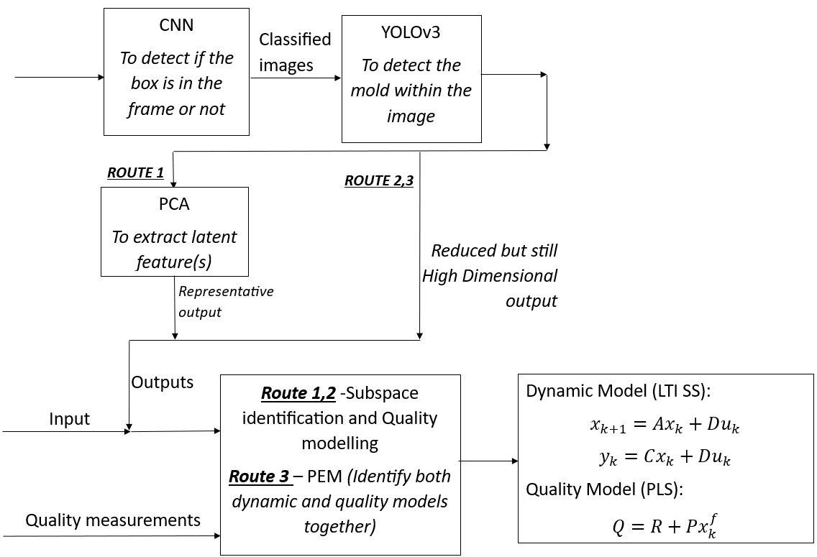
Figure 1
The first layer contains a Convolutional Neural Network (CNN) based classifier to differentiate between images that contain the mold from those that do not. An image, that is classified by the CNN model to contain the mold, goes through another pre-trained, CNN based object detection model (YOLOv3, You Only Look Once by Redmon and Farhadi (2018)), that captures the portion of the image that only contains the mold. This helps in reducing the image upto a certain extent by removing the surroundings, without losing important information related to the dynamics of the process itself. The frame size of the detected portion of image at every time step is set at 40x40. Once this is done, one of the proposed approaches is chosen to complete the modelling process. All the three approaches are shown in Figure 1.

    - First Approach
$$T=X*P$$ | (1)
$$x_{k+1}=Ax_{k}+Bu_{k}$$ | (2a)
$$y_{k}=Cx_{k}+Du_{k}$$ | (2b)
$$Q=\hat{R_{m}}+\hat{P_{m}}x\left[t_{end}\right]$$ | (3)
In the first approach, the 40x40 mold-containing image is further reduced by Principal Component Analysis (PCA) (Equation (1)) to a single latent variable which is then used as an output variable along with the heater input while constructing a Linear Time Invariant (LTI) State Space (SS) model (Equation (2)) of an order 2 using subspace identification. A modified version of the deterministic subspace identification algorithm (Moonen et al., 1989) as presented in Corbettt and Mhaskar (2016) that is capable of handling multiple batch data has been used for identifying the state space model. Finally, a Partial Least Squares Regression (PLS) based quality model (Equation (3)) is constructed to link the product quality $Q$ of a batch to the final state $x[t_{end}]$ of that batch, which is obtained from the state space model. Specific details regarding the quality modelling can be found in Mhaskar et al. (2019). The key quality variables of interest are sinkhole area % ${(Q}_{1})$ and the impact strength ${(Q}_{2})$. T represents the scores or the latent variables from PCA analysis, A, B, C, D are the model matrices for the SS model and finally, the R and P are the intercept and the coefficient matrices obtained from PLS regression.

    - Second Approach
In the second approach however, we directly apply subspace identification taking the 40x40 image as the output and the heater input as the sole input for the LTI SS model. The rest of the approach is similar to the first approach. The only difference is we do not reduce the image using a dimensionality reduction technique like PCA prior to modelling the dynamics.

    - Third Approach
Unlike the first two approaches, where subspace identification was used to identify the dynamics between the outputs and the inputs and subsequently a PLS quality model was identified, this approach tries to identify both the dynamic model and the quality model together using Prediction Error Minimization (PEM). In particular, the dynamic model is identified between the 40x40 image as the output and the heater input as the sole input, and. The optimization formulation used for identifying the models is given below:

$$\min_{A,B,C,D, P, R , x_{0}(b)}{\sum_{b=1}^{n_{b}}{\left({\left(Q_{b}-\hat{Q_{b}}\right)}^{T}*\left(Q_{b}-\hat{Q_{b}}\right) + \sum_{k=1}^{n_{t}}{{(y_{b,k}-{\hat{y}}_{b,k})}^{T}*(y_{b,k}-{\hat{y}}_{b,k})}\right)}}$$ | (4a)
$$x_{b,0}=x_{0}$$ | (4b)
$${\hat{x}}_{b,k+1} =A{\hat{x}}_{b,k}+Bu_{b,k}$$ | (4c)
$${\hat{y}}_{b,k}=C{\hat{x}}_{b,k}+Du_{b,k}$$ | (4d)
${\hat{Q}}_{b}=P+R{\hat{x}}_{b,n_{t}}$ | (4e)
Equation 4a, is the objective function, which minimizes the prediction error of the quality model and the dynamic model. 4b is the initial state of each batch in the data set. Note that the states also have to be estimated as part of the state space model identification. 4c and 4d form the state space model. 4e is the PLS based quality model which related the final state of the batch to the quality of the products obtained in that particular batch.
  - Open Loop Prediction Results
In this section, we compare and tabulate the prediction performance of the proposed approaches in Table 1. All the approaches were trained on 4 batches of data. We can see that the 1st approach performs well in predicting the end product quality from intermediate points during a batch. However, the 2nd approach gives better predictions towards the end of the batch. The PEM approach gives a model that is able to decently predict the qualities during the early stages of a batch and is able to recover the accuracy towards the end of the batch. It must be noted that PEM solves a non-linear optimization, and for this particular problem, the number of variables were found to be around 8000. Hence a good initial guess becomes crucial. The initial guess for the model parameters that were to be identified was used from the 2nd approach. Overall, we can see that all the three modelling approaches are able to sufficiently model the dynamics and in turn, the quality of the product in the batch process.
Method | Single Batch results  Absolute errors in Q₁ and Q₂ for a batch, as seen from different time instances |  |  | All batches  Cumulative MSE
Error in  Q₁ and Q₂ | t = 20 | t = 50 | t = 80 | t = End Point
1st Approach | 0.54 | 0.17 | 0.95 | 0.291
2nd Approach | 1.61 | 1.91 | 2.02 | 0.043
3rd Approach | 3.99 | 1.37 | 1.33 | 0.107
Table 1
  - Conclusions
In conclusion, this work presents different ways of modelling the quality variables in a batch process when the only available output measurements are high dimensional in nature. The proposed modelling approaches involve a combination of CNNs, PCA, PLS and LTI SS models to completely account for the process dynamics. In particular, the CNN models were used to detect images containing the mold and cut out the surrounding portions from the image. Then for the 1st approach, PCA is done on the images to reduce the high dimensional image to a single latent variable which can then be used as an output variable along with the input for subspace identification and finally quality modelling. For the 2nd and 3rd approaches, no reduction was done and the whole image was taken in the output space while constructing the LTI SS dynamics model and PLS quality model. Subspace identification and subsequently PLS was used in 2nd approach whereas both the models were jointly identified using PEM in the 3rd approach. The results show that all three approaches are able to sufficiently model the key quality variables of the batch process, hence making them implementable under closed loop control, which is the true objective.
References
Chandrasekar, A., Abdulhussain, H.A., Gritsichine, V., Thompson, M.R., and Mhaskar, P. (2022). Adaptive predictive control algorithm for batch processes: Application to a rotational molding process. Industrial & Engineering Chemistry Research, 61(48), 17572–17581. doi:10.1021/acs.iecr.2c02415.
Corbett, B. and Mhaskar, P. (2016). Subspace identification for data-driven modeling and quality control of batch processes. AIChE Journal, 62(5), 1581–1601. doi:10.1002/aic.15155
Gopaluni, R.B., Tulsyan, A., Chachuat, B., Huang, B., Lee, J.M., Amjad, F., Damarla, S.K., Kim, J.W., and Lawrence, N.P. (2020). Modern machine learning tools for monitoring and control of industrial processes: A survey. IFAC-PapersOnLine, 53(2), 218–229. doi: https://doi.org/10.1016/j.ifacol.2020.12.126. 21st IFAC World Congress.
Lu, Q. and Zavala, V.M. (2021). Image-based model predictive control via dynamic mode decomposition. Journal of Process Control, 104, 146–157.
Masti, D. and Bemporad, A. (2021). Learning nonlinear state space models using autoencoders. Automatica, 129, 109666.
Mhaskar, P.; Garg, A.; Corbett, B. (2019). Modeling and Control of Batch Processes; Advances
in Industrial Control; Springer International Publishing: Cham
Moonen, M., De Moor, B., Vandenberghe, L., and Vandewalle, J. (1989). On- And Off-Line Identification Of Linear State Space Models. International Journal of Control, 49(1), 219–232.
Narasingam, A. and Kwon, J.S.I. (2017). Development of local dynamic mode decomposition with control: Application to model predictive control of hydraulic fracturing. Computers & Chemical Engineering, 106, 501–511.
Verhagen, M. and Dewilde, P. (1992). Subspace model identification Part 1. The output-error state-space model identification class of algorithms. International Journal of Control, 56(5), 1187–1210. doi:10.1080/00207179208934363.
Wang, J. and Qin, S.J. (2002). A new subspace identification approach based on principal component analysis. Journal of Process Control, 12, 841–855.

