Prospective life cycle analysis of green platform chemicals uncovers their full environmental potential
Abhinandan Nabera,ª Robert Istrate,^{b} Antonio José Martín,ª Javier Pérez-Ramírez,^{a,}* Gonzalo Guillén-Gosálbez^{a,}*
ªDepartment of Chemistry and Applied Biosciences, ETH Zurich, 8093 Zurich, Switzerland
^{b}Institute of Environmental Sciences (CML), Leiden University, 2333 CC Leiden, The Netherlands
*jpr@chem.ethz.ch, gonzalo.guillen.gosalbez@chem.ethz.ch
Abstract
Current life cycle assessments (LCAs) of conventional and emerging chemical technologies often neglect future changes in the economy required to meet climate goals, such as those affecting transportation systems and heat and power generation. Disregarding these trends, which will shape the future economy, could lead to less accurate assessments and spurious conclusions. Hence, in this study, we conducted a prospective LCA to understand how future changes in the economy (until 2050) will affect the environmental impact of chemicals, using ammonia as a representative case. To achieve this, we used background data consistent with climate policies aimed at limiting global temperature rise across 26 regions. Our findings reveal that the environmental gap between fossil and green ammonia will significantly increase in the future, with solar-based routes showing the most improvement due to efficiency gains in solar panels and their lower carbon footprint resulting from the decarbonization of the energy mixes used in their manufacture. Overall, this study emphasizes the importance of considering future trends in the assessment of chemical technologies to draw a more comprehensive picture of their environmental potential.
Keywords: climate policies, platform chemicals, prospective life cycle assessment.
  - Introduction
The chemical industry poses a formidable challenge towards decarbonization, primarily due to its heavy reliance on fossil fuels, leading to 5.6 Gt CO₂-eq, accounting for 10% of global GHG emissions (Bauer et al., 2023). Moreover, only one-third of these emissions are direct, with the remaining attributed to energy acquisition and the upstream value chain, highlighting the industry’s dependence on global energy systems and supply chains. However, this challenge also presents an opportunity to reduce environmental impacts in chemical production through decarbonization of other key sectors. In recent times, there have been rapid technological advancements in response to decarbonization challenges and climate policies aligned with the Paris Agreement. In this context, key platform chemicals such as ammonia could play a crucial role in reducing emissions due to their large production volumes and diverse applications. Ammonia plays a pivotal role in the production of fertilizers, ensuring global food security. Currently, 60 to 70% of the ammonia is produced from fossil fuels, leading to emissions of 450 Mt CO₂ y^{–1} (Gabrielli et al., 2023). Several studies have evaluated low-carbon production routes for ammonia from renewable carbon and hydrogen-based feedstocks (D’Angelo et al., 2021; Gomez et al., 2020). These analyses have consistently highlighted the environmental superiority of green routes over their fossil counterparts. However, the majority of them often assume that the foreground system (chemical plant) interacts with the existing energy systems and supply chains, neglecting forthcoming decarbonization efforts, which could lead to less accurate and meaningful assessments. Hence, in this work, we evaluate the environmental impacts of fossil and green ammonia pathways until 2050, by considering expected changes in the power, materials, and transportation sectors under three climate-scenarios: a baseline scenario (3.5 °C), and two scenarios consistent with the 2 °C and 1.5 °C targets, respectively. Furthermore, we highlight the significance of locations in decision-making, by performing a temporal region-specific prospective LCA for 26 regions. Our results show that green ammonia could become more environmentally appealing in the future than originally thought.
  - Methods
In this study, we follow ISO 14040 and 14044 standards (International Standards Organization, 2006) in four phases. Phase one involves defining the goal and scope, where we assess the production of 1 kg of ammonia via specific technologies, considering cradle-to-gate impacts from 2020 to 2050 and various climate targets. Phase two includes the inventory analysis, where we use life cycle inventory (LCI) data generated automatically utilizing the IMAGE (Integrated Assessment of Global Environmental Change with IMAGE 3.0, 2014) Integrated Assessment Model (IAM) to evaluate the environmental performance of both fossil and green pathways for ammonia production. This enables us to project potential economic scenarios and provides insights into the environmental impacts based on expected socioeconomic and technological advancements. Specifically, we adopt the middle-of-the-road shared socioeconomic pathway (SSP2) and consider a range of representative concentration pathways (RCPs), including RCP6, RCP2.6, and RCP1.9. RCP6 corresponds to a scenario limiting global temperature rise to 3.5 °C, while RCP2.6 and RCP1.9 correspond to scenarios limiting temperature rise to 2 °C and 1.5 °C, respectively. To generate inventories for prospective LCAs covering the time period from 2020 to 2050, we utilize the premise framework (Sacchi et al., 2022). The year 2020 is considered as the reference year for our analysis. Additionally, we perform a regional assessment for the production of these platform chemicals across 26 global regions, considering location-specific temporal dynamics. Phase three involves life cycle impact assessment (LCIA) using IPCC 2013 global warming potentials (GWPs) and Environmental Footprint 3.0 methods to quantify various impact categories, with a focus on climate change. Lastly, phase four involves interpretation of the results obtained.
  - Results and Discussions
The impact of both fossil and green ammonia will decline in the future, but the environmental gap between them will grow substantially, thus drastically improving the environmental appeal of green ammonia (Figure 1a). Particularly, under an aggressive climate policy, such as the 1.5 °C scenario, these impacts will decrease significantly, with both the solar and wind-based pathways reducing their impact by 70% in 2050 (compared to 4% in the fossil analogue). Moreover, solar-based routes are projected to compete with, or even outperform, their wind-based counterparts. Under the moderate 2 °C scenario, the impacts of solar and wind-based ammonia routes are projected to decrease by two-thirds compared to their respective 2020 values. In both scenarios, green hydrogen accounted for half of the total impacts in 2020, and its contribution is expected to increase significantly to at least 80% by 2050. Grid electricity played a major role in green ammonia production due to the high-pressure Haber-Bosch process. However, by 2050, this contribution is expected to decrease six-fold due to the anticipated decarbonization of the electricity mix. Even under the baseline 3.5 °C scenario, the green ammonia routes are expected to display significant reductions ranging from 17% to 42%. Furthermore, a regional assessment reveals significant variations in impact reductions for both solar (Figure 1b) and wind-based (Figure 1c) ammonia production, with African regions demonstrating the highest reductions. This underscores the crucial importance of the location of green facilities in maximizing global benefits. These results indicate that a paradigm shift may occur, i.e., solar-based production routes may demonstrate the highest reduction in climate change impacts over time, approaching the performance levels of their corresponding wind-based counterparts. This nuances previous studies that consistently found wind-based routes to outperform solar pathways. This is in alignment with investigations indicating that wind turbine performances are plateauing and the most significant improvements in carbon intensity will be derived from the manufacturing and end-of-life recycling of these turbines (Li et al., 2022).
  - Conclusions
In this work, we assess the impact of future economic trends, with a focus on climate policies, on key platform chemicals, using ammonia as a testbed. We conduct this analysis across 26 regions spanning from 2020 to 2050. Our findings reveal that while the impact of both fossil and green routes will decrease, the gap between them will widen, especially under ambitious climate policies. Additionally, we emphasize the significance of facility location in our analysis, as it can significantly influence the results over time. Overall, this work underscores the importance of considering technological advancements, market trends, and regional factors in LCAs of emerging technologies. We hope this study will aid in making informed decisions during the transition towards more sustainable chemicals.
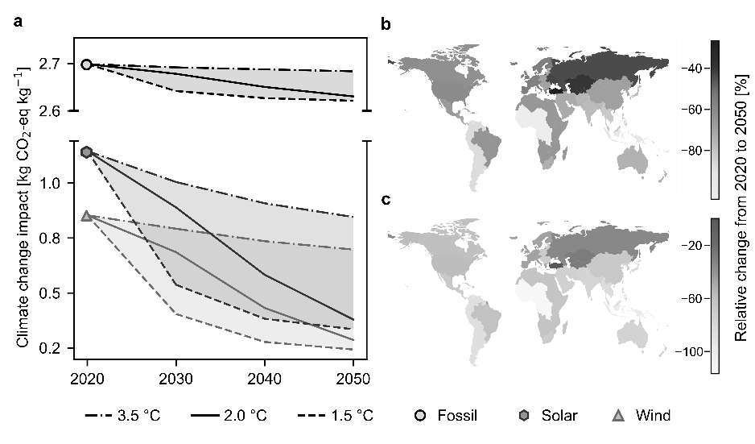
Figure 1 Climate change impacts of ammonia production technologies. (a) Global average impacts of fossil, solar and wind-based production from 2020 to 2050 across three scenarios (3.5 °C, 2 °C, and 1.5 °C). Regional analysis under the 2 °C scenario for (b) solar and (c) wind-based production pathways.
References
Bauer, F., Tilsted, J.P., Pfister, S., Oberschelp, C., Kulionis, V., 2023. Mapping GHG emissions and prospects for renewable energy in the chemical industry. Curr. Opin. Chem. Eng. 39, 100881.
D’Angelo, S.C., Cobo, S., Tulus, V., Nabera, A., Martín, A.J., Pérez-Ramírez, J., Guillén-Gosálbez, G., 2021. Planetary Boundaries Analysis of Low-Carbon Ammonia Production Routes. ACS Sustain. Chem. Eng. 9, 9740–9749.
Gabrielli, P., Rosa, L., Gazzani, M., Meys, R., Bardow, A., Mazzotti, M., Sansavini, G., 2023. Net-zero emissions chemical industry in a world of limited resources. One Earth 6, 682–704.
Gomez, J.R., Baca, J., Garzon, F., 2020. Techno-economic analysis and life cycle assessment for electrochemical ammonia production using proton conducting membrane. Int. J. Hydrog. Energy 45, 721–737.
Integrated Assessment of Global Environmental Change with IMAGE 3.0, 2014. PBL Netherlands Environmental Assessment Agency.
International Standards Organization, 2006. In ISO 14040:2006 Environmental Management--Life Cycle Assessment--Principles and Framework.
International StandardsOrganization, 2006. In ISO 14044:2006 Environmental Management--Life Cycle Assessment--Requirements and Guidelines.
Li, C., Mogollón, J.M., Tukker, A., Steubing, B., 2022. Environmental Impacts of Global Offshore Wind Energy Development until 2040. Environ. Sci. Technol. 56, 11567–11577.
Sacchi, R., Terlouw, T., Siala, K., Dirnaichner, A., Bauer, C., Cox, B., Mutel, C., Daioglou, V., Luderer, G., 2022. PRospective EnvironMental Impact asSEment (premise): A streamlined approach to producing databases for prospective life cycle assessment using integrated assessment models. Renew. Sustain. Energy Rev. 160, 112311.

