Novel closed-loop precursor re-synthesis assisted by roasting and wastewater electrolysis: Industrial scaled design and simulation
Sunwoo Kimª, Jeongdong Kimª, Junghwan Kim^{a,*}
ª Department of Chemical and Biomolecular Engineering, Yonsei University, Seoul 03722, Republic of Korea
Email of the corresponding author: kjh24@yonsei.ac.kr
Abstract
In recent spent lithium-ion batteries (LIBs) recycling studies, the concept of direct re-synthesis of NMC (Ni_{x}Mn_{y}Co_{z}O₂) precursor from spent LIBs is experimentally tested on a laboratory scale. However, beyond the laboratory scale, excessive usage of chemicals and wastewater disposal are the main issue in industrial scale application due to the accompanying operating cost and environmental degradation. Herein, to resolve the challenges, this study proposes a novel integrated system of closed-loop precursor re-synthesis assisted by roasting and wastewater electrolysis for sustainable LIB recycling. The proposed system consists of three major processes: hydrogen roasting for Li extraction, NMC precursor crystallization, and wastewater electrolysis for chemical regeneration. First, the spent LIB is decomposed into metal oxide by hydrogen roasting, and water-soluble lithium oxide is firstly separated from the metal oxide mixture. The recovered LiOH slurry undergoes further crystallization for high purity recovery. Second, the remaining metal oxide mixture undergoes acid leaching process, and pH adjustment via NaOH injection is conducted for satisfying minimum pH condition for precursor crystallization. Finally, the wastewater produced following the crystallization is fed to anion-exchange membrane-based electrolysis to regenerate sulfuric acid and NaOH in cathode and anode, separately. Recycling regenerated chemicals to leaching and pH adjustment step accomplished the closed-loop recycling system. This study firstly proposed conceptual design of closed-loop precursor re-synthesis assisted by roasting and electrolysis. The results of industrial scaled simulation showed the recovery of 98.95 % for Li and 79.00 % for NMC precursor. These results revealed that the proposed process could be a feasible solution for sustainable closed-loop battery recycling.
Keywords: Lithium-ion batteries, Battery recycling, Hydrogen roasting, Precursor crystallization, Wastewater electrolysis, Process design and evaluation
  - Introduction
Lithium-ion batteries (LIBs) occupy a dominant position in the energy storage field due to their advantages such as high energy capacity, and excellent cycling performance, leading to a rapidly growing market size. Among the various types of cathode materials, NMC (Ni_{x}Mn_{y}Co_{z}O₂)-type cathodes are expected to account for more than 80% of production by 2023. Due to the high share of the NMC market and limited reserves of valuable metals (e.g., Li, Ni, Mn, and Co), recycling spent LIBs is essential for a sustainable battery recycling system.
In the field of the batteries recycling technology, a method of direct re-synthesis of NMC precursor from spent LIB has recently been studied on a laboratory scale. NMC precursor is synthesized by adding a chelating agent and chemicals for pH adjustment to a leached solution of spent NMC cathode. Fang et al. experimentally achieved the recovery of NMC precursor and Li₂CO₃ through coprecipitation by adding Na₂CO₃ and NH₃⋅H₂O to leached solution. The synthesized precursor showed reliable electrochemical performance with the highest discharge specific capacity. Chen et al. synthesized the NMC precursor by simultaneously reacting spent cathode leached solution with Na₂CO₃ and NH₃⋅H₂O, and found that it reached the electrochemical properties of commercial cathode on a laboratory scale.
Despite various efforts in the direct resynthesis of NMC precursor to improve performance, application in industrial scale recycling requires to resolve following challenges. First, excessive usage of chemicals to achieve high metal recovery leads to increased operating costs. Second, excessive usage of chemicals results in large amounts of wastewater, causing environmental pollution. At industrial scale, operating costs and environmental impact are major issues. Thus, strategy to regenerating the chemicals via electrochemical treatment of wastewater may reduce the operating cost and environmental impacts.
In this study, a novel closed-loop precursor re-synthesis process design and simulation at industrial scale assisted by hydrogen roasting and wastewater electrolysis was conducted. By roasting, lithium can be first extracted as LiOH form by water leaching, which can reduce the usage of chemicals. Furthermore, the recovery of the NMC precursor was derived through a population balance equation (PBE) approach. Finally, the regeneration of sulfuric acid and NaOH was achieved through wastewater electrolysis.
  - Methodology
    - Process description

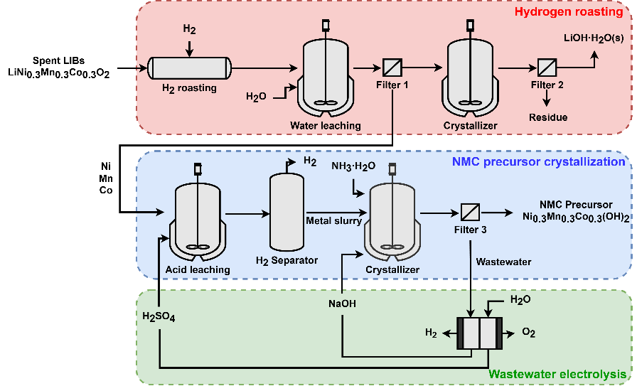
Fig. 1. Flow diagram of the proposed LIB recycling system.

Fig. 1 shows the flow diagram of proposed battery recycling system. The proposed system consists of three major processes: hydrogen roasting, NMC precursor crystallization, and wastewater electrolysis. First, the NMC cathode materials are decomposed into metal oxide by hydrogen roasting, and water-soluble lithium oxide firstly separated from the metal oxide mixture by water leaching. Then, the lithium oxide is recovered as LiOH·H₂O(s) by crystallization. Second, the remaining metal oxide mixture undergoes acid leaching process, followed by chelating agent injection and pH adjustment through NaOH injection to meet minimum pH conditions for precursor crystallization. Finally, the wastewater produced following the crystallization is fed to anion-exchange membrane-based electrolysis to regenerate H₂SO₄ and NaOH, separately.
    - Process model
      - Hydrogen roasting
The overall hydrogen roasting involves two main reactions: irreversible thermal decomposition to metal oxides and hydrogen roasting of metal oxides. In the thermal decomposition step shown in Eq. (1), the interlayer crystal structure of NMC is destructed and converted into a mixture of metal oxides. In the roasting step, the reduction of metal oxide with hydrogen is described as Eq. (2-4).

 | $Li{Ni}_{1/3}{Mn}_{1/3}{Co}_{1/3}O_{2}→\frac{1}{2}{Li}_{2}O+\frac{1}{3}NiO+\frac{1}{3}MnO_{2}+\frac{1}{3}CoO+\frac{1}{12}O_{2}$ | (1)

 | $$NiO+H_{2}→Ni+H_{2}O$$ | (2)

 | $$MnO+H_{2}→Mn+H_{2}O$$ | (3)

 | $$CoO+H_{2}→Co+H_{2}O$$ | (4)

The generated Li₂O is soluble in water, and water leaching is performed for selective Li extraction as shown in Eq. (5-6). Following, the LiOH slurry is converted into LiOH⋅H₂O(s) in the crystallization process as shown in Eq. (7).

 | $${Li}_{2}O(s)+H_{2}O(l)→2LiOH(s)$$ | (5)

 | $$LiOH\left(s\right)→{Li}^{+}\left(aq\right)+{OH}^{-}\left(aq\right)$$ | (6)
 | $${Li}^{+}\left(aq\right)+{OH}^{-}\left(aq\right)+H_{2}O(l)→LiOH∙H_{2}O\left(s\right)$$ | (7)

      - NMC precursor crystallization
In NMC precursor crystallization, mathematical modeling through population balance equation (PBE) approach is applied. In this approach, the evolution of the crystal size distribution is calculated by the particle growth rate and nucleation rate as shown in Eq. (8). Then, mass balance and energy balance equation are integrated with the PBE and solved iteratively in time steps.

 | $$\frac{∂Vf(L,t)}{∂t} + V\frac{∂[G\left(L\right)f(L,t)]}{∂L}=VBδ\left(L-L_{0}\right)$$ | (8)

The particle growth rate is described as Eq. (9), and nucleation rate is expressed by Eq. (10).

 | $$G\left(L\right)= k_{0}\exp\left(-{E_{g}}/{RT}\right){\left(1+k_{1}L\right)}^{k_{2}}{\left(S-1\right)}^{α}$$ | (9)

 | $$B= k_{b}{\left(S-1\right)}^{β}$$ | (10)

Detailed parameter definitions and ranges of Eq. (8-10) can be referred to in the study by Hu, Q et al.
      - Wastewater electrolysis
After NMC precursor crystallization, the wastewater mainly composed of sodium sulfate is fed into the anion-exchange membrane electrolysis. Deionized water and wastewater are introduced into the anode and cathode compartments, respectively. Applying voltage, the water splitting and anion diffusion through membranes leads to the production of sodium hydroxide and hydrogen at cathode compartment via Eq. (11), and sulfuric acid and oxygen at anode compartment via Eq. (12).

 | $$Cathode:2H_{2}O+2e^{-}→H_{2}+2{OH}^{-}$$ | (11)

 | $$Anode:{2H}_{2}O→O_{2}+4H^{+}+4e^{-}$$ | (12)

The electrochemical model is applied for wastewater electrolysis. The total cell voltage is defined in Eq. (13) as the sum of the reversible voltage, activation overpotential, and ohmic overpotential.

 | $$V=V_{rev}+η_{act}+η_{Ohm}$$ | (13)

The activation overpotential is related to the electrochemical reaction at the electrode and is expressed by the Butler-Volmer equation in Eq. (14).

 | $$η_{act}=\frac{RT_{a}}{2α_{a}F}\operatorname{arcsinh}\left(\frac{i}{2i_{0, a}}\right)+\frac{RT_{c}}{2α_{c}F}\operatorname{arcsinh}\left(\frac{i}{2i_{0, c}}\right)$$ | (14)

Ohmic overpotential is a term related to resistance when current flows and is expressed by ohmic's law in Eq. (15).
 | $$η_{ohm}=l_{a}\frac{i}{σ_{a}}+l_{m}\frac{i}{σ_{m}}+l_{c}\frac{i}{σ_{c}}$$ | (15)
Detailed parameter definitions and ranges of Eq. (10-12) can be referred to in the study by Federica Mosca. The ionic conductivity of anolyte and catholyte varies with the concentration of OH⁻ and H⁺ ions produced over time. Therefore, the current density over time is calculated at constant voltage, and the experimental values are used for parameter fitting using a genetic algorithm.
    - Process simulation
The overall system simulation is conducted using the Python environment and a process simulator. Fig. 2 shows the simulation framework of the proposed overall system. Steps 1 to 3, roasting, lithium recovery, and acid leaching, are performed in Aspen plus. The stream properties after acid leaching are linked with Python to calculate the NMC precursor crystallization process. The concentration of each ion in the wastewater generated after the crystallization process is taken to calculate the current, time, and flow rate of regenerated chemicals in the electrolysis process. The flow rate of the regenerated chemicals is then fed back into the input streams of the unit processes.

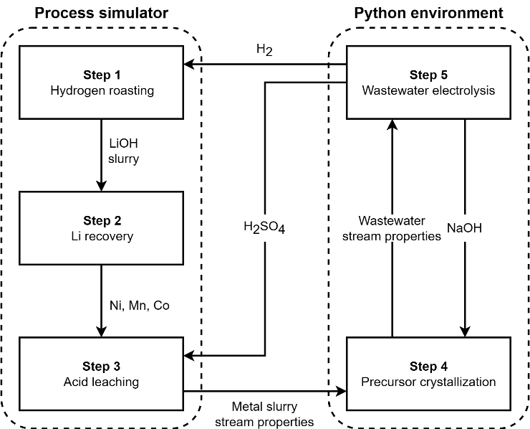
Fig. 2. Simulation framework of the overall proposed system.

  - Results
Table 1 shows the simulation results of the recovery efficiency of lithium and NMC precursor. Lithium is recovered in the form of LiOH·H₂O(s) with a recovery efficiency of about 98.95 % and NMC precursor with a recovery efficiency of about 79.00 %.

Table 1. Simulation result of the proposed process.
 | Li  crystallization | NMC precursor  crystallization
Temperature (°C) | 80 | 90
pH value | 7.0 | 10.6
Recovery efficiency (%) | 98.95 | 79.00

Fig. 3 shows the validation of the electrochemical model of the electrolysis cell with experimental data at voltage of 4.75 V. To improve the accuracy, parameter fitting is performed using a genetic algorithm.

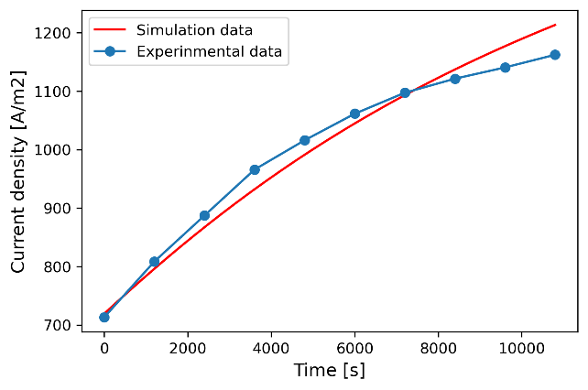
Fig. 3. Comparison between simulation results and experimental data.

  - Conclusions
This study firstly proposed conceptual design of closed-loop precursor re-synthesis assisted by hydrogen roasting and wastewater electrolysis. Furthermore, the results of industrial scaled simulation showed the recovery of 98.95 % for Li and 79.00 % for NMC precursor. As future work, techno-economic analysis will be conducted to reveal that the proposed process could be a feasible solution for economic and environmentally sustainable battery recycling.
References
C. Curry, 2017, Lithium-ion battery costs and market. Bloomberg New Energy Finance.
Jiahu Fang, 2022, Green recycling and regeneration of LiNi0.5Co0.2Mn0.3O2 from spent Lithium-ion batteries assisted by sodium sulfate electrolysis, Chemical Engineering Journal.
Xiaoqing Chen, 2022, Co-precipitation preparation of Ni-Co-Mn ternary cathode materials by using the sources extracting directly from spent lithium-ion batteries, Journal of Alloys and Compounds.
Jucai Wei, 2021, A zero-emission method for recycling phosphogypsum using Na2SO4 electrolysis: Preliminary study, Separation and Purification Technology.
Hyejeong Lee, Novel lithium production process using desalination wastewater and waste heat from natural gas combined cycle, Energy Conversion and Management.
F. Liu, 2021, Selective lithium recovery and integrated preparation of high-purity lithium hydroxide products from spent lithium-ion batteries, Separation and Purification Technology.
Jeongdong Kim, 2023, Process design and economic analysis of hydrogen roasting integrated with CCU for a carbon-free spent LIB recycling process, Chemical Engineering Journal.
Federica Mosca, 2023, Modelling and simulation of an Offshore Wind-Hydrogen combined system for hydrogen production using an anion exchange membrane electrolyzer, NTNU.
Hu, Q., 2004, Nonlinear kinetic parameter estimation for batch cooling seeded crystallization, AIChE Journal.
Jeongdong Kim, 2023, Integration of wastewater electro-electrodialysis and CO2 capture for sustainable LIB recycling: Process design and economic analyses, Journal of Cleaner Production.
Jeongdong Kim, 2023, Sequential flue gas utilization for sustainable leaching and metal precipitation of spent lithium-ion battery cathode material: Process design and techno-economic analysis, Journal of Cleaner Production.

