Model-based techno-economic analysis for integrated synthetic natural gas production system using atmospheric CO₂ captured by metal organic framework adsorbent
Hideki Harada,ª Anshuman Sinha,^{b} Tomoyuki Yajima,ª and Yoshiaki Kawajiri^{a,c*}
ªDepartment of Materials Process Engineering, Nagoya University, Furo-cho 1, Chikusa, Nagoya, Aichi 464-8603, Japan
^{b}School of Chemical and Biomolecular Engineering, Georgia Institute of Technology, 311 Ferst Drive, Atlanta, Georgia 30332, United States
^{c}School of Engineering Science, LUT University, Mukkulankatu 19, 15210 Lahti, Finland
kawajiri@nagoya-u.jp
Abstract
This study proposes an integrated system of carbon capture and utilization (CCU) to produce synthetic natural gas (SNG), and performs a techno-economic analysis. The proposed system employs a direct air capture (DAC) process using a metal organic framework adsorbent and converts the captured CO₂ into CH₄ product using H₂ produced by water electrolysis. Mass and energy balances in the main components of the system are described by rigorous mathematical models, enabling us to evaluate the capital and operating costs and energy consumption. In addition, a sensitivity analysis is carried out to find model parameters that influences the SNG cost.
Keywords: carbon capture and utilization, direct air capture, methanation, metal-organic framework, process simulation
  - Introduction
Direct air capture (DAC) is a CO₂ removal technology that physically or chemically captures CO₂ from the atmosphere. Various schemes have been proposed for DAC operation, among which the system using solid adsorbents for CO₂ capture is considered promising due to the possibility of utilizing waste heat to regenerate the adsorbent (Fasihi et al., 2019). In particular, the DAC process using a metal organic framework (MOF) as a CO₂ adsorbent has attracted much attention recently.
Carbon dioxide capture and utilization (CCU) is considered a promising mitigation measure for climate change. Using CO₂ captured by DAC as a feedstock, a CCU system synthesizes materials or fuels. As a measure for CO₂ utilization, methanation has recently gained attention, which converts CO₂ into CH₄ using H₂. The CH₄ produced here is referred to as synthetic natural gas (SNG).
To assess the performance and feasibility of CCU systems, rigorous mathematical models are required. Although model-based analytical studies of CCU systems that integrate DAC and methanation processes have increased in recent years, no study has conducted a model-based techno-economic analysis for the CCU system where the DAC process using a MOF adsorbent and the methanation process are integrated.
In this study, we perform a techno-economic analysis of a system that integrates three processes: DAC, methanation, and water electrolysis processes. This study carries out a dynamic simulation of the DAC process using MOF adsorbent for the techno-economic analysis, and detailed cost estimation for the water electrolysis process. Dynamic simulation allows detailed sizing of equipment and determining operating conditions for each unit, which enables more accurate economic analysis than steady-state simulation. The dynamic simulation of the DAC process performed in this study is based on Sinha et al. (2017). The solid adsorbent used is mmen-Mg₂(dobpdc) (McDonald et al., 2012), which is one of the promising MOFs for DAC. The reactor used in the methanation process is assumed to be a tube-bundle type. For the catalyst in the reactor, a Ni-based catalyst is employed. The water electrolysis process splits the H₂O into O₂ and H₂ using electricity. The produced H₂ is used as a feedstock in the methanation reactor, and the O₂ is discarded. The power requirement for the water electrolysis process is also estimated. Using these models, capital and operating costs are obtained to estimate the SNG production cost.
  - Methodology
    - Process description
Figure 1 shows a block flow diagram of the proposed integrated CCU system. There are three processes in the integrated system: DAC, methanation, and water electrolysis. The DAC process captures CO₂ from the atmosphere and produces a highly concentrated CO₂ stream. The MOF adsorbent used in the DAC process is mmen-Mg₂(dobpdc) (McDonald et al., 2012). The MOF adsorbents are coated on a monolithic contactor (Darunte et al., 2017). The water electrolysis process decomposes H₂O into H₂ and O₂. The produced H₂ is sent to the downstream processes, and the O₂ is discarded into the atmosphere. The methanation process produces SNG, whose main component is CH₄, through a chemical reaction using CO₂ from the DAC process and H₂ from the water electrolysis process. The byproduct, H₂O, is cooled and removed from the system. Some unreacted H₂ from the methanation process is recycled. The methanation process is assumed to produce SNG at a rate of 10,000 Nm³/h. More detailed information on the design of the system is provided in Harada et al. (2023).
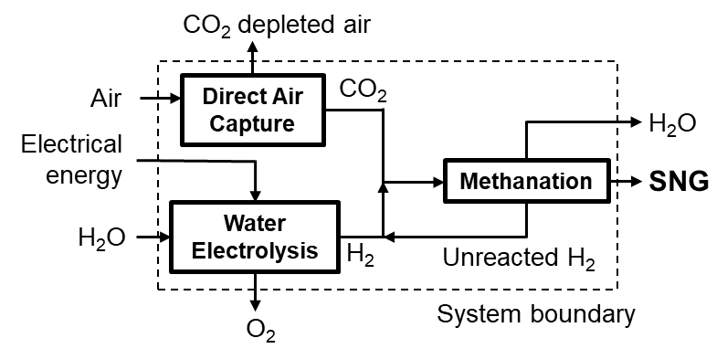
Figure 1. Schematic diagram of the integrated system of carbon capture and utilization.
    - Model description
      - DAC process model
For the DAC process model using a MOF adsorbent, temperature vacuum swing adsorption (TVSA) operation is modeled in this study. Figure 2(a) shows the strategy of TVSA operation. The operation has three steps: adsorption, desorption, and cooling. During the adsorption step, air passes through the monolithic contactor by blowers to capture CO₂. During the desorption step, saturated steam passes through the contactor to raise the temperature of the adsorbent, resulting in the desorption of the adsorbed CO₂. For a certain time after the start of this step, the gas obtained from the contactor outlet, which contains inert species (O₂ and N₂), is discarded to improve the product CO₂ purity. To purify CO₂ mixed with steam from the contactor outlet, it is cooled down to 298 K in heat exchangers to remove the steam. During the final cooling step, vacuum pumps depressurize the contactor and evaporate the condensed water, leading to a temperature decrease in the contactor. This step is necessary to avoid a high-temperature condition in the contactor at the beginning of the adsorption step, which is considered to oxidize the amine groups in the adsorbent. These three steps are repeated to capture CO₂ continuously. The details of the model including the mass and heat balance equations are introduced in Sinha et al. (2017).
Modeling is performed on a single monolithic channel described in Figure 2(b). We assume the channel to be cylindrical. The simulation results obtained from that modeling are used to determine the scale of the DAC process that can produce the required amount of CO₂.
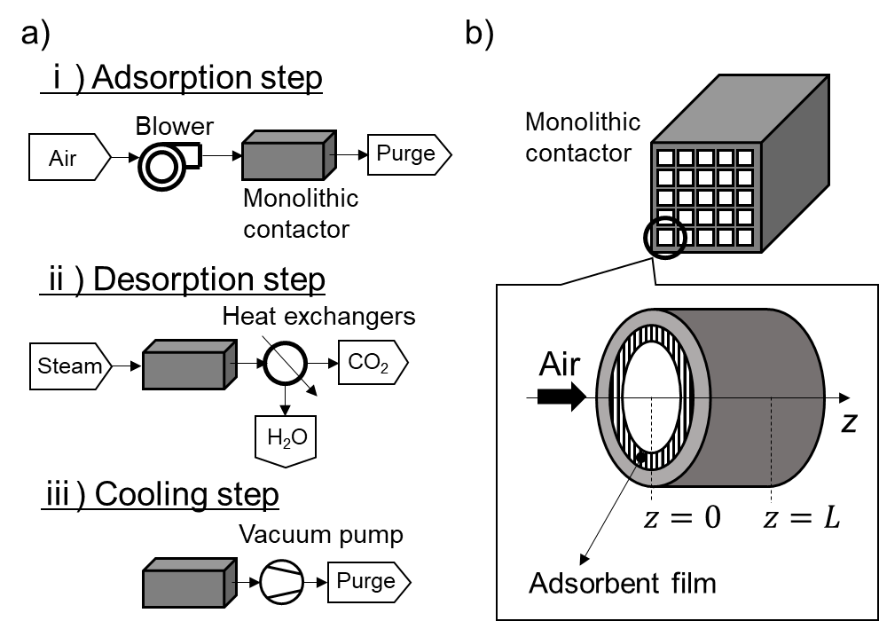
Figure 2. (a) Schematic diagram of the operation for temperature vacuum swing adsorption, and (b) monolithic contactor with multiple channels and schematic diagram of its single channel.
      - Methanation process model
The methanation process produces CH₄ through the Sabatier reaction given by:
$${CO}_{2}+4H_{2}↔{CH}_{4}+2H_{2}O, ∆_{r}H_{298K}=-165 kJ/mol$$ | (1)
The process model is based on Tsuboi et al. (2022). We assume a chemical reaction using a tube-bundle reactor in which 45,000 tubes are packed with the methanation catalysts. The reaction heat is removed using molten salt flowing outside the tube and utilized in the DAC process described in Section 3.2.1. Modeling is performed on a single tube. We use the Sabatier reaction rate equation given by Koschany et al. (2016).
      - Water electrolysis process model
In the water electrolysis process, alkaline water electrolysis is used. To calculate the power required for water electrolysis, the electrolytic cell voltage is estimated using the electrochemical model developed by Sakas et al. (2022).
    - Energy requirements and cost estimation
Using the results obtained from the model of each process in the integrated system, we calculate the thermal and electrical energy required to operate the integrated system. We carry out heat integration to design a heat exchanger network of maximum energy recovery (MER) to reuse the heat from the Sabatier reaction and reduce the thermal energy requirement in the integrated system. Electrical energy is required to run process equipment such as pumps and compressors and is used for water electrolysis.
The costs for each process in the integrated system are also estimated. We classify the costs into capital and operating costs. For the capital cost, the annualized cost is calculated considering the lifetime of each process equipment in the system based on cost correlation equations. The operating cost includes the cost of utilities such as electricity and cooling water.
  - Results
    - TVSA operation in DAC process
Figure 3(a) and (b) show the simulation results of TVSA operation in the DAC process: CO₂ concentration profiles in adsorbent during the adsorption step and desorption step, respectively. In the TVSA operation, the channel length, adsorption step time, and desorption step time are set to be 0.3 m, 1,500 seconds, and 1,800 seconds, respectively. During the adsorption step (Figure 3(a)), it can be seen that the adsorbent is almost saturated with CO₂ at 1,500 seconds after the start of adsorption. During the desorption step (Figure 3(b)), it can be seen that the CO₂ in the adsorbent is almost completely desorbed and discharged from the channel.
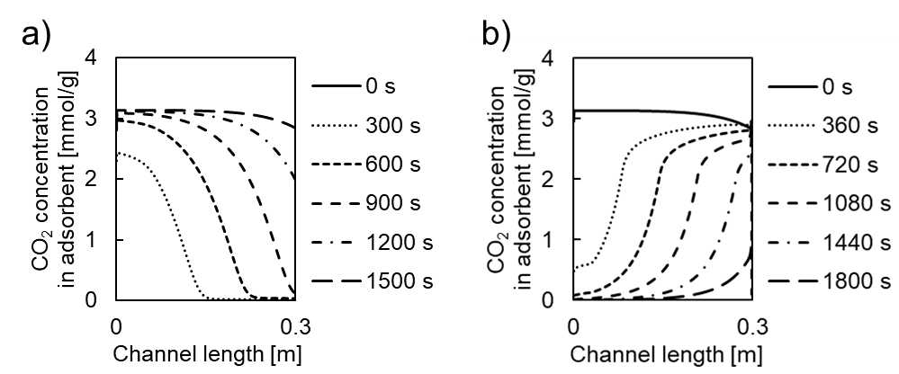
Figure 3. TVSA simulation: CO₂ concentration profiles in adsorbent during (a) adsorption step and (b) desorption step, respectively.
    - Overall integrated system
Table 1 shows the results obtained from each process model in the integrated system. In the DAC process, the CO₂ purity is defined on a steam-free basis. In the methanation process, SNG with a high CH₄ fraction is obtained by removing the byproduct H₂O. In the water electrolysis process, 173 MW of electric power is required to split water into H₂ and O₂.
Table 1. Results obtained from each process model in the integrated system.
Process | Item | Value
DAC | Productivity [mmol-CO₂/channel/h] | 0.0478
 | CO₂ purity [%] | 99.9
Methanation | CO₂ molar fraction in product SNG [%] | 0.477
 | H₂ molar fraction in product SNG [%] | 3.88
 | CH₄ molar fraction in product SNG [%] | 95.6
 | CO₂ conversion rate [%] | 99.5
Water electrolysis | Cell voltage [V] | 1.62
 | Electric power [MW] | 173
    - Energy and cost analysis
      - Energy analysis
Table 2 shows the net energy required for each process in the integrated system. For comparison, the amount of energy is given per unit volume of SNG. The heat energy required in the DAC process can be reduced to zero by heat integration described in Section 2.3, which recovers and utilizes the reaction heat from the Sabatier reaction in the methanation process. Only the methanation process requires heat energy from an external heat source. Regarding electrical energy, it can be seen that the water electrolysis process is the most energy-intensive in the integrated system.
Table 2. Net energy requirement for each process in the integrated system.
Process | Heat [MJ/Nm³-SNG] | Electricity [kWh/Nm³-SNG]
DAC | 0 | 0.98
Methanation | 0.41 | 1.24
Water electrolysis | 0 | 17.3
      - Cost analysis
Figure 4 shows the cost breakdown of the integrated system. The methanation process accounts for the largest portion of the capital cost, while the water electrolysis process accounts for the largest portion of the operating cost. The majority of the capital cost is the gas holder in the methanation process, while the majority of the operating cost is the electricity in the water electrolysis process. These results indicate that the costs of gas holder and electricity have a significant impact on the overall costs of the integrated system.
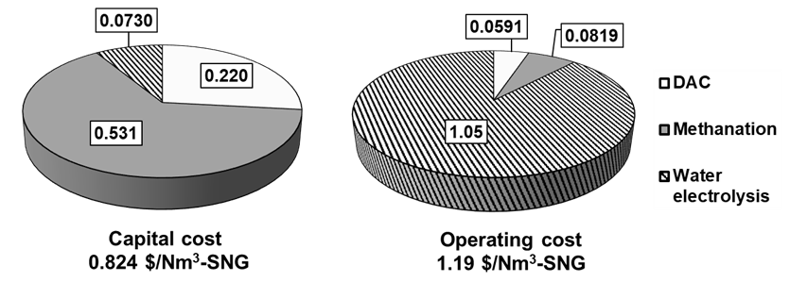
Figure 4. Results of cost estimation for each process in the integrated system.
      - Sensitivity analysis
We perform a sensitivity analysis on the parameters regarding SNG production cost. The parameters to be analyzed are chosen considering their uncertainty and impact on the cost. The values of the parameters chosen are considered for optimistic and pessimistic cases. From the results of the sensitivity analysis, we confirm that electricity cost has the largest impact on SNG production cost. Table 3 shows the result of the sensitivity analysis in which electricity cost varies. When electricity cost changes in the range of 30-90 $/MWh, SNG production cost changes in the range of 1.43-2.60 $/Nm³-SNG.
Table 3. Sensitivity analysis for electricity cost.
Process | Optimistic case | Reference case | Pessimistic case
Electricity cost [$/MWh] | 30 | 60 | 90
SNG cost [$/Nm³-SNG] | 1.43 | 2.01 | 2.60
  - Conclusions
In this study, we proposed an integrated system consisting of DAC, methanation, and water electrolysis processes to produce SNG, and performed a techno-economic analysis. We also performed an energy analysis to estimate the amount of thermal and electrical energy required in each process. Finally, we performed economic and sensitivity analyses. It was found that electricity cost dominates the total SNG production cost; the use of cheaper electricity is critical to reduce the cost.
Acknowledgment
This work was supported by the Japan Gas Association.
References
L. Darunte, Y. Terada, 2017, C. Murdock, K. Walton, D. Sholl, C. Jones, Monolith-supported amine-functionalized Mg₂(dobpdc) adsorbents for CO₂ capture, ACS Applied Materials and Interfaces, 9, 17042-17050
M. Fasihi, O, Efimova, C. Breyer, 2019, Techno-economic assessment of CO₂ direct air capture plants, Journal of Cleaner Production, 224, 957-980
H. Harada, A. Sinha, T. Yajima, Y. Kawajiri, 2023, Model-based techno-economic analysis for integrated synthetic natural gas production system with direct air capture and water electrolysis, submitted
F. Koschany, D. Schlereth, O. Hinrichsen, 2016, On the kinetics of the methanation of carbon dioxide on coprecipitated NiAl(O)x, Applied Catalysis B: Environmental, 181, 504-516
T. McDonald, W. Ram Lee, J. Mason, B. Wiers, C. Seop Hong, J. Long, 2012, Capture of carbon dioxide from air and flue gas in the alkylamine-appended metal−organic framework mmen-Mg₂(dobpdc), Journal of the American Chemical Society, 134, 7056-7065
G. Sakas, A. Ibáñez-Rioja, V. Ruuskanen, A. Kosonen, J. Ahola, O. Bergmann, Dynamic energy and mass balance model for an industrial alkaline water electrolyzer plant process, International Journal of Hydrogen Energy, 47, 4328-4345
A. Sinha, L. Darunte, C. Jones, M. Realff, Y. Kawajiri, 2017, Systems design and economic analysis of direct air capture of CO₂ through temperature vacuum swing adsorption using MIL-101(Cr)-PEI-800 and mmen-Mg₂(dobpdc) MOF adsorbents, Industrial and Engineering Chemistry Research, 56, 750–764
T. Tsuboi, S. Yasuda, C. Choi, W. Zhang, H. Machida, K. Norinaga, T. Yajima, Y. Kawajiri, 2022, Modeling and estimating kinetic parameters for CO₂ methanation from fixed bed reactor experiments, Journal of Advanced Manufacturing and Processing, e10145

