A Novel Process for Blue Hydrogen Production with Molten Carbonate Fuel Cell CO₂ Capture
Federico d’Amoreª, Luis M.C. Pereira^{b}, Stefano Campanari^{c}, Matteo Gazzani^{d,e}, Matteo C. Romano^{c}
ªCAPE-Lab – Computer-Aided Process Engineering Laboratory, Department of Industrial Engineering, University of Padova, via Marzolo 9, IT-35131 Padova, Italy
^{b}Centre Scientifique & Technique Jean Féger (CSTJF) TotalEnergies, Av. Larribau, 64000 Pau, France
^{c}Politecnico di Milano, Department of Energy, via Lambruschini 4, IT-20156 Milano, Italy
^{d}Copernicus Institute of Sustainable Development, Utrecht University, CS Utrecht, 3584, the Netherlands
^{e}Inorganic Membranes and Membrane Reactors, Sustainable Process Engineering, Chemical Engineering and Chemistry, Eindhoven University of Technology, Eindhoven, the Netherlands
federico.damore@unipd.it
Abstract
H₂ production via steam methane reforming is a mature and cost-effective technology. However, carbon capture and storage is required to decrease its CO₂ emissions. The adoption of molten carbonate fuel cells as means to capture CO₂ from flue gases is attracting scientific interest thanks to their inherent thermodynamic advantage of separating CO₂ while producing electricity. This study investigates and benchmarks the performance of an H₂ production plant equipped with molten carbonate fuel cell for post-combustion CO₂ capture, by proposing a novel configuration where the cell anode is fed with the carbon-rich off-gas from the H₂ separation unit. It emerges that the process can achieve higher capture rates than the reference solvent-based plant: 85-90 % with single cell, 95 % with two-stage cell. Moreover, recycling the carbon-rich off gas to the anode allows for smaller cell area, and potentially lower H₂ production costs compared to the benchmark.
Acknowledgments
This work has been funded by TotalEnergies’ R&D Strategic Anticipation Program.
Keywords: Steam methane reformer, Molten carbonate fuel cell, Carbon dioxide capture, Process simulation, Techno-economic modelling.
  - Introduction
H₂ is expected to become a key player in the decarbonisation challenge (van der Spek et al., 2022). The production of H₂ from fossil fuels with CO₂ capture is key to enable large scale production and will be complementary to electrolysis till the electric grid is decarbonised, provided that CO₂ capture is performed according to state-of-the-art and CH₄ fugitive losses are minimised (Bauer et al., 2022; Pettersen et al., 2022). This work focusses on H₂ production from steam methane reforming (SMR) of natural gas (NG), which is a mature and cost-effective technology (IEAGHG, 2017), coupled with molten carbonate fuel cell (MCFC) for post-combustion CO₂ capture.
In the literature, post-combustion CO₂ capture processes based on MCFC for H₂ plants and other emitters consider NG as fuel for the fuel cell (Consonni et al., 2021). This study proposes a novel configuration (d’Amore et al., 2023), which exploits part of the off-gas from H₂ purification unit as fuel to the MCFC, instead of NG. This configuration keeps a carbon-richer fuel on the MCFC anode side and reduces the flow rate of CO₂ in the SMR to be separated by the MCFC (thus, its area) for a given CO₂ capture rate, with significant beneficial effects in the overall techno-economic performance. Building upon the performance of the novel off-gas feed configuration, it is also assessed how a multi-stage cell configuration with inter-cooling would further improve the process (Spinelli et al., 2014), as it helps decreasing the air dilution at the MCFC cathode inlet and enhances the CO₂ separation efficiency.
  - Methodology
The plants were modelled and simulated in Aspen Plus software by using the Peng-Robinson equation of state, according to the technical assumptions summarised in d’Amore et al. (2023) (Table 1). All chemical reactors were simulated at chemical equilibrium, while the MCFC performance is described through a 0-D model of the polarisation curve taken from Barckholtz et al. (2022).
The reference standalone SMR without CO₂ capture is designed to produce 100,000 Nm³/h of H₂ (299.5 MW_{LHV}), comprising high temperature water-gas shift (WGS), pressure swing adsorption (PSA), steam cycle (set at 485 °C at 100 bar), and low pressure (LP) steam export (at 6 bar) (Figure 1a). This plant is characterised by an NG-to-H₂ efficiency of 73.5 % and specific CO₂ emissions of 9.29 kg of CO₂/kg of H₂, being the net electric and thermal power outputs equal to 10.4 MW_{el} and 23.2 MW_{th}, respectively. The SMR with post-combustion CO₂ capture with monoethanolamine (MEA) is designed for a CO₂ capture rate of 90 % and a specific heat demand of 3.57 MJ_{th}/kg of captured CO₂ (Figure 1b). This plant is considered as benchmark case for performance and costs comparison with MCFC-based CO₂ capture.
In the NG-based MCFC (i.e., NGF plant) the SMR flue gases are sent to the MCFC cathode for CO₂ separation. A CO₂ lean stream is produced at the cathode residue and emitted to the atmosphere (Figure 1c). The MCFC anode is fed with pre-reformed NG. The anode residue is sent to a WGS converter. The shifted syngas stream is sent to the low-temperature phase-change purification unit (CPU) to produce a high-purity CO₂ stream and a flow rate that is recycled to the PSA unit downstream the SMR. Differently, in the off-gas-based MCFC (i.e., OGF plant) the MCFC anode is fed with PSA off-gas (Figure 1d). This configuration keeps the carbon-rich fuel on the MCFC anode side and reduces the flow rate of CO₂ in the SMR to be separated by the MCFC (therefore, its area) for a given overall CO₂ capture rate. An additional case (i.e., OGF-2) involves the adoption of two cells in series with inter-cooling to decrease the air dilution at the cathode inlet and enhance the CO₂ separation efficiency for a given cell potential.
Table 1. Summary of the main input data.
Plant | Component | Parameter | Value | Unit
SMR | Pre-reformer | Steam-to-carbon | 3.4 | mol/mol
 | Reformer | Outlet temperature | 890 | °C
 | PSA | H₂ recovery | 90 | %
 | LP steam | Pressure | 6 | bar
 | HP steam | Pressure/temperature | 100/485 | bar/°C
MEA | CO₂ separation | Efficiency | 90 | %
 | CO₂ separation | Reboiler duty | 3.57 | GJ/t CO₂
MCFC | Cathode | Inlet temperature | 575 | °C
 | Cathode | Outlet temperature | 645 | °C
 | Cathode | CO₂ outlet concentration | 1 | %^{mol}
 | Pre-reformer | Inlet temperature | 600 | °C
 | Pre-reformer | Steam-to-carbon | 2.1 | mol/mol
 | Anode | Inlet temperature | 600 | °C
 | Anode | Outlet temperature | 645 | °C

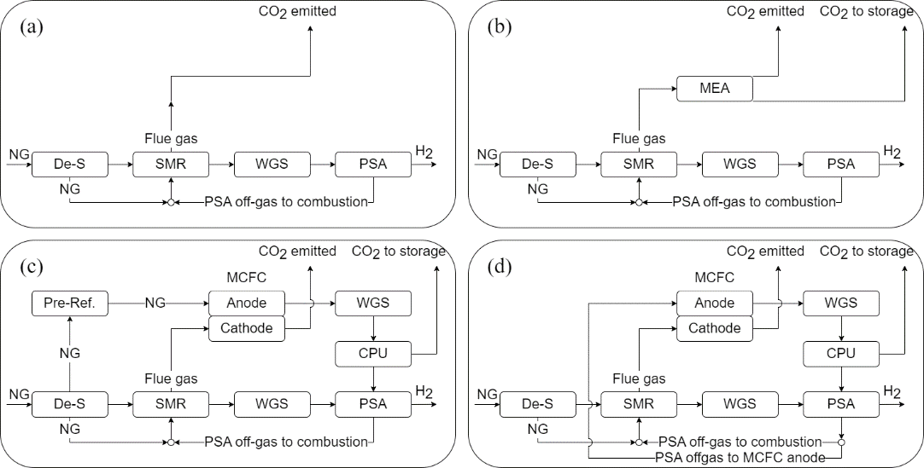
Figure 1. Simplified plant schemes: (a) SMR, (b) SMR with MEA, (c) NGF, and (d) OGF.
  - Results
Even though MCFC-based plants consume more NG with respect to the standalone SMR (between +8 % and +26 %), they also generate a larger low-carbon electricity output (Table 2). Plus, MCFC-based OGF and OGF-2 cases show a better performance compared to MEA solvent-based capture system in a wide range of NG and electricity prices. OGF appears superior to NGF, being the former characterised by higher carbon capture rate (90 % against 85 %), higher H₂ production efficiency (68 % against 59 %), lower specific energy consumption per unit of CO₂ avoided (0.5 against 1.1 MJ/kg of CO₂), and a significantly lower cell area (-43 %). This is due to the higher carbon intensity of the off-gas feed to the OGF cell anode, compared to the NG exploited in the NGF case, which allows reducing the flow rate of CO₂ to be separated by the MCFC for a given CO₂ capture rate. OGF-2 is a particularly competitive configuration, as it can achieve 95 % carbon capture rate with a smaller cell area than OGF (-19 %). This is due to the inter-cooling between cells, which allows reducing the CO₂ dilution resulting from the excess air to be mixed with the flue gas to control the MCFC temperature.

Table 2. Technical performance results.
 | SMR | MEA | NGF | OGF | OGF-2
Cell 1 potential [V] | - | - | 0.70 | 0.70 | 0.65
Cell 2 potential [V] | - | - | - | - | 0.60
Util. factor [%] | - | - | 75.0 % | 75.0 % | 70.0 %
CO₂ util. factor [%] | - | - | 81.7 % | 77.5 % | 87.1 %
Total cell area [m²] | - | - | 73123 | 41615 | 23605
NG plant inlet [MW_{LHV}] | 407.3 | 407.3 | 512.4 | 442.2 | 439.4
PSA off-gas [MW_{LHV}] | 97.1 | 97.1 | 90.8 | 95.0 | 94.6
Electricity outlet [MW_{el}] | 10.4 | -12.8 | 59.1 | 22.1 | 19.8
Steam outlet [MW_{th}] | 23.2 | 0.0 | 21.5 | 24.6 | 26.2
Spec. emis. [kg_{CO2}/kg_{H2}] | 9.29 | 0.93 | 1.75 | 0.98 | 0.50
H₂ prod. eff. [%] | 73.5 % | 73.5 % | 58.5 % | 67.7 % | 68.2 %
Carbon capt. Rate [%] | 0.0 % | 90.0 % | 85.0 % | 90.3 % | 95.0 %
The economic analysis is based on the assumptions reported in d’Amore et al. (2023). The plants have equivalent operating hours of 8400 h/year, being the electricity and natural gas prices equal to 60 €/MWh and 6 €/GJ, respectively. The results show that OGF and OGF-2 plants exhibit H₂ production costs (1.9-2.2 €/kg of H₂) that are lower than NGF (2.3-2.6 €/kg of H₂) and than SMR with conventional post-combustion CO₂ capture (2.2-2.3 €/kg of H₂). The sensitivity analyses on key economic parameters (e.g., carbon tax, NG cost, electricity price) did not affect the main outcome, i.e., the good economic performance of OGF and OGF-2 (d’Amore et al., 2023). Contrary to the NGF case, the OGF one (and especially the 2-stage configuration) emerges as cost competitive with conventional solvent-based post-combustion capture in the entire range of values explored in the sensitivities.
  - Conclusions
This study highlights the potential of molten carbonate fuel cells (MCFCs) as post-combustion CO₂ capture systems in blue H₂ plants, if fed with off-gas from H₂ purification unit as fuel. The resulting CO₂ capture rate is found equal to 90 % for the single cell configuration and equal to 95 % for the multi-stage cell configuration, against 85 % in the case of natural gas-based anode feed. H₂ production costs are in the range of 1.9-2.2 €/kg of H₂, therefore lower than a traditional natural gas anode feed (2.3-2.6 €/kg H₂), and competitive with solvent-based post-combustion capture (2.2-2.3 €/kg of H₂).
References
T.A. Barckholtz, K.M. Taylor, S. Narayanan, S. Jolly, H. Ghezel-Ayagh, 2022, Molten carbonate fuel cells for simultaneous CO₂ capture, power generation, and H₂ generation, Appl Energy, 313, 118553
C. Bauer, K. Treyer, C. Antonini, J. Bergerson, M. Gazzani, E. Gencer, J. Gibbins, M. Mazzotti, S.T. McCoy, R. McKenna, R. Pietzcker, A.P. Ravikumar, M.C. Romano, F. Ueckerdt, J. Vente, M. van der Spek, 2022, On the climate impacts of blue hydrogen production, Sustain Energy Fuels, 6, 66-75
S. Consonni, L. Mastropasqua, M. Spinelli, T.A. Barckholtz, S. Campanari, 2021, Low-carbon hydrogen via integration of steam methane reforming with molten carbonate fuel cells at low fuel utilization, Adv Appl Energy, 2, 100010
F. d’Amore, L.M.C. Pereira, S. Campanari, M. Gazzani, M.C. Romano, 2023, A novel process for CO₂ capture from Steam Methane Reformer with Molten Carbonate Fuel Cell, Int J Hydrogen Energy, 48, 37366-37384
IEAGHG, 2017, Techno-Economic Evaluation of SMR Based Standalone (Merchant) Hydrogen Plant with CCS
J. Pettersen, R. Steeneveldt, D. Grainger, T. Scott, L.M. Holst, E.S. Hamborg, 2022, Blue hydrogen must be done properly, Energy Sci Eng, 10, 3220-3236
M. Spinelli, M.C. Romano, S. Consonni, S. Campanari, M. Marchi, G. Cinti, 2014, Application of molten carbonate fuel cells in cement plants for CO₂ capture and clean power generation, Energy Procedia, 63, 6517-6526
M. van der Spek, C. Banet, C. Bauer, P. Gabrielli, W. Goldthorpe, M. Mazzotti, S.T. Munkejord, N.A. Røkke, N. Shah, N. Sunny, D. Sutter, J.M. Trusler, M. Gazzani, 2022, Perspective on the hydrogen economy as a pathway to reach net-zero CO₂ emissions in Europe, Energy Environ Sci, 15, 1034-1077

