Smoothing the Chaos: Addressing Chaotic Behavior in Energy System Models through MILP Stabilization
Jonas Schnidrig^{a*,b}, François Maréchal^{b}, Manuele Margniª
ª HES-SO Valais Wallis, CIRAIG, Sion, Switzerland.
^{b} Ecole Polytechnique de Lausanne, IPESE group, Sion, Switzerland.

*jonas.schnidrig@hevs.ch
Abstract
In MILP energy system modeling, chaotic behaviors frequently emerge because of the integer and linear nature of the problem, complicating the interpretability and utility of the model outputs. Such volatility has already been observed in equivalent solutions in previous works due to the symmetry of the problem definition ^{1–3}. Still, it can notably be observed in nonsymmetrical global energy system models while applying parametrization of penetration of various technologies, for example, high-altitude photovoltaic (PV) systems in the Swiss energy landscape, where equivalent solutions from the point of view of the objective function exist but are distinguished in the activated constraints and thus by the energy system configuration. The present study introduces an innovative methodology to stabilize the parametrization of technology penetration scenarios to address this. The technique is engineered to enable a more "smooth" and predictable energy system evolution when subjected to various penetration configurations, all within a mixed-integer linear programming (MILP) framework, thus opening the door to identifying equivalent solutions to an optimization problem.

Utilizing the MILP energy system modeling framework EnergyScope ^{4–6}, the research presents a novel, simple, and linear contribution by introducing an additional stabilization term into the model's objective function. This stabilization term is constructed to capture the absolute variation in the size of installed technologies between consecutive model runs, thus adding a term minimizing the configuration changes to the objective function. The challenge of weighting this contribution without penalizing the primary objective function value is assessed by assessing the impact of the latter scaling on the generated, thereby enriching the analysis and robustness of the model's output.

From a results standpoint, the study delineates the specific conditions that lead to optimal stabilization, culminating in a smooth transition of energy system configurations from one scenario to another. The implemented methodology significantly enhances the identification of vertices in the solution space, allowing for a more nuanced understanding of critical configurations within that space.

Moreover, the study extends its applicability by employing the stabilization methodology to the Swiss energy system's trajectory toward 2050, a system envisioned to be both energy-independent and carbon-neutral. In this context, the methodology displayed its utility in providing nuanced insights into the penetration scenarios of high-altitude PV. These insights are crucial for policymakers and stakeholders, offering actionable steps to meet energy transition indicators effectively. The methodology stabilizes the parametrization. It provides a sophisticated tool for evaluating energy transition indicators, catalyzing more robust and reliable energy system modeling.

Keywords: Mixed-Integer Linear Programming, Parametrization Stabilization, Equivalent solutions, Energy System model, Energy Transition

  - Introduction
    - Context

Modeling energy systems through mixed-integer linear programming (MILP) is pivotal in shaping our understanding and approach to the evolving energy landscape. In the quest for sustainable and efficient energy solutions, MILP models are instrumental in evaluating and strategizing energy system transitions. However, these models often encounter a significant hurdle: chaotic behaviors arising from their integer and linear problem structures. This complexity is not only a characteristic of symmetrical problems ^{1–3}, but also manifests in non-symmetrical global energy system models. A notable example is the parametrization of technology penetration, such as high-altitude photovoltaic (PV) systems in the Swiss energy landscape. Here, equivalent solutions, in terms of objective function outputs, diverge in their activated constraints, leading to varying energy system configurations.

    - Literature Review

The inherent volatility in MILP energy system modeling, particularly regarding technology penetration, has been a focal point of previous research. While the literature addresses the equivalent solutions arising from symmetrical problems, a gap exists in understanding and managing the chaotic behavior in non-symmetrical models. The EnergyScope framework ^{4–6} has been instrumental in this domain, offering a basis for developing more robust and nuanced models. However, the challenge of stabilizing parametrization in such models, especially in varied technology penetrations, has not been comprehensively addressed. This gap points to the need for a methodology that stabilizes the model outputs and enhances the interpretability and utility of these models in planning and decision-making processes.

    - Problem Statement

The primary challenge in MILP energy system modeling is the stabilization of parametrization under different technology penetration scenarios. The unpredictability and complexity inherent in these models hinder their effectiveness in guiding the transition to sustainable energy systems. This research aims to introduce an innovative methodology to address this challenge. The proposed technique is designed to add a stabilization term to the objective function of the MILP model, aiming to minimize configuration changes between model runs. This approach facilitates a smoother, more predictable transition in energy system configurations, enhancing the model's reliability and applicability. The methodology's effectiveness will be demonstrated through its application to the Swiss energy system, aiming for energy independence and carbon neutrality by 2050. By providing a more stabilized approach to modeling, the research offers a path toward more effective planning and implementation of energy transition strategies, catering to the needs of policymakers and stakeholders in the energy sector.
  - Methods

This research employs a mixed-integer linear programming (MILP) approach to stabilize the parametrization of technology penetrations in energy system modeling. The proposed methodology introduces a novel objective function that includes a stabilization term, aiming to reduce the variance in technology configuration between model iterations $n$ and $n-1$.

Adapting the modeling framework EnergyScope⁶, the optimization problem is enhanced by adding a stabilization term, such as the objective function (Eq. 1), which seeks to minimize the total cost $C_{tot}$, subject to a stabilization factor $ϵ$ that influences the change in technology size $ΔF_{n}$ between successive iterations. The total cost (Eq. 2) is the sum of the investment cost of the technologies-specific investments $c_{inv}$ multiplied by the technology annualization factor ($τ$), and maintenance costs $c_{maint}$ for each technology $i$, in addition to the operational costs $c_{op}$ for each resource $j$ in each time period $t$.
The end uses $EU$ for each layer $l$ and time period $t$ is defined by the technology utilization $F_{t}$ adjusted by the technology efficiency $η$ including the storage technology flows $F_{t}^{+}$and $F_{t}^{-}$ (Eq. 3).
The technology size $F$ is determined by the reference size $f_{ref}$ and the number of units $N$ installed, which is an integer value (Eq. 4). Technology sizes are constrained by their minimum and maximum feasible sizes $f_{min}$ and $f_{max}$ (Eq. 5).
Technology $Ξ$, in this case study, PV EHV is integrated via the penetration parameter $ξ_{n}$, which increases monotonically, thus varying the technology installed between $f_{min}\left(Ξ\right)$ and $f_{max}\left(Ξ\right)$ (Eq. 6).
The change in technology size $ΔF_{n}$ is the absolute difference between the sizes in consecutive runs (Eq. 8), ensuring non-negativity (Eq. 9).

$$\min_{F,F_{t},ξ_{n}}{C_{tot}}+ϵ⋅ΔF_{n}$$  s.t. |  | (1)
 | $$C_{tot}=\sum_{i}{\left(c_{inv}\left(i\right)⋅τ\left(i\right)+c_{maint}\left(i\right)\right)⋅F\left(i\right)}+\sum_{j}{\sum_{t}{c_{op}\left(j,t\right)⋅t_{op}\left(t\right)⋅F_{t}(j,t)}}, ∀ i∈TECH, j∈RES, t∈PERIODS$$ | (2)
 | $$EU\left(l,t\right)=\sum_{i}{F_{t}\left(i,t\right)⋅η\left(i,l\right)+\sum_{l}{F_{t}\left(l,t\right)}+ \sum_{s}{\left(F_{t}^{+}\left(s,l,t\right)-F_{t}^{-}\left(s,l,t\right)\right)}}, ∀ l∈LAYERS, t∈PERIODS, i∈TECH, j∈RES,s∈STO-TECH$$ | (3)
 | $$F\left(i\right)=f_{ref}\left(i\right)⋅N\left(i\right), ∀ i∈TECH, N\left(i\right) integer$$ | (4)
 | $$f_{min}\left(i\right)≤F\left(i\right)≤f_{max}(i), ∀ i∈TECH$$ | (5)
 | $$F\left(Ξ\right)=f_{min}\left(Ξ\right)+ξ_{n}⋅\left(f_{max}\left(Ξ\right)-f_{min}\left(Ξ\right)\right), ∀ ξ_{n}>ξ_{n-1}, ξ_{0}=0$$ | (6)
 | $$ΔF_{n}\left(i\right)≥\sum_{i}{\left(ΔF_{n}^{+}\left(i\right)+ΔF_{n}^{-}\left(i\right)\right)≥0}, ∀ n>0, i∈TECH$$ | (7)
 | $$ΔF_{n}^{+}\left(i\right)-ΔF_{n}^{-}\left(i\right)=F_{n}\left(i\right)-f_{n-1}\left(i\right), ∀ ΔF^{±}≥0, n>0, f_{0}=0, i∈TECH$$ | (8)

  - Results

Upon applying the stabilization methodology to the EnergyScope MILP framework, distinct operational configurations were observed under consistent high-altitude photovoltaic (PV) penetration levels. The analysis was conducted by parametrizing the PV penetration within the Swiss energy system model from 0 to 20 GW. The model was also run in reverse to ensure the identification of distinct solutions, from 20 GW down to 0. Notably, despite the different starting points and directions of parametrization, the total cost (primal objective function value) remained constant for equivalent levels of PV penetration.
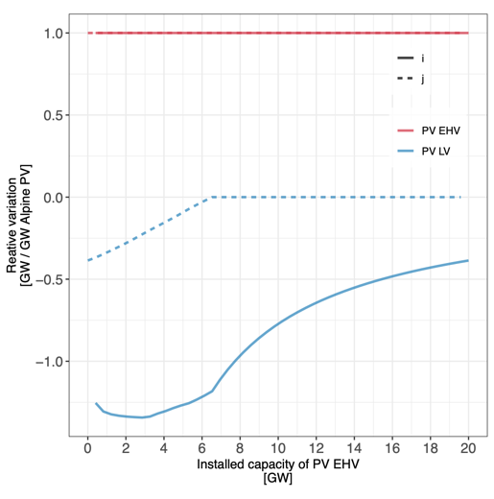
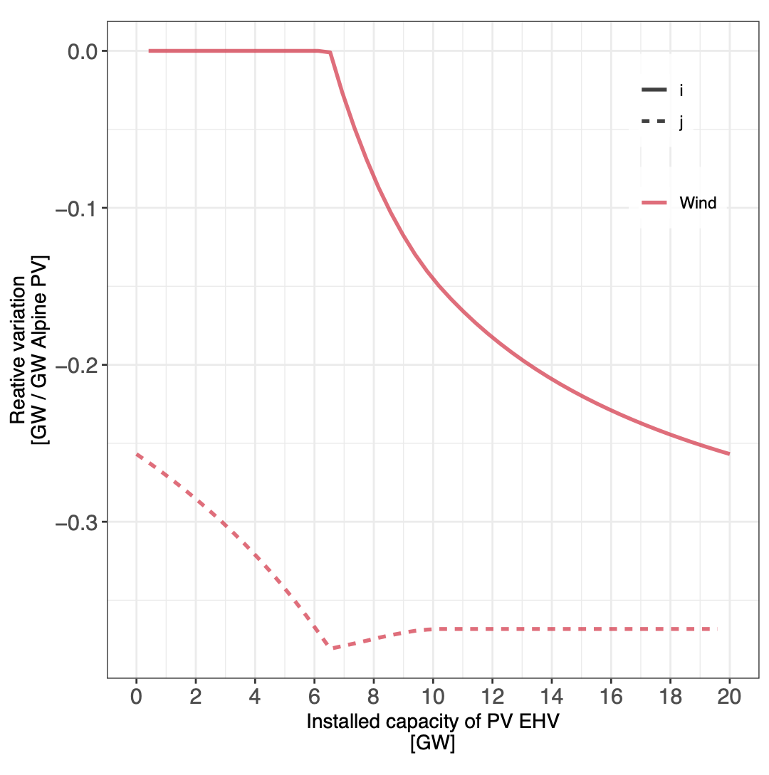
Figure 1: Comparison of relative variation of installed PV and Wind technologies under PV EHV parametrization.
Figure 1 highlights two technology configurations, wind, and PV, exhibiting this phenomenon. The solid lines represent the initial scenario of increasing PV penetration, while the dashed lines depict the reverse parametrization. It is observed that, at any given level of PV penetration, the total cost remains the same between scenarios, indicating the presence of equivalent solutions within the optimization problem.

Adding the stabilization term allows for the identification of these equivalent solutions, offering a strategy to avoid abrupt changes in suggested technology configurations—commonly referred to as "technology jumps"—that may arise from the inherently chaotic nature of the model. By stabilizing the parametrization process, the model can adhere to a particular set of solutions, lending consistency and predictability to planning the evolution of the energy system.

  - Conclusion

The study's findings indicate that the proposed stabilization methodology effectively identifies equivalent solutions within the MILP framework for energy system modeling. This outcome is pivotal for energy system planners and policymakers, providing a more stable and reliable foundation for making technological investments and system configuration decisions.

Stabilizing the parametrization process and adhering to consistent solutions amidst equivalent options is particularly beneficial for managing the dynamic and complex interactions within energy systems. This approach enhances the robustness of the model and simplifies the interpretation of results, thereby contributing to more informed and strategic energy planning.

In conclusion, the stabilization methodology introduced in this research offers a significant step forward in energy system modeling. Mitigating chaotic behaviors and revealing equivalent solution spaces allows for a more deliberate and systematic approach to the transition toward sustainable and resilient energy systems.

The exploration of the stabilization methodology in MILP energy system modeling has opened avenues for future research, particularly in addressing the challenges associated with the stabilization term and identifying equivalent solutions. The first challenge lies in thoroughly assessing the influence of the stabilization term, denoted as epsilon $ϵ$, which in our study was set equal to the solver's mipgap. Future investigations need to determine the optimal calibration of $ϵ$ to balance between stabilization and the primary objective of minimizing costs. This could involve sensitivity analyses or the development of heuristic methods to guide the selection of $ϵ$ based on model dynamics and the specific characteristics of the energy system under study.

The second challenge is devising a systematic approach to identify and enumerate the different equivalent solutions that the model yields at the same cost level. Using integer cuts presents a promising method to differentiate between these solutions. Adding integer cuts after each solution is found allows the model to explore alternative configurations, thereby mapping the landscape of equivalent solutions more comprehensively. This method could unveil hidden patterns and dependencies within the model structure, enriching our understanding of the solution space and aiding in strategic decision-making. Both challenges underscore the need for ongoing refinement of the stabilization methodology to enhance its applicability and effectiveness in energy system modeling.
References
(1) Ashouri, A.; Fux, S. S.; Benz, M. J.; Guzzella, L. Optimal Design and Operation of Building Services Using Mixed-Integer Linear Programming Techniques. Energy 2013, 59, 365–376. https://doi.org/10.1016/j.energy.2013.06.053.
(2) Maravelias, C. T.; Grossmann, I. E. A Hybrid MILP/CP Decomposition Approach for the Continuous Time Scheduling of Multipurpose Batch Plants. Comput. Chem. Eng. 2004, 28 (10), 1921–1949. https://doi.org/10.1016/j.compchemeng.2004.03.016.
(3) Westerlund, J.; Papageorgiou, L. G.; Westerlund, T. A MILP Model for N-Dimensional Allocation. Comput. Chem. Eng. 2007, 31 (12), 1702–1714. https://doi.org/10.1016/j.compchemeng.2007.02.006.
(4) Li, X.; Damartzis, T.; Stadler, Z.; Moret, S.; Meier, B.; Friedl, M.; Maréchal, F. Decarbonization in Complex Energy Systems: A Study on the Feasibility of Carbon Neutrality for Switzerland in 2050. Front. Energy Res. 2020, 8, 549615. https://doi.org/10/gjgz7v.
(5) Moret, S.; Codina Girones, V.; Bierlaire, M.; Maréchal, F. Characterization of Input Uncertainties in Strategic Energy Planning Models. Appl. Energy 2017, 202, 597–617. https://doi.org/10.1016/j.apenergy.2017.05.106.
(6) Schnidrig, J.; Cherkaoui, R.; Calisesi, Y.; Margni, M.; Maréchal, F. On the Role of Energy Infrastructure in the Energy Transition. Case Study of an Energy Independent and CO2 Neutral Energy System for Switzerland. Front. Energy Res. 2023, 11. https://doi.org/10.3389/fenrg.2023.1164813.

