Ab Initio Prediction of Surface Tension from Fundamental Equations of State using Density Gradient Theory (DGT)
Anna Šmídová, Lukáš Šatura, Alexandr Zubov*
Department of Chemical Engineering, University of Chemistry and Technology Prague,
Technická 5, Praha 6 – Dejvice, 166 28, Czech Republic
*Corresponding author: alexandr.zubov@vscht.cz
Abstract
The density gradient theory (DGT), is used to predict interfacial and surface tension, along with other thermodynamic parameters, for various chemical systems. DGT can be formulated based purely on the equations of state (EoS) describing thermodynamic equilibrium at the interface between studied phases without need of any parameter estimation. To ensure better numerical stability, we introduce a time-dependent Cahn-Hilliard equation into DGT formulation for the calculation of the density equilibrium profile. In this contribution we focus on using the van der Waals EoS and its modification, van der Waals-711, for one-component vapor-liquid systems, and the use of Flory-Huggins equation is demonstrated for one polymer-solvent system. The obtained results are compared with available experimental data and indicate that this ab initio approach is capable of predicting the surface/interfacial tension in reasonable agreement with experimental data.

Keywords: density gradient theory, surface tension, vapor-liquid equilibria, Cahn-Hilliard model, van der Waals equation of state.
  - Introduction
Knowledge of surface/interfacial tension is crucial in many branches of science and engineering. Motivation for this work stems from mathematical modelling of morphology evolution (typically done using Cahn-Hilliard approach) in complex polymer mixtures undergoing phase separation, such as during production of hollow fiber membranes, high-impact polymers or porous polymeric materials with well-defined porous microstructure. Models describing these processes contain the so-called interfacial parameter usually denoted as κ, which has significant impact on the resulting multi-phase morphology, is connected to interfacial tension between co-existing and evolving phases, and has usually highly uncertain value (Nistor et al., 2017).

A thermodynamically consistent approaches, such as the density gradient theory (DGT) and related classical density functional theory (cDFT), are used to predict interfacial and surface tension, along with other thermodynamic parameters, for various chemical systems. DGT can be formulated based purely on the equations of state (EoS) describing thermodynamic equilibrium at the interface between studied phases without need of any parameter estimation. In this formulation, the total free energy of the system as a function of the density at the boundary between two phases consists of the bulk contribution and weakly non-local terms, which are dependent on the first gradients of density (Landau and Lifshitz, 1980).

DGT is usually formulated as a boundary value problem (BVP), in which the pre-calculated equilibrium bulk densities of both phases form boundaries of the computational domain, while the interface is treated as a continuous spatial profile of varying density, having typical sigmoidal shape. From the estimated spatial density profile, surface (interfacial) tension can be predicted. However, BVP formulation of DGT often suffers from numerical issues, as large systems of nonlinear equations need to be solved to obtain equilibrium density profile at the interface (Liang and Michelsen, 2017).
To ensure better numerical stability, we follow the work of Šatura et al. (2022) and introduce a time-dependent Cahn-Hilliard equation into DGT formulation for the calculation of the density equilibrium profile. In this contribution we focus on using the van der Waals EoS and its modification, van der Waals-711, for one-component vapor-liquid systems (series of saturated liquid hydrocarbons), and the use of Flory-Huggins equation is demonstrated for one polymer-solvent system (polystyrene-cyclohexane). We compare performance of the extended vdW-711 EoS with the original vdW EoS in calculation of vapor-liquid equilibria (equilibrium densities and saturation pressures) and demonstrate ability of the presented approach to estimate surface and interfacial tension with decent accuracy without a need for model parameter estimation, i.e. ab initio.
  - Mathematical Model
    - Cahn-Hilliard Equation
Nonstationary, spatially one-dimensional molar balance of species in a one-component system with molar density ρ as a state variable, including non-local term describing surface energy of the interface between co-existing phases, is described by Cahn-Hilliard equation

$$\frac{∂ρ}{∂t}=\frac{D}{RT}\frac{∂}{∂x}\left[ρ\frac{∂}{∂x}\left(\frac{∂f}{∂ρ}-κ\frac{∂^{2}ρ}{∂x^{2}}\right)\right]$$ | (1)

where R denotes universal gas constant, T is temperature, f represents Helmholtz free energy density, κ is the interfacial (influence) parameter, and t, x denote temporal and spatial coordinate, resp. Mobility/diffusion coefficient D in our approach does not represent the actual diffusion coefficient of the species, but rather reflects rate at which the density profile at the interface evolves in time from the initial condition to the equilibrium shape between two co-existing phases. Term ∂f/∂ρ represents chemical potential of diffusing species and takes specific form depending on the actual form of the Helmholtz free energy density f, which is derived from the equation of state describing the system (see Subsections 2.2 and 2.3 below). The interfacial parameter κ can be estimated from properties of pure components as described in Section 2.4.
Initial condition for molar density is in our case represented by linear profile between two fixed boundary points (boundary conditions), which are found by solving conditions of thermodynamic equilibrium for given system. In the case of vapor-liquid systems, the conditions are represented by equality of chemical potential and pressure in both phases (Šatura et al., 2022), while for polymer-solvent system the equilibrium (boundary) points are found as the so-called binodal points in the energy vs. composition phase diagram, i.e., by finding common tangent line to these points, where the slope of the line represents equal value of chemical potential of polymer species in polymer-rich and polymer-lean phase (Nistor et al., 2017). Eq. (1) is integrated numerically, using explicit Euler method.

    - Van der Waals Equation of State
As the predictive power of the original vdW EoS is rather limited, more advanced cubic EoS have been developed and commonly used in chemical/process engineering practice, with Peng-Robinson (PR) and Soave-Redlich-Kwong (SRK) being probably the most popular of them. However, there exists also less known advanced version of vdW EoS called vdW-711, which in some cases even outperforms PR and SRK EoS (Tassios, 1992). In addition to already existing parameters a and b in the original formulation, new parameter, t (being function of temperature and acentric factor), is added to the equation, and parameter a is newly made temperature-dependent. Final form of vdW-711 EoS and its corresponding Helmholtz free energy density f, which is needed for evaluation of chemical potential used in Eq. (1) and can be derived following the methodology of Mauri (2013), is then

$$p=\frac{RT}{V_{m}+t-b}-\frac{a}{{(V_{m}+t)}^{2}}$$ | (2)
$$f\left(ρ\right)=\frac{aρ}{t(ρt+1)}+ρRT\text{ln}\left[\frac{ρ(t-b)}{ρ\left(b-t\right)-1}\right]$$ | (3)

The interfacial parameter κ appearing in Eq. (1) is estimated as

$$κ=\frac{9πT_{c}}{4T}N_{a}d^{5}$$ | (4)

where T_{c} is critical temperature, N_{a} is Avogadro number and d denotes the hard-sphere (hard-core) diameter of the molecule.

    - Flory-Huggins Equation of State
The Helmholtz free energy density of a polymer-solvent mixture is, according to the Flory-Huggins lattice theory,

$$f\left(ϕ\right)=\frac{ϕ}{N_{A}}\ln{ϕ}+\frac{1-ϕ}{N_{B}}\ln\left(1-ϕ\right)+χϕ(1-ϕ)$$ | (5)

In Eq. (5) symbol φ represents volume fraction of polymer in the mixture, N_{A} and N_{B} denote the number of lattice sites occupied by each molecule (A = polymer, B = solvent), and χ is Flory-Huggins interaction parameter, which can be estimated, for instance, using Hansen solubility parameters.
The interfacial parameter κ in this case can be estimated as

$$κ=\frac{R_{g}^{2}}{3}\left(χ+\frac{1}{N_{A}ϕ}+\frac{1}{1-ϕ}\right)$$ | (6)

where R_{g} represents polymer chain radius of gyration.
    - Evaluation of surface/interfacial tension
From the equilibrium density profile at the vapor-liquid interface calculated via solution of Eq. (1), the surface tension γ is estimated by integration of density spatial derivative square over the interface thickness L in the following way

$$γ=κRT\int_{0}^{L}{{\left(\frac{dρ}{dx}\right)}^{2}dx}$$ | (7)

In the case of polymer-solvent system, the state variable in the Cahn-Hilliard equation (1) is polymer volume fraction φ rather than molar density ρ, and evaluation of interfacial tension at polymer-solvent interface then must be slightly modified and involves molar density of polymer ρ_{m}

$$γ=κRTρ_{m}\int_{0}^{L}{{\left(\frac{dϕ}{dx}\right)}^{2}dx}$$ | (8)
  - Results and Discussion
Figure 1 presents comparison of saturation pressures and liquid densities estimated using vdW-711 EoS (continuous curves) and their experimental values (discrete points) for series of hydrocarbons, namely n-pentane, n-hexane, n-heptane, n-octane, n-nonane, n-decane and cyclohexane at different temperatures. From the plots it is evident that the agreement between experimental data and predictions by vdW-711 is excellent.
Figure 2 demonstrates similar results for a single compound – cyclohexane – but this time the comparison is made between the original vdW EoS and its extended form, vdW-711. The prediction error of the original vdW is relatively high, especially in the case of liquid densities, where it deviates from the experimental values almost by 50%. Figure 3 demonstrates how molar density and chemical potential evolve throughout the simulation during integration of Eq. (1) from the initial linear density profile into the final equilibrium profile of sigmoidal shape. The observed flat (constant) profile of chemical potential at the end of the simulation is a proof of reached thermodynamic equilibrium.

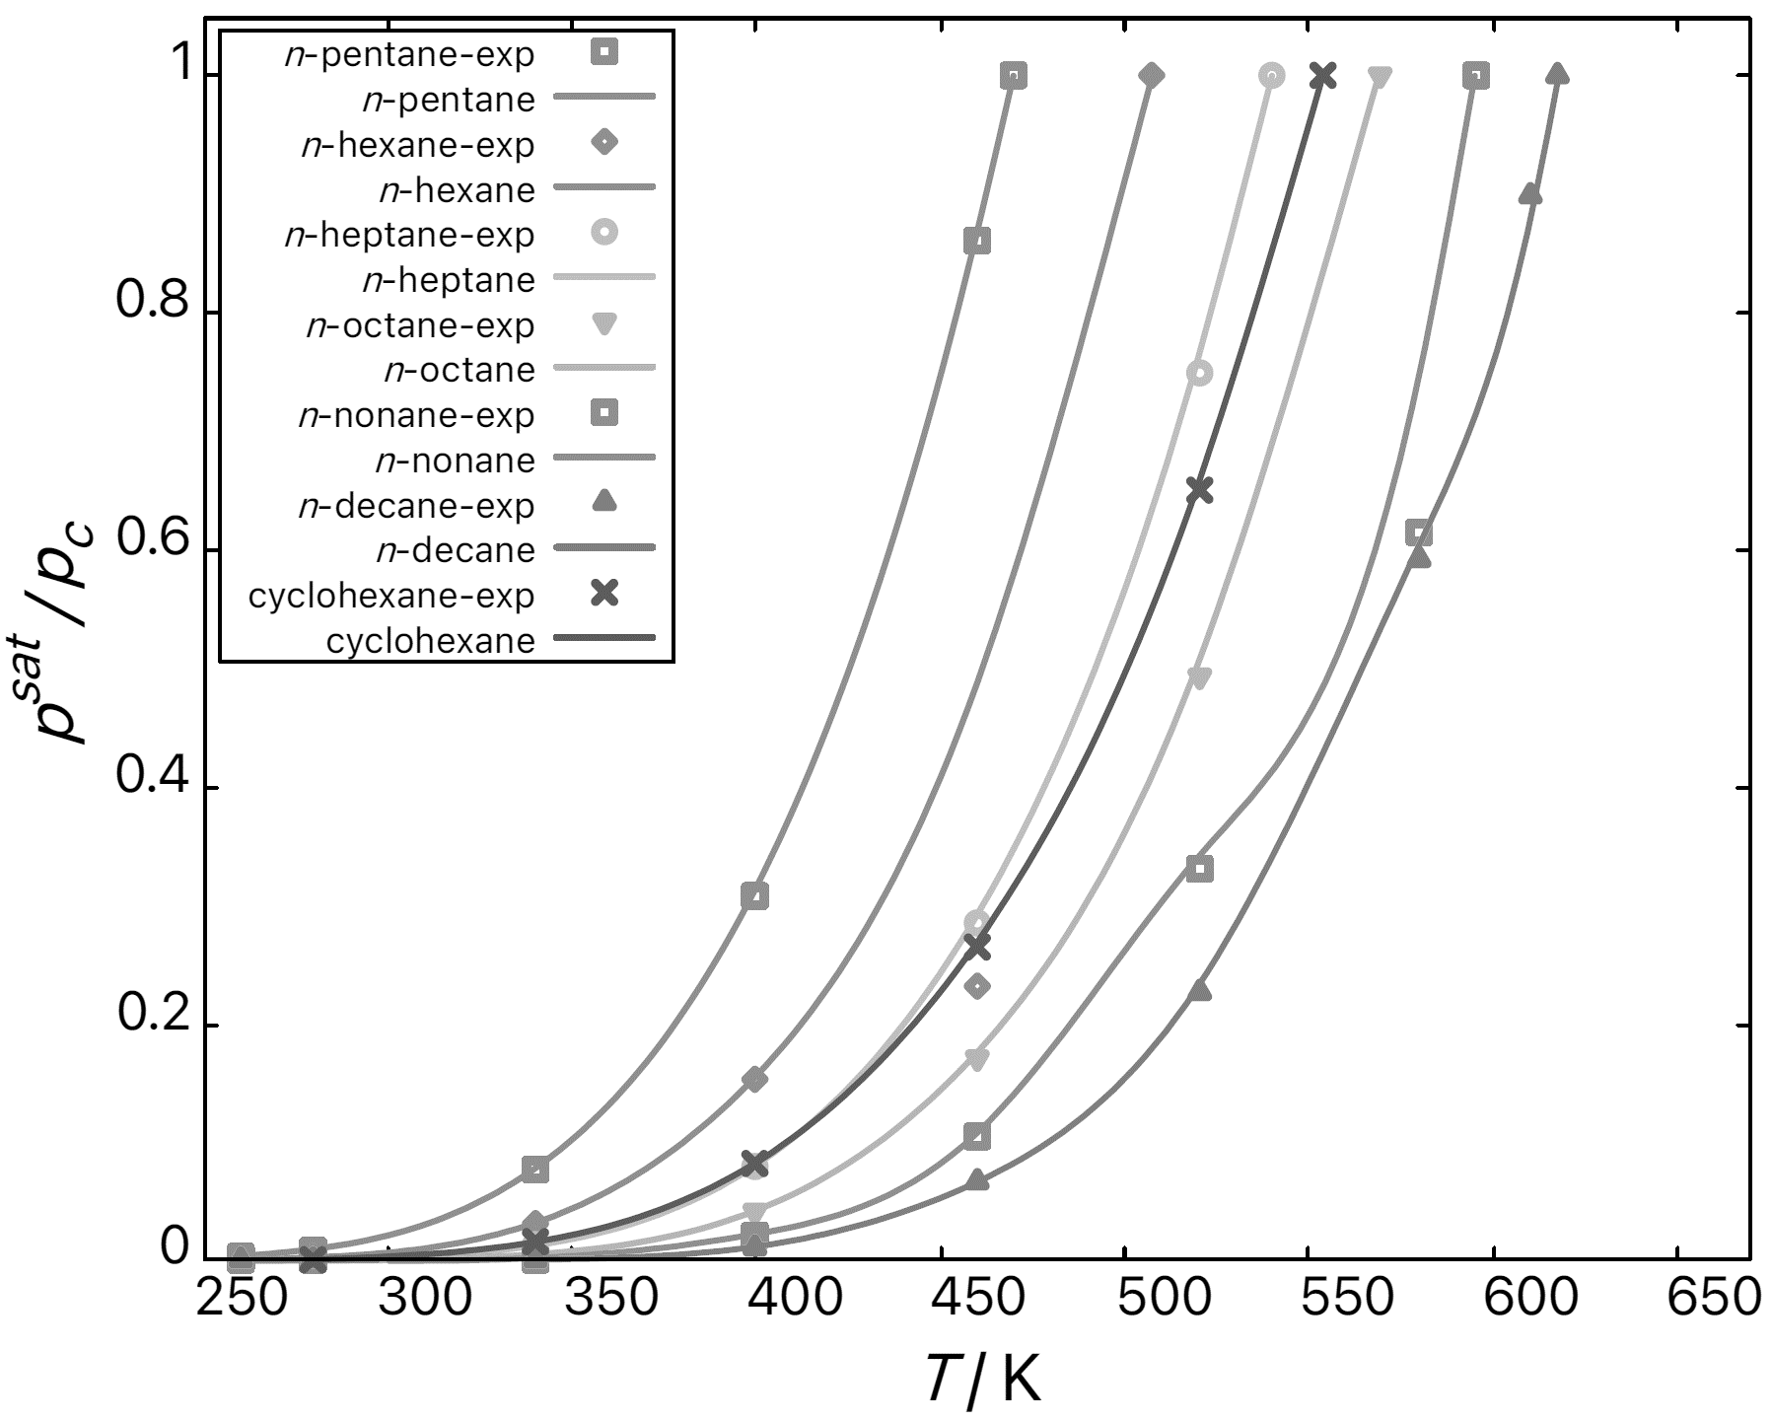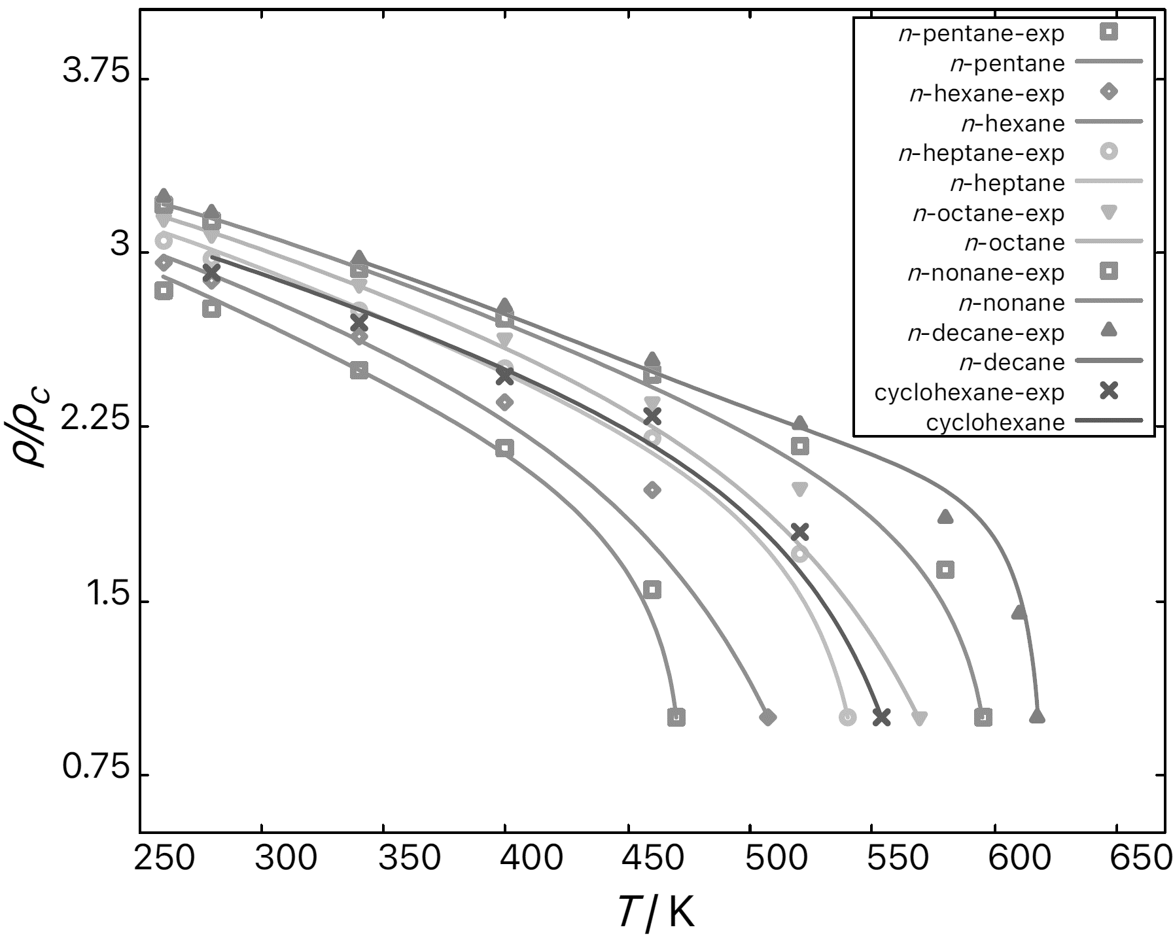
Figure 1. Comparison of predicted (continuous curves) and experimental (discrete points) temperature dependencies of (i) saturation pressure scaled by critical pressure (left), and (ii) liquid phase densities scaled by critical densities (right). The predictions were performed for n-pentane, n-hexane, n-heptane, n-octane, n-nonane, n-decane, cyclohexane using vdW-711 EoS. The experimental data are taken from the NIST Webbook of Chemistry.
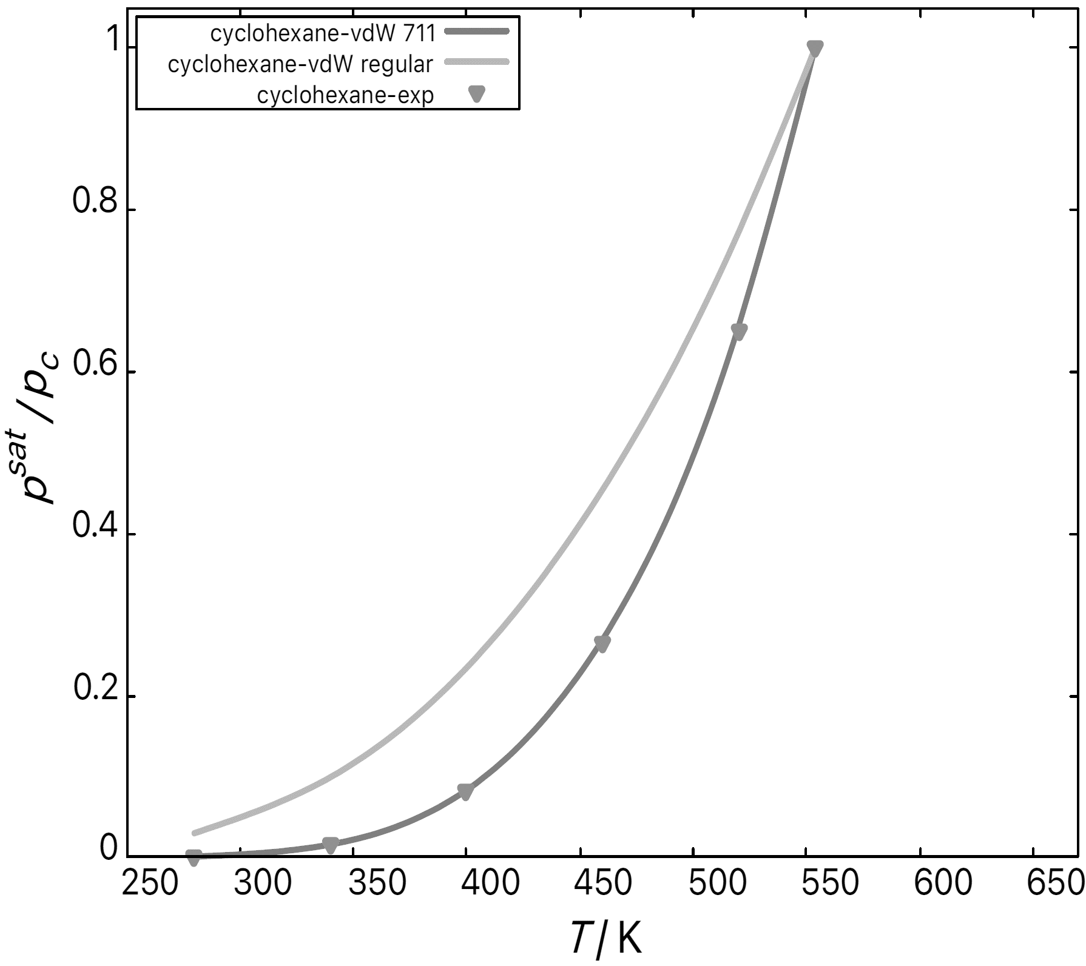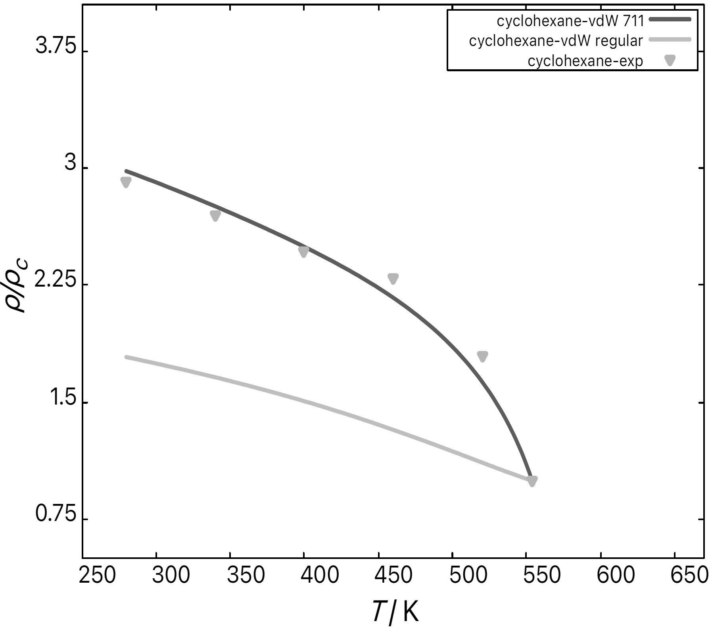
Figure 2. Comparison of predicted (continuous curves) and experimental (discrete points) temperature dependencies of (i) saturation pressure scaled by critical pressure (left), and (ii) liquid phase densities scaled by critical densities (right) for cyclohexane. Light grey curves represent predictions using classical vdW EoS, dark curves are calculated using extended vdW-711 EoS. The experimental data are taken from the NIST Webbook of Chemistry.

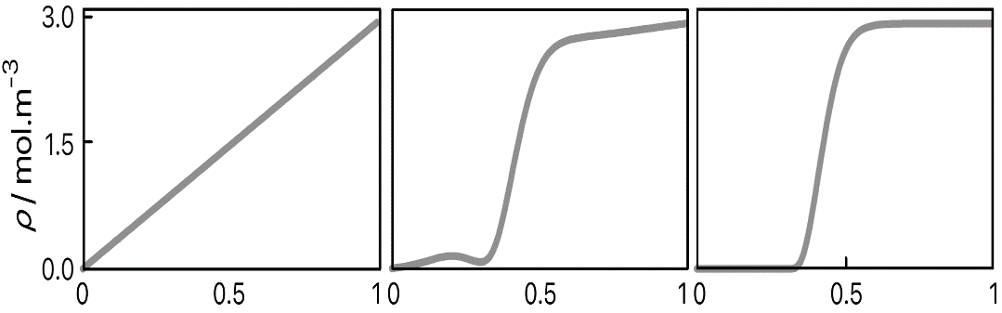
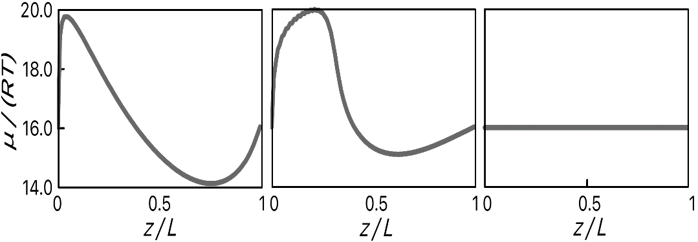
Figure 3. Dynamic evolution of spatial profiles of cyclohexane molar density (top graphs) and normalized chemical potential (bottom graphs) as predicted by Cahn-Hilliard model from initial condition (left) to the final equilibrium profiles (right). Spatial coordinate z is normalized by the length of the computational domain L = 10 nm. In this simulation, system temperature was set to T = 298.15 K.

Figure 4 shows comparison of predicted and experimental dependency of n-heptane surface tension on temperature and pressure. Considering that no parameters have been estimated from the experimental data for this prediction, the agreement is surprisingly good, rendering not only qualitative trends, but also being quantitatively close to the measured values.
Also for the polymer-solvent system, the interfacial tension can be estimated with reasonable accuracy – using Flory-Huggins equation, we predicted value of 0.0022 mN·m⁻¹ for system polystyrene-cyclohexane at 285 K, where the value measured at these conditions by Heinrich and Wolf (1992) was found to be 0.0015 mN·m⁻¹.
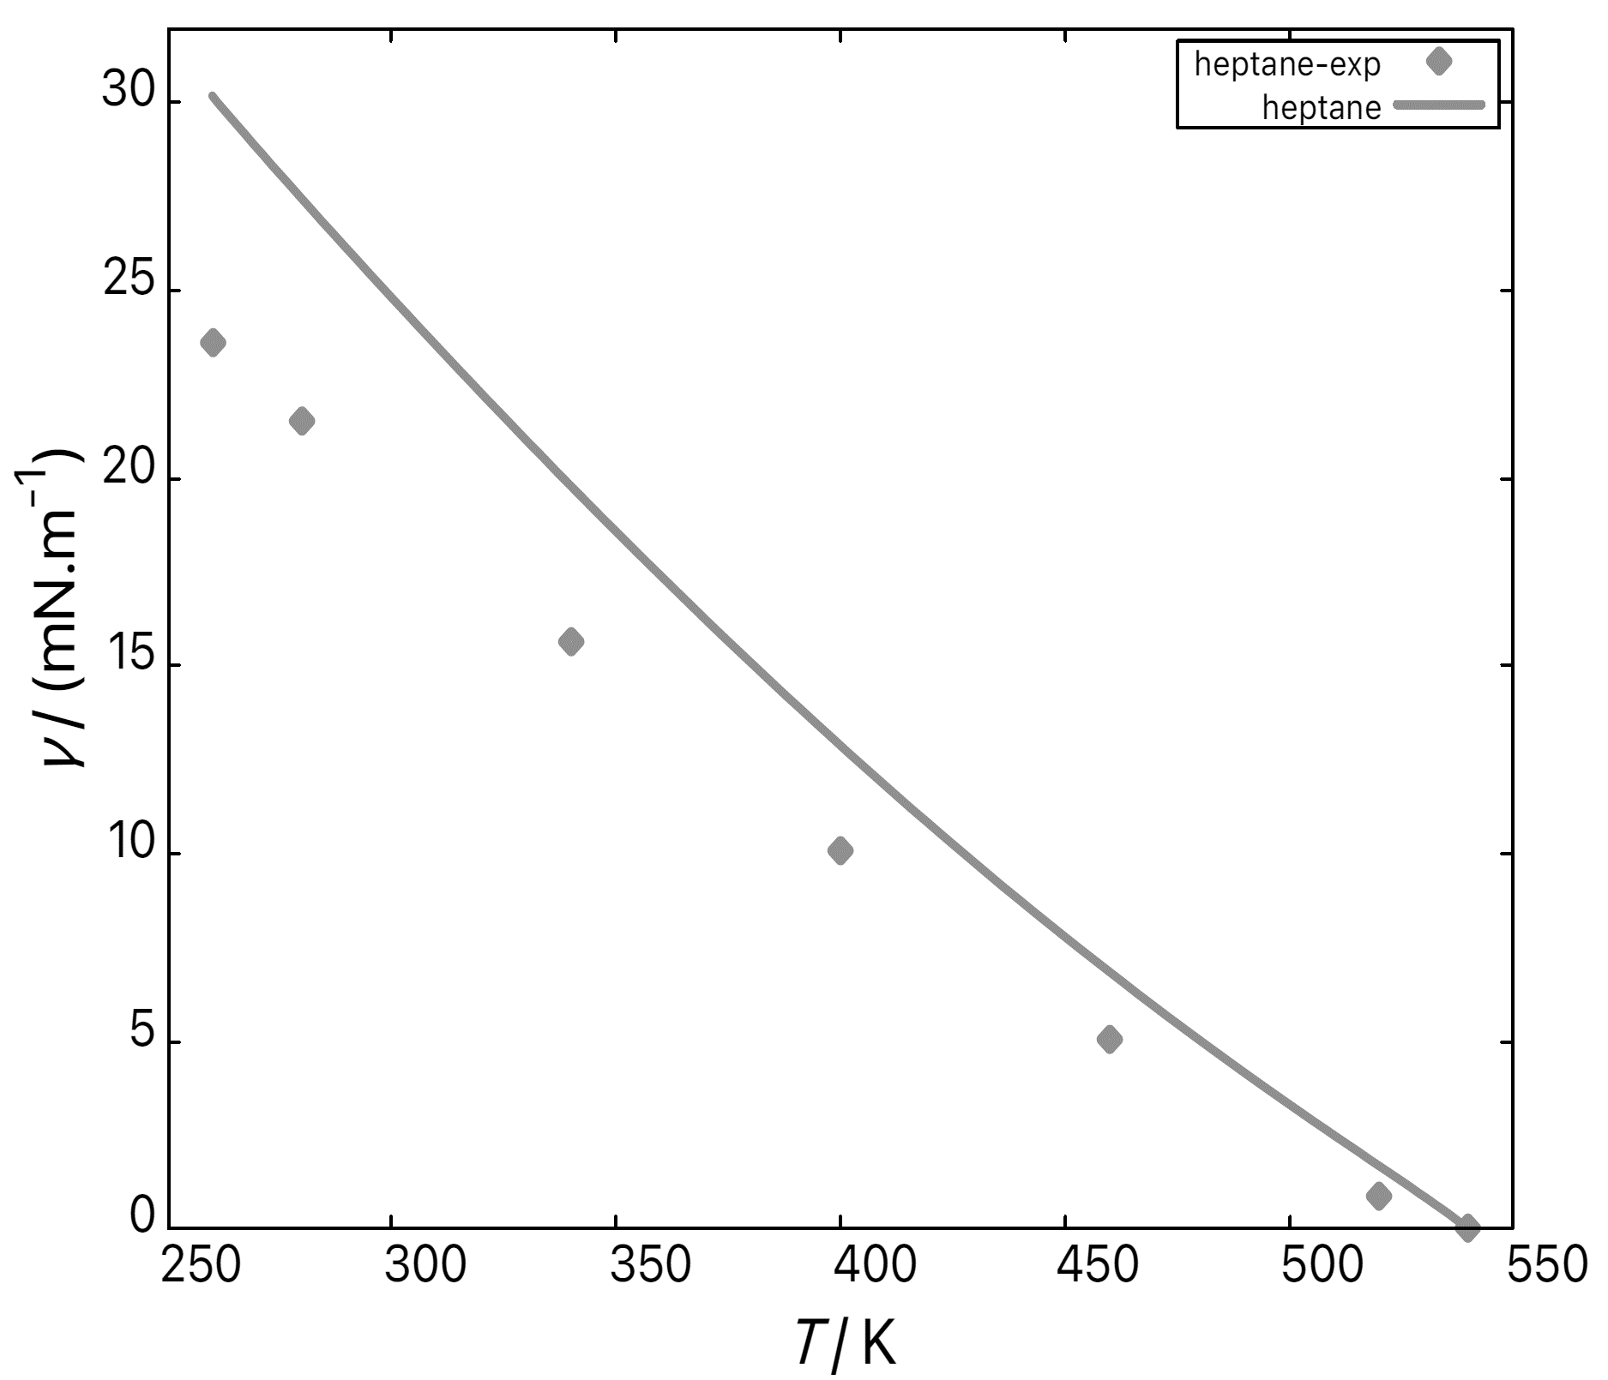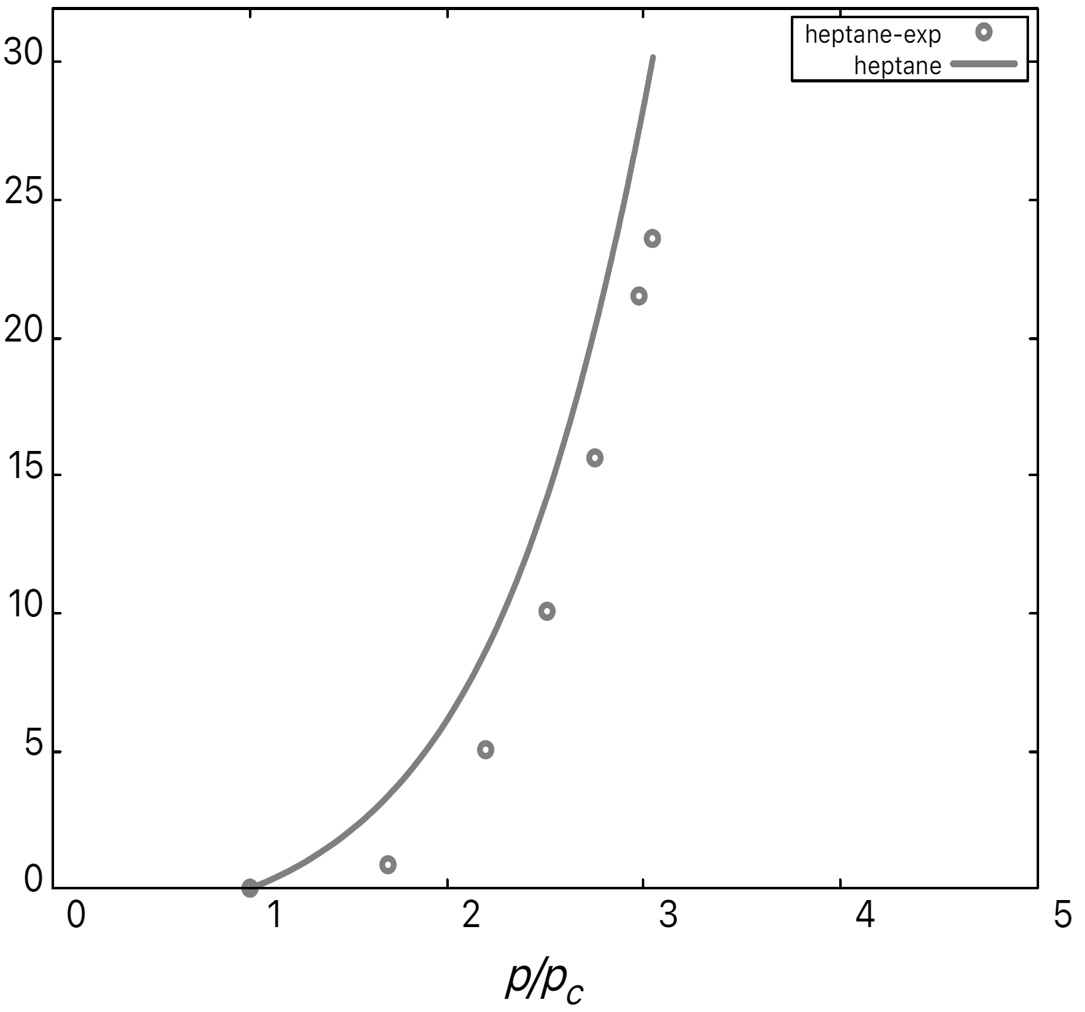
Figure 4. Comparison of predicted (using vdW-711 EoS) and experimental values of surface tension of n-heptane in dependence on temperature (left) and pressure (right). The experimental data are taken from the NIST Webbook of Chemistry.
  - Conclusions
We employed rarely used van der Waals-711 equation of state to estimate vapor-liquid equilibrium conditions for series of saturated hydrocarbons. Comparison with experimental data reveals that the predictive strength of this equation is comparable to more popular engineering cubic equations of state such as Peng-Robinson or Soave-Redlich-Kwong.
Numerically robust approach to Density Gradient Theory based on solution of time-dependent Cahn-Hilliard equation was used to estimate equilibrium density profile of vapor-liquid and polymer-solvent interface and subsequently to predict surface/interfacial tension. The obtained results are compared with available experimental data and indicate that this ab initio approach (i.e., based only on tabulated properties of pure compounds without need for parameter estimation) is capable of predicting the surface/interfacial tension in reasonable agreement with experiments.
References
M. Heinrich, B. A. Wolf, 1992, Interfacial tension between solutions of polystyrenes: establishment of a useful master curve, Polymer, 33, 1926-1931.
L. Landau and E. Lifshitz, 1980, Statistical Physics – Part 1, vol. 5, Course of Theoretical Physics, Butterworth-Heinemann.
X. Liang and M. L. Michelsen, 2017, General approach for solving the density gradient theory in the interfacial tension calculations, Fluid Phase Equilibria, 451, 79–90.
R. Mauri, 2013, Non-Equilibrium Thermodynamics in Multiphase Flows, Springer.
NIST Webbook of Chemistry, National Institute of Standards and Technology, available at: https://webbook.nist.gov/
A. Nistor, M. Vonka, A. Rygl, M. Voclová, M. Minichová, J. Kosek, (2017), Polystyrene Microstructured Foams Formed by Thermally Induced Phase Separation from Cyclohexanol Solution, Macromolecular Reaction Engineering, 11, 1600007.
L. Šatura, M. Minichová, M. Pavelka, J. Kosek, A. Zubov, 2022, A Robust Physics-Based Calculation of Evolving Gas-Liquid Interfaces, Journal of Non-Equilibrium Thermodynamics, 47, 143-154.
D. P. Tassios, 1993, Applied Chemical Engineering Thermodynamics, Springer.

