Production of High-Purity Methane via Sorption-Enhanced CO₂ Methanation in an Adiabatic Packed Bed Reactor
Giuseppe Piso^{a*}, Piero Bareschinoª, Claudio Tregambiª, Francesco Pepeª, Erasmo Mancusiª
ªDipartimento di Ingegneria, Università degli Studi del Sannio, Benevento 82100, Italy
* giuseppe.piso@unisannio.it
Abstract
In-situ water removal can enhance the CO₂ methanation conversion degree according to Le Chatelier’s principle. Sorption-enhanced methanation (SEM) using a bifunctional solid with Ni serving as catalyst and zeolite 13X for water removal can, in principle, be carried out in an adiabatic packed-bed reactor so that the produced heat will be used for water removal over the desorption phase. Under this perspective, this study presents a model of a SEM process based on an adiabatic fixed bed reactor. The results indicate that the production of pure methane occurs for a quite long time, showing promising outlooks for this technology.

Keywords: Synthetic natural gas, sorption enhanced methanation, mathematical model, packed bed reactor, 13X zeolite.
  - Introduction
The conversion of captured CO₂ and green H₂ to chemicals represents a promising route for both leveraging excess energy from renewable power plants and long-term energy storage. On the one hand, the high exothermicity of the CO₂ methanation reaction imposes limits on the maximum conversion degree. On the other hand, it is important to note that, due to the reaction stoichiometry, even a 99 % conversion of CO₂ would ensure just a 95 % mole fraction of methane, not matching the minimum regulatory requirements for direct gas grid injection in most Countries (97.5 %, according to Erdener et al., 2023). To overcome this challenge, several reactor concepts and layouts have been proposed ranging from multiple adiabatic packed beds with inter-cooling (Bareschino et al., 2021, Mancusi et al., 2021) and optional product recycle (Bareschino et al., 2022) to micro-structured reactors consisting of multiple micro tubes, filled by catalyst, and surrounded by a coolant fluid (Brachi et al., 2023).
In-situ water removal emerges as a key strategy to enhance the efficiency of the Sabatier reaction by addressing its thermodynamic constraints. Bifunctional solids, combining a methanation catalyst with a water-removing material such as zeolite (Gómez et al., 2023, Wei et al., 2021), were explored for this purpose. The main challenge in using zeolites for in-situ water removal is the high temperature reached during CO₂ methanation. Indeed, the zeolite's water adsorption capacity diminishes as temperature rises. In commercial methane production processes, reactors operate in a cascade (Rönsch et al., 2016), with the last reactor receiving lower reactant concentrations. Consequently, the heat generated during methanation in the final reactor is significantly less than in earlier stages. This results in temperatures below 450 °C in the last reactor, making it an ideal scenario for a sorption-enhanced methanation (SEM) process utilizing zeolites (Wei et ,al., 2021). Nevertheless, effective heat management is critical in SEM process, where high temperatures significantly impact sorption capacity (Kiefer et al., 2022). At the same time, it is crucial to observe that the heat produced during the SEM process can be used to remove the adsorbed water. Indeed, to sustain a continuous product supply, a minimum of two alternating reactors are required. While in one reactor sorption-enhanced methanation occurs, the other is dried. Heat produced during methanation can be efficiently managed using shell-and-tube reactors (Bareschino et al., 2023). Alternatively, adiabatic reactors facilitate the storage of produced heat within the bed, which can be harnessed during the drying phase.
This study introduces an adiabatic reactor tailored for sorption-enhanced methanation, employing a dynamic heterogeneous model. The model considers both inter- and intra-phase gradients, acknowledging for the non-stationary nature of sorption-enhanced methanation. Model predictions encompass axial variations in temperature and concentrations of all chemical species. A sensitivity analysis was conducted to evaluate the impact of variations in operating pressure and volumetric gas flow rate on process performances, including methane purity at the reactor exit and effective time length.
  - Mathematical Model
A dynamic model for an adiabatic reactor used in sorption-enhanced methanation is discussed. This model considers temperature and concentrations changes along the axis direction, addressing inter-phase and intra-phase gradients, is dynamic, reflecting the inherently non-stationary nature of sorption-enhanced methanation.
CO₂ methanation reaction Eq. (1), i.e. the Sabatier reaction, is a combination of CO methanation and reverse water gas shift reaction (Koschany et al., 2015):
${CO}_{2}+4H_{2}⟷CH_{4}+{2H}_{2}O$ (1)
In the case examined in this study, the fed mixtures contain a minimum of 80 % volume of CH₄, while the remaining 20 % is composed by H₂ and CO₂ in stochiometric ratio. As a result, the maximum temperatures attained remain strictly below 450 °C, and the presence of CO can be safely neglected (Koschany et al., 2015), so the mass balances just consider chemical species i (=CH₄, CO₂, H₂, H₂O). In detail, for the bulk gas phase axial dispersion, convection, and mass transfer between gas and solid phase are considered:
$ε_{b}\frac{∂C_{i,g}}{∂t}=ε_{b}D_{ax,i}\frac{∂^{2}C_{i,g}}{∂z^{2}}-\frac{∂\left(vC_{i,g}\right)}{∂z} -k_{m,i}a_{v}\left({\left.{C_{i,g}-C}_{s,i}\right|}_{r_{p}}\right)$ (2)
while the overall mass balance only considers convection and mass transfer between gas and solid phase:
$ε_{b}\frac{∂C_{tot,g}}{∂t}=-\frac{∂\left(vC_{tot,g}\right)}{∂z}-\sum_{i=1}^{Ns}{k_{m,i}a_{v}\left({\left.{C_{i,g}-C}_{s,i}\right|}_{d_{p/2}}\right)}$ (3)
Where, z is the axial position along each reactor, v the gas velocity (m∙s⁻¹) $ε_{b}$ represent the bed porosity, c (mol.m⁻³) the gas concentration for gas (g) and solid (s) phase, $D_{ax,i}$(m²∙s⁻¹) and k_{m,i} (m∙s⁻¹) effective axial dispersion and gas solid mass transfer.
Dynamical mass balance in the solid phase for CH₄, CO₂, and H₂ considers the simultaneous diffusion and reaction:
$ε_{p}\frac{∂C_{i,s}}{∂t}=ε_{p}D_{eff,i}\left(\frac{∂^{2}C_{i,s}}{∂{r_{c}}^{2}}+\frac{1}{r_{c}}\frac{∂C_{i,s}}{∂r_{c}}\right)+ρ_{cat}f_{cat}ν_{i}r_{i}$ (4)
While mass balance in the solid phase for H₂O considers adsorption too:
$ε_{p}\frac{∂C_{H_{2}O,s}}{∂t}=ε_{p}D_{eff,i}\left(\frac{∂^{2}C_{H_{2}O,s}}{∂{r_{c}}^{2}}+\frac{1}{r_{c}}\frac{∂C_{H_{2}O,s}}{∂r_{c}}\right)+ρ_{cat}ν_{H_{2}O}r_{H_{2}O}-ρ_{ads}f_{ads}\frac{∂q}{∂t}$ (5)
Where r_{c} represents the radial position along the pellet, q water load (mol∙kg⁻¹), $ρ_{cat}$ and $ρ_{cat}$ catalyst and zeolite densities (kg.m⁻³), $ε_{b}$ the catalyst porosity and $D_{eff,i}$(m²∙s⁻¹) effective diffusion of species i in solid and r_{i} (mol .kgcat⁻¹.s⁻¹) the rate of consumption or formation of i-species . Finally, in Eqs. (4)-(5), the reaction and adsorption terms are weighed by the volumetric fraction per unit volume f_{cat} and f_{ads}, respectively. Several authors (e.g. Gomez et al., 2023) showed that at the typical temperatures at which CO₂ methanation takes place, H₂O and CO₂ co-adsorption is negligible, thus just water adsorption is here considered.
The energy balance considers axial dispersion and convection, and heat transfer between gas and solid phase:
$ε_{b}ρ_{gas}c_{p,gas}\frac{∂T_{g}}{∂t}=λ_{ax}\frac{∂^{2}T_{g}}{∂z^{2}}-ρ_{gas}c_{p,gas}v\frac{∂T_{g}}{∂z}+h_{f}a_{v}\left(T_{s}-T_{g}\right)$ (6)
Due to the high thermal conductivity of the solid, intra-particle temperature gradients can be neglected and the energy balance for the solid phase is:
$\left(1-ε_{b}\right)\left(ρ_{cat}f_{cat}+ρ_{ads}f_{ads}\right)c_{p,s}\frac{∂T_{s}}{∂t}=h_{f}a_{v}\left(T_{s}-T_{g}\right)+{\left(1-ε_{b}\right)ρ}_{cat}f_{cat}\left(-{ΔH}_{m}\right)r+\left(1-ε_{b}\right)ρ_{ads}f_{ads}\left(-{ΔH}_{ads}\right)\frac{∂q}{∂t}$ (7)
In Eqs. (6)-(7), T (K) represent gas (g) and solid (s) temperature, c_{p} (J.kg⁻¹.K⁻¹) the heat capacity, h_{f} gas-solid heat transfer coefficient (W∙m⁻²∙K⁻¹), while ${ΔH}_{m}$ and ${ΔH}_{ads}$are the reaction and adsorption enthalpies, respectively.
To complete the gas and solid mass and enthalpy balances, classic Danckwerts boundary conditions were imposed at the reactor inlet and outlet, while symmetry and flux continuity represented the boundary conditions for the solid phase.
According to Mette et al. (2014) a linear driving force (LDF) model has been used to describe the adsorption rate:
$\frac{∂q}{∂t}=K_{LDF}\left(q^{*}-q\right)$ (8)
and the equilibrium adsorption capacity, q*, is described by the Dubinin- Ashtakov model (Mette et al., 2014). The kinetic model proposed by Koschany et al. (2015) for Ni-catalysed CO₂ methanation, which neglects side reactions, has been adopted. Moreover, these kinetics have been recently used to model a sorption-enhanced methane synthesis. For reader convenience, the reaction kinetic is:
$r_{m}=\frac{k{\left(P_{H2}P_{CO2}\right)}^{0.5}\left(1-\frac{P_{CH4}P_{H2O}^{2}}{P_{H2}^{4}P_{CO2}K_{eq}}\right)}{{\left(1+K_{OH}\frac{P_{H2O}}{P_{H2}^{0.5}}+K_{H2}P_{H2}^{0.5}+K_{mix}P_{CO2}^{0.5}\right)}^{2}}$ (9)
The mathematical model has been solved using the commercial software package COMSOL Multiphisycs®. The size of the PDE set is large, but model order reduction techniques are available for future studies (Cutillo et al., 2023).
The Shomate equation and data from the NIST Chemistry WebBook were used to calculate heat capacities and enthalpy of formation of all the gaseous species The temperature dependence of mass and heat transport coefficients, diffusivities, and gas properties were considered through the state-of-the-art correlations (see Bareschino et al., 2023). The operating conditions, reactor volumes, and catalyst properties used in the simulations are reported in Table 1.
Table 1 – Parameters used in the simulations.
Parameter | Value | Parameter | Value
c_{ps} | 1100 J∙kg⁻¹∙K⁻¹ | M_{cat} | 0.064 kg
λs | 0.25 W∙m∙K⁻¹ | M_{ads} | 1.22 kg
L | 6 m | ρ_{c} | 2350 kg.m⁻³
d_{t} | 1 m | T_{in} | 300 °C
d_{p} | 2.5 mm | P | 3 bar
$${ΔH°}_{ads}$$ | -45∙10³ J∙mol⁻¹ | $${ΔH°}_{m}$$ | -165∙10³ J∙mol⁻¹
  - Results and discussion
As already discussed, the proposed model applies to the last reactor in a cascade, designed to operate at lower temperatures. Accordingly, the composition of the feed gas in this research comprises CH₄ (80 %_{v}), H₂ (16 %_{v}), and CO₂ (4 %_{v}), maintaining a stoichiometric ratio.
Fig. 1 shows temperature and the distribution of adsorbed water along the reactor axis for several time instants. The temperature on catalyst layers closest to the reactor inlet quickly increases at the beginning, as the fresh feed meets a dry catalyst. The cold feed lowers the temperature of these catalyst layers and thus favors the absorption of the produced water.

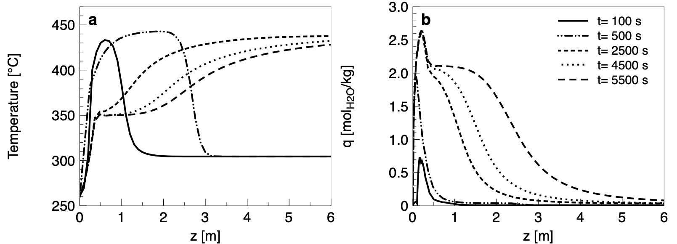
Figure-1 Temperature profiles (a) and adsorbed water (b) along the reactor axis for several time instants.
It is crucial to emphasize the bifunctional nature of the solid employed in this context. Consequently, even after reaching the maximum adsorption capacity in a specific section, the solid continues to act as a catalyst. Thus, as the catalyst layers near the inlet approach their maximum water adsorption capacity, the methanation reaction persists, albeit no longer water adsorption occurs. Over time, the innermost catalyst layers become water-saturated, impeding the methanation reaction in SEM conditions. This results in a reduction of reactant conversion, leading to a decrease in both heat generation and, consequently, overall temperature. The spatial profiles depicted in Fig.1 reveal a distinct pattern: the heat generated by the methanation reaction is concentrated in the reactor sections near the outlet, whereas water tends to be predominantly adsorbed on the sections closer to the inlet. These distributions are conducive to an optimal counter-current bed regeneration process.
Fig. 2 reports gas compositions and temperature at the reactor outlet. Methane concentration after 4200 s crosses below the 97.5 % line, as can be seen in Fig.2. (a), thus setting the maximum time length for reactor operation.
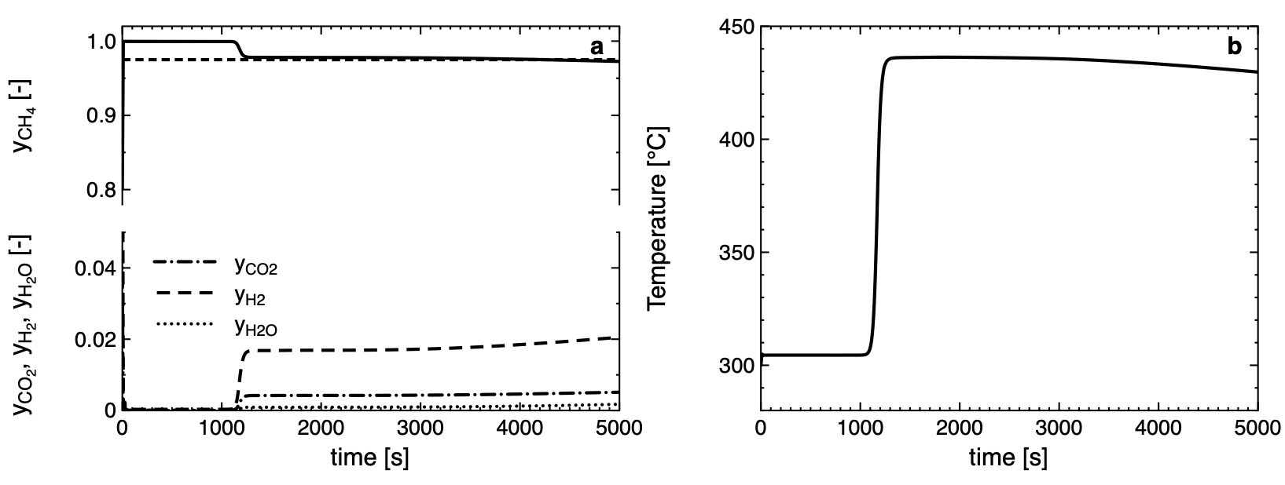
Figure-2 Gas molar fractions (a) and temperature (b) at the reactor outlet for F_{stp}=600 m³/h, dashed line representing the threshold value of y_{CH4}=0.975 for direct gas grid injection.
By analyzing the time series reported in Fig.2 (a), we can see that H₂ and CO₂ breakthroughs always precede the H₂O one, being more evident for H₂. This phenomenon is due to the limiting effect of the chemical reaction resulting in a lower conversion rate than convective mass transport thus a slip of reactants occurs (Kiefer et al., 2022). For the assigned operating conditions (Tab.1), a dry mixture is present at the reactor outlet, but for times larger than 4200 s the methane percentage drops below 97.5 %. Therefore, the time limit for this type of operation is not set by the breakthrough of the water but by the slip phenomenon of unconverted reactants. It is important to note, however, that up to this time, the reactor produces a mixture with a methane percentage greater than 97.5 %. To pursue process intensification, the effect of different pressure values and three different molar flow rates has been considered. As the pressure increases, the gas velocity decreases, which results in a longer utilization time for the same flow rate (see Fig. 3). Moreover, the pressure has a positive effect on conversion too. Indeed, CO₂ methanation is usually carried out at pressures greater than 10 bar (Rönsch et al., 2016) while for sorption enhanced methanation 100 % conversions are attained for a sufficient long-time even at pressure lower than 10 bar. Therefore, the increase in pressure ensures longer operating times for the same volumetric flow rate as summarized in Tab. 2.
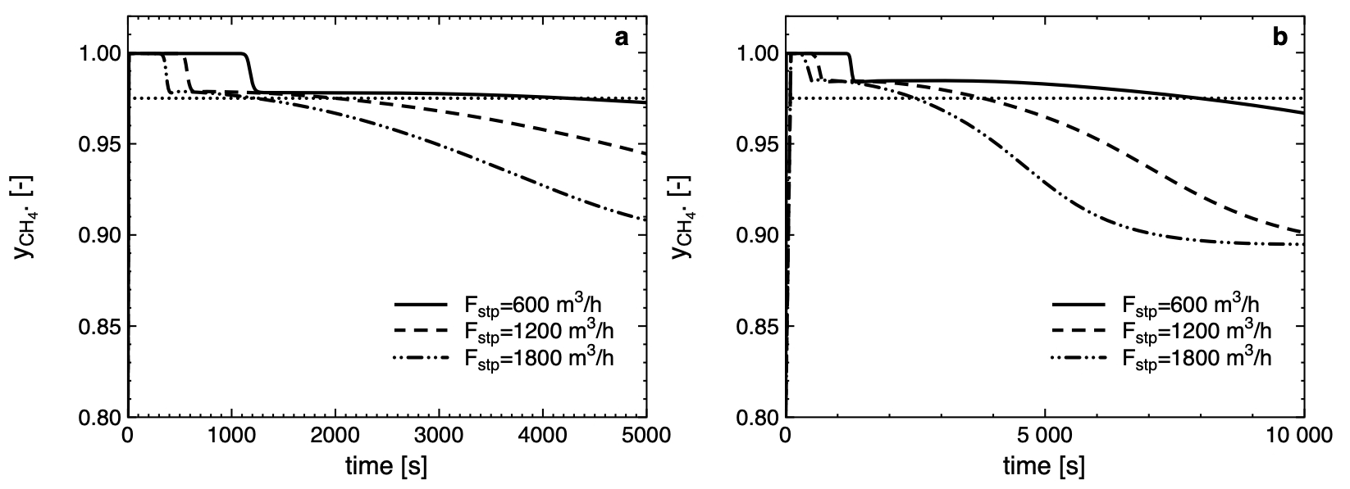
Figure-3 CH₄ molar fraction at reactor exit for different volumetric gas flow rates at P=3 bar (a) and P=5 bar (b). Dotted line represents the threshold value of y_{CH4}=0.975.
Table 2 – Operating time for several pressure and volumetric flow rates.
F_{stp} m³/h | P=3 bar | P= 5 bar
600 | 4200 s | 7960 s
1200 | 2040 s | 3810 s
1800 | 1230 s | 2450 s
  - Conclusions
This study shows that an adiabatic packed bed reactor, filled with bifunctional solids combining a methanation catalyst with a water-removing material, can be used as the last unit in a methanation cascade to produce a high-purity (y_{CH4}>97.5 %) methane stream. In particular, it has been observed that water is mainly adsorbed on the first catalyst layers, so drying will have to take place in counter-current. Process intensification can be pursued by increasing the reactor pressure, indeed even for high volumetric flow rate a methane output rate of more than 97.5 % is guaranteed for sufficiently large times.
References
P. Bareschino, G. Piso, C. Tregambi, F.Pepe, E. Mancusi, 2023. Numerical modelling of a sorption-enhanced methanation system. Chem. Eng. Sci, 277, 118876.
P. Bareschino, E. A. Cutillo, C. Tregambi, F. Pepe, G. Continillo, E. Mancusi, 2022. Periodic Oscillations in Methane Reactor: Effects of the Main Operating Parameters, Comput. Aided Chem. Eng. 51 1-6.
P. Bareschino, E. Mancusi, C. Tregambi, F. Pepe, M. Urciuolo, P. Brachi, G. Ruoppolo, 2021, Integration of biomasses gasification and renewable-energies-driven water electrolysis for methane production, Energy, 230, 120863
P. Brachi, P. Bareschino, C. Tregambi, F. Pepe, M. Urciuolo, G. Ruoppolo, E. Mancusi, 2023, Assessing the feasibility of an integrated CLC-methanation system using solar dried and torrefied biomasses as a feedstock, Fuel, 331, 125951.
E. A. Cutillo, E. Mancusi, K. Bizon, P. Bareschino, G. Continillo, 2023, A Reduced Order Model for the Prediction of the Dynamics of a Methane Reactor, Comput. Aided Chem. Eng. 52 11999–1204.
B.C. Erdener, B. Sergi,O.J. Guerra, A.Lazaro Chueca, K. Pambour, C. Brancucci, B.M. Hodge, 2023. A review of technical and regulatory limits for hydrogen blending in natural gas pipelines. Int. J. Hydrogen Energy 48, 5595–5617.
L. Gómez, I. Martínez, M.V. Navarro, R. Murillo, 2023, Selection and optimisation of a zeolite/catalyst mixture for sorption-enhanced CO₂ methanation (SEM) process, Journal of CO2 Utilization, 77, 102611.
F. Kiefer, M. Nikolic, A.Borgschulte, P. Dimopoulos Eggenschwiler, 2022. Sorption-enhanced methane synthesis in fixed-bed reactors. Chem. Eng. J. 449, 137872.
F. Koschany, D. Schlereth, O. Hinrichsen, 2015, On the kinetics of the methanation of carbon dioxide on coprecipitated NiAl(O)x, Appl. Catal. B Environ., 18, 504–516.
E. Mancusi, P. Bareschino, P. Brachi, A. Coppola, G. Rupppolo, M. Urciuolo, F.Pepe, 2021, Feasibility of an integrated biomass-based CLC combustion and a renewable-energy-based methanol production systems, Renew. Energy, 179, 29-36.
B. Mette, H. Kerskes, H. Drück, H. Müller-Steinhagen, Experimental and numerical investigations on the water vapor adsorption isotherms and kinetics of binderless zeolite 13X, 2014, Int. J. Heat Mass Transf., 7, 555–561.
S. Rönsch, J. Schneider, S. Matthischke, M. Schlüter, M. Götz, M., J. Lefebvre, P. Prabhakaran, S. Bajohr, 2016. Review on methanation - From fundamentals to current projects. Fuel 166, 276–296.
L. Wei, H. Azad, W. Haije, H. Grenman, W. de Jong, 2021. Pure methane from CO₂ hydrogenation using a sorption enhanced process with catalyst/zeolite bifunctional materials, Appl. Catal. B Environ. 297, 120399

