Enhancing Unit Operation Design: Leveraging Neural Networks to Enforce Physical Hard Constraints
Jana Mousa,* Stéphane Negny, Rachid Ouaret, Alessandro Di Pretoro, Ludovic Montastruc.
Laboratoire de Génie Chimique, Université de Toulouse, CNRS, INPT, UPS, Toulouse, France.
*Correspondence : jana.mousa@toulouse-inp.fr
Abstract
Neural networks have emerged as promising computational tools in machine learning for modelling complex systems due to their ability to learn intricate patterns from data. However, they come with inherent limitations as they often disregard the fundamental principles of the processes modelled making them incapable to incorporate physical laws and constraints into the learning and training processes. Tackling these limitations, in this work physics-informed neural networks and data reconciliation were the main approaches tested to embed such constraints within the neural network architecture and training process, aiming to bridge the gap between data-driven modelling and physics-based comprehension of systems. This innovative framework exposes the potentiality of hybrid modelling by forcing a neural network to integrate and harmonize with physical laws, paving the way for a robust fusion between fundamental laws and AI for engineering applications. In this study we propose and compare data reconciliation methods with standard neural networks and physics-informed neural networks and test their capabilities on the design of a flash drum for the separation of a binary mixture.
Keywords: neural networks, physics-informed neural networks, data reconciliation, unit operations.
  - Introduction
Neural networks have become an integral part of process engineering, serving as powerful computational tools for modelling complex systems. Their power lies in their ability to decipher intricate patterns within data sets, making them valuable tools for predictive modelling, optimization and control in a variety of industrial processes. However, despite their capabilities, neural networks often operate as black boxes, neglecting the fundamental physical principles that underpin the processes they seek to model.
In the realm of process engineering, where precision and reliability are paramount, the inability of neural networks to incorporate physical laws and constraints is a significant limitation. The black-box nature of these networks renders their predictions uninterpretable, making it difficult to understand the underlying mechanisms controlling a system. This is particularly problematic in industries where compliance with specific physical laws and constraints is critical for safe and efficient operation (Solle et al., 2017).
The importance of incorporating physical meaning into neural networks becomes apparent when considering their applications in fields such as chemical engineering, where processes adhere to fundamental principles of mass and energy conservation. Neural networks that ignore these principles can make inaccurate predictions and fail to capture the nuanced behavior of systems (Hussain et al., 2021). To address these drawbacks, recent research in process engineering has focused on the integration of neural networks with physics-based models, which we call hybrid modelling. This integration aims to exploit the strengths of both approaches, combining the data-driven capabilities of neural networks with the physical insight provided by first-principles models (Bhutani et al., 2006). This makes the neural network a more reliable tool for tasks such as model calibration, design optimization and control in industrial processes.
In conclusion, while neural networks offer remarkable capabilities in modeling complex systems, their limitations in incorporating physical significance can hinder their effectiveness in process engineering (Cavalcanti et al., 2021). The integration of physics-based principles into neural networks, represents a promising solution to overcome these limitations, fostering a more robust and interpretable framework for applications in various engineering domains. To achieve this, the aim of this study is to propose and test a new approach that couples fundamental principles and neural networks and to test and compare it with other approaches and methods
  - Case Study and Methodologies
This work focuses on optimizing the design of a flash drum—a vital component in chemical engineering for liquid-vapor separation. The flash drum's efficiency hinges on strict adherence to mass balances (Eq. (1)) which are the constraints to be respected. To achieve this, we employed two approaches, the first one being physics-informed neural networks (PINNs) and the second being a data reconciliation approach merged with the neural network.

$m_{i, in }=⅀m_{i, out }$ (1)

    - Physics-Informed Neural Networks
Physics-informed neural networks (PINNs) represent an eye-catching approach that integrates physical knowledge into the architecture of neural networks. These networks are designed to incorporate underlying physical principles and constraints directly into the learning process, making them highly desirable for modeling systems where disregarding the fundamentality is detrimental for efficient operation. The primary motivation behind utilizing PINNs lies in their ability to fuse the strengths of traditional physics-based models with the data-driven capabilities of neural networks (Raissi et al., 2019). In our approach, the physics-informed neural network was done by creating a custom loss function that aims to enforce the physical constraints of the system by minimizing an objective function during training. As seen in Figure 1, the custom loss function is meant to be embedded inside the neural network’s training process so that it learns from it. This function is composed of two components: a data-driven loss term and a physics informed constraint term.
The data-driven component (Eq. (2)) is responsible for minimizing the difference between the model's predictions and the actual observed data (mean squared error). While the second term (Eq. (3)) ensures that the neural network respects the mass balance equality by introducing a penalty term α to effectively guide the network to generate predictions that align with the underlying physics of the problem.

$Data \text{-} driven loss= MSE( y_{true}-y_{pred})$ (F1) (2)

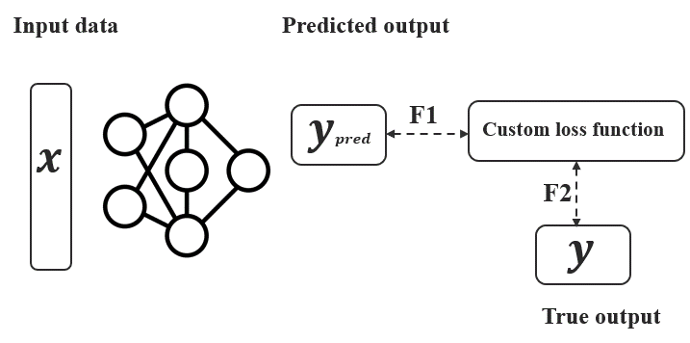
$Physics \text{-} informed loss= α* mass balance equality constraint$(F2) (3)
Figure 1. Visualization of a physics-informed neural network with a custom loss function.

    - Data-Reconciliation
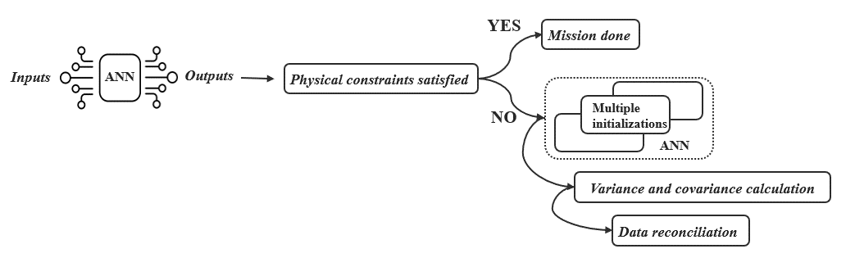
Data reconciliation is a process used in a variety of fields, including engineering, process industries and data management, to ensure the consistency and accuracy of data collected from different sources or obtained through different measurements(Crowe, 1996). The primary goal of data reconciliation is to identify and correct discrepancies or errors in the data, resulting in a more accurate and reliable dataset. In our case (Figure 2), data reconciliation techniques were applied by generating multiple initializations of the gradient descent used in the learning step.
Figure 2 Steps to constrained outputs via data reconciliation
Through iterative adjustments and corrections guided by reconciliation methods, we sought to reconcile any discrepancies in the network’s predicted outputs, thereby refining the model's predictions to align with the fundamental principles of mass conservation.
  - Results
The flash drum is dealing with a binary mixture of Toluene (Tol) and Biphenyl (Bip) where the inlet flow rate, temperature and pressure, along with the top and bottom outlet flowrates for both components are acquired as simulated data of 1594 points. An artificial neural network was studied for the prediction of the output flowrates of both components as well as a physics-informed neural network that was specifically equipped with physical constraints embedded in a custom loss function to uphold the mass balance equality, distinguishing it from the standard neural network (the train-test data split ratio was 80:20). Results are shown in Table 1.

Table 1. Performance of ANN and PINN.
 | ANN |  | PINN
 | Tol | Bip | Tol | Bip
Train MSE | 0.0025 | 0.00052 | 0.0022 | 0.0004
Test MSE | 0.01 | 0.0016 | 0.007 | 0.00078

Incorporating a physics-informed neural network (PINN) into our study yielded a notable decrease in the test mean squared error (MSE between predicted output and expected one) compared to the conventional neural network where the overall MSE for Toluene and Biphenyl was reduced by 70% and 49% respectively. The test performance of the model is improved when the physics term is introduced to the loss function. By enforcing these constraints, the PINN enhances the model's capability to capture the underlying physics of the system, resulting in more accurate and meaningful predictions during the testing phase.
Moreover, when working with a typical neural network, the mass balance equality was never satisfied which is an expected observation knowing that a neural network operates as a black box thereby disregarding the physical aspects of the process. However, when applying the physical term in the loss function, we notice a decrease of 58% in the mass balance values for both chemical components, which is considered as an improvement. Yet, the values indeed don’t hit 0, so on the broader aspect; the mass balance equality was not 100% satisfied even with a physics-informed neural network.
Accordingly, one can conclude that while the physics-informed neural network demonstrated improved results compared to the standard neural network, it is essential to acknowledge the inherent trade-off between predictive accuracy and the fulfilment of physical constraints.

To better understand this trade-off the model was tested by alternating the weight of the data-driven loss function between 0 and 1, and the same was done to the physics-informed loss function, to observe the effect they had on one another. The relationship between both terms can be described as antagonist. As seen in Figure 3, we can observe a pareto front between the two terms of the objective function. This, in PINNs, it is necessary to establish the relative significance of the two terms of the loss function. This is satisfied by following a compromised strategy that minimizes the predictive power and satisfies
the physical constraints. However, this also sacrifices the full satisfaction of the constraints due to the aforementioned trade-off.

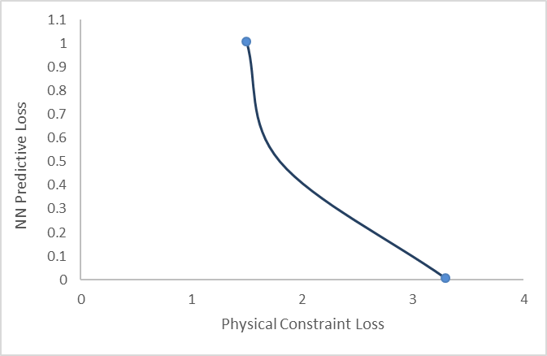
Figure 3. Observations on the loss terms upon varying the penalty term.

This antagonistic interplay reflects the inherent challenge of striking a balance between achieving accurate predictions and upholding the physical constraints when working with physics-informed neural networks.

As previously discussed, the usage of a neural network on is own did not respect properly the mass balance constraint on the chemical components. Accordingly, a data reconciliation methodology has been proposed to address this issue. This procedure is grounded in the concept that a neural network is treated as a soft sensor generating "prediction" errors that is consequently rectified using classical data validation techniques where the linear optimization problem (Eq. (4)) and its relative solution (Eq. (5)) are shown below:

$\left\{\begin{aligned}\min_{{\tilde{x}}_{ann}}{\frac{1}{2}{\left({\tilde{x}}_{ann}-x_{ann}\right)}^{t}V^{-1}\left({\tilde{x}}_{ann}-x_{ann}\right)} \\ M{\tilde{x}}_{ann}=B\end{aligned}\right.$ (4)

And the corresponding analytical solution is the following:

${\tilde{x}}_{ann}=x_{ann}-VM^{t}{\left(MVM^{t}\right)}^{-1}\left(M{\tilde{x}}_{ann}-B\right)$ (5)

The matrix M encodes the linear structure of the constraints as seen below:

$\left(\begin{matrix}1 & 0 & 0 & 0 & 0 & 0 \\ 0 & 0 & 0 & 1 & 0 & 0 \\ 1 & -1 & -1 & 0 & 0 & 0 \\ 0 & 0 & 0 & 1 & -1 & -1\end{matrix}\right){\tilde{x}}_{ann}=\left(\begin{matrix}Tol inlet flow \\ Bip inlet flow \\ 0 \\ 0\end{matrix}\right)$ (6)

Where V is the variance-covariance matrix calculate by running the neural network on multiple initializations for the same input. Also, ${\tilde{x}}_{ann}$ is a vector of validated data of the predicted output of the neural network and $x_{ann}$ is that of the desired expected output. Therefore, the data to be reconciled is that predicted from the neural network. This methodology completely satisfied the physical constraints but at the cost of having slightly less accurate predictions of the individual output flowrates. Accordingly, further investigations are ongoing to achieve a balance between adhering to physical constraints and the performance level associated with a machine learning model.

  - Conclusion
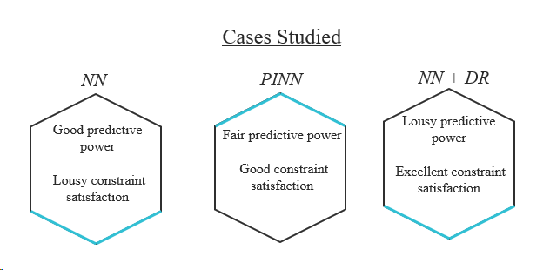
This study delved into enhancing the design of a flash drum through three distinct approaches: traditional neural networks, physics-informed neural networks, and neural networks integrated with data reconciliation (Figure 4). Our investigation revealed that while each method demonstrated its merits, a recurring theme emerged, that is the inherent trade-off between satisfying stringent physical constraints and achieving robust predictive power. Traditional neural networks showcased predictive powers but struggled to align with the physical significance. In contrast, physics-informed neural networks demonstrated a more nuanced understanding of underlying principles but to a limit to not lose the predictive power. The incorporation of data reconciliation into neural network models provided a promising avenue for enforcing physical constraints, yet this enhancement was matched with a subpar accuracy. Lastly, our findings underscore the importance of weighing the trade-offs inherent in each methodology according to one’s needs and the importance of further future investigations.
Figure 4. Insights from the three studied approaches

References
Bhutani, N., Rangaiah, G.P., Ray, A.K., 2006. First-Principles, Data-Based, and Hybrid Modeling and Optimization of an Industrial Hydrocracking Unit. Ind. Eng. Chem. Res. 45, 7807–
Cavalcanti, F.M., Kozonoe, C.E., Pacheco, K.A., Alves, R.M. de B., 2021. Application of Artificial Neural Networks to Chemical and Process Engineering, in: Mazzeo, P.L., Spagnolo, P. (Eds.), Deep Learning Applications. IntechOpen, Rijeka.
Crowe, C.M., 1996. Data reconciliation — Progress and challenges. Journal of Process Control, Process Systems Engineering 6, 89–98. https://doi.org/10.1016/0959-1524(96)00012-1
Hussain, M.M., Bari, S.H., Mahmud, I., Siddiquee, M.I.H., 2021. Chapter 5 - Application of different artificial neural network for streamflow forecasting, in: Sharma, P., Machiwal, D. (Eds.), Advances in Streamflow Forecasting. Elsevier, pp. 149–170.
Raissi, M., Perdikaris, P., Karniadakis, G.E., 2019. Physics-informed neural networks: A deep learning framework for solving forward and inverse problems involving nonlinear partial differential equations. Journal of Computational Physics 378, 686–707.
Solle, D., Hitzmann, B., Herwig, C., Pereira Remelhe, M., Ulonska, S., Wuerth, L., Prata, A., Steckenreiter, T., 2017. Between the Poles of Data-Driven and Mechanistic Modeling for Process Operation. Chemie Ingenieur Technik 89, 542–561.

