Efficient Numerical Methods for Dynamic Simulation of Fixed-bed Reactors

Joachim Weel Rosboa*, Anker D. Jensena , John Bagterp Jørgensenb, Jakob K. Huusoma

aDept. of Chemical and Biochemical Engineering, Technical University of Denmark,

bDept. of Applied Mathematics and Computer Science, Technical University of Denmark,

*jwro@kt.dtu.dk

Abstract  
The intermittent nature of renewable energies requires Power-to-X (P2X) plants to operate flexibly in contrast to traditional stable operation with fossil feedstocks. This emphasises the need for accurate and efficient dynamic models of P2X plants. In this paper, we study a partial differential algebraic equations (PDAEs) model for a fixed-bed gas phase reactor. The model is discretized in space by the finite volume method (FVM). The dispersion term from back-mixing in the bed is approximated by numerical diffusion by using an appropriate number of discretization cells. Five different numerical implementations of the Euler step are investigated for solving in time: One traditional explicit scheme and four implicit formulations. The performance of the numerical schemes is tested by solving the response of the bed to a step change in the inlet temperature. The most efficient implicit method is an order of magnitude faster than the traditional explicit method, while the slowest implicit method is an order of magnitude slower.

Keywords: Fixed-bed reactors, PDAE, Finite Volume Method, Implicit methods

* 1. Introduction  
     Catalytic fixed-bed reactors are the most used reactor type for synthesizing large-scale chemicals such as methanol, ammonia and sulphuric acid. Often literature and textbooks focus on steady-state modelling as chemical plants are traditionally built for stable operation with as few fluctuations in production as possible. But with today's focus on out-phasing fossil-based feedstocks and replacing them with renewable energy, new challenges are arising for the operation of chemical plants. Dynamic and flexible operation of power-to-X (P2X) plants is required to comply with the intermittent nature of renewable energies such as wind and solar power. This emphasizes the importance of dynamic models, which are fundamental for advanced control and critical in ensuring the safe and optimal operation of renewable-powered chemical plants. Steady-state 1D models of industrial fixed-bed reactors for ammonia or methanol production are common in the literature, and have proven an accurate model approach for industrial reactors in several studies (Shamiri & Aliabadi, 2021). Based on 1D PFR models several papers have set up dynamic models for fixed-bed ammonia and methanol reactors. Morud & Skogestad, (1998) transformed the fixed-bed partial differential equations (PDEs) model into an ordinary differential equations (ODEs) system by the finite volume method, while Manenti & Bozzano, (2013) applied a finite difference scheme. The papers use an explicit Euler step for the integration. The models qualitatively match transient behaviors observed for fixed-bed ammonia and methanol reactors, but quantitative accuracy is not discussed. The papers assume constant thermodynamic properties and do not account for deviations from ideal gas in the high-pressure reactors (up to 250 bar). Rosbo et al., (2023) presented a PDEAs model for the ammonia reactor beds, incorporating rigorous thermodynamics for calculating temperature and pressure dependent system properties. The PDEA was transformed into a DAEs problem via the FVM method, and an implicit Euler step was used for the timewise integration. However, the computational speed of the solution method was not assessed. In this paper, we investigate the optimal numerical implementation of the PDAE model presented by Rosbo et al., (2023) in terms of computational cost. Furthermore, we assess the influence of numerical diffusion on the transient solution and propose a strategy for coupling this to the physical dispersion term.
  2. Fixed-Bed Model   
     Fig. 1 displays a schematic illustration of the catalytic fixed-bed. For the packed bed reactor, we define the porosity, $ϵ_{B}$, as the void fraction of the reactor volume,

$$\begin{aligned}ϵ_{B} =\frac{V^{g}}{V_{R}}, 1-ϵ_{B} =\frac{V^{s}}{V_{R}} \#1\end{aligned}$$

where $V^{g}$ is the gas volume, $V^{s}$ is the solid catalyst volume, and $V_{R}$ is the total reactor bed volume. We model the bed as a 1-dimensional packed bed reactor with the following assumptions:

1. The reactor beds are adiabatic as the reactor is well insulated.
2. The reactor is isobaric both in time and space.
3. The particle and gas phases are isothermal.

Figure 1: Schematics of the fixed-bed. Figure 2: Finite volume discretization of the fixed-bed.

* + 1. Material and energy balances

For the 1-dimensional model with assumptions **A1-A3** the material and energy balances for the fixed-bed are given by the partial differential equations **(**Rosbo et al., 2023),

$$\begin{aligned}∂_{t}c = -∂_{l}N+ R \#2\end{aligned} \\ \begin{aligned}∂_{t}{\hat{u}}_{R} =-ϵ_{B} ∂_{l} \overline{H } \#3\end{aligned}$$

where $c$ is the gas phase concentration vector, $l$ is the spatial coordinate, $N$ is the molar flux vector, and $R$ is the production rate vector per gas volume.

The molar flux vector, $N$, consists of an advection and dispersion term,

$$\begin{aligned}N=vc-D_{L}∂_{l}c \#5\end{aligned}$$

in which $v$ is the interstitial flow velocity and $D_{L}$ is the axial dispersion coefficient. In the energy balance, $\overline{H}$ denotes the flux of enthalpy given by,

$$\begin{aligned}\overline{H}=H\left(T,P,N\right) \#6\end{aligned}$$

The thermodynamic function $H$ is calculated via a thermodynamic tool as described in Rosbo et al., (2023). The equation of state (EOS) must be satisfied in the entire domain,

$$\begin{aligned}V\left(T,P,c\right)=1 \#7\end{aligned}$$

Eq. 2-7 define the bed model as a partial differential algebraic equations system (PDAEs).

* + 1. Discretization in space

The fixed-bed PDAEs model (Eq. 2-7) can be solved by discretization of the spatial coordinate. We apply the finite volume method (FVM) where the bed is divided into $K$ cells as illustrated in Figure 2. For the discretized system the mass and energy balances are,

$$\begin{aligned}ΔV_{k}^{g}∂_{t}c_{k}=A_{c}^{g} N_{k-\frac{1}{2}}-A_{c}^{g} N_{k+\frac{1}{2}}+ΔV_{k}^{g}R_{k} \#8\end{aligned} \\ \begin{aligned} ΔV_{R,k} ∂_{t}{\hat{u}}_{R,k}=A_{c}^{g}{\overline{H}}_{k-\frac{1}{2}}-A_{c}^{g}{\overline{H}}_{k+\frac{1}{2}} \#9\end{aligned}$$

Where the flux over cell surfaces is given from an upwind scheme,

$$\begin{aligned}N_{k+\frac{1}{2}}=c_{k}v_{k+\frac{1}{2}} \#10\end{aligned}$$

We deliberately choose not to include the dispersion term. The FVM method introduces numerical diffusion, which we use to represent the physical dispersion (see Section 3.2). The EOS is enforced through,

$$\begin{aligned}V\left(T_{k},P_{k},c_{k}\right)=1 \#11\end{aligned}$$

Eq. 8-11 constitute a DAE system, which is expressed in semi-explicit form by,

$$\begin{aligned}\dot{x}=f\left(x,y\right), 0=g\left(x,y\right) \#12\end{aligned}$$

where $f$ contains the balance equations and $g$ represents the thermodynamic functions.

* + 1. Discretization in time

A first order Euler scheme is applied for the discretization in time of the material and energy balance. We can solve the Euler step either explicitly or implicitly depending on whether the spatial derivatives are approximated at the current or future time step,

**Explicit: $x^{n+1} =x^{n}+f\left(x^{n},y^{n}\right)Δt 13$**

**Implicit: $x^{n+1} =x^{n}+f\left(x^{n+1},y^{n+1}\right)Δt 14$**

where $Δt$ is the size of the Euler step. The studied literature has exclusively utilized explicit methods, which are relatively simple to implement. But the stability of the explicit algorithms is restricted by the Courant number, $Co$,

$$\begin{aligned}Co=\frac{vΔt}{ΔL}<1 for stability of explicit schemes \#15\end{aligned}$$

Where $ΔL$ is the length of the discretization cell. This implies, the time step is required to be smaller than the residence time of the cell for stability. The implicit method evaluates $f$ and $g$ at the next time step. This yields a nonlinear equation system, which we solve by Newton’s iteration method.

$$\begin{aligned}z_{new}^{n+1} =z_{old}^{n+1}-M{\left(z_{old}^{n+1}\right)}^{-1}R\left(z_{old}^{n+1}\right) \#16\end{aligned}$$

Where $z$ is a concatenation of $x$ and $y$, $R$ combines Eq. 14 and the algebraic equations in a residual function, and $M$ is the iteration matrix equal to the Jacobian of .

* + 1. Numerical formulations

We investigate one explicit (**E1**) and four different implicit (**I1-I4**) implementations of the Euler step as tabulated in Table 1. For the implicit formulations, we can choose to keep the algebraic equations and variables as a part of the equation system or express the algebraic variables explicitly as indicated in Table 1. The variable, $x$, is the mole fractions which is required for the partial pressures in the reaction rate expression,

$$\begin{aligned}x=\frac{c}{∑c}\#17\end{aligned}$$

In Rosbo et al., (2023)**,**  we utilized implicit method **I2.**

Table 1: Labeling of the numerical methods.

|  |  |  |  |  |  |
| --- | --- | --- | --- | --- | --- |
| Method name | E1 | I1 | I2 | I3 | I4 |
| States, $x$ | $$c, {\hat{u}}_{R}$$ | $$c, {\hat{u}}_{R}$$ | $$c, {\hat{u}}_{R}$$ | $$c, {\hat{u}}_{R}$$ | $$c, {\hat{u}}_{R}$$ |
| Algebraic variables, $y$ | $$T$$ | $$T$$ | $$T, x$$ | $$T, v$$ | $$T, x, v$$ |

Figure 3 displays the size and sparsity of the iteration matrices (with $K=10$ cells) for the implicit formulations. The size of the iteration matrix increases when more algebraic equations and variables are included in the formulation (I4). However, expressing the algebraic variables from the states may lead to a denser structure of the iteration matrix (I1 and I2). Figure reveals, that especially eliminating the velocities, $v$, from the algebraic variables increases the density of the iteration matrices. When expressing $v$ in terms of the states, a change in the states is influencing the velocities throughout the bed – hence the staircase structure.

Figure 3:Structure of the iteration matrices for different implementations of the implicit Euler: a) I1, b) I2, c) I3, and d) I4. The matrices are constructed for $K=10$, and $nz=$ non-zero elements.

* 1. Simulation efficiency   
     The simulation case is the first bed in an ammonia reactor system defined in (Rosbo et al., 2023). We investigate the 3 min system response for a step disturbance of 10 K in the bed feed temperature, $T^{in}$. The simulations are performed in Matlab on an Intel(R) Core(TM) i7-6700 3.40GHz CPU.
     1. Size of the time step

From the stability limit (Eq. 15), we find that using a fixed time step of, $Δt = 1/K$, ensures numerical stability for the explicit method. For the implicit methods, larger steps in time are feasible wrt. stability, but at the cost of numerical accuracy. Fig. 4a displays the simulated step response of the bed outlet temperature for an increasing size of the time step (with $K=80$ cells). The response shows an initial decrease in the bed outlet temperature (inverse response) to the 10 K step increase in the inlet temperature. This is a known phenomenon for exothermic fixed-bed reactors. Fig. 4b shows the maximum numerical error compared to a refined solution. The dotted line depicts a unit slope illustrating the first order global error of the Euler scheme. With a step size of $Δt = 20/K$, the maximum error is well below 1 K, smaller than the error we expect from applying the simplifying assumption (**A1**-**A3)**, and the bed response is almost identical to those for smaller time steps.

Figure 4: a) Bed outlet temperature response to a   
10 K step increase in the inlet temperature simulated with different timewise discretizations. b) Maximum error as a function of the time step size.

Figure 5: CPU time versus the number of cells for simulating 3 min physical time. The curves represent the five different numerical formulations.

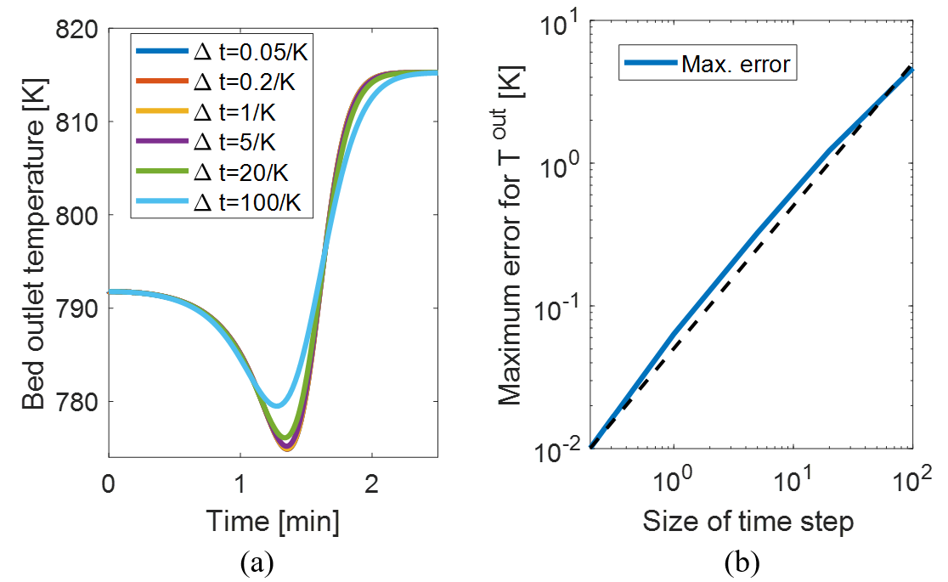  
  
  
  
For $Δt =\frac{100}{K}$, the bed response begins to deviate significantly from the finer timewise discretization, and the inverse response is not captured properly. Thus, in the following analysis, a time step of $Δt =10/K$ is used for the implicit methods.

* + 1. Spatial refinement

Figure 6 displays the bed outlet temperature response for increasing refinement of the spatial discretization. The inverse temperature response is larger and narrower for a higher number of cells. This reflects the effect of numerical diffusion as the truncation error of the FVM method (Froment et al., 2010). The numerical diffusion is not identical to a physical dispersion term, but the properties of the solution are very similar.

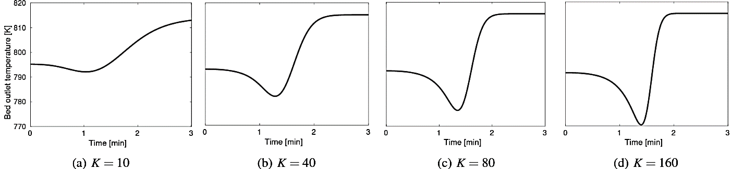

Figure 6: Step response for the bed outlet temperature to a 10 K step change in inlet temperature with FVM of a) 10 cells, b) 40 cells, c) 80 cells, and d) 160 cells.

For simulating physical dispersion with numerical diffusion, Froment et al. suggest using an equal standard deviation of the residence time distribution for a series of CSTRs and the analytical solution to a pure diffusion/advection problem,

$$\begin{aligned}K≅\frac{Pe}{2}+\frac{1}{2}, Re>2 \#18\end{aligned}$$

where $Pe=vL/D_{L}$ is the Peclet number. At high Reynolds numbers $(Re>2000)$ the axial dispersion from backmixing in packed beds can be approximated

$$\begin{aligned}D_{L}=\frac{1}{2}vd_{p}, Re>2000 \#19\end{aligned}$$

in which $d_{p}$ is the diameter of the catalyst particles. For a fixed-bed ammonia reactor, the Reynolds number in the bed is around $Re=vd_{p}ρ^{g}/μ^{g}≈15,000 ,$ where $ρ^{g}$ is the gas density and $μ^{g}$ is the gas viscosity. Thus, we are well within the regime where Eq. 18 is applicable. Inserting the definition of $Pe$ and Eq. 19 in Eq. 18,

$$\begin{aligned}K =\frac{Pe}{2}+\frac{1}{2} =\frac{vL}{2D_{L}}+\frac{1}{2}=\frac{L}{d_{p}}+\frac{1}{2}=\frac{1.2441 m}{8.00⋅ {10}^{-3} m}+\frac{1}{2}=156.0 \#20\end{aligned}$$

Thus, the physical dispersion can be resembled with numerical diffusion by discretizing the bed into 156 cells. For fixed-bed gas phase reactions $L/d_{p}$ typically ranges between 100-500. Note, if one wants to simulate the physical dispersion term by including it in the discretization, a significant higher number of cells are required to eliminate the effects from numerical diffusion.

* + 1. Computational efficiency

Section 3.2 illustrated that typically 100-500 cells are required to resemble the physical dispersion with numerical diffusion. This is a relatively fine discretization associated with significant computational effort. Figure 5 displays the computational time versus the number of discretization cells for solving 3 min physical time of the step response for the different numerical formulations in Table 1. We see significant differences between the efficiency of the algorithms. The algorithms expressing the flow velocities, $v_{k}$, explicitly (I1 and I2) are substantially more computationally expensive as the iteration matrices are not sparse. The number of elements in matrices of Figure 3a and 3b scales quadratically with the number of cells, $K^{2}$, which dramatically increases the computational cost for increasing number of cells. The iteration matrices for methods I3 and I4 (Figure 3c and 3d) scale linearly with the number of cells. Thus, the matrices become sparse for more cells, and the algorithms (I3 and I4) require significantly less computational effort as seen in Figure 5. Compared with the traditional explicit method (E1), I3 and I4 solve about a factor of ten times faster. The speed-up matches the ten times larger time step applied for the implicit methods.

* + 1. Discussion

Figure 5 shows that with 156 cells the traditional explicit method simulates the 3 min step response with a computational time of around 200 s, while the implicit method I3 requires about 40 s with the applied software. For P2X applications, the aim for dynamic modelling of fixed-bed reactors is ultimately to set up advanced dynamic control. For advanced control, e.g. nonlinear MPC, it is crucial that the simulator simulates faster than physical time. An ammonia plant contains a multi-bed reactor system with up to four beds in addition to several heat-exchangers, compressors, valves and a separator. Thus, the simulation results for one bed in this paper indicate, that computational time might be a concern especially using conventional explicit methods even with high-performance software and hardware. The implicit numerical methods presented in this paper might provide the basis for reducing the computational effort. The implicit Euler schemes can relatively easily be converted to higher-order schemes, which provide significant better numerical accuracy at larger time steps. Thus, higher-order implicit methods may bridge the computational gap for advanced control of fixed-bed reactors.

* 1. Conclusion

In this paper, we have solved a PDAEs model for a fixed-bed catalytic gas phase reactor by converting the system to a DAEs problem via the finite volume method. The simulations were based on a bed in an ammonia reactor, and the number of discretization cells required to resemble the physical dispersion was determined to 156 cells. We investigated the numerical efficiency of five different numerical implementations of the Euler step: One traditional explicit scheme and four implicit formulations. The efficiency of implicit formulation depended heavily on, which algebraic variables were implemented implicitly. Thus, the least effective implicit algorithm simulated significantly slower than the traditional explicit method, while most efficient implicit scheme was about 5 times faster. This is a promising speed up regarding model based advanced control of P2X plants.

**References**

Froment, Gilbert F. Bischoff, K. B., & De Wilde, J. (2010). *Chemical Reactor Analysis and Design* (3rd ed.). Wiley.

Manenti, F., & Bozzano, G. (2013). Optimal control of methanol synthesis fixed-bed reactor. *Industrial and Engineering Chemistry Research*, *52*(36), 13079–13091.

Morud, J. C., & Skogestad, S. (1998). Analysis of Instability in an Industrial Ammonia Reactor. *AIChE Journal*, *44*(4), 888–895.

Rosbo, J. W., Ritschel, T. K. S., Hørstholt, S., Huusom, J. K., & Jørgensen, J. B. (2023). Flexible operation, optimisation and stabilising control of a quench cooled ammonia reactor for Power-to-Ammonia. *Computers & Chemical Engineering*, *176*(108316).

Shamiri, A., & Aliabadi, N. (2021). Modeling and Performance Improvement of an Industrial Ammonia Synthesis Reactor. *Chemical Engineering Journal Advances*, *8*, 100177.