A Physics-Guided Data-Driven Model for Capacity Loss Prediction in Lithium-Ion Batteries
Keng-Sheng Linª, Chia-Hsi Wu^{b}, Chia-Hui Kuan^{b}, Yuan Yao^{a*}, Hung-Ping Tung^{b}, David Shan Hill Wongª, Sheng-Tsaing Tseng^{c}, Nan-Jung Hsu^{c}
ªDepartment of Chemical Engineering, National Tsing Hua University, Hsinchu, 300044, Taiwan, ROC
^{b}Department of Industrial Engineering and Management, National Yang Ming Chao Tung University, Hsinchu, 300093, Taiwan, ROC
^{c}Institute of Statistics, National Tsing Hua University, Hsinchu, 300044, Taiwan, ROC
* Corresponding Author’s Email: yyao@mx.nthu.edu.tw
Abstract
In this study, we utilize a physics-guided data-driven approach to model capacity loss in lithium-ion batteries. Spline fitting is used for fitting currently available data, with additional constraints imposed by the physical model. For future data, the extension of the spline fit is governed by the physical model that accounts for reaction diffusion, solid electrolyte interphase growth, and lithium plating. While both the physical model and spline fitting are able to model data across a large capacity range, only the proposed approach can predict degradation over time with a limited amount of data during the period when reaction-diffusion predominates. The ability to detect onset of a fast degradation behavior substantially enhances the accuracy of remaining useful life predictions for batteries and improves battery management systems.
Keywords: lithium-ion battery, capacity loss, reaction-diffusion, lithium plating, physics-guided data driven model

Introduction
Modelling and predicting the capacity loss of lithium-ion batteries is a challenging research problem, due to the complexity of loss mechanisms, unit-to-unit variations, and different charge-discharge histories. It is known that capacity loss in a battery can be primarily attributed to the formation the solid electrolyte interphase (SEI) (von Kolzenberg et al., 2020) and lithium plating (Yang et al., 2017). The onset of lithium plating causes rapid, accelerated capacity loss. However, such onset varies from unit to unit and depends on the charging rate. Parameters of physical models must be obtained only after sufficient data on various phenomena has been collected. On the other hand, despite of the prevalence of data-driven models in battery research (Severson et al., 2019), few of them take the underlying physical mechanisms into consideration and hence lacks the ability to predict future decay behaviors. In recent years, physics-guided machine learning has attracted interest in many engineering fields (Williard et al. 2020). In this study, we will examine the advantage of this approach by modelling the capacity loss data we have collected.

Experimental
Commercially available 3350mAh, 18650 cylindrical cells (Panasonic NCR18650B) were used in our experiments. A charge-discharge test chamber (NEWARE, CT-4008T-5V6A-S1) with temperature control was utilized. The chamber temperature was set at 25°C. Charging was carried out at 0.5C, involving a constant current charging process until the battery reached a cut-off voltage of 4.2V, followed by maintaining a constant voltage of 4.2V until the current dropped to 0.02C. The battery was then discharged at 1C. Between each charge and discharge cycle, there was a resting period of 1.5 hours.

Physical Model
This study models capacity fade by considering lithium loss due to both the formation of the solid electrolyte interface (SEI) on the negative electrode and lithium plating on the interface between the negative electrode and the separator.

SEI formation
The SEI is composed of lithium ethylene decarbonate, and the reaction is depicted as follows:
$$2C_{2}H_{4}{CO}_{3}+2{Li}^{+}+2e^{-}→{\left({CH}_{2}O{CO}_{2}Li\right)}_{2}\left(s\right)+C_{2}H_{4}$$
As an electrochemical reaction, the SEI reaction obeys the Butler-Volmer equation, combined with species conservation of diffusion. We can get the differential equation of capacity loss due to SEI formation as depicted in Eq. (1), in which ${CL}_{SEI}$ is the capacity loss due to SEI formation, $t$ is the cumulative charging time, $V$ is the initial negative electrode void volume, $c_{EC}^{0}$ is the bulk concentration of EC, $a_{s}$ is the specific interfacial surface area of graphite, $F$ is Faraday’s constant, $k_{0,SEI}$ is the kinetic rate constant of the SEI reaction, $α_{c,SEI}$ is the cathodic transfer coefficients of the SEI reaction, $R$ is the universal gas constant, $T$ is the absolute temperature, $η_{SEI}$ is the overpotential of SEI the reaction, $M_{SEI}$ is the molar weight of the SEI, $D_{EC}^{}$ is the diffusivity of EC in the SEI, and $ρ_{SEI}$ is the density of the SEI.
 | $$\frac{∂{CL}_{SEI}}{∂t}=\frac{Vc_{EC}^{0}}{\frac{2}{a_{s}Fk_{0,SEI}exp\left(-\frac{α_{c,SEI}F}{RT}η_{SEI}\right)}+\frac{2M_{SEI}}{F^{2}D_{EC}^{}ρ_{SEI}V}{CL}_{SEI}}$$ | (1)

Lithium plating
Lithium plating is an irreversible side reaction occurring in the anode, represented as
$${Li}^{+}+e^{-}→Li\left(s\right)$$
The capacity loss due to lithium plating is given by
 | $$\frac{∂{CL}_{lpl}}{∂t}=a_{s}i_{0,lpl}exp\left(-\frac{α_{c,lpl}F}{RT}η_{lpl}\right)$$ | (2)
in which $i_{0,lpl}$is the exchange current density of lithium plating, $α_{c,lpl}$ is the cathodic transfer coefficient of lithium plating, and $η_{lpl}$ is the overpotential of lithium plating.

Simplified model
The following assumptions were made to simplify the model:
- Side reactions occur only during the charging phase.
- The rate of SEI formation depends only on the electrolyte solvent concentration, which means that the overpotential of the SEI reaction remains constant.
- The exchange current density of lithium plating is constant
- The overpotential of lithium plating increases linearly with cumulative charging time, and exponential growth in lithium plating becomes prominent only after a period of charging.
- The capacity loss due to the two mechanisms can be integrated independently and is additive.
- The capacity loss can be normalized to the range $\left[0,1\right]$ over the time period $\left[0\right.,\left.∞\right)$.
Based on the above-mentioned equations and assumptions, we can derive a simplified model of capacity loss:
 | $${CL}^{phy}\left(t|β\right)=\frac{\tan^{-1}\left(β_{1}\left(\sqrt{1+β_{2}t}-1\right)+β_{3}\left(e^{β_{4}{\left(t-β_{5}\right)}_{+}}-1\right)\right)}{(π/2)},$$ | (3)
where $β={\left(β_{1},β_{2},…,β_{5} \right)}^{'}$.

Physics Guided Spline Fitting
I-spline (Ramsay, 1988), widely used as a spline basis for regression analysis where monotonicity is desired, is defined as
 | $$I_{i}\left(t | p,K\right)≡\int_{-∞}^{t}{M_{i}\left(u | p,K\right)}du, i=1,2,…,N,$$ | (4)
in which $p$ is the order of the piecewise polynomial, $K≡\{k_{1},k_{2},…,k_{N+p}\}$ is a set of knots in ascending order, and $N$ is the number of free parameters that I-splines having the specified continuity properties. With $p=1$,
 | $$M_{i}\left(u | 1,K\right)=\left\{\begin{aligned}\frac{1}{k_{i+1}-k_{i}}, for k_{i}≤u<k_{i+1}, \\ 0, otherwise. \end{aligned}\right.$$ | (5)
For $p>1$,
$M_{i}\left(u | p,K\right) =\frac{p \left[ \left(u-k_{i}\right) M_{i}\left(u | p-1,K\right) + \left(k_{i+p}-u\right){ M}_{i+1}\left(u | p-1,K\right)\right]}{\left(p-1\right)\left(k_{i+p}-k_{i}\right)}$. (6)
We fit capacity loss with a linear combination of I-splines:
 | $$\hat{CL}\left(t | δ,K\right)=\sum_{i=1}^{N}{δ_{i }I_{i}\left(t | p,K\right)},$$ | (7)
where $δ={\left(δ_{1},δ_{2},…,δ_{N} \right)}^{'}$ with $δ_{i}≥0$ are unknown parameters to be estimated. Physics-guided I-spline fits currently available data but is subject to additional constraints imposed by the physical model. To achieve it, for fixed $λ$ and $K$, the following objective is optimized:
 | $$\left({\hat{δ}}_{λ,K}, {\hat{β}}_{λ,K}\right)=arg\min_{δ, β}{\sum_{t∈D_{train}}{{\left(CL\left(t\right)-\hat{CL}\left(t | δ,K\right)\right)}^{2}+λ\sum_{t∈D_{train}}{{\left(\hat{CL}\left(t | δ,K\right)-{CL}^{phy}\left(t|β\right)\right)}^{2}.}}}$$ | (8)
Here, $λ>0$ controls the trade-off between the spline fitting and physical model. Finally, the optimal $λ$and $K$ are tuned on a grid via the Genetic Algorithm to minimize the validation data loss:
 | $$\left(K^{*},λ^{*}\right)=arg\min_{K,λ}\sum_{t∈D_{valid}}{{\left(CL\left(t\right)-\hat{CL}\left(t | {\hat{δ}}_{λ,K},K\right)\right)}^{2}}.$$ | (9)

Results and Discussions

Physical Model
Initially, we fit the complete dataset using the physical model through a nonlinear least squares method to validate the model. Figure 1a indicates that the simplified physical model adequately captures the pattern of capacity loss. As mentioned earlier, the growth of SEI can be seen as a diffusion-controlled reaction. Initially, the SEI layer is relatively thin, leading to a faster diffusion rate and a quicker capacity degradation. As the thickness of the SEI layer increases, the rate of degradation gradually slows down. Notably, the capacity loss exhibits a square root correlation with cumulative charging time before 1200h in Figure 1a, aligning with the behavior described by the reaction diffusion model. As the SEI layer thickens, it leads to a linear increase in lithium plating's overpotential over time. Once the SEI layer reaches a certain thickness, it triggers lithium plating. This rapid reaction significantly accelerates the loss of battery capacity with exponential correlation. In Figure 1a, it sharply increases as cumulative charging time reaches 1200 h, indicating the onset of lithium plating. Figure 1b illustrates fitting results of physical models using data from the initial 600 cycles. It seems there's a strong fit in describing the SEI growth phase, but there's no detection of the occurrence of lithium plating behavior. Obviously, the absence of data featuring significant lithium plating hinders the detection of its onset, leading to square root correlation prediction.
a  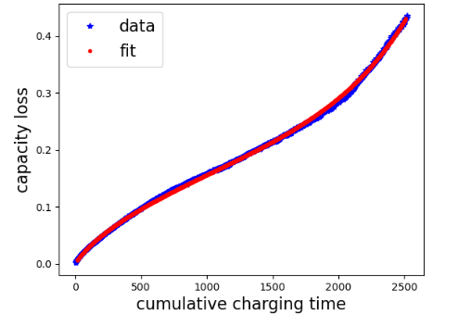 | b  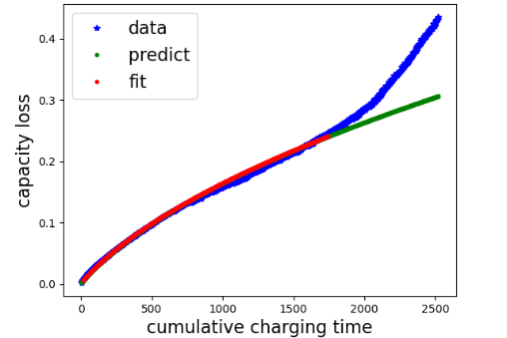
Figure 1: Physical model fitting with full range (left) and 600 cycles (right) of data

I-spline Fitting
Splines are widely recognized in numerical analysis for their exceptional performance in interpolation. In this section, we first fit the spline model with the full range of data. With a setup featuring 4 equally spaced knot intervals and an order of 4, Figure 2a suggests that the I-spline model effectively captures the pattern of capacity loss through interpolation. Figure 2b illustrates the fitting results of I-spline models using data from the initial 400 cycles as training data and the subsequent 200 cycles for validation. The optimal outcome is achieved with a fourth-order spline and three internal knots. Although I-splines are monotonically non-decreasing, through adjusting weight of each I-spline composing data-driven model can change tendency of the model. As the result of scarce data of lithium plating in training data, the weight of the spline in the last interval is adjust low. In this condition, the model underestimate the capacity loss of follow-up data. In conclusion, the lack of substantial data regarding lithium plating hampers the model’s performance in extrapolation.
a  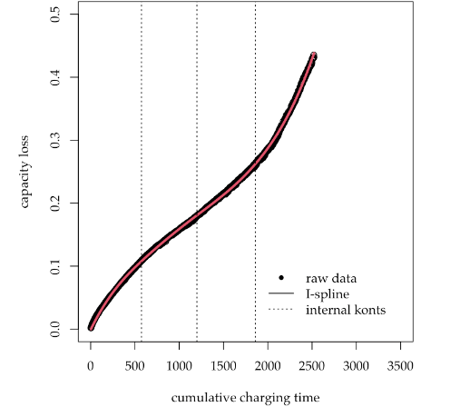 | b  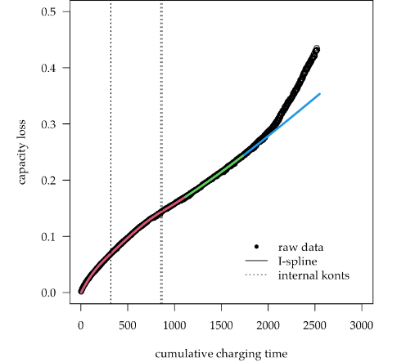
Figure 2: I-spline model fitting with full range (left) and 600 cycles (right) of data

Physics-Guided I-Spline Fitting
We incorporated a data-driven model into our physical mechanism analysis, utilizing the first 400 cycles as training data and the subsequent 200 cycles for validation. The fifth-order spline with 4 inner knots stands out as the optimal choice due to its minimal loss. The positions of each knot are illustrated by dotted lines along the x-axis. Within this physics-guided data-driven model, Figure 3 predicts the information of the onset of lithium plating that both physical model and I-spline model couldn’t achieve. The model adjusts the location of knots to satisfy the physical constrain in validation part. The location of the last internal knot is moved forward, so that the curve can match both data and physical model. It comes out that the physics-guided data-driven model can not only forecast the emergence of the turning point but also accurately track the trajectory of capacity loss.
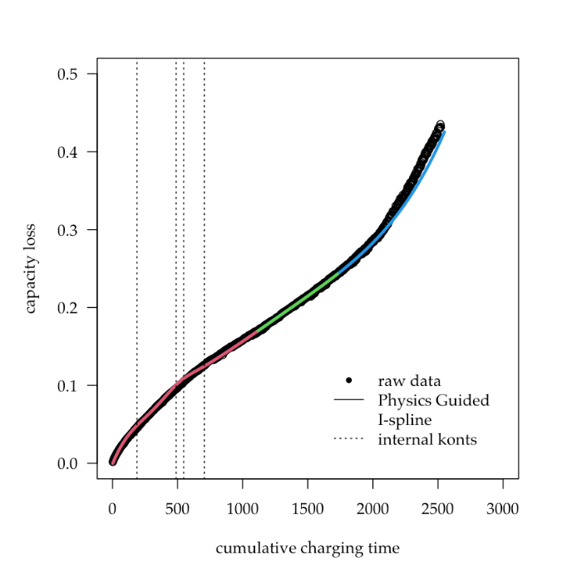
Figure 3: Physical-guided I-spline fitting model fitting with limited range data
  - Conclusions
In this study, we integrate a physical model with a data-driven approach to predict future capacity loss in lithium batteries. The experimental results show that while the physical model can effectively explain the mechanism of capacity loss over time, adequate data is crucial for accurate model parameterization. Otherwise, the physical model fails to detect the onset of lithium plating. Additionally, I-spline, known for its exceptional interpolation performance, shows less favorable results in extrapolation. The physics-guided data-driven model, which integrates spline and physical constraints, comes in handy when training data is insufficient. Consequently, this model predicts capacity loss more accurately than either the physical model or I-spline alone. It showcases significant potential in predicting battery end-of-life and enhancing battery management systems.
Acknowledgment
This work was supported in part by the National Science and Technology Council under project numbers NSTC 111-2634-F-007-010 and NSTC 112-2221-E-007-015.
References
von Kolzenberg L., Latz A. and Horstmann B., Solid–electrolyte interphase during battery cycling: Theory of growth regimes. ChemSusChem, 2020. 13: p. 3901–3910.
Severson, Kristen A; Attia, Peter M; Jin, Norman; Perkins, Nicholas; Jiang, Benben; Yang, Zi; Chen, Michael H; Aykol, Muratahan; Herring, Patrick K; Fraggedakis, Dimitrios; Bazant, Martin Z; Harris, Stephen J; Chueh, William C; Braatz, Richard D. (2019). Data-driven prediction of battery cycle life before capacity degradation. Nature Energy, 4: p. 383-391.
Ramsay, J. O. (1988). Monotone regression splines in action. Statistical Science, 3, 425-441.
Willard, J., Jia, X., Xu, S., Steinbach, M., & Kumar, V. (2020). Integrating physics-based modeling with machine learning: A survey. arXiv preprint arXiv:2003.04919, 1(1), 1-34.
Yang, X. G., Leng, Y., Zhang, G., Ge, S., & Wang, C. Y. (2017). Modeling of lithium plating induced aging of lithium-ion batteries: Transition from linear to nonlinear aging. Journal of Power Sources, 360, 28-40.

