Process efficiency enhancement of integrated hydrogen enrichment and liquefaction
Muhammad Islamª, Ahmad Naquashª, Ali Rehman^{b}, Moonyong Lee^{a*}
ª School of Chemical Engineering, Yeungnam University, Gyeongsan 38541, Republic of Korea
^{b} Ningbo Institute of Dalian University of Technology, Ningbo 315200, Zhejiang, PR China
*mynlee@yu.ac.kr
Abstract
Hydrogen has gained a remarkable position in the global market as a complete package for a cleaner fuel with carbon neutrality. Increasing hydrogen demand as a clean fuel sheds light on hydrogen transportation and large-scale storage. Liquid hydrogen is the viable way to go with the purest form of hydrogen. The purity of hydrogen is the key to avoiding impairments in hydrogen liquefaction. Primarily, hydrogen is produced from fossil-originated fuel, which requires purification to obtain pure hydrogen. Pressure swing adsorption is the commonly used technique for this purpose, which offers high purity (~99.99 %) and low recovery (~95 %). The emerging technique of cryogenic separation of hydrogen still has limitations: low recovery and purity on top of high energy consumption. However, cryogenic separation can have a dual purpose: the pre-cooling of hydrogen as well as the solidification of CO₂. The present work explores this exploitation towards lower energy requirements and process intensification via simulation in Aspen HYSYS® V14. The de-sublimation process conditions were based on the pure CO₂ and H₂ /CO₂ mixture phase behaviour. De-sublimation was operated in an equipped refrigeration chamber designed to accommodate the refrigeration cycle. After hydrogen enrichment and pre-cooling with 99.99 % purity and 99.99 % recovery, hydrogen was liquefied utilizing the same refrigeration cycles, making the process simpler. It subsequently provides energy benefits. There is a 7.5 % reduction in overall specific energy consumption (8.90 kWh/kg) from the base case (9.62 kWh/kg). The current study will be a building block in developing the hydrogen supply chain.
Keywords: Hydrogen liquefaction, CO₂ solidification, Integrated process, Process simulation, Cryogenic separation
  - Introduction
Hydrogen is acclaimed as a potential game-changer due to its clean energy characteristics, but its long-distance transportation presents a substantial challenge owing to its low energy density (0.01 MJ/L) in gas-phase, which can be enriched to 8.5 MJ/L by liquefying H₂, as mentioned by Valenti, 2016. As the demand for hydrogen continues to rise, driven by its clean attributes, there is a foreseeable potential for hydrogen to replace conventional fuels soon (IEA, 2022). To facilitate this transition, the crucial aspects of intercontinental or international transportation of hydrogen become vital components of the global energy mix. Long-term hydrogen storage is equally as important as transportation. Liquefying hydrogen at extremely low temperatures (−253 °C) increases its density, enabling the storage of larger quantities in a given space. This is vital for applications such as long-distance transportation, where the volume efficiency of hydrogen becomes paramount.

Owing to such issues in hand, development in the hydrogen liquefaction process is inevitable. In the commercial liquefaction of hydrogen quoted by Naquash et al., 2022, a standardized three-step process is employed: down to –193 °C at pre-cooling, down to –243 °C at cooling, and down to –253 °C at liquefaction step. In the initial pre-cooling phase, liquid nitrogen (N₂) serves as the refrigerant. At the same time, an integrated sequence of Joule Thomson valves (or expanders) and hydrogen is utilized in the adjoining cooling and liquefaction sections. Recent advancements have introduced mixed refrigerants (MR) as a substitute for pure liquid N₂. A study conducted by Qyyum et al., 2021 has highlighted the existence of numerous investigations proposing varied compositions incorporating low-boiling hydrocarbons and N₂, in MR. Neon (Ne) and Helium (He) are also considered along with H₂ in the cooling and liquefaction sections. These efforts aim to minimize the Specific Energy Consumption (SEC), striving to align it with the theoretical ideal case as closely as possible (Bi et al., 2022). Industrial processes typically exhibit SEC falling within the 12-15 kWh/kg_{LH2} range, having efficiency levels as minimal as 20-30 % (Krasae-in et al., 2010).

Moreover, the conditions during hydrogen liquefaction (around −253 °C) lead to the solidification of impurities, necessitating effective removal (Voldsund et al., 2016). The purification process must be highly efficient to prevent impurities from compromising the quality of the liquid hydrogen. Among the well-established technologies ensuring the production of high-purity hydrogen are pressure swing adsorption (PSA), cryogenic purification, and selective permeation gas membrane separation, which are well known. PSA stands out for its capacity to achieve remarkable purity, potentially attaining up to 99.999 % pure H₂. However, hydrogen recovery is typically 80 - 95%, depending on the specific process scheme and the adsorbent's capacity (Bernardo et al., 2020).

On the other hand, the cryogenic purification process offers an alternative route, providing up to 98 % pure H₂ with an impressive recovery rate of approximately 95% (Aasadnia et al., 2021). A potential study by (Naquash et al., 2022a) has proposed cryogenic separation of impurities (as solidified CO₂) and hydrogen liquefaction integrated with mixed refrigerant cycles. The study presented remarkable results with 99.9999 % purity and ~99 % recovery. The current research builds upon and enhances this work by (Naquash et al., 2022a), utilizing Aspen HYSYS® V14 to simulate an intensified process configuration. A comprehensive energy and exergy analysis was conducted to assess the enhancement in the proposed process.
  - Hydrogen Enrichment and Liquefaction
    - Process description
The proposed configuration integrates a cryogenic process employing two mixed refrigeration (MR) cycles for hydrogen enrichment and liquefaction (Figure 1). This cryogenic technique serves the dual purpose of pre-cooling hydrogen and solidifying carbon dioxide in the hydrogen enrichment process. Unlike the previous approach (Naquash et al., 2022a), both MR cycles are integrated at the first multi-stream heat exchanger (HX1). Following pre-cooling, a specially designed chamber facilitates de-sublimation, extracting hydrogen in vapor form from the top and solidifying CO₂ at the bottom. CO₂ de-sublimation conditions were set at −61°C and 5 bar based on its phase diagram (Naquash et al., 2022a).

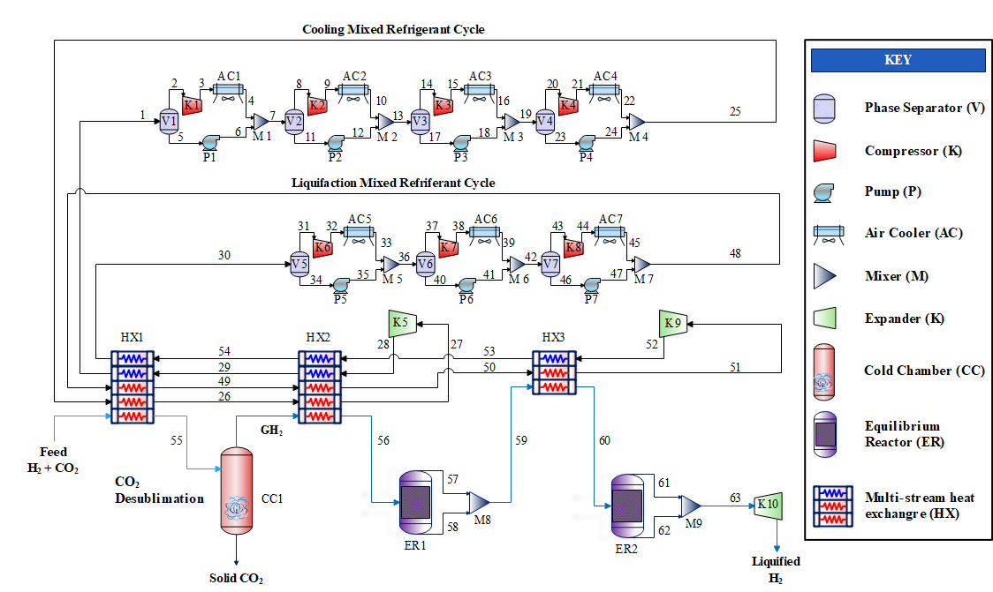Figure 1. Proposed integrated process schematic diagram
Subsequently, the process achieves hydrogen enrichment and pre-cooling with high purity (99.9999%) and recovery (99.9999%). Pure hydrogen exhibits a temperature-dependent ortho/para composition (Qyyum et al., 2021), managed by two equilibrium reactors (ER1 and ER2)(Harkness and Deming, 1932). The liquefaction process involves cooling and liquefaction through HX2 and HX3, incorporating mixed refrigeration cycles containing various components. The resulting hydrogen stream undergoes further cooling and conversion to 99.7% para-H₂ in ER2.

The cooling and liquefaction of H₂ occurred by passing through HX2 and HX3. CMR cycle contain C1, C2, C3, n-C4, n-C5, N₂ and LMR cycle contain H₂ and He. Table 1 outlines the key design parameters that govern the proposed process, providing a comprehensive overview of the specified conditions and criteria employed in the simulation.

At the outlets of HX2 and ER1, the H₂ stream (59), at a temperature of –160 ℃ and comprising 34.7 % para-H₂, undergoes additional cooling in HX3. Upon leaving HX3, the temperature of H₂ is further decreased to the liquefaction temperature of –252 ℃. Following this, the H₂ converts to 99.7% para-H₂ as it passes through ER2 and attains a pressure of 1.3 bar after passing through K10 (expander). The thermodynamic properties of the refrigeration cycles were calculated using the PR equation of state (Peng and Robinson, 1929). For the H₂ streams, the Modified Benedict-Webb-Rubin (MBWR) equation of state (Eckroll et al., 2017) was explicitly chosen to accurately utilize the relevant thermodynamic behaviours.

Table 1. Key parameters of the proposed H₂ separation and liquefaction process
Design Parameters | Unit | Values (Xu et al., 2012)
Feed
Flow rate | kg/s | 100
Pressure | bar | 5.0
Temperature | ℃ | 35
Molar Composition | mole %
Hydrogen |  | 0.2
Carbon Dioxide |  | 0.8
Product
Liquid H₂
Flow rate | kg/s | 1.13
Pressure | bar | 1.3
Temperature | ℃ | −252.2
Solid CO₂
Flow rate | kg/s | 98.87
Pressure | bar | 5
Temperature | ℃ | −61
    - Energy analysis
The energy analysis in this study is performed with a focus on SEC. Different design variables, as specified in Table 2, including refrigerant mass flow rates, suction pressure, and discharge pressure of the refrigeration cycles, are methodically modified to observe and analyse their influence on SEC.
    - Exergy analysis
Exergy analysis is a valuable technique for assessing process inefficiencies by considering the principles of the second law of thermodynamics. Physical and chemical exertion are the two main categories of energy, and they are computed as:
$${ex}_{ph,i}=\left(h_{i}-h_{o} \right)- T_{o}(s_{i}-s_{o})$$ | (1)
$${ex}_{ch,i}=\sum{x_{i}e_{i}^{CH}+RT_{o}\sum{x_{i}\ln{x_{i}}}}$$ | (2)
For physical and chemical exergy, ${ex}_{ph,i}$ and ${ex}_{ch,i}$ are used as symbols, the mole fraction of the i^{th} component in a stream is represented by $x_{i}$ and $e_{i}^{CH}$ is referred to as standard chemical exergy of i^{th} component obtained from (Szargut, 1989). While chemical exergy values are determined using Eq. 2, physical exergy values are derived from Aspen HYSYS® stream properties. The exergy destruction of every piece of equipment is calculated to gain complete insight into the exergy analysis. The reason behind the deviation of equipment performance from an ideal scenario can be attributed to energy destruction. The process performance decreases as the energy destruction increases. The formulas used to determine the equipment's exergy destruction are provided in (Naquash et al., 2022b).
  - Results and discussion
    - Energy analysis
The study analysed design variables concerning SEC, including suction/discharge pressures and refrigerant flow rates, as shown in Table 2. The proposed case demonstrates approximately 7.5% higher energy efficiency than the base case. The study streamlined operations by reducing two previously employed mixed refrigerant (MR) cycles - one for de-sublimation and the other for pre-cooling enriched hydrogen. This simplification noticeably benefits energy consumption. The load on the cold chamber increased to accommodate CO₂ de-sublimation, emerging as the most energy-consuming unit at 14552.14 kW. Additionally, omitting previously assisting cycles led to increased refrigerant load on the cooling MR cycle. However, discharge pressure adjustments were made to align with the energy consumption requirements.
Table 2. Process design variables and specific energy consumption (SEC)
Pre-cooling MR cycle | Units | Base case  (Naquash et al., 2022a) | Proposed study
Refrigerants flowrate | kg/s | 20.26 | -
Suction / Discharge pressure | bar | 1.10 / 36.0 | -
Cooling MR cycle
Refrigerants flowrate | kg/s | 18.85 | 44.02
Suction / Discharge pressure | bar | 1.70 /59.0 | 2.04 /32.48
Liquefication MR cycle
Refrigerants flowrate | kg/s | 6.0 | 10.78
Suction / Discharge pressure | bar | 1.32 /65.0 | 1.12 /18.13
SEC | (kWh/kg) | 9.62 | 8.90
Similar adjustments were applied in the Liquefaction MR cycle, contributing to the overall enhanced energy efficiency observed in the proposed case compared to the base case.
    - Exergy analysis
Exergy destruction is provided in Table 3, indicating the equipment-wise exergy destruction analysis. Comparing the current study with the base case is not feasible due to the change in process configurations. In the proposed study, multi-stream exchangers emerge as focal points, contributing approximately 26% to total exergy destruction, emphasizing their potential for efficiency refinement. Air coolers account for around 20%, functioning as heat sinks with implications for energy recovery.
Table 3. Exergy destruction of each unit operation for the proposed study
Equipment | Exergy destruction (kW)
Compressors (K) | 6780.69
Pumps (P) | 30.53
Coolers (AC) | 7803.87
Separators (V) | –6.74
Equilibrium reactors (ER) | 6543.91
Expanders (K) | 6965.30
Cold Chamber (CC) | –2405.42
Multi-stream exchangers (HX) | 10019.40
Total | 35731.54
Compressors, expanders, and equilibrium reactors collectively share the third-highest exergy destruction, each contributing around 17 to 18%. Intriguingly, phase separators and cold chamber exhibit negative exergy destruction values, warranting scrutiny and potential exploration into advanced exergy analyses to unveil distinct system intricacies.
  - Conclusions
The study emphasizes the significance of hydrogen liquefaction, detailing challenges in impurity removal and proposing an innovative cryogenic method. By integrating a de-sublimation-based cryogenic process, the research achieves high-purity hydrogen with energy and exergy destruction considerations. The proposed method showcases promising energy efficiency, paving the way for advancements in hydrogen production processes. The comprehensive analysis contributes insights into optimizing hydrogen liquefaction for a sustainable future with lower energy impact.
References

Aasadnia, M., Mehrpooya, M., Ghorbani, B., 2021. A novel integrated structure for hydrogen purification using the cryogenic method. J Clean Prod 278, 123872.
Bernardo, G., Araújo, T., da Silva Lopes, T., Sousa, J., Mendes, A., 2020. Recent advances in membrane technologies for hydrogen purification. Int J Hydrogen Energy 45, 7313–7338.
Bi, Y., Yin, L., He, T., Ju, Y., 2022. Optimization and analysis of a novel hydrogen liquefaction process for circulating hydrogen refrigeration. Int J Hydrogen Energy 47, 348–364.
Eckroll, J., Berstad, D., Wilhelmsen, Ø., Ept, S./, 2017. Concepts for Large Scale Hydrogen Liquefaction Plants.
Harkness, R.W., Deming, W.E., 1932. The Equilibrium of Para and Ortho Hydrogen. J Am Chem Soc 54, 2850–2852.
IEA, 2022. Global Hydrogen Review. Global Hydrogen Review 2022.
Krasae-in, S., Stang, J.H., Neksa, P., 2010. Development of large-scale hydrogen liquefaction processes from 1898 to 2009. Int J Hydrogen Energy 35, 4524–4533.
Naquash, A., Haider, J., Qyyum, M.A., Islam, M., Min, S., Lee, S., Lim, H., Lee, M., 2022a. Hydrogen enrichment by CO2 anti-sublimation integrated with triple mixed refrigerant-based liquid hydrogen production process. J Clean Prod 341, 130745.
Naquash, A., Qyyum, M.A., Islam, M., Sial, N.R., Min, S., Lee, S., Lee, M., 2022b. Performance enhancement of hydrogen liquefaction process via absorption refrigeration and organic Rankine cycle-assisted liquid air energy system. Energy Convers Manag 254, 115200.
Naquash, A., Riaz, A., Lee, H., Qyyum, M.A., Lee, S., Lam, S.S., Lee, M., 2022c. Hydrofluoroolefin-based mixed refrigerant for enhanced performance of hydrogen liquefaction process. Int J Hydrogen Energy 47, 41648–41662.
Peng, D., Robinson, D.B., 1929. A New Two-Constant Equation of State, Int. J. Heat Mass Transfer.
Qyyum, M.A., Riaz, A., Naquash, A., Haider, J., Qadeer, K., Nawaz, A., Lee, H., Lee, M., 2021. 100% saturated liquid hydrogen production: Mixed-refrigerant cascaded process with two-stage ortho-to-para hydrogen conversion. Energy Convers Manag 246, 114659.
Szargut, J., 1989. Chemical exergies of the elements. Appl Energy 32, 269–286.
Valenti, G., 2016. Hydrogen liquefaction and liquid hydrogen storage, Compendium of Hydrogen Energy. Elsevier Ltd.
Voldsund, M., Jordal, K., Anantharaman, R., 2016. Hydrogen production with CO2 capture. Int J Hydrogen Energy 41, 4969–4992.
Xu, G., Li, L., Yang, Y., Tian, L., Liu, T., Zhang, K., 2012. A novel CO2 cryogenic liquefaction and separation system. Energy 42, 522–529.

