Mathematical Modelling of a Novel Mineral Carbonation System Based on Biological pH Swing for Atmospheric CO2 Removal

Yukun Zhang,a Aidong Yanga*

aUniversity of Oxford, Parks Road, Oxford OX1 3PJ, United Kingdom

aidong.yang@eng.ox.ac.uk

Abstract

As an option for removing CO₂ from the atmosphere, this study uses mathematical modelling to explore a novel biological pH swing strategy for mineral carbonation at ambient temperature and pressure. This approach employs microbial processes to modulate pH and then facilitate mineral dissolution and precipitation. The system comprises a sulphur reduction bioreactor and a sulphur oxidation bioreactor utilizing *Desulfovibrio Vulgaris* and *Acidithiobacillus Thiooxidans* respectively. Simulations demonstrate successful pH swing and accelerated CO₂ removal from air, making the sulphur cycle based bioprocess a potential method for cost-efficient atmospheric CO2 removal.

**Keywords**: Carbon Capture, Mineral Carbonation, pH Swing, Bacteria, Model.

**1. Introduction**

The rapid increase in global CO₂ emissions is the primary contributing factor to the current challenges of global climate change. To address this problem, mineral carbonation, one of the representative carbon capture technologies proposed by Seifritz in 1990, is regarded as a promising method for mitigating greenhouse effect (Seifritz, 1990). It involves the chemical reaction between CO₂ and alkaline minerals, such as magnesium, calcium, and iron oxide-based silicates. This reaction results in the formation of carbonate minerals, which can be used to permanently store CO₂. When air is used as the source of CO₂, such a process implements atmospheric CO₂ removal, a measure considered necessary along with carbon capture from point sources to achieve climate goals (Hepburn et al., 2019).

Currently, a significant limitation of many existing mineral carbonation methods is their reliance on high-temperature and high-pressure conditions, which poses practical barriers to large-scale implementation (Olajire, 2013). In response to this constraint, our study explores the potential of biological pH swing, a novel approach designed to achieve more efficient mineral carbonation. Through the adjustment of pH within a biological system, our aim is to enhance the efficiency for both dissolution of alkaline minerals and precipitation of carbonates at ambient temperature and pressure, which could reduce energy consumption and therefore aid the wider adoption of mineral carbonation technology.

**2. Method**

*2.1* *Sulphur Cycle Biological pH Swing*

In this research, we employ the sulphur cycle biological pH swing strategy, which utilizes metabolic processes of microorganisms to implement the oxidation and reduction of sulphur, and consequently modulates the pH within the process. The idea of using a biological cycle to effect pH swing is based on the proposal by the GGREW project (Lam, 2022). For the alkaline mineral, we have chosen forsterite based on mineral abundance and dissolution rate.

As shown in Figure 1, the overall system is divided into two main components: the reduction bioreactor and the oxidation bioreactor. In the reduction bioreactor, microbes are employed to reduce sulfate ions (SO₄²⁻) to hydrogen sulfide (H₂S). The generated H₂S is then supplied to the oxidation bioreactor for the regeneration of sulfate. Simultaneously, microbes significantly elevate the pH in the reduction bioreactor, facilitating the reaction between magnesium ions (Mg²⁺) and atmospheric CO₂, thereby accelerating the precipitation rate of magnesium carbonate (MgCO₃).

On the other side, the oxidation bioreactor receives H₂S produced by the reduction bioreactor. Within the oxidation bioreactor, microbes metabolically oxidize H₂S to SO₄²⁻ ions, which supplies energy to sustain microbial activities while significantly reducing the environmental pH. The lowered pH substantially enhances the dissolution rate of forsterite, and then increases the concentration of Mg²⁺ ions in the bioreactor. Mg²⁺ ions and SO₄²⁻ ions produced in the oxidation bioreactor are then transported to the reduction bioreactor, initiating the next cycle of the process.

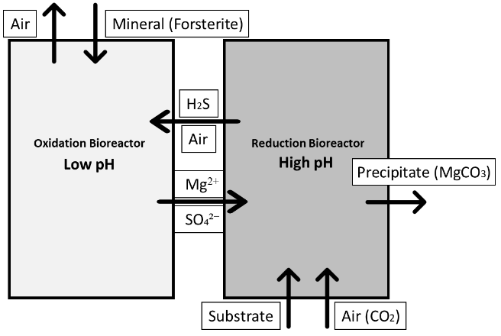

Figure 1. Overall scheme of the sulphur cycle biological pH swing system.

*2.2 Modelling of Reduction Bioreactor*

The reduction bioreactor serves the purpose of absorbing CO₂ from the air and subsequently precipitate MgCO3. It receives the influent liquid containing Mg²⁺ and SO₄²⁻ ions from the oxidation bioreactor, alongside feed air as the source of CO₂. The optimization for CO₂ removal necessitates an elevated pH environment to foster the formation of MgCO3. To facilitate this, we opt for the utilization of the gram-negative sulfate-reducing bacterium, *Desulfovibrio vulgaris* (*D. vulgaris*), within our model, which enables us to achieve pH swing. Through a series of chemical reactions delineated by the Eq. (1) and (2), both H2S and MgCO3 are generated (Noguera et al., 1998; Wang, 2013).

${{SO}_{4}}^{2-}+5H_{2}→H_{2}S+4H_{2}O$ (1)

${{Mg}^{2+}}_{(aq)}+{{{CO}_{3}}^{2-}}_{(aq)}→{Mg{CO}_{3}}_{(s)}$ (2)

Note that gas-liquid mass transfer exists in the reactor (and the oxidation reactor) was modelled using established correlations for stirred tank reactors. In the following, details of kinetics are presented.

*2.2.1 Microbial Kinetics*

As shown by Eq. (1), the growth of *D. vulgaris* consumes hydrogen (H2) (as the energy source) and SO₄²⁻ ions to generate H₂S (Badziong et al., 1978). To simulate this process in our model, we use the Monod kinetics equation (Smith et al., 2019):

$\frac{dS}{dt}=-\frac{μ_{max,S}*X}{Y_{S}}*\left(\frac{S}{K_{S}+S}\right)*(\frac{H_{aq}}{{K_{H}+H}_{max}})$ (3)

In Eq. (3), $μ_{max,L}$ (h–1) refers to the maximum growth rate of D. vulgaris, Ys (mg L–1 mM–1) refers to the biomass yield of D. vulgaris during sulphate reduction, S (mM) refers to the concentration of sulphate, $K_{S}$ and $K_{H}$ (mM) respectively refer to the Monod constants for sulphate and hydrogen, X (mg L–1) refers to the concentration of D. vulgaris, which satisfies the following equation:

$\frac{dX}{dt}=-Y_{S}*\frac{dS}{dt}-k_{decay}*X$ (4)

In this equation, kdecay (h-1) refers to the decay rate of *D. vulgaris* (Darnajoux et al., 2023).

*2.2.2 CO₂ Capture and Precipitation*

To mitigate the adverse effects of oxygen on the growth and metabolism of *D. vulgaris*, we strategically introduce air into the reduction bioreactor only after the majority of SO₄²⁻ ions have been reduced to H₂S. CO₂ introduced with air reacts with Mg²⁺ ions in the solution, leading to the precipitation of MgCO₃.

$Ω=\frac{a_{{Mg}^{2+}}*a_{{CO_{3}}^{2-}}}{K_{MgCO_{3}}}$ (5)

$r_{prec}=k*(Ω-1)^{n}$ (6)

We employ Eq. (5) to calculate the saturation index Ω (-), and subsequently use Eq. (6) to calculate the precipitation rate (mol m-2 h-1) based on the Ω. Under high-pH conditions, the concentration of carbonate ions in the solution is elevated, resulting in a higher Ω and therefore higher precipitation rate. In these two equations, $K_{MgCO_{3}}$ (-) refers to the equilibrium constant of MgCO₃, 𝑎 (-) refers to the activities of the participating ions, and (mol m-2 h-1) refers to the specific rate constant.

*2.3 Modelling of Oxidation Bioreactor*

In this oxidation bioreactor, a relatively low pH environment would be preferred to accelerate the dissolution of forsterite and therefore the release of Mg2+ ions. The process of forsterite dissolution can be described by the following chemical Eq. (7):

${Mg}_{2}{SiO}_{4}+4H^{+}→2{Mg}^{2+}+Si{(OH)}_{4}$ (7)

$H_{2}S+2O_{2}={{SO}_{4}}^{2-}+2H^{+}$ (8)

*Acidithiobacillus thiooxidans* (*A. thiooxidans*) is a Gram-negative bacterium known for its ability to facilitate sulphur oxidation and then create an acidic environment, which is shown as Eq. (8). The growth of *A. thiooxidans* is reliant on essential nutrients such as carbon, oxygen and nitrogen, which could be adequately supplied through continuous air feeding into the bioreactor (Waksman and Joffe, 1922).

*2.3.1 Forsterite Particle Dissolution*

The dissolution of mineral particles is positively related to their surface area. For each mineral particle, the decrease in radius during the process of dissolution would correspondingly decrease their surface area and therefore decrease the overall dissolution rate if no additional mineral added. Eq. (9) is used to estimate the shrinkage of forsterite particles. The rate of change in overall Mg2+ ion concentration depends on the dissolution rate (m-2h-1), forsterite particle radius $r_{Forsterite}$ (m), and the number of forsterite particles $n_{Forsterite}$ (-).

$\frac{d{Mg}^{2+}}{dt}=2*r_{dissolution}*4π*{r_{Forsterite}}^{2}*n_{Forsterite}$ (9)

To calculate the dissolution rate $r_{dissolution}$ at 298.15 K, the following Eq. (10) and (11) are used (Crundwell, 2014).

$r_{dissolution} = 2*{10}^{-7}* {10}^{-0.5* pH} if pH≤6$ (10)

$r_{dissolution} = 6.25*{10}^{-9}* {10}^{-0.25* pH} if pH>6$ (11)

*2.3.2 Microbial Kinetics*

We adopted the modified Monod-Gompertz kinetic model to simulate the proliferation of *A. thiooxidans* under the environment with varying dissolved oxygen (DO) (Namgung and Song, 2015).

$R_{bio}=μ_{max}*V_{L}*\frac{X}{Y_{X}}*γ_{bio}$ (12)

Eq. (12) shows the method to calculate biodegradation rate $R_{bio}$ (mg/min), where (min-1) is the maximum specific growth rate, $Y_{X}$ (mg-dry weight/mg-substrate) is the yield coefficient of microorganisms, $V_{L}$ (litre) is the effective liquid volume of the bioreactor, X (mg-dry weight/L) is the microbial density in the liquid phase, and $γ_{bio}$ (-) is biomass growth rate, which can be calculated by the following Eq. (13) (Namgung and Song, 2015).

$γ_{bio}=\frac{C_{LS}}{K_{S}+C_{LS}}*exp⁡[-exp⁡(\frac{K_{O}-C_{LO}}{K_{O}/2})]$ (13)

In this equation, $K_{S}$ (mg/L) refers to the half saturation constant of H2S, and (mg/L) correspondingly refer to the concentration of H2S and DO.

**3. Results and Discussion**

The simulations for both the reduction bioreactor and the oxidation bioreactor were completed by using the ode15s solver in MATLAB, and the pH was estimated according to the charge balance in each bioreactor. In both reactors, the temperature was maintained at 25 °C and the pressure were set to1 atm.

*3.1 Reduction Bioreactor*

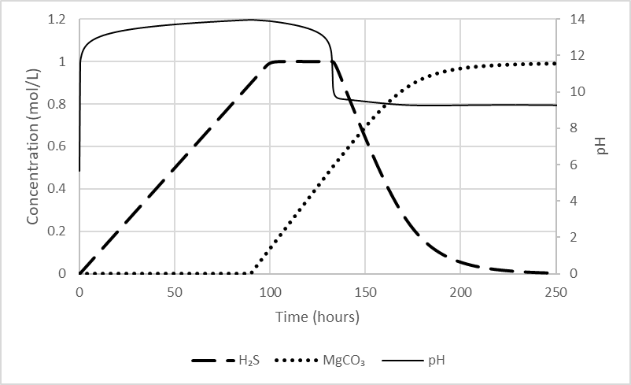

Figure 2. Trends for pH and concentrations of H2S and MgCO3 in reduction bioreactor.

As shown in Figure 2, within the initial 100 hours, *D. vulgaris* effectivelyelevated the pH by converting SO₄²⁻ ions to H2S; around the 90-hour mark, air (containing CO2) was introduced when the concentration of SO₄²⁻ ions reached a relatively low level, therefore MgCO3 precipitate started to be generated. This precipitation process led to the consumption of Mg2+ ions and a subsequent decrease in the overall pH. At about 130 hours, we can observe a decreasing trend for H2S concentration because the decrease in pH enabled the dissolved H2S to be transferred to the gaseous phase; the released H2S gas would be mixed with air and then supplied to the oxidation bioreactor.

3.2 Oxidation Bioreactor

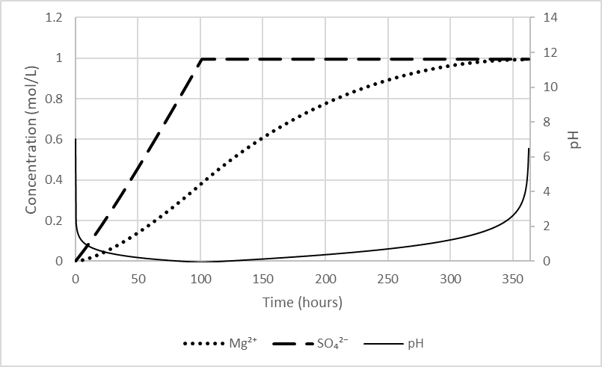

Figure 3. Trends for pH and concentrations of Mg2+ ions and SO42- ions in oxidation bioreactor.

For the oxidation bioreactor, the concentration and duration of supplied H2S gas were both set according to the effluent gas of reduction bioreactor. Additionally, gas-liquid mass transfer of H2S was adjusted through setting agitation such that H2S concentration in the effluent gas is minimized to avoid harmful leakage. As shown in Figure 3, H2S gas was supplied by the reduction bioreactor and oxidized by *A. thiooxidans* for the first 100 hours; the rise in concentration of SO42- ions significantly lowered the overall pH, thereby expediting the dissolution of forsterite. Until approximately 360 hours, the pH of solution returned to a neutral state, and Mg2+ ions reached their maximum concentration while ensuring a reasonable cycle length and operational efficiency.

*3.3 Predicted Time Schedule of the Entire Cycle*

Based on the simulation results of both reactors, Figure 4 summarises a feasible time schedule of the operation of the entire cycle over 500 hours.



Figure 4. Demonstration of operational cycle for both bioreactors.

**4. Conclusions**

Based on our simulation results for the reduction bioreactor and the oxidation bioreactor, the implementation of the sulphur cycle pH swing using *A. thiooxidans* and *D. vulgaris* appears to be feasible. This system demonstrates the capability to capture atmospheric CO₂ under ambient conditions. Building on this proof-of-concept modelling study, future work will address experimental validation and system optimisation to reduce energy consumption and operational cycle duration in order to achieve higher efficiencies.

References

W. Badziong, R.K. Thauer, J.G.Zeikus, 1978, Isolation and characterization of Desulfovibrio growing on hydrogen plus sulfate as the sole energy source. Archives of Microbiology 116, 41-49.

F.K. Crundwell, 2014, The mechanism of dissolution of forsterite, olivine and minerals of the orthosilicate group. Hydrometallurgy 150, 68-82.

R. Darnajoux, K. Inomura, X. Zhang, 2023, A diazotrophy-ammoniotrophy dual growth model for the sulfate reducing bacterium Desulfovibrio vulgaris var. Hildenborough. Computational and Structural Biotechnology Journal 21, 3136-3148.

C. Hepburn, E. Adlen, J. Beddington, E.A. Carter, S. Fuss, N. Mac Dowell, J.C. Minx, P. Smith, C.K. Williams, 2019, The technological and economic prospects for CO(2) utilization and removal. Nature 575, 87-97.

P. Lam, 2022. Microbial Enhancement of Alkalinity Release with Mine Tailing. In: GGREW project presentation, UKRI GGR Programme closing event, 10 May 2022, London.

H.K. Namgung, J. Song, 2015, The effect of oxygen supply on the dual growth kinetics of Acidithiobacillus thiooxidans under acidic conditions for biogas desulfurization. Int J Environ Res Public Health 12, 1368-1386.

D.R. Noguera, G.A. Brusseau, B.E. Rittmann, D.A. Stahl, 1998, A unified model describing the role of hydrogen in the growth of desulfovibrio vulgaris under different environmental conditions. Biotechnol Bioeng 59, 732-746.

A.A. Olajire, 2013, A review of mineral carbonation technology in sequestration of CO2. Journal of Petroleum Science and Engineering 109, 364-392.

W. Seifritz, 1990, CO2 disposal by means of silicates. Nature 345, 486-486.

N.W. Smith, P.R. Shorten, E. Altermann, N.C. Roy, W.C. McNabb, 2019, A Mathematical Model for the Hydrogenotrophic Metabolism of Sulphate-Reducing Bacteria. Front Microbiol 10, 1652.

S.A. Waksman, J.S. Joffe, 1922, Microorganisms Concerned in the Oxidation of Sulfur in the Soil: II. Thiobacillus Thiooxidans, a New Sulfur-oxidizing Organism Isolated from the Soil. J Bacteriol 7, 239-256.

F. Wang, 2013, Silicate Mineral Dissolution and Associated Carbonate Precipitation at Conditions Relevant to Geologic Carbon Sequestration. Washington University in St. Louis.