Towards PEA Matching from Simulation as Part of a Digital Twin Concept for Scale-Up in Modular Plants
Amy Koch^{a*}, Jonathan Mädlerª, Andreas Bamberg^{b}, Leon Urbasª
ªChair of Process Control Systems & Process Systems Engineering Group,
TU Dresden, Dresden 01062, Germany;
^{b}Merck Electronics KGaA, Frankfurter Str. 250, Darmstadt 64293, Germany,
amy.koch@tu-dresden.de
Abstract
Digital artefacts stored in different engineering tools must be semantically linked as part of a Digital Twin (Rosen et al., 2019). However, in the case of Digital Twins for modular plants made up of process equipment assemblies (PEAs) according to VDI 2776-1, different domains interact with different phases across a PEA asset lifecycle and a modular plant lifecycle, challenging existing vendor independent standards for information models (Koch et al., 2023b). To address this challenge, we present a new information model based on OntoCAPE and DEXPI P&ID to support selecting a PEAs from a PEA pool based on queries. To illustrate the functionality of the presented information model, an implementation is presented for matching a Buchwald-Hartwig reaction to a stirred tank reactor PEA using the Siemens engineering toolchain of gPROMS and COMOS. An example query is also provided.
Keywords: Digital Twin, modular plants, PEA pool, PEA match, information model
  - Motivation
The utilization of Modular Plants is crucial to maintain a competitive edge in the dynamic chemical and pharmaceutical markets by reducing time-to-process. Further benefit can be leveraged by combination of a Digital Twin with predesigned Process Equipment Assemblies (PEA) according to VDI 2776-1, a standard outlining modular plants. A Digital Twin is a semantically linked collection of all digital artefacts, including design and engineering data as well as operational data and behavior descriptions. Here, this semantic linkage between digital artefacts stored in different engineering tools is an essential part of a Digital Twin (Rosen et al., 2019). This semantic linkage is supported by descriptive models. However, in the case of Digital Twins for modular plants made up of process equipment assemblies (PEAs) according to VDI 2776-1, different domains interact with different phases across a PEA asset lifecycle and a modular plant lifecycle, challenging existing vendor independent standards for information models (Koch et al., 2023b). In this paper we present a new information model to support selecting a PEA from a PEA pool based on querying technical criteria (Schindel et al., 2021). The presented information model extends the OntoCAPE with the DEXPI P&ID standard to support PEA matching as part of a Digital Twin concept for scale-up in modular plants. This paper is structured as follows: in section 2, relevant workflows and lifecycles for Digital Twins are presented and aligned. Additionally, relevant standards for information models are presented, requirements for information exchanged during PEA matching is outlined, and the distinction between PEA types and PEA instances is discussed. Section 3 introduces the case study, information model architecture with the Siemens toolchain of gPROMS and COMOS is presented, and an example query is provided. We conclude with a discussion of the results and an outlook toward future work.
  - Methodology
    - Digital Twin Workflows in COMOS and gPROMS
Engineering of modular plants requires adapted workflows compared to conventional plants. As indicated by the VDI 2776-1, a significant portion of the design phase is dedicated to the matching of PEAs instead of the detailed engineering phase for conventional plants. Additional benefit can be taken from incorporating a Digital Twin combing structural, behavioral, and descriptive models. Koch et al. (2023a) has presented a Digital Twin workflow in COMOS and gPROMS based on stakeholder requirements. To support this Digital Twin workflow, descriptive models based on vendor-independent standards for information models are required. For this purpose, the Digital Twin workflows from Koch et al. (2023a) refined with the procedure model for process validation in modular plants from Mädler (2023) (see Figure 1). Additionally, this workflow is aligned to the Modular Plant Lifecycle (Mädler et al., 2022a) and the PEA Lifecycle (Menschner et al., 2018; Wiedau et al., 2019) presented in Koch et al. (2023b) to evaluate the suitability of existing vendor independent standards to describe the required information in each lifecycle phase. The workflow is described as follows: (1) product specification is provided from product development, (2) development of process steps in gPROMS, (3) block flow diagram (BFD) with technical criteria in COMOS, (4) query of PEA types in COMOS, (5) query of PEA instances in COMOS, followed by (6) additional steps in gPROMS. For the focus on this paper, emphasis is placed on the information used in steps 4 and 5 to describe PEAs for the PEA matching process.
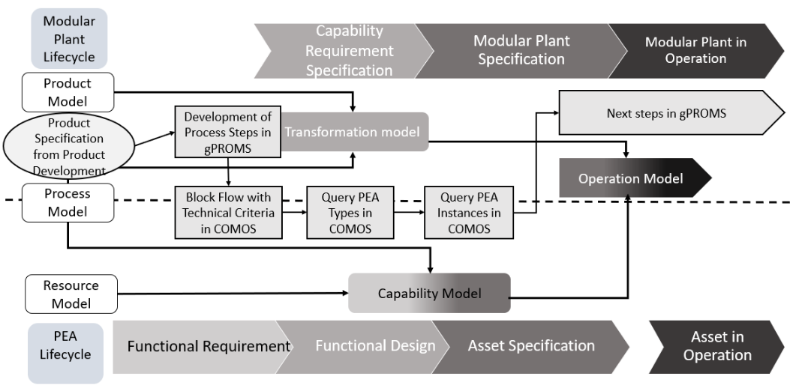Figure 1: Digital Twin workflow from Koch et al. (2023a) derived from Mädler (2023) aligned to the PEA Lifecycle and Modular Plant Lifecycles illustrated in Koch et al. (2023b).
    - Methodology for PEA Matching
The selection of PEAs is well described in literature. The VDI 2776-1 outlines the PEA selection process generally, describing a database with modular planning documentation to compare process requirements and PEA characteristics. In literature, Harding et al. (2021) have also proposed using technical criteria along with a Master Block Flowchart describing required process functions to evaluate different potential technologies while Schindel et al. (2021) suggest matching PEAs based on technical and evaluate criteria using matching matrices. First, technical criteria are used to knock out unsuitable technologies. The suitable technologies are ranked based on evaluative criteria.
    - Selection of PEA Types and Instances
In the procedure workflow of Mädler (2023), the querying of PEA types serves to match the capability requirements with the capabilities of the PEA using technical and evaluative criteria of Schindel at al. (2021), process functions from Harding et al. (2021), and the Module Type Package (MTP) (VDI/VDE/NAMUR 2658). Once non-suitable technologies are knocked out, a list of potential PEA types is generated. In the subsequent step, PEA instances are queried and again a list of potential PEA instances is propagated and ranked based on the relevant technical and evaluative criteria (Mädler, 2023). Klose et al. (2022) also distinguish between type-based and instance-based engineering workflows. Here, type-based engineering is part of the functional design phase while instance-based engineering is part of the asset specification phase. Analogue to the DT workflow in Figure 1, the process begins with a general recipe (IEC 61512-1), from which a block flow diagram (ISO 10628), functional plant topology, process-based safety requirements, and process-based service requirements are derived. For instance-based engineering, the MTP (VDI/VDE/NAMUR 2658) is used to define the software instances, from which the plant topology is derived and used for recipe design, design of control and interlocks, as well as safety aspects such as HAZOP.
    - Vendor-Independent Standards
Koch et al. (2023b) illustrated the suitability of DEXPI P&ID, OntoCAPE, IEC 61512-1, and VDI/VDE/NAMUR 2658 to describe the different phases of the PEA and Modular Plant Lifecycles. For the functional design phase, OntoCAPE and DEXPI P&ID were classified as potentially suitable to describe the information exchanged during this phase, which DEXPI P&ID, OntoCAPE, IEC 61512-1 and VDI/VDE/NAMUR 2658 were all considered to be potentially suitable for description of the asset specification phase. DEXPI P&ID is an industry wide standard for the exchange of P&ID data between CAE tools, OntoCAPE is an ontology describing the domain of chemical engineering, VDI/VDE/NAMUR 2658 describes the MTP which describe the automation perspective of the PEA, and IEC 61512-1 is a widely adopted information model for describing Batch Control and is used in the VDI/VDE/NAMUR 2658 for the description of services.
  - Case Study
    - Example System
The owner/operator (O/O) of a PEA is often from the pharmaceutical and speciality chemical industry where rapid time to market and short product lifecycles are a consistent reality and challenge. Thus, the Buchwald-Hartwig coupling, a palladium catalyzed reaction mechanism for the synthesis of aryl amines from amines and aryl halides, was selected as a case study due to its relevance in the production of pharmaceutical products. The overall schema for the Buchwald-Hartwig reaction mechanism is shown in (1):
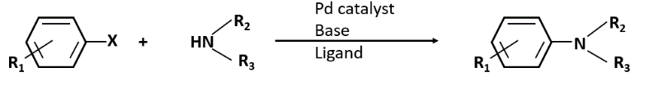 | (1)
In the reaction schema, X is Cl or Br, R₁ is an Alkyl, CN, or a CON group, and R₂ is an Alkyl or Aryl group. In addition to the generalized reaction schema, relevant technical criteria, cf. Mädler (2023) for the Buchwald-Hartwig reaction, an STR PEA type description, and a PEA instance of an STR “M02” are provided in Table 1.
Table 1: Technical Criteria for selection of reactor type with technical criteria for the Buchwald-Hartwig reaction mechanism, an STR PEA type, and a PEA instance (c.f. Mädler, 2023).
Technical Criteria | Buchwald-Hartwig Reaction | PEA Type STR | PEA Instance M02
Reaction Type | Liquid-Liquid | Liquid-Liquid | Liquid-Liquid
Pressure | Atmospheric | Mild | Mild
Temperature | 25 – 100°C | 30 – 150 °C | 25 – 100°C
Reaction Time | 6 to 24 hours | Broad | Broad

    - OntoCAPE and DEXPI P&ID
The goal of the information model is to describe the capability models of the PEA type and instance. As this is the first step towards PEA matching, the information model only considers the technical criteria as described by Schindel et al. (2021). As this information in the PEA pool must be searchable, linked data is used due to enable searchability with SPARQL or SQL query languages. As a first step, OntoCAPE (Marquardt et al., 2010), is used due to its suitability to describe both the process and PEA resources domains (Koch et al., 2023b). Also, DEXPI P&ID (Wiedau et al., 2019) is used to extend the descriptions of the PEA instances. Although for the information model in this paper, OntoCAPE would be entirely suitable, DEXPI P&ID has large support in the process industry, meaning that the P&ID data of documented PEA instances might often already exist in DEXPI P&ID or is easily done so using a plant engineering tool such as COMOS. The information model architecture using OntoCAPE is as follows: to describe the relationship between capability requirements for PEA matching with the PEA capabilities, the System Module and Technical System Modules in the Upper Layer of OntoCAPE are used. In the conceptual design phase, system requirements (functional requirements) are transformed into system functions (PEA type) during the basic design (functional design phase), which are detailed in the system realization (PEA instance). Ultimately it is the capabilities of PEA instance which constrain the system behavior during the asset specification and operation phases. This is in good agreement with the proposed Digital Twin workflow and the alignment to the PEA lifecycle in Figure 1.
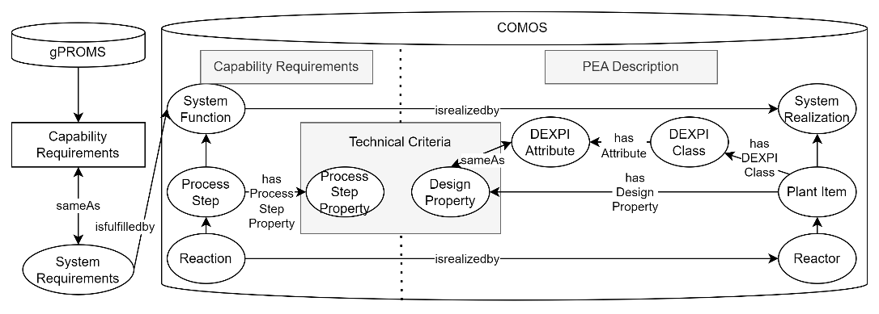
Figure 2: Linked-data based information model architecture for querying PEAs in COMOS.
Figure 2 illustrates the architecture of the information model with respect to the data sources of gPROMS and COMOS. Here, the PEA description is extended with the DEXPI P&ID classes and attributes as DEXPI P&ID is widely used in the process industry to document the equipment capabilities. The information model architecture in Figure 2 shows how the relevant technical criteria for PEA matching for both PEA types and instances can be linked to the capability requirements propagated by gPROMS and transferred to COMOS via BFD. In order to query the PEA instances and types, capability models must be catalogued in a PEA Pool database. The technical criteria of a PEA are described using the ProcessStep and capability requirements are described with ProcessStepProperty. For the PEA description, the Plant Item is used and the DesignProperty describes the technical capabilities. Here we suggest to extend the PEA description with DEXPI P&ID, due to its acceptance in the process industry to describe the equipment topography and design capabilities. The distinction is that PEA type has a more generalized description and the PEA instance has a more concrete constraint of the system behavior as the description considers additional aspects beyond the technical criteria. Next, we use the architecture in Figure 2 to describe the capability requirements of the Buchwald – Hartwig reaction with the PEA type “STR”, and the PEA instance M02. These connections are modelled in Figure 3. Here, a distinction is made between the PEA type “STR” and the PEA instance “M02” via the use of DEXPI P&ID classes and attributes for the description of the technical criteria of the M02 PEA instance.
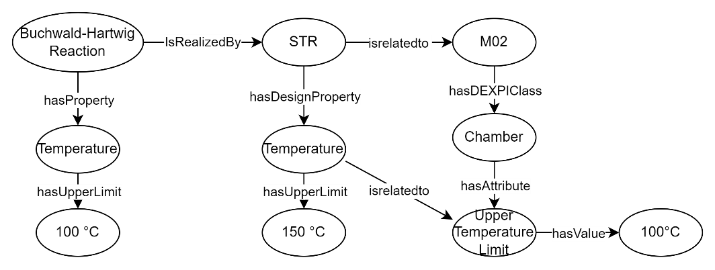
Figure 3: Connection of the Buchwald-Hartwig reaction with the STR PEA type and with the PEA Instance M02 for the technical criteria upper temperature limit using OntoCAPE and DEXPI P&ID.
    - Formulation of Queries
The goal of the queries is to generate lists of suitable PEA types and instances, with the intention of ranking the suitability based on technical and evaluative criteria (Mädler, 2023). We propose the use of the SPARQL query language to search the capability models of both PEA types and instances in the PEA Pool. In the example provided in Table 2, all PEA types are queried for the ProcessStep of reaction, and the ?Properties, which are the technical criteria, are displayed for two example reactor types (STR and PFR). We propose, that these technical criteria-based queries be used to propagate the lists of suitable PEA types and PEA instances. However, to evaluate these criteria, the methods from Schindel et al. (2021) or Harding et al. (2021) should be employed.
Table 2: Example result from a SPARQL query for ProcessStep = Reaction from a PEA databank.
Query | Result
 | ?Property | STR | PFR
?Reaction?Properties | ?ReactionType  ?ReactionTime  ?Temperature  ?Pressure | Liquid-liquid  Broad  30 – 150 °C  Mild | Gas-liquid; liquid-liquid  Narrow  80 – 200 °C  Up to 20 bar
  - Discussion and Conclusion
This paper presented an information model describing capability models of both PEA types and instances, with emphasis on the technical criteria. Using this information model, an example query and result was illustrated for PEA types for the process step “reaction”. As a use case, the technical criteria from the Buchwald-Hartwig reaction linked to a stirred tank reactor type, and a specific PEA instance of M02. Although the information model presented in this paper is a reasonable step towards PEA matching, the problem is in reality much more complex. Here, aspects such as service matching and recipes must be considered with respect to the IEC 61512-1 and VDI/VDI/NAMUR 2658 standard for the MTP. Additionally, the product specification in the DT workflow is considered to be a recipe therefore alignment and integration of the IEC 61512-1 is a key next step to expand upon the presented information model.
References
A. Bamberg, L. Urbas, S. Bröcker, M. Bortz, and N. Kockmann, 2021. The Digital Twin – Your Ingenious Companion for Process Engineering and Smart Production. Chemical Engineering & Technology 44, 954–961. https://doi.org/10.1002/ceat.202000562
D. Harding, M. Polyakova, D. Nowara, S. Rech, M. Grünewald, & C. Bramsiepe, 2021. New process function-based selection and configuration methodology for Process Equipment Assemblies (PEAs) exemplified on the unit operation distillation. Chemical Engineering and Processing - Process Intensification, 168, 108531. https://doi.org/10.1016/j.cep.2021.108531
A. Klose, J. Lorenz, L. Bittorf, K. Stark, M. Hoernicke, A. Stutz, H. Weinhold, N. Krink, W. Welscher, M. Eckert, S. Unland, A. Menschner, P. Da Silva Santos, N. Kockmann, L. Urbas, 2022. Orchestration of modular plants: Procedure and application for orchestration engineering. atp 63, 68–77. https://doi.org/10.17560/atp.v63i9.2599
A. Koch, J. Mädler, A. Bamberg, and L. Urbas, Digital Twins for Scale-Up in Modular Plants: Requirements, Concept, and Roadmap. In A. C. Kokossis, M. C. Georgiadis, & E. Pistikopoulos (Eds.), Computer Aided Chemical Engineering (Vol. 52, pp. 2063–2068). Elsevier. https://doi.org/10.1016/B978-0-443-15274-0.50328-0.
A. Koch, N. Hamedi, L. Furtner, T. Kock, A. Klose, & J. Mädler, (2023). Standards for Information Models Considering Knowledge Distribution in Modular Plants. 2023 IEEE 21st International Conference on Industrial Informatics (INDIN), 1–7. https://doi.org/10.1109/INDIN51400.2023.10218218
IEC 61512-1:1997, “Batch control - Part 1: Models and terminology.” IEC, Aug. 1997.
W. Marquardt, J. Morbach, A. Wiesner, and A. Yang, OntoCAPE. in RWTHedition. Berlin, Heidelberg: Springer Berlin Heidelberg, 2010. doi: 10.1007/978-3-642-04655-1
J. Mädler, 2023. Smarte Process Equipment Assemblies zur Unterstützung der Prozessvalidierung in modularen Anlagen.
J. Mädler, J. Rahm, I. Viedt, and L. Urbas, 2022, A digital twin-concept for smart process equipment assemblies supporting process validation in modular plants. In L. Montastruc & S. Negny (Eds.), Computer Aided Chemical Engineering (Vol. 51, pp. 1435–1440). Elsevier. https://doi.org/10.1016/B978-0-323-95879-0.50240-X
A. Menschner, S. Hensel, L. Urbas, T. Holm, C. Schäfer, T. Scherwietes, A. Stutz, M. Maumaier, and M. Hoernicke, 2018.“Module Lifecycle Model for Modular Plants,” Chem. Ing. Tech., 90(9), 1220-1220, doi: 10.1002/cite.201855192.
R. Rosen, J. Fischer, & S. Boschert, 2019, Next generation digital twin: An ecosystem for mechatronic systems?, IFAC-Paper, 52, 15, 265-270. https://doi.org/10.1016/j.ifacol.2019.11.685
A.-L. Schindel, M. Polyakova, D. Harding, H. Weinhold, F. Stenger, M. Grünewald, and C. Bramsiepe, 2021, General approach for technology and Process Equipment Assembly (PEA) selection in process design, CEP:PI, 159, 108223. https://doi.org/10.1016/j.cep.2020.108223
VDI/VDE/NAMUR, 2019, VDI/VDE/NAMUR 2658-Automation engineering of modular systems in the process industry-General concept and interfaces – Part 1, Beuth Verlag GmbH.
VDI 2776-1:2020, “Process engineering plants - Modular plants - Fundamentals and planning modular plants - Part 1 (VDI 2776:2020-11).” Beuth Verlag, Nov. 2020.
M. Wiedau, L. von Wedel, H. Temmen, R. Welke and N. Papkonstantinous, 2019. ENPRO Data Integration: Extending DEXPI Towards the Asset Lifecycle. Chemie Ingenieur Technik, 91(3), 240–255. https://doi.org/10.1002/cite.201800112

