Comparative Study on Hydrothermal Gasification and Thermal Gasification via Hydrothermal Carbonization of Digestate Residues from Anaerobic Digestion
Fadilla Noor Rahma^{a*}, Khanh-Quang Tran^{b}, Roger Khalil^{c}
ªNorwegian University of Science and Technology, Høgskoleringen 1, Trondheim 7034, Norway
^{b}SINTEF Energy Research, Sem Sælands vei 11, Trondheim 7034, Norway
fadilla.n.rahma@ntnu.no
Abstract
Anaerobic digestion (AD), one of the key technologies for achieving the climate-neutral target, is still facing various digestate management issues. The digestate’s high organic matter and energy content make it a potential feedstock for further processing into value-added products, i.e., through thermochemical conversion technologies. However, its high moisture content poses additional challenges related to extensive energy requirement for feedstock drying. This paper investigates two technologies for efficient processing of digestate, i.e., 1) hydrothermal gasification (HTG) and 2) hydrothermal carbonization coupled with thermal gasification of hydrochar (HTC-TG). Both technologies can convert digestate into producer gas while avoiding the energy-extensive drying step. Aspen Plus software is used to compare the performance of the two processes. The process performance is comparatively assessed based on the producer gas generation and overall system efficiency (OSE).
Keywords: Hydrothermal gasification, hydrothermal carbonization, thermal gasification, anaerobic digestion, Aspen Plus.
  - Introduction
Anaerobic digestion (AD) for biogas production from low-grade biomass is one of the essential technologies in the transition towards climate-neutral energy production. Despite its potentials, the implementation of AD technology is currently facing significant challenges related to digestate management (Nkoa 2014). The digestate stream is rich in organic matters and energy content, making it suitable for generating value-added products, heat, and power. Valorization of digestate through gasification technology is particularly promising since it mainly generates producer gas, a valuable source for alternative fuels or chemicals. However, digestate’s high moisture content leads to substantial energy demand during the initial drying step in gasification (Parmar and Ross 2019).
This paper investigates two potential gasification strategies to avoid the energy-intensive drying step, i.e., 1) hydrothermal gasification (HTG) and 2) thermal gasification through hydrothermal carbonization of digestate (HTC-TG). HTG is performed in supercritical water, where water acts as solvent, reactant, and catalyst to assist the chemical reactions (Tekin, Karagöz et al. 2014). The feedstock drying process is therefore not necessary during HTG, making it an interesting option for processing of high-moisture biomass such as digestate. Another strategy is to employ hydrothermal carbonization (HTC) for digestate pre-processing before thermal gasification (TG). HTC, which takes place in subcritical water environment, can assist mechanical dewatering of high-moisture biomass (Salaudeen, Acharya et al. 2021), thus reducing the feedstock drying requirement. Additionally, hydrochar from HTC is known to have improved fuel properties, leading to better efficiency of the TG process (Gai, Guo et al. 2016).
In comparison to TG, HTG is carried out at lower temperature without the energy-intensive drying step (Kumar, Oyedun et al. 2018). However, the technology requires considerable energy for the high-pressure reactor pumping system (Macrì, Catizzone et al. 2020). On the other hand, HTC-TG involves relatively lower pressure, with lower drying energy than stand-alone TG. Nevertheless, drying is still required to some extent, and the gasifier temperature is higher than HTG. These operational aspects can significantly influence the energy performance of both systems. To the best of the authors’ knowledge, research comparing the energy performance of HTG and HTC-TG has not been performed. Therefore, the present study aims to comparatively evaluate the energy performance of HTG and HTC-TG of biogas digestate.
  - Methods
- Process Simulation
Aspen Plus models of HTG and HTC-TG are employed to comparatively assess the performance of both systems. The HTG and HTC-TG models are presented in Figure 1 and Figure 2, respectively. The digestate feedstock is regarded as non-conventional component specified by its ultimate composition, as displayed in Table 1.
Both the HTG and TG models are based on thermodynamic equilibrium using Gibbs free energy minimization principle. This approach is widely used for evaluating the performance of gasification systems. Previous works employing the same model have been proven to accurately represent the experimental data for both HTG system (Hantoko, Kanchanatip et al. 2019, Okolie, Nanda et al. 2020) and TG system (Salaudeen, Acharya et al. 2021).

    - Hydrothermal Gasification (HTG)
The digestate and water mixture enter the system as stream FEED. The PUMP and HEATER increase the temperature and pressure of the feedstock mixture to the reactor condition, as specified in Table 3. The HTG reactor is theoretically represented with two reactor blocks in Aspen Plus, i.e., RYIELD (HTGYIELD) and RGIBBS (HTGGIBBS). The HTGYIELD breaks down the non-conventional digestate component into its element (C, H, O, N, S, and ash) according to its ultimate composition. To perform this operation, a Fortran statement is written on a calculator block embedded in the HTGYIELD reactor. The decomposed feedstock from HTGYIELD is reacted in HTGGIBBS, which performs the Gibbs free energy minimization. The resulting products are flown through COOLER and VALVE to reduce the temperature and pressure before being separated in SEP.
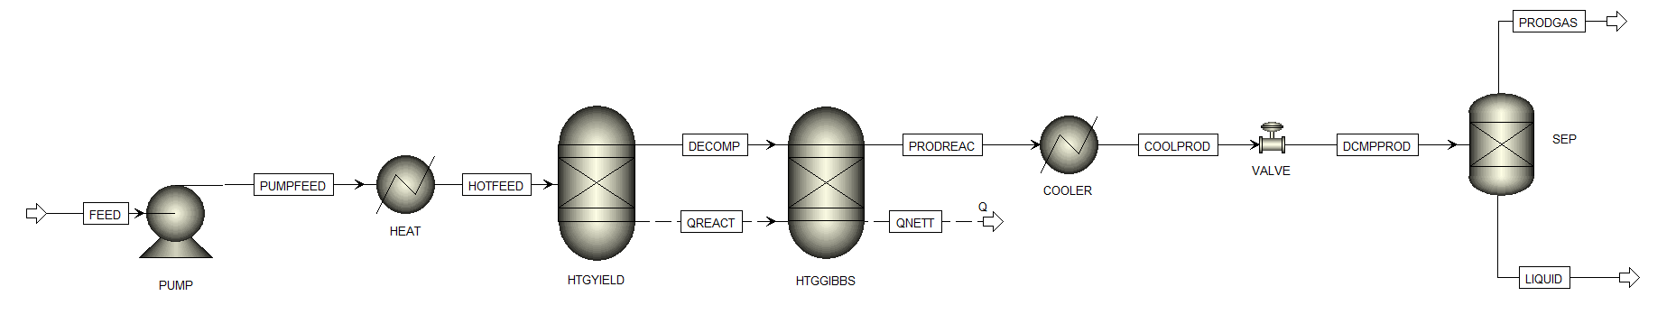

Figure 1. Process Flow Diagram of HTG in Aspen Plus
    - Hydrothermal Carbonization Integrated with Thermal Gasification (HTC-TG)
The stream FEED, consisting of digestate and water mixture, is flown through PUMP 1 and HEAT1 before being fed to the HTC unit. Due to the complexity of HTC reaction kinetic and mechanism, the data for HTC unit in the simulation is taken from experimental results available in literature (Ghavami, Özdenkçi et al. 2022). The reference data included the mass balance of the HTC system and the ultimate composition of hydrochar, as displayed in Table 2. In addition, energy requirements for the dewatering and drying steps are approximated according to experimental filtration (Aragon-Briceño, Pożarlik et al. 2022) and thermal drying of hydrochar (Zhao, Shen et al. 2014).
The dried hydrochar in stream TGFEED enters the gasification reactor system. Similar with the HTG process, the TG system is also theoretically modelled with RYIELD and RGIBBS reactor blocks, denoted by TGYIELD and TGGIBBS, respectively. TGYIELD decomposes the non-conventional hydrochar component into its elements with the aid of a calculator block, whereas TGGIBBS carries out the Gibbs free energy minimization. The product flows through SOLIDSEP for solid removal and COOLER and SEP for separation of condensate.

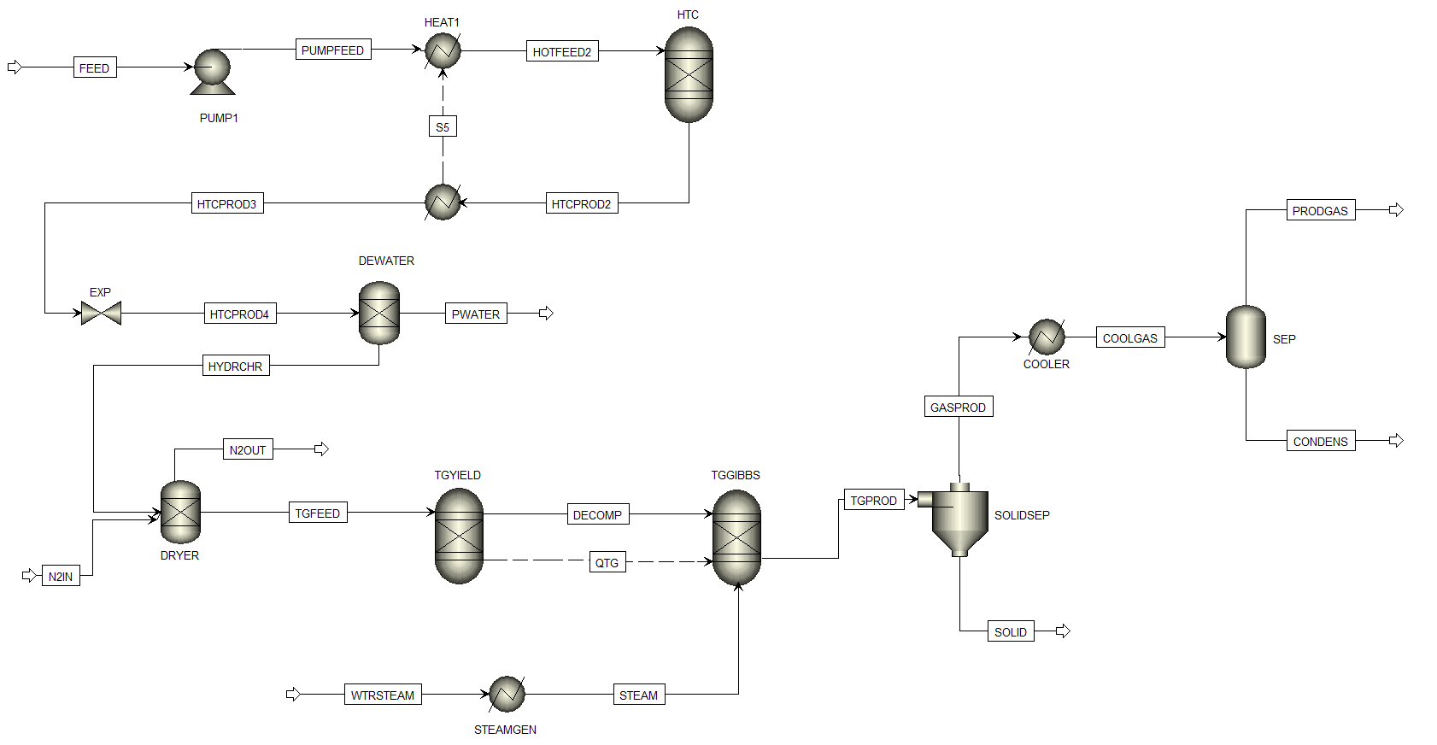
Figure 2. Process Flow Diagram of HTC-AD in Aspen Plus

Table 1. Input Data from Characterization of Digestate Feedstock
Parameters | Value | Units
C | 44.10 | %
H | 5.10 | %
O | 31.30 | %
N | 3.20 | %
S | 0.30 | %
Ash | 16.00 | %
HHV | 17.80 | MJ/kg

Table 2. Input Data from Characterization of Hydrochar from HTC
Parameters | Value | Units
C | 51.20 | %
H | 6.10 | %
O | 22.80 | %
N | 3.50 | %
S | 0.00 | %
Ash | 16.30 | %
HHV | 20.90 | MJ/kg

Table 3. Parameters for Simulation
Parameters | HTG | TG
Temperature | 400-600 ºC | 600-1000 ºC
Pressure | 250 bar | 1 bar
Digestate wt% | 30% | 30%

- Performance Assessment Indicators
The performance of both systems is calculated from the overall system efficiency (OSE), represented by Equation 1 and Equation 2 for HTG and HTC-TG, respectively.

$${OSE}_{HTG}=\frac{{LHV}_{Producer gas}-E_{HTG}}{{LHV}_{Digestate}}$$ | (1)
$${OSE}_{HTC-TG}=\frac{{LHV}_{Producer gas}-E_{HTC}-E_{TG}}{{LHV}_{Digestate}}$$ | (2)

In the equations, ${LHV}_{Producer gas}$ and ${LHV}_{Digestate}$ represents the lower heating value of producer gas and digestate; whereas $E_{HTG}$, $E_{HTC}$, and $E_{TG}$ represents the required energy in the HTG, HTC, and TG sections, respectively. The energy requirement is calculated from the total heating and electricity consumption in each section.
  - Results
The performances of HTG and HTC-TG system are comparatively assessed for the same digestate flow rate and composition. This study focuses on the effect of gasification temperature, which is one of the key factors influencing gasification systems performance (Sanaye, Alizadeh et al. 2022). The other parameters for simulation are summarized in Table 3.

(a) | 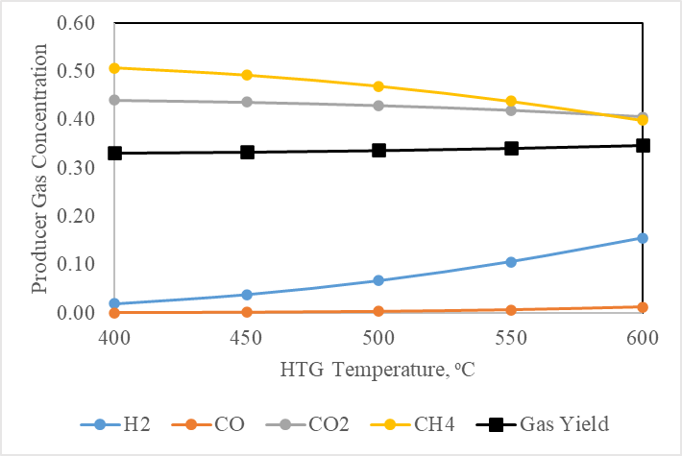 |  | (b) | 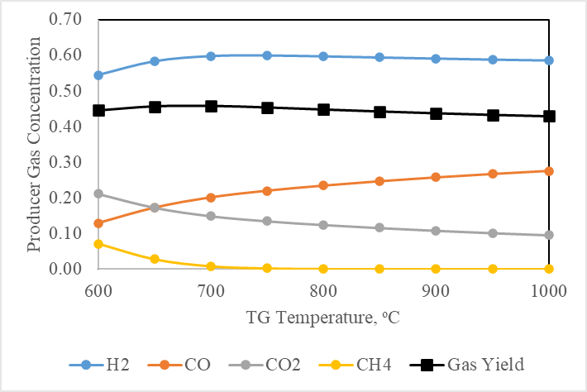
Figure 3. Effect of Temperature on Producer Gas Concentration in (a) HTG and (b) HTC-TG Systems
Figure 3 (a) and (b) display the comparison of gas yield and composition produced from HTG and HTC-TG systems, respectively. The results suggest that temperature plays a significant role influencing producer gas composition in both systems. In general, higher temperature results in increasing H₂ and CO concentration, whereas CH₄ and CO₂ production decrease. The effect of temperature can be explained by the basic law of chemical reactions: exothermic reactions are favored by lower temperature, whereas endothermic reactions are enhanced by higher temperature (Salaudeen, Acharya et al. 2021). At the particular range of operating conditions observed in this study, HTC-TG is more suitable for hydrogen production, whereas HTG produces higher methane concentration. However, other influencing factors such as feedstock-to-steam ratio and feedstock concentration can significantly change the process behavior.

(a) | 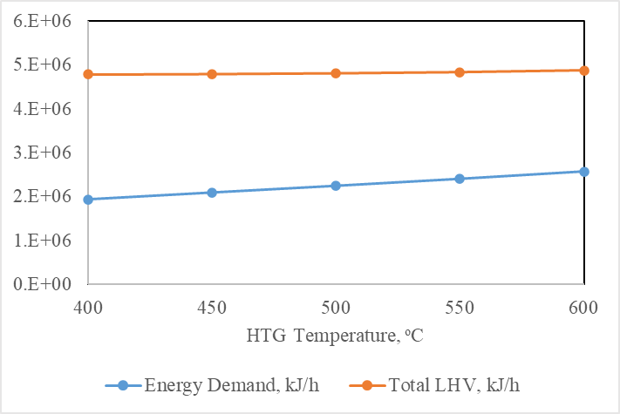 |  | (b) | 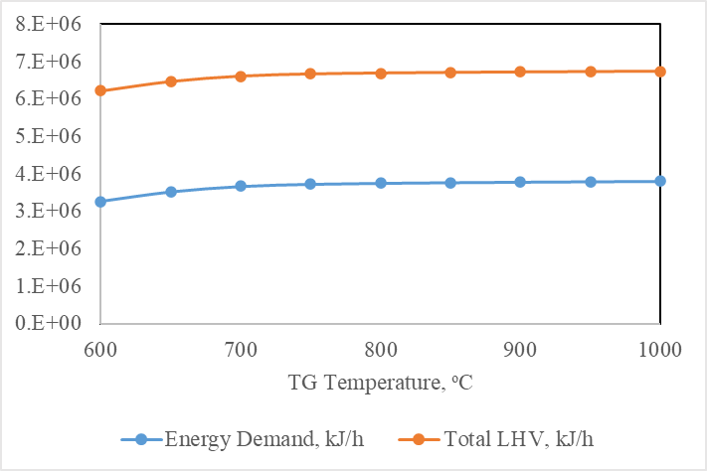
Figure 4. Effect of Temperature on Total Energy Demand and Producer Gas LHV in (a) HTG and (b) HTC-TG Systems

Figure 4 (a) and (b) display the system total energy demand and the product heating value, which is calculated by multiplying the producer gas flow rate with the producer gas LHV. The result shows that for both HTG and HTC-TG systems, total energy demand and heating value increase with higher temperature. The increase in energy demand is mostly contributed by the higher heating requirement in the gasification system, with regards to the higher temperature. The increasing temperature also enhances the product heating value in both systems. However, the increase in product heating value is not as significant as the increase in heating requirement, causing the overall system efficiency (OSE) to decrease, as displayed in Figure 5. It is possible to reduce energy demand of the system through better heat integration, which may result in better OSE. Furthermore, it was found that within the operating conditions observed in this study, HTC-TG system performs with higher OSE compared to HTG.

(a) | 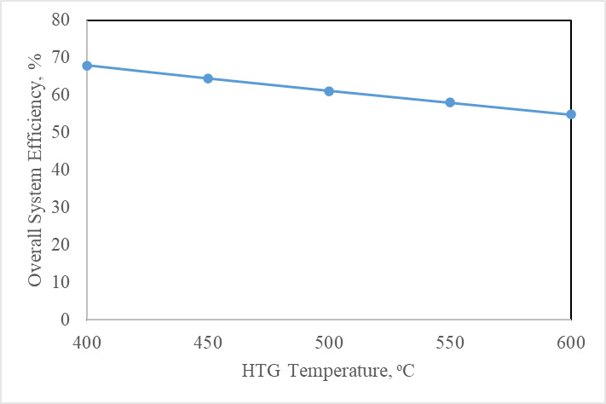 |  | (b) | 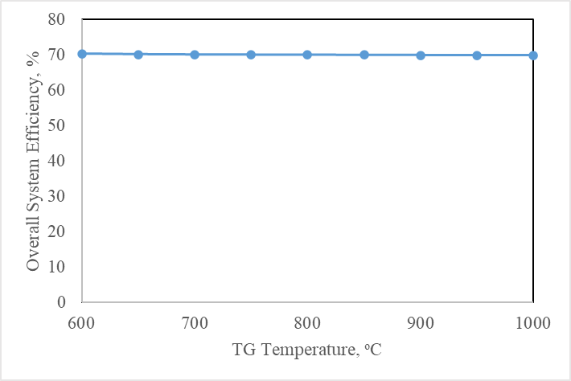
Figure 5. Effect of Temperature on Overall System Efficiency (OSE) in (a) HTG and (b) HTC-TG Systems

  - Conclusions
Two technologies for efficient processing of digestate, i.e., 1) hydrothermal gasification (HTG) and 2) hydrothermal carbonization coupled with thermal gasification of hydrochar (HTC-TG) are comparatively assessed using Aspen Plus software. The effect of temperature is observed, and it was found that higher temperature has a positive influence on H₂ and CO concentration, whereas CH₄ and CO₂ production are negatively affected. At the operating conditions observed in this study, HTC-TG is more suitable for hydrogen production, while HTG produces more methane. The higher temperature also increases both energy demand and product heating value in both systems. However, the OSE of the two systems decreases with increasing temperature. Within the operating conditions observed in this study, HTC-TG system performs with higher OSE compared to HTG.
References
Aragon-Briceño, C., A. Pożarlik, E. Bramer, G. Brem, S. Wang, Y. Wen, W. Yang, H. Pawlak-Kruczek, Ł. Niedźwiecki and A. Urbanowska (2022). "Integration of hydrothermal carbonization treatment for water and energy recovery from organic fraction of municipal solid waste digestate." Renewable energy 184: 577-591.
Gai, C., Y. Guo, T. Liu, N. Peng and Z. Liu (2016). "Hydrogen-rich gas production by steam gasification of hydrochar derived from sewage sludge." International Journal of Hydrogen Energy 41(5): 3363-3372.
Ghavami, N., K. Özdenkçi, S. Chianese, D. Musmarra and C. De Blasio (2022). "Process simulation of hydrothermal carbonization of digestate from energetic perspectives in Aspen Plus." Energy Conversion and Management 270: 116215.
Hantoko, D., E. Kanchanatip, M. Yan, Z. Weng, Z. Gao and Y. Zhong (2019). "Assessment of sewage sludge gasification in supercritical water for H2-rich syngas production." Process Safety and Environmental Protection 131: 63-72.
Kumar, M., A. O. Oyedun and A. Kumar (2018). "A review on the current status of various hydrothermal technologies on biomass feedstock." Renewable and Sustainable Energy Reviews 81: 1742-1770.
Macrì, D., E. Catizzone, A. Molino and M. Migliori (2020). "Supercritical water gasification of biomass and agro-food residues: Energy assessment from modelling approach." Renewable Energy 150: 624-636.
Nkoa, R. (2014). "Agricultural benefits and environmental risks of soil fertilization with anaerobic digestates: a review." Agronomy for Sustainable Development 34: 473-492.
Okolie, J. A., S. Nanda, A. K. Dalai and J. A. Kozinski (2020). "Hydrothermal gasification of soybean straw and flax straw for hydrogen-rich syngas production: Experimental and thermodynamic modeling." Energy Conversion and Management 208: 112545.
Parmar, K. R. and A. B. Ross (2019). "Integration of hydrothermal carbonisation with anaerobic digestion; Opportunities for valorisation of digestate." Energies 12(9): 1586.
Salaudeen, S. A., B. Acharya and A. Dutta (2021). "Steam gasification of hydrochar derived from hydrothermal carbonization of fruit wastes." Renewable Energy 171: 582-591.
Sanaye, S., P. Alizadeh and M. Yazdani (2022). "Thermo-economic analysis of syngas production from wet digested sewage sludge by gasification process." Renewable Energy 190: 524-539.
Tekin, K., S. Karagöz and S. Bektaş (2014). "A review of hydrothermal biomass processing." Renewable and sustainable Energy reviews 40: 673-687.
Zhao, P., Y. Shen, S. Ge and K. Yoshikawa (2014). "Energy recycling from sewage sludge by producing solid biofuel with hydrothermal carbonization." Energy conversion and management 78: 815-821.

