Detailed Design of Shell and Tube Heat Exchangers with Considering Fouling
Yi Cuiª, Chenglin Chang^{b}, Yufei Wang*ª
¹College of Chemical Engineering and Environment, China University of Petroleum, 102249, Beijing, China
² School of Chemistry and Chemical Engineering, Chongqing University, 400044, Chongqing, China
Email of the Corresponding Author: wangyufei@cup.edu.cn
Abstract
The shell and tube heat exchanger is a crucial component in the process industry for energy recovery. Its detailed design continues to be a prominent area of research. However, current research models of heat exchangers tend to oversimplify the system, overlooking practical factors, such as fouling. Fouling, being a common and significant factor, is often treated as a constant value during design optimization. This study proposes a method for optimizing the design of heat exchangers by considering fouling variations across multiple operating cycles. The method employs Set Trimming to obtain a comprehensive solution that accounts for the changes in fouling. The design optimization is performed within a specific operating cycle, resulting in an optimal heat exchanger solution for crude oil. Then sensitivity analysis using multiple operating cycles is conducted to identify the most suitable operating cycle and its corresponding heat exchanger design solution for crude oil. The results of the optimization indicate that, within 1-year descaling cycle, the proposed design method successfully reduces the required heat transfer area of the heat exchanger by 2.62%, comparing to the literature value. Through cost optimization, the method identifies the optimal operating cycle for crude oil as 3-year. These findings highlight the potential of the method to enhance heat exchanger performance and decrease refinery expenses.
Key words：Heat exchanger; Fouling; Global optimum; Set trimming.
  - Introduction
The design optimization of heat exchangers, a critical aspect of energy recovery in the industry, continues to be a prominent research area. Commonly employed algorithms for heat exchanger optimization can be broadly categorized into heuristic algorithms and mathematical planning methods.
Heuristic algorithms, such as genetic algorithms (Amini, 2014), simulated annealing algorithms (Khalfe et al., 2011), and particle swarm algorithms (Patel et al., 2010), have been extensively explored in heat exchanger research. In recent years, new algorithms like the imperialist competitive algorithm (Hadidi et al., 2013a), biogeography-based algorithm (Hadidi et al., 2013b), and harmony search algorithm (Turgut et al., 2014) have also been applied to address heat exchanger design problems. Heuristic algorithms offer relatively quick solutions to design problems. However, their limitations include the need for trial and error iterations and parameter adjustments.
In addition, the heat exchanger model often involves nonlinear equations, resulting in a mixed integer nonlinear model (MINLP) when solved using mathematical programming methods. To address this, some researchers have linearized the MINLP model and formulated it as a mixed integer linear programming (MILP) model (Gonçalves and Costa et al., 2016). However, this approach suffers from lengthy solution times and the challenge of model linearization adjustments.
While research on heat exchangers has reached a high level of maturity, many studies simplify calculations by assuming constant values for the physical properties of hot and cold streams during optimization. This undoubtedly reduces the calculations and allows the program to be solved in a short time. However, certain parameters that are considered as constant values in the optimization program may have a huge impact on the design and operation of the heat exchanger in real chemical plant. Fouling is just such a parameter, and its variation during the heat exchanger process is often neglected in current research.
Caputo et al. (2011) investigated the influence of flow velocity on fouling and used genetic algorithm to optimize the heat exchanger, with the total cost as the optimization objective. Costa et al. (2017) used a threshold model to model the fouling resistance value and designed a MILP model to solve the design problem. Comparison with traditional methods with fixed fouling factor showed that this method has the potential reduction of capital cost. Lemos et al. (2018) further explored the relationship between fouling and crude oil type, pressure drop manipulation, and energy integration based on the research of Costa et al. (2017). And then Lemos et al. (2022) employed Set Trimming to design the heat exchanger, considering fouling on both the tube and shell sides, resulting in more realistic outcomes. Among the existing studies on fouling, there is a paucity of research examining the economic cost of heat exchangers during long operating times. Furthermore, there seems to be a scarcity of research specifically focusing on the fouling-cleaning operation cycle.
In this paper, Set Trimming was used to solve the heat exchanger design problem considering the effect of time on the fouling resistance value. Set Trimming is an efficient enumeration algorithm proposed in recent years, which can solve the optimization problem in a short period of time. For a specified operation cycle, the design solution was given with the optimization objective of minimizing the heat transfer area, and the solution of Set Trimming was proved to be more reasonable when compared with the literature values. In addition, a sensitivity analysis of the operating cycle was conducted, using the total cost as the evaluation metric. This analysis aimed to identify the most suitable operating cycle for the given case and consequently provided the corresponding design solution.
  - Model Equations
Without loss of generality, the study in this paper is based on the following assumptions:
(1) the shell of the heat exchanger is E-type. (2) the hot and cold streams are liquids, and no phase changes occur. (3) In addition to the fouling resistance, other physical parameters of the hot and cold streams, such as density, viscosity, etc., are based on the values at the average temperature.
The model of the heat exchanger is given below, and in the description of the optimization model, the parameters that are initially given and do not need to be optimized have the symbol "" at the top.
    - Heat Exchanger Model
The shell-side models for the heat exchangers adopts the Kern model, and the tube-side models are from Incropera et al. (2006) and Saunders (1988). In addition to the general shell and tube side model, the tube-side fouling factor is given by equation (1).
where α and γ are model parameters, Re_{t} and Pr_{t} are the Reynolds, Prandtl number of tube-side, Ea is the activation energy, R is gas constant, and T_{w} is wall temperature.
    - Bounds
To ensure the validity of the model and the reasonableness of the design solution given by the program, some bounds are added.
The limitations of pressure drop, flow rate, and Reynolds number can be found in the literature (Lemos et al., 2018).
Structural parameters limitations are given by equations (2) and (3), proposed by Hewitt et al. (2008).
where d_{s} is the shell diameter, lbc is the baffle spacing, and L is the tube length.
Heat transfer area limitations are given by equation (4).
where A is the heat transfer area, A_{exc} is the area margin percentage.
    - Objective Function
The objective functions involved in this study are as follows, and all of them used in the optimization process are single-objective optimization. The first objective function selected is the heat transfer area. Its calculation is based on equation (5).
where Ntt is the total number of tubes.
In order to facilitate the comparison of cost reduction in the refinery, the total cost (TC) is selected as another objective function, which is calculated by equation (6)-(9).
where CA, CP, and CC are the investment cost, operation cost, fouling-cleaning cost of heat exchanger. af is the annual interest rate, a is the cost parameter of the heat exchanger, EC is the electricity price, Hour is the total operating time of heat exchanger, m_{s}, ρ_{s} are the shell-side stream mass flow rate and stream density, m_{t}, ρ_{t} are the data of tube-side, η is the motor efficiency, n is the number of fouling-cleaning times, and FC is the cost of a single cleaning operation.
  - Case Study
A case from Lemos et al. (2018) was selected. Detailed data on hot and cold stream as well as design variables can be found in the literature (Lemos et al., 2018). The hot stream fouling factor is 0, and the cold stream fouling factor is calculated according to equation (1). Using Set Trimming for optimization, detailed logic can be found in Costa et al. (2019).
In the optimization process, the following parameters are considered as constants. The thickness of the tube-side is 0.00165 m. A_{exc} in equation (4) equals 0. α in equation (1) equals 0.0002798 m²·K/(W·h), γ equals 4.17·10⁻¹³ m²·K/(W·h), Ea equals 48 KJ/mol, and R equals 8.314 J/(mol·K). af in equation (7) equals 0.264 and a equals 21. EC in equation (8) equals 0.12 $·kWh⁻¹, Hour equals 24,000 h (the heat exchanger has a service life of 30 years and operates 8,000 hours per year.), and η equals 75%. FC in equation (9) equals 2,000 $.
First, the heat exchanger descaling cycle is given as 1 year (8,000 h), the objective function is to minimize the heat transfer are. The design solutions, thermofluid dynamic results are shown in Table (1).

Table 1: Optimization results of heat transfer area
Design solutions |  | Thermofluid dynamic results
Total number of tubes | 1071 | Heat transfer area/m² | 312.58
Tube outer diameter/m | 0.019 | Tube-side velocity/m·s⁻¹ | 2.29
Tube length/m | 4.877 | Shell-side velocity/m·s⁻¹ | 0.72
Tube pitch ratio | 1.25 | Tube-side heat transfer coefficient /W·(m²·K)⁻¹ | 2372.24
Tube layout | Triangular | Shell-side heat transfer coefficient /W·(m²·K)⁻¹ | 1221.61
Number of tube passes | 4 | Overall heat transfer coefficient /W·(m²·K)⁻¹ | 657.96
Number of baffles | 13 | Tube-side pressure drop/Pa | 75,559.14
Shell diameter/m | 0.889 | Shell-side pressure drop/Pa | 74,074.57
 |  | Tube-side fouling factor/m²·K·W⁻¹ | 0.000128

Through the optimization of Set Trimming, the minimal heat transfer area is 312.58 m², representing a 2.62% reduction compared to the literature value of 321 m², proving the effectiveness of Set Trimming and the models. The reduction in heat transfer area is attributed to the selection of a smaller shell diameter, resulting in a smaller total number of tubes, and the adoption of triangular tube-layout, enabling more heat transfer tubes to be arranged on the same tube sheet area. Corresponding to the reduction of the heat transfer area is the improvement of the pressure drop, both the tube and shell pressure drops are improved to different degrees, 4.95% and 4.76%, respectively. In addition, from the thermofluid dynamic results, the overall heat transfer coefficient is 657.96 W·(m²·K)⁻¹, which is smaller than the literature value of 692 W·(m²·K)⁻¹. Nevertheless, this paper gives a smaller value of heat transfer area than the literature because A_{exc} is given to be 0. In the actual calculations, there are still some area margins in both the design solutions given in this paper and the literature. Larger overall heat transfer coefficient in the literature will result in a smaller A_{req}, leading to larger area margins and improved heat exchanger safety and operational flexibility. Despite these differences, it is crucial to emphasize that the design solutions proposed in this paper remain feasible and rational.
Subsequently, a sensitivity analysis of the descaling cycle is performed, assuming a heat exchanger operating life of 30 years and varying descaling cycles from 1 year to 10 years. The optimization is performed with the objective of minimizing the total cost.
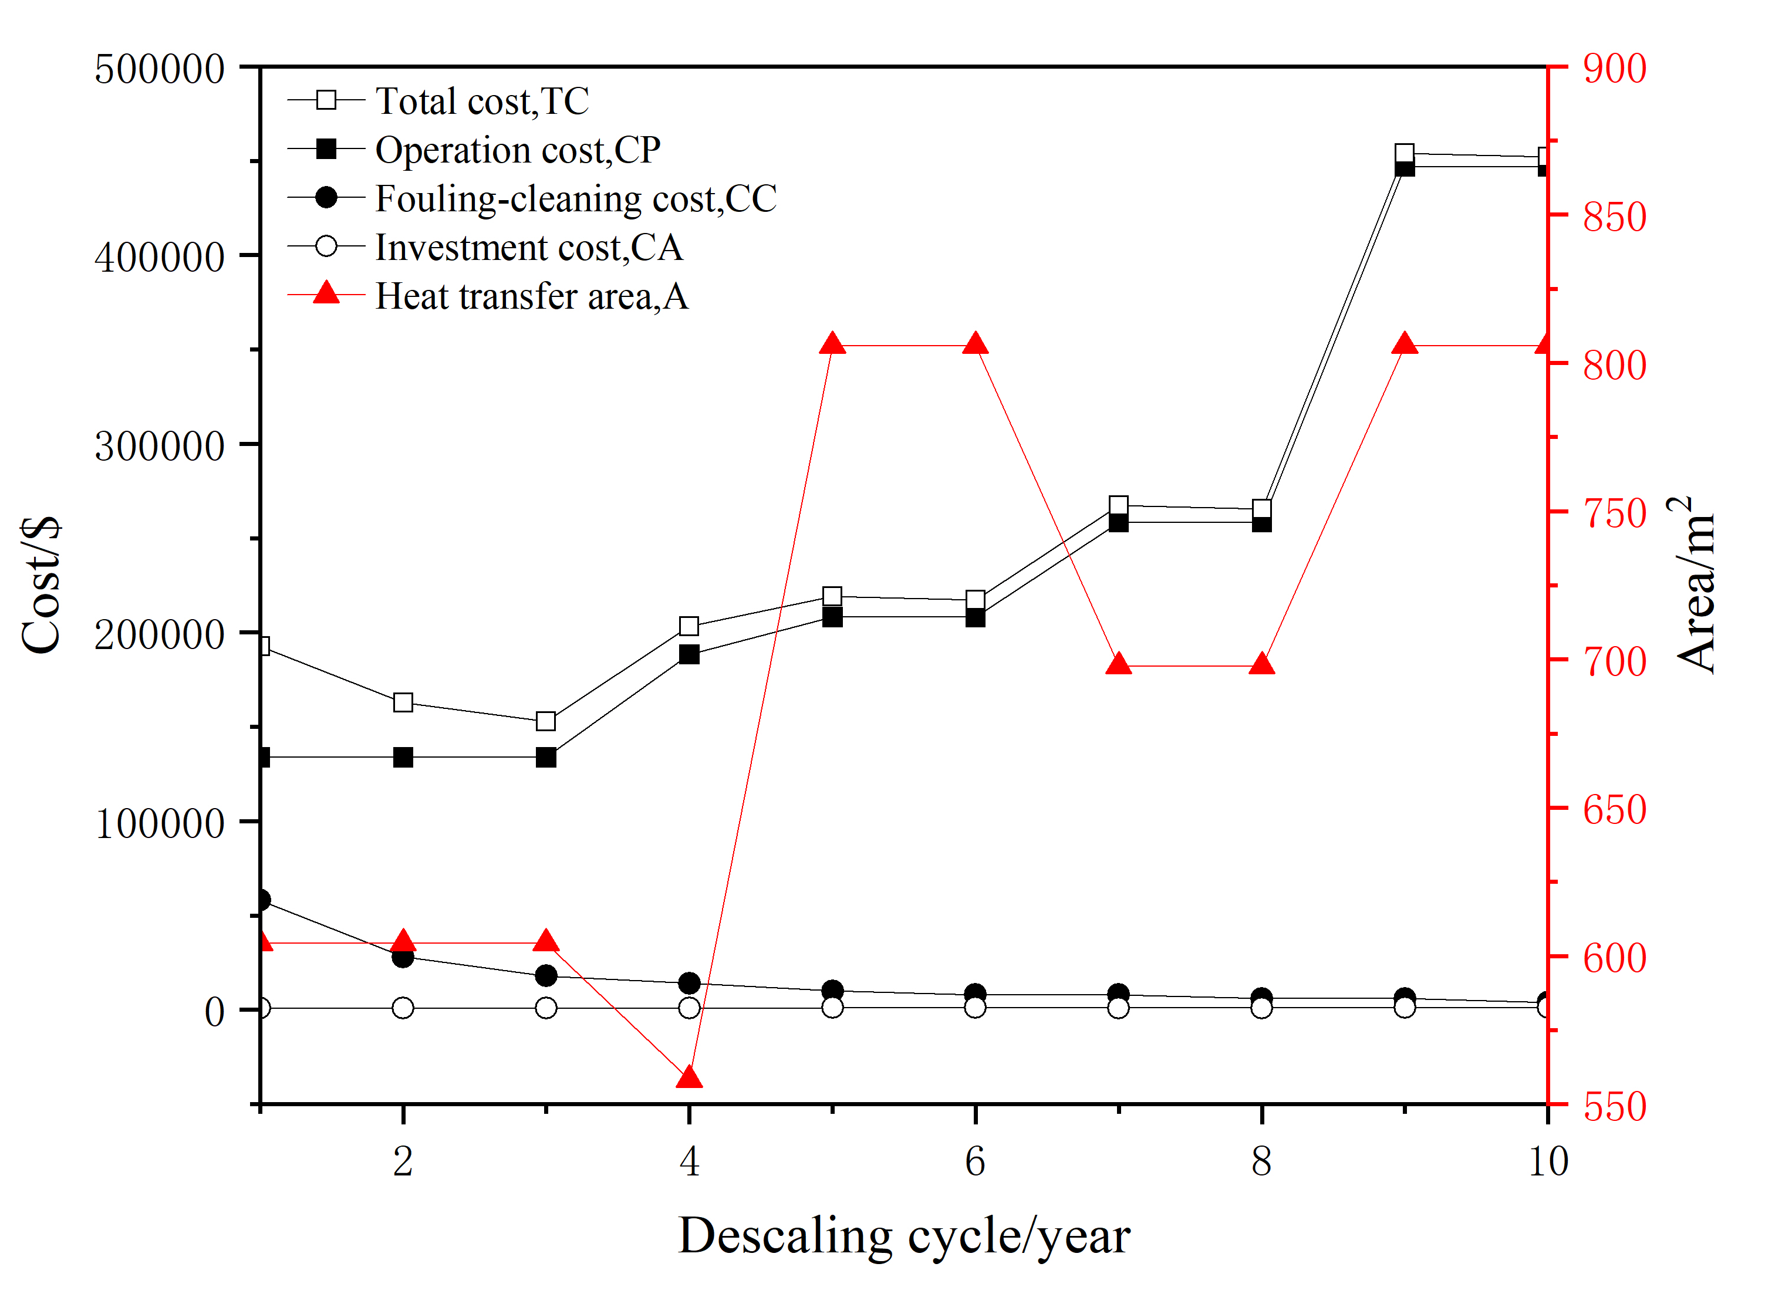
Figure 1: Sensitivity analysis results - based on descaling cycle
Figure 1 shows the results of the sensitivity analysis. It is evident that the minimum total cost is achieved with the 3-year descaling cycle. In terms of the composition of the total cost, the operation cost and the total cost have basically the same trend. As the heat exchanger descaling cycle increases, both the operation cost and the total cost show an upward trend. Conversely, the fouling-cleaning cost is decreasing with the extension of the descaling cycle, and the investment cost of the heat exchanger accounts for less in the total cost.
In terms of the heat exchange area, the program gives consistent results for different descaling cycle conditions. For descaling cycles of 1-year, 2-year, and 3-year, identical heat exchanger design solutions are produced, resulting in equivalent investment and operation cost. However, varying descaling cycles impact descaling cost, with the 3-year cycle resulting in the minimal cost. In the case of a 4-year descaling cycle, the largest tube outer diameter among the 10 cycles reduces the total number of tubes, leading to the smallest heat exchanger area. At the same time, adopting the 6-tube-pass increases tube-side velocity and pressure drop, consequently elevating operation cost and total cost. For descaling cycles of 5-year and 6-year, a set of design solutions is applicable, while 9-year and 10-year cycles correspond to another set. Despite both groups of design solutions providing the same heat transfer area, the longer descaling cycle prompts the latter set to select the 6-tube-pass, resulting in higher operation cost and a notably larger total cost compared to the former set. Descaling cycles of 7-year and 8-year result in a small heat transfer area and high total cost due to factors akin to those observed in the 4-year descaling cycle, including large tube outer diameters and an increased number of tube passes.
  - Conclusion
This paper introduces a novel approach to designing shell and tube heat exchangers, utilizing Set Trimming and incorporating a fouling model for more realistic optimization. When minimizing heat transfer area, the program generates a value 2.6% smaller than the literature value. This results in a higher pressure drop and reduced heat exchanger area margin, but remains within acceptable limits.
Moreover, a sensitivity analysis of the heat exchanger descaling cycle is conducted to minimize total cost, revealing that the 3-year descaling cycle offers optimal cost efficiency. Results indicate that operation cost have a greater impact on total cost, with investment and fouling-cleaning cost comprising a smaller fraction of total cost. However, when different descaling cycles yield identical design solutions, fouling-cleaning cost become the decisive factor. The proposed method is validated by adjusting the objective function and conducting a sensitivity analysis, demonstrating its rationality and superiority. This method has the potential to enhance heat exchanger performance and reduce refinery cost.
References
M. Amini, M. Bazargan, 2014, Two objective optimization in shell-and-tube heat exchangers using genetic algorithm, Applied Thermal Engineering, 69,1-2, 278-285.
A. C. Caputo, P. M. Pelagagge, P. Salini, 2011, Joint economic optimization of heat exchanger design and maintenance policy, Applied Thermal Engineering, 31, 8-9, 1381-1392.
A. L. H. Costa, J. C. Lemos, M. J. Bagajewicz, 2017, Heat Exchanger Design Optimization Considering Threshold Fouling Modelling, Computer Aided Chemical Engineering, 40, 799-804.
A. L. H. Costa, M. J. Bagajewicz, 2019, 110th anniversary: On the departure from heuristics and simplified models toward globally optimal design of process equipment, Ind. Eng. Chem. Res. 58, 18684–18702.
C. D. O. Gonçalves, A. L. H. Costa, M. J. Bagajewicz, 2016, Shell and tube heat exchanger design using mixed‐integer linear programming, AIChE Journal, 63, 6, 1907-1922.
A. Hadidi, M. Hadidi, A. Nazari, 2013a, A new design approach for shell-and-tube heat exchangers using imperialist competitive algorithm (ICA) from economic point of view, Energy Conversion & Management, 67, Mar., 66-74.
A. Hadidi, A. Nazari, 2013b, Design and economic optimization of shell-and-tube heat exchangers using biogeography-based (BBO) algorithm, Applied Thermal Engineering, 51, 1-2, 1263-1272.
G. F. Hewitt, 2008, Heat exchanger design handbook, Begell house: New York, United States of America.
F. P. Incropera, D. P. DeWitt, T. L. Bergman, A. S. Lavine, 2006, Fundamentals of Heat and Mass Transfer, 6th ed., John Wiley & Sons: Hoboken, United States of America.
N. M. Khalfe, S. K. Lahiri, S. K. Wadhwa, 2011, Simulated annealing technique to design minimum cost exchanger, Chemical Industry & Chemical Engineering Quarterly, 17, 4, 409-427.
J. C. Lemos, A. L. H. Costa, M. J. Bagajewicz, 2018, Globally optimal linear approach to the design of heat exchangers using threshold fouling modeling, AIChE Journal, 64, 6, 2089-2102.
J. C. Lemos, A. L. H. Costa, M. J. Bagajewicz, 2022, Design of shell and tube heat exchangers considering the interaction of fouling and hydraulics, AIChE Journal,68, 5, e17586.
V. K. Patel, R. V. Rao, 2010, Design optimization of shell-and-tube heat exchanger using particle swarm optimization technique, Applied Thermal Engineering, 30, 11-12, 1417-1425.
E. A. D. Saunders, 1988, Heat Exchangers Selection, Design and Construction, John Wiley & Sons: New York, United States of America.
O. E. Turgut, M. S. Turgut, M. T. Coban, 2014, Design and economic investigation of shell and tube heat exchangers using Improved Intelligent Tuned Harmony Search algorithm, Ain Shams Engineering.

