Stability and Fairness in Unconstrained
Multi-Actor Heat Integration Problems
Fabian Lechtenbergª, Antonio Espuñaª, Moisès Graells^{a*}
ªDepartment of Chemical Engineering, Universitat Politècnica de Catalunya, Barcelona, Spain
*moises.graells@upc.edu
Abstract
This work explores the application of cooperative game theory to multi-actor heat integration, focusing on unconstrained 3-player situations. A stability proof is given, paving the way for general stability proofs in N-player settings. The findings reveal that stable profit distribution is achievable in collaborative heat integration projects, in the case of unconstrainted integration potential. The study highlights the influence of key parameters on profit allocation, like the minimum temperature difference (ΔT_{min}), emphasizing the need for optimal alignment of efficiency and equity. This research offers crucial insights for process integration decision-makers, promoting sustainable and fair multi-actor collaborations.

Keywords: game theory, multi-actor heat integration, stability proof, profit distribution
  - Introduction
Process Integration (PI) has long been recognized as a key strategy in enhancing the efficiency of resource and equipment usage within the industrial sector. Traditionally limited to intra-company operations, PI has primarily focused on optimizing within a single company’s boundaries. Current trends like globalization and the push for more efficient solutions based on industrial symbiosis have shifted the focus towards a broader scope, encompassing resource exchange and equipment sharing across company boundaries. This expansion significantly increases the potential for integration but also introduces the challenge of collaborative dynamics. Questions arise about the existence of stable agreements and the fair distribution of profits among participants. These concepts are essential to ensure the feasibility of sustainable collaborative relationships within the process industry. As a result, the Process Systems Engineering (PSE) community has started to explore these complexities through the lens of Game Theory.

Notable examples include Hiete et al. (2012) who applied the Shapley Value for profit distribution in a 3-company heat exchange network, Cheng et al. (2014) who used a sequential approach integrating Nash equilibrium for trade price and network structure decisions, and Jin et al. (2018) who incorporated risk factors using a modified Shapley Value to account for uncertainties in coalition stability. These studies have successfully demonstrated the application of cooperative Game Theory concepts in multi-actor process integration scenarios, providing valuable frameworks for decision-makers to reach sustainable agreements.
However, the stability criterion, which is crucial for rational decision-making, is not addressed properly. While a couple of work such as Jin et al. (2018) illustrate the existence of stable agreements through the core constraints, the novelty of this work lies in the demonstration of a stability proof for a subset of process integration problems.
Furthermore, within the realm of stable profit allocations, the selection of a concrete allocation method is usually not well justified. For instance, the most popular Shapley value is often employed, despite its well-known caveat of not guaranteeing stable allocations. Thus, this work demonstrates the use of alternative methods, and elucidates the impact of process parameters of the PI problem on the outcome.
  - Problem Statement
This study focuses on two key aspects of the 3-player heat integration problem in a cooperative system:

Stability in the solution of unconstrained 3-player heat integration problems:
The objective is to prove that a stable profit distribution is always achievable in a 3-player heat integration scenario without integration constraints (e.g. limited total heat exchange area or piping length). This proof is crucial for the theoretical basis of collaborative PI projects, ensuring predictability and stability in profit sharing.

Fairness of the impact of allocation methods and dependence on the design parameters:
Following the establishment of stability, the study examines how the minimum temperature difference (ΔT_{min}) affects profit distribution in the PI problem.
  - Stability Proof of 3-Player Unconstrained Heat Integration
A transferable utility (TU) game is defined by a pair $\left\langle \left.N,v\right\rangle \right.$ where:
- $N=\left\{1,2,…,n\right\}$ is a finite set of players
- $v:2^{N}→R$ is a characteristic function which assigns a real number to each subset (coalition) of $N$, representing the total value the coalition can create.

In the context of a 3-player heat integration problem the players can be denoted as
$N=\left\{A,B,C\right\}$. The characteristic function for the profit allocation case can be written as:
$$v\left(A\right)=v\left(B\right)=v\left(C\right)=0$$ | $$v\left(A,B\right)=p_{AB}$$  $$v\left(A,C\right)=p_{AC}$$  $$v\left(B,C\right)=p_{BC}$$ | $$v\left(A,B,C\right)=p_{ABC}$$

Single-player profits are, by definition, zero; $p_{AB}$, $p_{AC}$, and $p_{BC}$ are the 2-player profits, and $p_{ABC}$ is the profit of the 3-player grand coalition. For the sake of brevity, the proof of super-additivity is omitted here, but it can be taken for granted that in process integration problems the grand coalition has always the best value, since rejecting the collaboration and returning to the standalone operation is always an option.

The feasible set of profit allocations that satisfy the core constraints can be interpreted as the set of stable allocations where no player has the incentive to deviate from the grand coalition to ensure a better outcome. This property is important to ensure that rational decision-makers will converge towards an outcome which grants them a level of confidence that is required for planning and design decisions. For a
3-player profit allocation situation the conditions for stability reduce to the following set of constraints:

$x_{A},x_{B},x_{C}≥0$ | (1)
$x_{A}+x_{B}≥p_{AB}$ , $x_{A}+x_{C}≥p_{AC}$, $x_{B}+x_{C}≥p_{BC}$ | (2), (3), (4)
$x_{A}+x_{B}+x_{C}=p_{ABC}$ | (5)

Where $x_{A}$, $x_{B}$, and $x_{C}$ are the profits allocated to the players. Equations (1) are the individual rationality constraints, ensuring that no player receives a worse payoff compared to working alone. In a similar fashion, Equations (2) – (4) are the group rationality constraints, ensuring that no subcoalition exists which can distribute the profit to ensure a better payoff to a subgroup of players. Finally, Equation (5) is the efficiency condition, which ensures that exactly the maximum profit of the grand coalition is distributed among the players.

These constraints can be illustrated in a ternary diagram of side length $p_{ABC}$. Each point within the diagram is an efficient allocation, and if it lies within the area enclosed by the rationality constraints it is a stable allocation. From this diagram, the conditions for the non-existence of stable allocations can be derived.

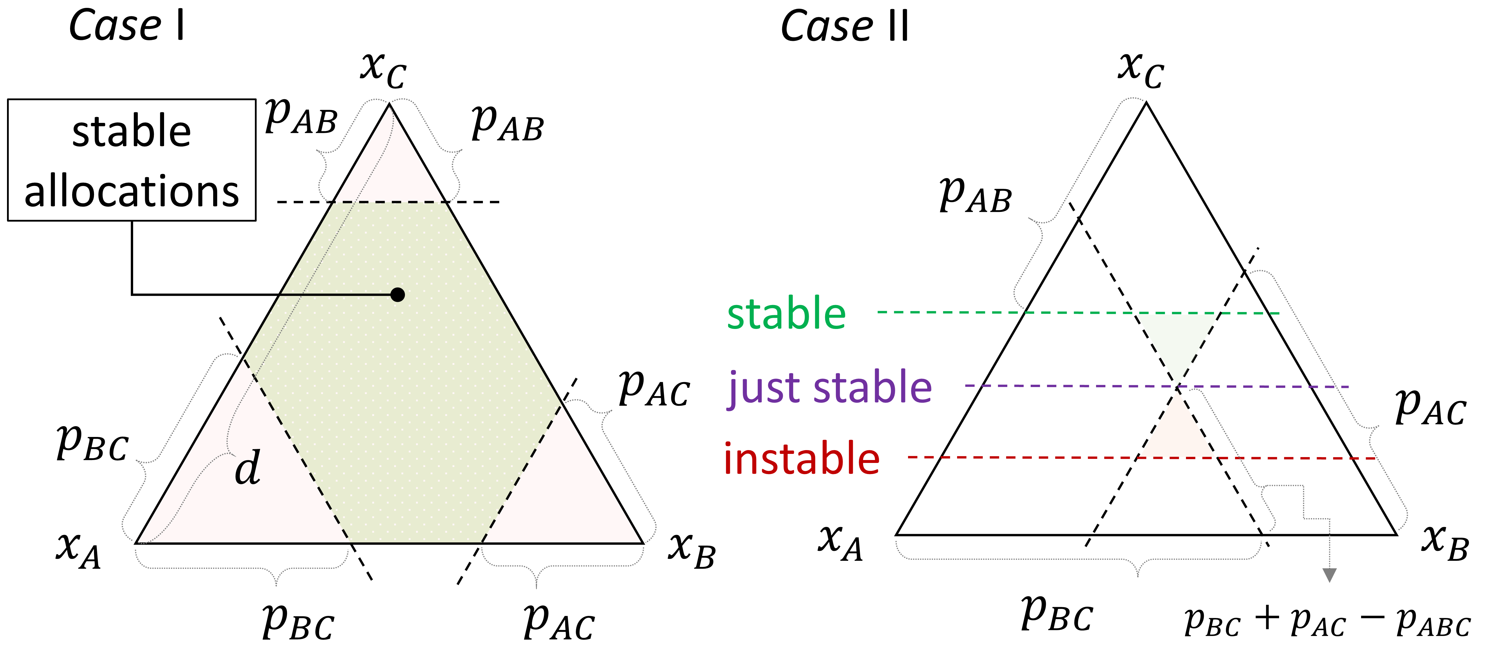
Figure 1. Geometric representation of stability in 3-player profit allocation problems.
Case I:
In the case that $p_{AB}+p_{AC}<p_{ABC}$, $p_{AB}+p_{BC}<p_{ABC}$, and $p_{AC}+p_{BC}<p_{ABC}$ it is evident that the area enclosed by the constraints is a six sided area that contains stable allocations.

Case II:
Assuming that at least for one of the sides (e.g. $p_{AC}$ and $p_{BC}$) the situation arises that that the sum of the 2-player profits exceeds the profit of the grand coalition (e.g.
$p_{AC}+p_{BC}≥p_{ABC}$) the condition on the profit of the remaining coalition (e.g. $p_{AB}$) for the non-existence of a stable allocation set can be graphically derived. Figure 1 (right) illustrates this for the case of one side and can be written as:

$p_{AB}>p_{ABC}-(p_{AC}+p_{BC}-p_{ABC})$ $⇔ 2∙p_{ABC}<p_{AB}+p_{AC}+p_{BC}$ | (6)

For the sake of brevity, this derivation deals with the simplest case of profit determination based on utility cost minimization, considering only a single heating and cooling utility, available at sufficiently high and low temperatures. Denoting the heat balance as shown in Figure 2 the problem can be written for a single company as:

$\min_{{\dot{Q}}_{z}^{H},{\dot{Q}}_{z}^{C}{\dot{Q}}_{z}}{cost=c^{Hot}⋅\sum_{z}{{\dot{Q}}_{z}^{Hot}}+c^{Cold}⋅\sum_{z}{{\dot{Q}}_{z}^{Cold}}}$ |  | (7)
$0=\sum_{h}{Δ{\dot{H}}_{h,z}^{Hot}}+{\dot{Q}}_{z}^{Hot}-\sum_{c}{Δ{\dot{H}}_{c,z}^{Cold}}-{\dot{Q}}_{z}^{Cold}+{\dot{Q}}_{z-1}-{\dot{Q}}_{z}$ | $$∀z$$ | (8)
${\dot{Q}}_{0}={\dot{Q}}_{zmax}=0$ |  | (9)
${{\dot{Q}}_{z}^{Hot},{\dot{Q}}_{z}^{Cold},\dot{Q}}_{z}≥0$ | $$∀z$$ | (10)

Where $h$ is the set of hot streams and $c$ is the set of cold streams available in the company’s process system. The set $z$ discretizes the heating and cooling demands $Δ{\dot{H}}_{h,z}^{H}$ and $Δ{\dot{H}}_{c,z}^{C}$ into $z_{max}$ temperature intervals. The external heating and cooling utilities ${\dot{Q}}_{z}^{H}$ and ${\dot{Q}}_{z}^{C}$ are also discretized into these intervals. In the objective function, these utilities are summed up and multiplied with the respective utility cost $c^{H}$ and $c^{C}$ to yield the final utility cost function. The heat transfer of higher temperature intervals to lower temperature intervals is modelled via the variable ${\dot{Q}}_{z}$ which is set to zero for the highest and lowest interval, as there are no available streams to receive from or transfer heat to.

A global optimum of this optimization problem exists and will be denoted as ${cost}^{*}$. With this, the profit maximization problem of a 2-player coalition can be written as:

$\max_{{\dot{Q}}_{z}^{H},{\dot{Q}}_{z}^{C}{\dot{Q}}_{z}}{\begin{aligned}{ p_{AB}=cost}^{*(A)}-\left(c^{Hot,A}⋅\sum_{z}{{\dot{Q}}_{z}^{Hot,A}}+c^{Cold,A}⋅\sum_{z}{{\dot{Q}}_{z}^{Cold,A}}\right)+ \\ { cost}^{*(B)}-\left(c^{Hot,B}⋅\sum_{z}{{\dot{Q}}_{z}^{Hot,B}}+c^{Cold,B}⋅\sum_{z}{{\dot{Q}}_{z}^{Cold,B}}\right)\end{aligned}}$ |  | (11)
$0=\sum_{hA}{Δ{\dot{H}}_{hA,z}^{Hot,A}}+{\dot{Q}}_{z}^{Hot,A}-\sum_{cA}{Δ{\dot{H}}_{cA,z}^{Cold,A}}-{\dot{Q}}_{z}^{Cold,A}+{\dot{Q}}_{z-1}^{\left(A\right)}-{\dot{Q}}_{z}^{\left(A\right)}+Q_{z}^{(A,B)}-Q_{z}^{(B,A)}$ | $$∀z$$ |  | (12)
$0=\sum_{hB}{Δ{\dot{H}}_{hB,z}^{Hot,B}}+{\dot{Q}}_{z}^{Hot,B}-\sum_{cB}{Δ{\dot{H}}_{cB,z}^{Cold,B}}-{\dot{Q}}_{z}^{Cold,B}+{\dot{Q}}_{z-1}^{\left(B\right)}-{\dot{Q}}_{z}^{\left(B\right)}-Q_{z}^{\left(A,B\right)}+Q_{z}^{(A,B)}$ | $$∀z$$ |  | (13)
${\dot{Q}}_{0}^{(A)}={\dot{Q}}_{0}^{(B)}={\dot{Q}}_{zmax}^{(A)}={\dot{Q}}_{zmax}^{(B)}=0$ |  |  | (14)
${\dot{Q}}_{z}^{(1)},{\dot{Q}}_{z}^{(2)},{\dot{Q}}_{z}^{Hot,A},{\dot{Q}}_{z}^{Hot,B},{\dot{Q}}_{z}^{Cold,A},{\dot{Q}}_{z}^{Cold,B},Q_{z}^{(B,A)},Q_{z}^{(A,B)}≥0$ | $$∀z$$ |  | (15)

This optimization problem introduces coupling variables $Q_{z}^{(A,B)}$ and $Q_{z}^{(B,A)}$ which enable the heat transfer between companies $A$ and $B$ as indicated in Equation (12). When forced to zero, the optimization problem can be decoupled into the two subproblems (see also Figure 3). Since these variables are introduced as positive reals, their inclusion may only improve the solution. Denoting the 2-player profit solution as $p_{AB}$, it can be reasoned that:

$p_{AB}≥ p_{A}+p_{B}$ | (16)

For the sake of brevity, here the derivation for the 3-player condition is not formally conducted in full length, but the reasoning can be followed. Introducing player $C$, counterparts $A^{*}$, $B^{*}$, and $C^{*}$, and the coupling variables $Q_{z}^{(A^{*},B^{*})}$, $Q_{z}^{(B^{*},A^{*})}$, $Q_{z}^{(B,C)}$, $Q_{z}^{(C,B)}$, $Q_{z}^{(C^{*},A)}$, and $Q_{z}^{(A,C^{*})}$ yields a particular structure. This problem may be expressed as summation of the three two player situations $(A,B)$, $(C,A^{*})$, and ${(B}^{*},C^{*})$. But similar to the reasoning of the two player case, the coupling variables connect these problems to yield, in this case, twice the problem of $(A,B,C)$. This is supported by the idea that the most economical solution to transfer heat from one player to another should be via the least amount of heat exchangers possible. For example, $A$ can directly exchange heat with $B$, so there is no incentive to go the long way to exchange heat with $B^{*}$, which offers the same synergies with $A$ as $B$. From this, it is possible to derive the relationship of the corresponding 3-player game:

$2∙p_{ABC}≥p_{AB}+p_{AC}+p_{BC}$ | (17)
Equation (17) is in direct contradiction with the necessary condition for instability derived in Equation (6), proving the proposition.
□
Figure 2. Energy balance for each temperature interval. | Figure 3. Division of multi-actor heat integration problems into subproblems.
However, if there are constraints on the process integration potential, e.g. via capacity constraints on the equipment that enables the integration, there is no guarantee of stability, as shown for instance in the case of constrained boiler capacity in the work of Lechtenberg et al. (2023).
  - Fairness of Allocation Methods and Design Parameters
With stability as an established baseline, the focus of this section lies on the fairness of allocation methods and the impact of design parameters in process integration on the outcome of profit allocation. The selection of allocation methods poses a significant challenge due to their varying notions of fairness. This is exemplified by the work of Chin et al. (2021), who have proposed and applied different methods in water integration problems. The difficulty lies in choosing the most suitable method from a set of stable allocations, a process akin to multi-criteria decision making (Grierson, 2008). To illustrate this, the problem presented by Jin et al. (2018) has been solved using four different allocation methods, employing the pyCoopGame python package, similar to the approach in Lechtenberg et al. (2023). The results, as shown in Figure 4, reveal significant variations in profit distribution based on the selected method, with each plant showing a preference for a different allocation method.
Additionally, the design parameter ΔT_{min} plays a critical role in determining the optimum balance between utility and investment cost for each company. In the study by Jin et al. (2018), which builds upon Yee and Grossmann et al. (1990), the optimum ΔT_{min} for each company was identified as unusually low (1.5K, 1.2K, and 1.7K). However, when a global ΔT_{min} of 10K was fixed, it led to two main consequences: a very different profit potential, directly resulting from the different compromise, and a biased relative profit allocation among the companies. This effect is demonstrated in Figure 4, which shows how different ΔT_{min} settings impact individual and grand coalition cost: A higher ΔT_{min}, i.e. further away from the optimal individual ΔT_{min}, is associated to a higher collaborative cost saving potential (543×10³$ for 15K). Specifying ΔT_{min} closer to the optimum balance, the integration potential of the standalone cases outpaces the collaborative integration potential, resulting in less profit to be shared among the participants (380×10³$ for 1K). From this it can be concluded that the coalition formation may, to some extent, make up for inefficient designs derived in the process integration problem. However, from a utilitarian perspective, such inefficiencies should be avoided from the very beginning. Traditionally, exclusively economics are used for decision-making in profit allocation. Future work should investigate how sustainability indicators may be utilized in the collaborative decision-making process to agree upon a definite solution.
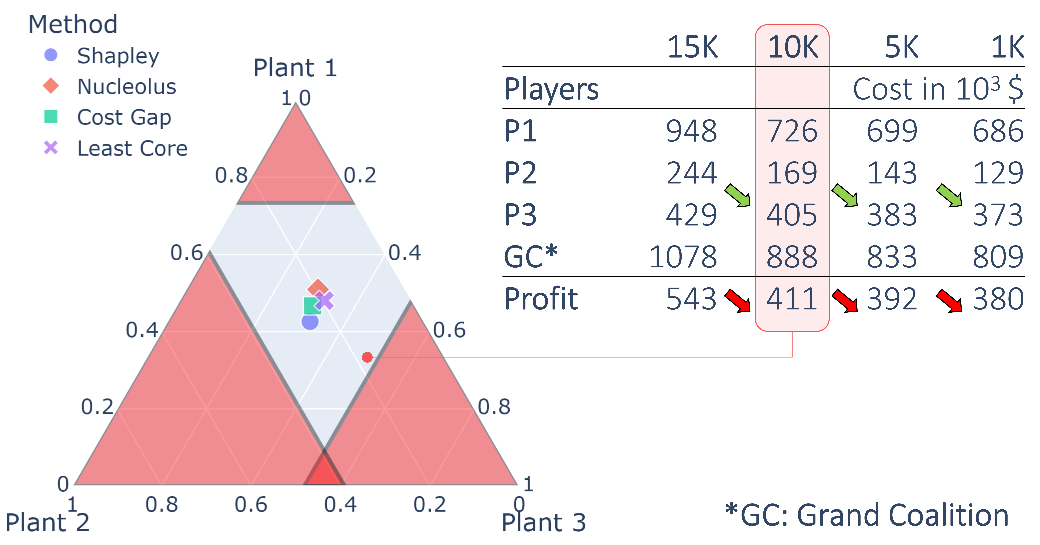
Figure 4. Profit allocation methods applied to the problem of Jin et al. (2018). The ternary diagram illustrates the shares of the total profit for the base case. The table shows the standalone and grand coalition cost and profit for varying ΔT_{min}.
  - Conclusions
This study provides a proof for stability in a subset of multi-actor process integration problems. This result is crucial for filling a gap often overlooked in previous research and paves the way for broader future proofs in collaborative profit allocation. Key findings highlight the significance of the ΔT_{min} parameter in determining both absolute and relative profits in process integration. Aligning ΔT_{min} with each participant's optimal level is essential to avoid inefficiencies and ensure fair allocations.
The stability proof offered here instills confidence in multi-actor process integration projects, assuring a degree of predictability and reliability. While the selection of allocation methods requires further research, guiding the choice of integration parameters with process engineering insights can lead to equitable and sustainable solutions, which is essential for the solutions to be accepted and implemented by all stakeholders.

Acknowledgements
Grant PID2020-116051RB-I00 (CEPI) funded by MCIN/AEI/10.13039/501100011033 and by “ERDF A way of making Europe” is fully acknowledged. Fabian Lechtenberg gratefully acknowledges the “Departament de Recerca i Universitats de la Generalitat de Catalunya” for the financial support of his predoctoral grant FI-2022.

References
S.-L. Cheng, C.-T. Chang, D. Jiang, 2014, A game-theory based optimization strategy to configure inter-plant heat integration schemes, Chemical Engineering Science, 118, 60–73
H. H. Chin, P. S. Varbanov, J. J. Klemeš, S. Bandyopadhyay, 2021, Subsidised water symbiosis of eco-industrial parks: A multi-stage game theory approach, Computers & Chemical Engineering, 155, 107539
D. E. Grierson, 2008, Pareto multi-criteria decision making, Advanced Engineering Informatics, 22(3), 371–384
M. Hiete, J. Ludwig, F. Schultmann, 2012, Intercompany Energy Integration: Adaptation of Thermal Pinch Analysis and Allocation of Savings, Journal of Industrial Ecology, 16(5), 689–698
Y. Jin, C.-T. Chang, S. Li, D. Jiang, 2018, On the use of risk-based Shapley values for cost sharing in interplant heat integration programs, Applied Energy, 211, 904–920
F. Lechtenberg, A. Espuña, M. Graells, 2023, Profit Allocation in Industrial Symbiosis Networks: Utility Exchanges, In A. C. Kokossis, M. C. Georgiadis, & E. Pistikopoulos (Eds.), Computer Aided Chemical Engineering, 961–966
T. F. Yee, I. E. Grossmann, 1990, Simultaneous optimization models for heat integration—II. Heat exchanger network synthesis, Computers & Chemical Engineering, 14(10), 1165–1184

