Discontinuous Galerkin spectral element method for continuous chromatography: Application to the Lumped Rate Model without pores
Jesper Frandsenª, Jan Michael Breuer^{b}, Eric von Lieres^{b}, Johannes Schmölder^{b}, Jakob K. Huusomª, Krist V. Gernaeyª, Jens Abildskovª
ªDept. of Chemical and Biochemical Engineering, Technical University of Denmark, Søltofts Plads, Building 228A, 2800 Kgs. Lyngby, Denmark
^{b}Forschungszentrum Jülich, IBG-1: Biotechnology, Jülich 52428, Germany
Corresponding author: jespfra@kt.dtu.dk
Abstract
This study presents CADET-Julia, an implementation of the Discontinuous Galerkin spectral element method (DGSEM) in Julia, applied to the Lumped Rate Model (LRM) and multi-component Langmuir isotherm for binary separation in both batch and simulated moving bed (SMB) operation. A comparative analysis was made of CADET-FV and CADET-DG, C++ implementations of finite volume and DGSEM found in CADET, respectively. For stiff systems operated in batch mode, CADET-FV, CADET-Julia and CADET-DG showed similar performance, however, for less stiff systems, CADET-Julia and CADET-DG were superior. For stiff systems in SMB operation, CADET-Julia was significantly faster than CADET-FV. CADET-DG could not be benchmarked at the current time.
Keywords: Chromatography, Continuous chromatography, SMB, numerical solver
1. Introduction
Chromatography is an essential unit operation for the purification of biopharmaceutical products and proteins. Continuous chromatography has the potential to increase productivity and reduce solvent consumption compared to batch chromatography. However, operating continuous chromatography is significantly more complex as it requires the use of multiple columns in series and/or parallel in either open or closed loops (Schmidt-Traub et al., 2020). Although shortcut design methods are fast tools to design some continuous operations such as the simulated moving bed (SMB) (Frandsen et al., 2023), the reliability of the design method when taking non-ideal phenomena into account such as film diffusion and pore diffusion is doubtful. Instead, design of operation can be carried out by solving comprehensive models numerically. While modelling can aid the design and operation of continuous chromatography, the simulation time required to solve the partial differential equation (PDE) models can become significant. One continuous chromatography operation, where the simulation time is significant, is the SMB operation (He et al., 2020).
Long simulation times strengthen the need for fast PDE solvers. To reduce the simulation time, Meyer implemented an arbitrary order Discontinuous Galerkin spectral element method (DGSEM) for solving the general rate model for batch chromatography (Meyer et al., 2020). More recently, Breuer developed a slightly different DGSEM and implemented it in C++. The code is open-source and publicly available in the software CADET (Breuer et al., 2023; Leweke & von Lieres, 2018). Whereas C++ is a high-performing computational language, it is a low-level compiled language and thus demands more programming expertise compared to languages like Python. Conversely, Python is a high-level programming language that is very dynamic and easy to use but also slower. The programming language Julia is a dynamic, high-level programming language, yet it produces fast, low-level machine code (Bezanson et al., 2017).
In this study, an implementation of the DGSEM in Julia is made and applied to the Lumped Rate Model (LRM) without pores and the multi-component Langmuir isotherm for a binary separation. The Julia implementation is compared to the C++ implementation in CADET in terms of convergence of overall maximum absolute error (MAE) of the outlet and simulation time for both batch and SMB operation. The Julia implementation allows for rapid prototyping and customized isotherms. The package is called CADET-Julia and can be found on Github (github.com/jespfra/CADET-Julia).
2. Methodology
2.1 Model
In this study, the LRM model with the multi-component Langmuir isotherm was studied. The model and isotherm are given for each component $i$ $∈$ $[1,...,N_{C}$] in eq. (1)-(2).

 | $$\frac{∂c_{i}}{∂t}=D_{ax}\frac{∂^{2}c_{i}}{∂z^{2}}-u\frac{∂c_{i}}{∂z}-\frac{1-ε}{ε}\frac{∂q_{i}}{∂t}$$ | (1)

 | $$\frac{∂q_{i}}{∂t}=k_{kin,i}\left(k_{eq,i}c_{i}q_{max,i}\left(1-\sum_{j=1}^{N_{c}}{\frac{q_{j}}{q_{max,j}}}\right)-q_{i}\right)$$ | (2)

Here, $t$ is time, $c_{i}$ is the mobile phase concentration, $N_{c}$ is the total number of solutes, $q$ is the corresponding stationary phase concentration, $z$ is the spatial coordinate, $D_{ax}$ is the axial dispersion coefficient, $ε$ is the total porosity, $k_{eq}$ is the equilibrium adsorption constant, $q_{max}$ is the maximum adsorption capacity and $k_{kin}$ is a kinetic constant. The boundary and initial conditions are given in eq. (3)-(4), respectively.

 | $$uc_{in,i}=uc_{i}\left(t,0\right)- D_{ax}\frac{∂c_{i}(t,0)}{∂z}$$ | (3a)
 | $$\frac{∂c_{i}(t,L)}{∂z}=0$$ | (3b)
 | $$c_{i}\left(0,z\right)=0, q_{i}\left(0,z\right)=0$$ | (4)
Where L is the column length. If assuming isotherm equilibrium, the PDE system in eq. (1)-(2) must be discretized and solved as a differential algebraic equations (DAE) system, setting eq. (2) equal to 0. Alternatively, one can set a large $k_{kin}$ value to approximate the equilibrium and still discretize and solve the system as an ODE system. In CADET-Julia, the latter approach was used. For the SMB operation, four columns were used. To connect the four columns, simple mass balances were set up (Frandsen et al., 2023).

2.2 Numerical methods
To discretize the spatial coordinate, the same mathematical formulation as (Breuer et al., 2023) was implemented in Julia (Breuer et al., 2023). A brief description is given here. The idea of the DGSEM is to break down the spatial domain into cells to approximate the solution by a piece-wise polynomial approximation. The polynomials are Lagrange polynomials on Legendre-Gauss-Lobatto nodes. The transport equation (1) can be translated into an ODE system with element-wise discrete operators, given in eq. (5),

 | $$\underline{{\dot{c}}_{i}}=\frac{2}{Δz} \left(-D\left(u\underline{c_{i}}-\underline{g}\right)+M^{-1}β\left(\left(u\underline{c_{i}}-\underline{g}\right)-{\underline{h}}^{*}\right)\right)-\frac{1-ϵ}{ϵ}\frac{∂\underline{q_{i}}}{∂t}$$ | (5a)
 | $$\underline{g}=\frac{2}{Δz}D_{ax}\left(D\underline{c_{i}}-M^{-1}β\left(\underline{c_{i}}-{\underline{c_{i}}}^{*}\right)\right)$$ | (5b)
Here $\underline{\dot{c}}$ is the vector of polynomial coefficients of the temporal derivative of the polynomial approximation, $M$ is the mass matrix, $D$ is the is the polynomial differentiation matrix, $\underline{g}$ is an auxiliary variable, $β$ is the lifting matrix, $Δz$ is equidistant cell-spacing, ${\underline{h}}^{*}$ and ${\underline{c}}^{*}$ are the feasible numerical fluxes. The mass matrix can either be determined exactly or approximated using collocation of interpolation and quadrature nodes. Here the collocation method can be computationally less demanding but at a cost of accuracy. More details can be found elsewhere (Breuer et al., 2023).
Parameter | Value | Unit
$$D_{ax}$$ | $$1.0⋅{10}^{-4}$$ | $$m^{2}/s$$
Column Length | 1 | $$m$$
$$u$$ | 0.1 | $$m/s$$
$$k_{eq}$$ | $$\left[0.1, 0.05\right]$$ | $$m^{2}$$
$$q_{max}$$ | $$\left[10,10\right]$$ | -
$$ε$$ | 0.4 | -
Feed concentration 1 | $$[10,10]$$ | $$mol/L$$
Feed concentration 2 | $$[0,0]$$ | $$mol/L$$
Time sections (Batch) | $$[0,12,40]$$ | $$s$$
Switching time (SMB) | 20 | $$s$$
Number of cycles (SMB) | 2 | -
$$[u_{1},u_{2},u_{3},u_{4}]$$ | $$[5.6, 3.8, 4.7, 3.2]⋅{10}^{-2}$$ | $$m/s$$
$$[u_{D},u_{F}]$$ | $$\left[2.4, 0.9\right]⋅{10}^{-2}$$
For the comparison of numerical solvers, the performance of CADET-Julia was compared with the Finite Volume and Discontinuous Galerkin solvers in CADET, called CADET-FV and CADET-DG, respectively. The solutions of the solvers were compared with a very finely discretized solution using CADET-FV. Here, 60000 axial cells were used for the batch operation whereas 15000 axial cells were used for the SMB operation for each column. For all tests, the ODE systems were solved using absolute and relative time integration tolerances of ${10}^{-12}$ and ${10}^{-10}$, respectively, to make the discretization error dominate. For all the CADET solvers, the initial time-step was set to ${10}^{-10}$. The solutions of the PDEs were evaluated at each 0.1 second. To investigate convergence, the polynomial orders and number of cells were varied. In CADET-FV and CADET-DG, the system was solved as a DAE system using IDAS BDF solver (Hindmarsh et al., 2005). In CADET-Julia, the DifferentialEquations.jl package was used to solve the ODE systems, and specifically, the QNDF solver was chosen for the multi-component Langmuir isotherm as it was the fastest solver in initial tests (Rackauckas & Nie, 2017). All tests were run on an Asus Vivobook equipped with Intel® Core ™ i5-1035G1 CPU 1.00 GHz processor, 8Gb Ram and 64-Bit Windows 11 operating system.
Table 1: Parameters for the Batch (Breuer et al., 2023) and the SMB case studies.
3. Results and Discussion
As case studies, the separation of two components described by the Lumped Rate Model with the Langmuir isotherm using batch and SMB operation was studied. The parameters for the case study are given in table 1 (Breuer et al., 2023), where $u_{1},u_{2},u_{3} \& u_{4}$ are the SMB inlet velocities in column 1,2,3 and 4, $u_{D}$ and $u_{F}$ are the SMB desorbent inlet and SMB feed inlet velocities, respectively.
With the multi-component Langmuir isotherm, the concentration profiles and the convergence in terms of simulation time and MAE are shown in Figure 1. To approximate the Langmuir equilibrium in CADET-Julia, the kinetic constant was set to ${10}^{8} 1/s$. The concentration profiles and convergence are shown in Figure 1.
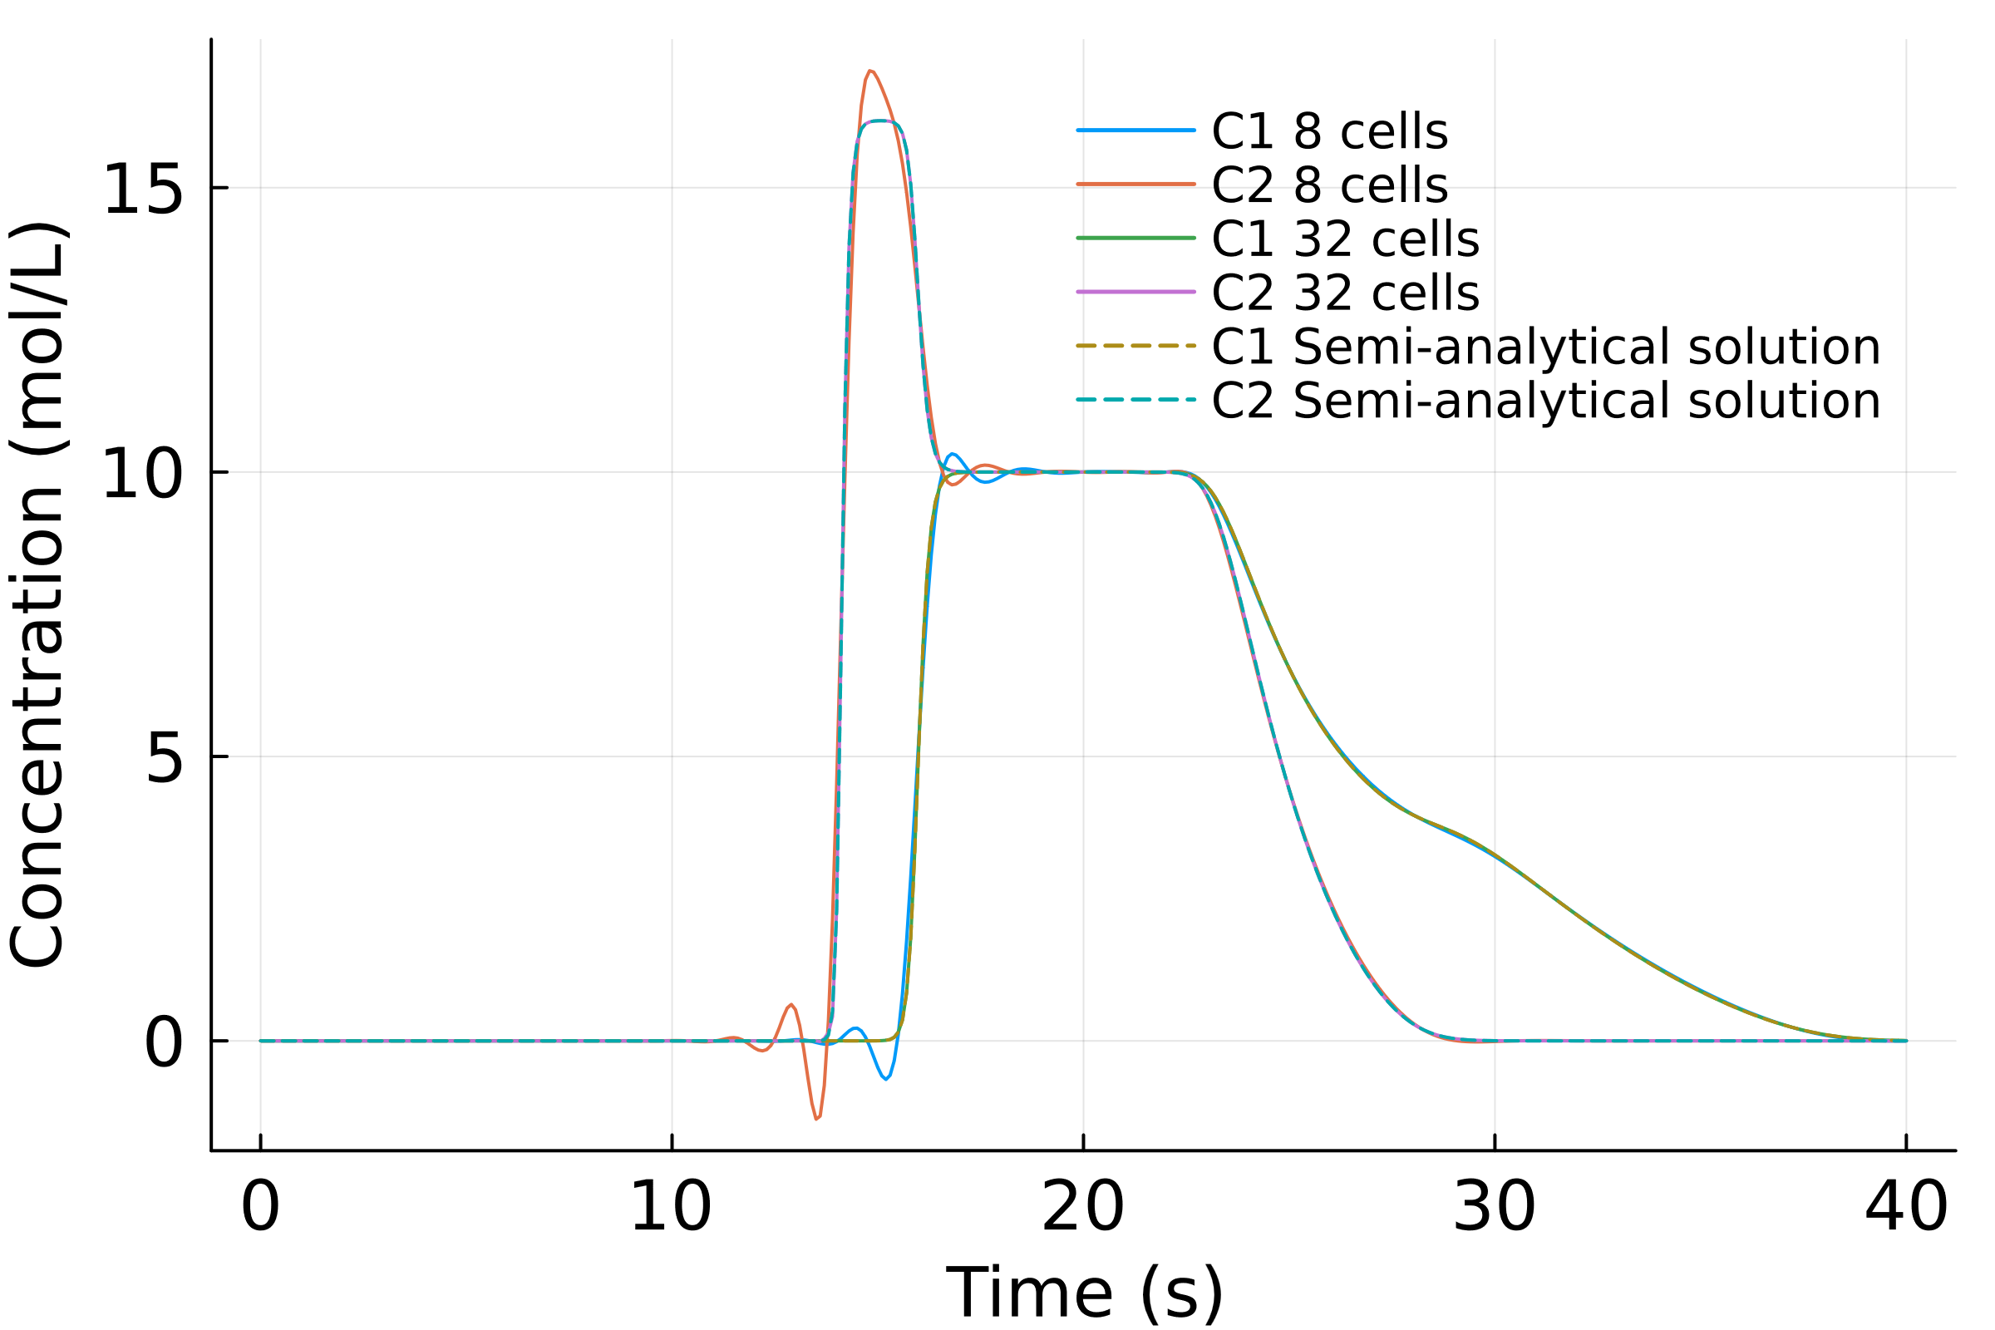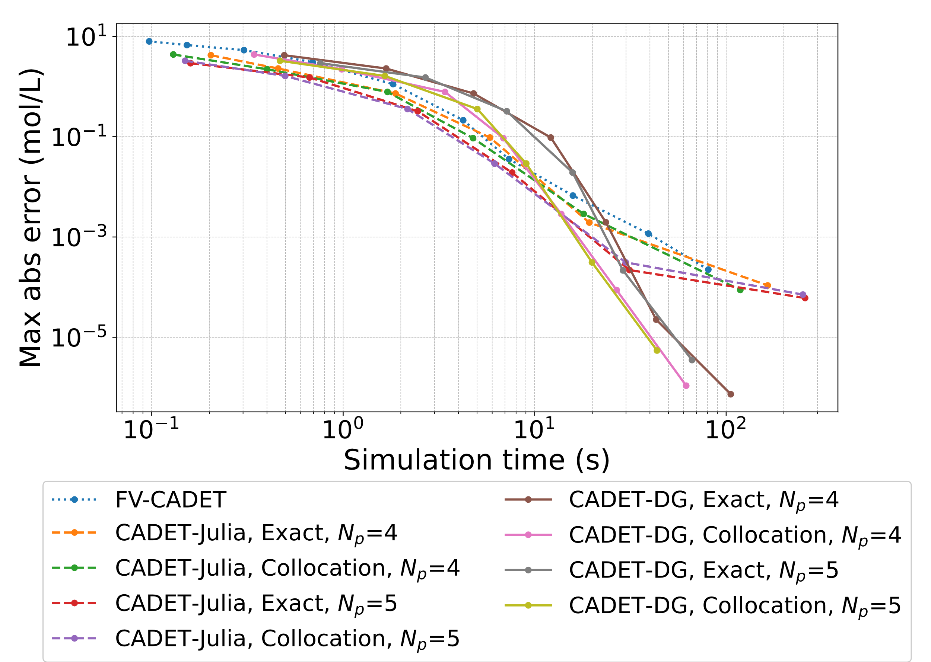
Figure 1: (a) Concentration profiles for Batch operation, simulated solutions using CADET-Julia with fourth order polynomials and 8 and 32 cells. (b) Convergence in terms of simulation time and overall maximum absolute error of the outlet.

Figure 1a shows the concentration profiles during batch operation as well as the solution simulated using CADET-Julia using up to fourth order polynomial and 8 and 32 spatial cells. The concentrations increase rapidly, and large gradients contribute to stiffness. Furthermore, when the problem is under-resolved (i.e., fewer cells), the DGSEM oscillates near these gradients which results in larger approximation errors and even negative concentration values. These oscillations disappear when increasing the number of cells as previously observed (Breuer et al., 2023). These oscillations could be corrected using for example weighted essentially non-oscillatory methods which have been implemented for CADET-FV (Leweke & von Lieres, 2018).
Figure 1b compares the simulation time and the MAEs. The figure shows similar convergence using CADET-FV, CADET-DG and CADET-Julia initially, however, at MAEs less than ${10}^{-4} mol/m^{3}$, CADET-DG is significantly faster.
For SMB operation, the concentration profiles and the convergence are shown in Figure 2. At the current time of writing, CADET-DG did not support cyclic systems for the LRM.
Figure 2a shows the concentration profiles for raffinate and extract during SMB operation along with simulations using CADET-Julia using up to fourth order polynomial and 8 and 32 cells. As for the batch operation, the simulations oscillate when using 8 cells for the raffinate concentration profiles which disappear when increasing the number of cells. In terms of convergence in Figure 2b, CADET-Julia is significantly faster despite using the same parameters as for the batch operation. This suggests that the DGSEM method for SMB systems can significantly reduce simulation time. To investigate the convergence for less stiff systems, the same simulations for batch operation have been performed using an increased axial dispersion coefficient of $1⋅{10}^{-3} m^{2}/s$.
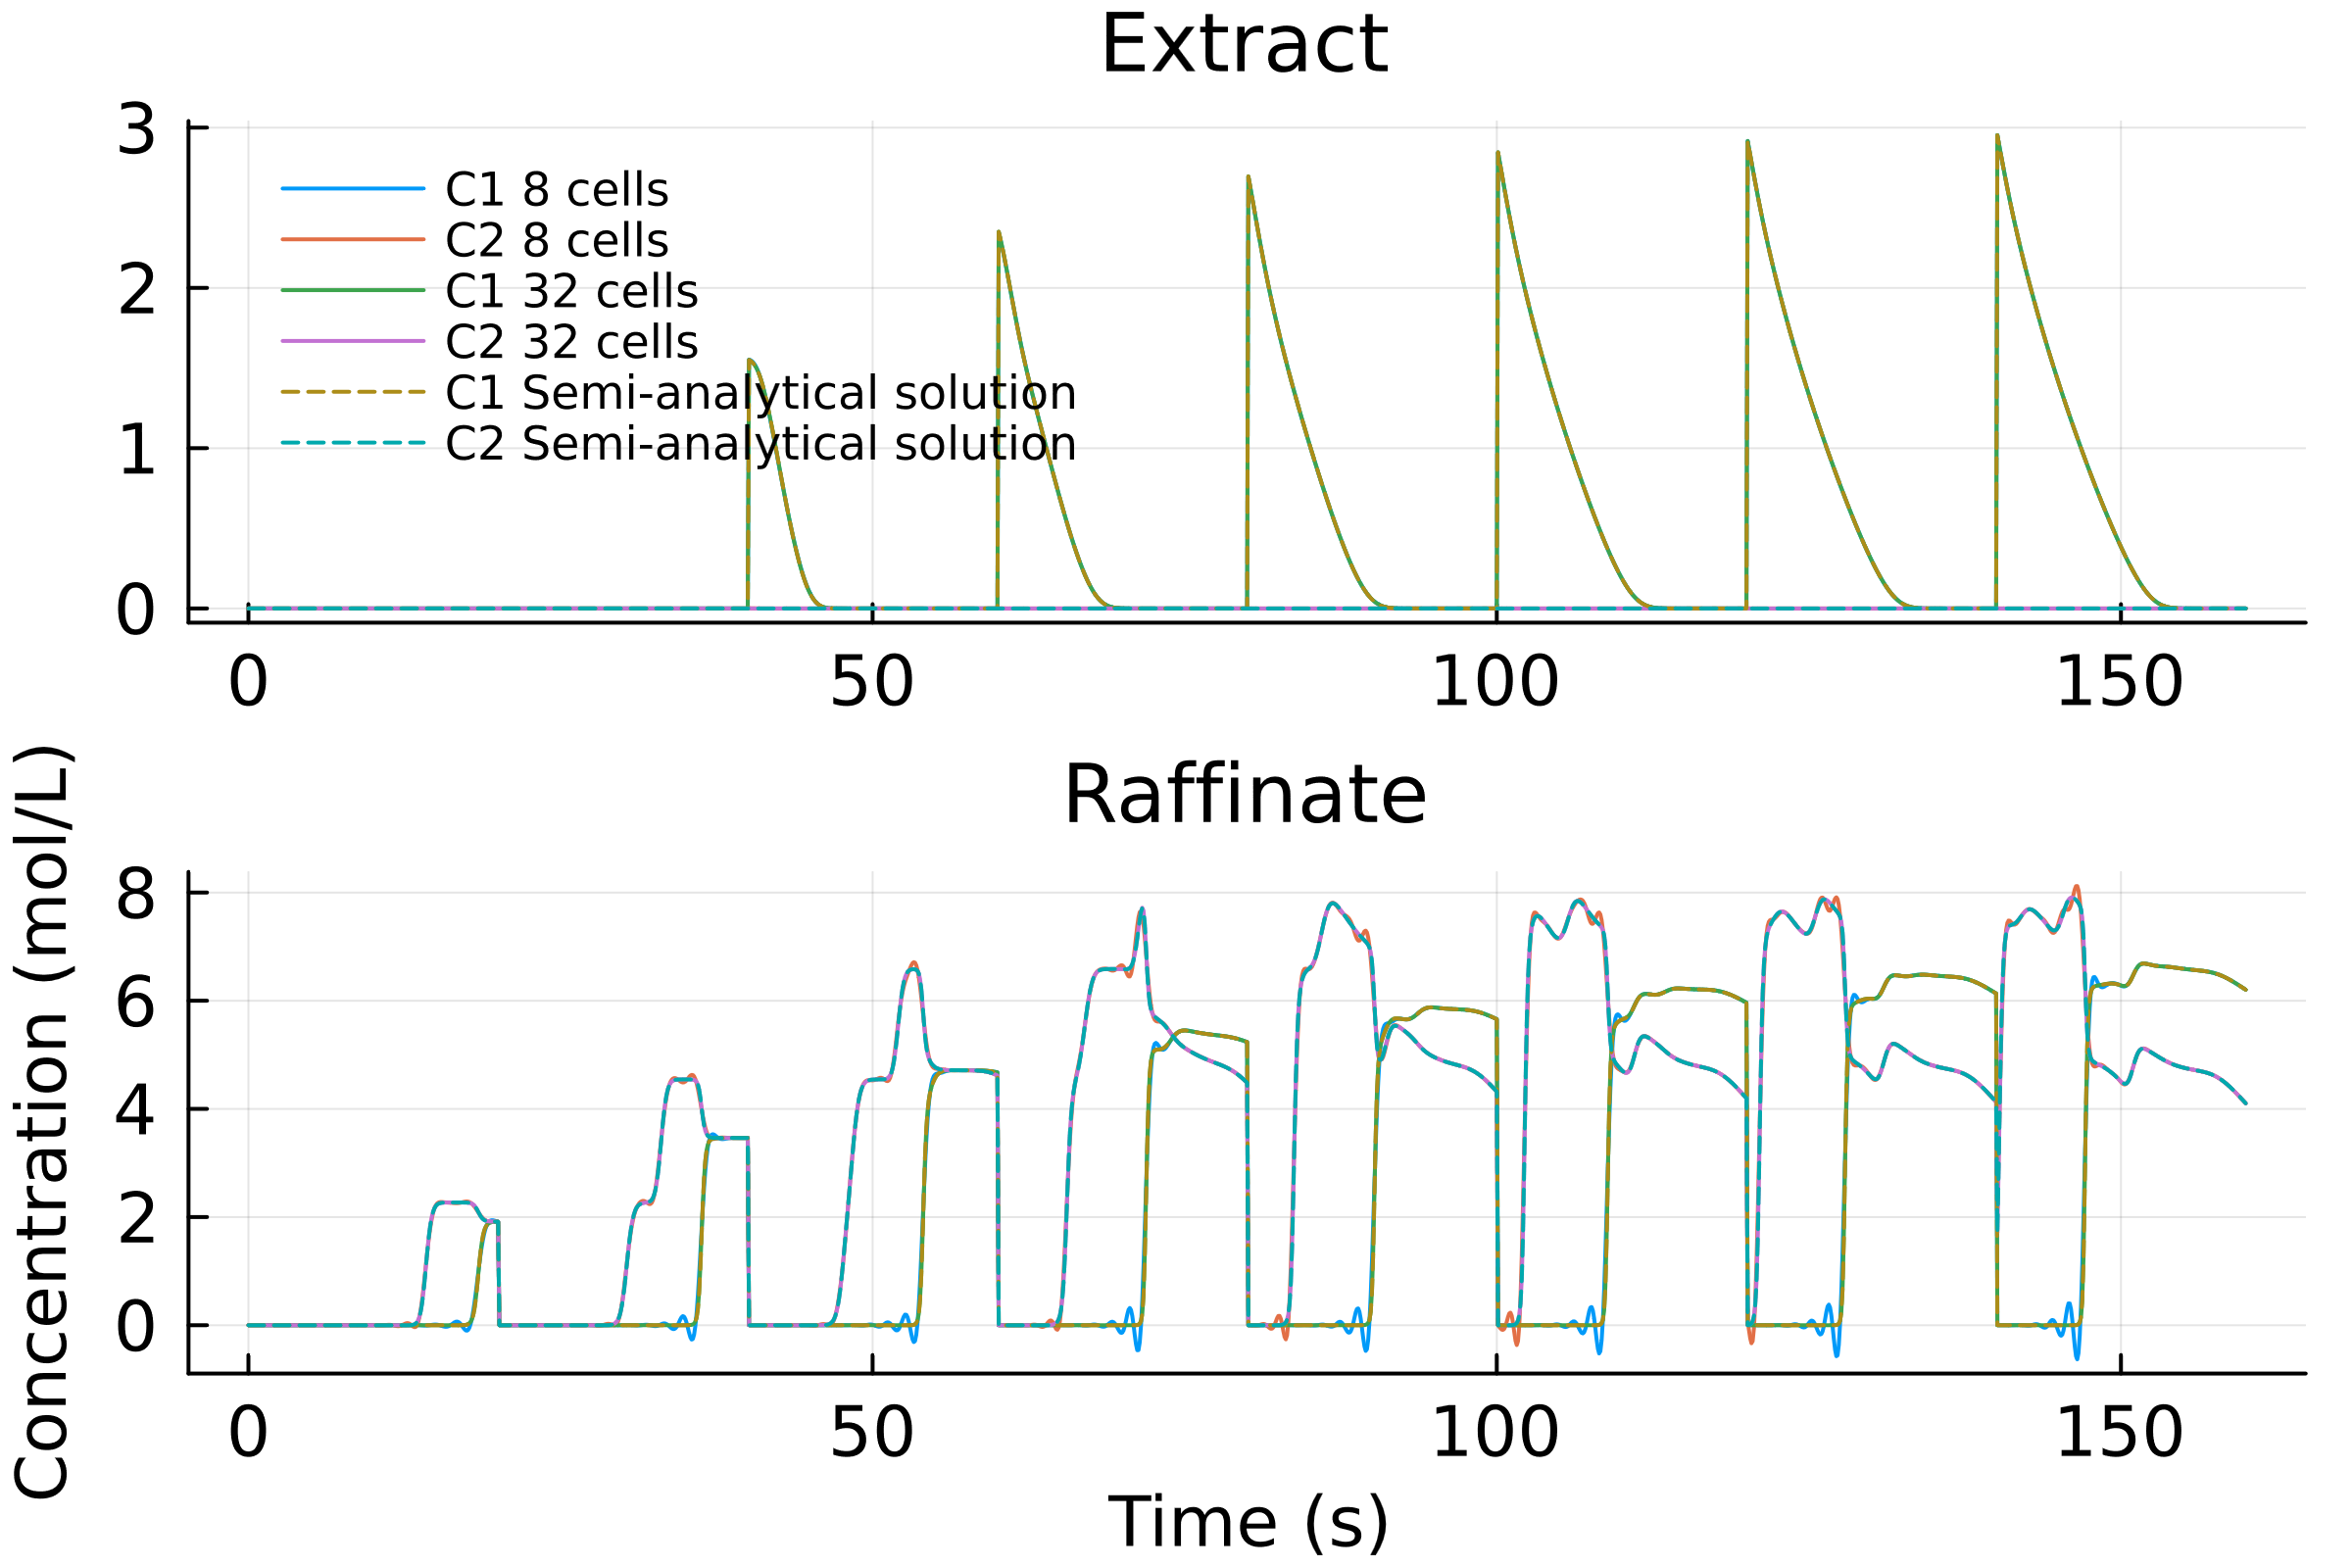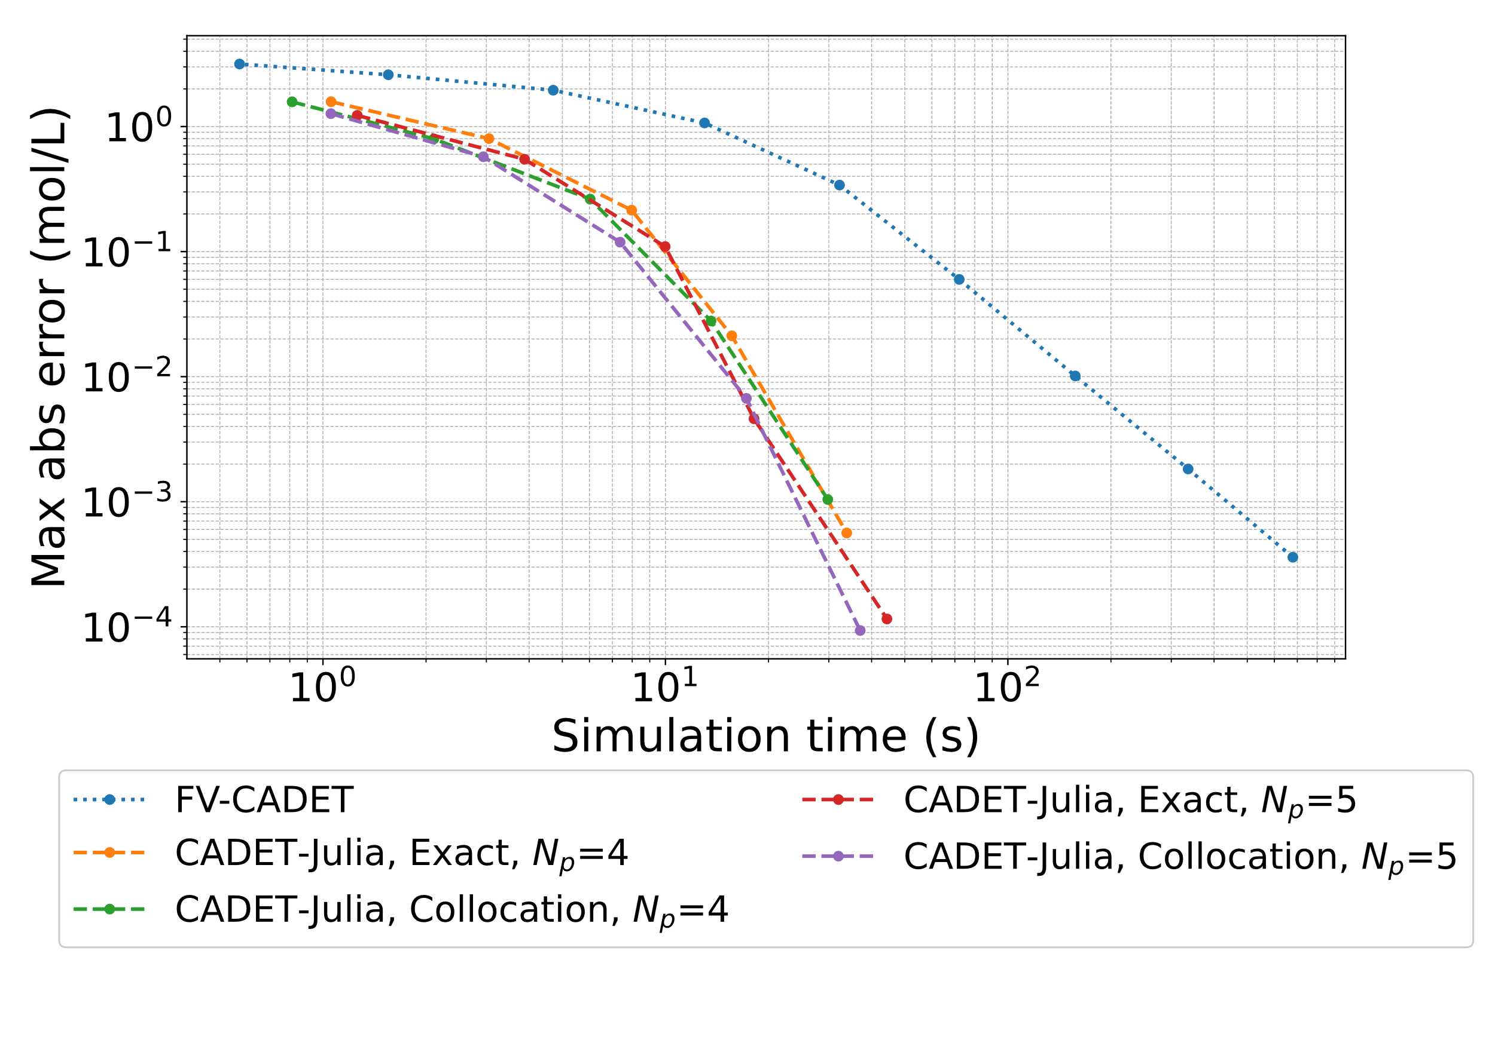
Figure 2: (a) Concentration profiles for SMB operation, simulated solutions using CADET-Julia with fourth order polynomials and 8 and 32 cells. (b) Convergence in terms of simulation time and overall maximum absolute error of the outlet.

The concentration profiles and the convergence are shown in Figure 3. The concentration profiles in Figure 3a show that few cells are adequate to simulate the profiles accurately and no oscillations were observed. The convergence in Figure 3b shows that both CADET-Julia and CADET-DG converge significantly faster than CADET-FV as expected. Comparing CADET-Julia and CADET-DG, the convergence is very similar in terms of simulation time. As in Figure 1, CADET-Julia seems to be slightly faster for a small number of cells whereas CADET-DG seems to be faster when using a larger number of cells. For Figure 3, CADET-Julia is faster at MAEs between ${10}^{-1} to {10}^{-4} mol/m^{3}$ whereas CADET-DG is faster at MAEs larger than ${10}^{-5}mol/m^{3}$. This is because CADET-Julia scales worse than CADET-DG when increasing the number of cells for discretization.
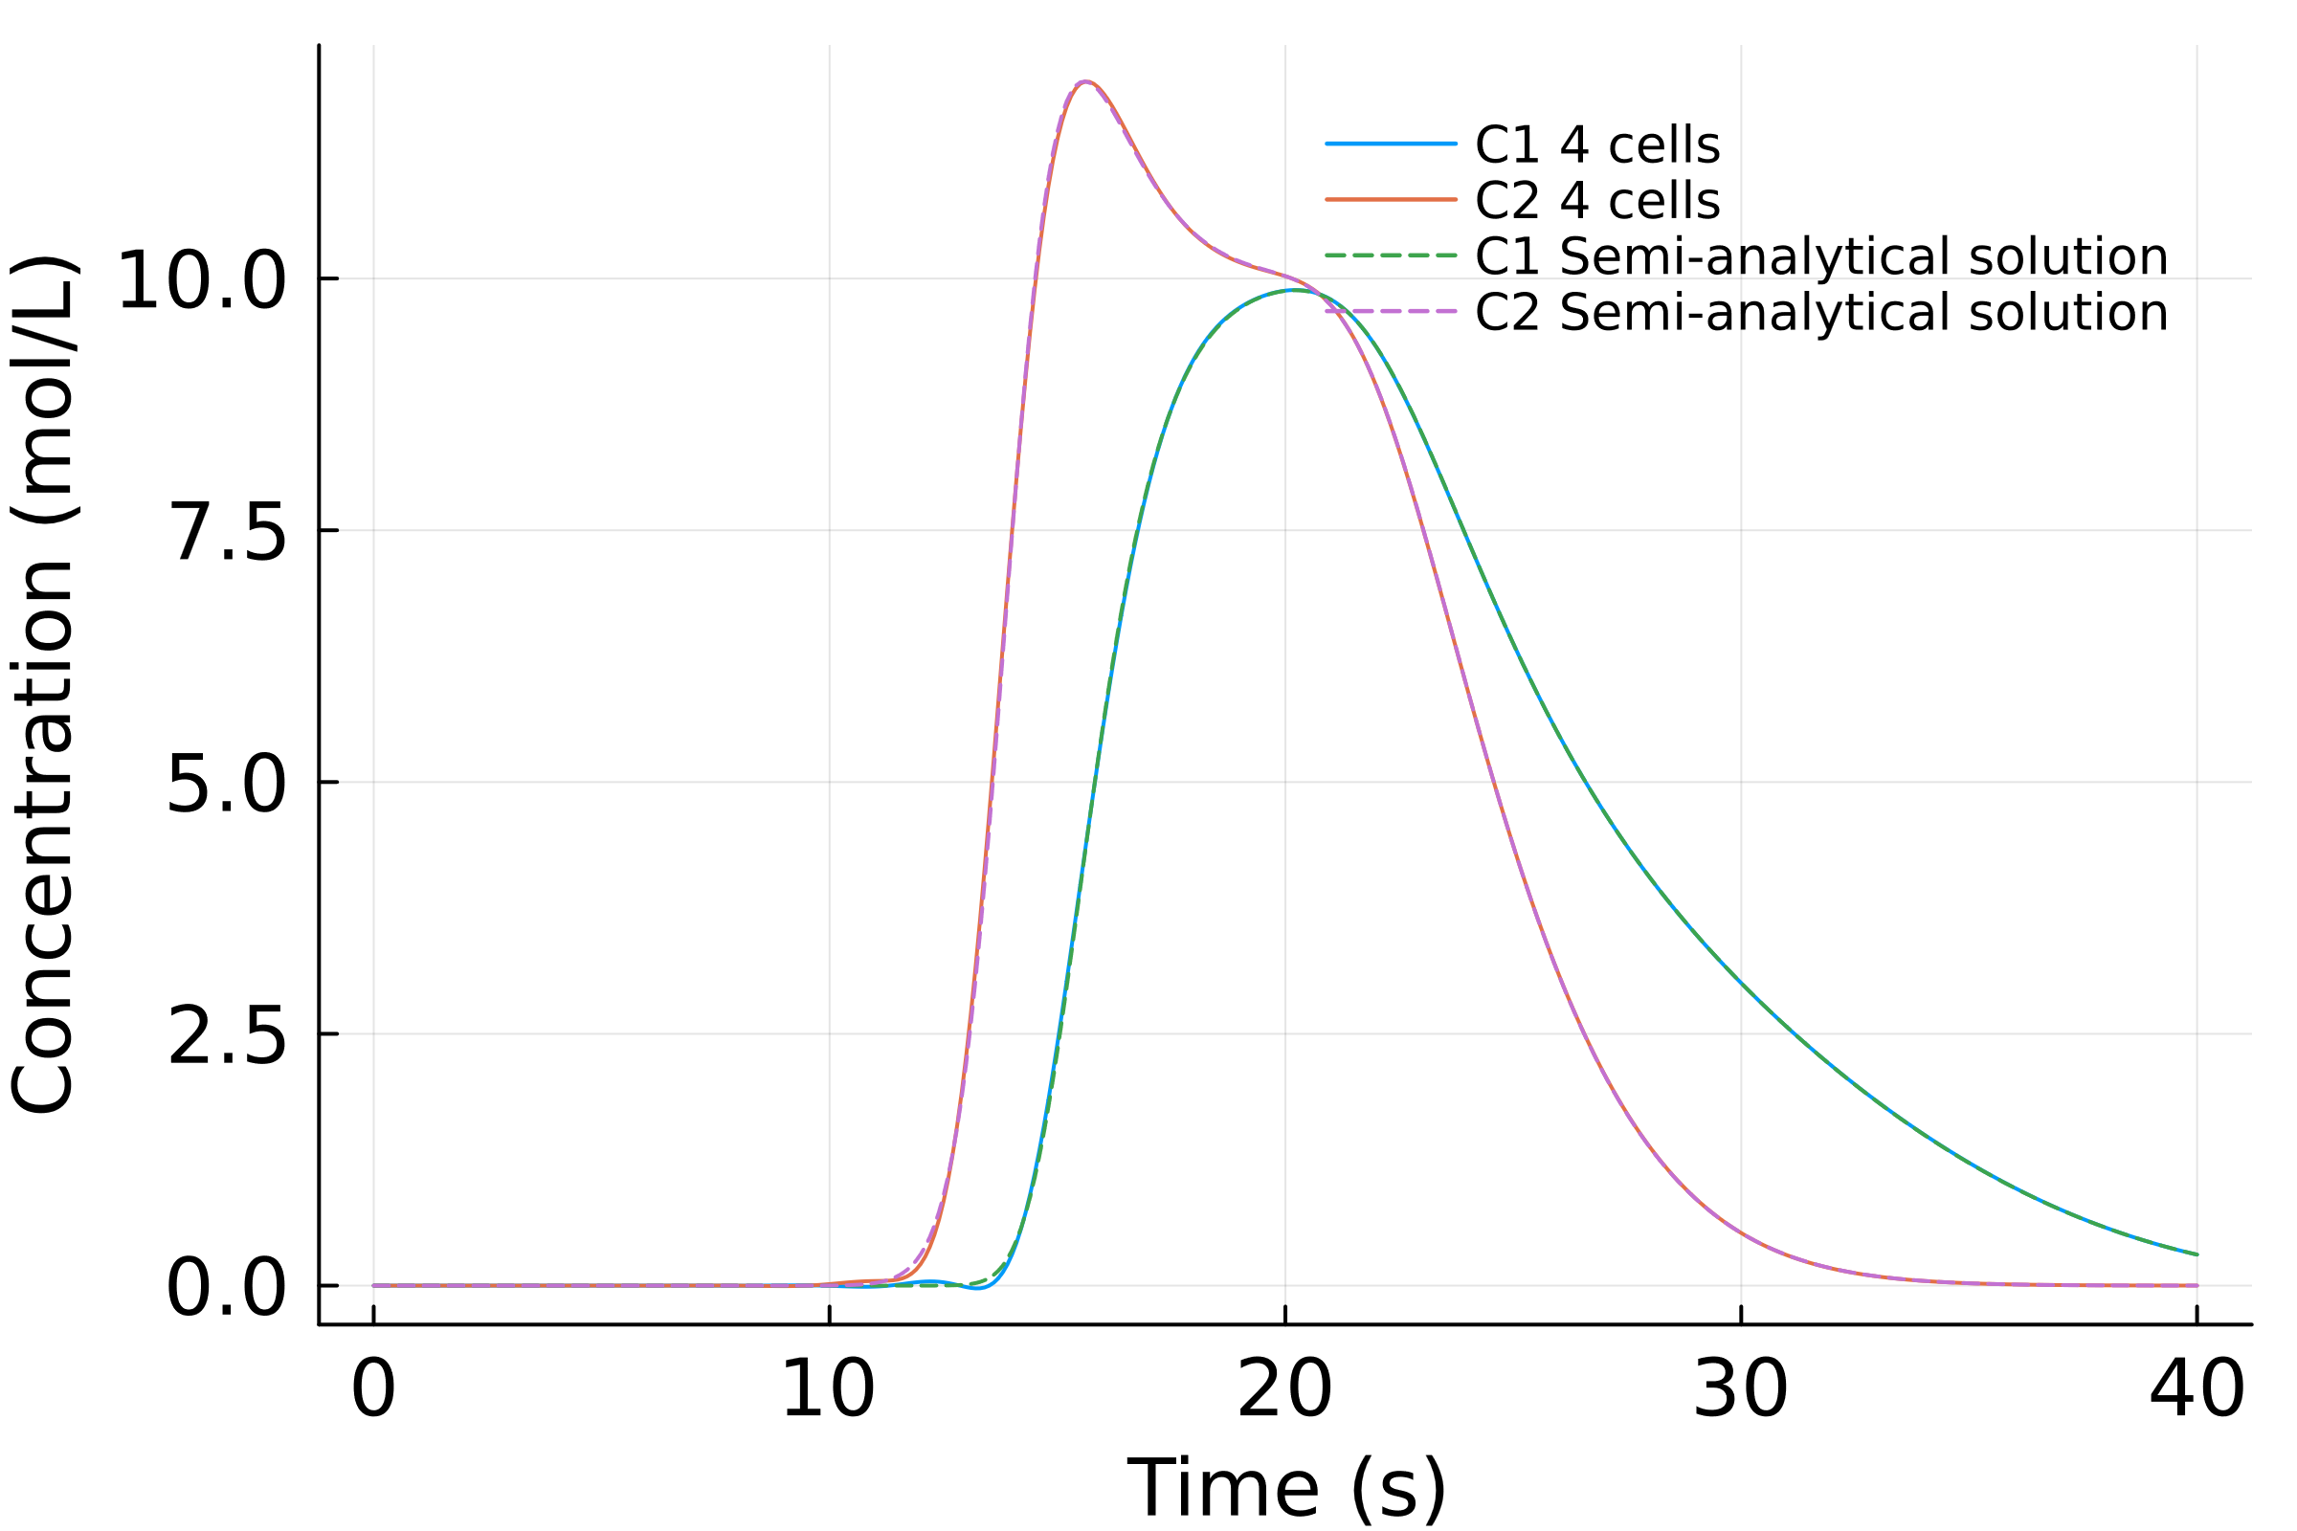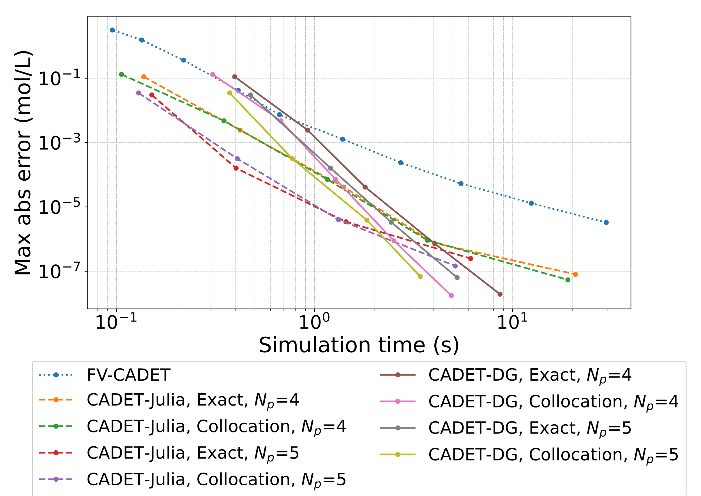
Figure 3: (a) Concentration profiles for batch operation with $D_{ax}={10}^{-3}{ m}^{2}/s$, simulated solutions using CADET-Julia with fourth order polynomials and 4 cells. (b) Convergence in terms of simulation time and overall maximum absolute error of the outlet.

The next step would be to compare CADET-Julia, CADET-FV and CADET-DG using more complex transport models such as the lumped rate model with pores or the general rate model and incorporating various isotherms. Conducting more extensive analysis would enhance the understanding of the performance differences between the C++ implementation in CADET and the Julia implementation in CADET-Julia. Another reasonable step for CADET-Julia would be to implement actual equilibrium isotherms which requires solving the PDEs as system of DAEs instead of approximating the equilibrium using a high kinetic constant and solving the system as system of ODEs. Additionally, correcting oscillatory solutions and negative concentrations should be implemented using an oscillation suppression mechanism for DG. This ensures a robust numerical scheme for especially steep concentration fronts. The Julia package DifferentialEquations.jl offers various solvers (Rackauckas & Nie, 2017). Rigorous testing of these solvers is needed to identify the most effective ones for different transport models, isotherms, and tolerances.
4. Conclusion
In this paper, a spatial DGSEM was implemented in Julia (CADET-Julia) and applied to the LRM with the multi-component Langmuir isotherm for both batch and SMB operation. The CADET-Julia was compared with CADET-FV and CADET-DG which are C++ implementations of the FVM and DGSEM, respectively. The results showed comparable simulation speeds between CADET-FV, CADET-Julia and CADET-DG in batch operation for a stiff system. For SMB operation, CADET-Julia was significantly faster compared to CADET-FV. In general, using too few cells with the DGSEM for stiff systems can lead to oscillating solutions with negative concentrations. Hence, when using DGSEM for stiff problems, care should be taken on the number of cells for discretization. For less stiff batch operation, CADET-Julia and CADET-DG were significantly faster than CADET-FV.

Acknowledgements
This study was financially supported by the Technical University of Denmark. Johannes Schmölder and Krist V. Gernaey have received support from the IMI2/ EU/EFPIA joint undertaking Inno4Vac under grant n° 101007799.
References
Bezanson, J., Edelman, A., Karpinski, S., & Shah, V. B. (2017). Julia: A fresh approach to numerical computing. SIAM Review, 59(1), 65–98.
Breuer, J. M., Leweke, S., Schmölder, J., Gassner, G., & von Lieres, E. (2023). Spatial discontinuous Galerkin spectral element method for a family of chromatography models in CADET. Computers & Chemical Engineering, 108340.
Frandsen, J., Huusom, J. K., Gernaey, K. V., & Abildskov, J. (2023). Shortcut design method for multicomponent gradient simulated moving beds. AIChE Journal.
He, Q. Le, von Lieres, E., Sun, Z., & Zhao, L. (2020). Model-based process design of a ternary protein separation using multi-step gradient ion-exchange SMB chromatography. Computers and Chemical Engineering, 138, 106851.
Hindmarsh, A. C., Brown, P. N., Grant, K. E., Lee, S. L., Serban, R., Shumaker, D. E., & Woodward, C. S. (2005). SUNDIALS: Suite of nonlinear and differential/algebraic equation solvers. Acm Transactions on Mathematical Software, 31(3), 363–396.
Leweke, S., & von Lieres, E. (2018). Chromatography Analysis and Design Toolkit (CADET). Computers and Chemical Engineering, 113, 274–294.
Meyer, K., Leweke, S., von Lieres, E., Huusom, J. K., & Abildskov, J. (2020). ChromaTech: A discontinuous Galerkin spectral element simulator for preparative liquid chromatography. Computers and Chemical Engineering, 141, 107012.
Rackauckas, C., & Nie, Q. (2017). DifferentialEquations.jl – A Performant and Feature-Rich Ecosystem for Solving Differential Equations in Julia. Journal of Open Research Software, 5(1), 15.
Schmidt-Traub, H., Schulte, M., & Seidel-Morgenstern, A. (2020). Preparative Chromatography for Separation of Proteins. In John Wiley & Sons (3rd edition). John Wiley & Sons.

