Learning based Adaptive Robust Control of a Precipitation Process
Sandesh Hiremath,ª Mikhail Kakanov,ª Andreas Voigt,^{b} Kai Sundmacher,^{b} Naim Bajcincaª
ªDepartment of Mechanical and Process Engineering, RPTU Kaiserslautern, Gottlieb
Daimler-Straße 42, 67663 Kaiserslautern, Germany.
^{b}Faculty of Process and Systems Engineering Institute of Process Engineering
Universitätsplatz 2, 39106 Magdeburg, Germany.
sandesh.hiremath@rptu.de
Abstract
In this work we propose a novel learning-based controller for the control of a batch-type precipitation process involving a carbonate substance. The controller utilizes a stochastic state space model for predicting the process dynamics. The prediction model is based on population balance equation and particle growth kinetics. The model also accounts for stochastic factors, process uncertainties and model imperfections. The controller is designed via a predictive stochastic control formulation and is implemented in a learnable manner. For this we propose a novel architecture where in both the prediction model $Φ$ and control synthesis model $Λ$are implemented using a deep neural network (DNN) based on which we incorporate joint training of $Λ$ and $Φ$ via transfer-learning technique. Finally, we perform simulations and demonstrate the superior robustness to stochastic disturbances and improved adaptivity to the varying process dynamics.
Keywords: Stochastic PDE control, Learning-based control, Process control.
  - Introduction
Solving global climate change problem requires innovative strategies for reducing green-
house gas emissions, particularly the permanent sequestration of carbon dioxide. Carbon
mineralization, proposed in 1990 (Seifritz, 1990), offers a way to store CO2 as stable and eco-friendly carbonates, establishing a leakage-free method for its disposal. Calcium and magnesium, among abundant alkaline earth metals, stand out for carbonate formation (Goff et al., 1998). Natural minerals and industrial waste streams like cement, coal ash, and steelmaking slag serve as viable feedstocks (Sanna et al., 2014). Chemical processes often involve macroscopic and microscopic phenomena, impacting material properties. Specifically, within carbonate precipitation, precise particle size distribution (PSD) control is pivotal for optimizing throughput and sustainability of carbon capture and storage. Control methodologies for chemical systems range from PDEs, molecular dynamics, and Monte-Carlo models to integro-differential equations like population balances. The field has seen significant advancements in nonlinear PDEs, leading to robust controllers (Armaou et al., 2006). Control strategies now encompass particulate and fluid dynamic systems (Rajagopalan et al., 2019) with approaches to distributed parameter systems like passivity-based (Ydstie, 2002) and predictive control (Chen et al., 2019). These classical control methods face challenges in handling noisy perturbations and lack real-time autonomy due to the necessity of frequent system re-identification, thus impeding production throughput. Furthermore, the static/dynamic optimization formulations limit adaptability and learning from data, unlike their statistical counterpart.
The success of machine learning, especially deep neural networks (DNNs) has revolutionized solution techniques across all domains of research and applications, in particular also for the control of particulate processes. The Deep-Q-Network (DQN) technique is an example of this approach (Mnih et al., 2013), which has been successfully applied in various industrial contexts, including optimizing multi-stage precipitation processes for zinc product purity (Chen et al., 2020). Similarly, for the control of mobile robots’ learnable predictive controllers are also popularly used (Hiremath. et al., 2023); (Hiremath. et al., 2022). Although DNN-based methods have limitations concerning explainability and risk quantification, hybrid methods such as model-based RL and physics informed approaches have emerged (Rudy et al., 2017); (Raissi, 2018) to alleviate some of these limitations. Altogether, DNN-based techniques offer innovative solutions to tough challenges in the autonomous control of particulate processes and promises generalized control strategies and high autonomy.
This work presents a novel control method of a precipitation process robust to noise and
adaptive to the variability of process dynamics. We employ stochastic partial differential equations (SPDEs) for modeling the evolution of PSD and stochastic optimal control problems (SOCPs) for control synthesis. Both the models are implemented using DNNs.
Specifically, a Gated Recurrent Unit (GRU) architecture is employed for control synthesis, while a UNet architecture for the prediction of the process dynamics. The two are combined via transfer-learning technique to obtain a learnable, adaptive and robust controller (LARC). The structure of this article includes a formal problem formulation (Section 2) detailing process modeling (Section 2.1) and predictive control (Section 2.2). We discuss the design concepts of the learning-based control system in Section 3 and in Section 4 presents insights from numerical simulations. Finally, in Section 5 we summarize the findings and provide concluding remarks.
  - Problem formulation
    - Process modelling
This work focuses on controlling the precipitation of a carbonate (such as $CaCO_{3}$, $MgCO_{3}$) from an aqueous solution containing corresponding ions (such as $Ca^{+2}$ or $Mg^{+2}$), carbon dioxide ($CO_{2}$), and seed particles. The operating conditions of the reactor tank such as pH, temperature, and pressure, influence the kinetics of the ions that eventually leads to the carbonate formation. We model the precipitation process using a coupled system of ordinary and partial differential equations. For the sake of simplicity and also to align with experimental settings, we neglect nucleation and disregard thermodynamic influences like temperature and pressure. Based on this we employ a population balance equation (PBE) to describe the evolution of particle size distribution (PSD) and couple it with the evolution of ion concentration, modeled using ODEs. Let $f:R^{+}×R^{+}→R^{+}$ represent the PSD of carbonate particles, where $f\left(t,x\right)$ denotes particle density at time $t ≥0$ and size $x > 0$. Similarly, letting $c:R^{+}→R^{+}$ be the ion concentration in the solution the simplified precipitation model reads
$$\frac{∂f}{∂t}\left(t,x\right)=\frac{1}{τ_{t}}\left(f_{0}\left(x\right)-f\left(t,x\right)\right)-G\left(t\right)\frac{∂f}{∂x}\left(t,x\right),\text{ for }t,x\text{ > 0},\text{ and }f\left(0,x\right)=f_{0},f\left(t,0\right)=\frac{b\left(t\right)}{G\left(t\right)}$$
$dc_{t}=\left(\frac{-c_{t}}{τ_{t}}-ρk_{v}G\left(t\right)M\left(t\right)\right)dt+σc_{t}dW_{t},\text{ for t > 0},\text{ and }c\left(0\right)=c_{0}$ (1)
$$G\left(t\right)=k_{g}{\left(\frac{c\left(t\right)}{c_{sat}}-1\right)}^{1.5}, M\left(t\right)=\int_{0}^{∞}{x^{2}f\left(t,x\right)dx}, b\left(t\right)=ρk_{b}{\left(\frac{c\left(t\right)}{c_{\text{sat}}}-1\right)}^{2.5}M\left(t\right).$$
As mentioned above, $f\left(t,x\right)∝1/m^{4}$ represents the PSD of carbonate, where $x ∝μm$ denotes particle size. $c\left(t\right)∝mol/l$ signifies the ion concentration, $G\left(t\right)∝m/s$ is the growth rate of the carbonate particles, and $M\left(t\right)∝1/m$ is the second moment of $f\left(t,x\right)$, indicating particle surface area. $τ\left(t\right)∝min$ denotes residence time for the ion particles in aqueous state. Additionally, $ρ∝mol/m^{3}$ represents density, $c_{\text{sat}}∝mol/l$ is the saturation constant, $k_{g}∝μm/s$ is the growth rate coefficient, and$k_{v}=1$ is the particle shape coefficient. The concentration equation incorporates state-dependent stochastic noise, modeled by standard Brownian motion $W_{t}$, capturing thermodynamic fluctuations and ion concentration impurities. This coupling with the PBE, in general, results in SPDE which we compactly write (1) as an abstract Cauchy problem
$$dX_{t}=\left[A\left(X_{t},U_{t};θ\right)X_{t}+H\left(X_{t},U_{t};θ\right)\right]dt+{X_{t}^{T}Σ}_{t}dW_{t}, for t>0,and X\left(0\right)=X_{0}$$
$A\left(X_{t},U_{t};θ\right)=\left(\begin{matrix}-G\left(t\right)∂_{x}-U_{t} & 0 \\ 0 & -U_{t}\end{matrix}\right), H_{t}≔\left(\begin{matrix}U_{t}f_{0} \\ -ρk_{v}G\left(t\right)M\left(t\right)\end{matrix}\right), U_{t}=\frac{1}{τ\left(t\right)}$ (2)
$$X_{t}≔{\left[f_{t},c_{t}\right]}^{⊤},Σ_{t}≔\left(\begin{matrix}0 & 0 \\ 0 & σ_{t}\end{matrix}\right),θ≔{\left[k_{v},k_{g},k_{b},ρ,c_{\text{sat}}\right]}^{⊤}$$Here $A$ denotes an unbounded nonlinear operator whose domain adheres to the boundary conditions, $H_{t}$ denotes the nonlinear reaction terms, $θ$ denotes the vector of process parameters, and $U_{t}$ denotes the control.
    - Predictive control formulation
The control method is based on the stochastic optimal control problem (SOCP) formulation. This entails the use of a suitable objective function J which reads
$$J(x,U;θ, X)= E[\int_{0}^{T}{α_{u}|u_{s}}|_{2}^{2}ds+α_{T}|X_{T}-Y_{T}|_{2}^{2}\left|X_{0}=x\right],α_{u}≔0.01,α_{T}≔1.$$
Based on this the optimal control policy $U^{*}$ is obtained as a solution to the SOCP
$$U^{*}=argmin_{U∈U} J\left(x,U;θ,Y\right),\text{ s.t. }\left(2\right) holds. \left(3\right)$$
Thus, obtained policy $U^{*}$ can be viewed as a mapping $\left(x,θ,Y\right)↦U^{*}$ which in turn defines an optimal control law denoted as $U^{*}=π^{*}\left(x,θ,Y\right)$.
  - DNN Implementation
We solve the above SOCP (3) in a generalized manner by leveraging the universal approximation power of DNNs. Thus, we focus on constructing an approximate $Λ\left(ξ\right)$ for the optimal control law $π^{*}\left(ξ\right)$. Based on this $Λ$ is implemented as a DNN whose parameters are represented by $λ∈R^{l}$. Thus $λ↦Λ\left(ξ;λ\right)$ represents a parameterized estimator and the optimal parameter $\hat{λ}$ is obtained by optimizing (training) it over a suitable dataset $X$. This leads to the following statistical problem (SP)
$$\hat{λ^{M}}=\arg{\min_{λ∈R^{l}}{\frac{1}{M}}\sum_{k=1}^{M}{\sum_{i=1}^{N}{|\hat{U_{t_{i}}^{k}}}}}|_{2}^{2}+|Φ_{t_{N}}-Y_{t_{N}}^{k}|_{2}^{2}+\max\left(0,mode\left(\hat{f_{t_{i}}^{k}}\right)-mode\left(f_{t_{i}}^{k}\right)\right). \left(4\right)$$
Here $Φ$ is another DNN, with parameters $φ∈R^{p}$, that serves as a model for predicting the dynamics of the process for a given input $ζ≔\left(x,θ,U\right)$. Similarly, the map $ζ↦Φ\left(ζ\right)$ is obtained by statistically optimizing over $Y$, which leads to the following SP
$$\hat{φ^{M}}=\arg{\min_{φ∈R^{p}}{ }}\frac{1}{M}\sum_{k=1}^{M}{\sum_{i=1}^{N}{|\hat{X_{t_{i}}^{k}}}}-X_{t_{i}}^{k}|_{2}^{2}+|mode\left(\hat{f_{t_{i}}^{k}}\right)-mode\left(f_{t_{i}}^{k}\right)|_{2}^{2}. \left(5\right)$$
Using $Φ$ as the predictor while training $Λ$ offers several advantages: (i) flexibility in coping with process variability, (ii) expediting controller training by avoiding explicit process dynamics solving, and (iii) enables adaptation to measured data. The combined networks $Λ\left(Φ\right)$ create a learning-based robust and adaptive controller called as LARC. Since the lab setup and experimentations are still in progress, we circumvent the bottleneck of data unavailability by synthetically generating the datasets $Y$ and $X$ for training the $Φ$ and $Λ$ networks respectively. To this end, the parameters are obtained by uniformly sampling from intervals defined in Table 1 and the reference process dynamics is obtained by numerical integration of (2). Altogether $X$ and $Y$ are composed of $M=15K$ samples each, which was then split into train, test and validation sets in the ratio $3 : 1: 1,$ resulting in $9K$ samples for training and $3K$ samples for testing and validation each.
Table 1: Variable interval bounds
Variable | Min | Max | Unit | Variable | Min | Max | Unit
$$τ$$ | $$10$$ | $$500$$ | $$min$$ | $$x$$ | $$0$$ | $$1$$ | $$μm$$
$$ρ$$ | $$0.01$$ | $$0.05$$ | $$g/cm^{3}$$ | $$c_{0}$$ | $$0.00125$$ | $$0.05$$ | $$mol/l$$
$$k_{g}$$ | $$1$$ | $$15$$ | $$μm/s$$ | $$μ_{0}$$ | $$0.2$$ | $$0.8$$ | $$μm$$
$$c_{sat}$$ | $$1e^{-05}$$ | $$2e^{-05}$$ | $$mol/l$$ | $$k_{b}$$ | $$0$$ | $$0$$ | $$1$$
The $Φ$ network predicts PSD $\hat{f_{t}}$ and ion concentration $\hat{c_{t}}$ in the joint space $\left[0,Time\right]×\left[0,Size\right]$. Due to the effective multiscale design of the UNet, $Φ$ is implemented as per that architecture, with $27$ layers resulting in $17M$ trainable parameters. The $Λ$ network, designed for sequential predictions, utilizes a stacked GRU-based architecture with $2$ stacked layers resulting in $156$ trainable parameters. The training sequence involves training $Φ$ first and subsequently using it for training $Λ$.
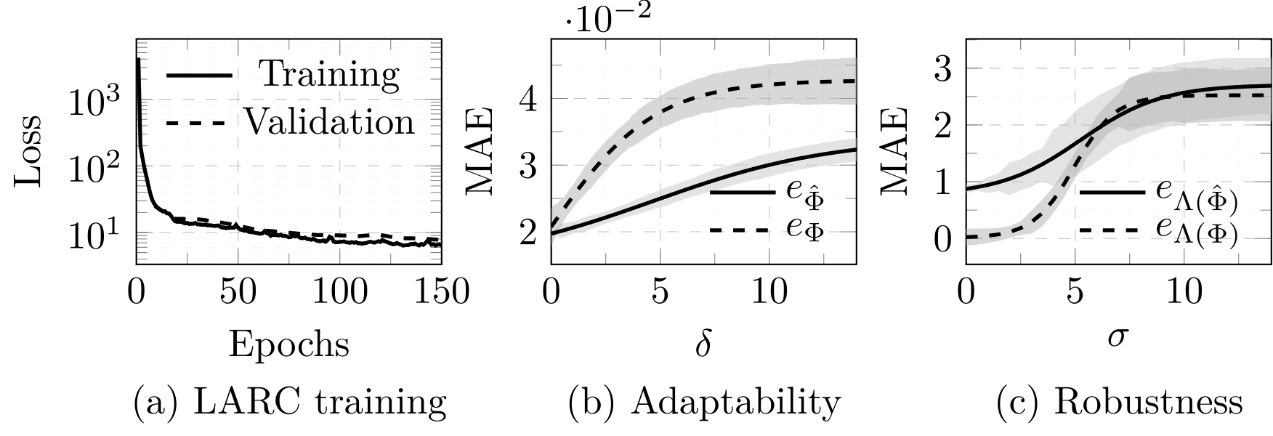
Figure 1: Training and validation plots for $Λ\left(Φ\right)$ (left), MAE values for adaptability (middle) test for $Φ$ and $\hat{Φ}$ and robustness (right) tests for $Λ\left(Φ\right)$ and $Λ\left(\hat{Φ}\right)$.
This constitutes the idea of transfer-learning where pre-trained process network $\hat{Φ}$ is jointly re-trained with the $Λ$ network. This approach on the one hand enables to obtain a more adaptive and robust control architecture and on the other hand facilitates online/active closed-loop learning on live data. After 150 epochs the joint training is resulted in a good reduction in the loss functional. Furthermore, a similar loss reduction on the validation-set (as shown in Figure 1(a)) signifies minimal over-fitting. With this we obtain a trained controller $Λ\left(Φ\right)$ which we shall use to perform closed loop simulations and also evaluate its robustness and adaptiveness behaviour.
  - Numerical Simulations
In this section, numerical experiments are conducted to study the adaptiveness and robustness property of the LARC model $Λ\left(Φ\right)$. For testing the adaptiveness, the $Φ$ model is fed with a noisy parameter ${\tilde{θ}}_{t}$ obtained as a noisy perturbation of the nominal value $θ_{t}$. More specifically, ${\tilde{θ}}_{t}=θ_{t}\left(1+δz\right)$ for $R^{d}∋z∼N\left(0,1\right)$, with $d$ being the dimension of $θ_{t}$. Letting $f_{T}$ denote the reference PSD obtained via numerical integration of (2) with $θ_{t}$ as the parameter and letting $\hat{f_{T}}\left(δ\right)$ denote the prediction of $Φ$ using ${\tilde{θ}}_{t }$, we define the mean absolute error (MAE) $e_{Φ}\left(δ\right)≔\frac{1}{b}\sum_{k=1}^{b}{\left|f_{T}^{k}-\hat{f_{T}^{k}}\left(δ\right)\right|}$ with batch size $b=100$. Based on this we compute $e_{Φ}\left(δ\right)$ and $e_{\hat{Φ}}\left(δ\right)$ for increasing values of $δ$ using retuned and the initial trained process models $Φ and \hat{Φ}$ respectively. The obtained values are plotted in Figure. 1(b) based on which we see that both models are fairly robust to perturbations in the parameter with deviation in the order of ${10}^{-2}$. Furthermore, we see that the retuned model (dashed line) is quicker in adapting to large perturbations. Based on this we can infer that the transfer-learnt $Φ$ model is relatively more adaptive compared to $\hat{Φ}$. Next, we performed a robustness experiment with the controller network $Λ\left(Φ\right)$ where we sequentially fed the controller with perturbed feedback $\tilde{X_{t}}={\left[\tilde{f_{t}},\tilde{c_{t}}\right]}^{⊤}$ obtained from a numerically simulated process with an increasing intensity of the process noise parameter $σ_{t}=σ$. This corresponds to a closed-loop simulation with a noisy simulated process model which we ran for 200 time steps with sampling time $t_{s}=0.1\text{min}$. Based on this we computed the MAE $e_{Λ\left(Φ\right)}\left(σ\right)≔\sum_{k=1}^{b}{\left|\hat{f_{T}^{k}}\left(σ\right)-\overline{f_{T}^{k}}\right|}$, of the final controlled PSD $\hat{f_{T}}\left(σ\right)$ from the prescribed target PSD $\overline{f_{T}}$ on the test dataset with batch size $b=100$. The errors so obtained for increasing values of $σ$ are as shown in Figure. 1(c). From the plot we see that even with $2$ fold increase in the noise intensity, $e_{Λ}\left(σ\right)$ was within the tolerable threshold of $≤0.05$. Furthermore, in comparison to $e_{Λ\left(\hat{Φ}\right)}$ (i.e. the MAE obtained for $Λ$ trained with fixed process network $\hat{Φ}$) we see that $e_{Λ\left(Φ\right)}$ is relatively negligible for small $σ$ values and also shows faster saturation to increasing $σ$ values. This further indicates that the higher adaptability of $Φ$ enables more robust behavior of $Λ\left(Φ\right)$. Altogether, from Figure. 1(b), (c) we can infer that $Λ\left(Φ\right)$ is an adaptive and robust controller. Finally, we used the $Λ\left(Φ\right)$ for the control of simulated precipitation process with default noise intensity of $σ=0.1$ and for a given fixed initial and target PSD $f_{0}$ and $\overline{f_{T}}$ respectively. We performed six sequential batch operations with each batch running for $100$ steps with sampling time $t_{s}=0.1\text{min}$. The results of the simulation are as shown in Figure. 2. Based on this we see that $Λ\left(Φ\right)$ was able to drive the initial PSD (dashed curve) of the simulated process (dark solid curve) to the target (dotted curve) in roughly $60\text{mins}$ even in the presence of moderate intensity of noise. Altogether, this indicates that the LARC model performs well in simulation and is ready for real closed loop testing.
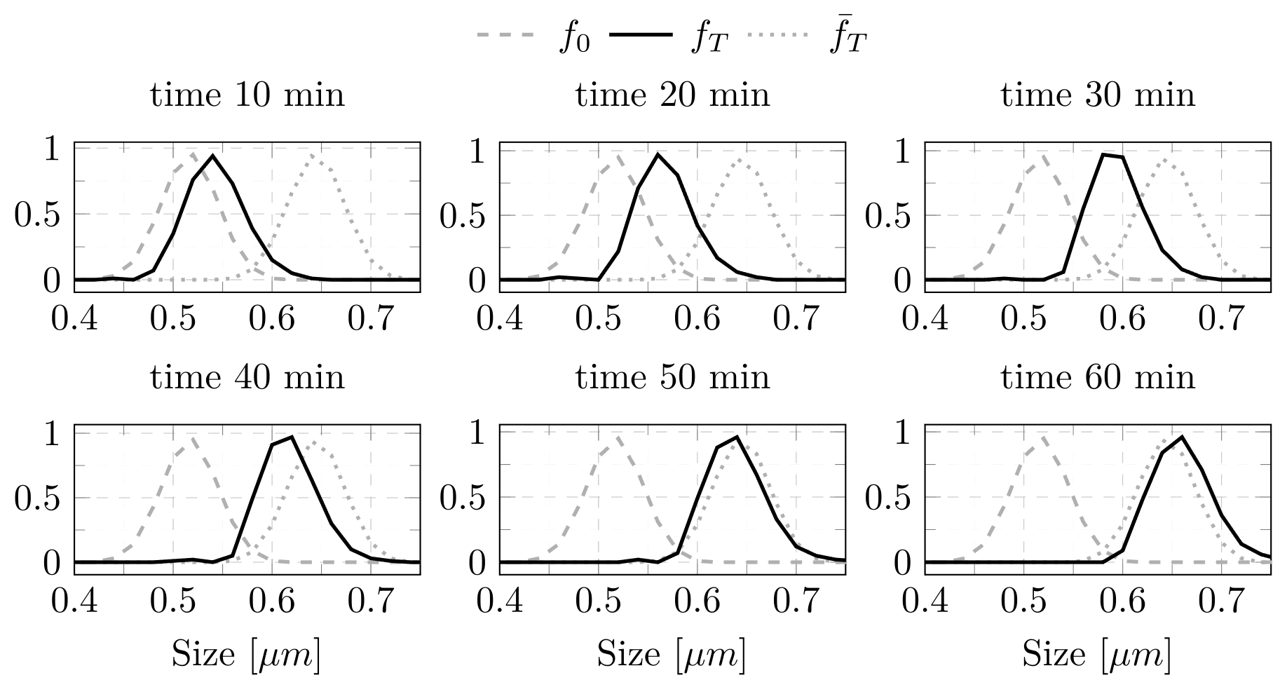
Figure 2: Batch control of precipitation process
  - Conclusions
In this work, we have introduced a novel learning-based adaptive and robust controller (LARC) $Λ\left(Φ\right)$ for the task of controlling a simplified precipitation model by utilizing the approximation power of DNN architectures, UNet for prediction and GRU for control synthesis. The numerical experiments indicate that the $Φ$ model not only provides accurate predictions of PSD and ion concentration but is also adaptive to varying process parameters. The ability of $Λ\left(Φ\right)$ to drive the system from an initial distribution to a predefined target, even in presence of moderate amount of noise, highlights its practical efficacy. Furthermore, the retuning of the $Φ$ model while training the $Λ$ network offers a more synchronized behavior wherein the retuned $Φ$ offers better adaptivity. Additionally, the use of $Φ$ as the prediction model facilitates active online/active learning based on live measurement data. Based on these, some of the planned work for the near future involves (i) incorporating measured data in the training, (ii) adapting the process model for pH-based control and also accounting for dynamic effects of temperature and pressure.
Acknowledgement: Funded by the Deutsche Forschungsgemeinschaft (DFG, German Research Foundation) - Priority Programme SPP2364 - Autonomous Processes in Particle Technology – project number 504852622.
References
A. Armaou, M. A. Demetriou, 2006. Optimal actuator/sensor placement for linear parabolic PDEs using spatial H2 norm. Chemical Engineering Science 61 (22), 7351–7367.
A. K. Rajagopalan, S. B ̈otschi, M. Morari, M. Mazzotti, 2019. Feedback Control for the Size and Shape Evolution of Needle-like Crystals in Suspension. III. Wet Milling. Crystal Growth and Design 19 (5), 2845–2861.
A. Sanna, M. Uibu, G. Caramanna, R. Kuusik, M. M. Maroto-Valer, 2014. A review of mineral carbonation technologies to sequester CO 2. Chem. Soc. Rev. 43 (23), 8049–8080.
B. Ydstie, 2002. Passivity based control via the second law. Computers & Chemical Engineering 26 (7), 1037–1048.
D. Shi, N. H. El-Farra, M. Li, P. Mhaskar, P. D. Christofides, 2006. Predictive control of particle size distribution in particulate processes. Chemical Engineering Science 61 (1), 268–281.
F. Goff, K. S. Lackner, 1998. Carbon Dioxide Sequestering Using Ultramafic Rocks. Environmental Geosciences 5 (3), 89–102.
M. Raissi, 2018. Deep hidden physics models: Deep learning of nonlinear partial differential equations. The Journal of Machine Learning Research 19 (1), 932–955.
N. Chen, J. Dai, X. Zhou, Q. Yang, W. Gui, 2019. Distributed Model Predictive Control of Iron Precipitation Process by Goethite Based on Dual Iterative Method. International Journal of Control, Automation and Systems 17 (5), 1233–1245.
N. Chen, S. Luo, J. Dai, B. Luo, W. Gui, 2020. Optimal Control of Iron-Removal Systems Based on Off-Policy Reinforcement Learning. IEEE Access 8, 149730–149740.
S. A. Hiremath, P. Gummadi, A. Tika, P. Rama, N. Bajcinca, 2023. Learning based interpretable end-to-end control using camera images. In: Proceedings of the 20th International Conference on Informatics in Control, Automation and Robotics - Volume 1: ICINCO. INSTICC, SciTePress, pp. 474–484
S. A. Hiremath, N. Bajcinca, 2022. DNN based learning algorithm for state constrained stochastic control of a 2d cartpole system. In: 2022 European Control Conference (ECC). IEEE.
S. H. Rudy, S. L. Brunton, J. L. Proctor, J. N. Kutz, 2017. Data-driven discovery of partial differential equations. Science Advances 3 (4).
V. Mnih, K. Kavukcuoglu, D. Silver, A. Graves, I. Antonoglou, D. Wierstra, M. Riedmiller, 2013. Playing atari with deep reinforcement learning.
W. Seifritz, 1990. CO2 disposal by means of silicates. Nature 345 (6275), 486–486.

