Modelling and Investigation of Continuous Ideal Flow Crystallizer with Multidimensional Population Balance Equations
László Balogh^{a*}, Attila Egedyª, Ágnes Bárkányiª
ª Department of Process Engineering, Faculty of Engineering, University of Pannonia, Egyetem street 10., Veszprém, Hungary
* balogh.laszlo@mk.uni-pannon.hu
Abstract
The importance of the continuous processes are increasing in the pharmaceutical sector, and the model based design and optimization is a powerful tool for the health safety and of adequate quality fabrication of the crystalline product. The two most important property of the crystal product are the particle characteristic size (for example diameter) and the size distribution. In this work we wish to investigate a continuous industrial size crystallizer on model base. The solution of these extended model is not an easy task because the breakage is a probability variable based phenomenon, so the integration of the population balance equation is not possible. So, we need to search for an adequate method for the solution for example Monte Carlo (MC) simulation.
Keywords: population balance, crystallizer, breakage
  - Introduction
In our research we want to investigate a continuous crystallizer (CMSMPR – Continuous Mixed Suspension Mixed Product Removal), the emerging crystals have two-dimension distributions. During the modelling we solve the model parametrically, so we do not handle a specific material system. Borsos and Lakatos (2012) investigated a continuous crystallizer with breaking events. In their model the crystals break into half, and the solution was made by standard method of moments. In our works we recreate their model and results in addition we compare it with our solution of MC simulation. Borsos and Lakatos (2014) modified their model, thus in this version the breaking of the crystals are happening in random in length. The solution method is a moments method but every integration step they integrate a random function for the breaking. Szilágyi et al. (2015) investigate a high aspects ratio crystals breaking with two-dimensional population balance. They used SMOM (standard method of moments) method and QMOM (quadratic method of moments) for the solution. Peborgh Gooch and Hounslow (1996) was engaged with MC simulation for different complexity population balance equation (PBE). They found the MC simulation gives very accurate results in comparison with analytical solution. Piotrowski and Piotrowski (2004) modelled a CMSMPR crystallizer with monte MC method, with two material systems. Their model does contain a heat balance, they handled the crystallizer as adiabatic. In this work we make a model for a CMSMPR crystallizer with heat balance, and we solve it with two different methods.
  - Mathematical Model for Continuous Crystallizer
During the modelling process we want to formalize a mathematical model of a CMSMPR crystallizer. The crystallizer is supplemented with cooling jacket. In the crystallization we consider three kinetic processes, the growing, the nucleation and the breaking process. The parameters of the model were used from Borsos and Lakatos (2012) and Borsos and Lakatos (2014). The following assumptions was implemented:
- The crystallizer perfectly mixed, the product removal is representative.
- Agglomeration is neglected.
- The crystals break into half, and only in the length of the crystal .
- The level control is ideal, so the volume of the inside is constant ($V=$ constant)
- The growing of the crystals is independent from the crystal sizes.
- Volume of the crystallized solute is the same as its volume in the dissolved state.
- The inlet stream does not contain crystals ($ϵ_{in}=0$) or any impurities.
    - Crystal Growing
The crystals have two-dimensional distribution; thus, we handled the crystals as square based column. The length of the crystals denotes by$z$ and the diameter denote by $r$. The growing in dimension $r$ and dimension $z$ can be described with the same expressions (when i = z, r) (Eq. (1)) (Borsos et al., 2012).
$G_{i}= k_{g,i}\exp\left(\frac{{-E}_{g,i}}{RT}\right) {\left(\frac{c-c_{s}}{c_{s}}\right)}^{g_{i}}$ where $k_{g,i}, g_{i},E_{g,i}>0$ | (1)
In the Eq. (1) the $k_{g,i};g_{i}$and $E_{g,i}$ are constants, the $c$is the actual concentration of solutes material, the $c_{s}$ is the solubility concentration, the $T$ denotes the temperature of the inside while $R$ is the universal gas constant. This form of the equations takes into account the relative supersaturations. The solubility concentration can be described with the following polynomial equation (Eq. (2)), the temperature is understood in °C and the parameters and comes from Szilágyi et al (2015).
$c_{s}\left(T\right)=a -bT+ cT^{2}$ | (2)
    - Nucleation
In case of nucleation, we count with primer ${(N}_{p})$ and seconder $\left(N_{s}\right)$ nucleation, that’s two expressions are the following (Eq. (3) and (4)) (Borsos et al., 2012).
$N_{p}=(1-ϵ) k_{p}\exp\left(\frac{-E_{p}}{RT}\right)\exp\left(\frac{{-k}_{e}}{\ln^{2}\left(\frac{c}{c_{s}}\right)}\right)$ where $k_{p}, E_{p}, k_{e}>0$ |  | (3)
$N_{s}= k_{s}\exp\left(\frac{-E_{s}}{RT}\right){\left(\frac{c-c_{s}}{c_{s}}\right)}^{s}μ_{1,2}^{b}$  $N_{s}= k_{s}\exp\left(\frac{-E_{s}}{RT}\right){\left(\frac{c-c_{s}}{c_{s}}\right)}^{s}V_{S}^{m}$ | where $k_{s}, E_{s}, s,b>0$ | (4)
The $ϵ$ denotes the solid volume fraction and that calculated with the following (Eq. (5)), this interpretation of the solid volume rate comes from Balogh et al. (2023).
$ϵ=\frac{V_{S}}{V_{S}+V_{F}}$ | (5)
In the Eq. (3) the $k_{p}, E_{p}, k_{e}$ are constants of the primary nucleation, and in the Eq. (4) the $k_{s},E_{s}, s,b$ are the constants of the secondary nucleation. The secondary nucleation is dependent on the volume of the solid fraction, so in case of SMOM the $μ_{1,2}$ modify the value of secondary nucleation while in case of MC we calculate directly the solid volume $(V_{S})$. The full rate of nucleation ($N_{\sum{ }}$) is the sum of the primary and secondary nucleation rate.
    - Crystal Breaking
The breaking of the crystals is characterized with the selection function ($S\left(z,r\right)$) and the breaking function ($b_{z}\left(z,λ_{z}\right)b_{r}(r,λ_{r})$). The previous function characterized the probability of the breaking the last determine the size after the breaking event. The selection function has the following form (Eq. (6)) (Borsos et al., 2012).
$$S\left(z,r\right)=k_{B}z^{β}r^{γ}$$ | (6)
In the Eq. (6) the $β$ and $γ$ are the parameters of the function. The $γ=0$ because the breaking happens only in z coordinates, the $β$ was chosen to 1, because the moments equations give an unclosed system if $β>1$ (Szilágyi et al. (2015)). In case of breaking functions, we assume that the crystals break into half, thus the function has the following form (Eq. (7)) (Borsos et al., 2012).
$b_{z}\left(z,λ_{z}\right)b_{r}\left(r,λ_{r}\right)=2δ\left(z-\frac{λ_{z}}{2}\right)δ(r-λ_{r})$ | (7)
The $δ$ denotes the Dirac delta function, the $λ$ is the size of the mother crystal. The meaning of the Eq. (7): after the breaking event we get two of equal length crystal with same diameter.
    - Population Balance equation
The population balance equation can be formulized with the following multivariable partial integro-differential equation (Eq. (8)). It has a same form with Borsos et al. (2012).
$\frac{∂Ψ\left(z,r,t\right)}{∂t}+G_{z}\frac{∂Ψ\left(z,r,t\right)}{∂z}+ G_{r}\frac{∂Ψ\left(z,r,t\right)}{∂r}=-\frac{B Ψ\left(z,r,t\right)}{V}+N_{\sum{ }}δ\left(z-z_{0},r-r_{0}\right)$ $-k_{B}\int_{o}^{z}{\int_{0}^{r}{z^{β}δ\left(λ_{z}-\frac{z}{2}\right)δ\left(λ_{r}-r\right)Ψ\left(z,r,t\right)dλ_{z}dλ_{r}}}$ $+k_{B} \int_{z}^{∞}{\int_{r}^{∞}{λ^{β}δ\left(z-\frac{λ_{z}}{2}\right)δ\left(r-λ_{r}\right)Ψ\left(λ_{z},λ_{r},t\right)}} dλ_{z}dλ_{r}$ | (8)
In the Eq. (8) the $Ψ$denotes the crystal size density function, $B$ means the volume flow rate. The initial condition (Eq. (9)).
$$Ψ\left(z,r,0\right)=Ψ_{0}(z,r)$$ | (9)
The two boundary conditions (Eq. (10)):
$\lim_{z→0;r→0}\left[G_{z}Ψ\left(z,r,t\right)+G_{r}Ψ\left(z,r,t\right)\right]=0$ $\lim_{z→∞;r→∞}{Ψ(z,r,t)=0 }$ | (10)
The macroscopic properties of the crystallizer were calculated with a same mathematical expression as Balogh et al. (2023) and the assumed equipment also a same.
  - Solution of the Model
In the following we would to introduce the two method what we use for the solution. The first is the standard method of the moments, the second is the Monte Carlo simulation.
    - Standard Method of Moments
One of the solution methods is the method of moments. At the first step we need to transform the Eq. (8) to moments equations. The definition of the moments is the following (Eq. (11)).
$μ_{k,m}= \int_{0}^{∞ }{\int_{0}^{∞}{z^{k}r^{m} Ψ\left(z,r,t\right)dzdr}}$ | (11)
After the moments transformation we get the following general equations (Eq. (12) for the $0,0$-th moment and Eq. (13) for the $m,k$-th moments).
$\frac{{d μ}_{0,0}}{dt}=-\frac{B}{V} μ_{0,0}+N_{\sum{ }}+ k_{B}μ_{1,0}$ | (12)
$\frac{{d μ}_{k,m}}{dt}=-\frac{B}{V} μ_{k,m}+kG_{z}μ_{k-1,m}+mG_{r}μ_{k,m-1}+k_{B}\left(\frac{1}{2^{k-1}}-1\right)μ_{k+1,m}$ | (13)
Thus, we get an ordinary differential equation system. In case of standard method of moments, the source term formulized by the following equation (Eq. (14)).
$R_{V_{S}}=k_{V}V(G_{z}μ_{0,2}+2G_{r}μ_{1,1})$ | (14)
    - Monte Carlo Simulation
During the MC simulation we need to distinguish continuous processes and discrete events in time. In our case the volume, the concentration, and the temperature were handled by continuous process, only the breaking is the discrete event. The continuous part of the model was solved by Euler method with fixed simulation step ($h=0.1$s). The general form of the used formula is the following (Eq. (15)).
$$y_{i+1}=y_{i}+h f(t_{i},y_{i})$$ | (15)
In the Eq. (15) the $f$ means the right side of the differential equation. In every simulation step the number of size fractions are expanding, and we collect the number of the crystals in every fraction and the size of the fractions. The source term in case of MC simulation is interpreted by the following figure (Figure 1.).
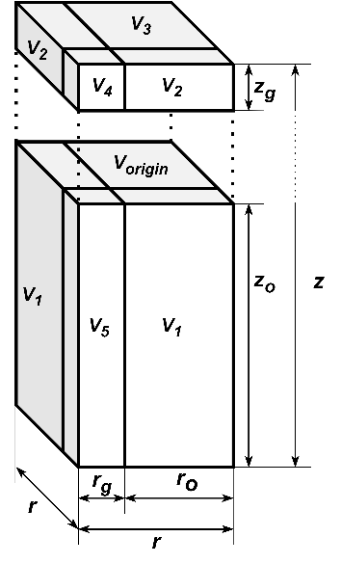
Figure 1.: Interpretation of the connection of the growing and the volume source term during one step ($V$ means the volume, the $o$ and $g$ in the lower index denotes the origin and the gain length)
The growing is gaining the size of the crystal in 3 dimensions; thus, we need to calculate the volume increase. The growing in specific size direction is independent from the size, but not independent from the other size coordinate. In case of MC simulation, the source term of one step formalized by the following (Eq. (16)) based on Figure 1.
$$R_{V_{S}}=2V_{1}+2V_{2}+V_{3}+V_{4}+V_{5}$$ | (16)
And because we calculate all crystal size we can determine the volume increase of each crystal, and the sum of that gives the full volume source.
  - Results and Discussion
In the following, we compare the simulation results of the SMOM and the MC simulations. At first, we plotted in common diagram the two method’s results with the break free case (Figure 2.)
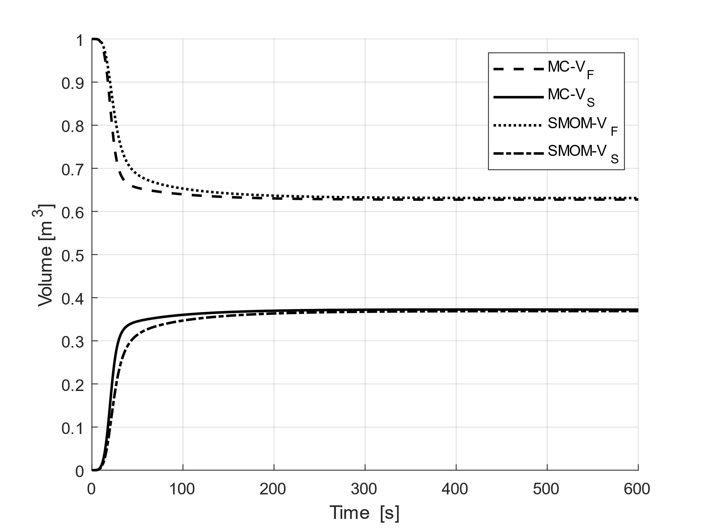 | 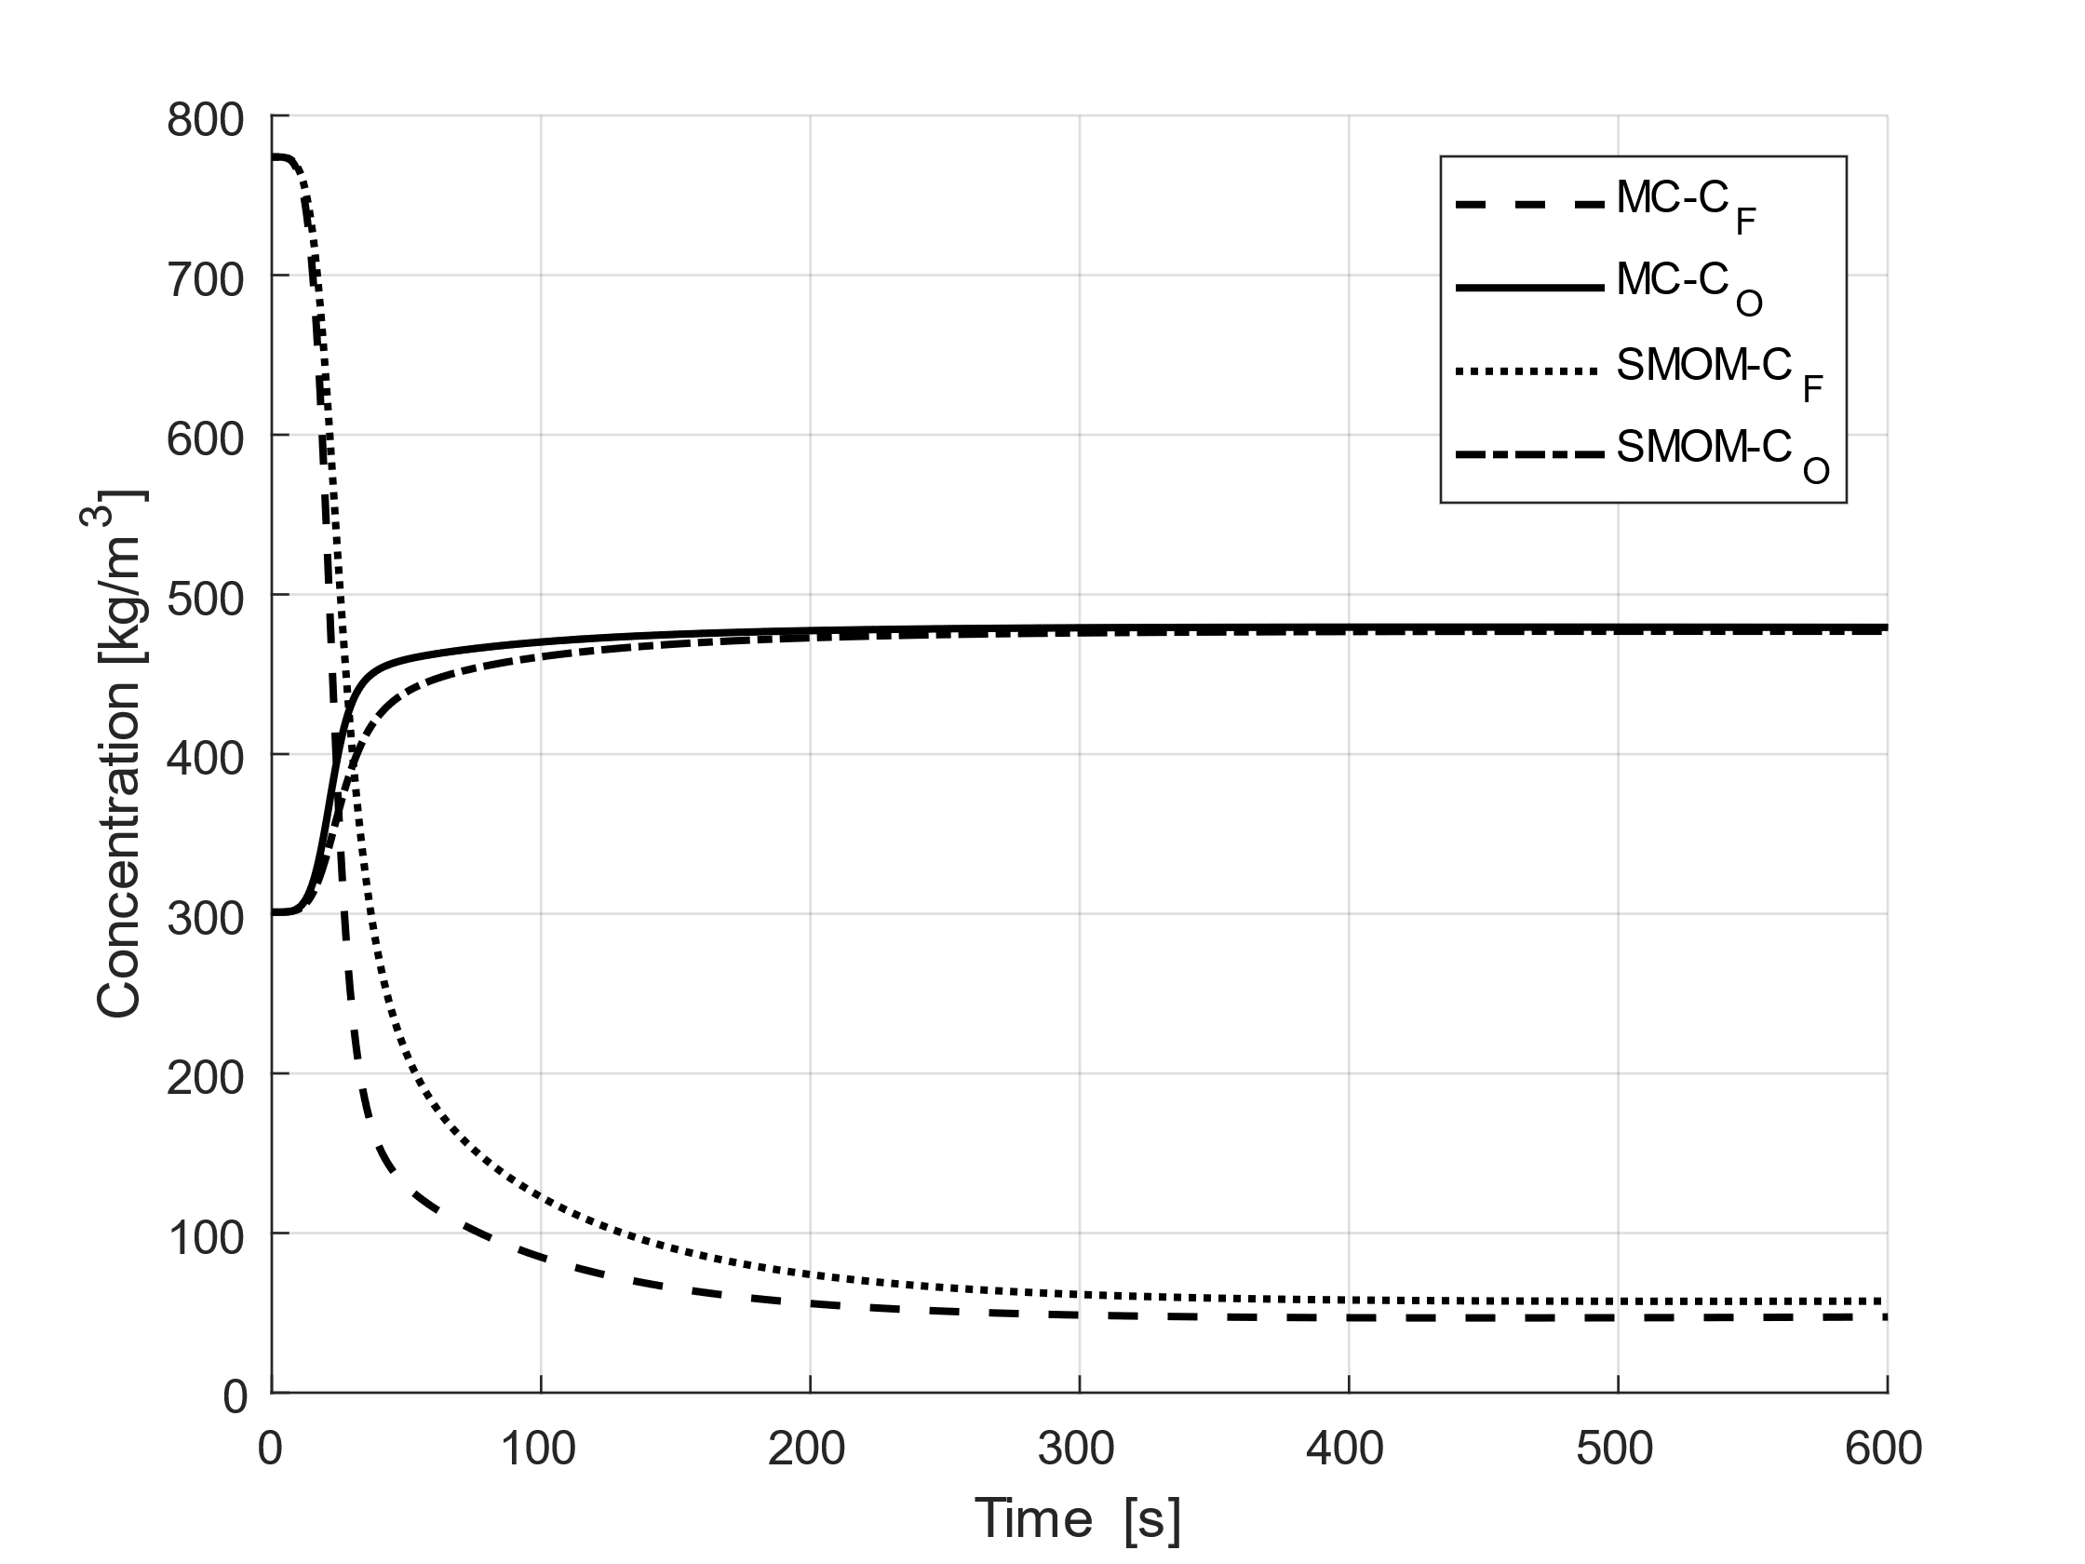
a. | b.
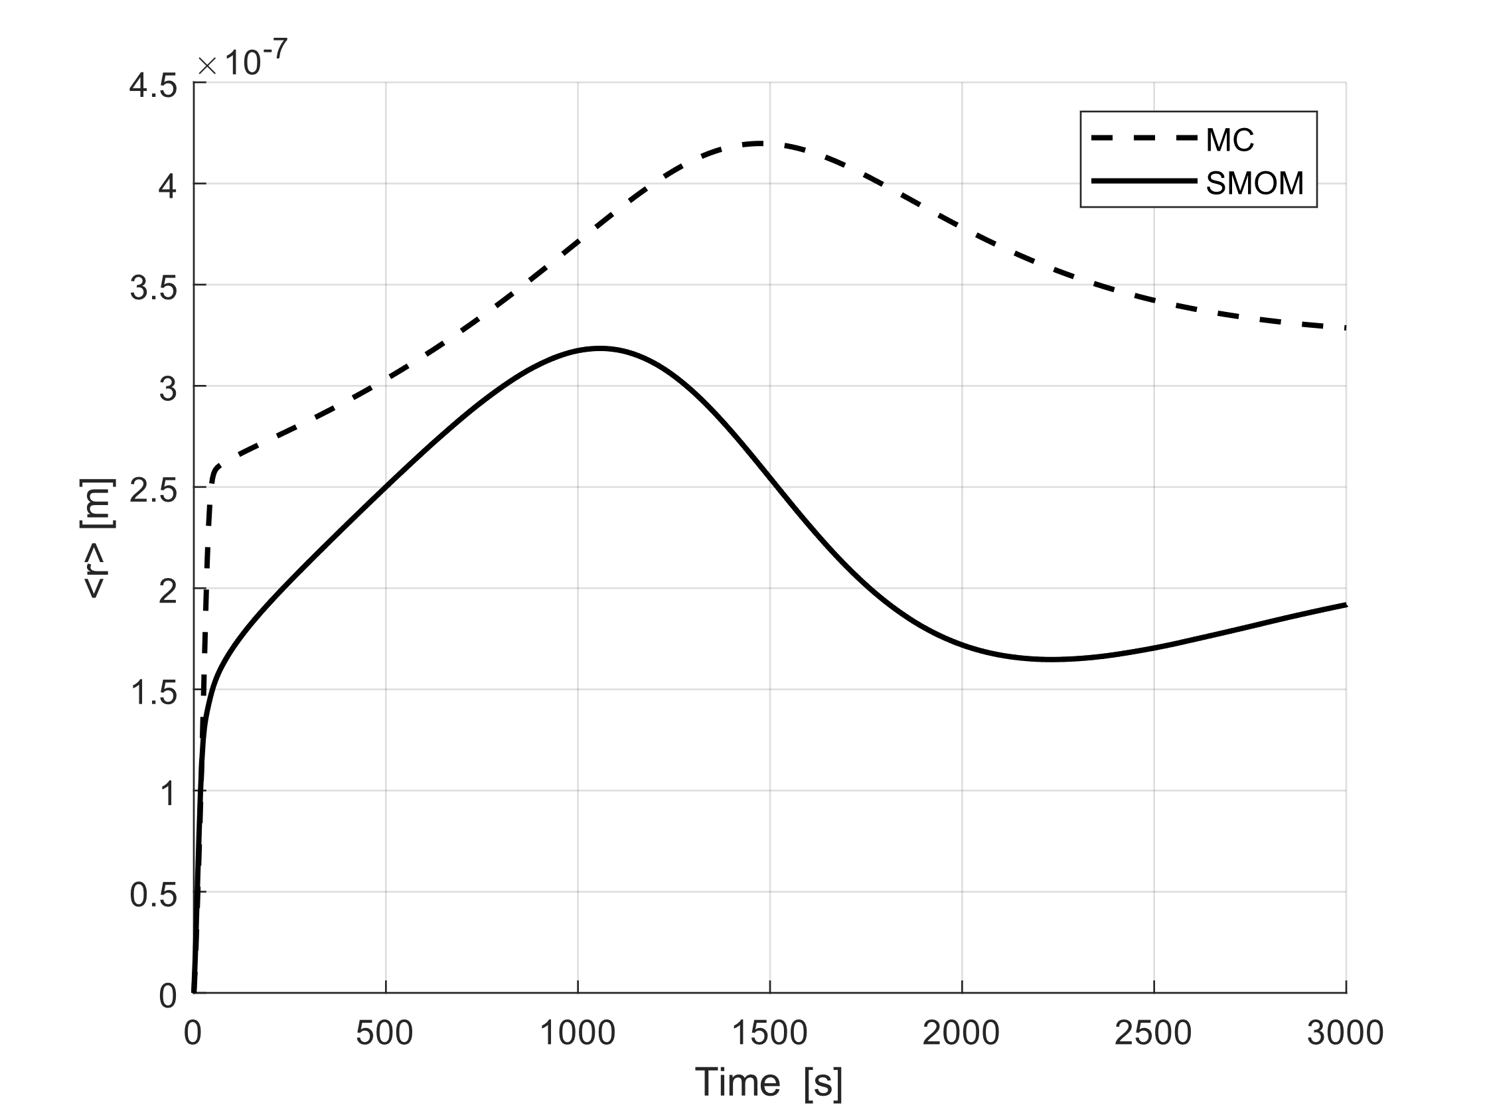 | 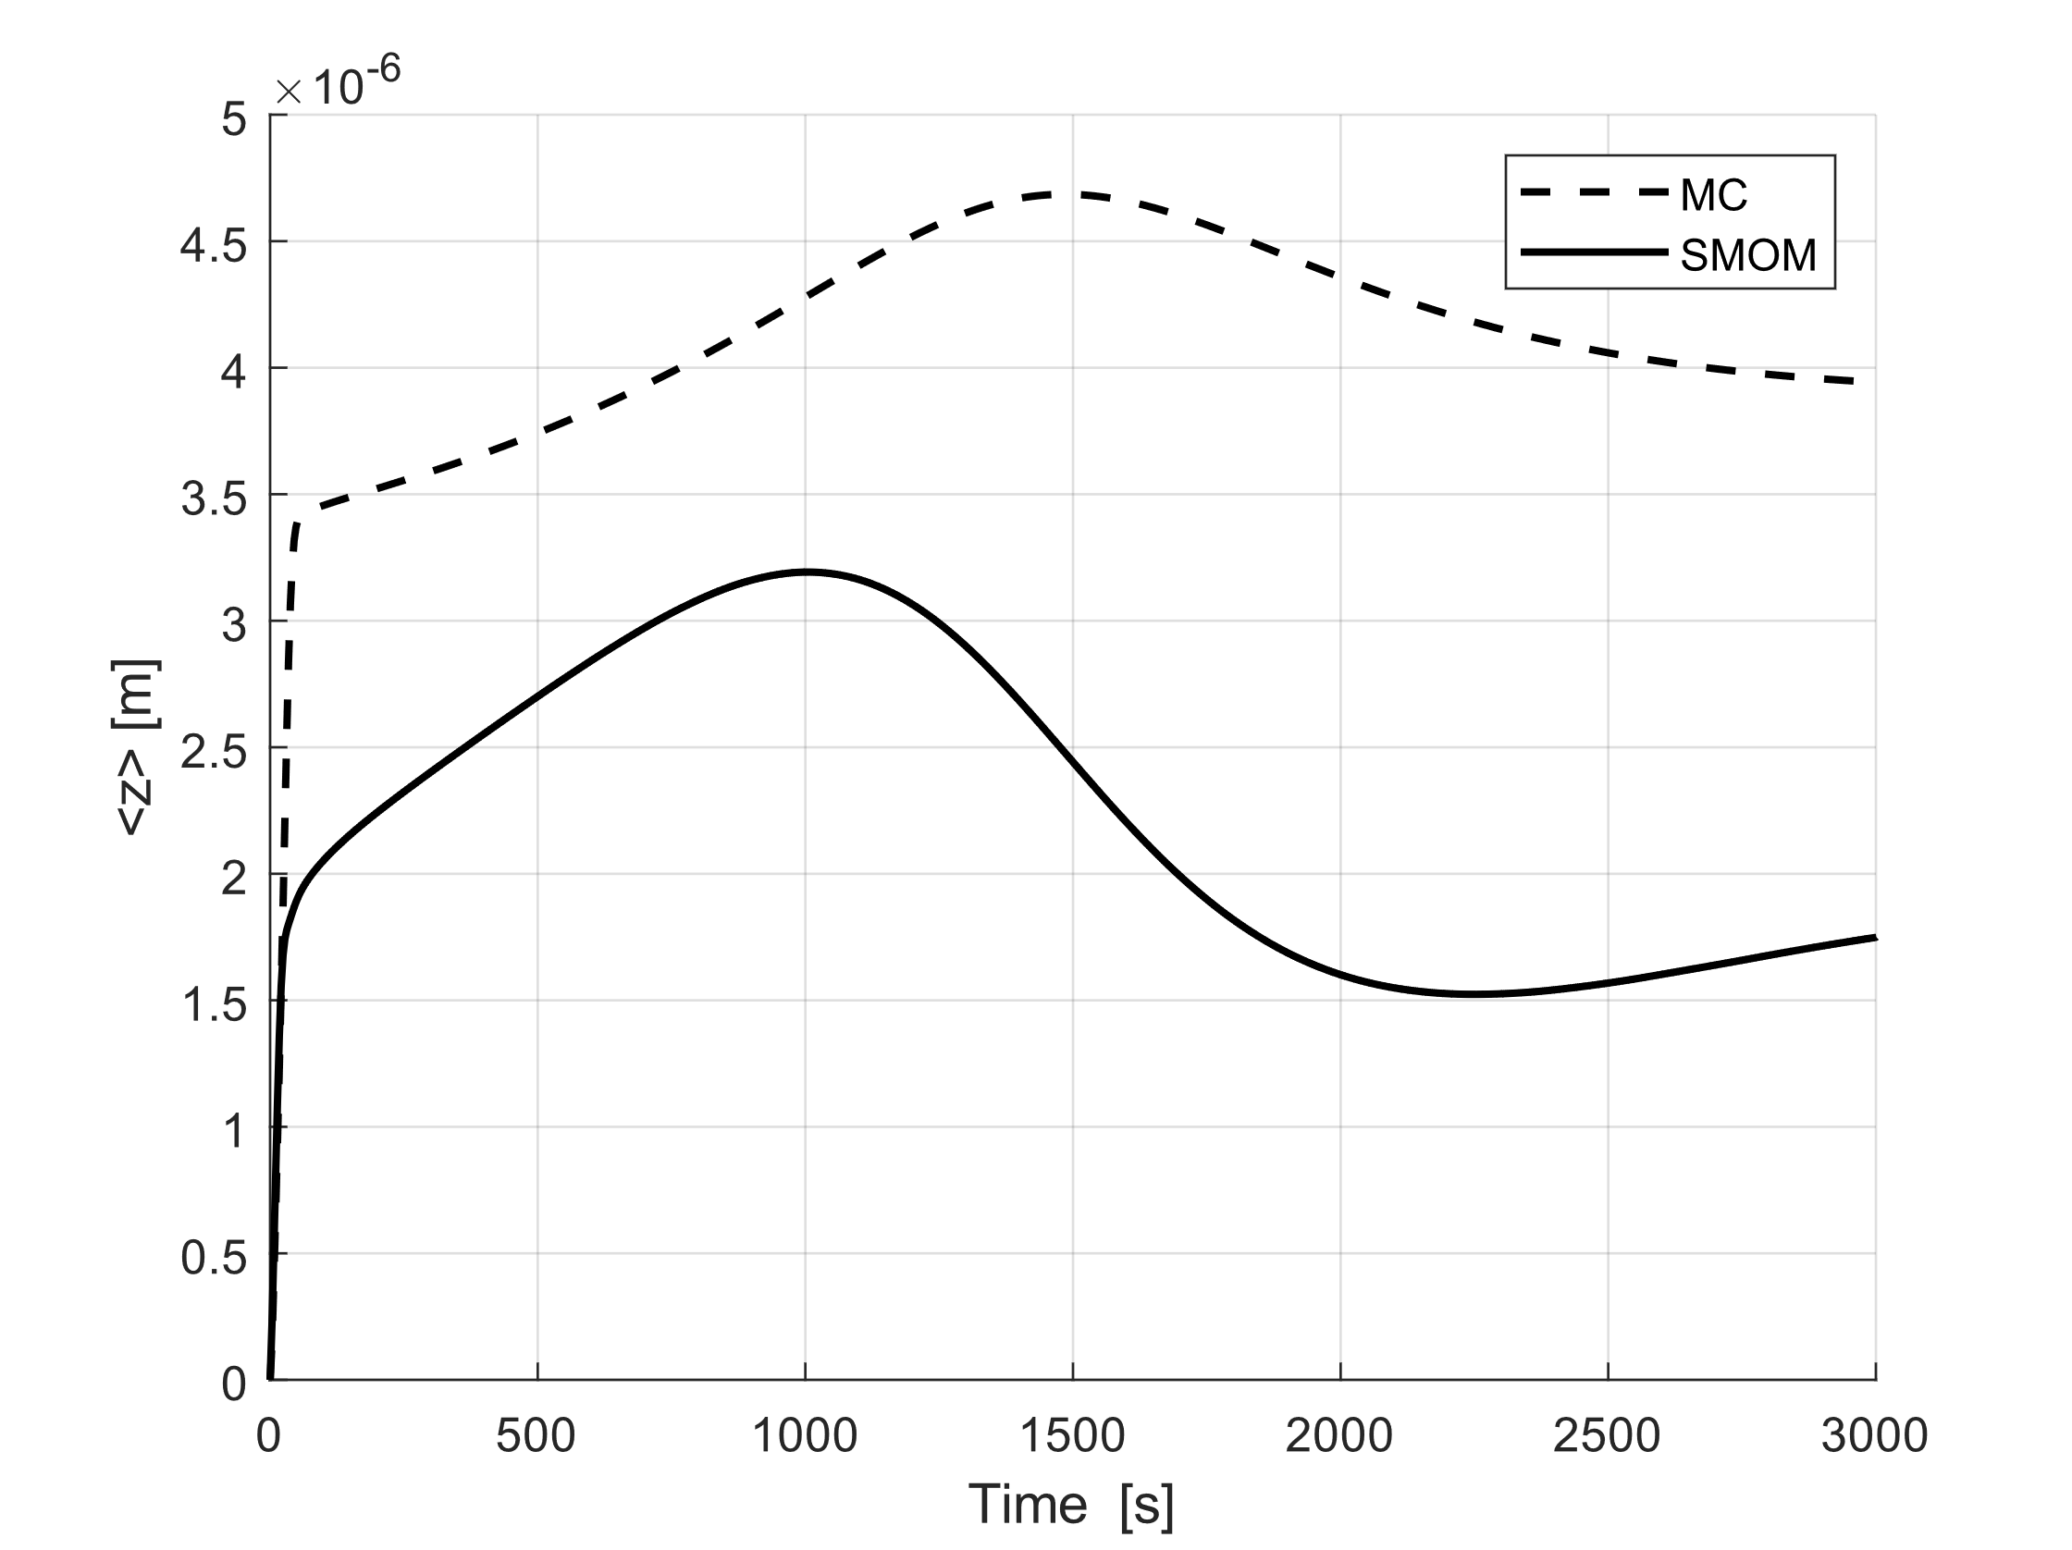
c. | d.
Figure 2.: Comparison of the results of the SMOM and MC simulations in time (a.: volume of the solid and liquid fraction; b.: concentration of the mother liquid, and the solvent; c.: average size of crystal diameter; d.: average size of crystal length)
In the Figure 2. can be seen a difference between the two methods. This can be explained by in one hand the inaccuracy of Euler method, in other hand the two methods from different approaches. At the next we compare the two methods with breaking event. In this work we don’t want to give a same result from the two simulations, just want to present the two methods give a same tendency. Matching the two methods is not easy for two reasons. The first is the breaking is dependent on the $k_{B}$ in case of SMOM and dependent on the breaking number in case of MC simulation, but these two parameter effects on different variable (in SMOM to the moments, in MC directly to the crystal length). The Figure 3. shows the comparison of the results of the two methods with breaking and breaking free case.
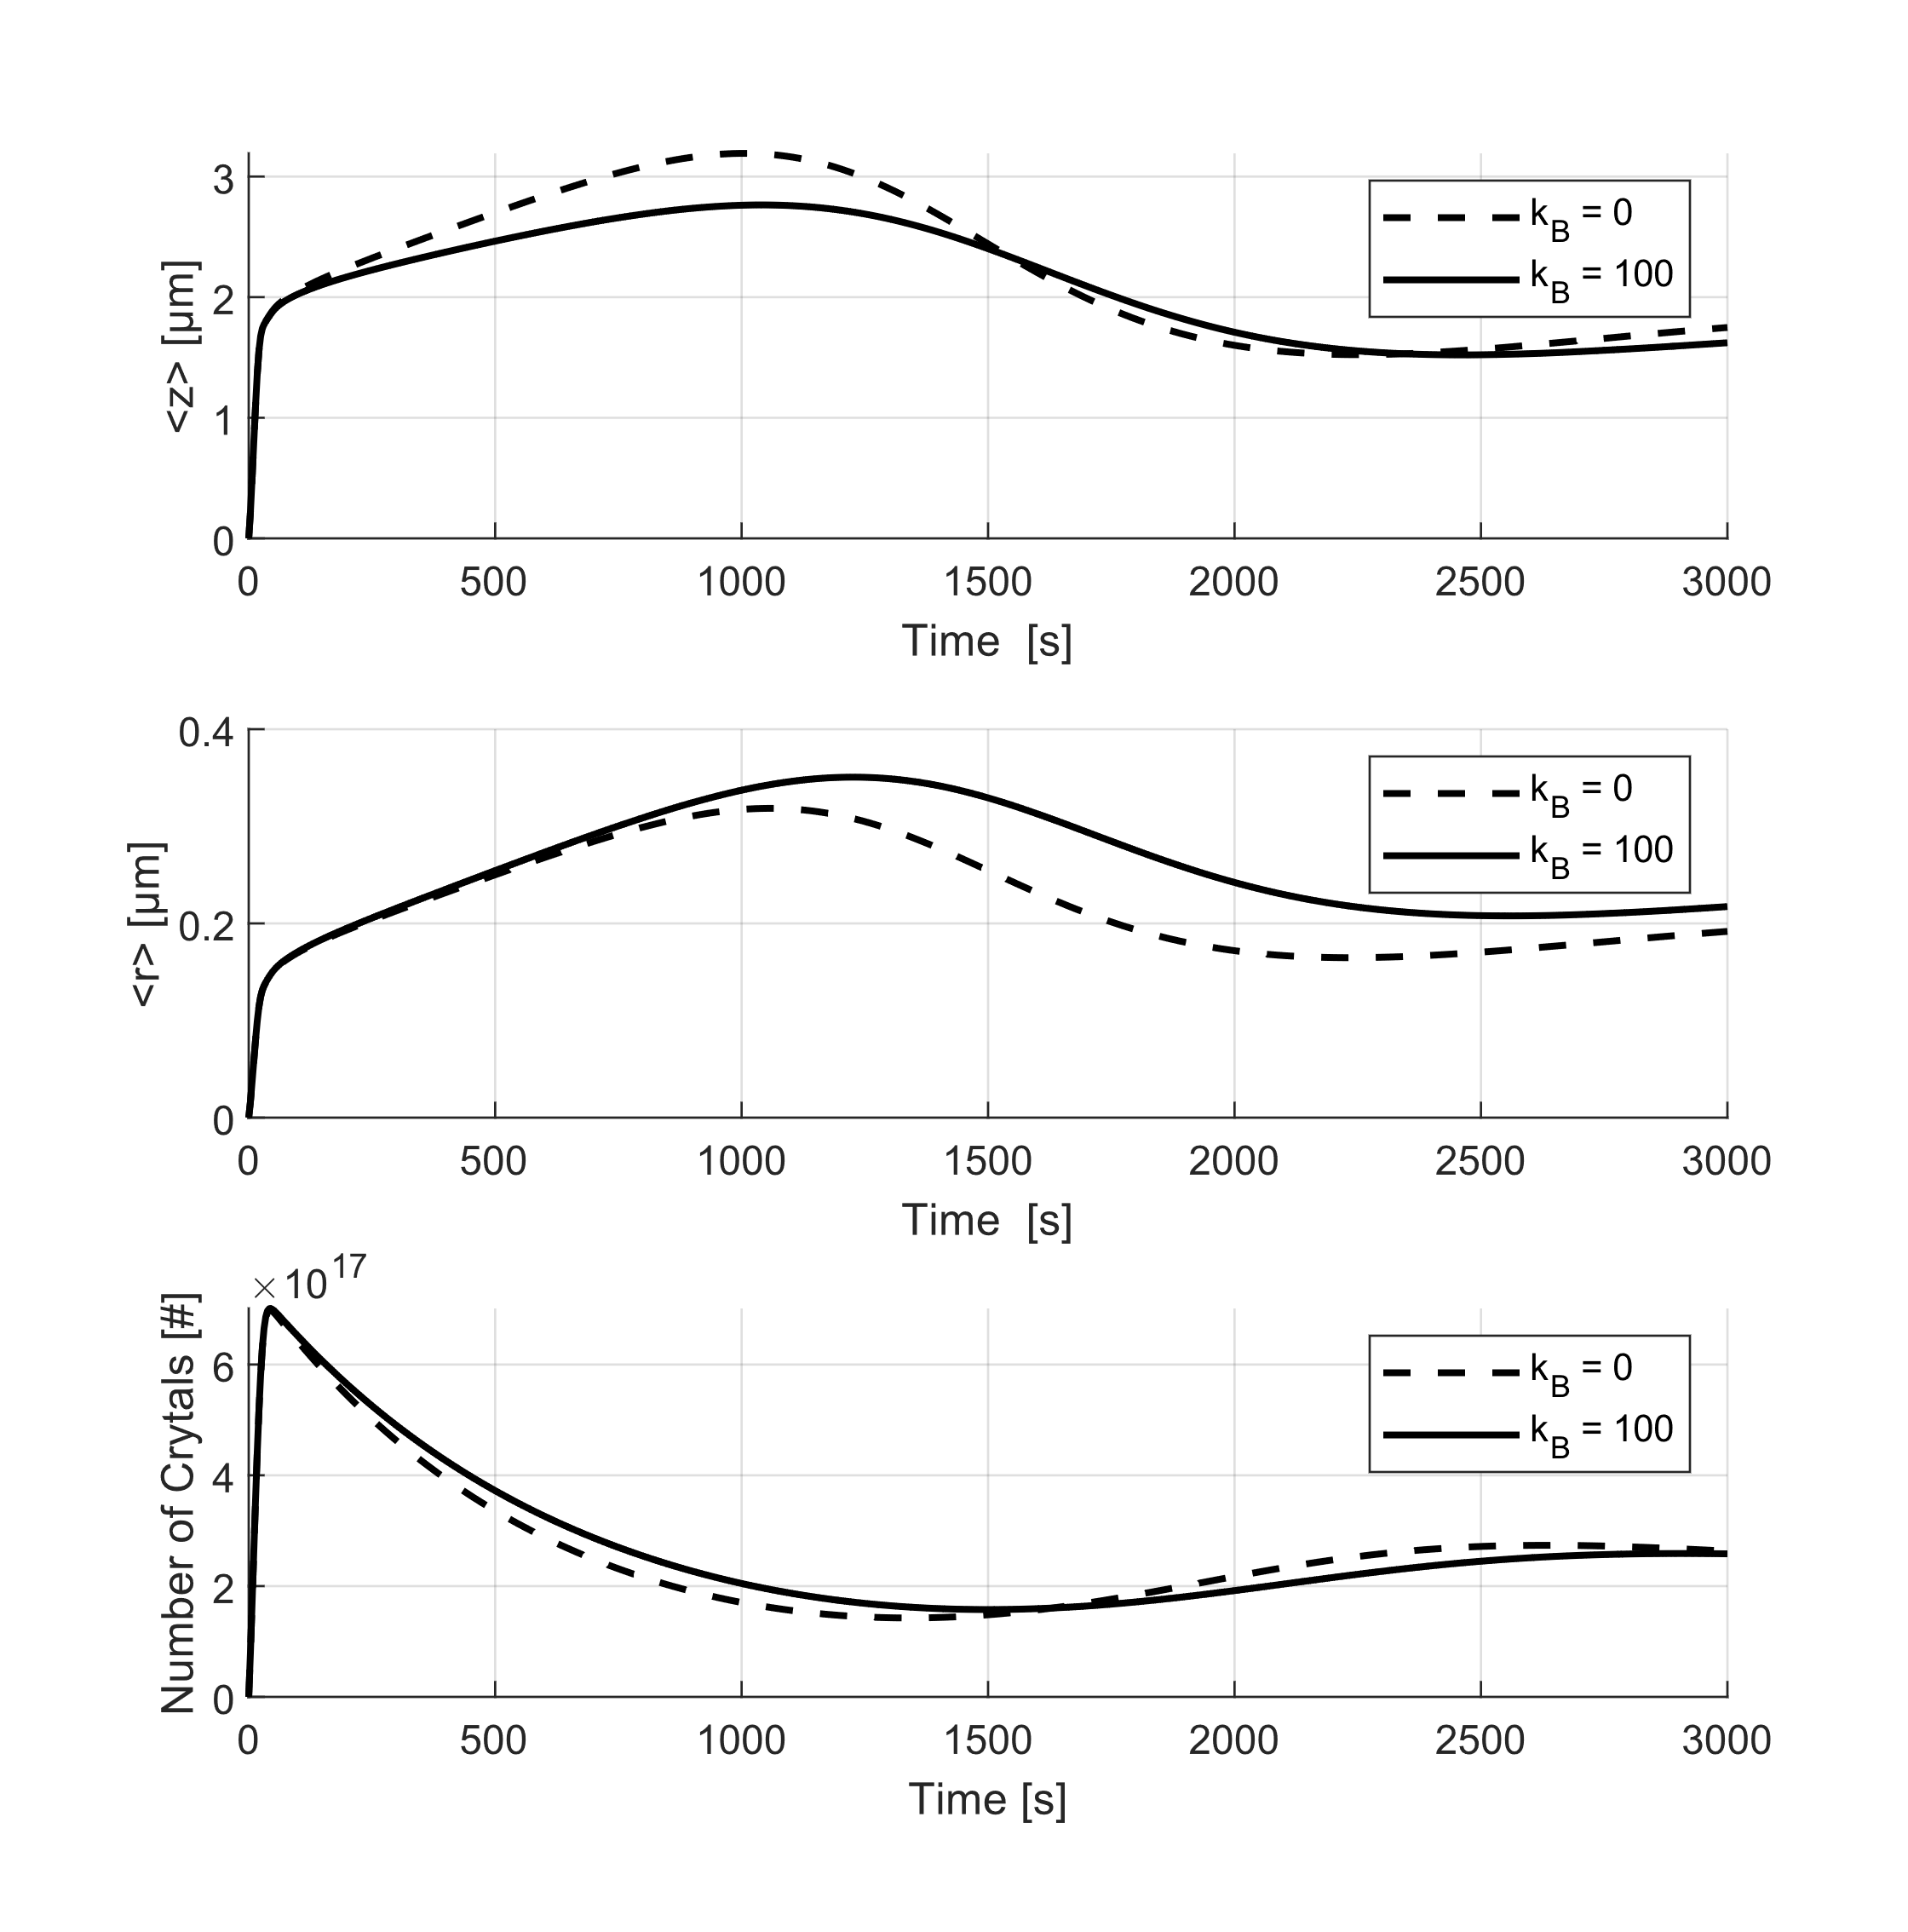 | 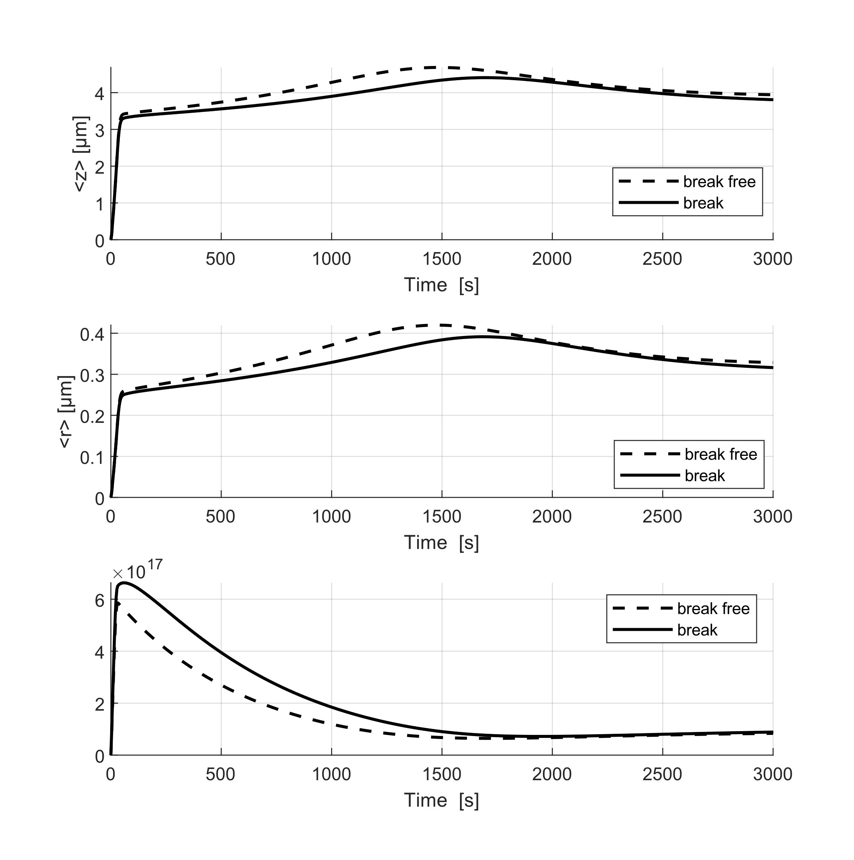
a. | b.
Figure 3.: Comparison of the result of breaking and breaking free case (a. SMOM; b. MC)
During the comparison of breaking case, we have chosen for the $k_{B}$ 0 and 100 value in case of SMOM and in case of MC we drew lots 100 random fraction and we assumed 0.1% of braking in one fraction. In Figure 3. can be seen the two method gives a different result in case of average size of crystals. That discrepancy also comes from the different approach and the random variable. The parametric matching of the two methods to each other is the fact of future research. In terms of simulation time the SMOM can be calculated only a few seconds, the MC simulation took 1000s approximately.
  - Conclusions
In this work we compare two methods for solve the same model and we compare the two results. The advantage of the SMOM is the short solution time, and the easy handling of the ordinary differential system, but disadvantage are the complex mathematical transformation and the losing of the information. The run of the MC simulation is slower but gives more information about the system and this method suitable to non-ideal and more complex system modelling. The matching of the two method is a hard task because the two approach is different. Unfortunately, in the absence of measurement results we do not choose which method is better. In the future work we would to make a parameter set for the identic solution.
Reference
Á. Borsos, B. G. Lakatos, 2012, Influence of breakage on crystal size distribution in a continuous cooling crystallizer, Periodica Polytechnica, Chemical Engineering, 56, 2, 65-69
Á. Borsos, B. G. Lakatos, 2014, Investigation and simulation of crystallization of high aspect ratio crystals with fragmentation, Chemical Engineering Research and Design, 92, 1133–1141
B. Szilágyi, P. S. Agachi, B. G. Lakatos, 2015, Numerical analysis of crystallization of high aspect ratio crystals with breakage, Powder Tecnology, 283, 152-162
L. Balogh, A. Egedy, Zs. Ulbert, Á. Bárkányi, 2023, Comparison of the Dynamic and Thermal Behavior of Different Ideal Flow Crystallizers, ChemEngineering, 7, 2, 2-21
J.R. van Peborgh Gooch, M.J. Hounslow, 1996, Monte Carlo Simulation of Size-Enlargement Mechanisms in Crystallization, Particle Technology and Fluidization, 42, 7,1864-1874
K. Piotrowski, J. Piotrowski, 2005, Monte Carlo modelling of continuous adiabatic MSMPR crystallizer, Chemical Engineering and Processing, 44, 517–529

