An Integrated Framework: Inverse Design for Optimal Amine Solvent using Reinforcement Learning and Enhanced CO₂ Chemical Absorption Processes
Youhyun Kim^{a,b}, Haeyeon Choi^{a,b}, Damdae Park^{c}, Kyeongsu Kim^{c}, Jonggeol Na^{a,b*}
ªDepartment of Chemical Engineering and Materials Science, Ewha Womans University, Seoul 03760, Republic of Korea
^{b}Graduate Program in System Health Science and Engineering, Ewha Womans University, Seoul 03760, Republic of Korea
^{c}Clean Energy Research Center, Korea Institute of Science and Technology, Seoul 02792, Republic of Korea
jgna@ewha.ac.kr
Abstract
This study proposes an integrated framework that combines inverse material design via reinforcement learning (RL) and process optimization to determine the optimal solvent for CO₂ chemical absorption process (Figure 1). The framework addresses the challenges posed by Computer-Aided Molecular and Process Design (CAMPD) and efficiently explores the design space characterized by infeasible subregions and a highly nonlinear relationship between process and molecular structure. The RL model, when combined with combinatorial chemistry, inversely designs amine solvent based on target properties such as CO₂ absorption capacity and solubility. Then, conductor-like screening model for real solvents (COSMO-RS) predicts the phase behavior through thermodynamic analysis and evaluates whether the solvent can achieve the desired CO₂ removal. This novel approach provides an efficient and systematic way to design an effective solvent and improve the CO₂ absorption process.
Keywords: process and product design, Materials discovery, Amine solvent design, CO₂ chemical absorption process, Reinforcement learning
  - Introduction
Designing a product that satisfies the desired target properties may not always be optimal from the perspective of the overall process. Process conditions have a considerable influence on solvent performance, and solvent properties directly affect the efficiency and economics of the process. To determine the optimal solvent, it is necessary to consider the interaction between the molecular level and the process level (Lee et al., 2023).
Here we introduce an integrated framework that connects inverse material design through reinforcement learning (RL) and process optimization. The RL model combined with combinatorial chemistry inversely designs molecules for target properties. Our model begins with a randomly chosen initial fragment and proceeds to select the next fragment for combination, considering chemical rules to ensure the generation of valid molecules (H. Kim et al., 2023). Then, the property prediction model such as the conductor-like screening model for real solvents (COSMO-RS) calculates the required features in the
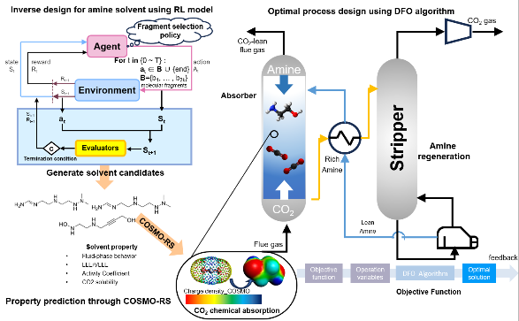

Figure 1. Overall schematic of proposed framework. Simultaneous operation of product design and process optimization
process model. The process system is converted into a surrogate model by nonlinear programming formulation, and DFO algorithm can be used to find the optimal solution in nonconvexity and nonlinearity black-box functions (M. Kim et al., 2023). The results of process optimization are returned to the target properties, which will be reflected in the setting of boundaries and initial values to serve as meaningful feedback. In this research, we will apply the framework to design an effective solvent and CO₂ chemical absorption process.
  - Methodology
    - Artificial intelligence-driven combinatorial chemistry
Inverse molecular design is a method to explore molecular structures with desired properties from a starting point. In our previous work, we developed artificial intelligence-driven combinatorial chemistry (AID-CC), which combines RL and combinatorial chemistry for inverse molecular design. Combinatorial chemistry is performed with molecular fragments and fragment combination rules. Since molecular fragments are connected randomly, it is possible to generate molecules with properties that deviate from known data. However, when using combinatorial chemistry to generate molecules, it is very expensive to generate molecules that satisfy the desired properties because the fragments are attached completely randomly rather than according to a learned policy (Furka, 1982). In this regard, RL learns in a way that maximizes the reward among selectable actions, so it was possible to combine the two to generate molecules that don't exist in existing databases.
The agent starts with a randomly selected molecular fragment. The policy is learned through the Proximal Policy Optimization (PPO) algorithm(Schulman et al., 2017). PPO is known for its stability, efficiency, scalability, and flexibility in discrete action spaces. Considering constraints such as molecular weight and number of fragments, the policy guides the agent to a more efficient exploration of chemical space by giving higher rewards when the properties of the generated molecules more closely match the target. The action is to select a molecular fragment to combine with the current structure and the state at each step is represented by the molecular structure. To ensure that only valid chemical structures are generated, the agent uses action masking, which prevents the selection of incompatible fragments based on the binding sites of the current molecule.

  - COSMO-RS
COSMO-RS is based on the statistical thermodynamics of a simplified model of molecular interactions, in which intermolecular contacts are replaced by contacts that interact independently in pairs between surface segments of the molecular community (Gerlach et al., 2018). The interaction between segments is described by the screening charge density from the COSMO calculation, and the sigma profile is represented by the probability of finding a specific screening charge density at the molecular surface:
$$p_{s}\left(σ\right)=\sum_{i∈}{x_{i}×p_{i}\left(σ\right)}$$ | (1)

$p^{Xi}\left(σ\right)=\frac{n_{i}\left(σ\right)}{n_{i}}=$ $\frac{A_{i}\left(σ\right)}{A_{i}}$ | (2)
${where x}_{i}, p^{Xi}\left(σ\right) and n_{i}\left(σ\right) s$tand for the mole fraction of component “i” in the mixture, the σ profile of any molecule X and the number of distributed segments that has surface charge density σ, respectively. $A_{i}\left(σ\right)and A_{i}$ are the segment surface area that has charge density σ and the area of the whole surface cavity rooted in the medium, respectively.

  - Results
    - Application to the discovery of amine solvent for CO₂ absorption
For a promising CO₂ capture solvent, it should (1) absorb a large amount of CO₂ into solution with efficient absorption rate as an ideal capture agent and (2) make captured CO₂ more reactive (Siegel et al., 2023). The descriptors of pKa, ePOS, sphericity, amide bond energy, and NCNN pattern can be used to find amine solvents. We set the CO₂ capture product to methanol and the catalyst to Ru-MACHO. When the amine detaches the hydrogen in the catalyst, its pKa should be larger than the catalyst, otherwise carbamate formation may increase. As the amine intercepts the CO₂ captured in the catalyst, the target properties should have a charge profile complementary to the Ru-MACHO and a small sphericity.
To react with the electronegative part of Ru-MACHO, the target amine must have a wide electropositive area to promote solubility and stability of the catalyst in the solvent. Smaller sphericity is preferred for CO₂ capture solvents. It should also have a low amide bond dissociation energy when the amine bond is broken. Experimental data also suggested that the NCCN pattern could be a key descriptor (Kar et al., 2019). Therefore, the reward is defined as in equation (3). Additionally, synthesizability prediction using AizynthFinder (Genheden et al., 2020) was also considered.

$$Reward=NCCN-BDE+Sphericity+ePos$$ | (3)

The molecular structures of the generated amine solvents are presented in Table 1.

ID | M1 | M2 | M3
Molecular  Structure | 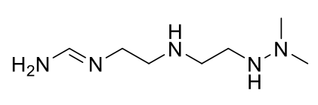 | 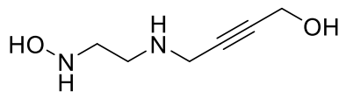

Table1. Three molecular examples that were generated by material design
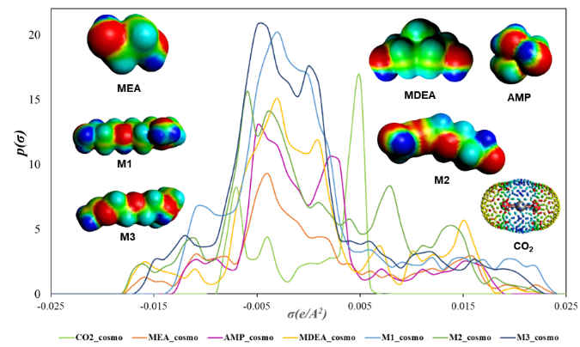

Figure 2. COSMOtherm generated σ profile and σ surface of MEA, MDEA, AMP, CO₂ and new amine solvents

    - σ profile and σ surface analysis by COSMO-RS model
The interactions between solvents and CO₂ significantly contribute to the solubility of CO₂. The σ profiles and surfaces of monoethanolamine (MEA), Methyldiethanolamine (MDEA), 2- amino-2-methyl-1-propanol (AMP), CO₂ and the generated amine are shown in Figure 2. Since the highest peak of CO₂ is present in the positive region, and M3 has the highest peak in the negative region, it is predicted to exhibit the best CO₂ absorption.
The red region of the σ surface is hydrogen-bond acceptor; the blue is hydrogen-bond donor; the green is nonpolar region of the molecule. Since CO₂ can act as a hydrogen bond acceptor, in the case of capture solvent, the presence of blue region is advantageous for CO₂ capture, and the nonpolar interaction between solvent and CO₂ can increase the solubility of CO₂.
3.3. Modelling of Amine-H₂O-CO₂
The solubility of CO₂ under a wide range of thermodynamic conditions is a crucial factor in evaluating the potential of a solvent for CO₂ capture applications (Pereira & Vega, 2018). To design absorber efficiently, it is necessary to predict the solubility of CO₂. In addition, since the regeneration process of the amine solvent occurs in the stripper, the operating conditions should consider CO₂ solubility so that the CO₂ can be easily separated from the solvent Modelling CO₂ absorption in amine aqueous solutions is a fundamental thermodynamic method.

3.3.1. The phase equilibrium
The concentration of CO₂ in the liquid phase and the partial pressure of CO₂ in the gas phase can be described by Henry's and Raoult's laws (Kim et al., 2022) :
$$ϕ_{{CO}_{2 }}y_{{CO}_{2 }}P^{tot}=H_{{CO}_{2 }}γ_{{CO}_{2 }}^{*}x_{{CO}_{2 }}exp⁡\left(\frac{v_{{CO}_{2 }}^{∞}\left(P-P_{w}^{0}\right)}{RT}\right)$$ | (4)
where $ϕ_{{CO}_{2 }}, y_{{CO}_{2 }} and P^{tot}$are the fugacity coefficient, the mole fraction of the vapor phase and the total pressure, respectively. The activity coefficient and Henry’s law constant are represented by $γ_{{CO}_{2 }}^{*}$and $H_{{CO}_{2 }}$, respectively.${ x}_{{CO}_{2 }}, P_{w}^{0}$ and $v_{{CO}_{2 }}^{∞}$are the mole fraction in the liquid phase, the vapor pressure of water and partial molar volume of CO₂ at infinite dilution in water, respectively. The phase equilibrium for the solvent species, amines and water is given by:
$$ϕ_{w}P_{w}=a_{w}ϕ_{w}^{s}P_{w}^{s}exp\left(\frac{v_{w}(P-P_{w}^{s})}{RT}\right)$$ | (5)
where subscript W represents water, $ϕ_{w}^{s}$ and $v_{w}$ are the fugacity coefficient of water at its vapor pressure and partial molar volume, respectively.

In this study, the chemical reaction of the H₂O-Amine-CO₂ system was also considered.
Chemical reactions were represented as equilibrium constants, and chemical equilibria were modelled by calculating charge balance equation and mass balance equations.
3.3. Discussion the advantages of the proposed method over other established method
Computer-Aided Molecular and Process Design (CAMPD) provides a systematic framework for evaluating a wide range of molecular structures in terms of system metrics when considering desirable physicochemical properties and process performance criteria (Adjiman et al., 2014). In CAMPD, the mathematical models governing the structure-property relationships of molecules and the performance of materials are related to process operating variables and presented as a large mixed-integer nonlinear problem (MINLP) formulation. However, many algorithms face challenges in CAMPD problems. The design space generated by the integrated product-process model is characterized by the presence of infeasible subregions and the relationship between process and molecular structure is highly nonlinear, making it difficult to find a solution (Lee et al., 2023). In addition, integrating machine learning-based material discovery methodology and Derivative-Free Optimization (DFO) algorithms within the CAMPD framework proves challenging, particularly due to the complex nature of MINLP structures.
The proposed method can design the capture solvent considering the process conditions by directly applying the optimal amine solvent generated through RL model to the process model and reflecting the results as feedback to the RL model. Instead of solving the MINLP problem, which many algorithms have difficulty solving, the process model is directly designed using the proposed amine solvents, thus avoiding multiple iterations and adjustments. The chemical process is also converted into a surrogate model using the DFO algorithm, which can be optimized more effectively.
  - Conclusion and future works
Consequently, this research can provide remarkable opportunities to effectively design a capture solvent that achieves the optimal performance and economic efficiency. We generated the optimal amine solvent candidates and predicted CO₂ solubility thorough COSMO-RS to connect with CO₂ absorption process. The proposed framework that can adapt to variations in process conditions improve process efficiency and expand domain knowledge of the material discovery. This can reduce the vast solvent design space, providing a clear advantage over sequential optimization which involves multiple iterations and adjustments.
In the future, parameter fitting will be conducted to fit the expected solubility with experimental data to increase accuracy. Therefore, we intend to construct accuracy and efficient VLE modelling of CO₂ absorption applied to new amine solutions. Based on the prediction of CO₂ chemical absorption derived from thermodynamic analysis, we aim to design the optimal process using DFO algorithms. The optimization results will lead to the expansion of domain knowledge and meaningful feedback to the material design framework. It is expected that this framework will be applied to design materials that have superior properties and economic feasibility.
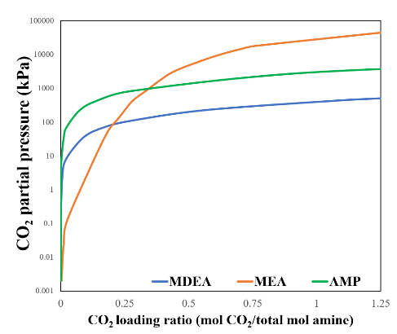
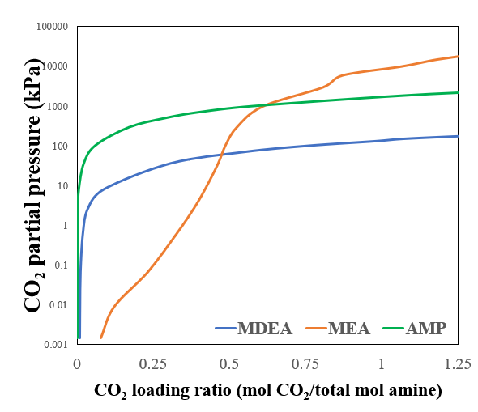
Figure 3. Partial pressure of CO₂ as function of CO₂ loading in aqueous solutions of MDEA, MEA and AMP at different temperatures (a) 313 K (b) 393 K

ㄲ
References
Adjiman, C. S., Galindo, A., & Jackson, G. (2014). Molecules Matter: The Expanding Envelope of Process Design. In M. R. Eden, J. D. Siirola, & G. P. Towler (Eds.), Computer Aided Chemical Engineering (Vol. 34, pp. 55-64). Elsevier.
Furka, A. (1982). Study on the possibilities of systematic searching for pharmaceutically useful peptides. Notarized Report (File number 36237/1982, in Hungarian).
Genheden, S., Thakkar, A., Chadimová, V., Reymond, J.-L., Engkvist, O., & Bjerrum, E. (2020). AiZynthFinder: a fast, robust and flexible open-source software for retrosynthetic planning. Journal of Cheminformatics, 12(1), 70.
Gerlach, T., Ingram, T., Sieder, G., & Smirnova, I. (2018). Modeling the solubility of CO2 in aqueous methyl diethanolamine solutions with an electrolyte model based on COSMO-RS. Fluid Phase Equilibria, 461, 39-50.
Kar, S., Sen, R., Kothandaraman, J., Goeppert, A., Chowdhury, R., Munoz, S. B., Haiges, R., & Prakash, G. K. S. (2019). Mechanistic Insights into Ruthenium-Pincer-Catalyzed Amine-Assisted Homogeneous Hydrogenation of CO2 to Methanol. Journal of the American Chemical Society, 141(7), 3160-3170.
Kim, H., Choi, H., Kang, D., Lee, W. B., & Na, J. (2023). Materials Discovery with Extreme Properties via AI-Driven Combinatorial Chemistry. arXiv preprint arXiv:2303.11833.
Kim, M., Han, A., Lee, J., Cho, S., Moon, I., & Na, J. (2023). Comparison of Derivative-Free Optimization: Energy Optimization of Steam Methane Reforming Process. International Journal of Energy Research, 2023.
Kim, S.-M., Kim, K.-M., Choi, B.-K., Mun, J.-H., Shin, B.-J., Lee, U., Shin, C.-H., Choi, J., Min, B.-M., Lee, U., & Moon, J.-H. (2022). CO2 absorption mechanism in aqueous ternary solutions of alkanolamines: Experimental and thermodynamic modeling approaches. Chemical Engineering Journal, 428, 132044.
Lee, Y. S., Galindo, A., Jackson, G., & Adjiman, C. S. (2023). Enabling the direct solution of challenging computer-aided molecular and process design problems: Chemical absorption of carbon dioxide. Computers & Chemical Engineering, 174, 108204.
Pereira, L. M., & Vega, L. F. (2018). A systematic approach for the thermodynamic modelling of CO2-amine absorption process using molecular-based models. Applied Energy, 232, 273-291.
Schulman, J., Wolski, F., Dhariwal, P., Radford, A., & Klimov, O. (2017). Proximal policy optimization algorithms. arXiv preprint arXiv:1707.06347.
Siegel, R. E., Pattanayak, S., & Berben, L. A. (2023). Reactive Capture of CO2: Opportunities and Challenges. ACS Catalysis, 13(1), 766-784.

