Flexible Hybrid Utility Systems for Industrial Decarbonization
Matthew Taylor,ª Martin Atkins,^{a*} Isuru Udugama,^{b} Timothy Gordon Walmsleyª
ªAhuora – Centre for Smart Energy Systems, School of Engineering, The University of Waikato, Private Bag 3105, Hamilton, 3240, New Zealand
^{b}Department of Chemical and Materials Engineering, Faculty of Engineering, The University of Auckland, Private Bag 92019, Auckland, 1142, New Zealand
*martin.atkins@waikato.ac.nz
Abstract
To reduce emissions produced due to process heat supply, fossil fuels need to be replaced by renewable fuels in steam boilers. An economical solution may be to utilize renewable electricity and biomass simultaneously to leverage the benefits of both types. This study investigates the economic viability of a dual-fuel boiler system using an industrial case study. Utility system operations were optimized using a Python-based mixed-integer linear programming model, where the minimum operating costs (including fuel and emission components) for all the data points was determined. Under current energy prices, only using coal as the fuel is initially seen as the most cost-effective system. However, as carbon costs increased the dual electrode and biomass system becomes slightly more cost effective. With high price volatility, a hybrid biomass and electrode system would give a 4.9 % cost reduction, as well as a 93.8 % emission reduction.

Keywords: Decarbonization, hybrid utility system, mathematical optimization
  - Introduction
In New Zealand, process heating is largely supplied through non-renewable sources with around 75% supplied by coal and natural gas (Energy Efficiency and Conservation Authority, 2023). Methods of process heat delivery are moving away from fossil fuels, in part due to rising carbon emission costs as well as climate action policy. The New Zealand government is phasing out coal boilers by 2037, prohibiting their usage. Much of the energy used for process heat is used in steam boilers and there are two main renewable alternatives - biomass and electrode boilers using renewable/low carbon electricity. Electrode boilers have high operational costs due to electricity prices and volatility of electrical pricing, whereas biomass boilers have high capital costs (if not retrofitting coal boilers) and potential issues with supply security.
A barrier to decarbonization is uncertainty and risk associated with costs and timeframes resulting in companies deferring investment decisions. Implementing both electrode and biomass boilers together as a hybrid system can reduce the economic barrier (Walmsley et al., 2023). For hybrid boiler systems, an electrode boiler could operate simultaneously and in a flexible manner with a biomass boiler. In this configuration the biomass boiler would provide baseload steam and the electrode boiler acting as a peaking boiler with rapid response times. In state-of-the-art utility systems, dual-boiler setups tend to have simple operating rules, such as triggers to switch the primary boiler.
The aim of this work is to quantify the economic viability of a price-responsive dual-boiler setup compared to individual boiler types for the same amount of load. To achieve this aim, the study focuses on minimizing the operating cost of different single and dual industrial boiler setups by manipulating which fuel is used, and how much of it is consumed over time. The scope of this study is limited to operating cost optimization, specifically the firing rates of the different boilers in the hybrid system. Future work will look at expanding the scope and move towards a real-time optimization approach.
  - Mathematical Optimization Model
    - Model Parameters
The main structure of the optimization model is an equation-based time-slice model where a year’s worth of data is split into multiple small slices, and these slices are then solved individually for the minimum cost. The main parameters into the model are the thermal demand, fuel costs, and emission trading scheme costs, with the output of the model being the annual operating cost and annual CO₂ emissions.
      - Thermal Model
For this work, an industrial case study is used as the basis for the modelling. This is a New Zealand processing plant that currently uses coal boilers as the medium for process heat delivery, but due to confidentiality reasons commercially sensitive details are omitted. One of the major objectives of this work is to understand how the varying electricity spot price can affect the operating cost, which required the thermal demand of the plant to be the same time-step as the spot-price. The thermal model was generated using a previous mass and energy balance, where the heat demand was determined by the change in enthalpy between the water and the steam for each boiler, using on-site sensors. This was then validated against recorded coal usage from the plant. The thermal is shown in Figure 1 as an ordered plot to show the distribution of values. Using this thermal model alongside knowledge of decision-making factors different models and scenarios could be made. Having a specific case study is also important as it establishes a fixed geography of the plant, which can affect many contributing factors, such as fuel price, fuel supply, and electricity prices.
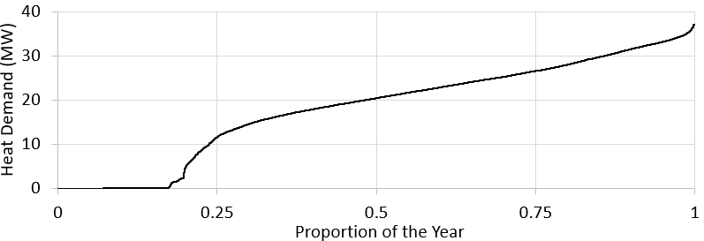
Figure 1: Plant site thermal demand.

      - Fuel Costs
The main parameters for the optimization are the different fuel costs, which are composed of supply costs and emission trading scheme costs. For the electricity pricing (excluding transmission and distribution costs), this is the trading period (half-hourly) price and applying a general pricing increase factor of 2 %. This increase represents the change in price over time for the average price, based on the location of the plant and plant experience. For the biomass and coal pricings, these were given as starting prices of $16 NZD/GJ and $5 NZD/GJ and increasing at 2 % per annum, with the numbers based on the experience of the plant.
      - Emission Costs
To calculate the emission-based costs both the emission factor and emission unit cost are required. The emission factor represents the relative mass of CO₂ emitted for every unit of fuel consumed. For this work, the emission factors used were 0.083 t_{CO2-e}/GJ for coal, 0.00278 t_{CO2-e}/GJ for biomass, and 0.0167 t_{CO2-e}/GJ for electricity (Ministry for the Environment, 2023a). The electricity emissions factor is an estimate of the average factor over the next 15 years. A price pathway for emissions starting at $70 NZD/t_{CO2-e} in 2023 rising to $144 NZD/t_{CO2-e} in 2030, and then $260 NZD/t_{CO2-e} CO₂ in 2050 was used (Ministry for the Environment, 2023b). A piece-wise linearization was applied to the price pathway. For the optimization of the plant in this study, the final time is set at 2037 (the 2050 pricing helps create the linearization).
      - Boiler Limits
The boilers in the model have established upper (Q_{UL}) and lower limits (Q_{LL}) that constrain the firing rate, represented by Equation 1. For electrode boilers in the model, the lower limit is set at zero duty (the same as no lower limit) as it has a consistently high efficiency at all partial firing rates.
Q_{LL} ≤ Q ≤ Q_{UL} | (1)
Solid fuel boilers however have a diminishing efficiency at lower firing rates, so while the partial efficiency model was not used, this was represented by setting the lower operating limit to be half of the upper operating limit. The limits for the boilers are defined based on the current specifications of the boilers in the plant (for the solid fuel boilers) and potential plans (for the electrode boiler). The upper limits are 30 MW for solid fuel boilers, and 12 MW for electrode boilers.
    - Optimization Formulation
The optimization is performed using the equation based GEKKO Python package (Beal et al., 2018). For the optimization of a year of data the parameters are defined before solving, with the main parameters being the total fuel cost (C_{F}) and the limits of the boiler firing rate (Q). For all fuel types, the total cost is made of the supply cost (C_{S}) and the emission cost (C_{E}) (based on the emission factor (EF)), shown in Equation 2:
C_{F} = C_{S} + EF ⋅ C_{E} | (2)
The firing rate of the boiler is a variable within the model and is the primary aspect that is changed within a timestep. The optimizer will change the duty for each timestep to minimize the operating cost (C_{T}) while simultaneously meeting the overall demand (Q_{T}). For an example optimization of a hybrid biomass (denoted by subscript B) and electrode (denoted by subscript E) system, the objective function and demand definition are shown in Equation 3 and Equation 4:
min (C_{T}), where C_{T} = Q_{B} ⋅ C_{F,B} ⋅ z_{B} + Q_{E} ⋅ C_{F,E} ⋅ z_{E} | (3)
Q_{T} ≤ Q_{B} ⋅ z_{B} + Q_{E} ⋅ z_{E} | (4)
Where z is the binary switch for each boiler that represents the operating state (0 for off, 1 for on). This is used for boilers with a lower limit above 0 MW. The optimization is solved using the GEKKO APOPT solver.
  - Results and Discussion
Five different scenarios are used in this study: coal, biomass, and electrode only, and two hybrid scenarios of biomass/electrode and coal/electrode. Individual boilers give a reference point, whereas the two hybrid scenarios represent potential transition pathways. The main aspect that changes over time is the emission trading scheme pricing, and as the price increases over time, the expectation is that electricity would be the primary fuel in the coal and electrode hybrid and the biomass would be primary fuel in the biomass and electrode hybrid. Figure 2 shows the annual energy costs of the different scenarios at five-yearly intervals. These intervals are capped in 2037, as this is when coal boilers will be phased out in New Zealand, and unable to be used. Comparing coal and biomass as the base fuel, coal-based systems are cheaper to operate due to the low emissions trading scheme pricing. However, if capital costs are not included, then operating an electrode boiler as well as the coal boiler makes the system cheaper than running just the electrode boiler. 2037 is the year where the biomass hybrid system becomes cheaper than the coal hybrid systems, due to the trading scheme making coal supply more expensive than biomass.

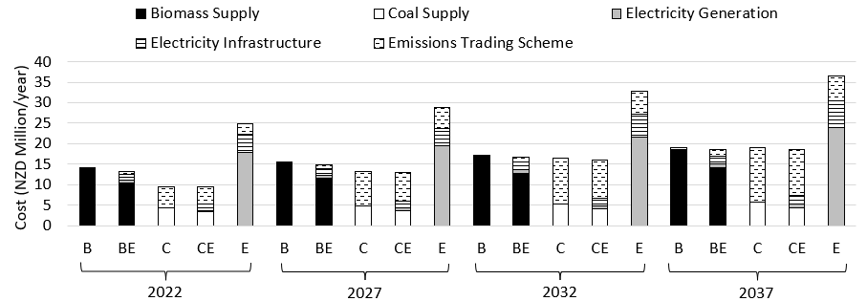
Figure 2: Annual energy costs for the five main scenarios over 15 years.
These results assume that the volatility of the electricity price stays consistent throughout the years. The magnitude is increased by the same 2 % increase factor, but the price volatility stays the same. Volatility (or variance) in this study is the measure of how much the electricity fluctuates away from a recent historical moving average (previous day). To be more realistic, the variance in price is likely to increase because of the addition of more renewable electricity supply into the grid (Electricity Authority, 2022). To investigate this, the model was re-run with new electricity prices, where the variance was increased as a factor of time. The variance was calculated by scaling the difference between actual price (P_{A}) and the moving average price of the previous day (P_{M}). The variance increase factor (F) was initially high (20 %) due to the increase not compounding. The main equation is shown in Equation 5, with P_{F} representing the new price after scaling. This equation is applied to each price point, repeated for every year since the base year (2022).
P_{F} = P_{M} + (P_{A} – P_{M}) * F | (5)
The coal hybrid operating cost is recalculated using the new prices, with the results shown in Table 1. With a larger variance on electricity price, the total energy cost decreases because of more periods with a lower electricity price. The constant-variance scenario has a cost reduction of 1.0 %, whereas the increasing variance scenario has a cost reduction of 4.9 %. This means that electrode boiler can be better utilised and meeting the capacity more often. For the scenario without variance, this results in an emissions reduction of 93.8 %, and a reduction of 93.6 % for the high variance scenario.
Table 1: Cost breakdown for different 2037 utility system scenarios.
2037 Scenario | Annual Operating Cost (Million $ NZD) |  |  |  | Annual Emissions  (kt CO₂-e)
 | Coal/ Biomass | Electricity | Emission Trading Scheme | Total Energy Cost
Coal Only | 5.81 | 0.00 | 13.28 | 19.09 | 53.95
Coal Hybrid (No Variance) | 4.43 | 2.85 | 11.23 | 18.51 | 42.78
Coal Hybrid (With Variance) | 4.11 | 3.23 | 10.86 | 18.20 | 40.34
Biomass Only | 18.59 | 0.00 | 0.44 | 19.03 | 1.80
Biomass Hybrid (No Variance) | 13.45 | 3.73 | 1.71 | 18.89 | 3.36
Biomass Hybrid (With Variance) | 13.15 | 3.23 | 1.78 | 18.16 | 3.44
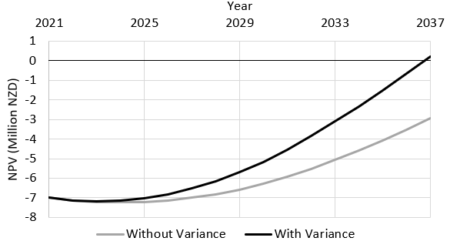
Figure 3: Net present value over time for an implemented 12 MW electrode boiler.
Knowing that variance reduces the operating cost can help with cost justification, as it means the payback period will be shorter. For both the variant and non-variant pricing, the net-present value has been calculated, assuming that an electrode boiler was built in the starting year (2022). Only the electrode boiler costing was included, as this is closer aligned with the direction of the case study plans. Figure 3 shows this value over time, showing that a variance increase factor of 1.2 (20 % increase) per year is required to make the electrode boiler pay back (assuming the specific parameters of this case study) by 2037. The initial capital cost of the boiler was set at 7 million NZD as an average for the boiler and required infrastructure costing. By not including the variance, the electrode boiler does not pay back before the 2037 mark which can make it harder to justify the decision from an industrial perspective.
    - Future Work
The optimization of this study has focused on the time-of-use minimization. However, only the specific firing rate of the boilers has been included in the optimization loop. A future iteration of the optimization should include the boiler capacity as an outer layer. However, this is not a simple process, as the sizing of the boilers has implications on the capital costing, which does not often have linear scaling. Other aspects to investigate would be the costing of individual aspects (like the emission trading scheme, fuel, and electricity costs). These have been assumed as fixed values or linear progressions, but in practice this does not happen. An example is the evolving biomass market within New Zealand, which could cause the fuel cost to increase non-linearly. Finally, better defined installation timelines should be calculated, considering the existing lifespan of coal boilers on-site. The hypothesis would be that if a coal boiler were to reach end-of-life, it should be replaced by a biomass boiler, but there could be value in having the biomass boiler fire coal at a lower efficiency and retrofitting it to biomass after a few years.
  - Conclusion
The optimisation suggests a two-step utility system transition plant (for cost minimisation). Considering higher electricity volatility prices in the future, the recommendation is that first, as soon as practicable, an electrode boiler (12 MW capacity) should be installed next to the coal boiler, reducing annual energy costs by up to 4.9 % and emissions by 25.2 %. Second, the coal boiler would be replaced by a biomass boiler towards 2037, for a total emissions reduction of 93.6 %.
References
L.D.R. Beal, D. Hill, R.A. Martin, J.D. Hedengren, 2018, GEKKO Optimization Suite, Processes, Volume 6, Number 8
Electricity Authority, 2022, Electricity price volatility, https://www.ea.govt.nz/news/eye-on-electricity/electricity-price-volatility-an-emerging-feature-in-an-increasingly-renewable-market/
Energy Efficiency and Conservation Authority, 2023, Energy End Use Database – Key insights and methodology, Wellington, New Zealand. https://www.eeca.govt.nz/insights/data-tools/energy-end-use-database/
Ministry for the Environment, 2023a, Measuring emissions: A guide for organisations, Wellington, New Zealand, https://environment.govt.nz/assets/publications/Measuring-Emissions-Guidance_DetailedGuide_2023_ME1764.pdf
Ministry for the Environment, 2023b, Review of the New Zealand Emissions Trading Scheme: Summary of modelling, Wellington, New Zealand
T. Walmsley, M. Philipp, M, Picón-Núñez, H. Meschede, M. Taylor, F. Schlosser, M. Atkins, 2023, Hybrid renewable energy utility systems for industrial sites: A review, Renewable and Sustainable Energy Reviews, Volume 188

