Assessing Climate Variability in Tomato Supply Chain Optimization: A Multi-Objective Approach for Qatar's Tomato Imports
Bashar Hassna, Sarah Namany, Mohammad Alherbawi, Adel Elomri, Tareq Al-Ansari*
College of Science and Engineering, Hamad Bin Khalifa University, Doha, Qatar
*talansari@hbku.edu.qa
Abstract
In an era of escalating climate variability, characterized by unpredictable monthly trends in temperature and precipitation, the stability of global food supply chains faces unprecedented challenges. Nowhere is this more evident than in countries like Qatar, which heavily depend on imports to meet their food demands. This research investigates the influence of climate variability on determining the optimal network of trade partners to supply tomatoes to Qatar. The suggested framework employs a stochastic multi-objective optimization framework, simultaneously addressing critical objectives: the minimization of transportation costs, the reduction of water consumption, and the tracking of virtual water trade in tomato imports, while accounting for climate uncertainty, such as rainfall, modeled as stochastic parameters following a normal distribution. Findings of this study shed light on the intricate dynamics within Qatar's tomato sourcing network. A notable observation relates to the identification of discernible seasonal variability in the percentage contribution of certain countries, with a visible aggregation of supply sources during the summer months. This observation underscores the susceptibility of tomato supply chains to the influence of climatic factors, particularly during periods characterised by heightened fluctuations in temperature and low precipitations. Furthermore, results discern explicit correlations between climate variability and trade networks selection. These findings not only furnish invaluable insights for Qatar's policymaking in the field of imports but also contribute to a broader comprehension of the strategies employed by nations reliant on food imports as they endeavor to strengthen the resilience and sustainability of their supply chains in the midst of prevailing climatic uncertainties.
Keywords: optimisation, precipitation, supply chain, virtual water, climate variability.
  - Introduction
The foundation of food security lies in food production. Availability, defined as the physical presence of food supplies in appropriate quantities, hinges on factors such as net domestic production, net imports, and stock drawdown, adjusted for feed, seed, and waste. Physical availability in specific areas necessitates market integration, robust storage, and transportation infrastructure. Yet, the cornerstone of food availability remains food production. As highlighted by Swaminathan, the global challenge is to sustainably increase production amid decreasing per capita arable land, irrigation water supplies, and mounting abiotic and biotic pressures, intensified by a projected global population exceeding 8.5 billion by 2030 (Swaminathan MS, 2013).
Given the significant impact of weather on food production, the focus is on remediation strategies across various domains. These encompass food production and quality yields, irrigation water requirements, technological advancements in crops and livestock, erosion-induced loss of arable land, fish production needs, and emerging risks affecting food security. Adverse weather events, marked by unusually high or low temperatures and erratic rainfall patterns, negatively impact cattle and agriculture performance. Although contemporary technologies can mitigate these effects (Gomez-Zavaglia, A., 2020), the interplay between temperature, crop land, water quality, and irrigation significantly influences the environment.
Irrigation, a key factor in altering hydrological conditions, poses environmental concerns, especially as regions transition from rain-fed to irrigated agriculture. Climate variability, including temperature extremes during critical phenophases, affects crop growth, development, and yields. This climate uncertainty, coupled with concerns about water availability, highlights the importance of integrated water management. Water scarcity is a potential constraint for crop production and food security, with studies emphasizing the critical role of efficient water use (Fujihara et al., Kang et al.). Assessing water availability is essential for maintaining biodiversity, human life, and the environment, especially considering the strains on the hydrological cycle due to pollution, population growth, land use changes, and climate change.
The paper's objective is to propose a framework utilising multi-objective optimisation that addresses critical objectives such as minimising transportation costs, reducing water consumption, and tracking virtual water trade in tomato imports, the framework accounts for climate uncertainty, modelled as stochastic parameters with a normal distribution. The findings unveil the intricate dynamics of Qatar's tomato sourcing network, highlighting discernible seasonal variability in certain countries' contributions and an aggregation of supply sources during summer months.
  - Data and Methods

The methodology suggested in this paper aims to determine the optimal trade network that satisfies the demand for tomatoes in the state of Qatar while considering environmental and economic aspects. The purpose is to quantify the impact of the variability of weather conditions of trade partners on their contributions in supplying the overall demand. In this model, the influence of weather fluctuations is expressed by means of the crop water requirement (CWR). It is defined as the optimal amount of water required for the crop to grow adequately. Due to the limited access to data of trade partners, the CWR computation was assumed based on the CWR of Qatar which is estimated based on the following equation (Eq.1), such that w is the crop water requirement, A is the area cultivated and ${ET}_{C}$ is the evapotranspiration.

$w=\frac{A × {ET}_{C}}{1000}$ (1)

Linear regression is used to link the water to temperature and forecast the values for all participating countries (Namany et al., 2020). The dataset was subjected to a fitting process utilizing a normal distribution model. Subsequently, the parameters of the normal distribution were estimated to best align with the observed data, thereby characterizing the underlying statistical distribution of the dataset as approximately normal. The crop water data along with cost environmental data were used to in a multi-objective optimisation model that minimises economic costs (Eq 2) and GHG emissions (Eq 3) along with global water consumption (Eq 4). Table 1 summarises the set of data used in the model. The mathematical formulation of the optimisation framework is described in the following section:

Objective functions:

$min \sum_{i=1}^{7}{{Dc}_{i}x_{i}}$ (2) $min \sum_{i=1}^{7}{{De}_{i}x_{i}}$ (3)
$min \sum_{i=1}^{7}{{Dw}_{i}x_{i}}$ (4)

Subject to:

$\sum_{i=1}^{7}{x_{i}=100\%}$
$Dx_{i}<{Ex}_{i}$

Such that,

$x_{i}$ is the decision variable that represents the share of each trade partner i. D is total demanded quantity, c_{i} is the unit cost of crop production, e_{i} is the unit GWP emissions as for w_{i} , it represents the unit crop water requirement. Considering ${Ex}_{i}$, it refers to the allowed exportable quantity of every exporting country.

Table 1. Economic and environmental data used for the optimisation model.
Objective Function | USA | Iran | Lebanon | India | Turkey | Morocco | Nether-lands
CWR (m³/kg) | µ=0.0152  $σ$=0.0024 | µ=0.0147  $$σ=0.0092$$ | µ=0.0187  $$σ=0.0046$$ | µ=0.0238  $$σ=0.00314$$ | µ=0.0103  $$σ=0.0074$$ | µ=0.0151  $$σ=0.0033$$ | µ=0.0085  $$σ=0.0048$$
Cost ( $/kg) | 5.4007 | 0.7541 | 3.5796 | 1.1799 | 3.9110 | 2.8374 | 4.1137
GWP(kg of CO₂eq) | 0.0002 | 0.0002 | 0.0002 | 0.0003 | 0.0001 | 0.0002 | 0.0001

  - Results
The developed multi-objective optimization model is solved in MATLAB using the genetic algorithm. Results of the framework are summarised in the 3-D Pareto front illustrated in Figure 1. Figure 2 displays the percentage contributions of each trade partner to the overall demand considering 200 data points. Findings display some noticeable variations in supply from certain countries such as India, Morocco and Lebanon. This can be explained by the variations in their weather conditions. The US on the other hand has a low and fixed contribution. This is due to its high economic costs and emissions associated with transportation. In order to further investigate the results and understand the distributions, the optimal graphical solution is generated and illustrated in figure 3. The major contributions are from Netherlands, Iran then India thanks to their low crop water requirement, and relatively cheap cost that is due to their proximity to Qatar. Generally, the cost and proximity which is a major influence of the environmental performance are the main driver for the selection of trade partner. The weather conditions come to play when the variability is significant between the hot and cold season.

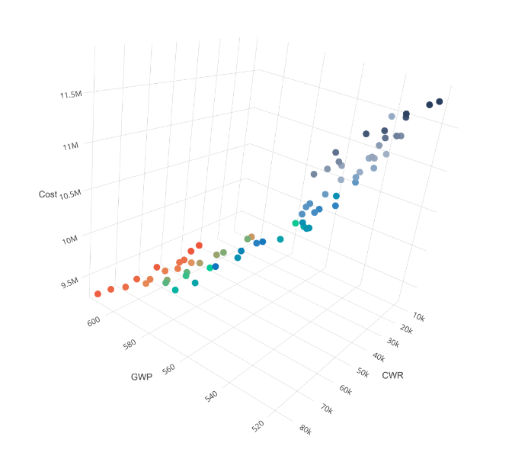

Figure 1. The Pareto Front.
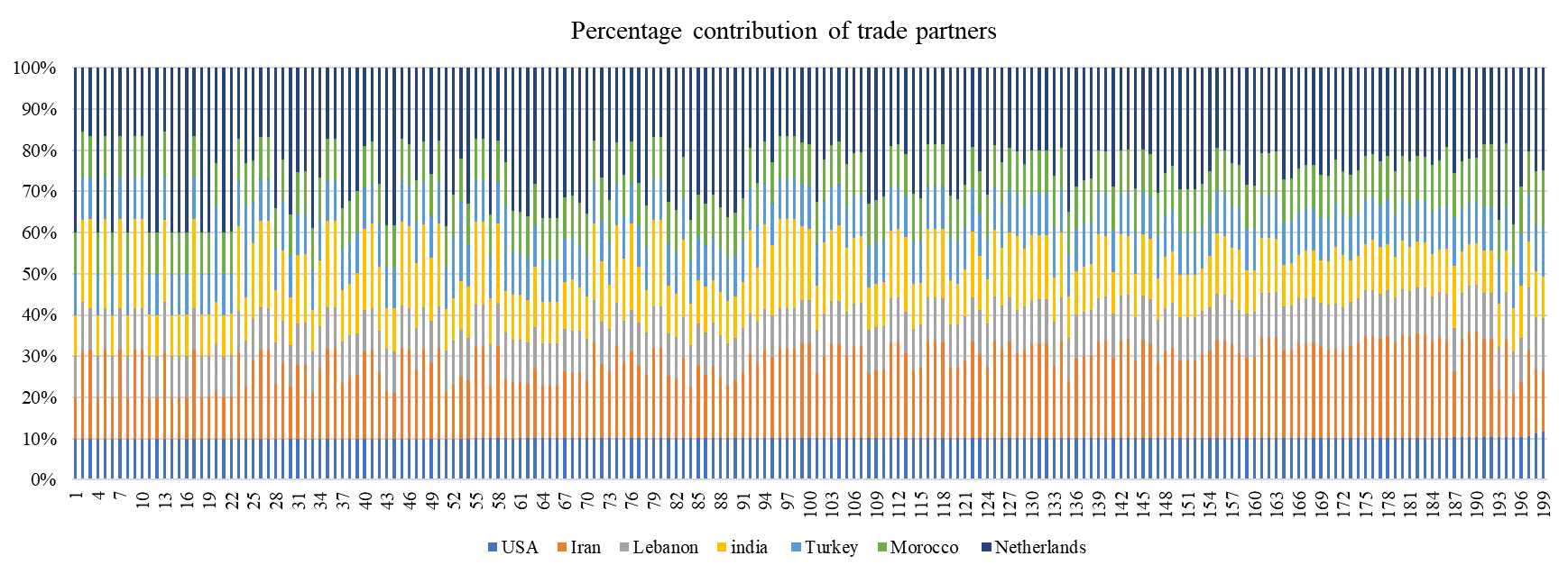
Figure 1. The contribution of each trade partner.
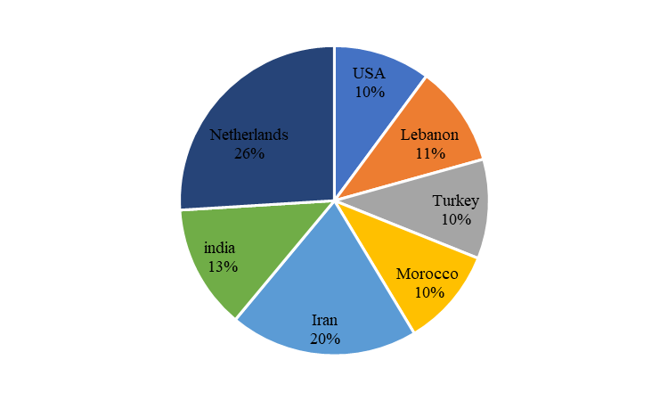

Figure 3. Average optimal solution.

  - Conclusions
This research examines how climate variability impacts the determination of the most effective network of trade partners for supplying tomatoes to Qatar. The proposed framework utilizes a stochastic multi-objective optimization approach that simultaneously addresses key objectives, including minimizing transportation costs, reducing water consumption, and monitoring virtual water trade in tomato imports. This framework also considers climate uncertainty, such as rainfall, modeled as stochastic parameters that follow a normal distribution. The study's findings provide insights into the complex dynamics within Qatar's tomato sourcing network. Notably, the research identifies distinct seasonal variations in the percentage contribution of specific countries, with a noticeable concentration of supply sources during the summer months. This observation highlights the vulnerability of tomato supply chains to climatic factors, especially during periods characterized by significant temperature fluctuations and low precipitation. Additionally, the results reveal clear correlations between climate variability and the selection of trade networks. These findings not only offer valuable insights for Qatar's import-related policymaking but also contribute to a broader understanding of the strategies employed by nations reliant on food imports. These nations aim to enhance the resilience and sustainability of their supply chains amidst ongoing climatic uncertainties.

  - Acknowledgement
This research was made possible by an Award (GSRA7-1-0521-20080) and supported by proposal number MME01-0922-190049 from Qatar National Research Fund (a member of Qatar Foundation). The contents herein are solely the responsibility of the authors[s].

  - References

Gomez-Zavaglia, A., Mejuto, J. C., & Simal-Gandara, J. (2020). Mitigation of emerging implications of climate change on food production systems. Food Research International, 134, 109256. https://doi.org/10.1016/j.foodres.2020.109256
Kang, Y., Khan, S., & Ma, X. (2009). Climate change impacts on crop yield, crop water productivity and food security – A review. Progress in Natural Science, 19(12), 1665–1674. https://doi.org/10.1016/j.pnsc.2009.08.001
Luo, Q. (2011). Temperature thresholds and crop production: a review. Climatic Change, 109(3-4), 583–598. https://doi.org/10.1007/s10584-011-0028-6
Namany, S. et al. (2020) ‘Sustainable food security decision-making: an agent-based modelling approach.’, Journal of Cleaner Production. Elsevier, p. 120296. doi: 10.1016/J.JCLEPRO.2020.120296.
Swaminathan MS, Bhavani RV. Food production & availability--essential prerequisites for sustainable food security. Indian J Med Res. 2013 Sep;138(3):383-91. PMID: 24135188; PMCID: PMC3818607.

