A virtual entity of the digital twin based on deep reinforcement learning model for dynamic scheduling process

^{b}Beijing Key Laboratory of Industrial Big Data System and Application, Tsinghua University, Beijing, China
jinsongzhao@tsinghua.edu.cn
Abstract
Digital twins (DT) are increasingly recognized as a transformative technology in the process industry. In complex chemical industrial systems, the management of operations is fraught with multiple steps, resource constraints, and dynamic events such as anomalies and equipment maintenance. Current scheduling methods for dynamic scenarios, though capable of handling these complexities, are primarily manual methods based on on-site information and are unable to respond to fault in time. These methods often result in slow and uneconomical outcomes and could not fit the uncertain and volatile production environment, especially process where safety is a problem of great concern. This paper introduces a DT framework that incorporates a deep reinforcement learning (DRL) model based on heterogenous graph neural networks (HGNN) as its core virtual entity, which could contract features from basic structure regardless of the constraints of size of problems. This HGNN-DRL design is also able to meet the needs of uncertainty and safety, fulfilling both of the requirements for full lifecycle adaptability and real-time interaction which is hard to effectively implement by traditional methods.
Keywords: Digital Twin, schedule, dynamic event, safety.
  - Introduction
Within chemical industrial parks, malfunctions in critical equipment can trigger cascading disruptions to production schedules, culminating in significant economic losses. Consequently, the implementation of a rational and effective maintenance plan is paramount for ensuring operational stability and profitability. For instance, disruptions in coal chemical industrial ports, such as equipment breakdowns, processing blockages, and conveyor mistracking not only induce production pauses but also incur demurrage charges and other financial penalties associated with delays.
The integration of smart manufacturing technology is propelling a new era of synergy between advanced information technology and various sectors of the manufacturing industry. Digital twin (DT) is considered one of the most promising technologies for realizing intelligent manufacturing which can achieve seamless integration and interaction between the physical and informational realms, causing increasing interest of chemical industries. There are documented instances of DTs in the realm of specific equipment and unit operations (Kender et al., 2022; Spinti et al., 2022; W. Wang et al., 2021) and on broader process scale (Koulouris et al., 2021; Perez et al., 2022), facilitating lifecycle monitoring and prediction as well as fault identification.
In contrast to the traditional approach of manually adjusting the schedule and introducing passive maintenance after failures, DT enable predictive maintenance and dynamic scheduling by monitoring equipment and diagnosing failures in advance through cyber-physical connections, and help to avoid the delays and losses caused by slow and unstable human response.
In DT implementations, employing machine learning techniques to create surrogate models has proven beneficial in reducing the duration of process simulations and decreasing the online computational load (Galeazzi et al., 2022). Among various machine learning approaches, deep reinforcement learning (DRL) is increasingly being utilized in production processes, showing distinct advantages in computation speed and optimization effectiveness as well as the ability to handle the flexibility and uncertainty in production processes (Gao et al., 2023; Panzer & Bender, 2022; X. D. Wang et al.; Yan et al., 2022).
This work introduces a novel digital twin (DT) framework that comprehensively incorporates dynamic scheduling processes with integrated safety considerations. It details the development of a virtual entity encompassing a novel DRL algorithm, HGNN-DRL method, designed to simultaneously solve scheduling problems and provide real-time responses to dynamic events. The framework is applicable to diverse flexible job shop scheduling problems (FJSP), including transportation and some batch processes, as demonstrated by an example to laytime in coal chemical industrial ports.
  - Methodology
    - Proposed DT
With five-dimensional modelling methodology (Fei Tao et al., 2019), this paper establishes the following framework which has 5 fundamental components: physical entity, virtual entity, connections, data, and services. The DT fitting into the category of a generic DT model in system-hierarchy (F. Tao et al., 2022). Dimensionally, our focus is on physical properties of key objects, as well as the behaviour and scheduling rules. Functionally, the emphasis is on implementing basic planning arrangements and completing maintenance plans based on timely information.
DT framework of real-time scheduling (Fig. 1a) adapts to processes by extracting base structure information. Its physical entity mirrors scheduling elements (storage, transport, etc.), and is modelled as a dynamic FJSP. The virtual counterpart, centred around a DRL model, is the core part of DT. It updates the problem information to a graph structure and extracts features to be used by an intelligent agent to generate an efficient schedule.
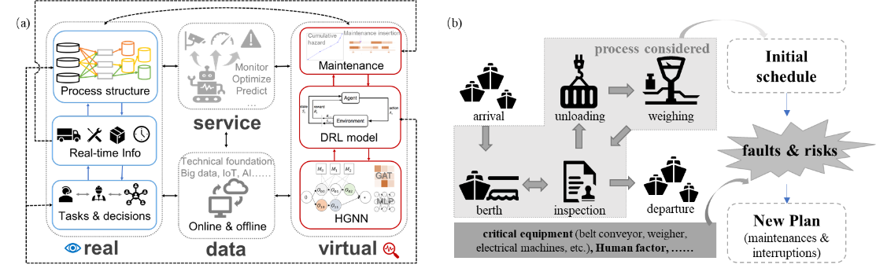
Figure 1 (a)DT framework. Bidirectional connections ensure synchronization. (b)An example of dynamic laytime schedule with fault detection and risk assessment.
In order to ensure safety, real-time measurement data should be fed into intelligent models to identify abnormal variables, and then develop maintenance plans by means of fault detection, diagnosis, and prediction (Bi et al., 2022).
Here, an example of laytime schedule in coal chemical industrial ports is elucidated. The workflow which can be described as FJSP is depicted in Figure 1b. During the laytime, transportation, manual inspection, unloading, weighing, and other tasks are initiated. Several factors such as berth occupation, device examination and faults on conveyors, weighers and other devices, impact the scheduling, thereby disrupting the former plans. DT monitors key variables (Figure 1b) and triggers plan updates upon detected faults. This enables proactive preventive maintenance at optimal intervals, minimizing machine downtime while the flexible model preserves schedule efficiency.
    - Scheduling model of the virtual entity
FJSP traditionally employs disjunctive graphs (Figure 2a) with operation nodes ($O{}_{ij}$), source, sink, conjunctive arcs (indicating job operation priorities), and disjunctive arcs (linking operations on the same machine). Solving FJSP involves selecting and directing input/output disjunctive arcs for each operation node. While various methods (mathematical programming, heuristics, metaheuristics) exist, DRL has recently demonstrated superior speed and performance (Panzer & Bender, 2022; Qin et al., 2023).
DT serves as an interface linking the physical and digital worlds by representing the past, present, and predicting future states of physical objects, offers a unified framework integrating existing technologies to integrate functions, especially in adapting to dynamic scenarios and real-time changes. Although there are many solutions available to solve similar problems, we still need to select and design rapid response measures that meet the DT requirements.
Considering the need for universality and rapid response in DT, one innovative DRL method based on heterogeneous graph neural networks (HGNN) (Song et al., 2023) from recent literature inspired us to construct a generic solution. This approach redefines the conventional disjunctive graph into a heterogeneous graph structure (Figure 2). Extracting features by encoding operation nodes, machine nodes, and arcs via HGNN into specific dimensions help the model to accommodate samples of varying sizes. Then HGNN forms a part of the actor component of the proximal policy optimization (PPO) model which is capable of rapidly calculating FJSP overall outperforming other methods. However, the model does not account for dynamic event insertion, limiting its ability to handle real-world scenarios like maintenance or unexpected incidents.
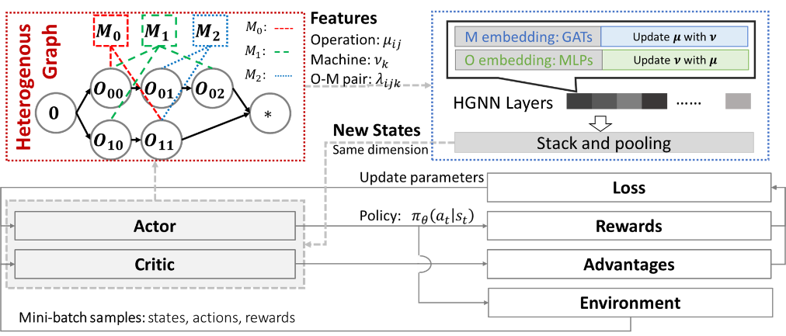
Figure 2 Information extraction and utilization with HGNN and PPO algorithm.
We expand upon the aforementioned method, transforming its application from static scenarios to dynamic ones. This enables rapid adaptation to fluctuations in production demands and unforeseen events, while incorporating equipment downtime and workflow interruptions. Consequently, the problem representation closely approximates real-world production situations. Figure 2 illustrates the learning process of the DRL model, showcasing the interactive loop between the PPO model agent and the environment. This environment is encoded using "OpenAI Gym 0.25.0" and the model is developed with "PyTorch 1.12.1".
  - Performance
The model is trained on randomly generated FJSP instances, with dynamic events applied to half of the machines. The duration of events $d$ follows a normal distribution $d\sim N\left(μ,σ^{2}\right)$ according to completion time $CT$ as seen in Eq. (1). $μ=0.2CT$, $σ=0.5μ$.
$CT=\max_{i}{\sum_{j}{\overline{p_{ijk}}}}, k=0,1,…m-1$ | (1)
The model validation process is applied on a dataset provided by Song (Song et al., 2023).
To evaluate the performance of the proposed deep reinforcement learning model with samples of varying scales and characteristics, the model was assessed by comparison of other methods using FJSP instances. Meta-heuristic algorithms like the genetic algorithm and swarm intelligence algorithm are not effective for dynamic FJSP as they are designed for static manufacturing settings (Qin et al., 2023). Therefore, to evaluate the dynamic FJSP model, a comparison with heuristic rules is a viable approach. Some heuristic rules that combine machine dispatching rules like Shortest Processing Time (SPT) and Earliest End Time (EET) with job sequencing rules such as Most Operation Number Remaining (MOPNR), Most Work Remaining (MWKR) and Least Work Remaining (LWKR) are usually used in tests and show advantageous results(Lei et al., 2022).
We compared our DRL model with heuristic rules on a public dataset of 10 instances (Mk01 to Mk10) which vary in size and structure (Brandimarte, 1993). The aforementioned dynamic event generation scheme is employed to produce 100 randomly generated cases for each instance, upon which each method is applied to rigorously evaluate their performance under diverse scenarios. HGNN-DRL method demonstrated the capability to efficiently solve given problems, delivering responses within a few seconds (0.5 to 8 seconds). It outperformed heuristic rules on 9 instances but gave less efficient results than the Most Work Remaining and Earliest End Time rule on the small-scale Mk01 instance.
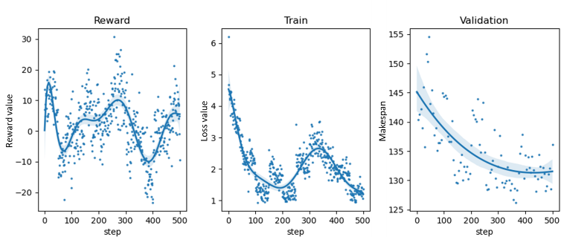
Figure 3 Model training and validation process.

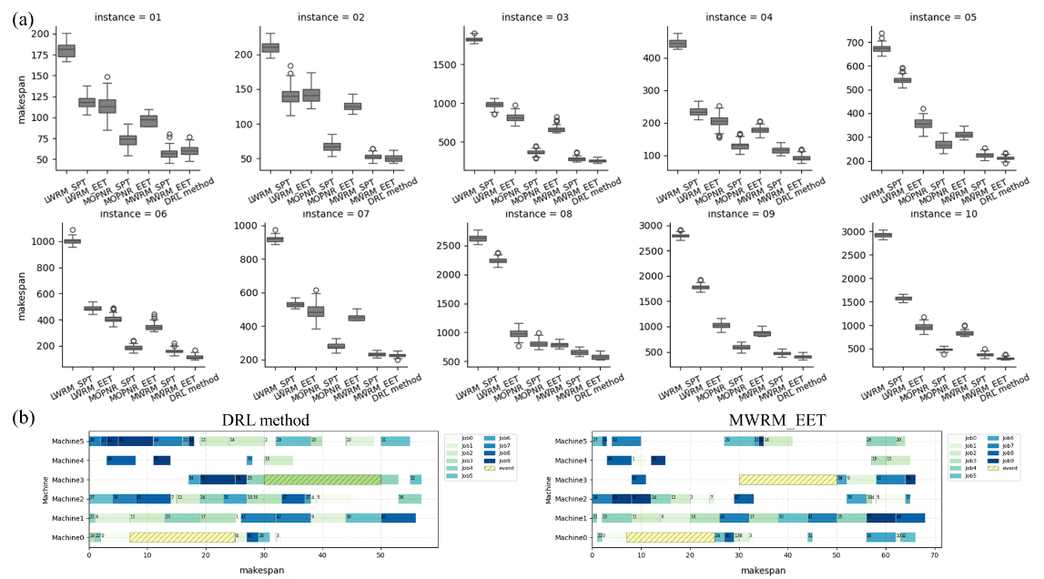
Figure 4 Tests on Brandimarte dataset. (a) Makespans calculated by different rules with insertions of dynamic events. (b) Mk01 instance with dynamic events.
Nonetheless, the DRL model provided robust and generally better plans for large-scale instances with more operations and longer duration (Figure 4a). Additionally, the solution of Mk01 instance with stochastic dynamic events is shown as an example (Figure 4b). Cause there is no standardized solution gap for dynamic FJSP, we compared mean makespan on each instance with MWRM-EET method, the heuristic rule with the smallest solution, and find an average improvement of 11%.
  - Conclusions
This paper establishes a generic DT framework for dynamic scheduling processes, applicable to various processes such as laytime schedule of ports and batch processes which can be described as similar structures. A novel HGNN-DRL model is proposed as the core of its virtual entity. By dynamically integrating real-time data and fault detection technology, it empowers the system to autonomously establish proactive maintenance plans and implement swift emergency responses to fault scenarios, optimizing efficiency and minimizing downtime. By means of numerical experiments, its capabilities and comprehensive performances that outperforming heuristic methods are demonstrated, which shows its potential to reduce waste and swiftly respond to equipment status as well as to design reasonable maintenance plans. The DT could be a high-efficient and inherent safety design for scheduling processes in chemical industries. To the best of the author’s knowledge, this methodology has a little utilization in similar scenarios.
In future work, the DT can incorporate various constraints, such as energy consumption optimization (Mokhtari & Hasani, 2017), work pre-emption, and maintenance demands. Bi-directionally connection between the physical and virtual entities would be built. Additionally, advanced fault diagnosis approaches will be applied to more challenging real-world industrial cases, validating its flexibility and effectiveness that demonstrate application potential in chemical manufacturing field.
  - Acknowledgement
The authors gratefully acknowledge support from the National Science and Technology Innovation 2030 Major Project (2018AAA0101605) of the Ministry of Science and Technology of China and the National Natural Science Foundation of China (No.62003004).
References
X. Bi, R. Qin, D. Wu, S. Zheng, & J. Zhao. 2022. One step forward for smart chemical process fault detection and diagnosis. Computers & Chemical Engineering, 164, 107884.
P. Brandimarte. 1993. Routing and scheduling in a flexible job shop by tabu search. Annals of Operations Research, 41, 157-183.
A. Galeazzi, K. Prifti, F. Gallo, & F. Manenti. 2022. A Methodology for The Optimal Surrogate Modelling of Digital Twins Using Machine Learning. In L. Montastruc & S. Negny (Eds.), Computer Aided Chemical Engineering (Vol. 51, pp. 1543-1548): Elsevier.
Y. P. Gao, D. F. Chang, & C. H. Chen. 2023. A digital twin-based approach for optimizing operation energy consumption at automated container terminals. Journal of Cleaner Production, 385.
R. Kender, F. Roessler, B. Wunderlich, M. Pottmann, D. Golubev, S. Rehfeldt, & H. Klein. 2022. Development of control strategies for an air separation unit with a divided wall column using a pressure-driven digital twin. Chemical Engineering and Processing-Process Intensification, 176.
A. Koulouris, N. Misailidis, & D. Petrides. 2021. Applications of process and digital twin models for production simulation and scheduling in the manufacturing of food ingredients and products. Food and Bioproducts Processing, 126, 317-333.
K. Lei, P. Guo, W. Zhao, Y. Wang, L. Qian, X. Meng, & L. Tang. 2022. A multi-action deep reinforcement learning framework for flexible Job-shop scheduling problem. Expert Systems with Applications, 205, 117796.
H. Mokhtari, & A. Hasani. 2017. An energy-efficient multi-objective optimization for flexible job-shop scheduling problem. Computers & Chemical Engineering, 104, 339-352.
M. Panzer, & B. Bender. 2022. Deep reinforcement learning in production systems: a systematic literature review. International Journal of Production Research, 60, 4316-4341.
H. D. Perez, J. M. Wassick, & I. E. Grossmann. 2022. A digital twin framework for online optimization of supply chain business processes. Computers & Chemical Engineering, 166.
Z. Qin, D. Johnson, & Y. Lu. 2023. Dynamic production scheduling towards self-organizing mass personalization: A multi-agent dueling deep reinforcement learning approach. Journal of Manufacturing Systems, 68, 242-257.
W. Song, X. Chen, Q. Li, & Z. Cao. 2023. Flexible Job-Shop Scheduling via Graph Neural Network and Deep Reinforcement Learning. IEEE Transactions on Industrial Informatics, 19, 1600-1610.
J. P. Spinti, P. J. Smith, & S. T. Smith. 2022. Atikokan Digital Twin: Machine learning in a biomass energy system. Applied Energy, 310.
F. Tao, B. Xiao, Q. L. Qi, J. F. Cheng, & P. Ji. 2022. Digital twin modeling. Journal of Manufacturing Systems, 64, 372-389.
F. Tao, H. Zhang, A. Liu, & A. Y. C. Nee. 2019. Digital Twin in Industry: State-of-the-Art. IEEE Transactions on Industrial Informatics, 15, 2405-2415.
W. Wang, J. Wang, J. Tian, J. Lu, & R. Xiong. 2021. Application of Digital Twin in Smart Battery Management Systems. Chinese Journal of Mechanical Engineering, 34.
X. D. Wang, X. F. Hu, & J. F. Wan. Digital-twin based real-time resource allocation for hull parts picking and processing. Journal of Intelligent Manufacturing.
Q. Yan, H. F. Wang, & F. Wu. 2022. Digital twin-enabled dynamic scheduling with preventive maintenance using a double-layer Q-learning algorithm. Computers & Operations Research, 144.

