PULPO: A Technosphere-Wide Lifecycle Optimization Package
Fabian Lechtenbergª, Robert Istrate^{b}, Antonio Espuñaª, Moisès Graellsª, Gonzalo Guillén-Gosálbez^{c*}
ªDepartment of Chemical Engineering, Universitat Politècnica de Catalunya, Barcelona, Spain
^{b}Institute of Environmental Sciences (CML), Leiden University, Leiden, Netherlands
^{c}Department of Chemistry and Applied Bioscience, Institute for Chemical and Bioengineering, ETH Zurich, Zurich,Switzerland
*gonzalo.guillen.gosalbez@chem.ethz.ch
Abstract
Life cycle optimization (LCO) couples multi-objective optimization with life cycle assessment (LCA). It is often carried out by adding LCA-based linear equations to the mathematical formulation, which are parameterized with data retrieved from environmental databases. While the mathematical model is used to optimize the foreground system (i.e., the system of decisions over which the modeller has a degree of control), its influences on the parameters of the background system (i.e., the system which provides inputs to the foreground such as electricity or transport) are omitted in this approach. The main limitation of this approach is that it does not allow to optimize decisions in the background system (i.e., those activities in the supply chains of the main processes in the foreground system). Moreover, in large-scale assessments, technological changes in the foreground will affect the background, making LCO less accurate unless full integration between optimization and LCA is attained. To overcome these shortcomings, this work introduces PULPO, a novel framework integrating mathematical optimization with LCA. Building upon open-source tools, PULPO allows for concurrent optimization of foreground and background decisions, accounting for feedback loops between them. A case study on sustainable methanol production demonstrates PULPO's effectiveness in designing constrained and coupled global supply chains considering a range of impact categories.
Keywords: methanol, supply chain, carbon capture and utilization, open-source
  - Introduction
In Process Systems Engineering, LCA indicators have been integrated into process and supply chain optimization problems to quantify trade-offs between economic and environmental performance, facilitating sustainable decision-making (Ferdous et al., 2023). However, process modeling & optimization and LCA are often combined offline, that is, LCA data expressed via eco-vectors representing the impact linked to mass and energy flows in the foreground (e.g., 1 kWh, 1 kg of chemical) are retrieved from environmental databases and incorporated into mathematical models as parameters. Here, the mathematical model represents the foreground system (e.g., chemical plant, supply chain) over which we have a certain level of control (i.e., through the optimization of the decision variables). Meanwhile, LCA data denote the background system (surrounding activities providing inputs to the foreground system) that is often assumed to be fixed during optimization. This approach omits feedback loops between both systems. For example, when optimizing the power system of a country, the carbon footprint of power technologies will depend on the composition of the power mix, which needs to be decided by the optimization model. In the process systems realm, the optimization of a supply chain model including degrees of freedom such as capacity and planning decisions may constitute the foreground decisions. The static environmental indicators obtained from the background (surrounding activities such as electricity, transport, storage etc.) parameterize the linear LCA-based equations in the model.
Following the traditional offline integration, such a model would assume fixed carbon footprints of the power technologies, omitting the coupling between foreground and background activities. Moreover, using fixed background data provides limited insights into how changes in the Technosphere, in which the foreground system is embedded and with which it displays strong links, will affect the outcome of the environmental analysis.
In a seminal work, Kätelhön and coworkers introduced the Technology Choice Model (TCM) for optimizing technology choices in production systems (Kätelhön et al., 2016), which, so far, used aggregated unit processes in the underlying linear programming approach, omitting potential feedback effects between the choices made across the product supply chain. Inspired by this work, here we present a framework to carry out Technosphere-wide optimizations attaining full integration between optimization and LCA. This is achieved through the development of PULPO, a user-friendly open-source tool which instantiates and solves user defined LCO problems, integrating, opposed to the original TCM approach, complete Life Cycle Inventory (LCI) databases instead of aggregated unit processes.
  - Methodology
Here we introduce PULPO (Python-based User-defined Lifecycle Product Optimization). This innovative framework forges a direct link between mathematical optimization and LCA. PULPO seamlessly integrates full LCI databases in the optimization problem, enabling the concurrent optimization of both foreground and background systems. Figure 1 illustrates the implemented flow of information and connectivity to other packages. To define the optimization problem, the user is required to establish several key components. First, the functional unit that represents the production system’s primary output. Second, the objective function based on a selected method for evaluating environmental impacts. Third, the potential process choices, which could involve technological or geographical decisions across supply chains in the Technosphere. Lastly, additional constraints shall be imposed, like limits on production capacity or the availability of resources.
Utilizing the data management features of the “brightway2” package (Mutel, 2017), users have the flexibility to include new processes into the LCI database. These LCIs are extensive and serve as the foundational framework for constructing the superstructure optimized in PULPO. Such a superstructure is tailored based on the user-defined options and limitations. The PULPO package encapsulates all this data into a “pyomo” optimization model (Bynum et al., 2021), which can be solved with open-source solvers, e.g., HiGHS, or through integration with proprietary software like GAMS.
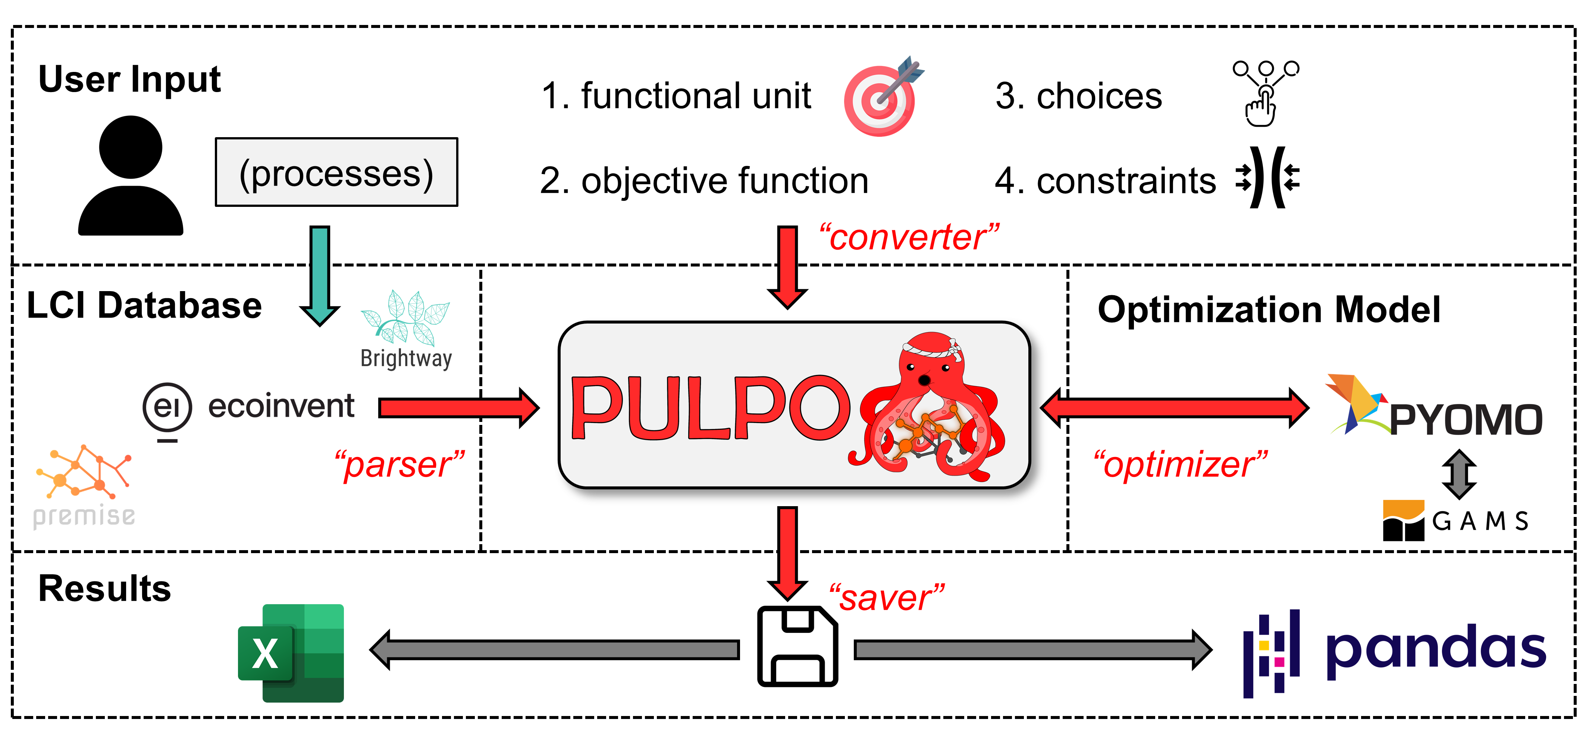
Figure 1. PULPO information and workflow.

The underlying optimization framework, inspired on the TCM approach (Kätelhön et al., 2016), is summarized in (OP1). A noteworthy conceptual extension is the “$slack$” vector, which enables the direct specification of final supply instead of final demand values, an issue which has been previously addressed via an auxiliar optimization problem (Meys et al., 2021).
$\min_{s.t. s, slack}{Q⋅B⋅s}$ |  | (OP1)
$A⋅s=f+slack$
$s_{j}^{low}≤s_{j}≤s_{j}^{high}$ | $∀ j$
$0≤slack_{i}≤{slack}_{i}^{high}$ | $∀ i$

Where the notation used is as follows: $A$ is the rectangular Technosphere matrix, $B$ is the Biosphere matrix, $Q$ is the matrix containing the characterization factors of the lifecycle impact assessment method, $s$ is the scaling vector, $f$ is the final demand vector, $s_{j}^{low}$ and $s_{j}^{high}$ are the upper and lower limits on the production quantities (capacity limits) of processes $j$ respectively, and $slack$ is the newly introduced vector containing decision variables for the case of specifying final supply instead of final demand values. The $slack_{i}^{high}$ vector is zero for all products $i$ which have a defined final demand and takes a big constant value for those products where the final supply is specified. This notation follows the computational structure of LCA elaborated by Heijungs and Suh (2002).
PULPO is available on GitHub, Zenodo (Lechtenberg, 2023) and PyPI. In an example provided as a jupyter notebook in the open repository, a case study optimizing the German power mix is presented. Using the ecoinvent 3.8 cutoff system, the share of lignite, coal, wind and nuclear power is optimized. In the unconstrained case, the global warming potential is minimized when relying exclusively on nuclear power. Using the ReCiPe human health indicator as objective, PULPO identifies wind power as most suitable option. Here, capacity constraints alongside the supply chain are introduced. We note that optimizing the mix following a standard LCO approach (i.e., the background data is not updated during the optimization) leads to an overestimation of the total impact by about 8% due to the omission of feedback loops between the foreground and background systems.
  - Results and Discussion
PULPO was utilized to explore the role of carbon capture and utilization (CCU) in sustainable methanol production, analyzing its interplay with the electricity market. The goal and scope of this LCO is to decide on the optimal portfolio of methanol pathways in a set of locations considering region- and scenario-specific performance metrics and constraints. For demonstration purpose, the minimization of the global warming potential (GWP) is used as the objective function.
The functional unit is the production of 100 Mt of methanol, as well as regional final supply values for electricity as projected by an integrated assessment model (IAM). In order to enforce these final supply constraints, the previously mentioned slack variables were utilized. We select the 1.5 °C and 3.5 °C temperature increase scenarios of the REMIND IAM and use the corresponding background databases based on the ecoinvent 3.8 cutoff system model generated by “premise” v.1.8.1 (Sacchi et al., 2022) as backbone for the superstructure.
These LCIs contain datasets for methanol production via direct-air capture (DAC) based methanol but do not implement them in the markets because this option is not considered in the IAM. Precisely, the IAM only considers steam methane reforming for methanol production, which we refer to as the business as usual (BAU). Additionally, we added inventories for point-source capture (PSC) based methanol, as well as the necessary inventories for retrofitting fossil thermal powerplants with carbon capture to supply the CO₂. The choices that the optimizer must take involve the selection of the optimal technology (BAU, DAC, or PSC) in the 12 regions of the IAM. If PSC is selected, a lower-level choice on the retrofitting of the available fossil thermal powerplants (coal and natural gas) must be taken.
The potential of CO₂-based methanol production routes heavily relies on the availability of green hydrogen, which in turn hinges on the availability of low-carbon electricity. Thus, shifting from the BAU practices to these new technologies implies the need for expanding power production capacities. In order to assess only a marginal deviation from the IAM baseline, we introduce a constraint on the power capacity expansion in each region.
With these configurations, the two scenarios have been optimized for a range of electricity capacity constraints. Figure 2 illustrates the results for a total GWP reduction of 50 Mt CO₂e. Comparing the amount of additional power capacity needed to reach this target underlines the pressing need to decarbonize the power sector for the hard-to-abate sectors to tag along in the quest for sustainability. The base case, aligning with a 3.5 °C scenario, requires an additional 417 TWh of electricity annually, whereas the 1.5 °C scenario reduces this need to 223 TWh.
Additionally, the transformation in the chemical sector is less extensive. In the 3.5 °C scenario, 50.4 Mt of fossil methanol needs replacement with carbon-capture alternatives, compared to only 23.0 Mt in the 1.5 °C scenario. This result does not suggest the chemical sector should wait for the power sector's progress. Instead, it emphasizes the need to prepare for the transition by developing suitable infrastructure and technology to meet or surpass these targets.
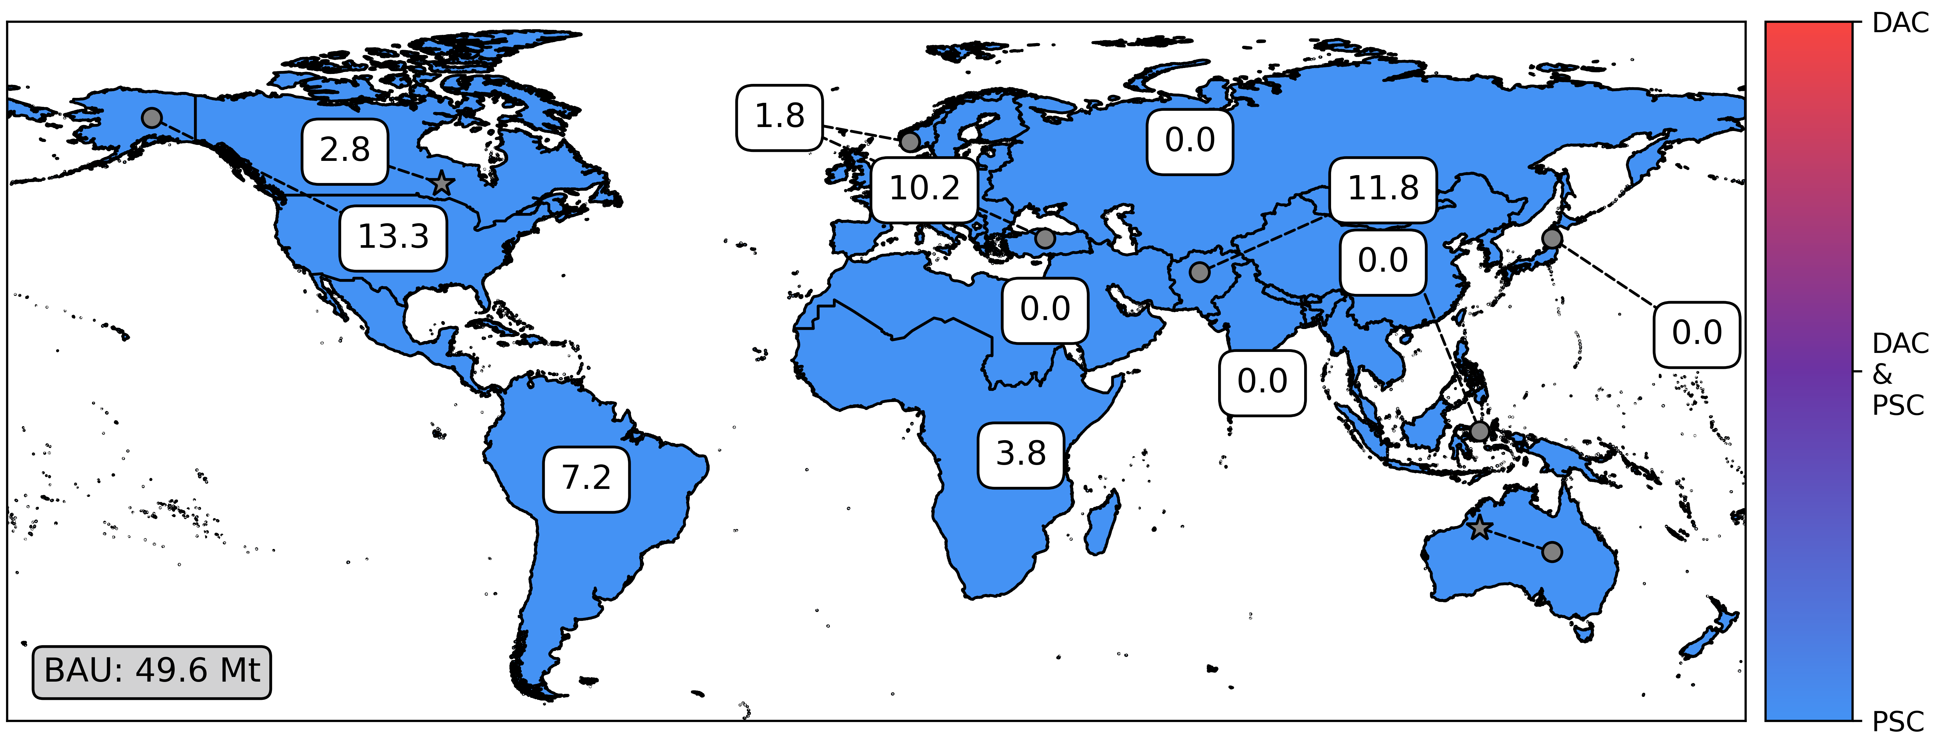
(a) Base (3.5°C)
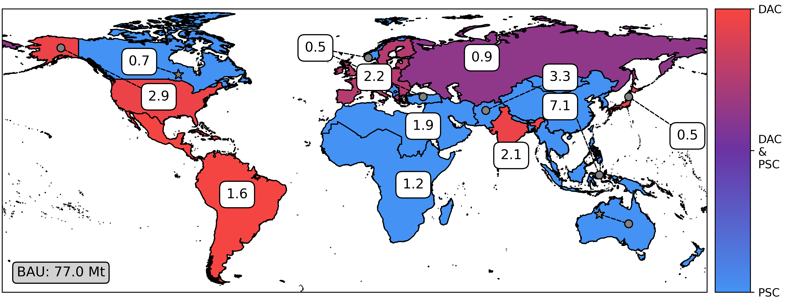
(b) PkBudg500 (1.5°C)
Figure 2. Optimized global methanol supply chains in 2040 for a (a) 3.5 °C temperature increase and a (b) 1.5 °C temperature increase scenario. Both systems reduce the total GWP by 50 Mt CO₂e. Methanol production quantities are indicated in each region (boxes) and the share of the technology employed (color). DAC: direct-air capture; PSC: point-source capture, BAU: business as usual (fossil based).

Our use of PULPO in this study provides detailed technological and regional insights, as depicted in Figure 2. In the 3.5 °C scenario, regions with more decarbonized grids face greater pressure to implement PSC for CCU, explained by the limited number of regions where PSC can outperform BAU. Consequently, electricity production capacities in these regions increase by 2.1 %. In the 1.5 °C scenario, this pressure decreases due to universally decarbonized grids, allowing better GWP performance from PSC and DAC compared to BAU. The maximum regional increase in electricity production capacity observed is 0.4 %. These geographically distributed results are strongly linked to the electricity constraint included in the optimization problem.
Notably, compared to the 3.5 °C scenario, the 1.5 °C scenario employs DAC based methanol production. This can be explained by the fact that some regions like South America and Europe have grids with a very low fossil share. Consequently, they fail to provide sufficient CO₂ for green methanol, making DAC necessary to cover the carbon source requirements.
Leveraging the comprehensive data in the LCIs, this assessment was enabled by PULPO's ability to integrate the entire database as a superstructure. Furthermore, the impact of optimizing power mixes by retrofitting with carbon capture technologies plays a crucial role in ensuring an accurate and coherent assessment. Although less pronounced, the assessment also implicitly considers additional feedback effects originating from changes in the chemical sector.

  - Conclusions
PULPO represents a significant leap forward in merging mathematical optimization with LCA. Its integrated approach enables more precise and insightful analysis of technological and regional options in production systems. By accommodating dynamic changes within the Technosphere, PULPO enhances the accuracy and relevance of environmental impact assessments, particularly in the context of large-scale, impactful socio-economic decisions. This framework opens new avenues to support sustainable decision-making in Process Systems Engineering, building bridges with the Industrial Ecology community currently working on LCA.
Acknowledgements
Grant PID2020-116051RB-I00 (CEPI) funded by MCIN/AEI/10.13039/501100011033 and by “ERDF A way of making Europe” is fully acknowledged. Fabian Lechtenberg gratefully acknowledges the “Departament de Recerca i Universitats de la Generalitat de Catalunya” for the financial support of his predoctoral grant FI-2022. This publication was created as part of NCCR Catalysis (grant number 180544), a National Centre of Competence in Research funded by the Swiss National Science Foundation.
References
M. L. Bynum, G. A. Hackebeil, W. E. Hart, C. D. Laird, B. L. Nicholson, J. D. Siirola, D. L. Woodruff, 2021, Pyomo—Optimization Modeling in Python, Springer International Publishing
J. Ferdous, F. Bensebaa, N. Pelletier, 2023, Integration of LCA, TEA, Process Simulation and Optimization: A systematic review of current practices and scope to propose a framework for pulse processing pathways, Journal of Cleaner Production, 402, 136804
R. Heijungs, S. Suh, 2002, The Computational Structure of Life Cycle Assessment, Springer Netherlands
A. Kätelhön, A. Bardow, S. Suh, 2016, Stochastic Technology Choice Model for Consequential Life Cycle Assessment, Environmental Science & Technology, 50(23), 12575–12583
F. Lechtenberg, 2023, flechtenberg/pulpo: PULPO Release v1.0.0, Zenodo
R. Meys, A. Kätelhön, M. Bachmann, B. Winter, C. Zibunas, S. Suh, A. Bardow, 2021, Achieving net-zero greenhouse gas emission plastics by a circular carbon economy, Science, 374(6563), 71–76
C. Mutel, 2017, Brightway: An open source framework for Life Cycle Assessment, The Journal of Open Source Software, 2(12), 236
R. Sacchi, T. Terlouw, K. Siala, A. Dirnaichner, C. Bauer, B. Cox, G. Luderer, 2022, PRospective EnvironMental Impact asSEment (premise): A streamlined approach to producing databases for prospective life cycle assessment using integrated assessment models, Renewable and Sustainable Energy Reviews, 160, 112311

