Advancing Liquid Level Recognition: A Combined Deep Learning and Pixel Manipulation Approach
Borui Yangª, Jinsong Zhao^{a,b*}
ªState Key Laboratory of Chemical Engineering, Department of Chemical Engineering, Tsinghua University, Beijing 100084, China
^{b}Beijing Key Laboratory of Industrial Big Data System and Application, Tsinghua University, Beijing 100084, China
jinsongzhao@tsinghua.edu.cn
Abstract
In the process industry of chemical engineering, process monitoring and safety are of utmost importance, especially for accurate monitoring of liquid levels. In recent years, with the ongoing deployment of IoT (Internet of Things) devices, a myriad of computer-vision (CV) based measurement methods have emerged. However, these methods are mainly applicable to laboratory conditions with cylindrical level gauges, which turned out to be delicate and limited in real-world scenarios. To address these challenges, this paper proposed a novel framework that combines deep learning with pixel manipulation techniques, focusing on the more challenging circular-observation-window liquid level gauges (LLGs). The deep learning part utilized the Mask R-CNN framework to identify and extract the regions of interest (RoI) through supervised learning, followed by the recognition of liquid level by pixel manipulation method. The proposed framework effectively integrates the robustness of deep learning and the reliability of traditional methods, achieving high accuracy under complex conditions. If integrated into real-time process monitoring systems, it could further enhance the timeliness, reliability and safety of chemical process monitoring.
Keywords: liquid level recognition, deep learning, pixel manipulation, circle Hough transform.
  - Introduction
In the chemical industry, process monitoring and safety issues are of paramount importance. With the ongoing deployment of IoT devices in chemical scenarios, image acquisition equipment and corresponding supporting systems are gradually becoming one of the key nodes in the whole monitoring workflow. In chemical engineering processes, the liquid level is a crucial parameter as well. Many devices in chemical processes have strict limitations for liquid level, where a change may be an indicator of some unusual incidents. The measurement techniques of it are mostly hardware-based, such as optical, thermal capacity, and buoyancy level meters, which are relatively much more complex to deploy and maintain. Moreover, there are LLGs specially designed for manually reading, which are commonly found in smaller devices, for instance, oil tanks and fans, facilitated with transparent windows for viewing the level and colour of the liquid.
LLGs that require manual reading can be roughly categorized into 2 types: those with readout and without. The solution of the first one is quite simple: use YOLO-based model for Region of Interest (RoI) detection (Zou et al., 2021) and CNN-based (Zou et al., 2022) or RNN-based model (Zhang et al., 2022) for recognition of digits on the screen or dial. However, in this paper we mainly focused on the alternative category, where the researches have been remaining rudimentary and undeveloped.
Thus, an extensive literature research was done, whose result shows that current CV-based methods for liquid level recognition have certain limitations. H. Zhu (2009) utilized a Sobel-operator-based algorithm to measure the liquid level inside the transparent infusion bottle. L. Peng et al. (2019) employed ArUco tag to localize the RoI and binarization method to recognize the liquid level in a cylindrical gauge. The studies all share some common characteristics: images are predominantly collected under lab-conditions and particularly designed for cylindrical level gauges, which may make their methods more vulnerable in practical conditions.
Motivated by the above, our paper proposes a novel method for liquid level recognition. We select a type of circular-observation-window LLG as the subject, whose recognition problem turn out to be a much more challenging and complicated one due to the strong disturbance of the images collected. The level recognition work is divided into two stages: level gauge area detection/segmentation and level recognition. The Mask R-CNN framework proposed by K. He et al. (2017) is introduced for level gauge region identification to find out the where the level gauge is and crop it to a smaller size to facilitate the subsequent level recognition stage. Subsequently, the level recognition based on Hough circle transform and pixel manipulation is conducted in the smaller image after cropping and then the liquid level is obtained and thus can be further fed into the control system. This liquid level recognition method combines the robustness of the deep learning method with the reliability of the traditional method: the neural network part is good at robustly recognizing the features of the level gauge window region, while the pixel operation part ensures the reliability of further liquid level recognition work.
  - Methodology
    - Mask R-CNN
The Mask R-CNN is a strong modification of Faster R-CNN framework, whose main purpose lies in predicting segmentation on RoI. The traditional Faster R-CNN (S. Ren et al., 2015) framework has two outputs for each candidate object, namely, a class label and a bounding box. The Mask R-CNN is comprised of three different blocks (S. Zhang et al., 2022): feature extraction backbone, region proposal network and result inference branches. It adds an extra branch that can predict the mask of the object, which turned out to be more suitable for the gauge region segmentation job. All these blocks are built based on neural networks (especially CNNs), which is tested to be effective in learning complicated image features.
    - Pixel Manipulation
      - Pre-processing of image
In general, in the pre-processing part CV-based method employed includes grayscale conversion, blurring, dilation and erosion. The images captured by industrial cameras are often in the RGB format, in which each channel contains different features. Grayscale conversion integrating the information from all channels by merging the channels into one, laying a foundation for subsequent processes. Blurring is achieved by convolving the image with a low-pass filter kernel, which is primarily employed to rule out the high-frequency noises in images, aiding in keeping the edge detection part from malfunction. Dilation and erosion are used to expand and contract the boundaries of objects respectively in an image.
      - Edge Detection: Canny method
Edge detection is another crucial part in computer vision, aiming at identify the contour lines and feature boundaries. Canny method is widely accepted as a superb edge detection approach in industrial usages, which has been included in OpenCV library.
      - Circle Hough Transform
Circle Hough Transform (CHT) is a feature extraction method utilized to detect circles in grayscale images. The mechanism of CHT is basically to construct an accumulator space $(a, b, r) ∈R^{3}$for circles. For each pixel on $circle (a, b, r)$, it adds a vote on the value on the accumulator space whose index is $(a, b, r)$. After all the edge points have voted in the accumulator space, circles with more votes would standout and could be further filtered by setting the min distance between circles and min votes of each circle, etc.
  - The proposed method
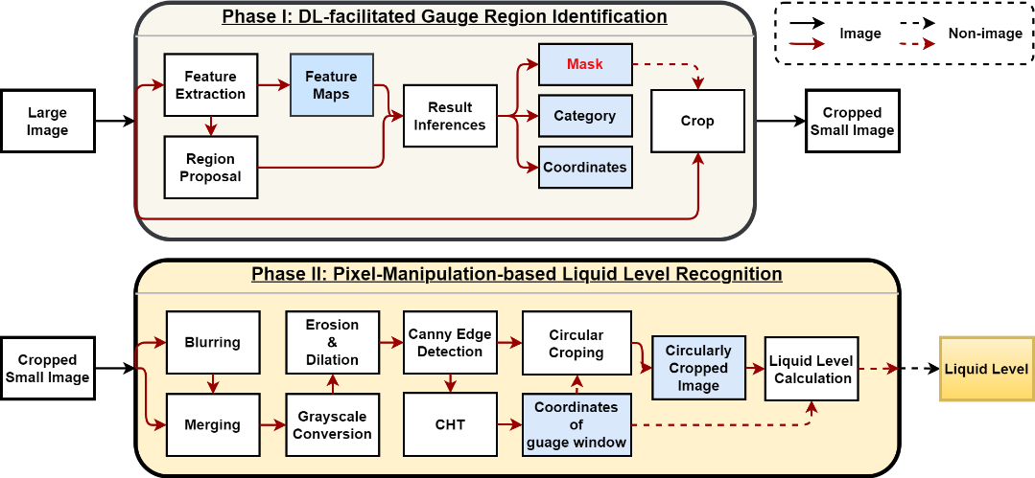
Fig. 1. Diagram of proposed framework (Solid-line arrows: image transference, dashed-line arrows: non-image (Parameter transfer, etc.) transference)
    - Phase I: DL-facilitated Gauge Region Identification
The proposed liquid level recognition framework is shown in the Fig. 1. In the phase I, an image is fed into the Mask R-CNN and got the mask of circular viewing-window as the output. According to the position of the mask, the original large-sized image is cropped into smaller-sized one, which is suitable for the liquid level recognition part.
    - Phase II: Pixel-Manipulation-based Liquid Level Recognition
Table. 1. Pseudo-code of algorithms (End For is omitted for clarity)
$$Algorithm: Circular Cropping and Liquid Level Calculation$$
1: | $Circular Cropping: Input: tuple (img[height,width], \left(a, b, r\right))$
2: | $$for i in range\left(0,height\right):$$
3: | $for j in range\left(0,width\right):$
4: | $if {\left(i-a\right)}^{2}+{\left(j-b\right)}^{2}≥{\left(r-α\right)}^{2} then do img\left[i,j\right]=0$
5: | $return img$
6: | $$Liquid Level Calculation: Input:tuple \left(img_{circle} ,\left(a, b, r\right), t=0\right)$$
7: | $$for i in range\left(0,height\right):$$
8: | $for j in range\left(0,width\right):$
9: | $if img_{circle}>0 do t=i$
10: | $$Liquid Level=(b+r-t)\text{/(2×r)}$$
In the Phase II, the cropped image undergoes blurring, merging, grayscale conversion, erosion, dilation, Canny edge detection in sequence, and the after-canny image is then supplied into the CHT algorithm, with the coordinates of circular viewing-window as the output tuple$(a, b, r)$, of which the unit is pixel. The canny image is cropped conforming to the algorithm shown in Table.1. Subsequently, using the coordinates of the circle and the circularly cropped canny image, schematic diagram is shown in Fig. 2, and the level is calculated according to Table. 1.
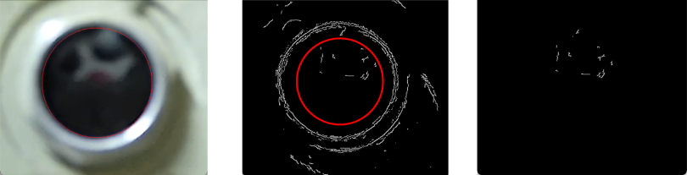
Fig. 2. Schematic diagram of level recognition part (Left: blurred with predicted circular gauge area depicted. Middle: cropping with the pixels inside the circle remaining. Right: cropped image.)
  - Results and discussion
    - Phase I: DL-facilitated Gauge Region Identification
In our study, the backbone is set to ResNet50 (K. He et al, 2016) for its outstanding result. The dataset is comprised of 74 images of oil gauges, captured via an iPhone11 camera, from a total of 12 different wind turbines. The dataset is separated in to train set and test set in a ratio of 51: 23 (~ 2:1) The resolution of large images is $4032×3024$. Data Augmentation tricks are not employed due to the fact that some of the images are taken from the same gauge, which could be considered as manually augmented.
$$diameter MAE=\frac{1}{N}×∑(d_{predicted}-d_{truth})$$ | (1)
As for the evaluation criterions, we adopted diameter mean absolute error (MAE) (Eq. (1)) and Intersection over ground truth (IoGT) as measures of size and mask accuracy respectively. We evaluated the model on the test set and the metrics are satisfactory, which indicates that the gauge regions are excellently identified (IoGT~0.99, 99% of the pixels are correctly masked). Metrics are arranged in Table. 2 left.
Table. 2. Detection results and recognition results respectively, from left to right.
Name | Result (N=23)
diameter MAE | 11.16 pixels
IoGT | 0.9881

Datasets | N | MRE | Error range | Shape
Daytime | 15 | -0.619% | 6.4% | (1000,1000)
Night | 10 | -1.609% | 9.6% | (600, 600)

    - Phase II: Pixel-Manipulation-based Liquid Level Recognition
Through the gauge area recognition part, the images are cropped into a smaller size and be supplied into Phase II. We employed 15 pictures taken in the daytime and 10 pictures at night to evaluate the effectiveness of the level recognition algorithm. There are 10 different gauges in the day-time dataset and 2 in the night-time. For the reason that this is a prediction problem, we employed range of error and mean relative error (MRE) as the evaluation indicator. Results are summarized in Table. 2 right.
In practical applications, we conducted fine-tuning of the hyperparameters through evaluation. The best preforming configuration is: kernel size of erosion: (10,10), canny higher_thres=95, lower_thres=20. This yields to more accurate and stable results in the recognition process of images of higher resolution and much more noises. Different cropping size is applied for data acquired during daytime and night is designed as a test for the robustness of the method.
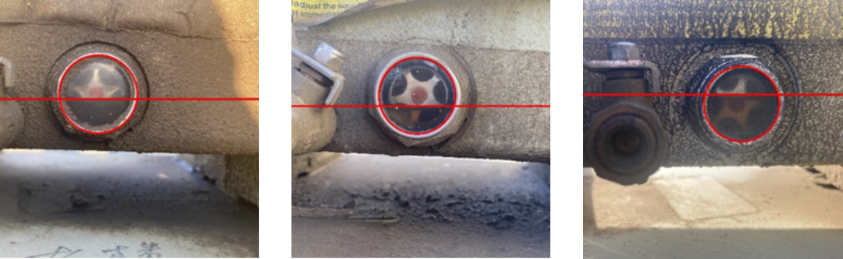
Fig. 3. Robust recognition results under severe conditions. (Horizontal lines depict the oil levels)
Our research indicates that the method proposed can provide with a considerably stable measurement of the liquid level, with the range of error limited to 10%. Moreover, the measured level is quite close to the ground truth except for a slight negative bias. However, the negative bias is relatively small, which eloquently attested the method’s efficacy and accuracy. The bias could be stemming from an unlevel shooting angle of image collector, which was done intentionally for elevation in robustness but simultaneously leads to distortion of the circular view-window and thus consequently gives rise to the inaccurate recognition. The bias could be easily corrected in industrial situations, where the installation spots and angles of cameras is standardized.
The test samples span a vast range in terms of but not limited to oil colour, RoI location, surrounding environment, and deliberate disturbances are introduced to assess the method’s stability, as shown in Fig. 3. It is evident that the method remains stable under conditions of significant interference and adapts exceptionally well to situations of intense noise, light colour of oil where is hard to identify the liquid-gas interface, and obscure viewing window, etc. In constructing the model, we found that the blurring, erosion and dilation layers are crucial for improve the robustness of liquid recognition. Additionally, the sequence of these layers cannot get exchanged, altering it fails to progressively remove sharp noise in the image.
    - Alternative approach: Colour-attention mechanism
In addition to that, we have discovered a method that highlights the liquid-level-related features and suppresses attention to other irrelevant details, which we call it a colour-attention mechanism. The three channels, namely RGB, typically contain different information, in other words, different attentions emphasizing different objects in the image, which is quite similar to the concept of attention in Transformer (Vaswani, 2017). Therefore, a colour-attention mechanism can be designed, which could be built based on traditional blocks or neural networks that can process information from different channels, thereby enhancing features related to the liquid level while negating the impact of irrelevant features. Below is a preliminary experimental result: by filtering and doing simple operations on different channels, critical parts for liquid level recognition could be highlighted. And after several rounds of erosion and dilation, clear liquid level features are obtained, as shown in Fig. 4d.
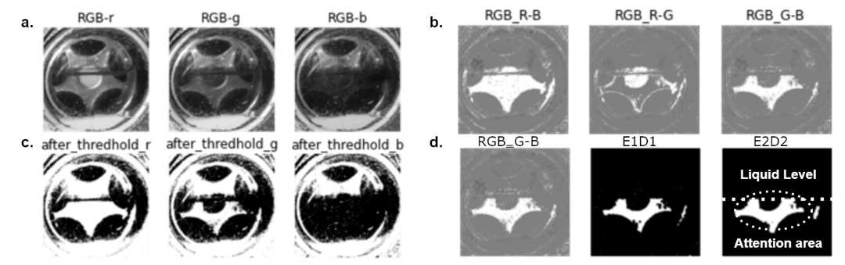
Fig. 4. Different treatment to an oil level gauge. (a. different channels of the image, b. subtraction of channels, c. binarization, d. erosion & dilation on image G minus B)
  - Conclusion
In this paper, we propose a liquid level recognition framework for circular-observation-window LLGs that combines Mask R-CNN and Pixel Manipulation techniques. This framework demonstrates high accuracy in recognition and performs effectively on images with significant interference. We also introduce the concept of colour-attention, which extracts information from different colour channels in conjunction to more effectively eliminate noise in images. In the future, we aim to further focus on the colour attention framework and develop a universal liquid level recognition framework, thereby better serving process monitoring and safety in the chemical industry.
References
K. He, G. Gkioxari, P. Dollár and R. Girshick, 2017, Mask R-CNN, IEEE International Conference on Computer Vision (ICCV), Venice, Italy, 2980-2988.
K. He, X. Zhang, S. Ren and J. Sun, 2016, Deep residual learning for image recognition, Proceedings of the IEEE conference on computer vision and pattern recognition, 770-778.
H. Ma and L. Peng, 2019, Vision based liquid level detection and bubble area segmentation in liquor distillation, IEEE International Conference on Imaging Systems and Techniques, 1-6.
S. Ren, K. He, R. Girshick and J. Sun, 2015, Faster r-cnn: Towards real-time object detection with region proposal networks, Advances in neural information processing systems, 28.
A. Vaswani, N. Shazeer, N. Parmar, J. Uszkoreit, L. Jones, A. Gomez and I. Polosukhin, 2017, Attention is all you need, Advances in neural information processing systems, 30.
J. Zhang, W. Liu, S. Xu and X. Zhang, 2022, Key point localization and recurrent neural network based water meter reading recognition, Displays, 74, 102222.
S. Zhang, X. Liang, X. Huang, K. Wang and T. Qiu, 2022, Precise and fast microdroplet size distribution measurement using deep learning, Chemical Engineering Science, 247, 116926.
H. Zhu, 2009, New algorithm of liquid level of infusion bottle based on image processing, International Conference on Information Engineering and Computer Science, IEEE,1-4.
F. Zou, Z. Shi, Z. Gan, L. Liao and J. Xu, 2021, Water meter reading recognition based on lightweight CNN, International Conference on Frontiers of Electronics, Information and Computation Technologies, 1-6.
L. Zou, L. Xu, Y. Liang, L. Chen, J.Yin and N. Xu, 2021, Robust water meter reading recognition method for complex scenes, Procedia Computer Science, 183, 46-52.

