Inventory Strategies for Optimizing Resiliency and Sustainability in Pharmaceutical Supply Chains – A Simulation-Optimization Approach
Catarina M. Marques^{a*}, Ana Carolina Silvaª, Jorge Pinho de Sousa^{a,b}
ªINESC TEC, Rua Dr. Roberto Frias, Portugal
^{b}Faculdade de Engenharia da Universidade do Porto, Rua Dr. Roberto Frias, Porto, Portugal
catarina.m.marques@inesctec.pt
Abstract
In this work a hybrid simulation-optimization approach is presented to support decision-making towards improved resiliency and sustainability in pharmaceutical supply chain (PSC) operations. In a first step, a simulation model is used to assess the PSC performance under a set of disruptive scenarios to select the best inventory-based strategy for enhanced resiliency. Disruptions addressed in this work are mainly related to unpredicted medium-term production stoppages due to unexpected high-impact events such as accidents in production and transportation, or natural disasters. In a second step, a multi-objective mixed integer linear programming (MO-MILP) model is developed to optimize the selected inventory-based strategy regarding the economic, social, and environmental dimensions. In particular, the social and environmental aspects are introduced by anticipating the expected waste generation of close to expire medicines, redirecting them into a donation scheme. The proposed approach is applied to a representative PSC, with preliminary results showing the relevance of this tool for decision-makers to assess the trade-offs associated to the economic and social dimensions, as well as their impacts on waste generation.
Keywords: closed-loop supply chain, optimization, simulation, resiliency, sustainability.
  - Introduction
The pharmaceutical sector comprises a global industry responsible for the development, manufacturing, and distribution of medicines worldwide. Similarly to any other sector, the pressures to become cost-efficient had led to distribution networks highly globalized and complex, imposing significant managerial challenges, particularly in dealing with uncertainty.
With disruptive events becoming ever more frequent and severe, key vulnerabilities also become more significant, with any unpredicted changes resulting in substantial economic and social losses. Ensuring resilient operations across the entire pharmaceutical value chain is, therefore, not only a critical management concern, but also a core social responsibility (Tat & Heydari, 2021). Resilience, defined by Fahimnia and Jabbarzadeh (2016) as the ability to withstand and recover from disturbances, still remains elusive despite ongoing efforts to improve supply chain networks. Organizations, striving to react more effectively to uncertainties, often resort to strategies involving operational redundancies, such as holding extra inventory or dual sourcing (Pavlov et al., 2019). Inventory-based strategies are among the most common approaches used in practice, and are particularly interesting in pharmaceutical contexts as the continuous supply of products needs to be guaranteed in a long-run perspective (Lücker et al., 2019). These initiatives, however, come along with key trade-offs regarding the impact on the supply chain sustainability performance. Building up extra inventory is not only costly, but also environmental impactful through extra resource consumption and higher waste generation (Pavlov et al., 2019). Understanding and quantifying these trade-offs are crucial to define effective strategies that are both resilient and sustainable (Roostaie et al., 2019).
Despite some recent notable works (Ivanov, 2018; Zahiri et al., 2017), the join consideration of these two aspects, although critical, is still a key research challenge, particularly in the pharmaceutical industry.
The focus of this work lies, therefore, on the interface between resiliency and sustainability by exploring the right balance between risk mitigating inventory strategies and the PSC environmental and social performances.
A decision-support tool is proposed integrating a simulation model developed in an author’s previous work (Silva et al., 2022) and a new Multi-Objective Mixed Integer Linear Programming (MO-MILP) model to achieve optimal supply chain management for enhanced resiliency and sustainability operations.
  - The Problem
A generic 3-echelon supply chain is considered in this work, as depicted in Figure 1. The network structure is composed by primary and secondary manufacturers, donation centres and markets.
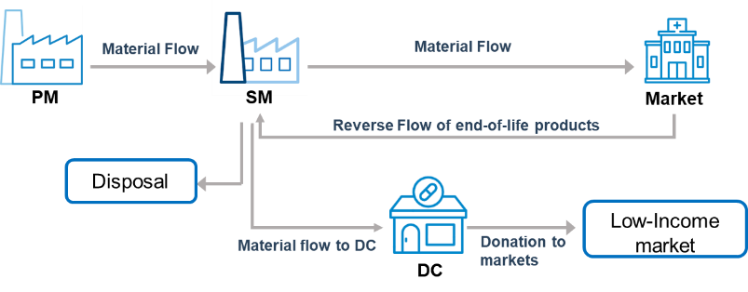
Figure 1 – Supply Chain network structure

Material flows from the Primary Manufacturers (PM) that are responsible for the production of the Active Pharmaceutical Ingredient (API) to the Secondary Manufacturers (SM), where the API product will be converted into the final drug product (FP) to be distributed to final markets through health providers such as hospitals and pharmacies, and finally, Donation Centres (DC) responsible for supplying low-income markets with donated material. It is assumed that the company adopts a donation policy and carries out social responsibility initiatives, redirecting unused risk mitigating inventory to these initiatives.

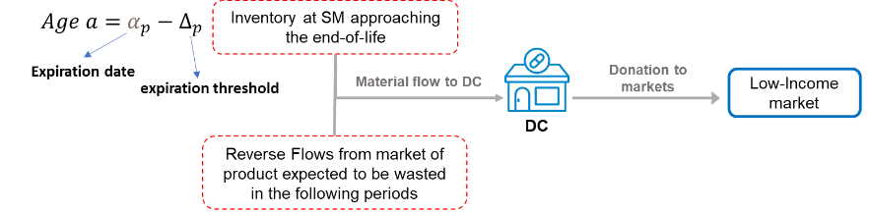
Figure 2 – Material flows to donations centres and low-income markets.
Therefore, donations have two distinct sources, as depicted in Figure 2: one related to the inventory product at the SM, approaching its end-of-life date; and the other one related to the product amounts recovered from the market, that are expected to be wasted in the upcoming time periods. In both cases, a threshold value is defined as the period of time in which no longer will it be possible to deliver the product to the market within its expiration date. Moreover, in the case of material from the reverse flows, it is also considered that a defined percentage of products reaching the market close to the threshold value, are expected to be wasted in the following periods. Therefore, in both situations, the expected waste generation is anticipated and avoided by redirecting it to markets in need.
The main goal of the proposed approach is, therefore, to optimize capacity and distribution planning decisions, including product recovery and donation flows, that minimize costs and waste, and maximize the social benefit, considering inventory-based resilient strategies.
  - Proposed Methodology
    - Solution Approach
The aim of this work is to build a hybrid simulation-optimization decision-support tool to both enhance resiliency and sustainability of global pharmaceutical supply chains. The proposed methodology extends the authors previous work (Silva et al., 2022), in which a simulation model was developed to assess the PSC performance under a set of disruptive scenarios and considering different inventory-based strategies, to improve resiliency and flexibility. In order to fully capture the complexity of the PSC, the simulation model was developed integrating three simulation paradigms.
While System Dynamics was used to model the high-level behaviour of the PSC, Agent-Based Simulation and Discrete Event Simulation were used to model the individual performance of each entity and the associated production processes (Silva et al., 2022).
In this work, an optimization model is developed to be integrated with the simulation approach (Figure 3), aiming to optimize the previously selected inventory-based strategy towards enhanced sustainability regarding the economic, environmental, and social dimensions.
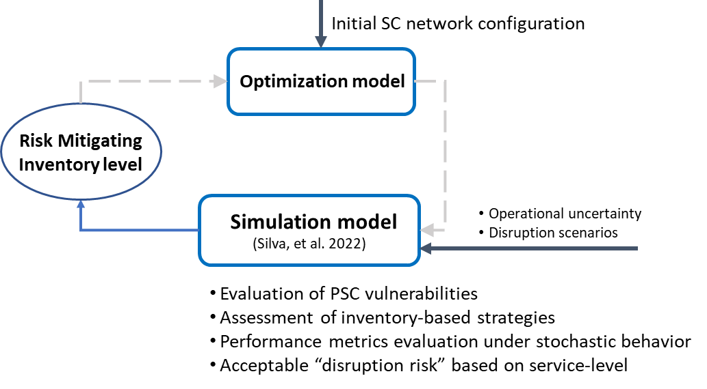
Figure 3 - Proposed hybrid simulation-optimization approach.
As shown in Figure 3, the simulation model is used to simulate several disruption scenarios, identify vulnerabilities in the PSC and proactively define target-specific strategies based on extra inventory to ensure a defined “acceptable” level of resiliency in terms of service level. The inventory level that best performs in terms of resiliency will be selected as an input parameter to the optimization model. As these strategies are both economically and environmentally costly, the optimization model will be instrumental in achieving the best trade-offs between the excess inventory, required to perform resiliently, and the optimal capacity, inventory, and production planning decisions, required to perform sustainably.
    - Mathematical Model
A bi-objective Mixed Integer Linear Programming (MILP) model is proposed in this work, encompassing strategic-tactical decisions related with capacity management, and production and inventory planning. The main decision variables include: (i) product allocation to facilities $X_{pi}$ ($X_{pi}=1$ if product $p$ is assigned to facility i; = 0, otherwise); (ii) production quantities of each product p, with age a, in each factory i and time period t ($Q_{pit}^{API}$, $Q_{piat}^{FP}$); (iii) inventory levels of both types of products, explicitly considering the product age a for the FP ($S_{pit}^{API}$, $S_{piat}^{FP}$); (iv) product direct and reverse flows between the allowable entities ($F_{p\left(i,i^{'}\right)t}^{API}$, $F_{p\left(i,i^{'}\right)at}^{FP}$, $RF_{p\left(i,i^{'}\right)at}^{FP}$); (v) donation amounts ($D_{p\left(i,i^{'}\right)at}^{FP}$); (vi) amount of waste generated at secondary manufacturers and final markets due to product expiration ($W_{piat}^{SM}$, $W_{piat}^{M}$); (vii) amount of lost sales ($L_{pit}$); and (viii) number of new production lines installed in factory i and time period t (${PL}_{it}$). It is worth to notice that the age-based inventory, production, and distribution management is only accounted for the final products (FP).
Two objective functions are considered: the Profit; and a social metric denoted here as Social Benefit, based on donation initiatives. The Profit is given by the difference between the incomes from product sales and the overall costs related to production, storage, distribution, donation, waste generated, lost sales, and investment in new production capacity. The second objective function (Eq. (1)) – Social Benefit – is given by the amount of product that is donated, considering two key social aspects: i) the affordability index of each market ($ω_{pi}$), and ii) the essential medicines index for each product and market (${}_{pi}$). The former is related to the economic ability of a specific region to purchase medicines, and the latter to the products importance to each market based on incidence of specific diseases. In this way, the social benefit is expected to be greater, by directing donations to the neediest regions and most critical products.

$$\max{SocialBenefit= \sum_{p∈P}{\sum_{i^{'}∈Z^{DM}}{\sum_{i∈I^{M}}{\sum_{a∈A}{\sum_{t∈T}{D_{p{(i}^{'},i)at}}}}}}×\left(1-ω_{pi}\right)×{}_{pi}}$$ | (1)

The main constraints of the model account for: (i) production allocation; (ii) resource and material balances at primary and secondary manufacturers, and donation centers; (iii) production and storage capacities; (iv) flows of products between all entities, according to the allowed connections; (v) age-based inventory levels; (vi) production quantities at primary and secondary manufacturers; (vii) possible production capacity expansions; and, finally, (viii) demand constraints defining the production and donation requirements.
  - Case study and preliminary results
    - Case study
To demonstrate the applicability of the proposed approach, a small instance of a global PSC was considered, including: 2 primary manufacturers (North America and Asia); 5 secondary manufacturers (North America, South America, Europe, Asia, and Africa); 5 global markets (North America, South America, Europe, Asia, and Africa); and 9 donation centres (distributed across Africa, Asia, and south America). Two final products are modelled, requiring each a specific API produced in the primary manufacturing facilities. Product recoveries from the market are based on the “age” at the moment of delivery to the market, considering that the older the product, the more likely it is to be wasted.
    - Results
Following the integrated approach depicted in Figure 3, the first step is to determine the risk mitigating inventory level for enhanced SC resiliency through the simulation model previously developed (Silva et al., 2022). Based on these results, the extra inventory level was defined as being 40% of market deliveries. For this value, a service loss of 9% was obtained immediately after a disruption, reaching the value of only 4% after recovering.

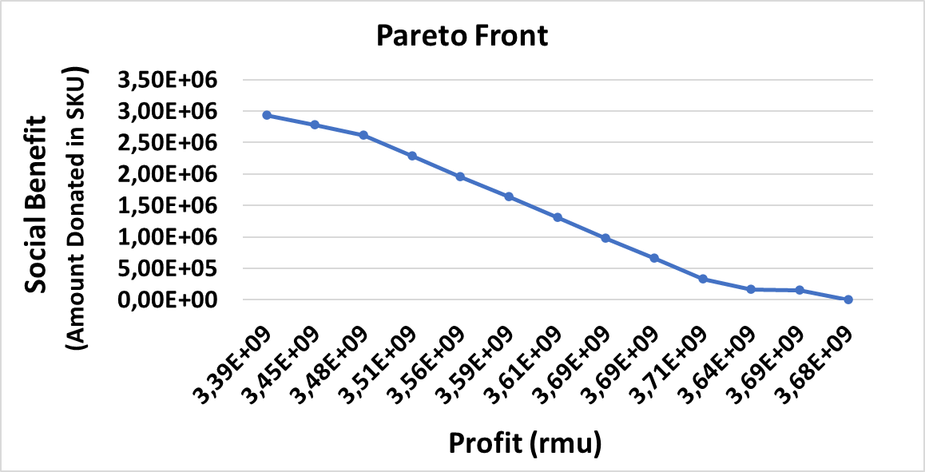
(a)

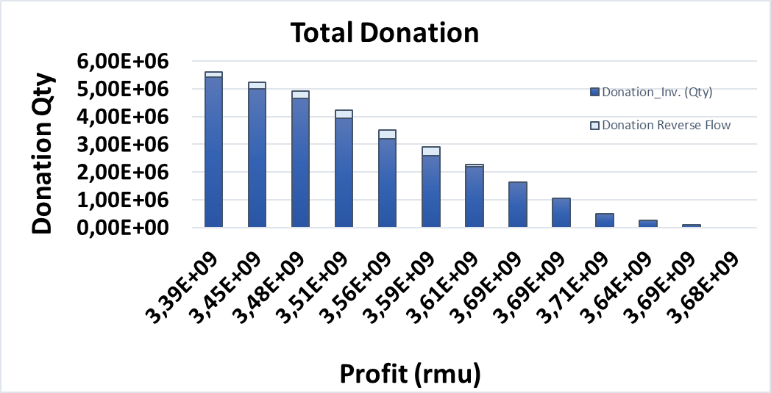  (b) | 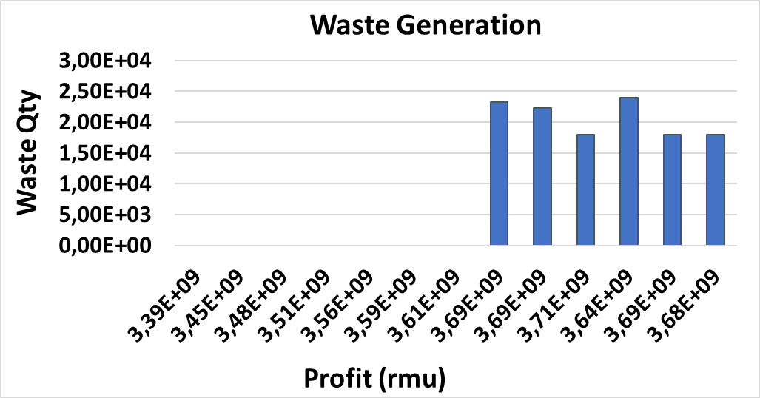  (c)
Figure 4 – (a) Approximate pareto efficient frontier, (b) total donation quantity, and (c) total waste generated for each pareto optimal solution.
Considering this inventory level, the bi-objective MILP model was solved by the ε-constraint method with the Profit as the primary objective function. Figure 4(a) represents the pareto efficient frontier; and Figure 4(b) and Figure 4 (c) show the main results regarding total donation amounts and waste generation respectively, for the different pareto optimal solutions. The preliminary results show that when profit is prioritized, as expected, some waste is generated, almost entirely due to market deliveries close to expiration. In this case, the model seems to follow a First Expired, First Out (FEFO) approach to manage the age-based inventory at the secondary manufacturers. On the other hand, when the social benefit objective is prioritized, the waste generated becomes zero at a certain point and the product donations increase. It is interesting to note that when increasing the importance of social benefit, the inventory management changes from FEFO to a strategy more similar to Last Expired, First Out (LEFO). This is due to the extra transportation costs associated to the reverse flows from market to the donation centres. Therefore, the model favours the “close to expire” products to take place still in the secondary manufacturers leading to an increase in donations directly from the SM instead of from the market.
  - Conclusions and Future Work
This paper presents an innovative hybrid simulation-optimization approach to tackle both resiliency and sustainability aspects in PSC operations. While simulation, under different disruptive scenarios, is able to select the inventory policy that best performs in terms of resiliency, optimization is used to refine this policy and determine optimal production and distribution plans for improved sustainable operations. Preliminary results show the potential of this approach in understanding the relevant trade-offs between resiliency and sustainability, and how to exploit them to raise a positive social and environmental impact. In fact, the developed methodology proved to be instrumental for decision-support regarding enhanced supply chain resiliency and sustainability. Moreover, a clear trade-off between the economic and social dimensions was observed, as well as their impact on waste generation. Future work will focus on extending the pharmaceutical supply chain to a 4-echelon structure to include the wholesalers as key players in a foreseen collaborative approach considering more refined donation schemes. Additionally, the developed models are expected to be improved to accommodate other resilient-driven strategies such as dual sourcing or dynamic capacity management. Finally, although these results are promising, some challenges still need to be further addressed regarding the interaction between simulation and optimization.
Acknowledgement
This work is partially financed by National Funds through the FCT - Fundação para a Ciência e a Tecnologia, I.P. (Portuguese Foundation for Science and Technology) within the project FuturePharma, with reference PTDC/EME-SIS/6019/2020.
References
Fahimnia, B., & Jabbarzadeh, A. (2016). Marrying supply chain sustainability and resilience: A match made in heaven. Transportation research part e: logistics transportation review, 91, 306-324. doi:doi.org/10.1016/j.tre.2016.02.007
Ivanov, D. (2018). Revealing interfaces of supply chain resilience and sustainability: a simulation study. International Journal of Production Research, 56(10), 3507-3523. doi:doi.org/10.1080/00207543.2017.1343507
Lücker, F., Seifert, R., & Biçer, I. (2019). Roles of inventory and reserve capacity in mitigating supply chain disruption risk. International Journal of Production Research
57(4), 1238-1249. doi:doi.org/10.1080/00207543.2018.1504173
Pavlov, A., Ivanov, D., Pavlov, D., & Slinko, A. (2019). Optimization of network redundancy and contingency planning in sustainable and resilient supply chain resource management under conditions of structural dynamics. Annals of Operations Research, 1-30. doi:doi.org/10.1007/s10479-019-03182-6
Roostaie, S., Nawari, N., & Kibert, C. (2019). Integrated sustainability and resilience assessment framework: From theory to practice. Journal of Cleaner Production, 232, 1158-1166.
Silva, A., Sousa, J., & Marques, C. (2022). Supply Chain Resiliency in the Pharmaceutical Industry–a Simulation-Based Approach. Paper presented at the 5th European International Conference on Industrial Engineering and Operations Management.
Tat, R., & Heydari, J. J. J. o. C. P. (2021). Avoiding medicine wastes: Introducing a sustainable approach in the pharmaceutical supply chain. 320, 128698.
Zahiri, B., Zhuang, J., & Mohammadi, M. (2017). Toward an integrated sustainable-resilient supply chain: A pharmaceutical case study. Transportation research part e: logistics transportation review, 103, 109-142.

