Modelling of PCL Production: Multi-Scale Approach and Parameter Estimation
Jakub Staś,ª*Alexandr Zubovª
ªDepartment of Chemical Engineering, University of Chemistry and Technology Prague, Technická 5 166 28 Prague 6 - Dejvice, Czech Republic
stask@vscht.cz
Abstract
The rheological properties of polycaprolactone (PCL) are useful for handling and manufacturing of final products. In this work, we present the modification of a model developed by Zubov and Sin (2018) for polylactic acid (PLA) production. This model consists of three sub-models (macro-, micro- and meso-scale). Using experimental data from literature, we have found the values of kinetic parameters for proposed reaction mechanism of caprolactone ring-opening polymerization. To speed up the kinetic parameter estimation process, we decomposed the parametric space into two parts: (i) parameters associated with reactions that affect only monomer conversion, and (ii) parameters that influence the polymer mean molecular masses M_{n} and M_{w}. The agreement between predicted and measured data is discussed in this paper.

Keywords: polycaprolactone, ring opening polymerization, kinetics, melt rheology, Monte Carlo simulation
  - Introduction
Nowadays there are trends around the world to substitute conventional polymers with biodegradable ones, such as polycaprolactone. This polymer is fully compostable and biocompatible, has a relatively low production cost and maintains structural rigidity in a physiological environment. Thanks to these properties it can be used in medicine as a drug carrier, to produce stitches or as a tissue scaffold (Behtaj et al. 2021).

The information about polymerization kinetics and its relation to polymer chain length distribution is useful for production optimization to obtain material of desired properties. One of the most popular methods of industrial PCL production is ring-opening polymerization (ROP) of ε-caprolactone catalysed by stannous octoate with alcohol as a co-catalyst. (Wu et al. 2017). There have already been published some simple kinetic studies of PCL production by, e.g., Rafler and Dahlmann (1992), Punyodom et al. (2021) or Punyodom et al. (2022), which discussed the polymerization mechanism and focused on estimation propagation kinetics. Similarly to PCL, polylactic acid (PLA) is also produced by the ROP with stannous octoate as the catalyst – this analogy has been used by Rosa et al. (2018), who used the same kinetic model including the same kinetic rate coefficients as Yu et al. (2011) did previously for PLA.

The rheological properties of polymer melt are useful for handling and manufacturing of final products. These properties are dependent on many factors, including the type of monomeric unit(s) and chain architecture. One of the state-of-the-art tools in the prediction of polymer melt rheological properties is the publicly available Branch-on-Branch (BoB) software published by Das et al. (2006). Combining this software with a model which simulates evolution of polymer chain architecture enables one to predict the rheology of the product melt during the polymerization reaction. This approach was already applied by Zubov and Sin (2018) for the ROP of PLA.

In this work, we are presenting the modification of a model by Zubov and Sin (2018) for PCL. This model consists of three sub-models (macro-, micro- and meso-scale) and aims to predict the rheological properties of polymer melt using reaction conditions. We decided to use the same kinetic scheme as was proposed by Yu et al. (2011) for the ROP of PLA. For estimation of the elementary reactions’ kinetic constants, we used the experimental data published by Wu et al. (2017).
  - Methodology
Thanks to multi-scale modelling we can combine different types of information and strengths of different approaches. As it was mentioned before, our model is based on the work of Zubov and Sin (2018) and consists of 3 sub-models (macro-, micro- and meso-scale). The macro-scale and micro-scale models have been implemented in FORTRAN programming language. The last part, meso-scale model, is publicly available as C++ code and was developed by Das et al. (2006).
    - Macro-scale model
The first part is a simulation of the batch polymerisation reactor. Inputs to this sub-model are the initial composition of the reaction mixture (concentrations of monomer, catalyst, and co-catalyst), temperature and duration of the reaction. By solving the population and material balances (set of ODEs) are obtained temporal evolutions of concentrations, reaction rates, monomer conversion and number- and weight-average molecule masses of polymer, M_{n} and M_{w}, respectively.

Because of similarities between the two processes, we assume that the polymerization mechanism of PCL should follow that of PLA, with the only difference between them being the number of monomer units in one monomer molecule. For the ROP of PLA, L, L-lactide is used as a monomer molecule which contains two monomer (lactoyl) units. In the case of PCL, ε-caprolactone consisting of only one monomer unit is used. The modified kinetic scheme is presented in Figure 1. Reaction scheme published by Yu et al. (2011) for lactide ROP has been modified for ROP of ε-caprolactone. In Figure 1 M stands for monomer unit (ε-caprolactone), C for catalyst (tin (II)octoate) and A for octanoic acid. Symbols R_{n}, D_{n} and G_{n} are used for the active (growing), dormant and terminated chains of length n, respectively. The co-catalyst (typically alcohol) molecule can be denoted as D₀. Apart from reversible catalyst activation and active chain propagation, the kinetic scheme involves also reversible chain transfer, intermolecular transesterification and nonradical chain scission.

The kinetic parameters of propagation, chain transfer, transesterification and chain scission follow the Arrhenius dependency on temperature. Therefore, we need to estimate the preexponential factors k_{p0}, k_{s0}, k_{te0}, k_{de0} and activation energies E_{a,p}, E_{a,s}, E_{a,te}, E_{a,de}. In contrast to Zubov and Sin (2018), we did not assume temperature-independent kinetics of chain transfer. It is assumed that catalyst activation is much faster than other reactions, so the kinetic constant of this reaction is set to $k_{a1}= {10}^{6}$ L/mol/h. For calculation of the kinetic constant of catalyst deactivation, the equilibrium condition, $k_{a2}=\frac{k_{a1}}{K_{eq}}$, is used and it is assumed that equilibrium constant K_{eq} is temperature dependent in the following way:
$$K_{eq}=\exp\left(-\frac{A}{T}+B\right)$$
The value of the depropagation rate coefficient $k_{d}$ is calculated as $k_{d}= k_{p}[M_{eq}]$, where monomer equilibrium concentration $\left[M_{eq}\right]$ is assumed dependent on temperature via reaction enthalpy and entropy according to
$$\left[M_{eq}\right]=\exp\left(\frac{ΔH_{lc}}{RT}-\frac{ΔS_{lc}}{R}\right)$$

The model further details on the model can be found in paper by Zubov and Sin (2018).

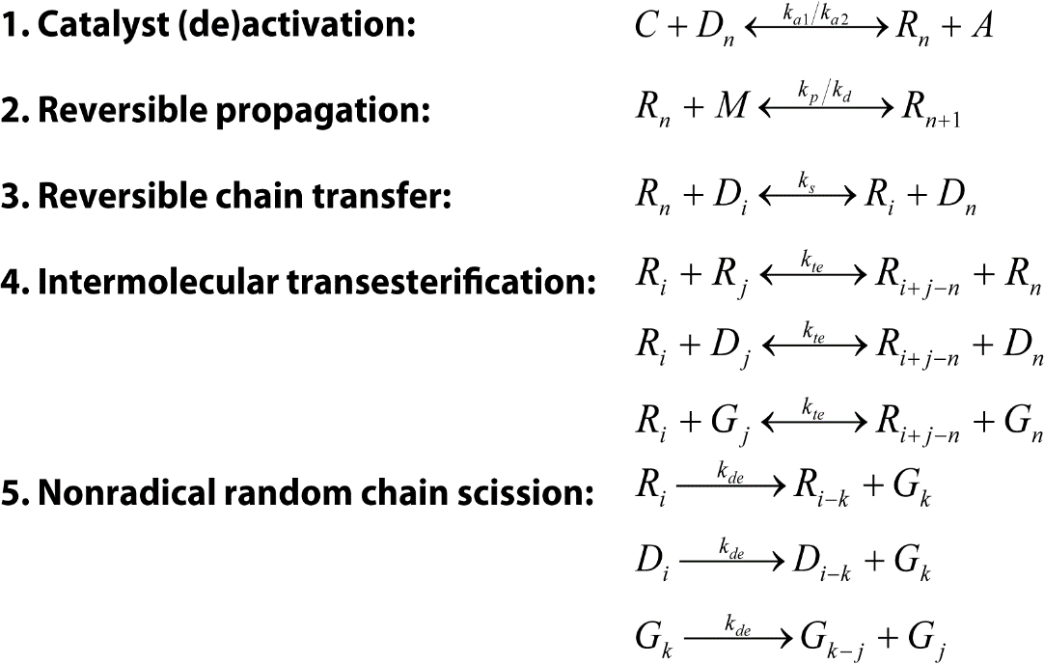
Figure 1. Reaction scheme published by Yu et al. (2011) modified for PCL ROP from ε-caprolactone.
    - Micro-scale model
The Monte Carlo model is based on a stochastic simulation algorithm for dynamic modelling of coupled reactions which was pioneered by Gillespie (1976). We are following the hybrid Monte Carlo approach, as described in Zubov and Sin (2018), which uses the temporal evolutions of concentrations and reaction rates pre-calculated by the macro-scale model and simulates only the growth of polymeric chains step-by-step. This results in prediction of polymer chain architecture and its evolution in time. The hybrid approach offers a significant increase of computational efficiency of the Monte Carlo (micro-scale) simulation when compared to the original formulation by Gillespie (1976).
    - Meso-scale model
The last part of our multi-scale modelling framework is prediction of the rheological properties (loss and storage moduli, complex viscosity) using the distribution of molecular masses generated by the Monte Carlo model. The employed model of chain reptation is based on tube theory and was developed by Das et al. (2006). Besides the polymer chain architecture or mean molecular masses (in the case of linear polymers) this model also needs as input the temperature at which the rheological properties should be calculated, the molecular mass of monomer, density, mean chain entanglement length and characteristic (mean) entanglement time.
    - Estimation of kinetic parameters
We have re-implemented the macro-scale model in MATLAB environment for kinetic parameters estimation. MATLAB was chosen because of built-in global optimisers that are already parallelised.

For the reaction mechanism described in previous subsections, we needed to estimate 12 parameters. We have decided to decompose the problem into two parts: (i) estimation of parameters of reactions that affect only the monomer conversion, and (ii) estimation of parameters of reactions that change the polymer mean molecular masses M_{n} and M_{w}. For this task, we have used experimental data from the literature which were published by Wu et al. (2017), who conducted 6 experiments. Four of them were performed with the same concentration of monomer [ε-CL]₀ = 3 mol/L at different temperatures (60, 70, 80, and 90°C). The other two experiments were carried out at 80°C and the initial monomer concentration varied (1.5 mol/L and 0.5 mol/L). The initial concentrations of monomer, catalyst (tin octoate) and co-catalyst (n-butanol) were in all experiments set to the same ratio, [ε-CL]₀:[Sn(Oct)₂]₀:[n-butanol]₀ = 300:1:1.

The experimental data consisted of values of M_{n}, M_{w} and caprolactone conversion measured in time. We used the whole available dataset (from all six experiments) for estimating the first six parameters. However, to estimate the rest of the six parameters (affecting the change in mean molecular weights), we used only the experimental data at 70, 80 and 90°C (all with [ε-CL]₀ = 3 mol/L), as the course of the measured average molecular masses of polymer in the omitted experiments did not follow the expected trends, could not be rendered by the model predictions not even qualitatively, and was probably burdened with experimental error. MATLAB genetic algorithm from the Global Optimization Toolbox has been employed to estimate the desired kinetic parameters.
  - Results
As stated above, first we have found the parameters affecting the monomer conversion. Values of estimated parameters can be found in Table 1. The comparison of model predictions compared to experimental results – in good agreement between both – can be found in Figure 2.

Table 1. Values of parameters affecting monomer conversion.
Parameter | Value | Unit
A | -40506.8 | K
B | 127.588 | -
k_{p0} | 4.53873∙10¹¹ | L/mol/h
E_{a,p} | 73.4463 | kJ/mol
$$ΔH_{lc}$$ | -9.56587 | kJ/mol
$$ΔS_{lc}$$ | -6.80662 | kJ/mol/K
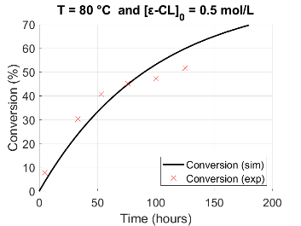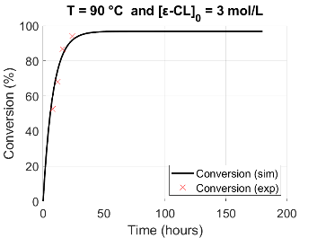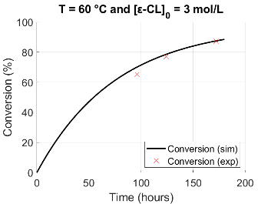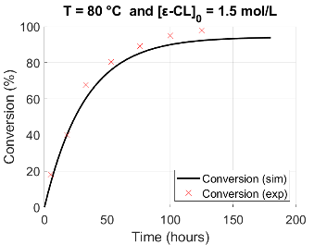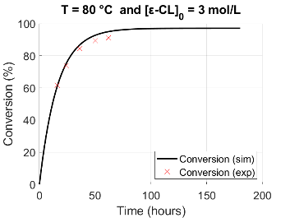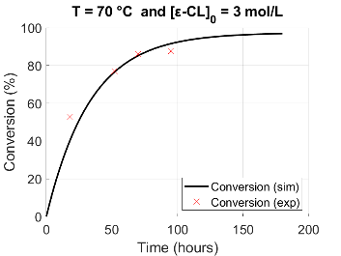
Figure 2. Comparison of model and experimental results of monomer conversion evolution.
Using the values of the first six parameters we found values of the remaining six ones, which are describing the kinetics of reactions between polymeric chains without the monomer influence. Values of these parameters are summarized in Table 2. Simulation results compared with experimental data can be found in Figure 3. The agreement with experimental data in this case is significantly worse than for the monomer conversion. Qualitatively, the observed trends are described well by the model predictions, including the initial increase of the molecular weights due to fast propagation and subsequent decay due to polymeric chains re-shuffling. This suggests that the kinetic scheme used previously for PLA production can be used for PCL modelling as well. The quantitative discrepancy between model predictions and measured data can be caused either by small data set or lower quality of experimental data.
Table 2. Values of parameters related to reactions involving only polymeric species.
Parameter | Value | Unit
k_{s0} | 4.173∙10¹⁹ | L/mol/h
E_{a,s} | 186.27 | kJ/mol
k_{te0} | 5.014∙10¹⁹ | L/mol/h
E_{a,te} | 158.40 | kJ/mol
k_{de0} | 9.045∙10¹⁸ | 1/h
E_{a,de} | 148.35 | kJ/mol
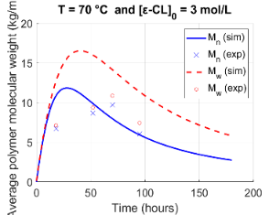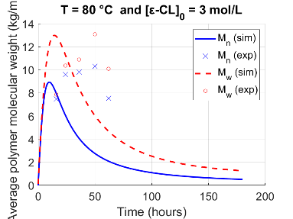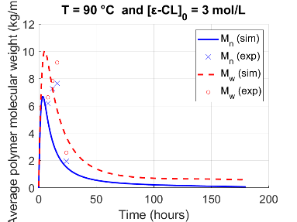
Figure 3. Comparison of model and experimental results of mean molecular masses evolution.
  - Conclusions & future work
We have modified the model of Zubov and Sin (2018) to simulate polycaprolactone (PCL) production. We have assumed the same kinetic scheme for the ring opening polymerization (ROP) of ε-caprolactone as was previously used for the modelling of PLA production by ROP. For this scheme we have estimated kinetic parameters using the experimental data published by Wu et al. (2017). We have achieved good agreement between simulated and experimental values of monomer conversion. Although qualitatively polymer mean molecular masses can be predicted by the presented model, the quantitative agreement is weaker. Because of that we are actively seeking for another experimental datasets (especially those carried out at higher polymerization temperatures), so that we can re-estimate kinetic parameters of our model. In the future we are planning to perform global sensitivity analysis of our model. We are also planning to modify our model, so that it will be able to simulate production of branched polymers.
References
S. Behtaj, F. Karamali, E. Masaeli, Y. G. Anissimov and M. Rybachuk (2021). "Electrospun PGS/PCL, PLLA/PCL, PLGA/PCL and pure PCL scaffolds for retinal progenitor cell cultivation." Biochemical Engineering Journal 166: 107846.
C. Das, N. J. Inkson, D. J. Read, M. A. Kelmanson and T. C. B. McLeish (2006). "Computational linear rheology of general branch-on-branch polymers." Journal of Rheology 50(2): 207-234.
D. T. Gillespie (1976). "A general method for numerically simulating the stochastic time evolution of coupled chemical reactions." Journal of Computational Physics 22(4): 403-434.
W. Punyodom, W. Limwanich, P. Meepowpan and B. Thapsukhon (2021). "Ring-opening polymerization of ε-caprolactone initiated by tin(II) octoate/n-hexanol: DSC isoconversional kinetics analysis and polymer synthesis." Designed Monomers and Polymers 24(1): 89-97.
W. Punyodom, P. Meepowpan and W. Limwanich (2022). "Determination of the activation parameters for the ring-opening polymerization of ε-caprolactone initiated by Sn(II) and Zn(II) chlorides using the fast technique of DSC." Thermochimica Acta 710: 179160.
G. Rafler and J. Dahlmann (1992). "Biodegradable polymers. 6th comm. Polymerization of ϵ-caprolactone." Acta Polymerica 43(2): 91-95.
R. P. Rosa, F. V. Ferreira, A. P. K. Saravia, S. A. Rocco, M. L. Sforca, R. F. Gouveia and L. M. F. Lona (2018). "A Combined Computational and Experimental Study on the Polymerization of epsilon-Caprolactone." Industrial & Engineering Chemistry Research 57(40): 13387-13395.
D. Wu, Y. Lv, R. Guo, J. H. Li, A. Habadati, B. W. Lu, H. Y. Wang and Z. Wei (2017). "Kinetics of Sn(Oct)(2)-catalyzed ring opening polymerization of epsilon-caprolactone." Macromolecular Research 25(11): 1070-1075.
Y. C. Yu, G. Storti and M. Morbidelli (2011). "Kinetics of Ring-Opening Polymerization of L,L-Lactide." Industrial & Engineering Chemistry Research 50(13): 7927-7940.
A. Zubov and G. Sin (2018). "Multiscale modeling of poly(lactic acid) production: From reaction conditions to rheology of polymer melt." Chemical Engineering Journal 336: 361-375.

