Improving food security through water management and allocation: A geospatial optimization approach
Maryam Haji, Mohammad Alherbawi, Sarah Namany, Tareq Al-Ansari
College of Science and Engineering, Hamad Bin Khalifa University, Qatar Foundation, Doha, Qatar
*talansari@hbku.edu.qa
Abstract
In response to the growing population and rising demand for agricultural production, the need for efficient and sustainable allocation of water resources becomes highly crucial. In the State of Qatar, these imperatives are particularly pronounced due to its arid desert climate and limited freshwater resources. Consequently, Qatar has been striving to enhance its food security. This research focuses on optimising the spatial distribution of water resources, encompassing various sources such as desalinated water (DW), groundwater (GW) and treated sewage effluent (TSE), to supply a variety of agricultural and fodder farms. By leveraging geospatial data within ArcGIS, the study deploys advanced optimisation techniques to create an optimal allocation network map that enhances resource utilization while concurrently minimising the costs associated with supplying water from various water sources to these farms. This research takes a comprehensive approach to tackle the multifaceted challenges of water allocation in agriculture, which includes integrating alternative water sources, prioritizing cost-effectiveness, and promoting sustainability. Furthermore, this study incorporates factors that will guide the geospatial distribution of different water resources. This includes groundwater depth, pH, salinity, and recharge rate. In addition to socio-environmental factors, such as public acceptance. The outcomes of this study offer the potential to provide valuable insights for policymakers along with agricultural and water resources stakeholders. By optimizing the allocation of water resources across various ranges of farms, the aim is to contribute to the long-term sustainability and resilience of agricultural practices, even in the face of evolving environmental and economic constraints. This research stands as a promising initiative to ensure a sustainable future of agriculture while addressing the serious global challenge of resource scarcity
Keywords: EWF nexus; food security; geospatial optimisation; water resource allocation
  - Introduction
The issue of limited water availability has garnered significant global attention due to the escalating population growth and ongoing socioeconomic progress observed in the 21st century (Hogeboom, 2020). Studies indicate that nearly 92% of global freshwater usage is linked to agricultural activities (Hoekstra & Mekonnen, 2012). Specifically, irrigation which is a crucial component of agricultural practices, dominates freshwater usage constituting roughly 70% of the total in 2021 (FAO, 2021). Anticipations point toward a continual surge in irrigation requirements over the forthcoming decades (FAO, 2021). By 2030, it is predicted that the worldwide demand for freshwater will soar to 160% of the current available quantities if the current rate of increase persists, a trend driven by the imperative to secure food resources (Ricart & Rico, 2019). This is particularly critical in arid regions such as the State of Qatar, where the harsh desert climate and scarcity of freshwater resources pose significant challenges to agricultural sustainability. Qatar's drive to bolster its food security and reduce its dependence on imported agricultural products has placed a premium on optimizing the utilization of its water resources. Consequently, there is an urgent need to devise effective strategies for accounting and managing water resources to harmonize the escalating demand for agricultural freshwater with the imperative of sustainable water supply. Against this backdrop, this study will adopt a holistic EWF nexus approach, to address the intricate challenges of water allocation in agriculture through the integration of alternative water sources, with a focus on cost-effectiveness, and a commitment to sustainable practices. Thus, this research embarks on a comprehensive investigation to optimize the spatial distribution of various water sources, including desalinated water (DW), groundwater (GW), and treated sewage effluent (TSE), across diverse agricultural and fodder farms. Hence, by employing an advanced spatial optimization technique within the ArcGIS platform, the study endeavors to devise an optimal allocation network map, aimed at maximizing resource efficiency and minimizing the costs associated with water supply from multiple sources to these farms. Moreover, specific risk factors that are critical to the geospatial distribution of water resources were meticulously incorporated into the analysis, this includes groundwater characteristics (such as depth, pH, salinity, and recharge rate) and socio-environmental considerations (such as public acceptance). The research's outcomes offer crucial guidance for decision-makers, farmers, and those overseeing water resources, setting the foundation for a resilient and sustainable farming industry in the State of Qatar. By optimizing the water resource allocation among various farms, the study contributes meaningfully to the long-term sustainability and resilience of agricultural practices, even in the face of evolving environmental and economic hurdles. Highlighting the urgent worldwide issue of limited resources, this research exemplifies Qatar's forward-thinking and creative strategies for a sustainable future in agriculture.
  - Methodology
    - Data Collection and Mapping
The geospatial data of the two different food industries were selected and located on the map, including 11 agriculture farms, and 3 fodder farms. Besides this, two water industries (including 22 treated wastewater stations and 32 desalinated reservoirs) and critical groundwater characteristics impacting food production industries; such as depth and salinity were re-mapped in ArcGIS (10.7.1) using the Universal Transverse Mercator (UTM) coordinates system, as illustrated in Figure 1 and Figure 2.
The water capacity for every treated wastewater plant, desalinated reservoir, and groundwater basin was assumed to be 3,180,000, 3,000,000, and 3,700,000 m³/year respectively. In which the water requirement to be fulfilled for each food industry was assumed to be 1,000,000 m³. Furthermore, the distances between the 54 water supply sites and the 14 food industries were calculated in ArcGIS along with the corresponding transportation costs.

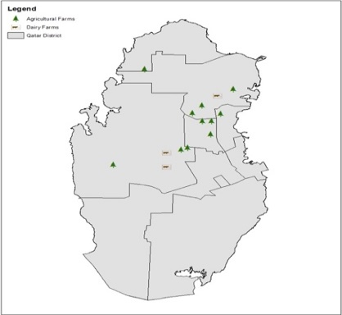 | 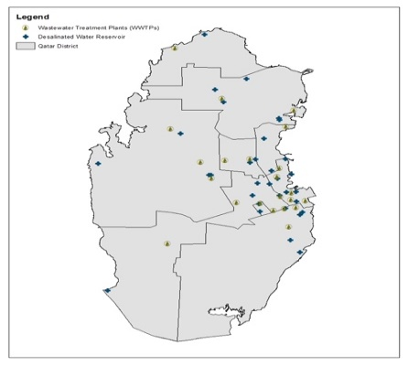
- Agriculture and Fodder Farms | - Desalinated and TSE plants
Figure 1: The GIS maps representing the location of the two food and water industries (a) agriculture and fodder farms and (b) desalinated and wastewater treatment plants.
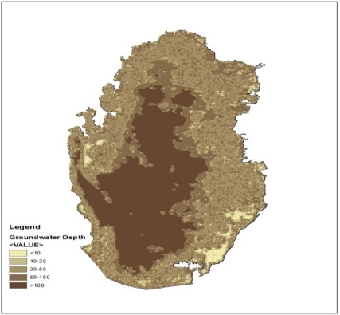 | 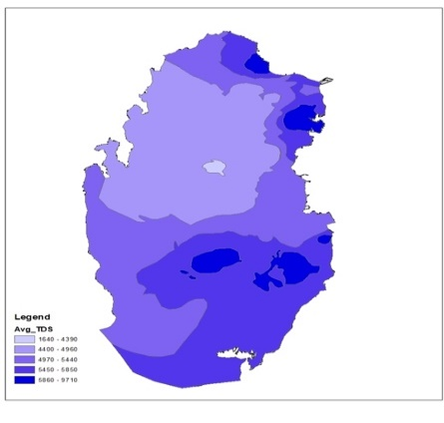
- Groundwater Depth | - Groundwater Salinity
Figure 2: The GIS maps representing geospatial groundwater characteristics including (a) depth and (b) salinity.
    - Optimisation Model Development
The multi-objective optimisation model aims at minimising the total transportation cost from different water industries to food production sites. A summary of the mathematical model is presented in Table 1. Five constraints were introduced to ensure the optimal contribution of groundwater sources and minimal transportation cost of the other two water sources to the food production industries (including agriculture and fodder farms). The first constraint is to allow only 10% (5,180,000 m³/year) utilisation of total groundwater capacity for food production industries. The same applied for the second and third constraints, allowing only 20% (19,200,000 m³/year) and 30% (20,988,000 m³/year) utilisation of the total capacity of desalinated water and treated wastewater respectively. The fourth constraint represents the public acceptance aspect, where people in the State of Qatar have concerns about the potential health risks associated with the use of treated wastewater for irrigation and the safety of the crops irrigated with treated wastewater. The third constraint is to restrict groundwater to participate in supplying groundwater to fodder farms, as it’s considered the scarcest water resource in the country studied. Thus, Excel Solver was used to run and solve the optimization problem.
Table 1: The multi-objective function formulation.
Objective Function:
$$Min Cost=C_{t}\sum_{i=1}^{14}{\sum_{j=1}^{54}{D_{ij}\frac{Q_{j}}{L}} W_{ij}}+\sum_{j=55}^{68}{{Dp}_{j}}C_{p}W_{ij}$$ | Minimising the total cost (Transportation cost of both desalinated water and treated wastewater + Pumping cost of groundwater) for the food industries (agriculture and fodder farms).
Subject to:
$$\sum_{i=1}^{11}{\sum_{j=55}^{68}{W_{ij}} }=0.1A_{g}$$ | The sum of total utilisation from groundwater must be 10% of the total capacity of 14 sites (3,700,000 m³/year/site).
$$\sum_{i=1}^{14}{\sum_{j=23}^{54}{W_{ij}} }=0.2A_{d}$$ | The sum of total utilisation from desalinated water must be 20% out of the total capacity of 32 sites (3,000,000 m³/year/site).
$$\sum_{i=12}^{14}{\sum_{j=1}^{22}{W_{ij}} }=0.3A_{w}$$ | The sum of total utilisation from treated wastewater must be 30% of the total capacity of 22 sites (3,180,000 m³/year/site).
$$\sum_{i=1}^{11}{\sum_{j=1}^{22}{W_{ij}} }=0$$ | Treated wastewater from sites (1 to 22) is not suitable for the food industry (1 to 11).
$$\sum_{i=12}^{14}{\sum_{j=55}^{68}{W_{ij}} }=0$$ | Restricts the utilisation of groundwater from sites (55 to 68) for the food industry (12 to 14).
$$W_{ij}, X_{i} ,Y_{i} ,X_{j} ,Y_{j}≥0$$ | It implies that all decision variables must be strictly positive.
Distance Formula:
$$D_{ij}=\sum_{i=1}^{14}{\sum_{j=1}^{54}{\sqrt{{(X_{i}-X_{j})}^{2}+{(Y_{i}-Y_{j})}^{2}}}}$$ | Distance between water production site (j) to food industry (i) based on UTM coordinates.

Decision variables:
$W_{ij}$: Allocated water (t/y) from water supply site (j) to food industry (i).
$(X_{i} ,Y_{i})$: Coordinates of the food industry (i).
$(X_{j} ,Y_{j})$: Coordinates of water production site (j).
Parameters:  $C_{t}$: Cost of transportation ($/km).  $C_{p}$: Cost of pumping groundwater ($/km)  $A_{g}$: Total capacity of groundwater (51,800,000 m³/year).  $A_{d}$: Total capacity of desalinated water (96,000,000 m³/year).  $A_{w}$: Total capacity of treated wastewater (69,960,000 m³/year).  $D_{ij}$: Distance (km) between water production site (j) to food industry site (i).  $Q_{j}$: Total quantity (t) of water production at a site (j).  $L$: Freight load (t/y). | Where;  i=1, 2, … ,11 is representing agriculture farm  i=12,13,14 represent fodder farm  j=1, 2, … ,22 is representing treated wastewater stations  j=23, 24, … ,54 is representing desalinated water reservoirs  j=54, 55, … ,68 is representing groundwater sites
  - Result and Discussion
The Excel solver yielded an optimal water allocation from 17 sites (out of a total of 68 sites) as shown in Table 2 and Figure 3. The 17 selected sites will satisfy the total water requirements for each farm (equivalent to 1,000,000 m³). As such, the water requirement for the three fodder farms (no. 12, 13, and 14) was fulfilled using only treated wastewater from sites 2, 6, and 20. Whereas desalinated water and groundwater were allocated for agriculture farms (no. 1-11).
Besides this, Table 3 summarises the net and average transportation costs from different water sources to the 14 food industries. Hence the optimal water allocation yielded a total transportation cost of $4,231,185 per year, with an average cost equivalent to $0.30 per m³.

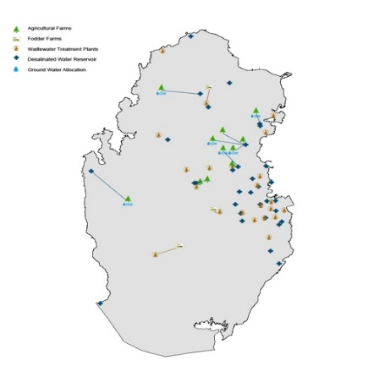
Figure 3: Representation of optimal water allocation over food industries.

Table 2: The optimal allocation of water from 3 different sources over 11 agriculture and 3 fodder farms.
Water sources | Water allocation amount from different water sources to the food industries (m³)
 | F1 | F2 | F3 | F4 | F5 | F6 | F7 | F8 | F9 | F10 | F11 | F12 | F13 | F14
WW #2 | - | - | - | - | - | - | - | - | - | - | - | - | - | 1,000,000
WW #6 | - | - | - | - | - | - | - | - | - | - | - | 1,000,000 | - | -
WW #20 | - | - | - | - | - | - | - | - | - | - | - | - | 1,000,000 | -
DW #3 | - | - | - | - | - | - | - | 1,000,000 | 1,000,000 | - | - | - | - | -
DW #4 | - | - | - | 320,000 | - | - | - | - | - | - | - | - | - | -
DW #5 | 1,000,000 | - | 250,000 | - | - | - | 250,000 | - | - | - | - | - | - | -
DW #6 | - | - | - | - | 250,000 | - | - | - | - | 250,000 | - | - | - | -
DW #26 | - | 1,000,000 | - | - | - | - | - | - | - | - | - | - | - | -
DW #28 | - | - | - | - | - | - | - | - | - | - | 250,000 | - | - | -
DW #31 | - | - | - | - | - | 250,000 | - | - | - | - | - | - | - | -
GW #3 | - | - | 750,000 | - | - | - | - | - | - | - | - | - | - | -
GW #4 | - | - | - | 680,000 | - | - | - | - | - | - | - | - | - | -
GW #5 | - | - | - | - | 750,000 | - | - | - | - | - | - | - | - | -
GW #6 | - | - | - | - | - | 750,000 | - | - | - | - | - | - | - | -
GW #7 | - | - | - | - | - | - | 750,000 | - | - | - | - | - | - | -
GW #10 | - | - | - | - | - | - | - | - | - | 750,000 | - | - | - | -
GW #11 | - | - | - | - | - | - | - | - | - | - | 750,000 | - | - | -
Total Water Requirement (m3) | 1,000,000 | 1,000,000 | 1,000,000 | 1,000,000 | 1,000,000 | 1,000,000 | 1,000,000 | 1,000,000 | 1,000,000 | 1,000,000 | 1,000,000 | 1,000,000 | 1,000,000 | 1,000,000
Table 3: The net cost of water from 3 different sources over 11 agriculture and 3 fodder farms.
Water sources | The total cost of transporting different water sources to the food industries ($/year)
 | F1 | F2 | F3 | F4 | F5 | F6 | F7 | F8 | F9 | F10 | F11 | F12 | F13 | F14
WW #2 | - | - | - | - | - | - | - | - | - | - | - | - | - | 160,781
WW #6 | - | - | - | - | - | - | - | - | - | - | - | 181,805 | - | -
WW #20 | - | - | - | - | - | - | - | - | - | - | - | - | 95,504 | -
DW #3 | - | - | - | - | - | - | - | 625,406 | 625,406 | - | - | - | - | -
DW #4 | - | - | - | 209,877 | - | - | - | - | - | - | - | - | - | -
DW #5 | 678,838 | - | 173,017 | - | - | - | 151,330 | - | - | - | - | - | - | -
DW #6 | - | - | - | - | 168,370 | - | - | - | - | 145,072 | - | - | - | -
DW #26 | - | 601,921 | - | - | - | - | - | - | - | - | - | - | - | -
DW #28 | - | - | - | - | - | - | - | - | - | - | 192,752 | - | - | -
DW #31 | - | - | - | - | - | 178,632 | - | - | - | - | - | - | - | -
GW #3 | - | - | 4,557 | - | - | - | - | - | - | - | - | - | - | -
GW #4 | - | - | - | 9,251 | - | - | - | - | - | - | - | - | - | -
GW #5 | - | - | - | - | 3,383 | - | - | - | - | - | - | - | - | -
GW #6 | - | - | - | - | - | 7,691 | - | - | - | - | - | - | - | -
GW #7 | - | - | - | - | - | - | 6,822 | - | - | - | - | - | - | -
GW #10 | - | - | - | - | - | - | - | - | - | 6,281 | - | - | - | -
GW #11 | - | - | - | - | - | - | - | - | - | - | 4,487 | - | - | -
Net Cost  ($/y) | 678,838 | 601,921 | 177,575 | 219,129 | 171,753 | 186,323 | 158,152 | 625,406 | 625,406 | 151,353 | 197,239 | 181,805 | 95,504 | 160,781
Avg Cost ($/m³) | 0.68 | 0.60 | 0.18 | 0.22 | 0.17 | 0.19 | 0.16 | 0.63 | 0.63 | 0.15 | 0.20 | 0.18 | 0.10 | 0.16
  - Conclusions
This study presents a novel EWF Nexus framework designed to optimally allocate water resources from three district sources (groundwater, desalinated water, and treated wastewater) over food production industries (agriculture and fodder farms). Leveraging ArcGIS and Excel tools, the framework integrates geospatial, quantitative, and qualitative considerations for both water-supplying sites and receiving food industries. The model aimed at selecting optimal water resources while minimising overall transportation costs. Among the 68 water sites evaluated, 17 were strategically chosen to supply water for the 14 food industries, resulting in an annual transportation cost of $4,231,185, which is equivalent to an average cost equivalent to $0.30 per m³. Placing our findings within the broader field of research, the existing water resource allocation models, such as WEAP, SWAT, and AQUATOOL provides comprehensive insights into specific aspects of water management. However, our model excels in seamlessly integrating geospatial considerations and cost optimization, thereby offering a unique and holistic approach to address the complex challenges within the broader field of sustainable water resource allocation. Thereby, this model provides insights on possible means to optimally utilise different water resources at lower costs while ensuring long-term sustainability and resilience of agricultural practices.
  - Acknowledgments
This research was made possible by an Award (GSRA7-1-0407-20014) and supported by proposal number NPRP11S-0107-180216 from Qatar National Research Fund (MME01-0922-190049). The contents herein are solely the responsibility of the authors[s].
  - References
FAO. (2021). Monitoring Water Use in Agriculture through Satellite Remote Sensing. Retrieved from https://www.fao.org/aquastat/en/
Hoekstra, A. Y., & Mekonnen, M. M. (2012). The water footprint of humanity. P. Natl. Acad.Sci. USA., (109), 3232–3237. https://doi.org/https://doi.org/10.1073/pnas.1109936109.
Hogeboom, R. J. (2020). The water footprint concept and water’s grand environmental challenges. In One Earth 2. https://doi.org/https://doi.org/10.1016/j.oneear.2020.02.010.
Ricart, S., & Rico, A. M. (2019). Assessing technical and social driving factors of water reuse in agriculture: a review on risks, regulation and the yuck factor. Agric. Water Manag., (217), 426–439. https://doi.org/https://doi.org/10.1016/j.agwat.2019.03.017

