Using CFD to calculate the heat transfer effectiveness of a particle curtain heat transfer device for an atmospheric pressure gas with high effectiveness and extremely low pressure drop
Marko Trifunovićª, Mark Lathamª, Andrew Hoadleyª, David Frederick Fletcher^{b}, Caecilia Potterª
ªVenso Pty Ltd, 106 Church Street, Melbourne , Australia
^{b}School of Chemical and Biomolecular Engineering, The University of Sydney, NSW 2006, Australia
cpotter@vensogrow.com
Abstract
Recovering heat from an atmospheric gas stream and transferring this heat into another atmospheric gas stream is a relatively common, but challenging operation. Traditional heat exchangers such as shell and tube, plate and plate and fin are unable to do this effectively without costing more in compression than the energy recovered. An alternative is to use a solid intermediate for heat storage between two gas streams, such as a crossflow gas-particle system. The advantage of these systems is that the heat transfer surface area can be equivalent or greater than a traditional heat exchanger whilst having a much lower pressure drop. In the context of heat recovery, the use of CFD is important for predicting the heat transfer in gas-particle interactions as well as the hydrodynamics of the bulk system, as CFD can consider the gases influence on each particle and vice versa, which is more difficult to predict with the use of analytical methods. Additional to providing a calculation method for heat transfer effectiveness of scaled up crossflow systems, CFD was also found to identify relationships in pressure drop when scaling up to total heat recovered. Our findings indicate that on a complete gas-gas heat exchanger basis, the use of a solid particle crossflow medium for heat transfer results in orders of magnitude smaller pressure drop than conventional technologies.
Keywords: CFD, Gas-particle interaction, Low pressure drop, Heat recovery
  - Introduction
Typically, recovering heat from gases at atmospheric pressure has proven to be difficult. An option is to use a fluid intermediate, such as steam or hot oil system, but both require significant infrastructure and maintenance to support them despite dealing with the issue of pressure drop (Mitra, 2015). Alternatively, a solid device such as a Ljungstrom heat exchanger can deal with heat recovery at or near atmospheric pressure, however leakage is common and can impact on the heat transfer effectiveness and the process operation in air preheating applications (Maharaj et al., 2015).

Gas-particle contact can also provide a very high heat transfer surface area which is formed by a particle curtain and provides a reasonable heat transfer effectiveness, at very low pressure drops (Ouyang et al., 2003). Asfar and Sheehan (2013) incorporated CFD into their hydrodynamic and heat transfer analysis of a curtain of particles free falling in air. They obtained good agreement between the experiment and the CFD model for small particle sizes using the Eulerian-Eulerian approach. Wardjiman and Rhodes (2009) investigated heating silica sand in a horizontal stream of warm air and identified a non-uniform horizontal velocity profile following the curtain, leading to a need for better understanding of the pressure profiles and path of the gas streamlines inside and outside the particle curtain. Potter (2013) also investigated the performance of crossflow particles of silica sand using a computational model that relied on estimating the residence time, surface area and overall heat transfer coefficient using analytical methods in estimating the number of gas heat transfer units necessary as an input into the model. He calculated the heat transfer effectiveness on an equal heat capacity flowrate basis, and from this, analytically determined the Number of Transfer units, NTUs, by iterating through a matrix of cells describing the gas-particle interactions. However, his simplified computational model did not consider the drag effects of the particles on the direction of the gas flow and the impact on the magnitude and distribution of the residence time, nor the implication on the gas temperature mixing nor the effect of the slip velocity on each particle.

From the investigations mentioned above, the pressure drop was assumed to be very low, but was not studied in detail or quantitatively determined, particularly for large systems where heat recovery would be economically viable. Furthermore, the drag effects on the gas in one crossflow curtain and its effect on proceeding curtains was not investigated.

In this study, CFD is used to provide a calculation method for assessing the overall heat transfer effectiveness and resultant pressure drop required for a scale-up crossflow heat recovery system. Furthermore, the CFD is used to determine the effectiveness and pressure drop relationships during scale up for different orientations of particle curtains used as a solid intermediate in heating ambient air using hot air. A crossflow system using three curtains in each duct is shown in Figure 1. The study extrapolates a scaled-up crossflow system for recovering heat into ambient air to a maximum of 5.05 MW. Assessing the suitability for atmospheric heat recovery, the crossflow system is compared with a duty-equivalent shell and tube heat recovery system.
  - Methodology
The schematic shown in Figure 1 describes the interaction of air at 200°C interacting with silica sand in the sand heating duct and ambient air at 15°C interacting with the resultant hot sand in the air heating duct. For this investigation, it is important to approximate the system based on an equalized heat capacity flowrate between the solids and gases, such that temperature changes between all interactions are equal.

$Z=\frac{m_{hot}C_{p, hot}}{m_{cold}C_{p, cold}}$ = 1 | (1)

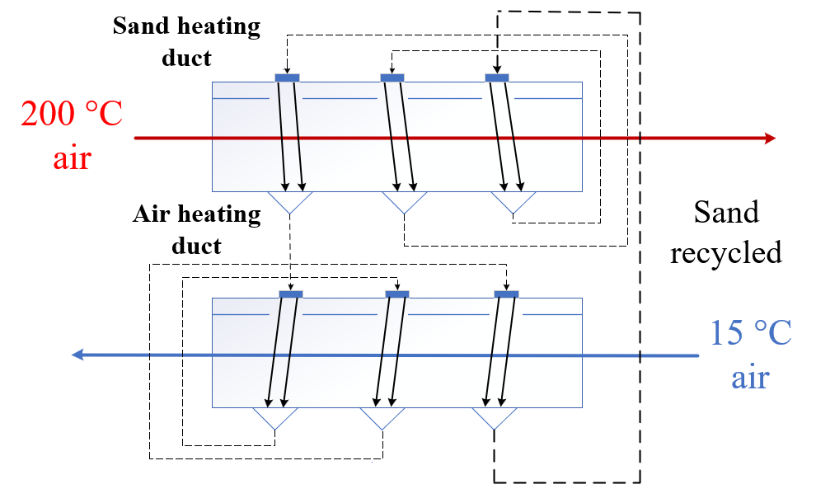
Figure 1 Schematic of 3-curtain looping crossflow heat recovery device heating sand using 200 °C air in the sand heating duct, then heating up 15 °C air in the air heating duct with the resultant sand, with sand being recycled between both individual ducts.
Ansys Fluent 2022R2 commercial CFD software is used to simulate the moving particle moving gas system. The gas side is solved with the Navier-Stokes equations and the $k-ω$SST turbulence model. The particles are modelled using Lagrangian discrete particle tracking to consider trajectories, residence time analysis and reinjection (Jadhav and Barigou, 2022). The simulation considers a two-way coupling between each particle and the continuous phase of air while calculating the heat transfer coefficient according to Ranz-Marshall. The exchange of momentum between the particles and gas is also modelled. The particles were assumed to exhibit no internal temperature profile, as well as thermal equilibration consistent with low Biot numbers. The inlet air flow is assumed to enter the simulation with a turbulence intensity of 5% and a turbulent viscosity ratio of 10. Except for the final curtain, particles reaching the bottom wall are reinjected into the proceeding curtain/s with the same temperature and size properties, assuming no heat losses.

Due to the computationally expensive nature of large Lagrangian simulations, the methodology relies on a base simulation described by a 1 m $×$ 1 m cross-section processing 1 kg/s of sand and the mass flow rate of hot air to satisfy eq. (1) for 1, 2 and 3 curtains. Only the sand heating duct is simulated using CFD to determine the heat transfer effectiveness and pressure drop of the interaction. The base simulation assumes the sand is entering at 15 °C. The overall gas-gas heat transfer effectiveness is then calculated according to the following steps:

- The same heat transfer effectiveness value is assumed in the air heating duct due to similar NTU value and $Z$ = 1 mixture of the resultant air and sand are then calculated based on this value.
- The resultant sand is recycled back into the sand heating duct, changing the theoretical maximum heat transfer in the sand heating duct. The resultant temperatures are then recalculated by assuming the same heat transfer effectiveness as determined by CFD.
- Steps 1 and 2 are repeated iteratively until the solution converges and the overall gas-gas heat transfer effectiveness is found.
- The same pressure drop calculated from CFD produced in the sand heating duct is assumed for the air heating duct.

Different particle sizes of sand are simulated first for the base simulation to emphasize the effect on the heat transfer effectiveness and pressure drop based on differing available surface areas, residence times and heat transfer coefficients associated with different slip velocities produced by fluid drag effects. The base simulation using 200-micron particles is then used to scale up the target heat duty given to the ambient air in two different ways. The first relies on a geometric scaling of the duct while conserving the mass fluxes of both the solids and the gases, subsequently increasing the overall heat transfer based on the increase in flow rates. The second scaling up method involves scaling up both sand and air flow rates within the same duct geometry, increasing the overall duty and pressure drop.

Both scaling up methods are investigated individually using CFD to identify the effect on the overall heat transfer effectiveness and pressure drop. The resultant data are used to extrapolate a pressure drop estimate for the target duty of 5.05 MW to be compared with a shell and tube heat exchanger with the same duty. For comparison purposes, a network of 1-2 shell and tube heat exchanger designs are also included. These designs calculated using Kern’s method are based on a pressure drop fixed at 10 kPa on both hot and cold air sides (Sinnot and Towler, 2009). This pressure drop was chosen to ensure a reasonable heat transfer effectiveness without requiring excessive compression. However, both streams are compressed/recompressed to satisfy atmospheric operation.
  - Results
Figure 2 shows the impact of particle size on the resultant heat transfer performance of the base case heat recovery system and the impact of exhibiting larger NTU values for 1, 2 and 3 curtain systems. For example, more heat can be exchanged to the ambient air in one curtain of 200-micron particles, than three curtains of 1 mm particles or two curtains of 600-micron particles. Although the pressure drop did differ for different particle sizes for all 3 curtain combinations, the total pressure drop did not exceed 7 Pa for the base simulation, regardless of the particle size. Figure 3 shows the effect of the smaller particle size inducing a downward flow in each curtain for the 200-micron particle size but allowing the air to pass through each curtain horizontally for the 1 mm particle size. The hydrodynamic impact of particles on the horizontal flow of the gas stream introduces opportunities for further study and design with the use of CFD, to ensure the flow is as perpendicular to the particles as possible, thereby increasing the slip velocity.

The NTU vs Effectiveness relationship was compared with conventional 1-2 shell and tube heat exchanger with a fixed pressure drop of 10 kPa on both sides. Although the effectiveness relationship is slightly higher for the shell and tube heat exchanger, this is due to additional heat coming from compressing the air back to one atmosphere. The cost of this compression is approximately 25% in work of the heat recovered.

Figure 2 NTU vs Effectiveness values for 1, 2 and 3 curtains in crossflow heat recovery system for different particles sizes compared with shell and tube heat exchanger with fixed 10 kPa pressure drop on both sides.
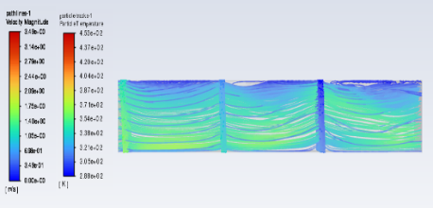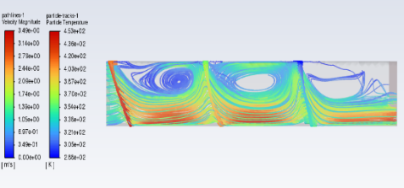
Figure 3 CFD simulations of the air path-lines interacting with 3 curtains in the sand heating duct for 1 mm particles (left) and 200-micron particles (right) in the base simulation.
Figure 4 describes the pressure drop relationship for 1, 2 and 3 curtain systems when increasing the cross-section and feeder sizes while conserving the mass fluxes of the sand and air as well as the pressure drop relationship when the solids and gas flows are multiplied by some factor in the same duct. While the square scale factor did have an impact on the pressure drop induced by the curtain, the pressure drop was still of the same order or magnitude despite increasing the heat transfer duty by approximately a factor of 4 and 9, for the 2 squared and 3 squared scale ups, respectively. The small increase is likely due to the exaggerated vortex generated from a taller curtain and its effect on subsequent curtains. It was also found that the heat transfer effectiveness did increase for all 3 curtain formations with a quadratic relationship, likely due to the increase in residence time per kilo of particles, due to the taller duct. The taller duct allowed the particles to have more time to heat up and increased the scaled total surface area. For example, the 3-curtain heat transfer effectiveness of the base simulation was 0.703, while the simulation involving a 3 m $×$ 3 m cross section processing 9 kg/s of sand was 0.719.

When scaling up both flows within the same geometry, it was found that a general linear increase in pressure drop occurred when increasing the number of curtains, reflecting a linear relationship between the pressure drop and NTU for each scaling up factor. However, the increase in total pressure drop when scaling up both flows showed a general polynomial relationship, where the increase in pressure drop from a larger number of curtains increases with the scale factor. This is largely due to an improvement in the perpendicular nature of the interaction for increased flow scale factors, resulting in a higher particle slip velocity leading to a higher pressure drop. Despite this, the heat transfer effectiveness was relatively constant.

The scaled-up heat recovery system with a target duty provided to the ambient air of 5.05 MW was considered in a 3 m $×$ 3 m horizontal duct with a flow scale factor of 4.1 exhibiting a heat transfer effectiveness of 0.719 and an extrapolated pressure drop of 115 Pa. This is orders of magnitude smaller than the shell and tube heat exchanger case with the same effectiveness value and a 10 kPa pressure drop. The crossflow heat recovery system can therefore be considered for atmospheric operation without the need for compression.

Figure 4 Pressure drop relationship for 1, 2 and 3 curtains when square scaling up (left) and flow scaling up (right).
  - Conclusion
In conclusion, this work has provided a calculation method for determining the heat transfer effectiveness and pressure drop for crossflow curtain systems using CFD for a system involving two crossflow ducts with looping particle curtains for heating ambient air using hot air at near atmospheric pressure. The CFD determined an insignificant increase in pressure drop occurs when scaling up the geometry of the system while conserving mass fluxes of both solids and gases while slightly improving the heat transfer effectiveness. The scaling up of heat duty due to scaling up the flows within the same duct showed a relatively constant heat transfer effectiveness while showing a general polynomial increase in the pressure drop based on 1, 2 and 3 curtain systems. Furthermore, the crossflow system was determined to have orders of magnitude lower pressure drop when compared with a duty-equivalent shell and tube heat exchanger system exchanging 5.05 MW of heat, demonstrating its suitability for atmospheric heat recovery. This paper has also introduced a need for better understanding and management of the impact of particles on the horizontal flow path of the gas in subsequent curtains.
References
Afshar, S., Sheehan, M., 2013. CFD and experimental study of convectional heat transfer in free-falling particle curtains. 11th International Conference of Numerical Analysis and Applied Mathematics, AIP Conf. Proc., 1558, 2005-2008.
Jadhav, A., Barigou, M., 2022. Eulerian-Lagrangian modelling of turbulent two-phase particle-liquid flow in a stirred vessel: CFD and experiments compared. International Journal of Multiphase Flow, 155, 104191.
Maharaj, A., Schmitz, W., Naidoo, R., 2015. A numerical study of air preheater leakage. Energy, 92(1), 87-99.
Mitra, S., 2015. Design of hot oil system: A technical report. The University of Newcastle, Australia, DOI: 10.13140/RG.2.1.4159.0882.
Ouyang, S., Mao, Q.M., Rhodes, M., Potter, O.E., 2003. Short contact time gas-solid systems. Reviews in Chemical Engineering, 19(2), 133-228.
Potter, O., 2013. Crossflow gas-particle heat and mass transfer and chemical reaction. Chemical Engineering Research and Design, 91(2), 244-253.
Sinnott, R., Towler, G., 2009. Chemical Engineering Design (5th ed.). SI edition.
Wardjiman, C., Rhodes, M., 2009. Heat transfer in a particle curtain falling through a horizontally-flowing gas stream. Powder Technology, 191(3), 247-253.

