Multi-objective optimization for pharmaceutical supply chain design: application to COVID-19 vaccine distribution network
Jonathan J. Cuevas-Lopezª, Catherine Azzaro-Pantelª* and Sofıa De-Leon Almarazb
ªLaboratoire de Génie Chimique, Université de Toulouse, CNRS, INPT, UPS, Toulouse, France
bCorvinus University of Budapest. Department of Supply Chain Management. 8 Fo˝vam te´r. 1093 Budapest, Hungary
jonathanjair.cuevaslopez@toulouse-inp.fr,
Abstract
In response to the exigencies of the COVID-19 pandemic, this study proposes a novel Pharmaceutical Supply Chain (PSC) model for vaccination. Our model encompasses a five-echelon structure, integrating manufacturing plants, fill-finish facilities, distribution centres, and administration points focusing on a stratified deterministic demand for COVID-19 vaccines. A distinctive feature of our work is the incorporation of a multi-objective optimization approach within the General Algebraic Modeling System (GAMS) environment using Mixed Integer Linear Programming (MILP). This approach is designed to optimize cost, CO₂ emissions, and backlog over a 40-week vaccination campaign. Utilizing an augmented epsilon-constraint method, our model facilitates the identification of trade-offs between these objectives, thus enabling informed decision-making in PSCs. The results underscore the inherent trade-offs among the objectives, reflecting the complexity of the supply chain management for vaccination as shown in the Pareto fronts.
Keywords: Pharmaceutical Supply Chain, Mixed Integer Linear Programming, multi-objective optimization, COVID-19 vaccines, epsilon-constraint.
  - Introduction
The COVID-19 pandemic has highlighted the essential role of Pharmaceutical Supply Chains (PSCs) in maintaining global health. Unlike other supply chains, the pharmaceutical supply chain is unique, particularly in its crucial role during a pandemic for vaccine distribution. Disruptions in this supply chain can lead to severe consequences. Inadequate management strategies in healthcare industries can result in substantial financial losses and significantly impact patient care and outcomes (Uthayakumar, 2013).
To address the optimization of the supply chain, approaches can be either single-objective, focusing mainly on cost, or multi-objective where traditional models, primarily focused on cost and service efficiency (Papageorgiou, 2009), often overlook environmental considerations (Alnaji, 2013). This oversight, coupled with concerns about social equity in vaccine distribution, (Sazvar, 2021) underscores the need for a more comprehensive approach to PSC management. To bridge this gap, our study introduces a new PSC model for the distribution of COVID-19 vaccines. In this work, we are particularly interested in understanding the impact of integrating various sustainability objectives when designing a specific PSC. This model incorporates a multi-echelon structure, reflecting insights from studies like (Papageorgiou, 2009). It employs a multi-objective optimization strategy using an augmented epsilon-constraint method (Mavrotas, 2009), enabling the identification of balanced solutions between cost, backlog, and environmental impacts. Our objective is to address the existing gaps in PSC management and offer a model that seamlessly integrates economic, service-level, and environmental objectives. This model serves as a valuable tool for stakeholders and modelers engaged in multi-criteria decision-making within the pharmaceutical supply domain.
  - Formulation of the PSC Mathematical Model
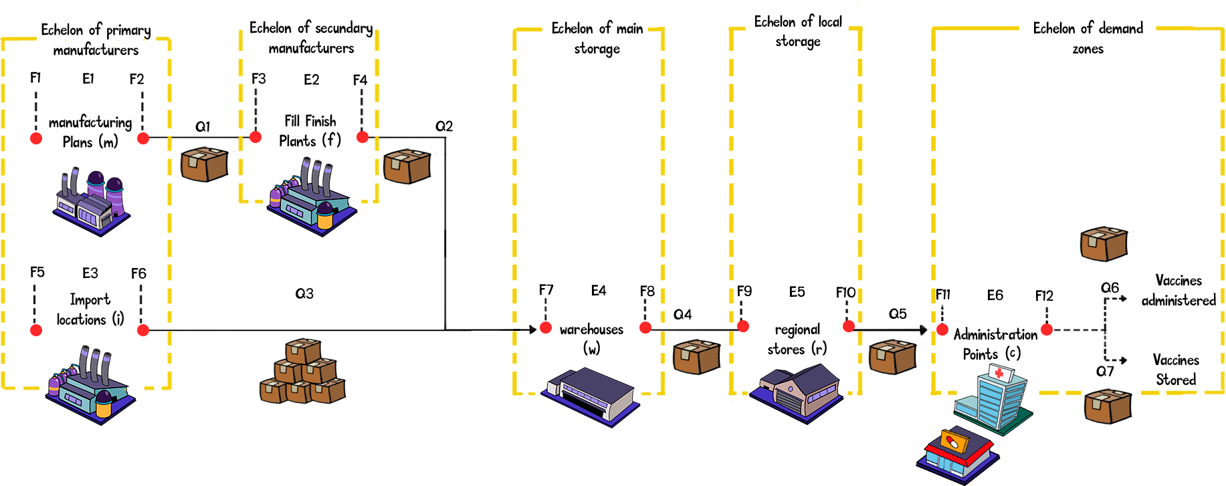
Our model for COVID-19 vaccine distribution integrates various stages of the supply chain, from manufacturing plants to administration points. Figure 1 showcases the vaccine’s journey through the supply chain. The primary manufacturers echelon involves vaccine synthesis at import locations (i) or manufacturing plants (m), followed by fill-finish plants (f) in the secondary manufacturers echelon. Subsequently, vaccines are stored and distributed through the main and local storage echelons, represented by warehouses (w) and regional stores (r), respectively. The final demand zone echelon includes administration points (c), where the public receives vaccines. Likewise, the variable ”F” indicates the flow of vaccines entering and leaving each entity, which are denoted as variables with the letter ”E”, while the ”Q” is interpreted as the quantity of vaccines transported between the different entities.
Figure 1. PSC scheme
Table 1 briefly encapsulates the Pharmaceutical Supply Chain (PSC) model’s components, illustrating the intricate framework designed to optimize the distribution of vaccines. Parameters bring real-world context into the model, grounding it with empirical data such as costs and capacities. Central to the model are the objective functions, which guide the system towards cost efficiency, backlog minimization, and reduced environmental impact. Optimization variables dictate the supply chain’s functionality, while sets categorize the key elements, from manufacturing entities to distribution factors, within a structured matrix. This integration is key to optimizing the three above mentioned objectives. The use of continuous integer and binary variables in linear constraints results in an MILP model and a strategy of multi-objective optimization through an enhanced epsilon-constraint approach is implemented, as outlined by Mavrotas (2009) within the GAMS environment.

Table 1. Summary of the PSC model framework
Inputs | Optimization | Outputs
Sets:  - Manufacturing plants  - Fill-finish facilities  - Distribution centers  - Administration points  - Time periods (weeks) | Constraints:  - Supply flow conservation  - Capacity limitations  - Inventory bounds  - Transportation logistics  - Service level requirements | Optimization Variables:  - Vaccine quantities  - Associated costs  - Emission metrics  Network Configuration:  - Supply chain structure
Parameters:  - Cost factors  - Capacity constraints  - Distance matrices  - Demand forecasts  - CO₂ emissions | Objective Functions:  - Minimizing cost  - Minimizing backlog  - Minimizing CO₂ emissions | Performance Metrics:  - Total cost  - Environmental impact  - Backlog
  - Case study
In this work, insights from the framework proposed by (Ibrahim, 2021) have been used to validate our methodology. Within the four echelons used in the COVID-19 vaccine supply chain, the case study utilizes a single import location since the vaccine comes from Puurs, Belgium. Regarding warehouse locations, there are four major cities in the UK, including the capital. Additionally, there are 12 potential sites for regional stores and 12 administration points..
Our focus is exclusively on the Pfizer vaccine, selected due to the availability of detailed data and its widespread use during the study period. This choice allowed for a more precise and data-driven analysis, crucial for the model’s accuracy. The vaccination campaign was planned for a duration of 40 weeks, aiming for full vaccination (two doses per person). It is noteworthy that the demand is entirely met by imported vaccines, as domestic production of Pfizer vaccines was not available.
For cost parameters, including fabrication, storage, and application, we drew insights from studies such as those by (Martonosi, 2021). These studies provided a comprehensive understanding of various cost factors in the vaccine supply chain. Logistics parameters, particularly those associated with vaccine transportation, cold chain requirements, and packaging, were informed by research including (Holm, 2021) and (Organization, 2022). Finally, the environmental impact, focusing on CO₂ emissions related to refrigeration, transportation, and waste, was a critical aspect. The ecological footprint of the vaccine supply chain is assessed similarly to the approach taken by (Kurzweil, 2021), ensuring that our model also incorporates sustainability.
  - Results
The statistics of the MILP model are presented in Table 2. The computations were carried out on a system running Microsoft Windows 10 as the operating system. The core processing tasks were managed by an 11th Gen Intel(R) Core(TM) i7-11850H processor, operating at a base frequency of 2.50GHz and equipped with 8 cores. The system was supported by 16 GB of RAM.

Table 2. Typical features of the model instance.
Typical features of the instance | Value
Blocks of Equations. | 143
Single Equations. | 237,306
Blocks of Variables | 92
Single Variables | 111,090
Non-Zero Elements | 591,480
Discrete Variables | 24,376
Generation Time (seconds) | 1.382

The model consists of 143 blocks of equations, further detailed into 237,306 single equations, highlighting the detailed level of modelling. The variable blocks are fewer, at 92, but expand into 111,090 individual variables, of which 24,376 are discrete, likely representing binary decisions within the supply chain. The large number of non-zero elements, 591,480, reflects the density and connectivity of the model constraints. The model was generated and solved in a relatively swift 1.382 seconds, demonstrating the efficiency of the solver in handling such an extensive model.
Table 3 presents some typical results of a single-objective optimization for the PSC model for COVID-19 vaccines. The objectives were individually minimized, showcasing the minimal results for cost, backlog (BL), and CO₂ emissions.
Table 3. Payoff table with single-objective results
 | Min Cost (billion $) | Min BL (Million vaccine) | Min CO₂ (Million Kg CO₂-eq)
Cost | 5.693 | 321.534 | 50.514
BL | 6.326 | 0 | 85.989
CO₂ | 5.693 | 321.534 | 33.426

When minimizing cost, the model achieved a balance with a cost of 5.693 billion dollars, a backlog of 321.534 million vaccines, and CO₂ emissions of 50.514 million kg. Focusing solely on minimizing the backlog resulted in zero backlog but increased cost and CO₂ emissions, indicating the trade-offs involved. Lastly, targeting CO₂ reduction led to lower emissions but at the cost of higher expenses and backlog. These results underscore the inherent compromises in supply chain optimization, emphasizing the need for a balanced approach for practical implementation.
Table 4 encapsulates the outcomes of a multi-objective optimization using the epsilon constraint method, which simultaneously considers cost, backlog (BL), and CO₂ emissions.
Table 4. Payoff table with multi-objective optimization results
 | Cost (billion $) | BL (Million vaccine) | CO₂ (Million Kg CO₂-eq)
Multi-objective Optimization | 6.131 | 32.153 | 37.763

This trade-off solution showcases the efficacy of the epsilon constraint method in deriving a balanced solution that does not excessively favour one objective over the others. With a cost of 6.131 billion dollars, a backlog of 32.153 million vaccines, and CO₂ emissions of 37.763 million kg, a feasible and sustainable approach to managing the vaccine supply chain is proposed, underlining the method’s capacity to find a middle ground that could be acceptable on multiple fronts. The outcomes of the multi-objective optimization, conducted through the augmented epsilon constraint method, are graphically depicted in Figures 2, 3, and 4. These Pareto fronts collectively encapsulate the trade-offs within the vaccine supply chain optimization process. Figure 2 presents the trade-offs between the cost (USD) and backlog (Vaccines) in vaccine distribution. Lower costs are associated with higher backlogs, demonstrating the complexities inherent in optimizing for cost-effectiveness while maintaining high levels of service.
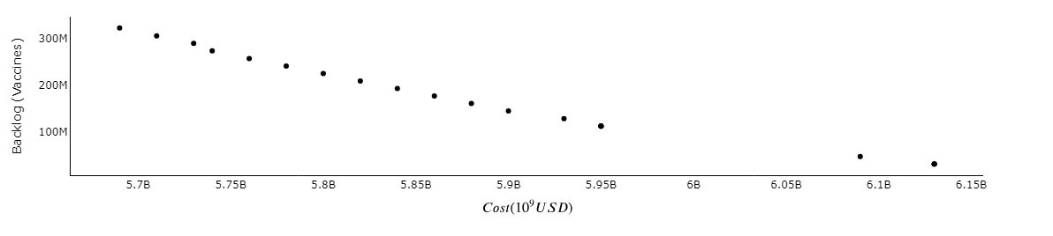
Figure 2. Pareto front with cost and backlog
In Figure 3, the interplay between operational costs (USD) and CO₂ emissions (kg) is explored. It becomes evident that more cost-effective operations tend to result in increased emissions, positing a challenge for balancing financial and environmental considerations in supply chain management.
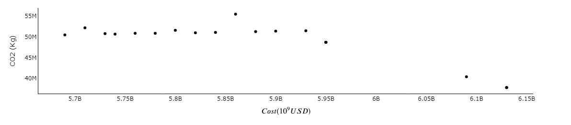
Figure 3. Pareto front with cost and CO₂ emissions
Figure 4 demonstrates the correlation between backlog (Vaccines) and CO₂ (kg) emissions. It is observed that scenarios with reduced backlogs are associated with higher emissions, underscoring the environmental cost of enhanced service levels in vaccine distribution.
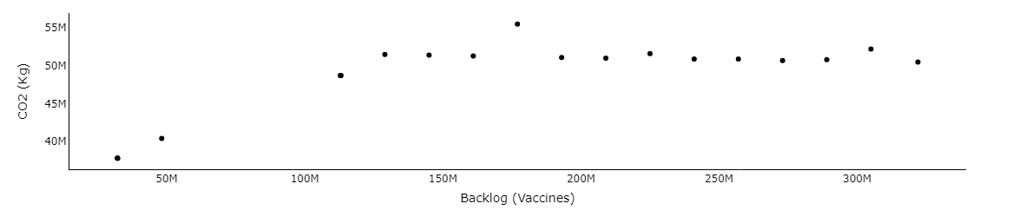
Figure 4. Pareto front with backlog and CO₂ emissions.
Together, these Pareto fronts offer a multifaceted view of the decision-making landscape, where the goals of minimizing costs and backlogs must be weighed against the imperative of reducing carbon footprint. The analyses provide strategic insights into achieving an optimal compromise in the complex domain of global vaccine distribution logistics.
  - Conclusions
In this study, a novel Pharmaceutical Supply Chain (PSC) model for the effective distribution of COVID-19 vaccines has been developed. This model showcases a significant advancement in supply chain management by integrating a multi-objective optimization framework using MILP within the GAMS environment. Its unique capability lies in balancing critical objectives like minimizing costs, reducing CO₂ emissions, and optimizing backlog during a 40-week vaccination campaign. Employing the augmented epsilon-constraint method, the model effectively navigates trade-offs between these objectives, aiding informed PSC management decisions. Its comprehensive approach, drawing from diverse data sources including academic research and public health data, ensures robustness and adaptability in the complex realm of pharmaceutical supply chains, especially during pandemics. While the multi-objective nature of the model impacts resolution times, it achieves a significant reduction in CO₂ emissions, at least 38%, highlighting its substantial contribution to managing pharmaceutical supply chains more effectively in crisis situations like the COVID-19 pandemic.
References
Alnaji, L. (2013). The role of Supply Chain Applications in Jordanian Pharmacies: A case study on Pharmacies in the capital city Amman. Industrial Engineering Letters, 65--71.
Holm, M. (2021). Critical aspects of packaging, storage, preparation, and administration of mRNA and adenovirus-vectored COVID-19 vaccines for optimal efficacy. Vaccine, 457.
Ibrahim, D. (2021). Model-based planning and delivery of mass vaccination campaigns against infectious disease: Application to the COVID-19 pandemic in the UK. Vaccines, 430--445.
Ivanov, D., & Dolgui, A. (2020). Viability of intertwined supply networks: extending the supply chain resilience angles towards survivability. A position paper motivated by COVID-19 outbreak. International journal of production research, 2904--2915.
Kurzweil, P. (2021). The ecological footprint of COVID-19 mRNA vaccines: estimating greenhouse gas emissions in Germany. International Journal of Environmental Research and Public Health, 7425.
Lainez, J. (2012). Prospective and perspective review in integrated supply chain modelling for the chemical process industry. Current Opinion in Chemical Engineering, 430--445.
Martonosi, S. (2021). Pricing the COVID-19 vaccine: A mathematical approach. Omega, 102451.
Mavrotas, G. (2009). Effective implementation of the $\varepsilon$-constraint method in multi-objective mathematical programming problems},. Applied mathematics and computation, 455--465.
Organization, W. H. (2022). Operational guidance on establishing an ultra-cold chain system in support of the Pfizer-BioNTech COVID-19 vaccine rollout, 1 February 2022.
Papageorgiou, L. G. (2009). Supply chain optimisation for the process industries: Advances and opportunities. Elsevier, 1931--1938.
Sadjadi, S. (2019). The design of the vaccine supply network under uncertain condition: A robust mathematical programming approach. Journal of Modelling in Management, 841--871.
Sazvar, Z. (2021). Designing a sustainable closed-loop pharmaceutical supply chain in a competitive market considering demand uncertainty, manufacturer’s brand and waste management. Annals of Operations Research, 1--32.
Uthayakumar, R. (2013). Pharmaceutical supply chain and inventory management strategies: Optimization for a pharmaceutical company and a hospital. Operations Research for Health Care, 52--64.
Zahiri, B. (2018). Design of a pharmaceutical supply chain network under uncertainty considering perishability and substitutability of products. Information sciences, 257--283.

